ĐỀ SỐ 6
Mark the letter A, B, C, or D on your answer sheet to indicate the word whose underlined part differs from the other three in pronunciation in each of the following questions.
Question 1. A. laughter B. caught C. taught D. daughter
Question 2. A. handicraft B. shopaholic C. honour D. highland
Mark the letter A, B, C, or D on your answer sheet to indicate the word that differs from the other three in the position of primary stress in each of the following questions.
Question 3. A. popular B. industry C. politics D. disaster
Question 4. A. addicted B. leftover C. tornado D. mechanic
Mark the letter A, B, C, or D on your answer sheet to indicate the correct answer to each of the following questions.
Question 5. Mother ______ to the supermarket. She won't come home till 10 o'clock.
A. just goes B. is just going C. has just gone D. will just go
Question 6. They are considering ______ the house before the prices go up.
A. buy B. to buy C. bought D. buying
Question 7. To be healthy, try to ______ the amount of fat in your diet.
A. rise B. reduce C. reject D. refuse
Question 8. They say it will be ______ to drive a car through the city in the rush hour because of the traffic jams.
A. possible B. impossible C. possibly D. impossibility
Question 9. If the sun shines, we'll go on ______ outing to the suburb.
A. the B. a C. an D. ∅
Question 10. When he arrived at the hotel, ______.
A. he asked for a room B. a room is waiting for him
C. he will have a room to stay D. he was going to ask a room
Question 11. Students have a(n) ______ between learning French or German as a second foreign language.
A. choice B. opportunity C. difference D. variety
Question 12. -"Would you like me to give you a hand?" – “______”
A. Yes, the work is very hard. B. No. I wouldn't like it.
C. Certainly. You're a good man. D. Thank you. That's very kind of you.
Read the following conversation and mark the letter A, B, C, or D on your answer sheet to indicate the correct option that best fits each of the numbered blanks from 13 to 16.
What to do in Case of a Fire at School
1. Evacuate the building by the nearest or exit if possible. Do not use elevators during an evacuation!
2. (13) ______ calm and listen to the teacher's instructions.
3. Do not stop to collect personal belongings.
4. Stay low to avoid* smoke and cover your nose and mouth (14) ______ needed.
5. Do not re-enter the building until you are (15) ______ that it is safe to return
6. If your clothes catch fire, stop, drop on the (16) ______, and roll. Keep rolling until the flames are gone.
Question 13. A. Stay B. Stand C. Come D. Wait
Question 14. A. because B. unless C. if D. but
Question 15. A. informing B. informed C. inform D. to inform
Question 16. A. earth B. soil C. land D. ground
Mark the letter A, B, C, or D to indicate the correct answer to each of the following questions from 17 to 18.
Question 17. Put the sentences (a-c) in the correct order, then fill in the blank to make a logical text.
Life in the countryside is often calm and enjoyable. The air is fresh and the nature is beautiful. In the countryside, you can see farms with animals like cows, sheep, and chickens. People grow fruits and vegetables, which are healthy and tasty. ______
a. However, some people might find country life boring as there are fewer shops and activities compared to the city.
b. The community is close-knit, neighbours are friendly and often help each other.
c. Children can go outside freely, exploring fields and forests and playing traditional games.
A. a-b-c B. a-c-b C. b-c-a D. b-a-c
Question 18. Choose the sentence that can end the text (in Question 17) most appropriately.
A. In addition, city life is busier, more convenient, so cities attract many young people to come and live there.
B. Overall, living in the countryside offers a slower pace of life, allowing people to enjoy simple pleasures like watching sunsets or having picnics by rivers.
C. Some people might miss the excitement of the city, where there are many shops, restaurants, and activities.
D. It is believed that life in the countryside is a perfect life for many people, especially for old people.
Read the following passage and mark the letter A, B, C, or D on your answer sheet to indicate the correct word or phrase that best fits each of the numbered blanks from 19 to 24.
Community service is a great way to help others and make a positive impact in our neighborhoods. It involves volunteering time and effort to (19) ____ local projects or organizations. There are many ways to get involved in community service. For example, you can help at (20) ______ by sorting and distributing food to people in need. Another option is to participate in clean-up events at parks or beaches, (21) ______ helps keep our environment beautiful. Community service also allows you to meet new people and learn more about different cultures. It can be a rewarding (22) ______ because you see the difference you make in others' lives. Additionally, volunteering can help you develop new skills, such as teamwork and communication. Many schools and universities encourage (23) ______ community service, as it builds a sense of responsibility and connection to the community. Overall, community service is not just about helping others; it is also about growing (24) ______ and creating a better world for everyone.
Question 19. A. support B. maintain C. achieve D. protect
Question 20. A. a food local bank B. a local bank food
C. a local food bank D. a bank local food
Question 21. A. that B. which C. who D. what
Question 22. A. knowledge B. practice
C. performance D. experience
Question 23. A. students to participate in B. students participating in
C. students to participate with D. students participation for
Question 24. A. personal B. personally C. person D. personnel
Mark the letter A, B, C or D on your answer sheet to indicate the sentence that is closest in meaning to the original sentence in each of the following questions.
Question 25. More tourists would come to this country if it had a better climate.
A. Not many tourists come to this country as its climate is not so good.
B. Many tourists come to this country because its climate is better.
C. When many tourists come to a country, its climate should be good.
D. Tourists do not come to this country as the climate here is so good.
Question 26. They didn't tell the police about the theft until it was far too late.
A. They didn't tell the police about the theft as they were too far.
B. When it was far too late, then the police report about the theft.
C. The theft wasn't reported to the police until it was far too late.
D. The police were not asked about the theft until it was far too late.
Mark the letter A, B, C, or D on your answer sheet to indicate the sentence that is made from the given cues in each of the following questions.
Question 27. wish / can buy / tickets / tomorrow's football match
A. They wish they could buy tickets for tomorrow's football match.
B. Their wish is they can buy tickets for tomorrow's football match.
C. Their wish that they could buy tickets for tomorrow's football match.
D. They wish they have bought tickets for tomorrow's football match.
Question 28. I / listen / music / my headphones on/ so / not hear / anything
A. I am listening to music and my headphones on so I didn't hear anything.
B. I was listening to music with my headphones on so I not hear anything.
C. I listened to music without my headphones on so I didn't hear anything.
D. I was listening to music with my headphones on so I didn't hear anything.
Read the following sign or notice and mark the letter A, B, C, or D on your answer sheet to indicate the correct answer to each of the following questions.
Question 29. What does this sign say?
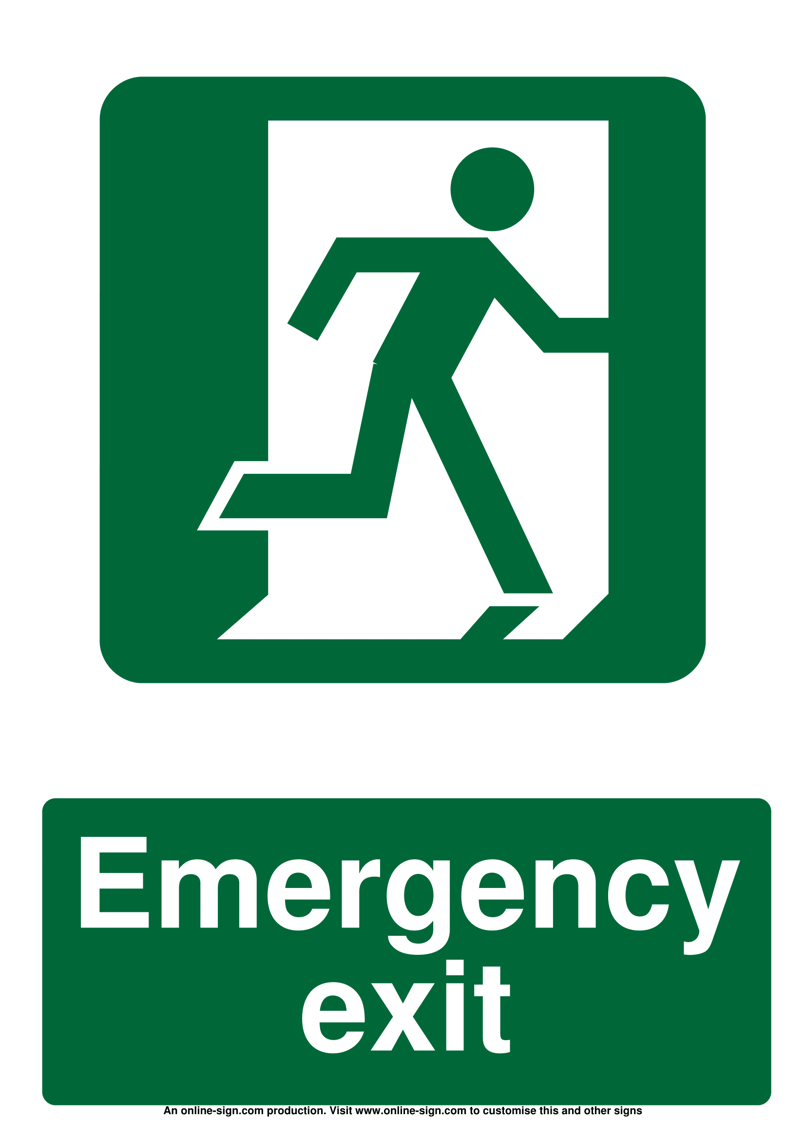 | A. You can't escape by the exit.  B. Go this way in case of emergency.  C. Don't run through the emergency exit.  D. There is no "Emergency exit" sign.
Question 30. What the notice say?
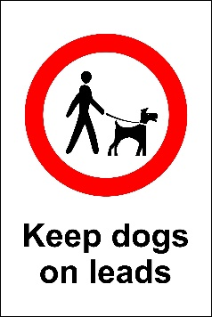 | A. You can let your dog run about.  B. You must tie your dog to a post.  C. You must keep your dog under control.  D. You must lead your dogs out.
Read the following passage and mark the letter A, B, C, or D on your answer sheet to indicate the correct answer to each of the following questions from 31 to 36.
In recent years, online shopping has become extremely popular, especially among teenagers. With just a few clicks, teenagers can buy clothes, shoes, gadgets, and more from the comfort of their own homes. This trend is not only convenient but also exciting for many young people.
One of the reasons teenagers prefer online shopping is the wide variety of choices. They can easily browse through hundreds of websites to find the latest fashion trends or the coolest gadgets. Online stores often offer discounts and promotions, which attract young shoppers who are always looking for a good deal.
Another unique aspect of online shopping for teenagers is the influence of social media. Many teenagers follow fashion influencers and celebrities on platforms like Instagram or TikTok. When they see their favorite influencers wearing certain brands, they want to buy the same items. This has made online shopping a social activity, where teens discuss and share their shopping experiences with friends.
However, there are also some concerns. Teenagers may spend too much time shopping online or waste money on things they don't really need. Despite these challenges, online shopping continues to grow in popularity among teenagers, shaping the way they shop in the modern world.
Question 31. The word variety in paragraph 2 is CLOSEST in meaning to ______.
A. limit B. few C. range D. number
Question 32. What can be inferred about the role of social media in teenage shopping?
A. It has no influence on teenage shopping habits.
B. It encourages teens to buy what their favorite influencers wear.
C. It helps teenagers save money on online shopping.
D. It makes teenagers shop in physical stores.
Question 33. According to the passage, why do some teenagers prefer online shopping?
A. It is never expensive.
B. They want to avoid discounts.
C. It takes less time than going to a store.
D. They can find the latest trends easily.
Question 34. Which of the following .is NOT TRUE according to the passage?
A. Teenagers can find many choices when shopping online. . .
B. Teenagers do not like discounts or promotions.
C. Online shopping has become a social activity for teenagers.
D. Teenagers may spend too much money shopping online.
Question 35. The word However in the last paragraph is used to ______.
A. introduce a contrasting statement
B. add some information
C. give a result of what is mentioned
D. mention another person or thing
Question 36. What is the main idea of the passage?
A. Online shopping is becoming popular among teens.
B. Teenagers prefer shopping in physical stores.
C. Teenagers do not like online shopping.
D. Social media is not related to shopping.
Four phrases/ sentences have been removed from the text below. For each question, mark the letter A, B, C, or D on your answer sheet to indicate the correct option that best fits each of the numbered blanks from 37 to 40.
Last summer, I had a memorable experience when I travelled to Ly Son Island with my family. It is a beautiful island belonging to Quang Ngai Province. The sun was shining, (37) ______.
On the first day, we built a big sandcastle together. My brother and I used buckets and shovels. It was fun to create towers and walls. Later, we swam in the sea. (38) ______. We saw colorful fish swimming around us, which made it even more exciting.
In the evening, we had a picnic on the beach. We ate seafood, fresh fruits and sandwiches while watching the sunset. (39) ______. After dinner, we played games, and I felt very happy.
This trip was special because I spent time with my family and enjoyed nature. I will always remember (40) ______ at the beach. It was truly a wonderful experience!
A. The sky turned orange and pink, which was so beautiful
B. and the sand was warm and soft
C. the fun we had and the beautiful moments we shared
D. The water was cool and refreshing
Question 37. _____ Question 38. _____ Question 39. _____ Question 40. _____

