|  |  |
| --- | --- |
| **Mã đề 7.2.35** | **MA TRẬN ĐỀ KIỂM TRA GIỮA HK II**  **NĂM HỌC 2022-2023**  **MÔN : TIẾNG ANH 7**  ***Thời gian làm bài 60 phút*** |

**Matrix**

|  |  |  |  |  |  |  |  |  |  |  |  |
| --- | --- | --- | --- | --- | --- | --- | --- | --- | --- | --- | --- |
| **Language areas or skills** | **Recognition** | | **Understanding** | | | **Application** | | | | | **total** |
| **Low** | | **High** | | |  |
| **MCQ** | **Ob** | **MCQ** | | **Ob** | **MCQ** | **Ob** | **MCQ** | | **Ob** |  |
| ***Listening*** | 1) Listen and choose the correct pictures  2) Listen to a dialog and fill in the information | | | | |  | |  | | |  |
| *N0 Q* | **5** |  |  | | **5** |  |  |  | |  | **10** |
| *Points* | ***1.0*** |  |  | | ***1.0*** |  |  |  | |  | ***2.0 (20%)*** |
| ***MC*** | Choose the best answer to complete each of the following sentences. | | | | | | | | | |  |
| *N0 Q* |  |  | ***10*** |  | |  |  |  | |  | ***10*** |
| *Points* |  |  | ***2.0*** |  | |  |  |  | |  | ***2.0(20%)*** |
| ***Reading*** | *I. Which notice (A-E) says this (1-5)* | | | | | | | | | |  |
| *N0 Q* |  |  |  |  | | ***5*** |  |  | | | ***5*** |
| *Points* |  |  |  |  | | ***1.0*** |  |  | | | ***1.0 (10%)*** |
| ***Reading*** | II.Read a passage and choose the best answer | | | | | | | | | |  |
| *N0 Q* |  |  | ***5*** |  | |  |  |  | | | ***10*** |
| *Points* |  |  | ***2.0*** |  | |  |  |  | | | ***2.0 (20%)*** |
| ***Writing*** | I. Rewrite these sentences without changing the meaning, use the words suggested | | | | | | | | | |  |
| *N0 Q* |  |  |  |  | |  |  |  | | ***5*** | ***5*** |
| *Points* |  |  |  |  | |  |  |  | | ***1.0*** | ***1.0 (10%)*** |
| ***Writing*** | II. Write a essay of 80-100 words about your favorite dish | | | | | | | | | | |
| *Points* |  | |  | | |  | | | ***2.0*** | | ***2.0 (20%)*** |
| ***Total*** | | | | | | | | | | | |
| *N0 Q* | ***35*** | | | | | | | | | | |
| *Points* | ***100%*** | | | | | | | | | | |

|  |  |
| --- | --- |
| **Mã đề 7.2.35**  **ĐỀ CHÍNH THỨC** | **ĐỀ KIỂM TRA GIỮA HỌC KỲ II**  NĂM HỌC 2022 - 2023  Môn: Tiếng Anh - Lớp 7  Thời gian làm bài: 60 phút  Đề bài gồm 05 trang |

**A. LISTENING:**

**Question 1.** You will hear five short conversations. You will hear each conversation twice. There is one question for each conversation.

*For question 1-5: choose the right answer A, B or C.**(1.0 pt)*

1. What does Daisy want for supper?

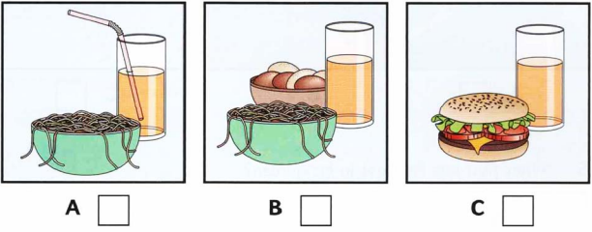

1. What did Sally get for her birthday?

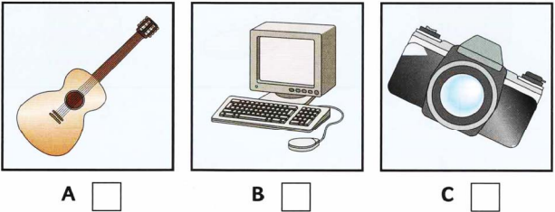

1. Where did Peter go at the weekend?

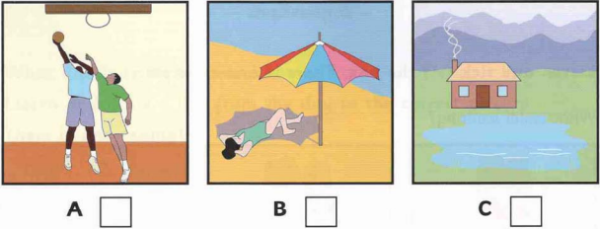

1. What was the matter with Mary?

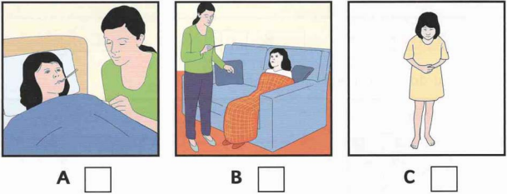

1. What fruit has Fred got in his garden?

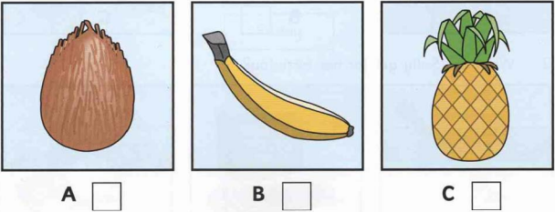

**Question 2.** Listen and write. You will hear the conversation twice (1.0 pt)

Name: Jill Walker

6. Lives at: 7…………………………….Street

7. Class number: …………………………………………

8. Favourite sport: …………………………………………

9. Likes reading: …………………………………………

10. Pet: ………………………………………………………

**B. VOCABULARY - GRAMMAR**

**Question 3.** Choose the best answer to complete each of the following sentences. (2 pt)

11. __________does it take you to get to Ho Chi Minh City by plane?

- About 2 hours.

A. How far B. How much C. How long D. How many

12. There__________ a bus station in the city centre, but it has been moved to the suburbs.

A. used to be B. used to have C. use to have D. were

13. Public __________ in my town is good and cheap.

A. transport B. tour C. journey D. travel

14. Mai’s dad usually drives her to school__________ her school is very far from her house.

A. but B. though C. because D. or

15. __________ being frightened by the images, Lan still liked the film so much.

A. In spite B. Despite C. Although D. Nevertheless

16. Most __________ say that this film is worth watching.

A. plots B. settings C. critics D. acting

17. I was__________ in that gripping film.

A. interested B. interests C. interest D. interesting

18. We found the plot of the film __________.

A. bored B. boring C. interested D. acting

19. Last night, I didn’t go to bed early__________ being very tired.

A. despite of B. in spite of C. although D. because

20. The festival __________ annually at the end of August.

A. occurs B. helds C. are held D. takes

**C. READING**

**Question 4**. Which notice ( A-F ) says this ( 21-25) . For questions 21-25 , marks the correct letter A-H on the answer sheet.(1,0pt)

|  |  |
| --- | --- |
| 21. You cannot bring your dogs here unless they are guided.  22. There is a primary school ahead.  23. This is the place you can pay them to fix your sandals, boots,…  24. You need to wear special clothes for this.  25. If you buy something that doesn’t fit, you can’t bring it back. | A.  B.  C.  D.  E.  F. |

**Question 5:**Read the passage and choose the best answer to each question. (2.0 pts)

Who are the best drivers? Which drivers are the safest on the road? According to a recent survey young and inexperienced drivers are the most likely to have an accident. Older drivers are more careful. Young men have the worst accident records or all. They often choose faster cars with bigger engines. One of the most interesting facts in survey is that passengers have an effect on the driver. When young male drivers have their friends in the cars, their driving becomes worse. When there wife of girlfriend is in the car, however, their driving is better. But opposite is true for women. Their driving is more dangerous when their husband or boyfriend is in the car.

26. According to the survey, who are the most likely to have an accident?

A. Young and experienced driver.

B. Old and inexperienced drivers

C. Young and old drivers

D. Young and inexperienced drivers.

27. Young men often choose ____

A. expensive cars

B. fast cars with big engines

C. slow cars with big engines.

D. fast cars with small engines.

28. Who have an effect on the driver?

A. passengers. B. policemen. C. children. D. journalists.

29. When young male drivers have their wife of girlfriend in the car, their driving becomes ____.

A. worse. B. better. C. slower. D. faster.

30. The worst accidents are often taken by _____.

A. Male drivers. B. Female drivers. C. Young men. D. Young women.

**C. WRITTING**

**Question 6:** Rewrite these sentences without changing the meaning, use the words suggested. (1.0 pt)

31**.** Although Tom was a poor student, he studied very well.

⇨In spite of………………………………………………

32. In spite of his good salary, Tom gave up his job.

⇨Although……………………………………………….

33. My brother wore glasses when he was young (used to)

⇨………………………………………………………….....

34. Although it rained heavily, she still went to school on time .

⇨ Despite ……………………………………….

35. Classical music is interesting. Folk music makes me feel bored. (However)

⇨………………………………………………………….....

**Question 7:** Describe your favourite film, using the following cues. (2 pt)

* *What is the kind of that film?*
* *What is the title of the film ?*
* *Who the film is directed by?*

*Who is the main character ?*

* *Who are the main characters ?*
* *A short description of the plot (the story)*
* *Details of special effects/ costumes/ music, etc.*
* *What we think is good or bad about the film?*
* *A recommendation (advice about whether your classmates should watch this film and who will enjoy it).*

|  |  |
| --- | --- |
| **Mã đề 7.2.35** | **HƯỚNG DẪN CHẤM**  ĐỀ ĐÁNH GIÁ GIỮA HỌC KỲ II  NĂM HỌC 2022 - 2023  **Môn: Tiếng Anh - Lớp 7**  Hướng dẫn chấm gồm: 01 trang |

1. Trắc nghiệm

|  |  |  |  |  |  |  |  |  |  |  |
| --- | --- | --- | --- | --- | --- | --- | --- | --- | --- | --- |
| Câu | 1 | 2 | 3 | 4 | 5 | 6 | 7 | 8 | 9 | 10 |
| Đáp án | A | C | C | B | C | Main | 4b | hockey | comics | Snake |
| Câu | 11 | 12 | 13 | 14 | 15 | 16 | 17 | 18 | 19 | 20 |
| Đáp án | C | A | A | C | B | C | A | B | B | D |
| Câu | 21 | 22 | 23 | 24 | 25 | 26 | 27 | 28 | 29 | 30 |
| Đáp án | A | E | D | F | B | D | B | A | B | C |

1. Tự luận

**Question 6:**

31. being a poor student, he studied very well. (0.2pt)

32. Tom has good salary, he gave up his job. (0.2pt)

33. My brother used to wear glasses when he was young. (0.2pt)

34. the heavy rain, she still went to school on time (0.2pt)

35. Classical music is interesting. However, folk music makes me feel bored (0.2pt)

**Question 7:**

* Form: (0,5p)

- correct form

* Task fulfillment: (1pt)

- complete the passage with all relevant information

- well- organized.

- Content

*Language: (0,5p)

- accurate grammar

- appropriate vocabulary