Unit 12 Test
I. Listening
Listen to the conversation at the International Robot Show and tick (✓) T (True) or F (False).
STT | Statements | T | F
1 | H8 is a home robot that can make meals and iron clothes.
2 | WB2 is the smallest robot in the show.
3 | Worker robots can repair broken machines.
4 | Shifa is a doctor robot but it is not very smart.
5 | In the future, robots might do many things like humans.

II. Pronunciation
Choose the correct intonation for each sentence.
6. "My robot can water the plants in the garden."
- A. My robot can water the plants in the garden. ↗
- B. My robot can water the plants in the garden. ↘
7. "WB2 is the strongest of all the robots in this show."
- A. WB2 is the strongest of all the robots in this show. ↘
- B. WB2 is the strongest of all the robots in this show. ↗
8. "Which sentence has a FALLING tone (↘) at the end?"
- A. Can a home robot do the laundry?
- B. Shifa is a very smart doctor robot.
9. "Choose the statement with the correct intonation mark."
- A. I often help my parents with the housework. ↘
- B. Do you like this International Robot Show? ↘
III. Language use
Choose the best answer A, B, C or D.
10. My robot is the ________ robot in the show. It can lift a car!
A. strong B. stronger C. strongest D. most strong
11. Which robot is the ________? – It’s Shifa. It can understand 30 languages.
A. smart B. smarter C. smartest D. most smart
12. Future robots will be able to ________ the dishes and cook meals.
A. do B. make C. fix D. iron
13. "I think robots will replace teachers one day." – "I ________. Teachers are more than just robots."
A. agree B. don't agree C. am agree D. not agree
14. This is the ________ robot I have ever seen. It’s only 10 centimeters tall.
A. small B. smaller C. smallest D. most small
15. Doctor robots can help ________ people and take care of them.
A. healthy B. sick C. strong D. heavy

IV. Signs & Notices
Look at the signs and choose the best explanation.
16. What should you do?
A. You can enter when the light is red.
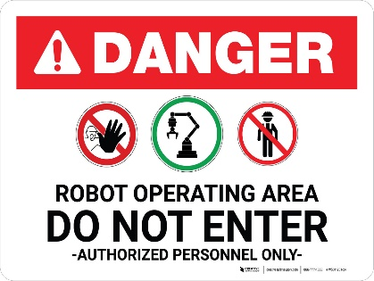
B. You must wait for the green light to enter.
C. Stay out of this area if you see a red light.
D. Robots only work in red light.
17. This sign tells you:
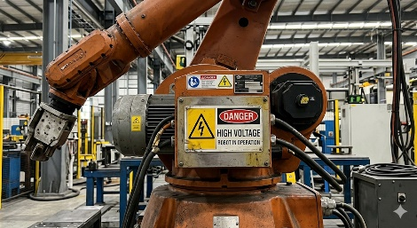
A. This robot is very fast.
B. Be careful! This robot uses very strong electricity.
C. You can charge your phone here.
D. The robot is broken.
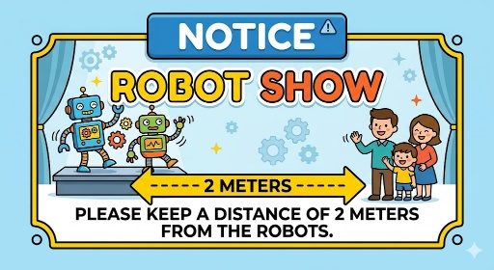
18. Read the notice. What should you do?
A. You should stand close to the robots.
B. Don't stand too near the robots for your safety.
C. You can touch the robots if you want.
D. The robots are 2 meters tall.

19. What does it mean?
A. This robot doesn't need oiling.
B. You should put more oil here.
C. The robot is leaking oil.
D. Buy some oil for the robot.
V. LOGIC
Rearrange the sentences (a-d) to make a complete conversation.
20. a. It’s Shifa, a doctor robot. It’s the smartest robot here.
b. And what is this robot, Dr. Adams?
c. It can help sick people and do many things like humans.
d. Wow! What can it do to help us?
A. b - a - d - c B. b - d - a - c C. a - b - d - c D. d - c - b - a
21. a. I agree with you. They help us a lot in our daily life.
b. I think home robots are the most useful of all robots.
c. Yes, they can cook meals, clean the house and even do the laundry.
d. That's true. We will have more free time thanks to them.
A. b - a - c - d B. b - c - a - d C. a - b - d - c D. c - d - b - a
22. a. It's WB2, a worker robot. It's the strongest robot in the show.
b. Look! That's the biggest robot I've ever seen.
c. It can move heavy things or repair broken machines.
d. What are its special skills?
A. b - a - d - c B. b - d - a - c C. a - b - d - c D. d - c - b - a
23. a. Peter says robots can do everything like humans.
b. I don't agree with him. Robots can't understand our feelings.
c. You're right. They are just machines, after all.
d. Hi Mary, what do you think about Peter's opinion?
A. d - a - b - c B. d - b - a - c C. a - d - b - c D. b - c - d - a
VI: READING
A. Read and choose the correct word for each blank.
Today there is an international robot (24) ________ in Ha Noi. People can see many types of robots there. Home robots are useful (25) ________ housework. They can do most of the housework: cook meals, clean the house, and do the washing. Teacher robots are the best (26) ________ for children. They can help them to study English, literature, maths and other subjects. They can also help children to improve their English (27) ________.

24. A. show B. station C. factory D. hospital
25. A. with B. for C. at D. in
26. A. choice B. thing C. robot D. person
27. A. grammar B. vocabulary C. pronunciation D. speaking
B. Read the text and choose the best answer A, B, C or D.

Robots are very popular today. There are different types of robots. Worker robots can
build houses and move heavy things. Doctor robots can look after sick people. Space robots can build space stations on the Moon and on other planets. Among them, M10, H9, and A3 are the most famous robots. M10 is the youngest; it is only 5 years old. H9 is the cheapest robot, costing only $1,000. A3 is the tallest robot; it is 150 cm tall. Each robot has its own skills to help humans. In the future, robots will be much smarter and more useful.

28. What can worker robots do?
A. Take care of sick people B. Build houses
C. Build space stations D. Cook meals
29. Which robot can help sick people?
A. Home robot B. Teacher robot C. Doctor robot D. Space robot
30. Where can space robots build space stations?
A. In the factory B. In the hospital C. On the Moon D. In the garden
31. How old is M10?
A. 5 B. 7 C. 10 D. 150
32. Which is the cheapest robot?
A. M10 B. H9 C. A3 D. None of them
33. How tall is the tallest robot?
A. 20 cm B. 45 cm C. 80 cm D. 150 cm
34. What will robots be like in the future?
A. Smarter B. Weaker C. Younger D. Cheaper
35. Is A3 the tallest of the three robots?
A. Yes, it is B. No, it isn't C. It is the shortest D. We don't know
VII: WRITING
A. Rearrange the words to make complete sentences.
36. strongest / all / WB2 / the / of / is / robots / the / .
______________________________________________________________________.
37. sick / take / Doctor / people / robots / of / care / can / .
______________________________________________________________________.
B. Rewrite the sentences without changing their meanings.
38. No robot in the show is smarter than Shifa. (Sử dụng so sánh nhất "smartest")
Shifa is ________________________________________________________________.
39. My robot is 150cm tall. Your robot is 120cm tall. His robot is 100cm tall. (Sử dụng "tallest")
My robot is ____________________________________________________________.
40. V10 has the ability to do the washing and water plants. (Sử dụng "can")
V10 ____________________________________________________________________.

AUDIO SCRIPT (Dành cho giáo viên)
Welcome to the International Robot Show! Here is H8. It’s a very useful home robot. It can make meals, do the dishes, and iron clothes. Over there is WB2, a worker robot. It is the biggest and strongest robot here. It can move heavy things and repair broken machines. And this is Shifa, a doctor robot. It’s the smartest because it can help sick people. We think robots will do many things like humans in the future.
*************************************
Đáp án tham khảo
I. Listening: 1. T | 2. F (It is the biggest) | 3. T | 4. F (It is the smartest) | 5. T
II. Pronunciation
• 6. B: Đây là một câu trần thuật (Statement), theo quy tắc trang 60, giọng chúng ta thường xuống ở cuối câu.
• 7. A: Tương tự, đây là câu khẳng định về robot WB2, ta dùng ngữ điệu xuống.
• 8. B: Câu A là câu hỏi Yes/No (thường lên giọng), câu B là câu kể (xuống giọng).
• 9. A: Câu A là câu kể (đúng quy tắc xuống giọng). Câu B là câu hỏi Yes/No, không dùng ngữ điệu xuống ở cuối.
• Language: 10. C | 11. C | 12. A | 13. B (Sử dụng cấu trúc Expressing disagreement - trang 63) | 14. C | 15. B
• Signs & Notices: 16. C | 17. B | 18. B | 19. A
• Logic: 20. A | 21. A | 22. A | 23. A
• Reading A: 24. A | 25. B | 26. A | 27. C
• Reading B: 28. B | 29. C | 30. C | 31. A | 32. B | 33. D | 34. A | 35. A
ĐÁP ÁN PHẦN VII (WRITING)
- 36. WB2 is the strongest of all the robots.
- 37. Doctor robots can take care of sick people.
- 38. Shifa is the smartest robot in the show.
- 39. My robot is the tallest of the three robots.
- 40. V10 can do the washing and water plants.

