UNITS | VOCABULARY | GRAMMAR
Unit 6  EDUCATION | - Vocabulary related to education  - Adjectives to talk about feelings at school | - Present Simple and “have to”  - Intensifiers and “because”  - Conjunctions “However”, “Although”
Tiếng Anh 7 – i-LEARN SMART WORLD

UNIT 6 TEST
Note: Each correct answer earns 0.2 points.

I. PRONUNCIATION (0.8 points)
A. Choose the word whose underlined part is pronounced differently.
1. A. before B. report C. homework D. uniform
2. A. excited B. annoyed C. pleased D. surprised
B. Choose the word that has a different stressed syllable from the rest.
3. A. classmate B. finish C. essay D. abroad
4. A. difficult B. however C. positive D. chemistry

II. VOCABULARY AND GRAMMAR (2.4 points)
Choose the best option (A, B, C or D) to complete each of the following questions.
5. Sammy studied really hard, so she __________ all of her tests.
A. passed B. failed C. got D. did
6. Student A: How’s the course going?
Student B: I’m __________ enjoying it.
A. very B. much C. really D. a lot
7. Ivy was so __________ because she failed two tests last semester.
A. pleased B. delighted C. relaxed D. upset
8. We __________ buy lunch in the canteen. There’s a shop next to the school and it sells sandwiches and other snacks.
A. have to B. don’t have to C. mustn’t D. should
9. The teacher asked us to choose a book from the list, read it at home and then write a __________ about it.
A. project B. presentation C. report D. revision
10. Our math teacher, Mr. Thomas, is funny and friendly, but he gives us too much __________ to do after school.
A. homework B. exams C. essays D. exercise
11. Nick got 100% on his physics test. His twin brother, Adam, ______, had to retake the test.
A. although B. but C. so D. however
12. I’m really __________ with Nick. We have an important biology project, but he doesn’t do his part.
A. hopeful B. annoyed C. pleased D. excited
13. Yesterday, I wrote a(n) __________ about the benefits of studying overseas, and the teacher said it was good.
A. homework B. test C. essay D. paper
14. Student A: I’m going to the movies this evening. Do you want to join me?
Student B: _________. I have too much homework to do.
A. Sure, I can.
B. Thanks, but I don’t think I can.
C. Of course, I will.
D. Thanks, but sorry, I’m not.

15. Read the notice and choose the correct statement.
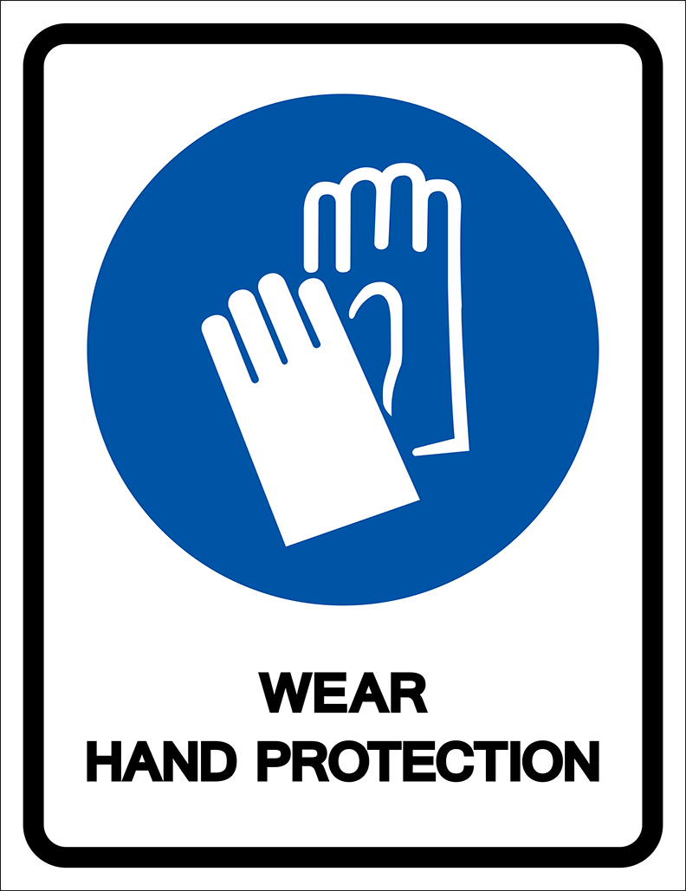 | A. You have to wear gloves when you enter this place.  B. You don’t have to wear gloves in this place.  C. It’s a good idea to wear gloves in this place.  D. You need to bring gloves to this area.

16. What does this sign mean?
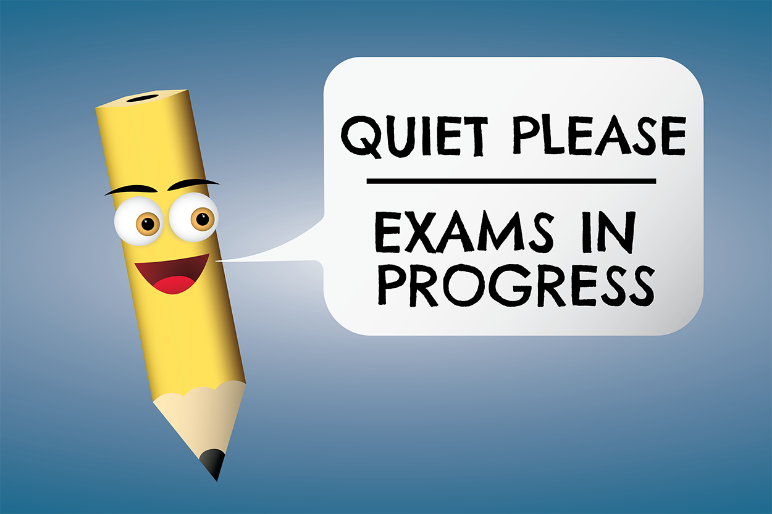 | A. You don’t have to talk in this area.  B. You have to keep silent in this area.  C. You have to take the exam in this area.  D. You don’t have to make any noise during the exam.

III. WORD FORMATION (1.2 points)
Write the correct form of the words in brackets.
17. I was so __surprised________ because I got an A plus on my English test. (SURPRISE)
18. In my English class, we have to give ___presentations________ about various topics. (PRESENT)
19. Philip was really ___disappointed_______ when he got a D on his math test. He studied very hard for it. (DISAPPOINT)
20. Studying abroad puts you into an unfamiliar situation, so you will become more ___independent_______. (DEPEND)
21. Studying overseas also gives you the opportunity to make friends with people from _different_________ backgrounds. (DIFFER)
22. When I first came to the USA, I was ___scared_______ and lonely because I couldn’t understand what other people said. (SCARY)

IV. LISTENING (2 points)
A. You will listen to Alex talking to his friend Tom about studying abroad. For each question, complete the notes with NO MORE THAN TWO WORDS.
Tom’s trip was amazing, although he (23)__really__ missed his friends and family. The thing that (24)__surprised__ him was how welcoming everyone was.
His friend Alex was (25)__pleased__ to hear Tom didn’t have trouble making friends.
Tom thought the food was (26)__so__ delicious because it tasted hot and spicy, and he found it hard to take a (27)__test__ in a foreign language.
B. You will listen to a student and teacher talking about studying abroad. For each question circle the correct option A, B, C, or D.
28. How many years did Ms. Sullivan spend teaching abroad?
A. one B. two
C. four D. six

29. What can an online exchange provider do?
A. help make travel arrangements B. call your parents
C. drive you to the airport D. cook you food

30. Why should Simon start saving money?
A. to buy a plane ticket B. in case something happens
C. to be prepared D. in case it rains

31. Why would Simon’s mom be pleased with him?
A. because he cleaned his room B. because he talked with his teacher
C. because he saved money D. because he passed his test

32. What is true about the conversation?
A. Ms. Sullivan traveled to Europe. B. Simon’s mom was pleased he passed his test.
C. Simon doesn’t need to save money. D. Simon needs advice about studying abroad.

V. READING (2 points)
A. Read the following passage. For each question, circle the correct option A, B, C, or D that best suits each blank.
Studying abroad is becoming popular for many students looking to learn more about other languages and countries. Sometimes, students (33)__________ work with an online exchange organization to make travel arrangements and make sure they have a wonderful and safe experience while away.

Studying abroad is also a (34)__________ way to meet new friends, visit new places, and experience different things. Students are (35)__________ to learn about new opportunities and meet people from other cultures. (36)_________ learning in a foreign country can be difficult, they are pleased when they (37)__________ their first test, complete their first project, or meet amazing new people. Overall, it’s a great way to travel to other countries and learn more about the world.

33. A. have B. have to C. to have D. has to
34. A. great B. terrible C. pleased D. surprised
35. A. upset B. disappointed C. annoyed D. delighted
36. A. Because B. Although C. However D. So
37. A. present B. fail C. pass D. make
B. Read the following passage. For each question, write T if the statement is TRUE, F if the statement is FALSE, and NI if there is NO INFORMATION on it.
When Sophie was a little girl, she dreamed about visiting another country. One day, while looking on the internet, she was surprised to learn about a way to travel and study abroad. First, Sophie would have to decide which country to visit. She would also need to learn a foreign language to take tests and write essays. Sophie quickly knew it would take a lot of work to make her dreams come true, so she began working with her parents on making plans.

Sophie was so excited about her future that she spent an entire summer working with her dad to save money. She also took French lessons because she always dreamed about traveling to Paris. The following summer, Sophie was accepted into an exchange program and spent a year traveling and studying abroad.

38. Sophie made her dreams of traveling abroad come true by working hard. __T__
39. Sophie didn’t have to learn a foreign language. __F__
40. Sophie planned to take a train to Paris. __NI__
41. Sophie worked with her dad to save money. __T__
42. Sophie spent one whole summer studying abroad. __F__

VI. WRITING (1.6 points)
A. Rewrite the following sentences without changing their meaning.
43. Anna’s mother is from China, but she can’t speak Chinese. (HOWEVER)
→ Anna’s mother is from China. However, she can’t speak Chinese.
→ Anna’s mother is from China. She, however, can’t speak Chinese.
44. Luke wants to study overseas, but he is afraid of living alone.
→ Although Luke wants to study overseas, he is afraid of living alone.
45. According to the rules, it’s necessary for students to hand in their assignments on time.
→ Students have to hand in their assignments on time.
46. It isn’t necessary for Cathy to buy new textbooks because she can borrow them from the library.
→ Cathy doesn’t have to buy new textbooks because she can borrow them from the library.
→ Cathy doesn’t need to buy/ needn’t buy new textbooks because she can borrow them from the library.

C. Use the given words or phrases to make complete sentences.
47. I / have / be / school / 8:50 / because / first lesson / start / 9:00
→ I have to be at school at 8:50 because the first lesson starts at 9:00.
48. Although / Ann / not like / sports / she / have / play / basketball / P.E. lessons.
→ Although Ann doesn’t like sports, she has to play basketball in P.E. lessons.
49. I / pass / all / exams / so / parents / be / so / delighted.
→ I passed all my exams, so my parents were so delighted.
→ I passed all of my exams, so my parents were so delighted.
→ I passed all of the exams, so my parents were so delighted.
→ I passed all exams, so my parents were so delighted.
→ I passed all the exams, so my parents were so delighted.
50. Tom / play / computer games / right now / although / he / have / important test / tomorrow morning.
→ Tom is playing computer games right now although he has/ is having and important test tomorrow morning.

***End – Of – Test***
Listening Scripts

Script A

Alex: Hello Tom! It’s good to see you again. How was studying abroad in Spain?
Tom: My trip was amazing, although I really missed my friends and family.
Alex: I bet! I would have to call my mom every day. Did you meet any new friends?
Tom: I sure did. I was surprised at how welcoming everyone was to me.
Alex: I’m pleased to hear that. What else did you enjoy about your trip?
Tom: The food was so delicious! Everything there tasted hot and spicy.
Alex: How was taking a test in a foreign language?
Tom: It was hard at first because I was not very good at understanding the teacher, but it became much easier after a while.
Alex: Well, I am glad you're back and can't wait to hear more about your trip.

Script B

Simon: Hello teacher! I am planning to study abroad next year. Do you have any advice for me?
Ms. Sullivan: Sure Simon, I can give you some great advice. I spent four years abroad teaching students in Asia and learned many things from my experience. Have you decided where you would like to study?
Simon: I was thinking about Europe or North America.
Ms. Sullivan: Well, you might consider working with an online exchange provider. They can help you make travel arrangements.
Simon: That’s an excellent idea! I will look into it. Any other suggestions?
Ms. Sullivan: You might also want to start saving money just in case something happens.
Simon: Wow! I didn't think of that. My mom would be so pleased to learn I am saving money. How much should I save?
Ms. Sullivan: I would suggest you save about $1500.

