School: ……………………………………….. | Date:……………………………………..
Class: ……………………………..................... | Period: 43

UNIT 4: NATURAL DISASTERS
Lesson 3.2 – Speaking & Writing, page 43
1. Objectives
By the end of this lesson, students will be able to…
1.1. Language knowledge/ skills
- talk about the dangers of disasters and what people should do
- write an emergency announcement for a disaster
1.2. Competences
- improve Ss’ communication, collaboration, analytical, critical thinking skills.
1.3. Attributes
- know the dangers and advice for keeping safe during a disaster.
2. Teaching aids and materials
- Teacher’s aids: Teacher’s aids: Student’s book and Teacher’s book, class CDs, DCR– Phần mềm tương tác trực quan, DHA – Ứng dụng trò chơi tương tác, projector / interactive whiteboard /TV (if any), PowerPoint slides.
- Students’ aids: Student’s book, Workbook, Notebook.
3. Assessment Evidence
Performance Tasks | Performance Products | Assessment Tools
- In pairs: Discuss the different disasters you know: the dangers and what people should and shouldn't do during each disaster.  - Choose one disaster and complete the table with information about the dangers and your most important pieces of advice.  - Write an emergency announcement (80 to 100 words) warning another town about the disaster you discussed in Speaking. | - Ss’ answers.  - Ss’ answers.  - Ss’ answers. | - Observation.  - Observation.  - Checking.
4. Procedures
A. Warm up: 5’
a. Objective: to review lesson 3.1 and lead in the new lesson.
b. Content: ordering sentences activity.
c. Expected outcomes: Ss can put the sentences of a passage in a logical order.
d. Organization
Teacher’s activities | Students’ activities
Ordering sentences  - Ask Ss to work in pairs, putting the sentences below in the correct order:  A. Find a strong building and stay upstairs.  B. Emergency announcement from the National Weather Service:  C. The flood water is very dangerous and can cause lots of damage.  D. There is a flood warning in the area until tomorrow at 10 a.m.  - Call some pairs to give their answers.  - Give feedback. | -Work in pairs, putting the sentences below in the correct order.  Give answers.  Answer keys:  A.4 B.1 C.3 D.2
B. New lesson (35’)
1. Speaking: 10’
a. Objectives: to help Ss practice asking and answering about natural disasters and get ideas for their writing task.
b. Content: tasks a and b.
c. Expected outcomes: Ss can talk about the dangers and what people should/shouldn’t do during a disaster.
d. Organization
Teacher’s activities | Students’ activities
Task a: In pairs: Discuss the different disasters you know. What are the dangers of these disasters? What should and shouldn't people do during each disaster?  - Ask Ss to work in pairs to discuss the different disasters they know: the dangers and what people should and shouldn't do during each disaster.  - Elicit ideas from Ss.  - Give feedback. | - Work in pairs to discuss the different disasters they know: the dangers and what people should and shouldn't do during each disaster.  - Give ideas.
Task b: Imagine it's your job to warn your town about a disaster. Choose one disaster and complete the table with information about the dangers and your most important pieces of advice. (You can use ideas from  the last lesson.)  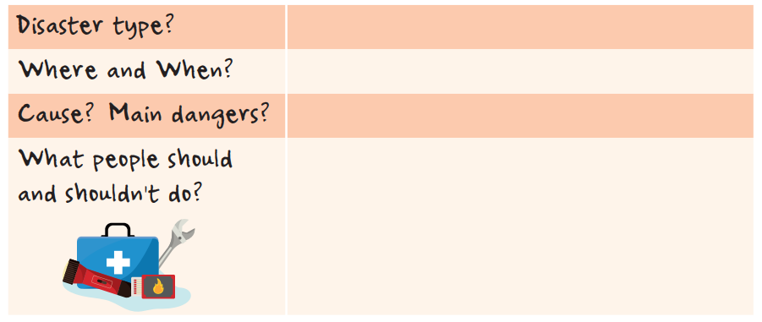  - Explain the task.  - Give Ss time to discuss with their partners and complete the table.  - Go around to help if necessary.  - Pick some pairs to present the disaster they have discussed.  - Give feedback. | - Discuss with their partners and complete the table.  - Present information about the disaster they have discussed.
2. Write: 10 minutes
a. Objectives: to help Ss to practice writing an emergency announcement.
b. Content: Let’s write.
c. Expected outcomes: Ss can produce an emergency announcement about a natural disaster.
d. Organization
Teacher’s activities | Students’ activities
Review:  -Ask Ss the following questions:  a) How many parts are there in a basic descriptive passage?  b) What is the function of each part?  Let’s write: Now, write an emergency announcement warning another town about the disaster you discussed in Speaking. Use the Writing Skill box and your speaking notes to help you. Write 80 to 100 words.  - Assign the task.  - Give Ss some time to write.  - Monitor the class and help them if necessary.  - Pick some Ss to show their writing and give feedback.  - Show sample passage. | - Give their answers  Answer Keys:  a)Heading, What/Where/When notes, Summary, Instructions.  b)  1. Heading – Note the emergency type, who is sending the announcement, and when.  2. What/Where/When notes – Keep these short and simple.  3. Summary – Briefly note the cause and main dangers.  4. Instructions – Note what people should do as point form notes.  - Write an emergency announcement, using the information they have discussed.  - Show their writing.  Sample emergency announcement:  Typhoon warning from the National Weather Service  Sent: 20:15 July 11  What: Typhoon  Where: Rainytown  When: From 22:30 July 11 to 08:00 July 12  There is a large typhoon coming to Rainytown. Winds could be as strong as 100 km/h with heavy rain. We expect damage to buildings, trees, and houses.  Instructions:  • Have an escape plan.  • Have emergency items ready to go.  • Make sure cell phones/radios etc. are fully charged.  • Board up windows.  • Turn off electricity/gas.  • Stay indoors.  • Listen to local news reports.  • Be prepared to leave your home and follow your escape plan.

C. Consolidation and homework assignments: 5’
- Do exercises in workbook on page 25.
- Prepare the next lesson: Review Unit 4, page 92.
- Do the exercises in Tiếng Anh 8 i-Learn Smart World notebook (page 35).

V. REFLECTION

a. What I liked most about this lesson today:
…………………………………………………………………………………………
b. What I learned from this lesson today:
…………………………………………………………………………………………
c. What I should improve for this lesson next time:
…………………………………………………………………………………………

