Thời gian làm bài: 40 phút (Không kể thời gian giao đề)
-------------------------
Họ tên thí sinh: .................................................................
Số báo danh: ......................................................................
Mã Đề: 002.
Câu 1. "What activity is the person inviting their friend to do?"
Hey friend! I hope you're having a good day. I wanted to see if you're up for watching a film this weekend. I heard that a new blockbuster just came out and it's supposed to be really good. Let me know if you're free and we can catch it together.
A. Read a book B. Watch a film C. Go to a museum D. Attend a play
Câu 2. Which day is the City Zoo closed?
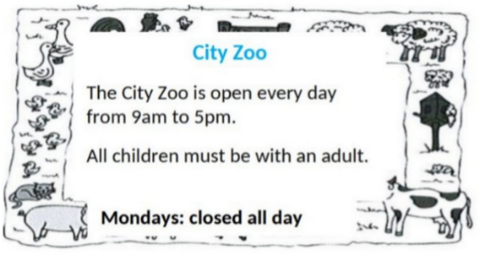
A. Saturday B. Friday C. Monday D. Sunday
Câu 3. Which of the following items is NOT included in the half-price sale?
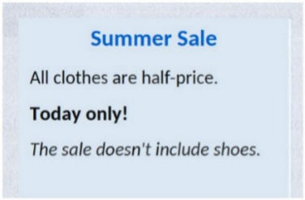
A. Shoes B. Pants C. Dresses D. T-shirts
Câu 4. Look at the signs. Choose the best answer for the question.

A. You can buy cheaper apples after 6 p.m.
B. You can only buy apples today.
C. Today you can buy apples at a cheaper price before 6 p.m.
D. You can’t buy any apples before 6 p.m.
Câu 5. What should visitors do if the gate is closed?
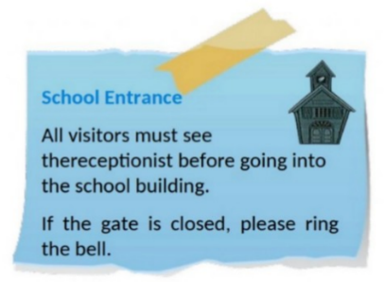
A. Call the school office B. Wait for someone to open it
C. Come back later D. Ring the bell
Câu 6. Look at the signs. Choose the best answer for the question.
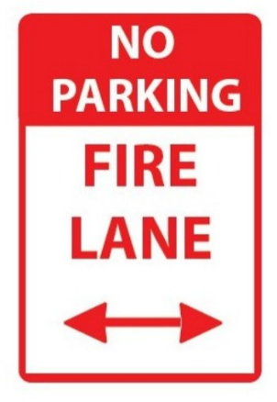
A. You can’t park your car here because this area is for fire trucks.
B. If there is a fire, park your vehicle in this area.
C. This area prevents your cars from fire.
D. You can’t park your car here when it is on fire.
Câu 7. Look at the signs. Choose the best answer for the question.
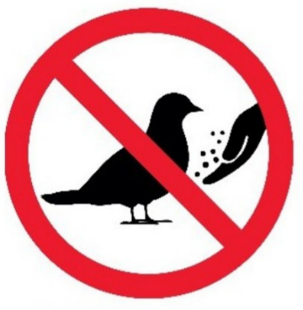
A. Birds don’t have to be given food. B. You can’t bring any birds here.
C. No bird can be found here. D. You mustn’t feed the birds.
Câu 8. Which of the following statements is true?

A. The IT course starts on 1st October.
B. The IT course covers hardware, software, networking, and security.
C. The IT course is for advanced learners.
D. The IT course does not provide a certificate.
Câu 9. What does it say?
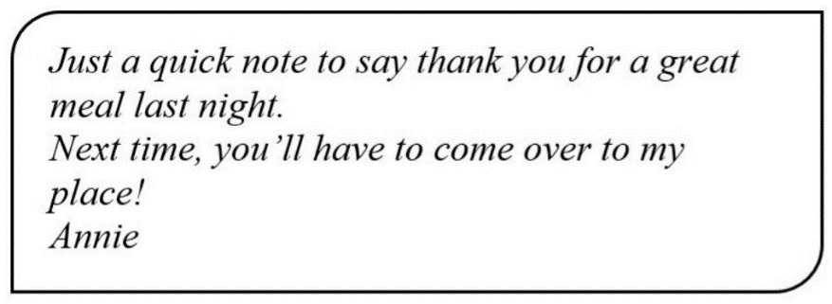
A. Annie went to a restaurant last night. B. Annie cooked a great meal last night.
C. Annie invited her friend to her house last night. D. Annie went to her friend’s house last night.
Câu 10. Look at the signs. Choose the best answer for the question.
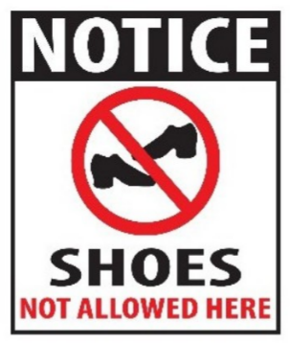
A. Please take off your shoes when entering this place.
B. You don’t have to wear shoes in this place.
C. Please put on your shoes when entering this place.
D. You can’t buy any shoes in this place.
----HẾT---

