Date of preparing: ………………………………….
Date of teaching: ………………………………….

Period …
UNIT 4: FESTIVALS and FREE TIME
Lesson 2 - Part 1 (Page 33) - Vocabulary and Reading

I. OBJECTIVES
By the end of the lesson, Ss will be able to…
1. Knowledge
- know more vocabularies about events.
- talk about future events.
- use the Present Simple for future use.
2. Ability
- improve the use of English and Reading skills.
3. Quality
- have positive attitude in English language learning so that they actively participate in all classroom activities.
- know how to relax after hard working time at school.

II. TEACHING AIDS AND LEARNING MATERIALS
Lesson plan, PPT slides, student’s book, workbook, notebook, personal computer (if any), projector/TV, speakers, DCR & DHA on Eduhome, handouts…
III. PROCEDURES
A. Warm up: (5’)
a) Objective: to introduce the new lesson and set the scene for Ss to acquire new language; to get students' attention at the beginning of the class by means of enjoyable and short activities as well as to engage them in the steps that followed.
b) Content: Introducing some events (festival activities).
c) Product: Ss know more about festival activities they are going to study in the lesson.
d) Competence: collaboration, communication, critical thinking.
e) Organization of the activity:
Teacher’s Activities | Students’ Activities
- Give greetings  - Check attendance  - Option 1: Use the “New Word” activity – Part a, page 33, to warm up  - Show pictures and festival activities, have Ss work in pairs to number the pictures  - Call Ss to give answers  - Give feedback  - Lead to the new lesson  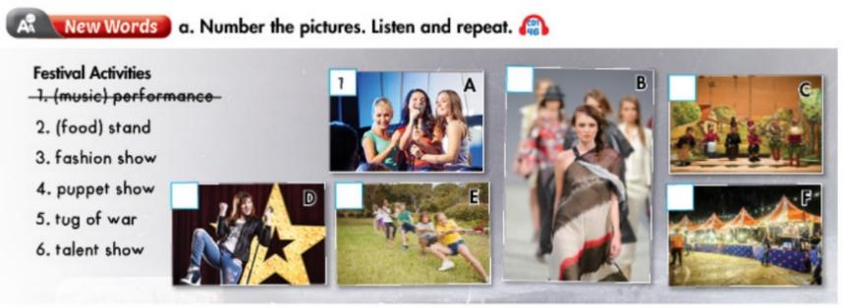  - Option 2: Clip: Glastonbury Festival  - Play a video clip about Glastonbury Festival (about 2 minutes)  - Have Ss watch the video clip and list festival activities they can see from the clip  - Have Ss give answers  - Check, give feedback  Lead to the new lesson  *Link:  https://www.youtube.com/watch?v=6iV_3wfGBRY  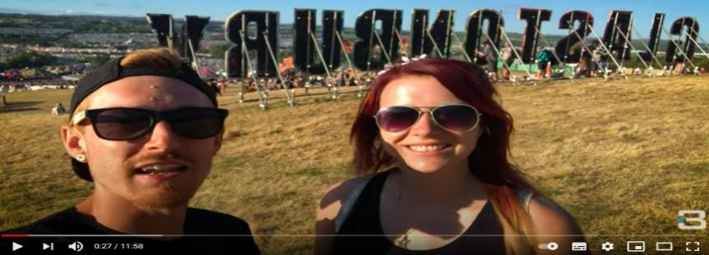 | - Greet T  - Work in pairs and number the pictures  - Give answers  - Listen  Answer keys  2F 3B 4C 5E 6D  - Watch  - List festival activities  - Give answers  Suggested answers  Festival activities Ss can see from the clip:  - Music show  - Magic show  - Dancing  - Playing games  - Food stand  - Making arts and crafts  - Dragon and lion dancing

B. New lesson (36’)
- Activities 1: Vocabulary (17’)
a) Objective: Ss know some names of festival activities and adjectives to talk about festival activities
b) Content:
- numbering the pictures.
- adding more adjectives and talking about festival activities.
c) Products: Ss can talk about festival activities.
d) Competence: communication, collaboration, presentation, analytical and synthesizing skills.
e) Organization of the activity:
Teacher’s Activities | Students’ Activities
a. Number the pictures. Listen and repeat.  - Option 1: (If T doesn’t use this part for Warm-up)  - Demonstrate the activity, using the example in the book.  - Have Ss look, read and number the pictures  - Ask Ss to work in pairs to check their answers with their partners  - Check answers as a whole class  - Play the audio (CD1 – Track 46) for Ss to listen and repeat.  - Call some Ss to read the phrases again, correct their pronunciation and stress  - Option 2: (If T has used part a. for Warm-up)  - Give Ss an extra activity  - Have Ss close all books  - Use other pictures (different pictures from those in the book) to help Ss remember the new words they have learnt  - Have Ss look at the pictures and give names of festival activities  - Ask Ss to give answers  - Check answers as a whole class  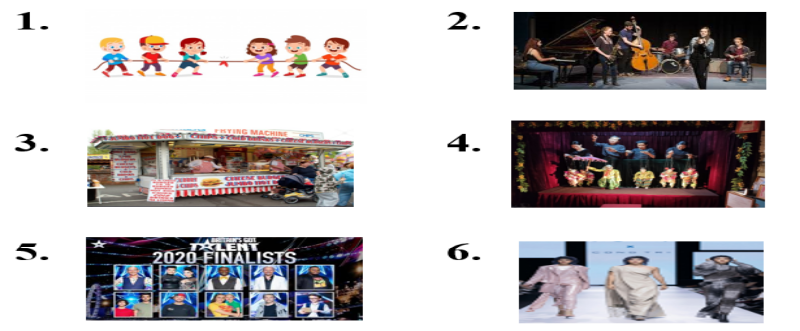  b. Draw the table. Add more adjectives and talk about some festival activities.  - Have Ss draw the table and add more positive and negative adjectives  - Call Ss to give answers  - Give feedback, help them add more adjectives if necessary  - Have Ss describe the festival activities-using the adjectives  - Have some Ss share their ideas with the class  - Give feedback and evaluation | - Look and listen  - Work in pairs  - Listen and check  - Listen and repeat  - Read  Answer keys  2F 3B 4C 5E 6D  - Close books  - Look and give names  - Give answers (Say or write on the board)  Answer keys  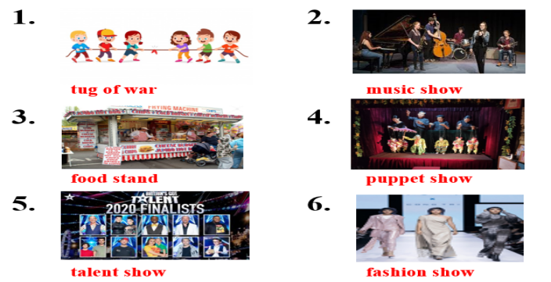  - Work in pairs  - Give answers  - Listen and take notes  - Talk about festival activities  - Give answers  Suggested answers  Positive adjectives: Fun, interesting, fascinating, …  Negative adjectives: Boring, dangerous, adventurous, expensive, …
- Activity 2: Reading (19’)
a) Objective: Ss can develop their reading skills.
b) Content: reading the text messages and answering the questions.
c) Products: Ss can read for specific information.
d) Competence: collaboration, communication, analytical and synthesizing skills.
e) Organization of the activity:

Teacher’s Activities | Students’ Activities
Read the text messages between Amy and Jim and answer the questions  - Option 1:  - Have Ss read the text messages individually  - Have Ss work in pairs to read the text messages  - Have Ss answer the questions  - Remind Ss to use the Present Tense  - Have some Ss share their answers with the class (write on the board)  - Give feedback  - Have Ss finish writing the answers in their notebooks  - Option 2: (For class with better students)  - Follow the same steps as option 1  - Then, give an extra activity:  - Have Ss work in groups and think of an oncoming festival (real or imaginative) (place of the festival, time to open, time to end, activities, participants, …)  - Have Ss practice asking and answering about the festival  - Remind Ss to use the text messages as examples  - Have Ss demonstrate their conversation in front of the class  - Give feedback and evaluation | - Read and answer the questions  - Write answers  - Check answers  - Write in notebooks  Answer keys  1. It is in the park.  2. It starts at 10 a.m.  3. There’s a tug of war and a fashion show.  4. The food stands open at 10.30 a.m.  5. The bus leaves at 9.30 a.m.  - Work in groups  - Ask and answer about a festival  - Act out the conversation  - Listen  Suggested conversation  A: Hi! Are you free this weekend?  B: Sure, why?  A: There’s a festival in the city center. Do you want to go?  B: Sounds interesting! When does it start?  A: It starts at 7p.m on Saturday.  B: Cool! What activities can they do there?  A: There’s a music show, a fashion show and a lot of food stands  B: Great! How can we come to the city center?  A: We can take a taxi  B: ok! I can’t wait. See you on Saturday!

C. Consolidation (2’)
* Vocabulary:
Festival activities: music performance, fashion show, puppet show, talent show, food stand, tug of war, dancing, magic show …
Adjectives to describe festival activities: boring, sad, dangerous, fun, interesting, wonderful, …
* Talk about a festival: Time, place, activities, people, …

D. Homework (2’)
- Learn by heart the new words.
- Do exercises in Workbook: Lesson 2 - New words – Part a, b and c (page 22).
- Prepare: Lesson 2 – Grammar (page 34 – SB).

