Period
LESSON PLAN
TIẾNG ANH 10 FRIENDS GLOBAL
UNIT 3: ON SCREEN
LESSON 3B: GRAMMAR – QUANTITY
I. OBJECTIVES:
By the end of the lesson, students will be able to:
1. Knowledge:
- Remember the rules and the usages of quantity
- Grammar: expressions of quantity
2. Ability:
- main skills: reading and writing skills
- sub skills: listening and speaking skills
- Use quantities properly in exercises as well as everyday conversations
3. Quality:
- Have positive attitude in English language learning so that they can participate enthusiastically in all classroom activities, especially with the topic conducted by the teacher
- Know how to talk about quantities precisely
II. TEACHER AIDS AND LEARNING MATERIALS:
Lesson plan, PPT slides, student’s book, workbook, notebook, personal computer (if any), projector/TV, speakers, IWB software.
III. PROCEDURES:
A. Warm-up (8’)
a) Objective: Introduce the new lesson and set the scene for students to acquire new language; get students' attention at the beginning of the class by means of enjoyable and short activities as well as to engage them in the steps that followed.
b) Content: Students play a game about video games.
c) Outcomes: Students can gain more confidence and interest in the lesson.
d) Competence: communication, collaboration, critical thinking
e) Organisation of the activity:

TEACHER’S ACTIVITIES | STUDENT’S ACTIVITIES | CONTENTS
WARM-UP. T-Ss/ S-S/ Individual  Activity 1 (5’):  Game “VIDEO GAMES QUIZ”  (Task 1 page 36)  - Divide class into two large groups  - Tell students the rules of the game: Watch pictures and short trailers of some video games and choose the correct genres  - Ask students “What types of video games you prefer? Why?”  Activity 2 (3’): Task 2 page 36  - Ask students to read the text in one minute  - Ask students “Does the game sound interesting to you? Why? / Why not?”  - Lead to the lesson: “Quantity” | - Play game in groups and volunteer to answer  - With one correct answer, a whole group get one point.  - Listen and answer the question given by the teacher  - Read the text in limited time  - Listen and answer the question given by the teacher  - Open book page 36 |   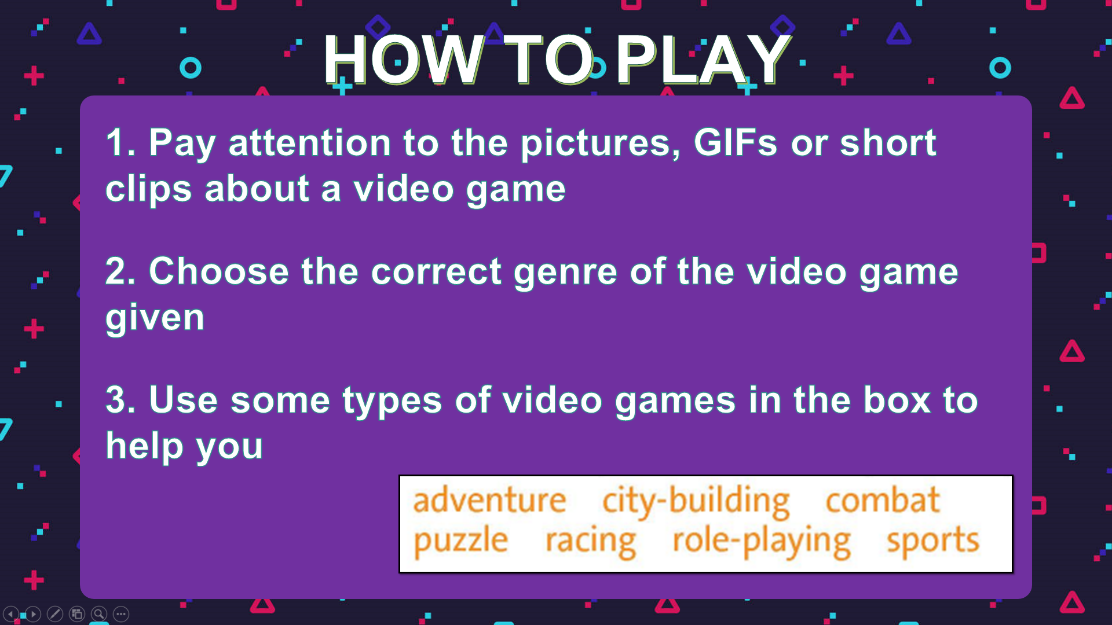  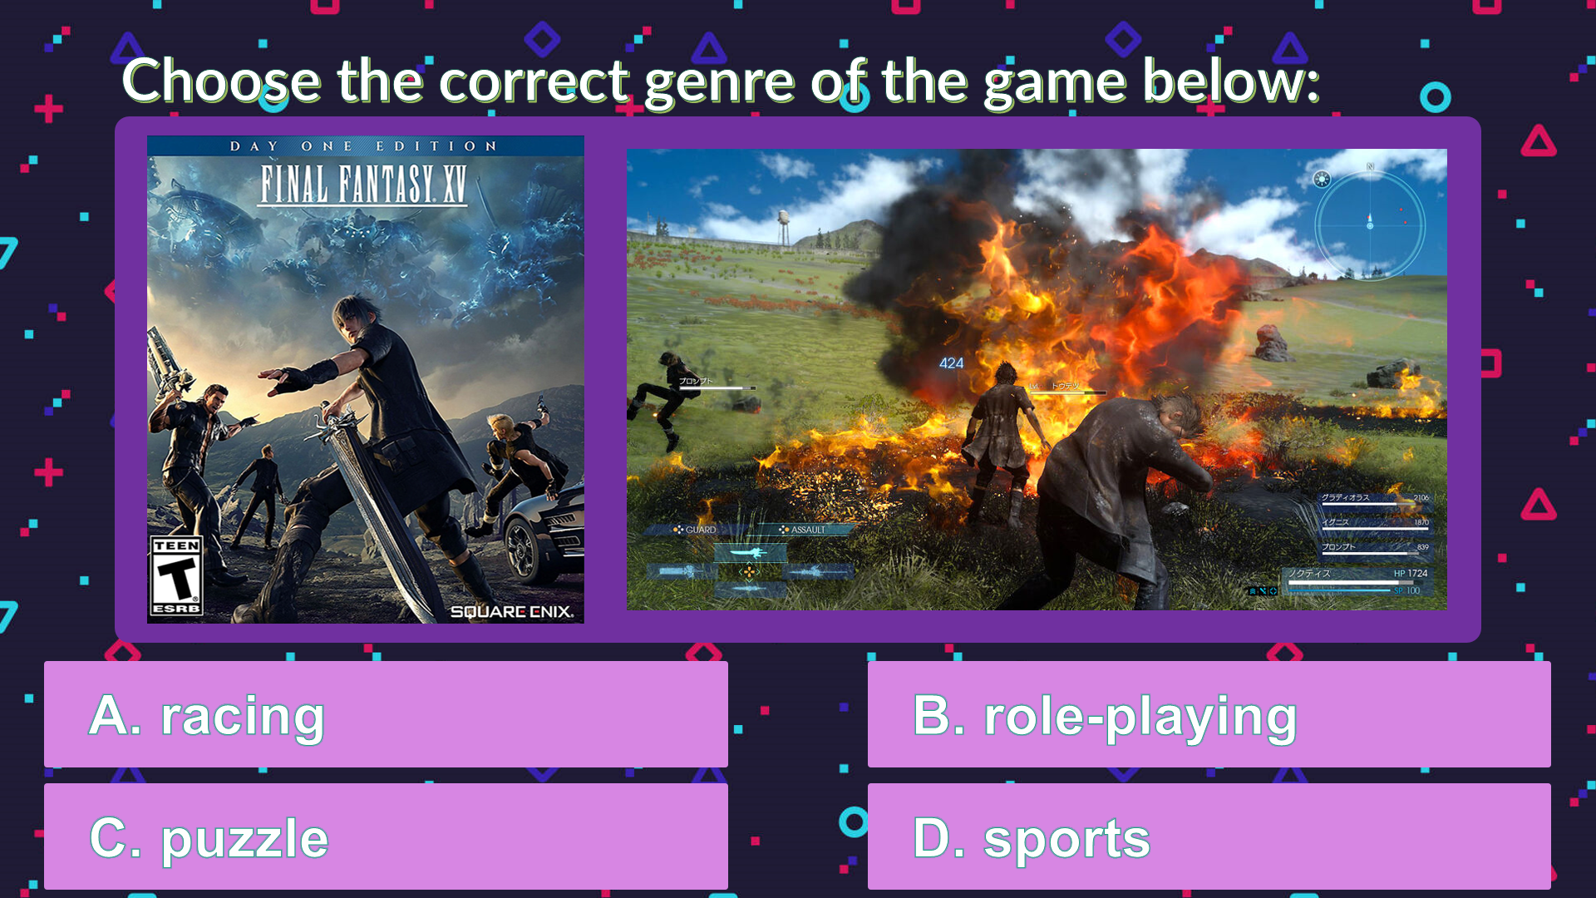  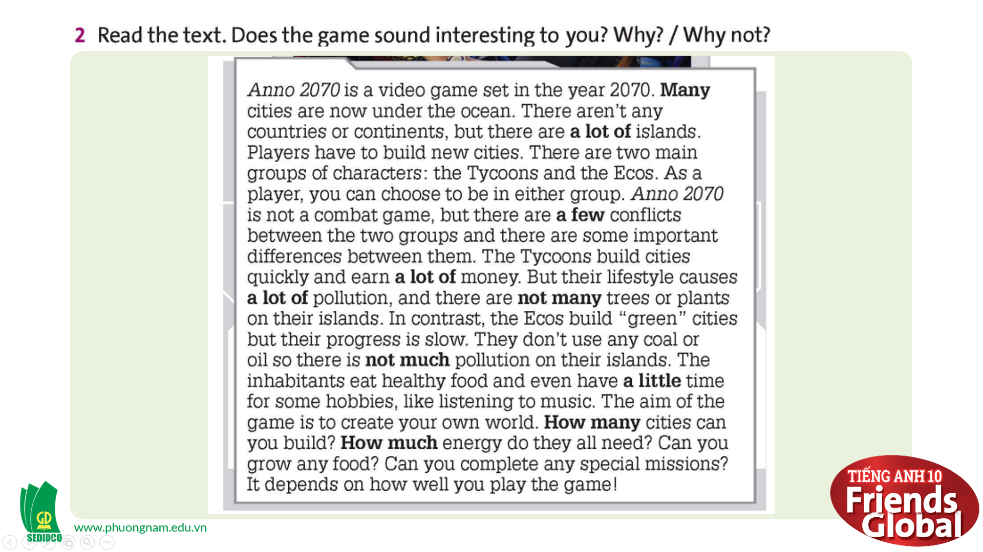
B. New lesson (32’)
- Activity 1: Presentation (4’)
a) Objective: Present some common quantities for students
b) Content: Students learn some new common quantities.
c) Outcomes: Students can apply the useful language in everyday speaking and writing.
d) Competence: communication
e) Organisation of the activity:
TEACHER’S ACTIVITIES | STUDENT’S ACTIVITIES | CONTENTS
PRESENTATION. T-Ss/ S-S/ Individual  - Present some common quantities to the students and ask them “How to use these expressions of quantity?” to raise their interest  Quantities:  every (det.)  a lot of (det.) / lots of (det.)  any (det.)  some (det.)  many (det.)  a large number of (det.)  a little (det.)  a few (det.)  much (det.) | - Listen and answer the question given by the teacher  - Take notes | 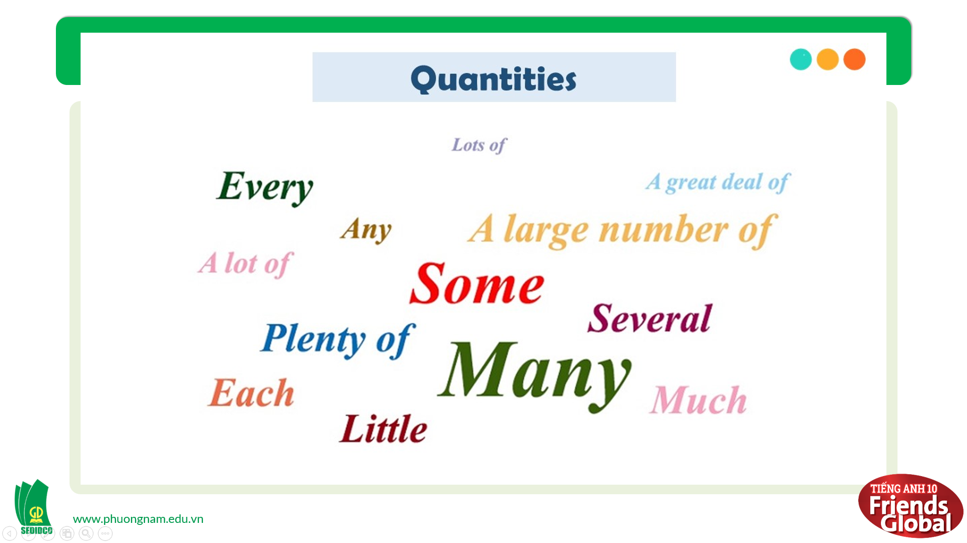

- Activity 2 Practice (20’)
a) Objective: Students know more about expressions of quantity and use it properly.
b) Content: Grammar study; Speaking
c) Outcomes: Students can apply the useful language in everyday speaking and writing properly.
d) Competence: communication, collaboration, presentation
e) Organisation of the activity:
TEACHER’S ACTIVITIES | STUDENT’S ACTIVITIES | CONTENTS
PRACTICE. T-Ss/ S-S/ Indiv.  Activity 1 (4’): Task 3 page 36  - Ask students to find examples of some and any in the text  - Ask students to fill in the LEARN THIS! box based on these examples  - Check the answers & explain more about the quantities for the students to understand deeply  Activity 2 (5’): Task 4 page 36  - Ask students to complete the sentences with some or any  - Give the answers to the class  Activity 3 (5’): Task 5 page 36  - Ask students to look at the bold phrases and the nouns that follow them in the text  - Ask students to fill in the LEARN THIS! box based on these examples  - Check the answers & explain more about the quantities for the students to understand deeply  Activity 4 (6’): Task 6 page 24.  - Ask students to read the LOOK OUT! box and the dialogue given, then circle the correct words  - Invite some students to show their answer  - Open the audio for the students listen and check their answers  - Give the answers to the class | - Find the examples and volunteer to answer  - Complete the LEARN THIS! box  - Check answers with the teacher and take notes  - Complete the task  - Check the answers with the teacher.  - Find the examples and volunteer to answer  - Complete the LEARN THIS! box  - Check answers with the teacher and take notes  - Complete the task  - Volunteer to answer  - Listen to the audio and check the answer  - Listen carefully to the teacher and take notes | 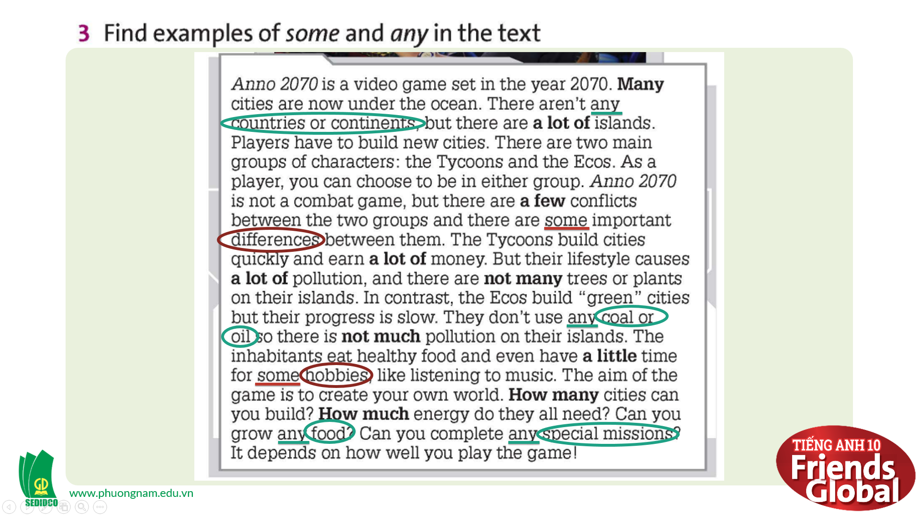  Answer:  any countries or continents; any coal or oil; any food; any special mission  some differences; some hobbies  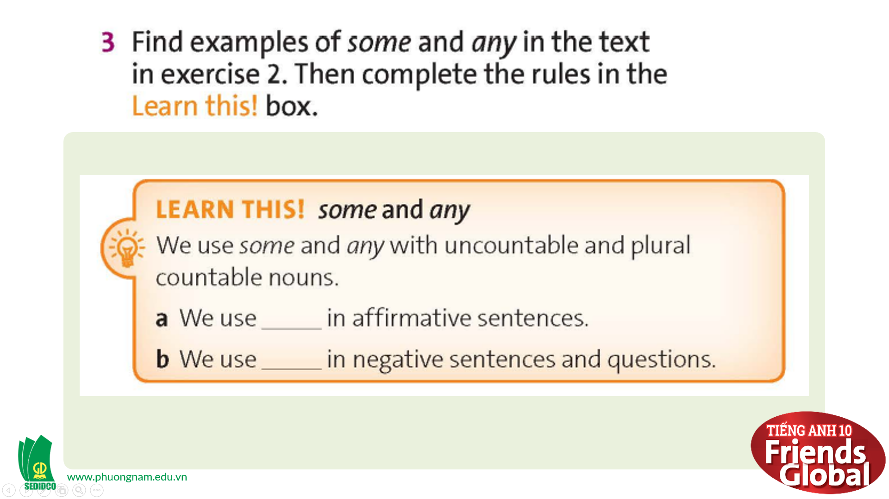  Answer:  some  any  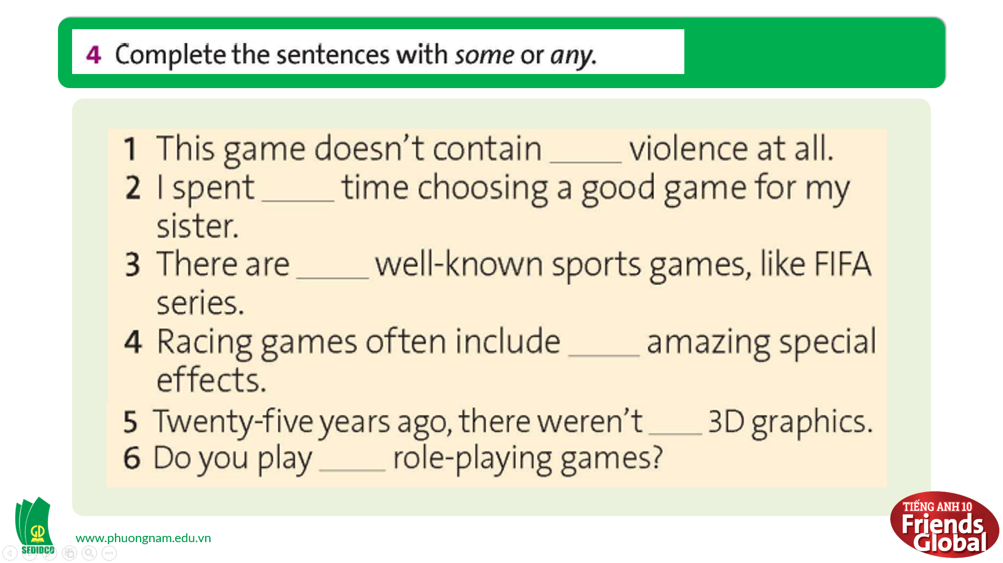  Answer:  1. any 2. some 3. some  4. some 5. any 6. any  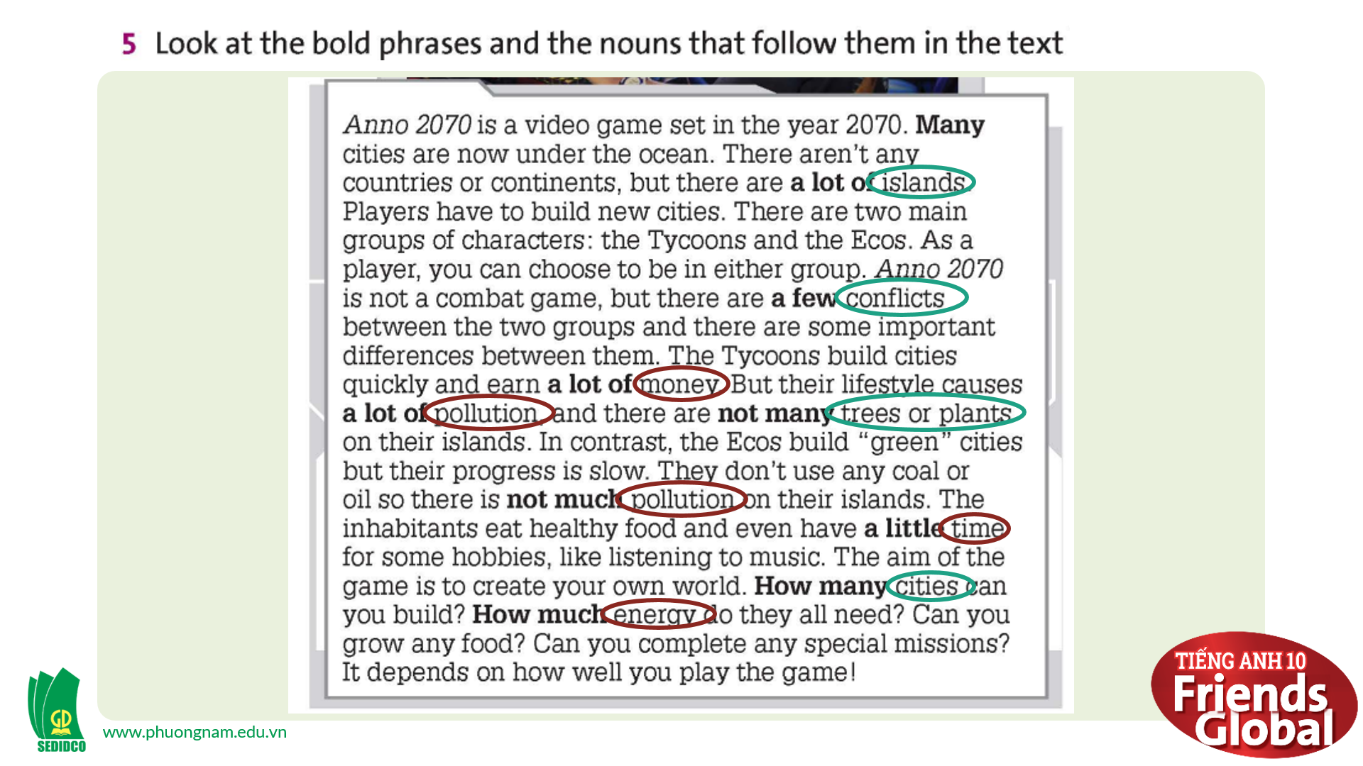  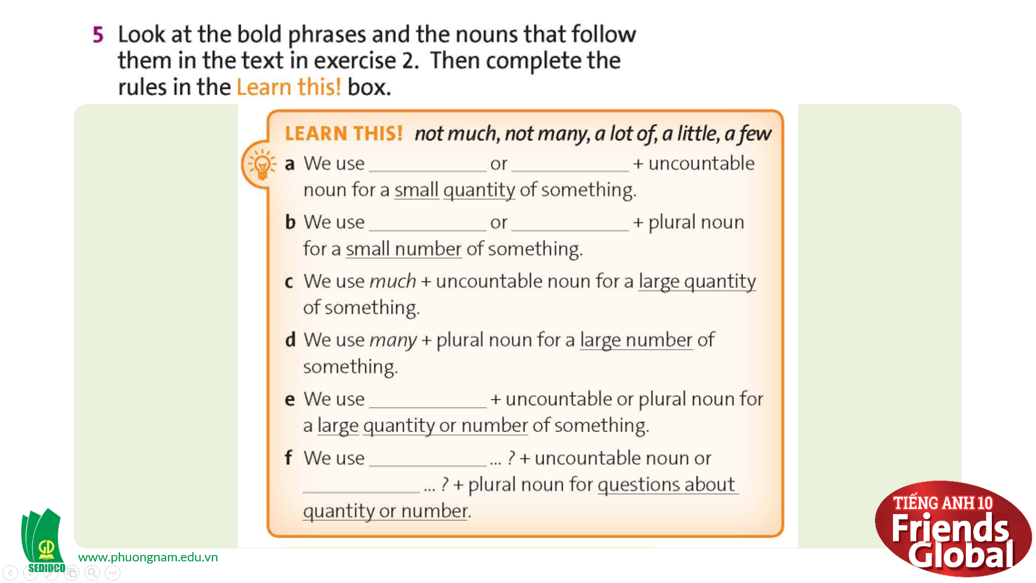  Answer:  a. not much / a little  b. not many / a few  e. a lot of  f. how much / how many  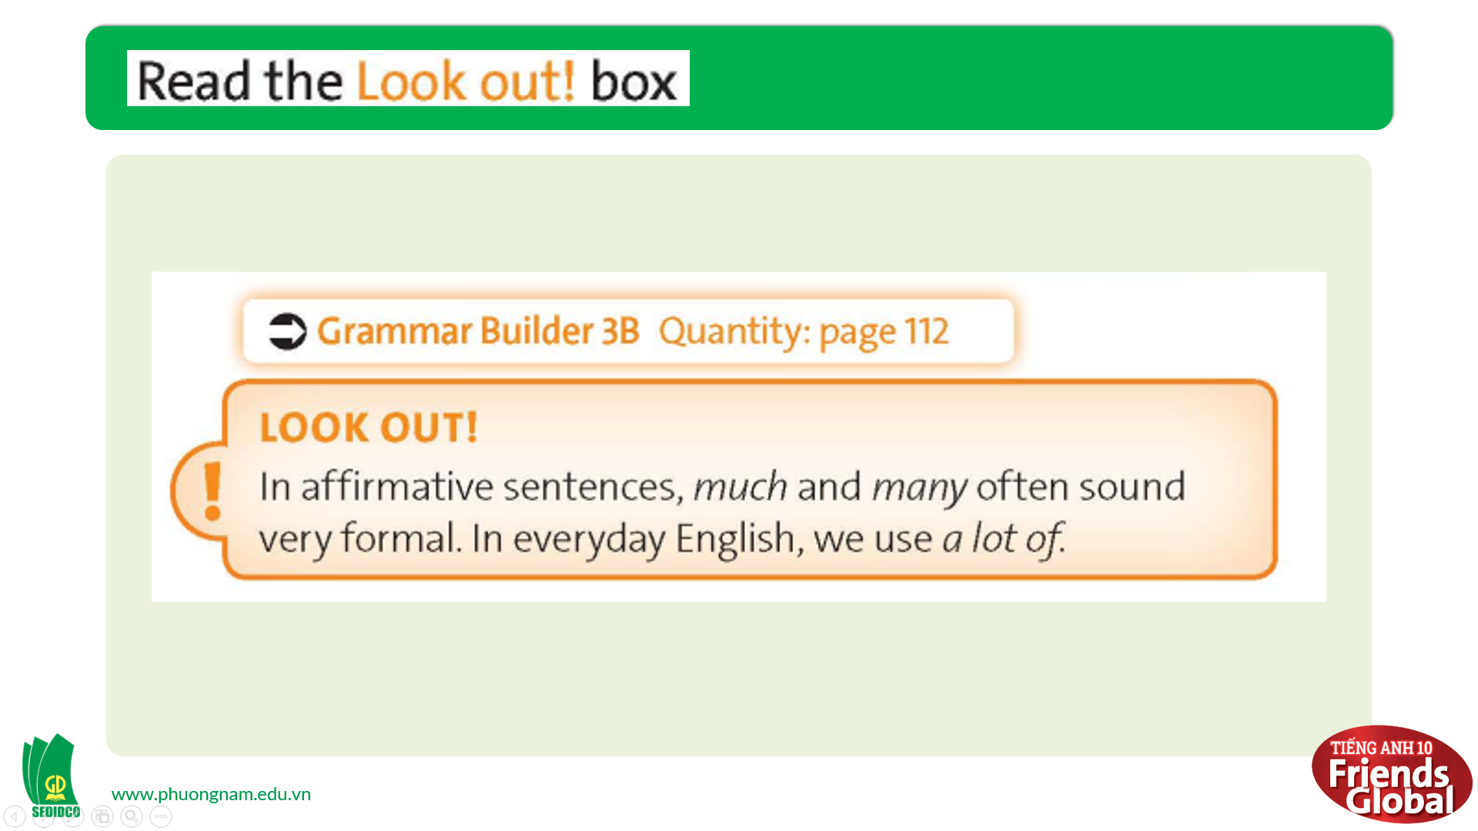  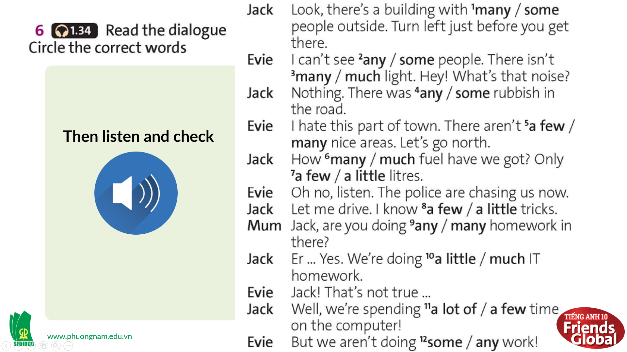  Answer:  1. some 2. any 3. much  4. some 5. many 6. much  7. a few 8. a little 9. any  10. a little 11. a lot of 12. any

- Activity 3: Outcomes (8’)
a) Objective: Students can talk about their favorite types of video games, express their opinion about a video game, and describe its setting by using quantities.
b) Content: Students work in pairs, share with their partners about their favorite video game and describe its setting.
c) Outcomes: Students speak and listen mutually, they can apply the structure of past simple or some adjectives to their conversations.
d) Competence: Collaboration, communication
e) Organisation of the activity:
TEACHER’S ACTIVITIES | STUDENT’S ACTIVITIES | CONTENTS
PRODUCT. T- Ss/ S-S  - Ask students work in pairs and share with their partners about their favorite video game  - Encourage the students to describe the game setting by using quantities | - Work in pairs and discuss  - Try to use the language they have learnt | 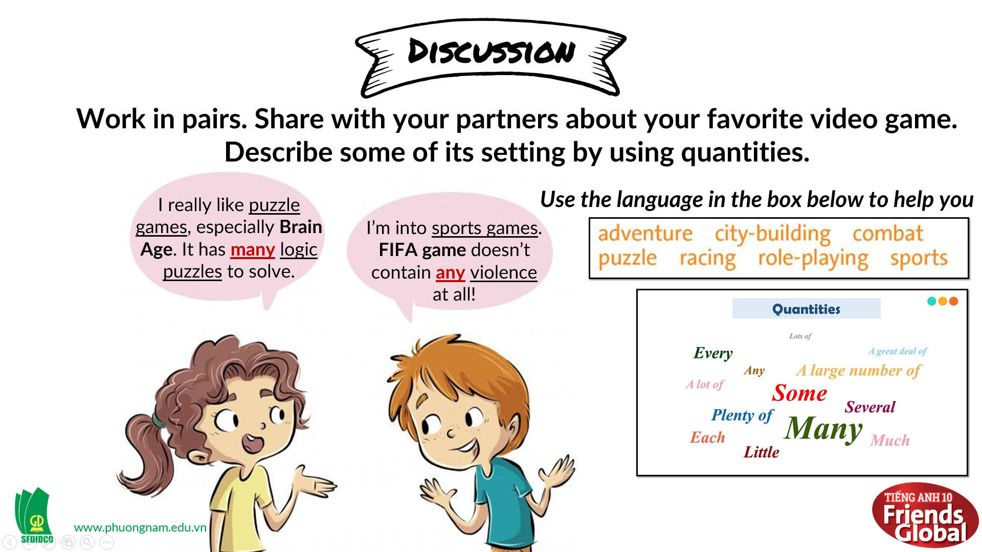
C. Consolidation (3’)
Grammar: Quantity
D. Homework (2’)
- Learn by heart all the grammar rules
- Do exercise
- Prepare: Unit 3 – C-Listening (page 37 – SB)

