

Tiết thứ ......
UNIT 4: MUSIC AND ARTS
Lesson 4: Communication
Class | Date of teaching | Attendence
7A | ..../09/2022
7B | ..../09/2022
7C | ..../09/2022
I. OBJECTIVES: By the end of this unit, students will be able to gain the following things:
1. Knowledge:
- Learn how to deal with some ways of expressing preferences
- Practise using some grammar points and vocabulary related to the topic
+ Vocabulary: - Use the vocabulary to talk about Music and arts:
+ Grammar: - Comparisons with like, different from, (not) as … as:
2. Competence:
a) General competencies:
Students will be able to know more words and phrases about music and arts; Develop communication skills and creativity; Actively join in class activities.
b) Specific competencies:
- Develop communication skills.
- Be cooperative and supportive in pair work and teamwork.
- Actively join in class activities.
3. Qualities:
- To educate the love of music and art.
- Be ready to know the words about music and arts.
- Develop self-study skills.
II. PREPARATIONS
- Teacher: Grade 7 text book, laptop, projector / TV/ pictures and cards.....
- Students : Text books, studying equipment….
III. PROCEDURE:
Notes: In each activity, each step will be represented as following:
* Deliver the task.
* Implement the task.
* Discuss.
* Give comments or feedback.
Activity 1. WARM UP (5’-IW, GW)
* Aim:
To revise the old lesson and introduce the new lesson by playing a game: PELMANISM.
To lead in the lesson.
* Content: Playing a game: PELMANISM.
* Product: Having a chance to speak English and focus on the topic of the lesson..
* Implementation: Teacher’s instructions…
Teacher’s & Student’s activities | Content
GAME: PELMANISM  * Teacher divides the class into 2 teams and asks them to think of the vocabulary they have learnt in the previous lessons.  ** In 2 minutes, each member from each team has to take turns to turn over one card and try to find a card that matches it.  *** If the two cards match each other, the team gets one point.  - If the two cards are different, put them back in the same places, facing down.  **** The team with more points will win the game.  Teacher leads students into the lesson by telling what they are going to learn: “We are going to learn how to express preferences and use the grammar and the vocabulary related to our topic Music and arts”. | Suggested answer:
  art gallery | concert hall | actress | portrait
  composer | landscape | painter | puppet theatre
      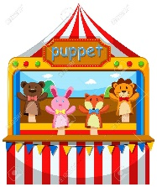 | 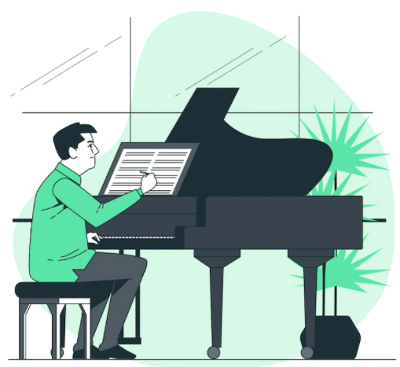 | 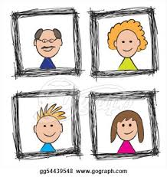
Activity 2. KNOWLEDGE FORMATION (15'- PW, IW)
* Aim:
To introduce two ways of expressing preferences.
* Content: Teach some new words.
* Product: Knowing more new words. Understanding the conversation; topic of the lesson, grammar points…
* Implementation: Teacher’s instructions…
Teacher’s & Student’s activities | Content
1. Listen and read the dialogue, paying attention to the highlighted parts. (Ex. 1, p. 45)  * Teacher plays the recording for students to listen and read the conversation.  ** Students listen and practise saying with their partners.  *** Teacher calls some pairs to read aloud.  **** Teacher corrects pronunciation if needed.  * Teacher asks students to pay attention to the highlighted parts and asks them some questions to elicit the new structure  ** Students answer teacher’s questions to find out new structure to express preferences.  *** Some students give the new structure to the teacher.  **** Teacher corrects and writes on the board: | 1. Listen and read the dialogue, paying attention to the highlighted parts. (Ex. 1, p. 45)  Structure: to express preference  - prefer sth  - like sth better
Activity 3. PRACTICE (15’-IW, PW, GW)
* Aim:
To help students practise expressing their preferences.
To help students recall or get to know some information about famous people in the field of music and arts, and some common forms of arts.
To help students revise vocabulary related to the topic and to introduce how students in other countries learn music and arts.
* Product: Ss can learn how to use the comparisons to do the excersises.
* Implementation: Teacher’s instructions…
Teacher’s Student’s activities | Content
2. Make similar conversation. (Ex. 2, p. 45)  Work in pairs. Ask and answer questions about your preferences for painting and taking photos; singing and dancing.  * Teacher has students look at the situation in Ex. 2 to make similar dialogue:  1. painting and taking photos  2. singing and dancing  ** Students work in pairs to make similar dialogue.  *** Teacher calls some pairs to present it in front of the class.  **** Teacher gives feedback and some comments. | 2. Make similar conversation. (Ex. 2, p. 45)  Work in pairs. Ask and answer questions about your preferences for painting and taking photos; singing and dancing.  Suggested answers:  A: Which do you prefer, painting or taking photos?  B: I prefer taking photos because it is more interesting.  A: And which do you like better, singing or dancing?  B: I like dancing better.
3. Choose the correct answer to each question. (Ex. 3, p.45)  What do you know? Work in groups and choose the correct answer to each question.  * Teacher asks students to work in pairs to choose the correct answer.  ** Students do the task in pairs.  *** Teacher calls some students to give their answer and explain it.  **** Teacher confirms the correct answers. | 3. Choose the correct answer to each question. (Ex. 3, p.45)  Answer key:  1. B  2. A  3. A  4. B
4. Read the following paragraph. Underline the words related to the topic of arts and music. (Ex. 4, p. 45)  * Teacher asks students to work individually to read through the paragraph, find, and underline the words related to the topic.  ** Students work in individually.  *** Some students read aloud.  **** Teacher confirms and corrects if needed. | 4. Read the following paragraph. Underline the words related to the topic of arts and music. (Ex. 4, p. 45)  Suggested answer: (Teacher’s book, p.69)  Hi. My name is Susie. I’m from Australia. I’m in grade 7. My school teaches arts and music to all the students. Some forms of art such as painting or drama are optional: you can choose to learn them if you like. Music and dancing are compulsory: all of us must study them every week. The school even has a choir, and they perform every month. There are also different art clubs, and you can join any of them.
Activity 4. APPLICATION (7’-IW, PW, GW)
* Aim:
- To help students talk about how students in Viet Nam study music and arts.
- To help them compare their school and schools in other countries.
* Content: like, different from, (not) as … as
* Product: Ss can remember the words. Revise and learn more new words.
* Implementation: Teacher’s instructions
5. Talk about how you learn music and arts. Compare susie’s school with your school. You can use like, as … as, or different from. (Ex 5, p. 45)  * Teacher asks students to work in group to discuss how students in Viet Nam learn music and arts, then compare with Susie’s school.  ** Students work in groups to take notes some activities they have when learning music and arts, then compare.  - Teacher goes round the class to monitor and give support if necessary.  *** Students from each group present their ideas to the class.  ****Teacher comments on their clarify, language, fluency, grammar,…  * Home assignment  Do exercises in the workbook.  To prepare for the next lesson:  Skills 1. | 5. Talk about how you learn music and arts. Compare susie’s school with your school. You can use like, as … as, or different from. (Ex 5, p. 45)  * Home assignment  Do exercises in the workbook.  To prepare for the next lesson:  Skills 1.
V. FEEDBACK:
With 7A ……………………………………………………………………………..…
With 7B …………………………...……………………………………..……………
With 7C ………………………………………………………………………….……

