## **Tiếng Anh 8 i-Learn Smart World_Unit 3.3 Time allotted: 45**

**PART 1**  **PRONUNCIATION (4 questions)**

**Choose the word whose underlined part differs from the other three in pronunciation in the following question.**

1. A. caused B. affected C. provided D. prevented

2. A. protect B. water C. national D. plastic

**Choose the word that differs from the other three in the position of the main stress in the following question.**

3. A. recycle B. energy C. pollution D. important

4. A. disease B. reduce C. effect D. wildlife

**PART 2**  **USE OF ENGLISH (14 questions)**

**Choose the option that best completes the following sentence.**

5. One of the main ______________ of water pollution is waste which is pumped into rivers, lakes and seas.

A. effects B. causes C. damages D. results

6. Many cities around the world are ______________ by air pollution.

A. affected B. produced C. caused D. wasted

7. Local people and visitors ______________ the streets after the Đà Nẵng International Firework Festival.

A. collected B. reduced C. washed away D. cleaned up

8. The government should prevent people ______________ throwing trash in the river.

A. to B. with C. from D. against

9. We can ______________ the environment by making small changes in our daily live.

A. take care of B. take part in C. take place D. take turn

10. Plastic waste can ______________ the environment in many ways.

A. remove B. harm C. decrease D. prevent

11. You should ______________ the air conditioner when you are not in the room to save energy.

A. turn up B. turn on C. turn off D. turn down

12. If we ______________ polluting the air, we ______________ the ozone layer.

A. will keep / damage B. will keep / will damage C. keep / will damage D. keep / could damage

13. Our cities will get cleaner ______________ people use public transport more.

A. if B. unless C. so that D. although

14. We should plant more trees ______________ we can help to clean the air.

A. or B. so C. unless D. despite

15. Children should ride a bike to school ______________ they shouldn't litter.

A. or B. nor C. so D. and

16. Unless we ______________ the forests, many animals ______________.

A. protect / will disappear

B. don't protect / will disappear

C. will protect / don't disappear

D. won't protect / will disappear

**Find the underlined part that needs correction in the following question.**

17. Noise pollution can have a negative effect in both human health and wildlife

A. Noise pollution B. have C. in D. wildlife

**Choose the best option.**

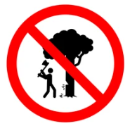

18. What does the sign mean?

A. You shouldn't cut down trees in this area.

B. You mustn't cut down trees in this area.

C. Cutting down trees is allowed in this area.

D. Trees in this area are too difficult for you to cut down.

**PART 3**  **WORD FORMATION (6 questions)**

**Write the correct form of the given word.**

19. Smoke from vehicles is responsible for the air ______________ in our city. ***(POLLUTE)***

20. If we turn off lights when we leave a room, we can save ______________. ***(ELECTRIC)***

21. Eating ______________ fish can lead to serious health issues. ***(POISON)***

22. The ______________ impact of the oil spill was too serious for the local ecosystem to recover.

***(ENVIRONMENT)***

23. The future of a country's ______________ is directly linked to the environment. ***(TOURIST)***

24. We should ______________ furniture so we can give old furniture a new life. ***(USE)***

**PART 4**  **READING (5 questions)**

**Read advice from a website about the environment. Choose the best word or phrase for each space. (5 questions)**

**How can we save the planet?**   
This is a very difficult question. We certainly need national and local governments to spend money on big projects. But every one of us should help every day. Here are a few problems and some solutions.   
•Water pollution is a very big problem. If dirty water gets into rivers, it can cause problems for fish. If people eat the fish, they may catch (25)___________. If you see dirty water going into a river, tell your local government. We should all help to (26)___________ our freshwater.   
•We must try to (27)___________ the amount of plastic which we use. Use the same bag again and again when you go shopping.   
•Trash looks horrible in parks and open spaces, but it is also dangerous. It can kill (28)___________ if it contains things which poison animals, and animals can die if they eat plastic, glass, or metal. Take your trash home!   
•Also, try to make less food trash! Did you know that 33% of all food around the world goes into trash cans? Don’t buy too much food and then (29)___________ a lot of it.   
**We can save the planet, day by day!**

(25) A. damages B. diseases C. harm D. hurt

(26) A. protect B. provide C. prevent D. produce

(27) A. recycle B. reduce C. reuse D. repair

(28) A. soil B. lands C. wildlife D. forests

(29) A. use B. save C. keep D. waste

**PART 5**  **LISTENING (5 questions)**

**Listen to five short texts. Choose the correct picture for each question. (5 questions)**

30. What is the speaker talking about?

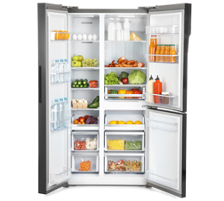 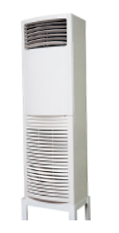 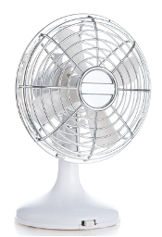

**A. ☐** **B. ☐** **C. ☐**

31. Which type of pollution is the most dangerous?

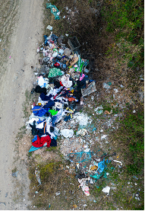 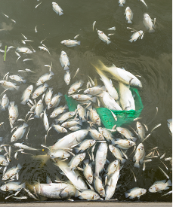 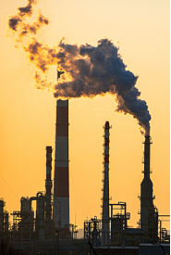

**A. ☐** **B. ☐** **C. ☐**

32. How does the speaker suggest reducing trash in the park?

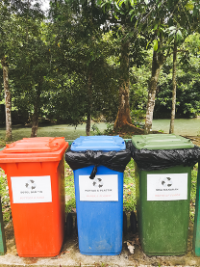 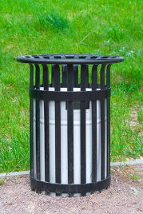 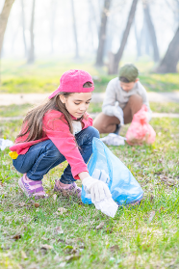

**A. ☐** **B. ☐** **C. ☐**

33. Which way of making green electricity is the most common, according to the speaker?

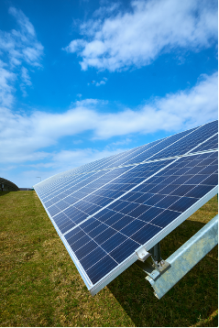 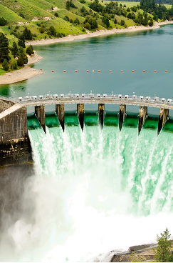 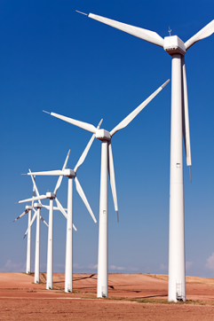

**A. ☐** **B. ☐** **C. ☐**

34. Which way of reducing waste is the speaker talking about?

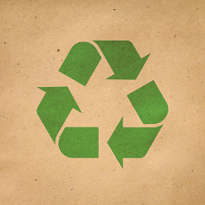 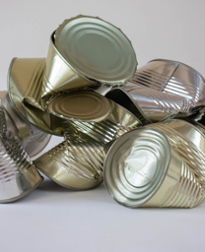 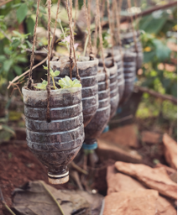

**A. ☐** **B. ☐** **C. ☐**

**PART 6**  **WRITING (6 questions)**

**Rewrite the following sentence without changing its meaning. Use the given word(s) if any.**

35. Recycle glass bottles and we will reduce the amount of waste sent to landfills.

→ IF___________

36. People shouldn't use single-use plastic bags in order to protect the environment. (SO THAT)

→ ___________

37. Because plastic looks like food, sea animals may eat it. (SO)

→ ___________

38. Take action now or we won't be able to protect the environment. (UNLESS)

→ ___________

**Put the words in the correct order to make correct sentence.**

39. Keywords: should bring/the amount/and lunchboxes/their own/Students/they can/of waste/so that/reduce/water bottles/.

→ .......................................

40. Keywords: there won't/keep wasting/fresh water/If people/be enough/water,/./in the future

→ .......................................

**---THE END---**

## **Tiếng Anh 8 i-Learn Smart World_Unit 3.3 Time allotted: 45 ANSWER KEY**

**PART 1**  **PRONUNCIATION (4 questions)**

**Choose the word whose underlined part differs from the other three in pronunciation in the following question.**

1. A. caused B. affected C. provided D. prevented

2. A. protect B. water C. national D. plastic

**Choose the word that differs from the other three in the position of the main stress in the following question.**

3. A. recycle B. energy C. pollution D. important

4. A. disease B. reduce C. effect D. wildlife

**PART 2**  **USE OF ENGLISH (14 questions)**

**Choose the option that best completes the following sentence.**

5. One of the main ______________ of water pollution is waste which is pumped into rivers, lakes and seas.

A. effects B. causes C. damages D. results

6. Many cities around the world are ______________ by air pollution.

A. affected B. produced C. caused D. wasted

7. Local people and visitors ______________ the streets after the Đà Nẵng International Firework Festival.

A. collected B. reduced C. washed away D. cleaned up

8. The government should prevent people ______________ throwing trash in the river.

A. to B. with C. from D. against

9. We can ______________ the environment by making small changes in our daily live.

A. take care of B. take part in C. take place D. take turn

10. Plastic waste can ______________ the environment in many ways.

A. remove B. harm C. decrease D. prevent

11. You should ______________ the air conditioner when you are not in the room to save energy.

A. turn up B. turn on C. turn off D. turn down

12. If we ______________ polluting the air, we ______________ the ozone layer.

A. will keep / damage

B. will keep / will damage

C. keep / will damage

D. keep / could damage

13. Our cities will get cleaner ______________ people use public transport more.

A. if B. unless C. so that D. although

14. We should plant more trees ______________ we can help to clean the air.

A. or B. so C. unless D. despite

15. Children should ride a bike to school ______________ they shouldn't litter.

A. or B. nor C. so D. and

16. Unless we ______________ the forests, many animals ______________.

A. protect / will disappear

B. don't protect / will disappear

C. will protect / don't disappear

D. won't protect / will disappear

**Find the underlined part that needs correction in the following question.**

17. Noise pollution can have a negative effect in both human health and wildlife

A. Noise pollution B. have C. in D. wildlife

**Choose the best option.**



18. What does the sign mean?

A. You shouldn't cut down trees in this area.

B. You mustn't cut down trees in this area.

C. Cutting down trees is allowed in this area.

D. Trees in this area are too difficult for you to cut down.

**PART 3**  **WORD FORMATION (6 questions)**

**Write the correct form of the given word.**

19. Smoke from vehicles is responsible for the air ______________ in our city. ***(POLLUTE) => pollution***

20. If we turn off lights when we leave a room, we can save ______________. ***(ELECTRIC) => electricity***

21. Eating ______________ fish can lead to serious health issues. ***(POISON) => poisoned/poisonous***

22. The ______________ impact of the oil spill was too serious for the local ecosystem to recover.

***(ENVIRONMENT) => environmental***

23. The future of a country's ______________ is directly linked to the environment. ***(TOURIST) => tourism***

24. We should ______________ furniture so we can give old furniture a new life. ***(USE) => reuse***

**PART 4**  **READING (5 questions)**

**Read advice from a website about the environment. Choose the best word or phrase for each space. (5 questions)**

**How can we save the planet?**   
This is a very difficult question. We certainly need national and local governments to spend money on big projects. But every one of us should help every day. Here are a few problems and some solutions.   
•Water pollution is a very big problem. If dirty water gets into rivers, it can cause problems for fish. If people eat the fish, they may catch (25)___________. If you see dirty water going into a river, tell your local government. We should all help to (26)___________ our freshwater.   
•We must try to (27)___________ the amount of plastic which we use. Use the same bag again and again when you go shopping.   
•Trash looks horrible in parks and open spaces, but it is also dangerous. It can kill (28)___________ if it contains things which poison animals, and animals can die if they eat plastic, glass, or metal. Take your trash home!   
•Also, try to make less food trash! Did you know that 33% of all food around the world goes into trash cans? Don’t buy too much food and then (29)___________ a lot of it.   
**We can save the planet, day by day!**

(25) A. damages B. diseases C. harm D. hurt

(26) A. protect B. provide C. prevent D. produce

(27) A. recycle B. reduce C. reuse D. repair

(28) A. soil B. lands C. wildlife D. forests

(29) A. use B. save C. keep D. waste

**PART 5**  **LISTENING (5 questions)**

**Listen to five short texts. Choose the correct picture for each question. (5 questions)**

30. What is the speaker talking about?

  

**A. ☐** **B. ☐** **C. ☐**

31. Which type of pollution is the most dangerous?

  

**A. ☐** **B. ☐** **C. ☐**

32. How does the speaker suggest reducing trash in the park?

  

**A. ☐** **B. ☐** **C. ☐**

33. Which way of making green electricity is the most common, according to the speaker?

  

**A. ☐** **B. ☐** **C. ☐**

34. Which way of reducing waste is the speaker talking about?

  

**A. ☐** **B. ☐** **C. ☐**

**PART 6**  **WRITING (6 questions)**

**Rewrite the following sentence without changing its meaning. Use the given word(s) if any.**

35. Recycle glass bottles and we will reduce the amount of waste sent to landfills.

→ IF we recycle glass bottles, we will reduce the amount of waste sent to landfills./If we recycle glass bottles, we can reduce the amount of waste sent to landfills.

36. People shouldn't use single-use plastic bags in order to protect the environment. (SO THAT)

→ People shouldn't use single-use plastic bags so that they can protect the environment.

37. Because plastic looks like food, sea animals may eat it. (SO)

→ Plastic looks like food, so sea animals may eat it.

38. Take action now or we won't be able to protect the environment. (UNLESS)

→ We won't be able to protect the environment unless we take action now./Unless we take action now, we won't be able to protect the environment.

**Put the words in the correct order to make correct sentence.**

39. Keywords: should bring/the amount/and lunchboxes/their own/Students/they can/of waste/so that/reduce/water bottles/.

→ Students should bring their own water bottles and lunchboxes so that they can reduce the amount of waste.

40. Keywords: there won't/keep wasting/fresh water/If people/be enough/water,/./in the future

→ If people keep wasting water, there won't be enough fresh water in the future.

**---THE END---**