Date of preparing: ………………………………….
Date of teaching: ………………………………….

Period …
UNIT 1: HOME
Lesson 3 - Part 2 (Page 13) – Reading, Speaking and Writing

I. OBJECTIVES
By the end of the lesson, Ss will be able to…
1. Knowledge
- read a paragraph about a city in Vietnam.
- talk about some famous places in Europe.
- write a paragraph about their hometown.
2. Ability
- improve the reading, speaking and writing skills.
3. Quality
- have positive attitude in English language learning so that they actively participate in all classroom activities.
- love hometown.

II. TEACHING AIDS AND LEARNING MATERIALS
Lesson plan, PPT slides, student’s book, workbook, notebook, personal computer (if any), projector/TV, speakers, DCR & DHA on EDUHOME, handouts…
III. PROCEDURES
A. Warm up: (5’)
a) Objective: Introduce the new lesson and set the scene for Ss to acquire new language; get students' attention at the beginning of the class by means of enjoyable and short activities as well as to engage them in the steps that follow.
b) Content: Introduction of Cần Thơ City /Colmar (France), Clovelly (England).
c) Product: Ss have general idea about the places that are mentioned in the lesson.
d) Competence: Collaboration, critical thinking, communication.
e) Organization of the activity:
Teacher’s Activities | Students’ Activities
- Give greetings  - Check attendance  - Option 1:  - Have Ss guess: Which city is it?  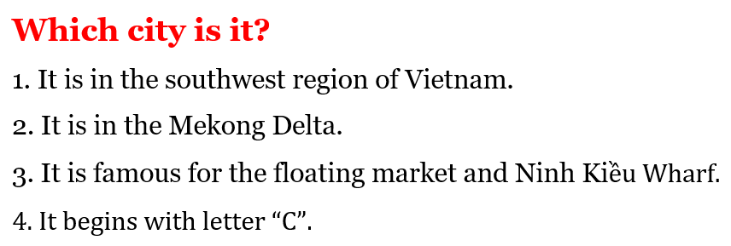  - Call Ss to give answers  - Give a small gift to the first Ss who can give the right answers  - Show the map and have Ss find Cần Thơ on the map  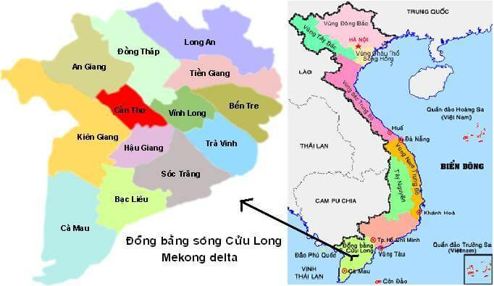  Lead to the new lesson.  - Option 2: Video clip: Colmar - France  - Have Ss close all books  - Write these questions on the board and have Ss work in pairs/ groups to guess the answers to these questions  1. Where is Colmar?  2. Is it a town or a village?  3. What is Colmar famous for?  - Show a video clip about Colmar – France (about 2 minutes)  Link: https://www.youtube.com/watch?v=xBGvdJYntGw  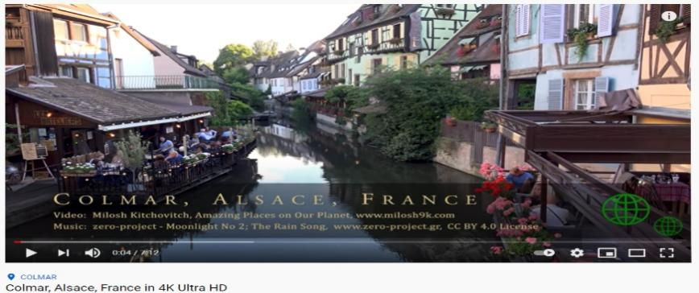  - Have Ss watch the clip and answer some questions:  - Introduce: Colmar – France is the place in the listening section Ss are going to study today  Lead to the new lesson | - Greet T  - Guess  - Give name of the city, then find the city on the map  Answer Keys  Cần Thơ City  - Close books  - Work in pairs/ groups to guess the answers  - Watch the clip and giving answers  Answer Keyss  1. It’s in France.  2. It’s a big town.  3. It’s famous for beautiful houses and museums.

B. New lesson (36’)
- Activities 1: Reading (10’)
a) Objective: Ss improve their reading skill (scanning, skimming)
b) Content:
- Reading the paragraph and answering the questions.
- Reading and finding detailed information.
c) Products: Ss know about Cần Thơ – a big city in the southwest region of Vietnam.
d) Competence: Collaboration, guessing, communication, analytical skills.
e) Organization of the activity:
Teacher’s Activities | Students’ Activities
a. Read the paragraph and answer the questions  - Option 1:  - Have Ss read the paragraph individually  - Have some Ss read the paragraph aloud  - Demonstrate the activity using the example  - Have Ss answer the questions  - Call Ss to write answers on the board  - Check answers as a whole class  - Option 2: (for class with better students)  - Have Ss read the questions and underline the key word (the word that helps they find the answers quickly and correctly)  - Have Ss read the paragraph again and answer the questions  - Haves Ss underline the sentences that help them find the answers  - Call Ss to give answers, explain why they think they are the correct answers  - Check answers as a whole class  - Ask more questions:  5. What is the population of Cần Thơ?  6. What is the temperature of Cần Thơ?  7. How important is Cần Thơ City? | - Read in silence  - Read in front of the class  - Do the task  - Check  Answer Keyss  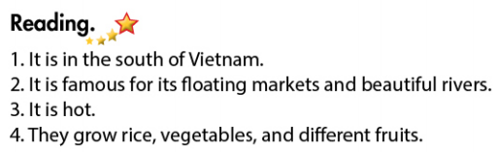  - Read, find key words  - Do the task  - Give answers, explain  Answer Keys  Keywords:  1. where 2. famous for  3. weather 4. Farmers grow  Answer extra questions:  1. The population of Cần Thơ is more than 1.2 million people (2018 statistics)  2. It is about 28ºC.  3. It is an important center for business and transportation.
- Activity 2: Speaking: What do you know about these places? (11’)
a) Objective: Ss can talk about some famous places in Europe.
b) Content: Asking and answering about Colmar and Clovelly.
c) Products: Ss practice and produce the target language successfully to talk about the places they know.
d) Competence: Collaboration, communication, creativity, public speaking - presentation.
e) Organization of the activity:

Teacher’s Activities | Students’ Activities
a. You’re planning a geography presentation. Work in pairs. Student A, answer Student B’s questions about Colmar. Swap roles and repeat with Clovelly  - Demonstrate the activity by asking and answering with a student  - Have Ss practice the conversation in pairs: Student B asks about Colmar and Student A answers the questions-using the information in the textbook  - Have Ss swap the roles for Clovelly  - Observe and give help if necessary  - Have some pairs act out the conversation in front of the class  - Give feedback and evaluation  b. Ask and answer about other places you know  - Option 1:  - Have Ss work in pairs to talk about other places they know.  - Go round and give help if necessary  - Call some pairs to demonstrate the activity  - Give feedback and evaluation  - Option 2:  - Give Ss some suggestions about other places (like pictures and phrases in part a)  Example: Đà Lạt City  - Have Ss practice the conversation in pairs and present their conversation in front of the class  - Give feedback and evaluation  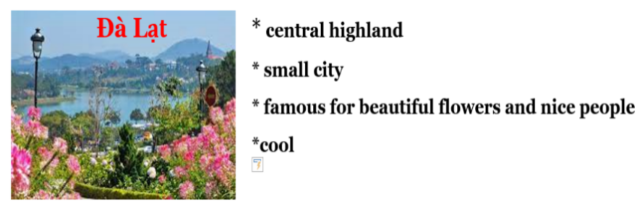 | - Observe and listen  - Work in pairs  - Present  - Work in pairs  - Present  - Look  - Work in pairs  - Present
- Activity 3: Writing (15’)
a) Objective: Ss can write about their hometown.
b) Content: asking and answering about the places Ss live, then write.
c) Products: Ss can use what they have learnt to produce the language successfully.
d) Competence: Collaboration, communication, writing, public speaking.
e) Organization of the activity:
Teacher’s Activities | Students’ Activities
a. Ask and answer about where you live. Then fill in the notes  - Demonstrate the activity by asking and answering with a student  - Have pairs ask and answer about where they live and complete the notes  - Have some pairs demonstrate the conversation in front of the class  - Check answers as a whole class  b. Use your notes to write a paragraph about your hometown. Use the Reading to help you  - Have Ss use their notes and the Reading to write a paragraph about your hometown  - Have Ss write their paragraph on the board  - Check, correct Ss’ mistakes  - Have Ss finish their writing part in their notebooks | - Observe  - Work in pairs  - Present  Expected answers  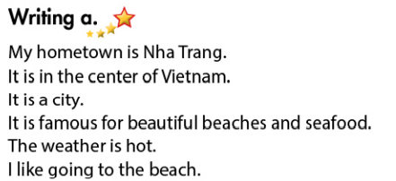  - Do the task  - Write/read  Suggested writing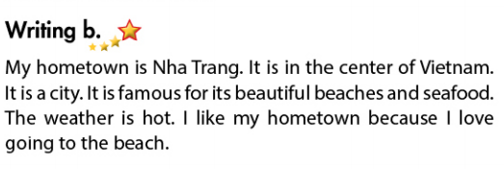

C. Consolidation (2’)
* Talk about your hometown follow the outline:
What is the name of your hometown?
Where is your hometown?
Is your hometown a town / village or a city?
What is your hometown famous for?
What is the weather like?
What do you like about it?

D. Homework (2’)
- Finish the writing part.
- Find more information about some famous places in Vietnam.
- Do exercises in Workbook: Reading and Writing (page 7).
- Prepare: Unit 1 - Review (page 86 – SB).

