Week 8
Period 21
Teaching date: 25/10/2021

UNIT 3 : MY FRIENDS
(DHLH) LESSON 7 : LOOKING BACK + PROJECT
I.OBJECTIVES:By the end of the lesson, students will be able to:
1. Knowledge:
a- Vocabulary: Review some adjectives related to people’s appearance and personalities.
b- Grammar: - Review The present simple / continuous tense .
- Review : What + do/does + S + look like ? /What + be + S + like ?
2. Competence: Ss can use the present simple /present continuous and personality / appearance adjectives .
3. Educational aims: To teach SS to be hard- working, love their friends.
II. TEACHING AIDS: Text books, laptop , smart TV , video clips
III. PROCEDURE:
Contents |  |  | Teacher’s and Ss’activities
I.ACTIVITY :( 7’)
-To help students revise the vocabulary items they have learnt in the unit.

WARM UP:  * Game: * Brainstorming:  * Suggested answers:  -Appearance: tall, short, beautiful, smart, …  -Personalities: confident, careful, clever, funny, … |  |  | -T: divides the board, and divides the class into 2 big groups.  -Each group will be assigned a category: APPEARANCE & PERSONALITIES  -T: asks Ss to brainstorm all adjectives related to people’s appearance and personalities.  -The group having the most suitable answers is the winner.
II. ACTIVITY 2:(7’)
To help students revise some personality adjectives
1. Choose the best options to complete the sentences. (Ex. 1, p. 34)  * Answer key:  1. B 2. A 3. C  4. A 5. C | -T: encourages students to complete the task individually.  -Students exchange their textbook to discuss the reasons why they are choosing the appropriate adjectives.  - Feed back- Correction
III. ACTIVITY 3:(8’)
To help Ss answer questions related to people’s appearance .
2. Answer questions about your classmates.  1. ….. has long hair in my class.  2. …….. has a small nose.  3. ………has a round face .  4. Yes, he/she does / No, he / she doesn’t  5. Yes, he/she does / No, he / she doesn’t |  | - Pair work  - Practice  - Correction
IV. ACTIVITY 4:(15’)
To help students revise the present simple / continuous tense in context

3. Put the verbs in the brackets in correct forms.  * Answers  1. are running  2. are talking  3. are not talking / aren’t talking  4. are drawing  5. is not teaching / isn’t teaching  4. Put the verbs in brackets in the present simple or present continuous .  * Answers  1. are you doing / am writing  2. cycles / don’t cycle / walk  3. Is he doing / is reading |  | -T:has Ss complete the task individually.  -Ss exchange their textbooks to discuss the reasons about their choices.  - T: gives feedback  -T: reminds the present simple or present continuous .  -T: guides Ss how to do the task  -Individually  -Correction
V. ACTIVITY 5:.PROJECT :(5’)
To allow students to apply what they have learnt (vocabulary and grammar) into practice through a project.

* My class yearbook:  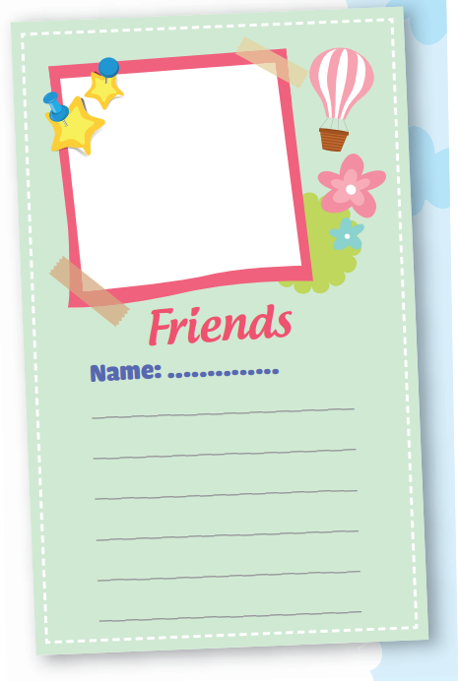 |  | -T: sets the context and asks students to bring a photo of his/her friend to class.  -T:asks students to write a draft (using the clues)  -T: checks and sets time for students to make a year-book page.  - T: gives comments and feedback
*Home work: (3’)
- Review some adjectives related to people’s appearance and personalities.
- Review The present simple / continuous tense .
- Prepare : REVIEW 1 ( Page 36)

