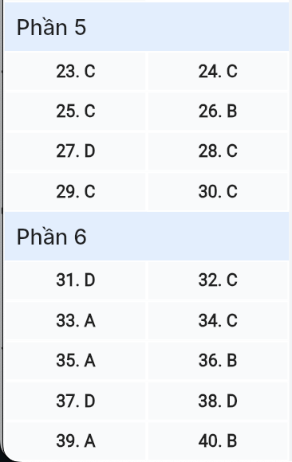
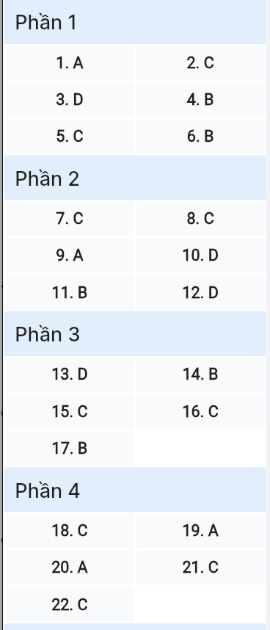
ĐỀ MINH HỌA SỐ 15
KỲ THI TỐT NGHIỆP TRUNG HỌC PHỔ THÔNG NĂM 2025
(Đề thi có 08 trang)
Môn thi: TIẾNG ANH
Thời gian làm bài: 50 phút, không kể thời gian phát đề

Read the following advertisement and mark the letter A, B, C or D on your answer sheet to indicate the option that best fits each of the numbered blanks from 1 to 6.
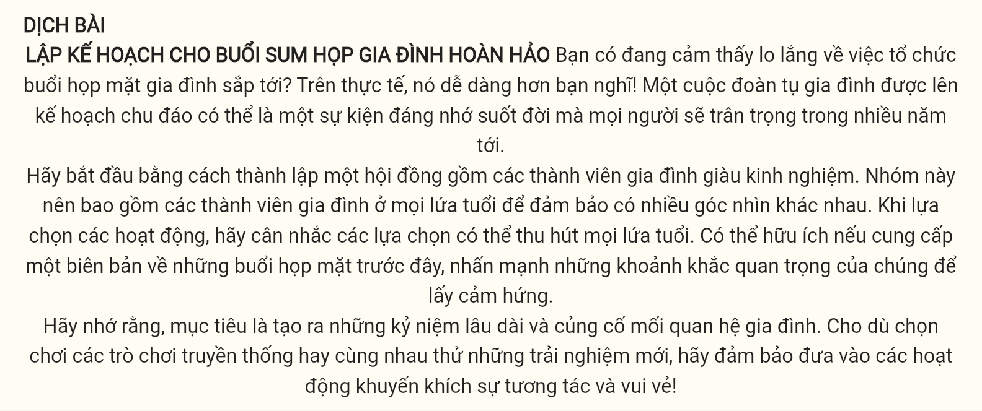
PLANNING THE PERFECT FAMILY REUNION
Are you feeling (1) _______ about organizing your next family gathering? In fact, it’s easier than you think! A well-planned family reunion can be a (2) _______ that everyone will cherish for years to come.
Start by forming a committee (3) _______ of experienced family members. This group should include family members (4) _______ all age ranges to ensure diverse perspectives. When choosing activities, consider options that will appeal to all age groups. It might be helpful to (5) _______ an account of past reunions, highlight their key moments to get inspiration.
Remember, the goal is to create lasting memories and strengthen family bonds. Whether to opt (6) _______ traditional games or try new experiences together, make sure to include activities that encourage interaction and fun!
(Adapted from Practical English Usage)
Question 1 [698709]: A. worried B. worrying C. worriedly D. worry
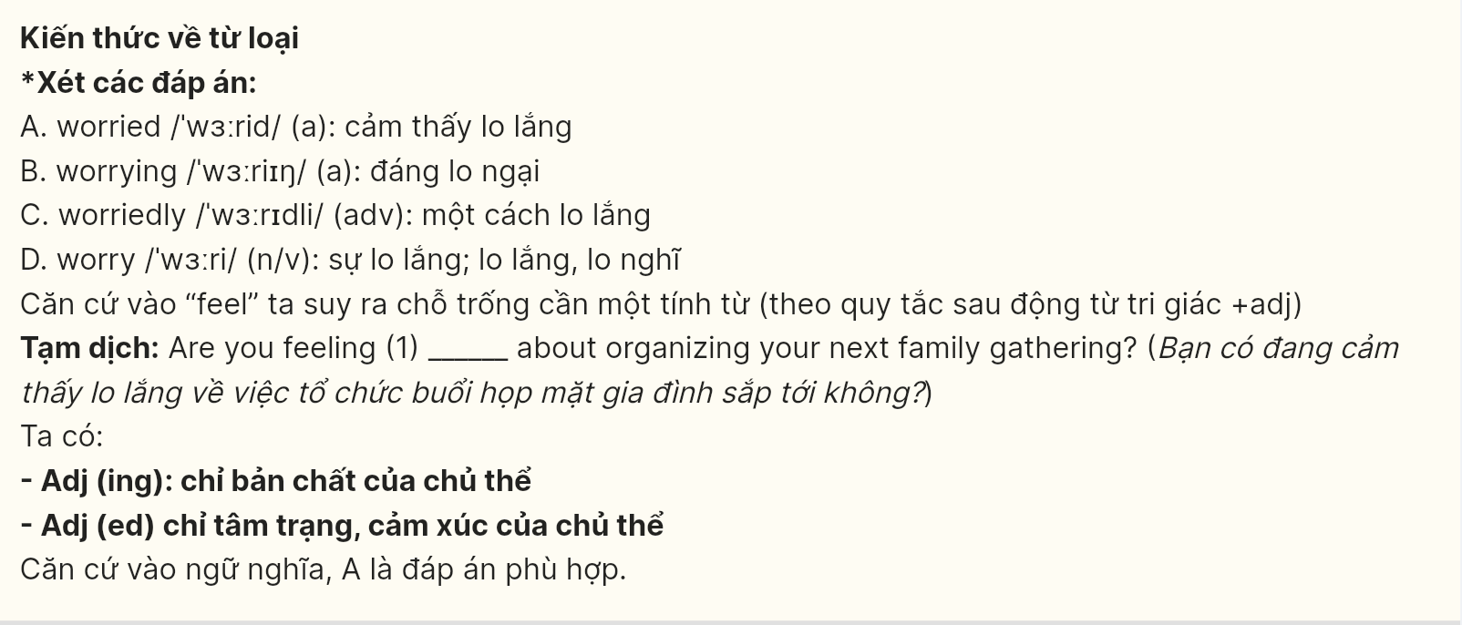
Question 2 [698710]: A. memory lifelong event B. lifelong event memory
C. lifelong memory event D. event lifelong memory
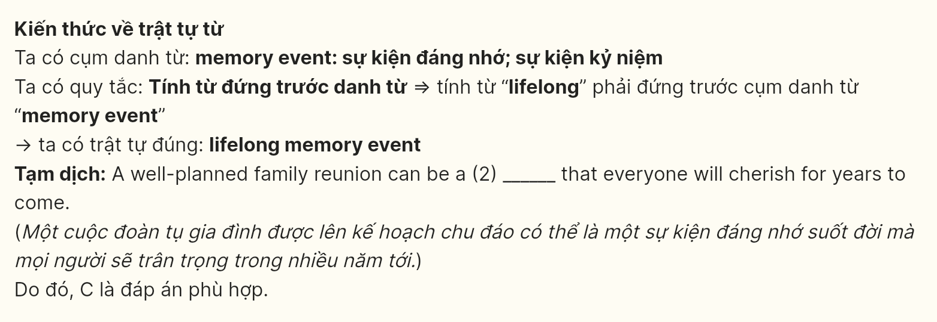
Question 3 [698711]: A. which comprises B. to comprise C. comprising D. comprised
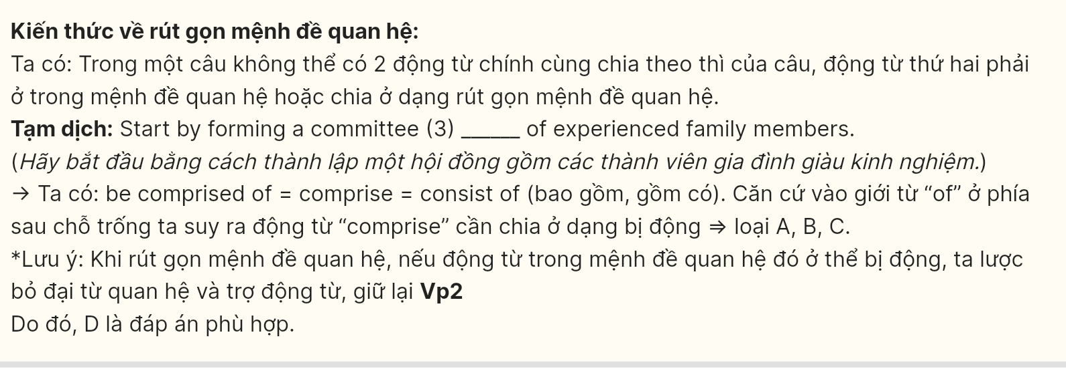
Question 4 [698712]: A. as B. among C. within D. between
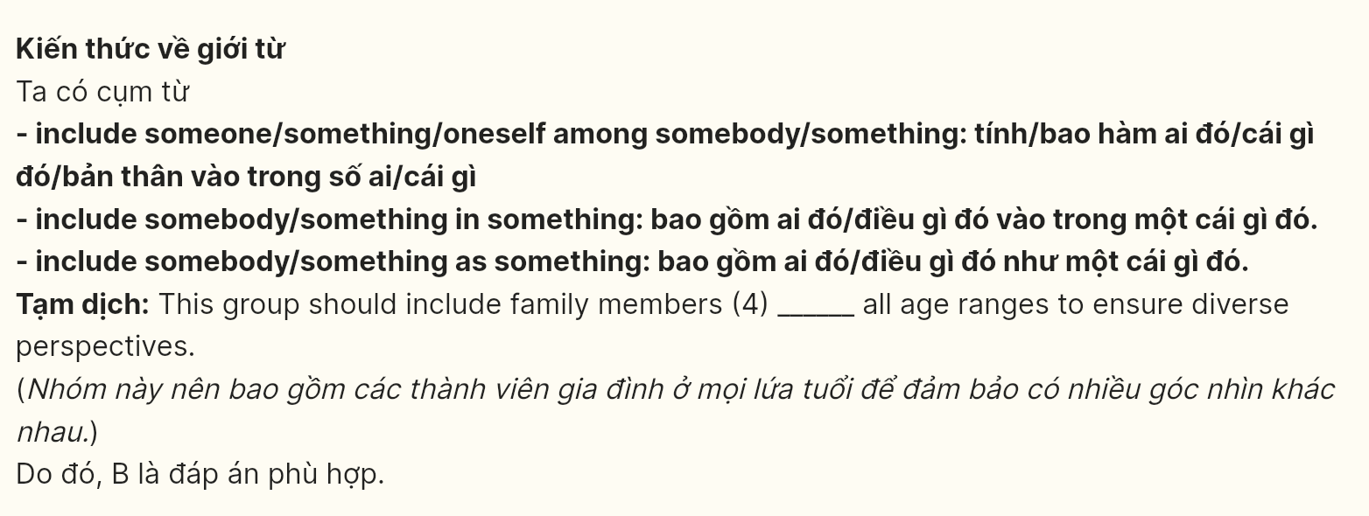
Question 5 [698713]: A. make B. do C. give D. put
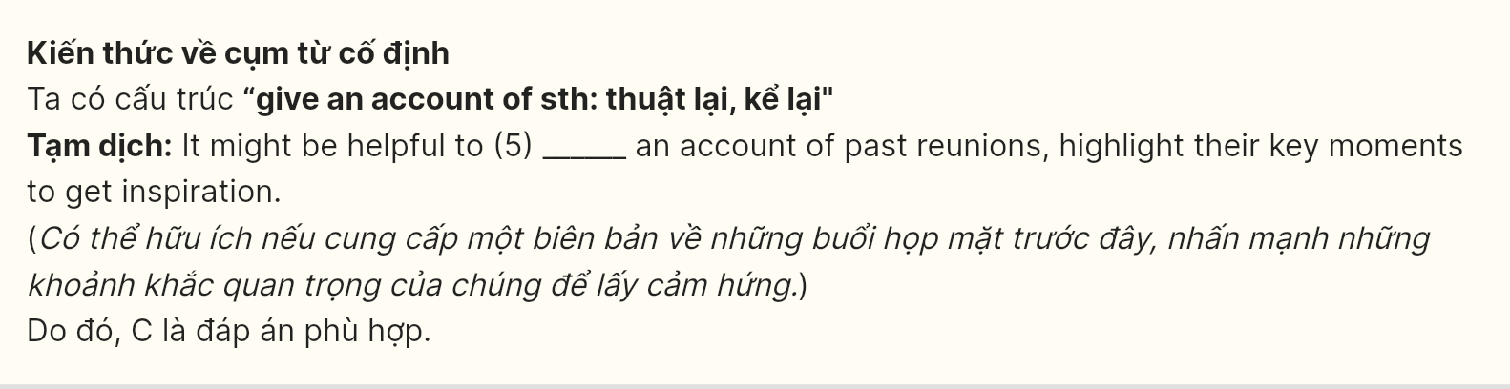
Question 6 [698714]: A. playing B. to play C. play D. to playing
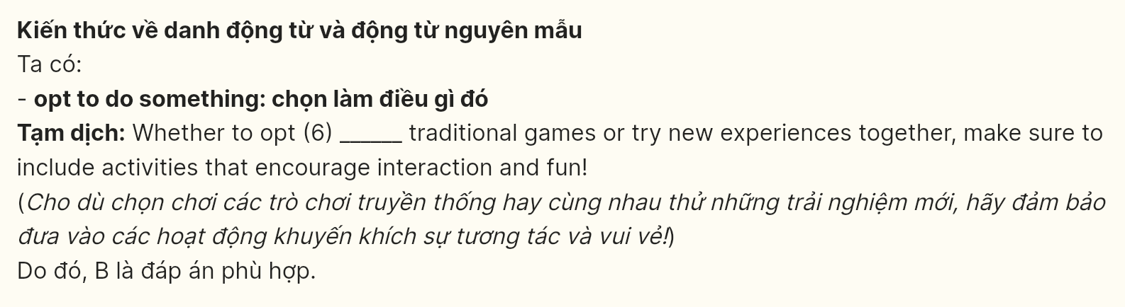
Read the following leaflet and mark the letter A, B, C or D on your answer sheet to indicate the option that best fits each of the numbered blanks from 7 to 12.
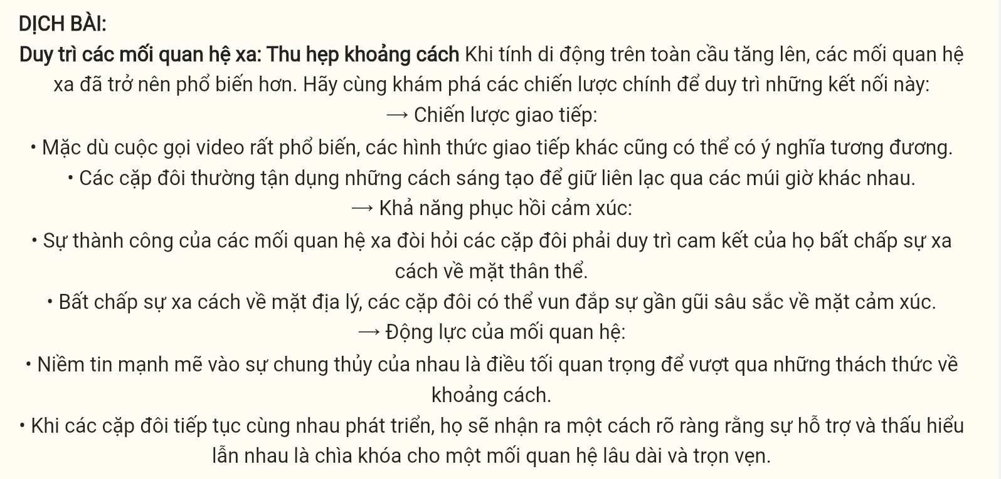
Sustaining Long-Distance Relationships: Bridging the Gap
As global mobility increases, long-distance relationships have become more common. Let’s explore key strategies for maintaining these connections:
Communication Strategies:
- While video calls are popular, (7) _______ forms of communication can be equally meaningful.
- Couples often (8) _______ creative ways to stay connected across time zones.
Emotional Resilience:
- Successful long-distance relationships require partners to (9) _______ their commitment despite the physical separation.
- (10) _______ geographical separation, couples can cultivate deep emotional intimacy.
Relationship Dynamics:
- A (11) _______ conviction in each other’s loyalty is crucial for weathering the challenges of distance.
- As partners continue to grow together, they will (12) _______ realize that mutual support and understanding are the keys to a lasting, fulfilling relationship.
(Adapted from www.ldmagazine.com)
Question 7 [698715]: A. the others B. others C. the other D. another
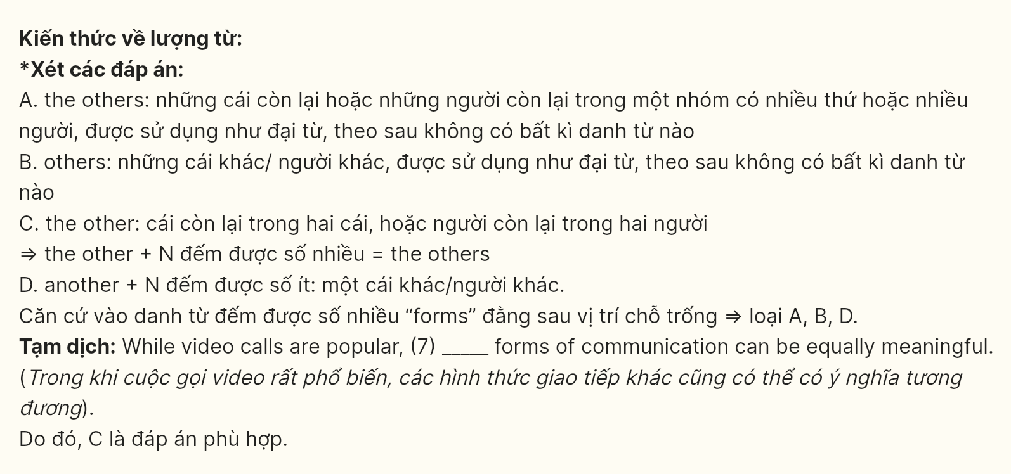
Question 8 [698716]: A. sum up B. hash out C. tap into D. whip up
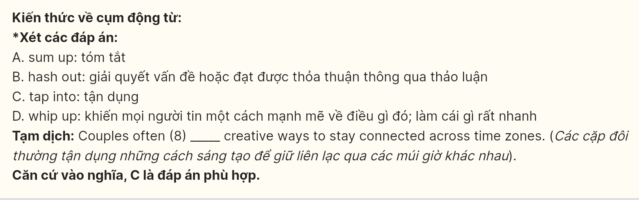
Question 9 [698717]: A. uphold B. renege C. waver D. falter
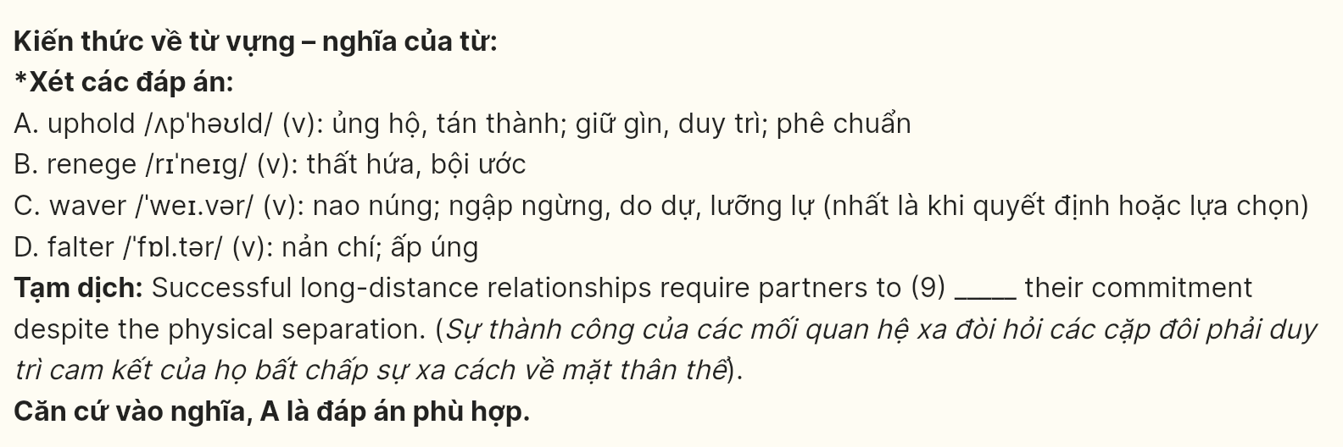
Question 10 [698718]:A. By virtue of B. In terms of
C. With regard to D. In spite of
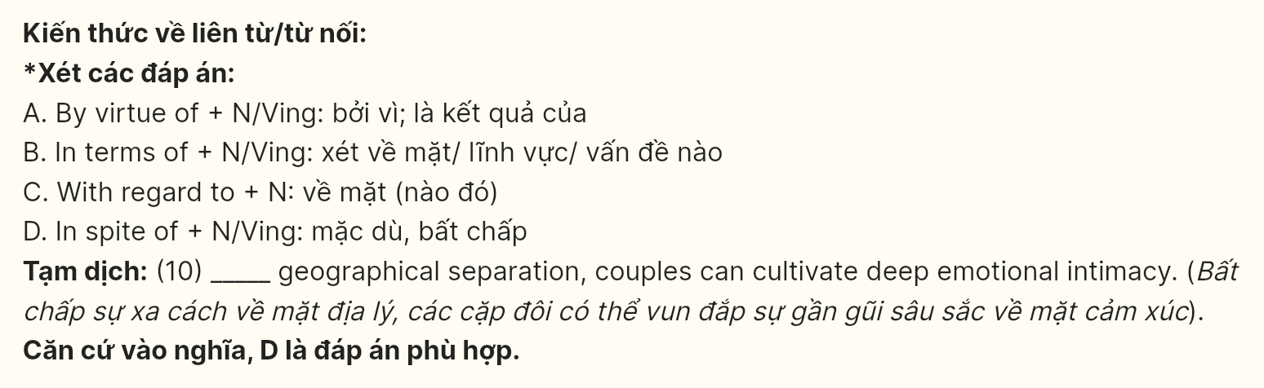
Question 11 [698719]: A. tenuous B. resolute C. vigorous D. tentative
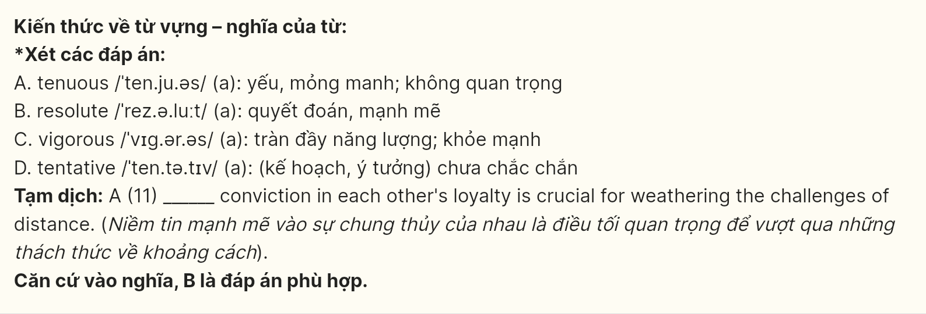
Question 12 [698720]: A. unambiguously B. obviously C. apparently D. unequivocally
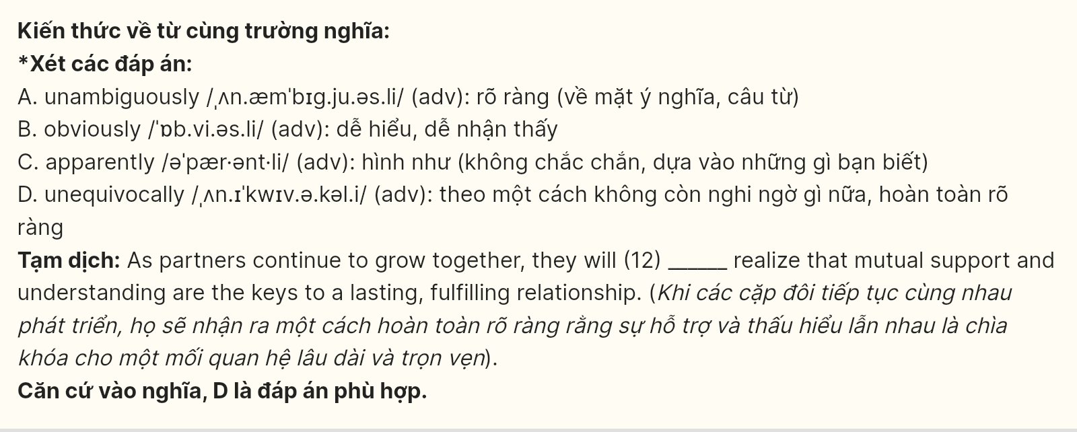
Mark the letter A, B, C or D on your answer sheet to indicate the best arrangement of utterances or sentences to make a meaningful exchange or text in each of the following questions from 13 to 17.
Question 13 [698721]:
a. Mia: Yes, it’s really alarming. Many species are losing their habitats.
b. Emma: Have you seen the news about the deforestation in the Amazon?
c. Emma: I know! It’s heartbreaking to think about how many animals are affected.
A. B - C – A B. A - C – B C. C - B – A D. B - A - C
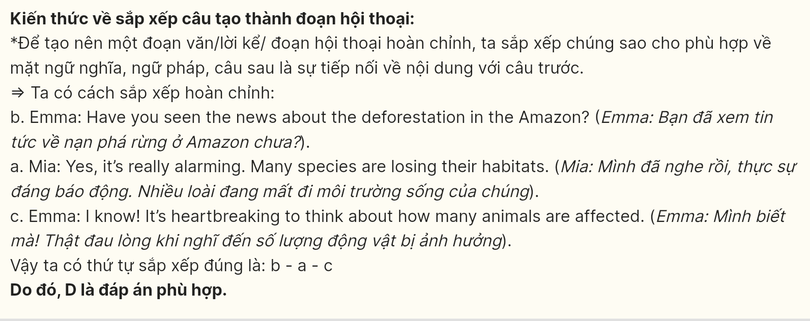
Question 14 [698722]:
a. Anna: I think we should reduce our carbon footprint by using less energy and supporting renewable sources.
b. Anna: Hi Tom, have you heard about the latest reports on global warming? It’s getting worse!
c. Tom: Yes, I read that the ice caps are melting at an alarming rate. What do you think we can do to help?
d. Anna: Definitely! Every little action counts in the fight against global warming.
e. Tom: That’s a great idea! We could also raise awareness in our community about the importance of recycling and conserving energy.
A. B - A - C - D – E B. B - C - A - E – D C. B - D - C - A – E D. B - E - A - C - D
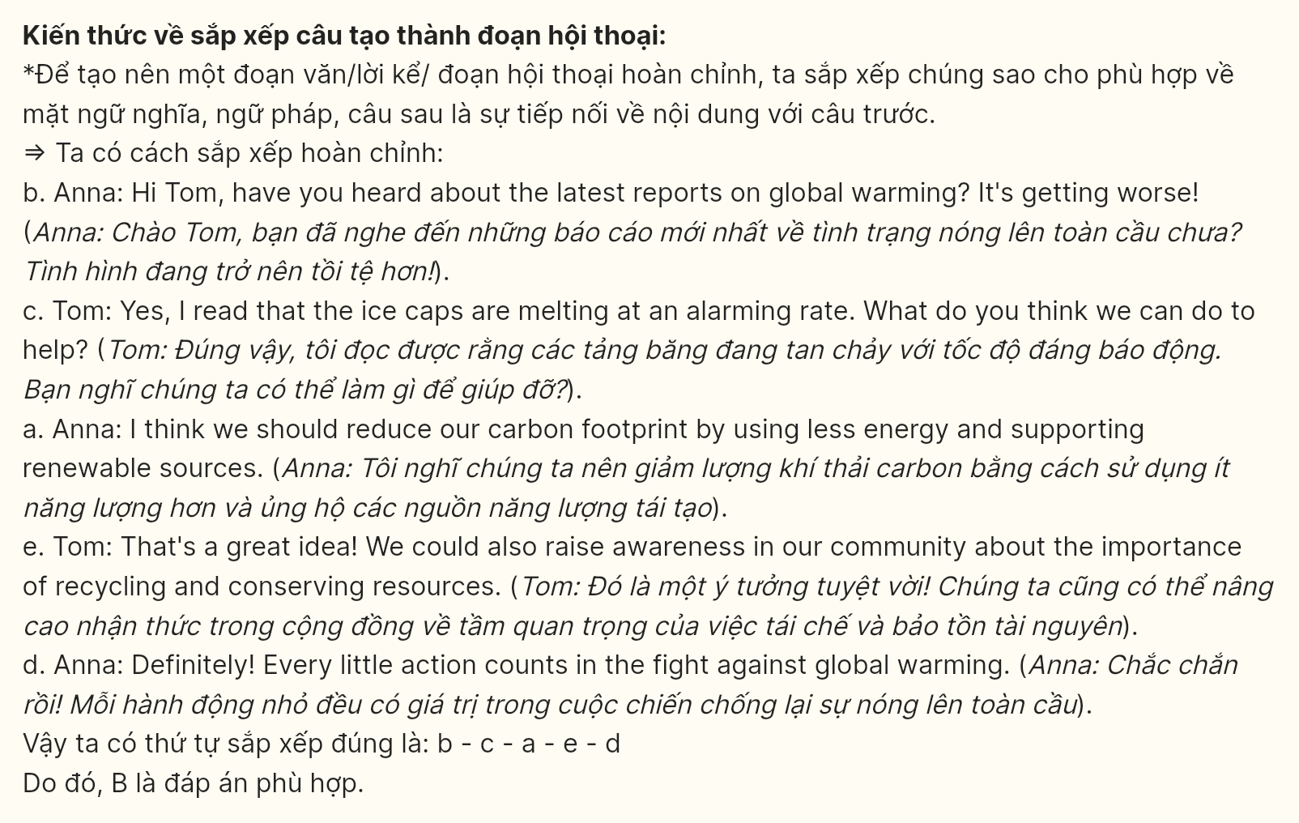
Question 15 [698723]:
Dear Lucy,
a. I highly recommend that you explore the multicultural world around you, as there is so much to discover and appreciate.
b. I hope this letter finds you well. I’m excited to share with you some insights into the diverse cultures that make up our world.
c. Finally, embracing multiculturalism benefits us all. It exposes us to new ideas, expands our perspectives, and fosters a more inclusive society.
d. Secondly, understanding different cultures helps us become more open-minded and tolerant.
e. Whether it’s trying international foods, attending cultural events, or simply having meaningful dialogues, engaging with diversity can truly enhance our lives.
f. Firstly, diversity is a beautiful thing that enriches our global community. Each culture has its own unique traditions, practices, and ways of life that are worth learning about and appreciating.
Best regards,
Emma
A. d-a-c-f-b-e B. f-a-c-d-e-b C. b-f-d-e-c-a D. a-b-e-f-d-c
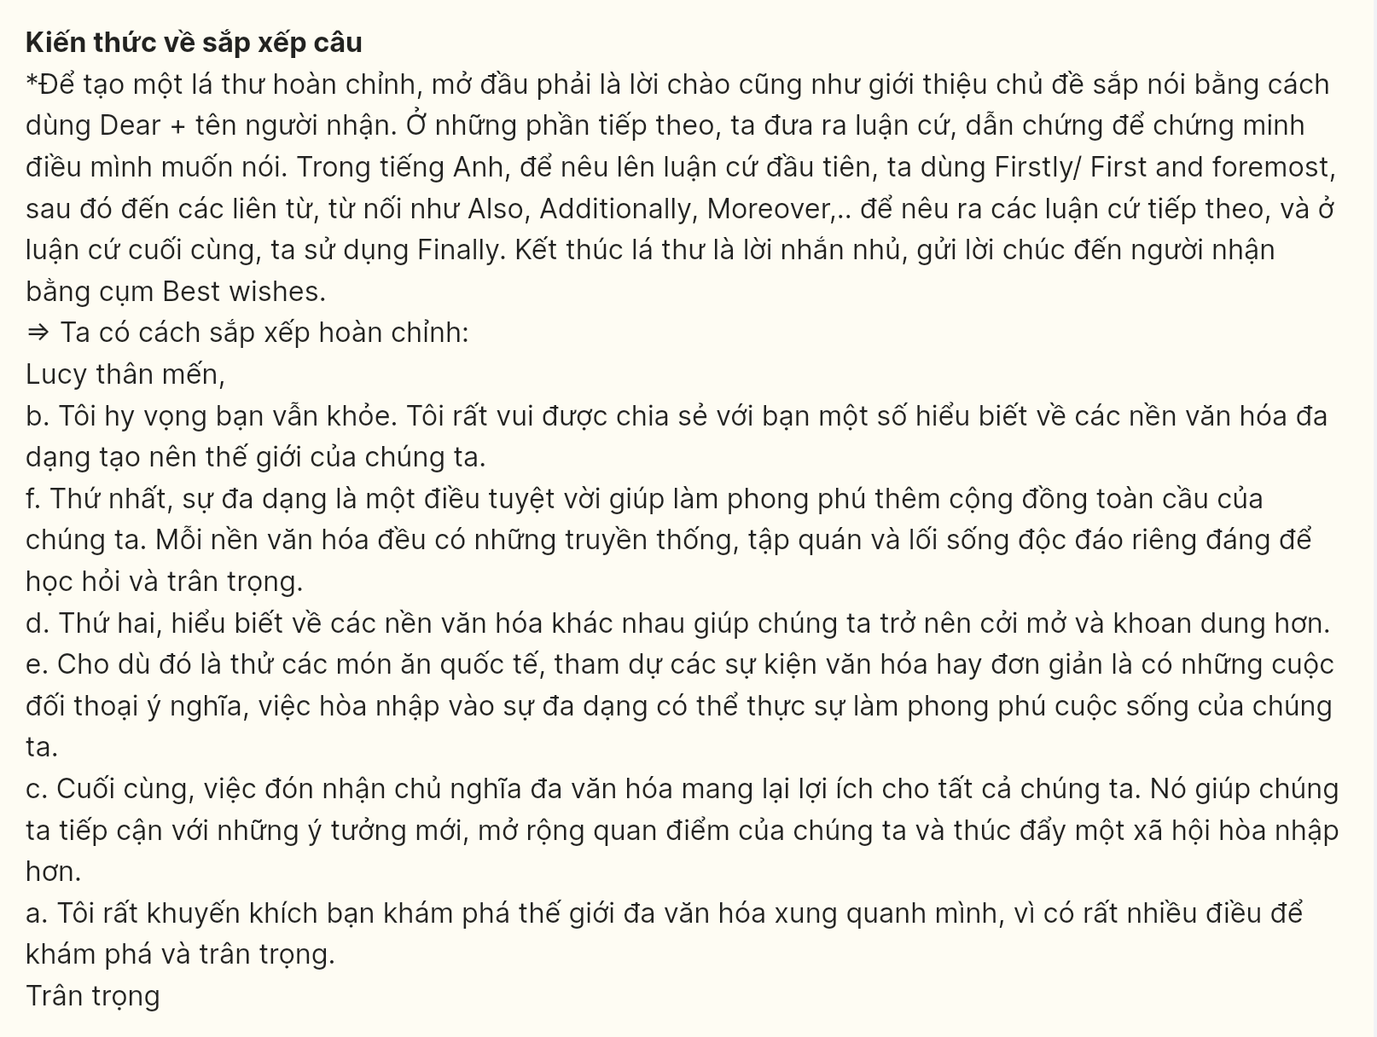
Question 16 [698724]:
a. Living on my own has taught me valuable life skills, such as budgeting and time management, that I didn’t fully appreciate before.
b. Over time, I’ve learned how to handle household responsibilities efficiently, making me more self-sufficient.
c. Though challenging at first, this experience has helped me grow more independent and confident in my ability to manage life’s demands.
d. The freedom to create my own schedule and make decisions without relying on others has been incredibly rewarding.
e. Ultimately, I believe independent living has made me more resilient and prepared for future challenges.
A. a-d-e-b-c B. d-b-c-a-e C. a-b-c-d-e D. d-c-b-e-a
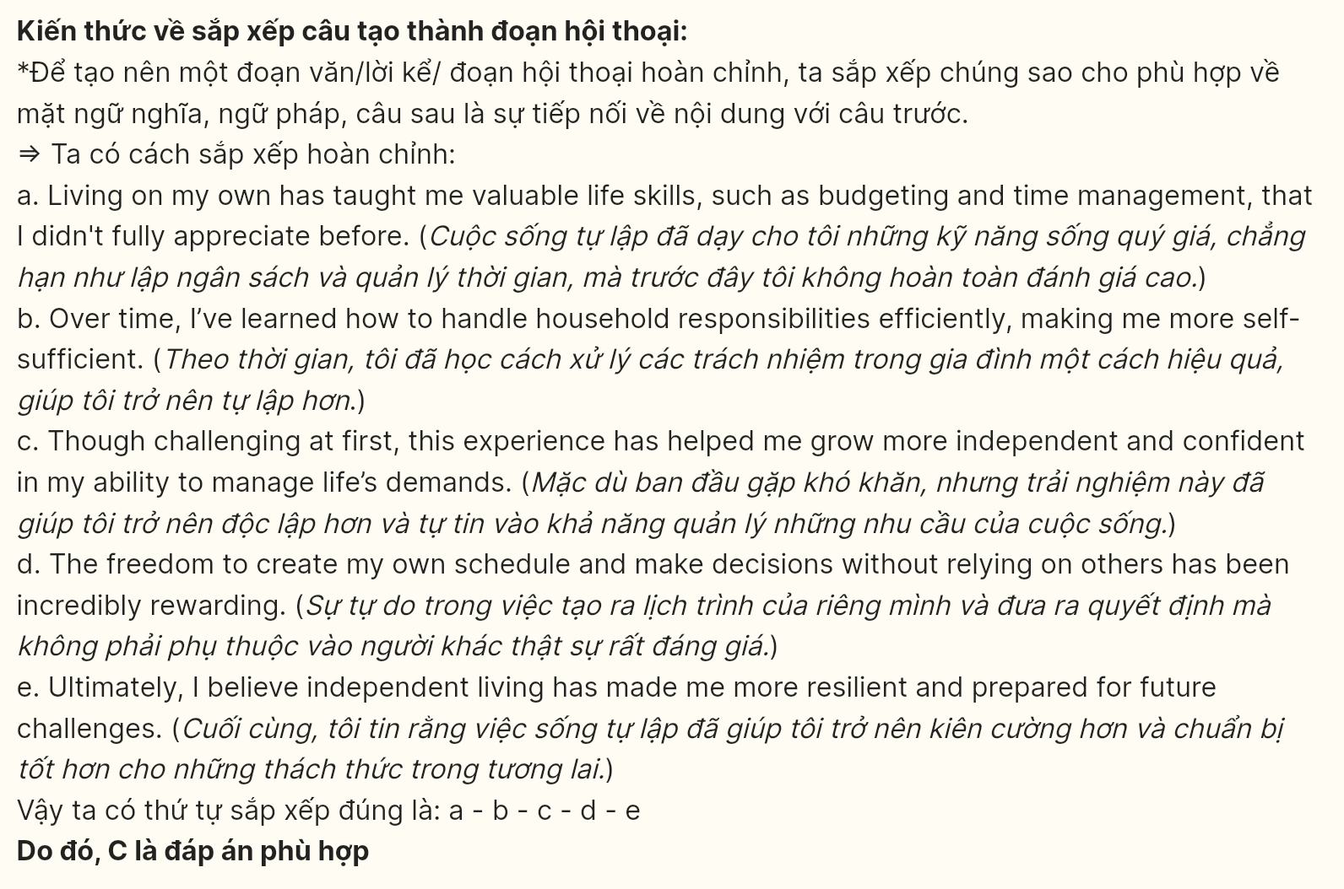
Question 17 [698725]:
a. Meeting my current partner was completely unexpected, as I had sworn off dating after my previous heartbreak.
b. Slowly, I began to trust again, and we built a relationship based on open communication and shared values.
c. At first, I was hesitant to open up and let someone new into my life, but they were incredibly patient and understanding.
d. Now, several years later, I can confidently say that this is the healthiest and most fulfilling partnership I’ve ever had.
e. I’m grateful every day for the love and support we share, and I’m excited to see what the future holds for us.
A. a-d-b-c-e B. a-c-b-d-e C. a-d-c-b-e D. a-b-d-e-c
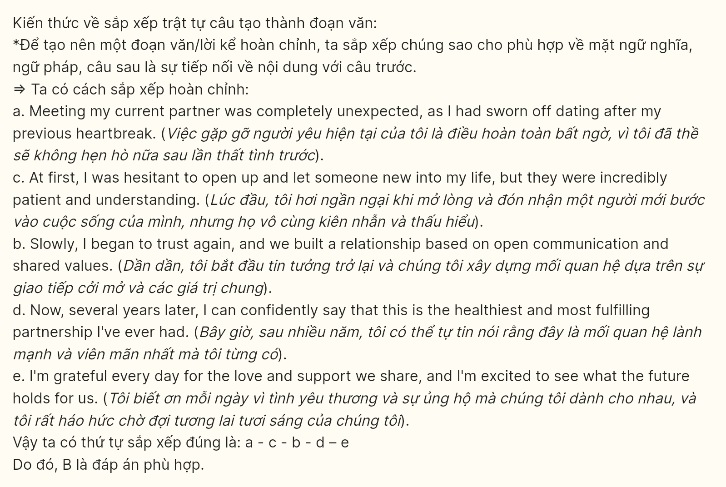
Read the following passage about Trịnh Công Sơn, a famous Vietnamese musician, and mark the letter A, B, C or D on your answer sheet to indicate the option that best fits each of the numbered blanks from 18 to 22.
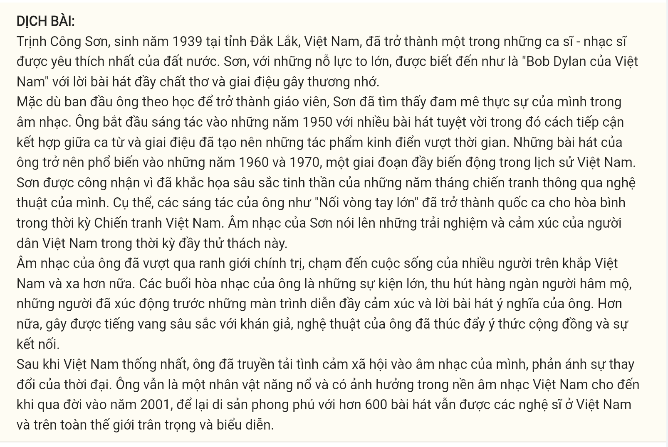
Trịnh Công Sơn, born in 1939 in Đắk Lắk Province, Vietnam, became one of the country’s most beloved singer-songwriters. Sơn, with great efforts, (18) _______.
Despite initially studying to become a teacher, Sơn found his true calling in music. He began composing in the 1950s with a number of wonderful songs (19) _______. His songs gained popularity in the 1960s and 1970s, a tumultuous period in Vietnamese history.
(20) _______. Specifically, his compositions like “Nối vòng tay lớn” (The Great Circle of Vietnam) became anthems for peace during the Vietnam War era. Sơn’s music spoke to the experiences and emotions of the Vietnamese people during this challenging time.
His music transcended political boundaries, touching lives across Vietnam and beyond. His concerts were major events, drawing thousands of fans who were moved by his soulful performances and meaningful lyrics. Moreover, resonating deeply with audiences, (21) _______.
After Vietnam’s reunification, (22) _______. He remained an active and influential figure in the Vietnamese music scene until his passing in 2001, leaving behind a rich legacy of over 600 songs that continue to be cherished and performed by artists in Vietnam and around the world.
(Adapted from https://en.wikipedia.org)
Question 18 [698726]:
A. of whom poetic lyrics and haunting melodies were known as the "Bob Dylan of Vietnam"
B. as the "Bob Dylan of Vietnam" known for his poetic lyrics and haunting melodies
C. became known as the "Bob Dylan of Vietnam" for his poetic lyrics and haunting melodies
D. becoming "Bob Dylan of Vietnam" known for his poetic lyrics and haunting melodies
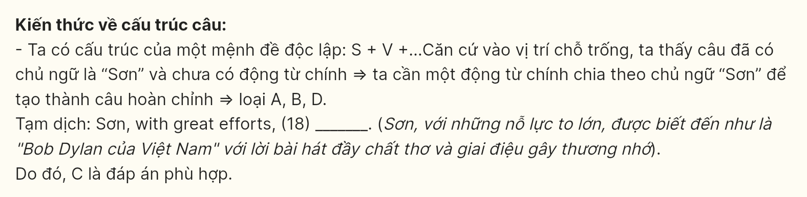
Question 19 [698727]:
A. of which blended approach to lyrics and melodies have given rise to timeless classics
B. attracted listeners with lyrics and melodies that contributed to timeless classics
C. approached to lyrics and melodies in order to be acknowledged as timeless classics
D. whose blended approach to lyrics and melodies in shaping timeless classics
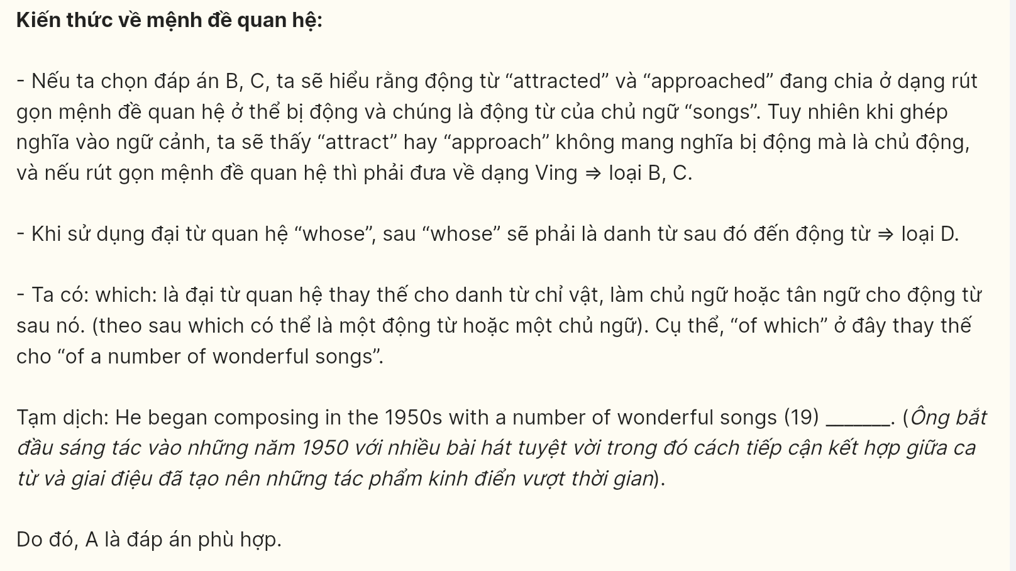
Question 20 [698728]:
A. Sơn was recognized for capturing the spirit of the war years through his artistic expression
B. Artists in the realms of poetry, music, and social reflection in the war years contributed to Sơn’s impact
C. Aiming to resonate with the masses through song, Sơn’s songs evolved as a cultural icon in the war years
D. The fusion of poetic simplicity and national, social awareness in the war years shapes Sơn’s influence
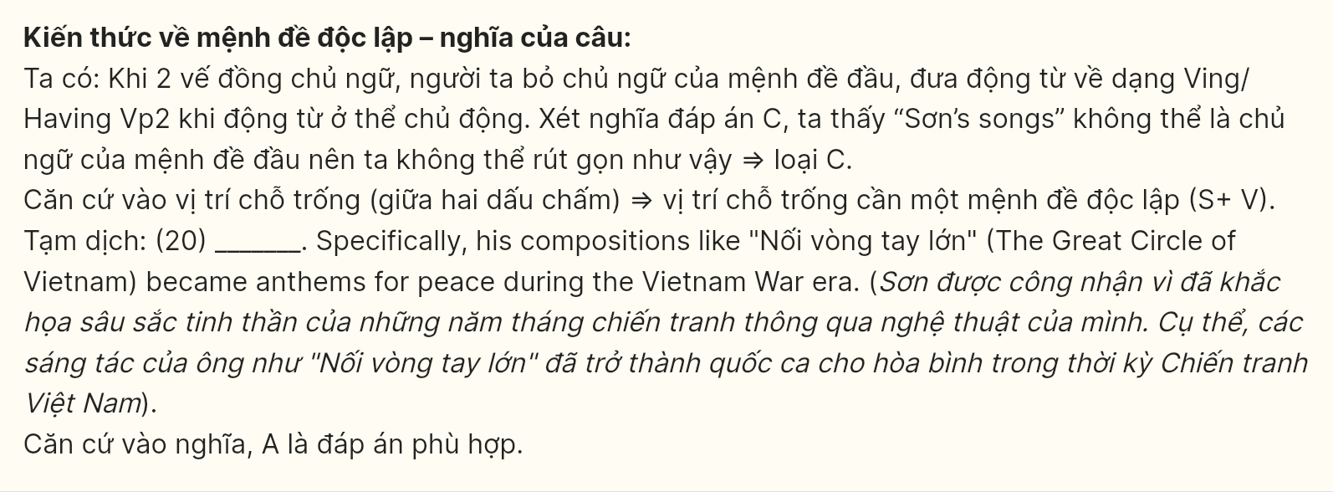
Question 21 [698729]:
A. a sense of community and connection was encouraged
B. Sơn could make his artistry foster community connection
C. his artistry fostered a sense of community and connection
D. enhancing community connection was Sơn’s intention
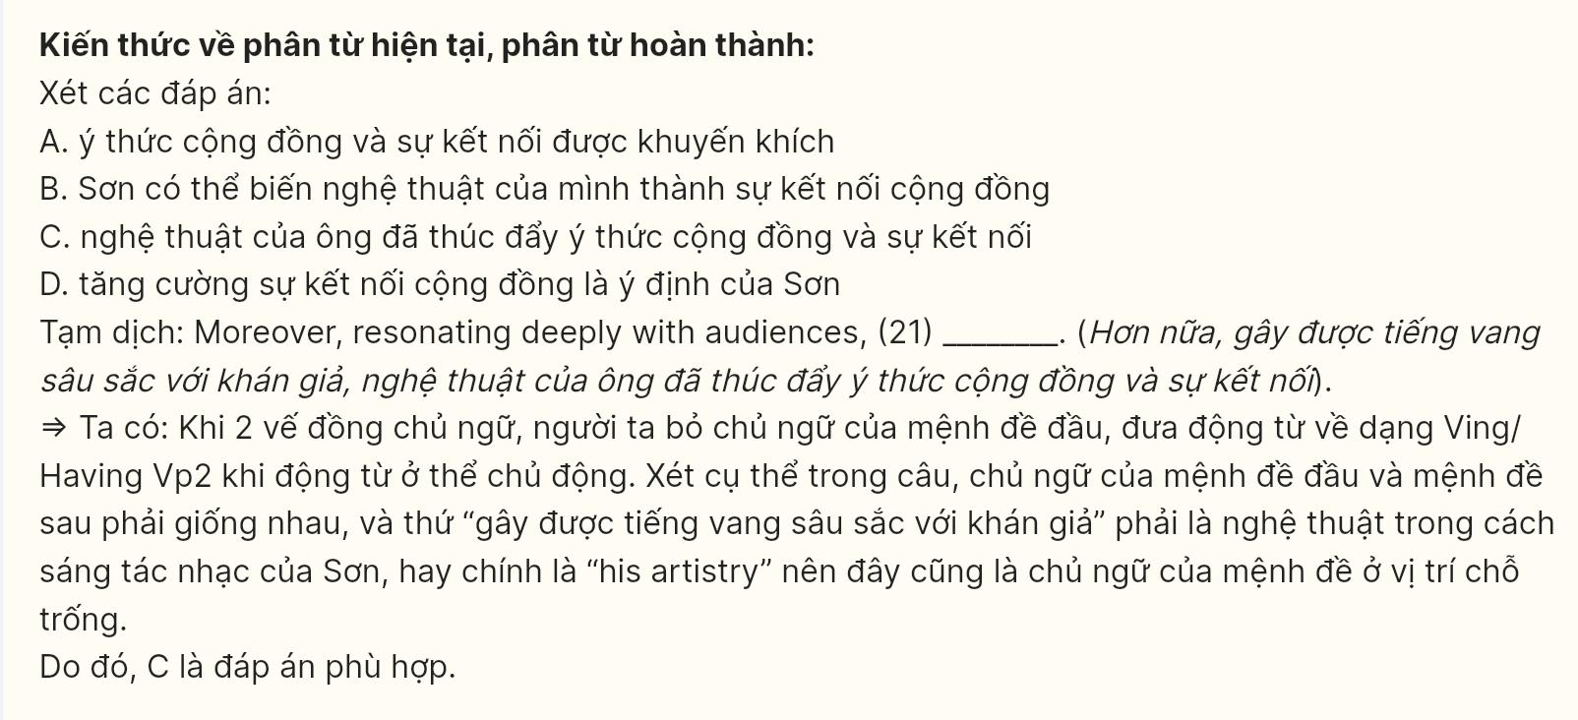
Question 22 [698730]:
A. by channeling societal sentiments into his music, it couldn’t reflect the changing times
B. integrating societal sentiments into his music, they helped him reflect on the changing times
C. he channeled societal sentiments into his music, reflecting the changing times
D. reflecting the changing times through his music, societal sentiments were channeled
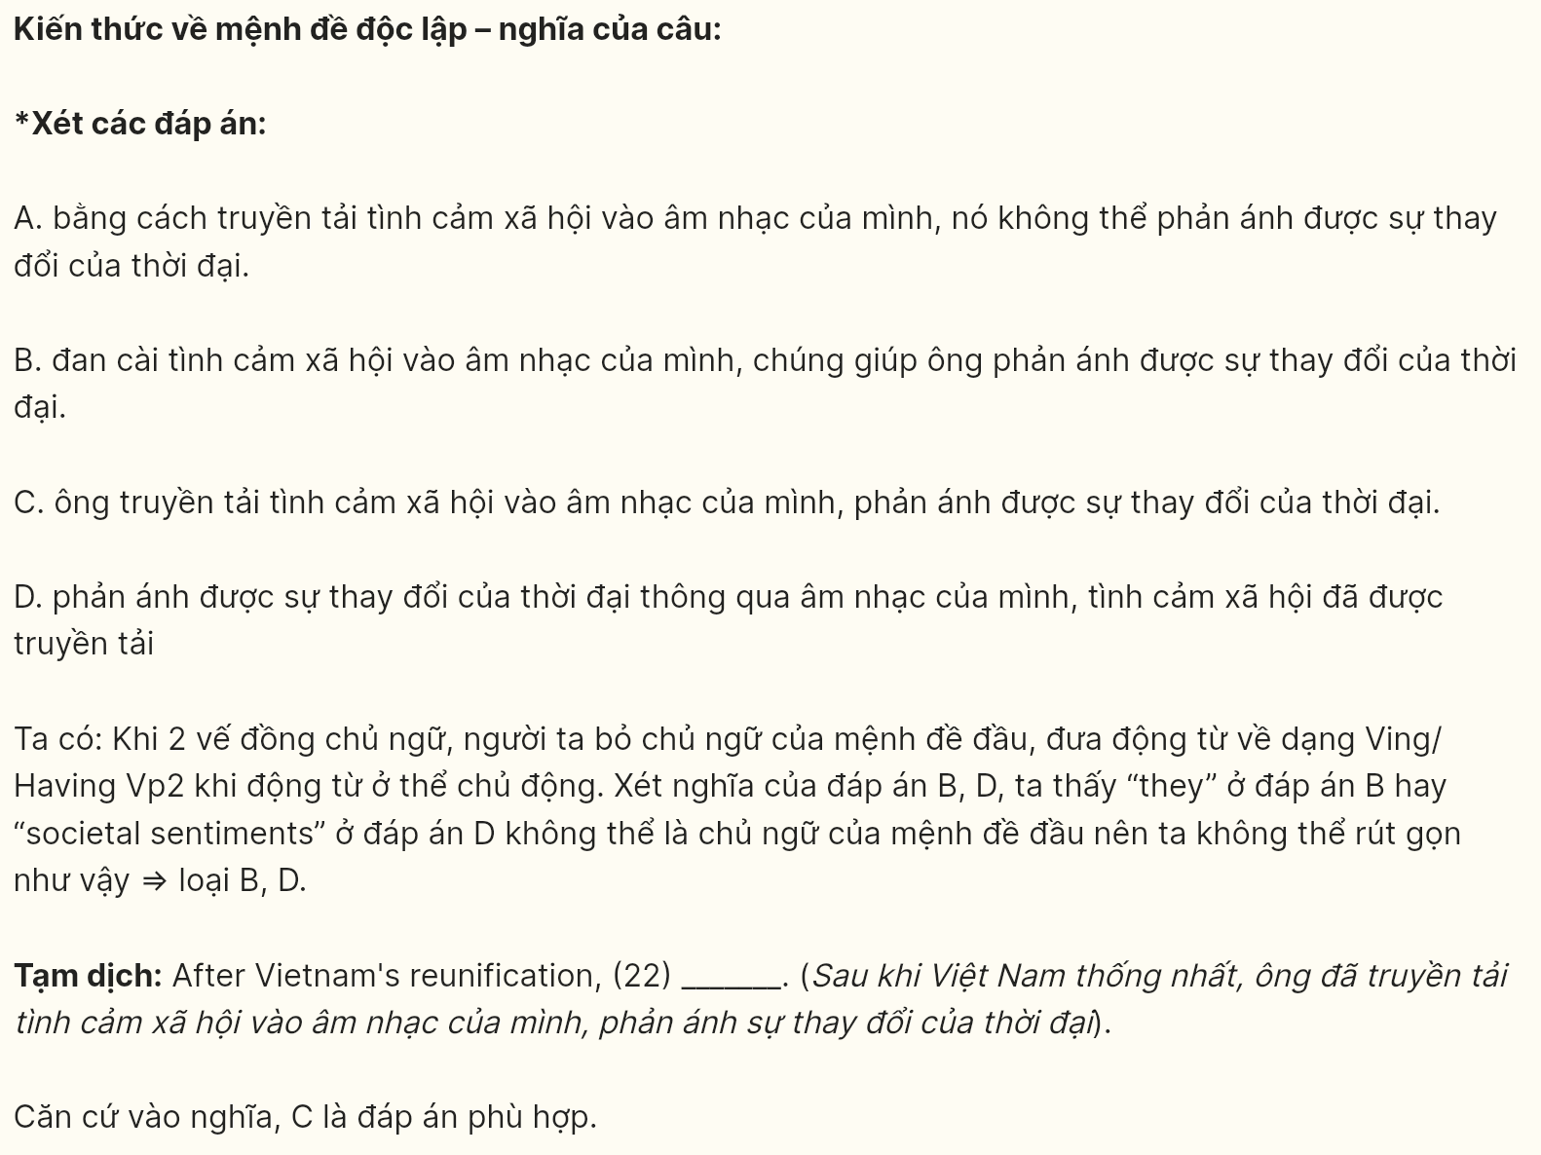
Read the following passage and mark the letter A, B, C or D on your answer sheet to indicate the best answer to each of the following questions from 23 to 30.
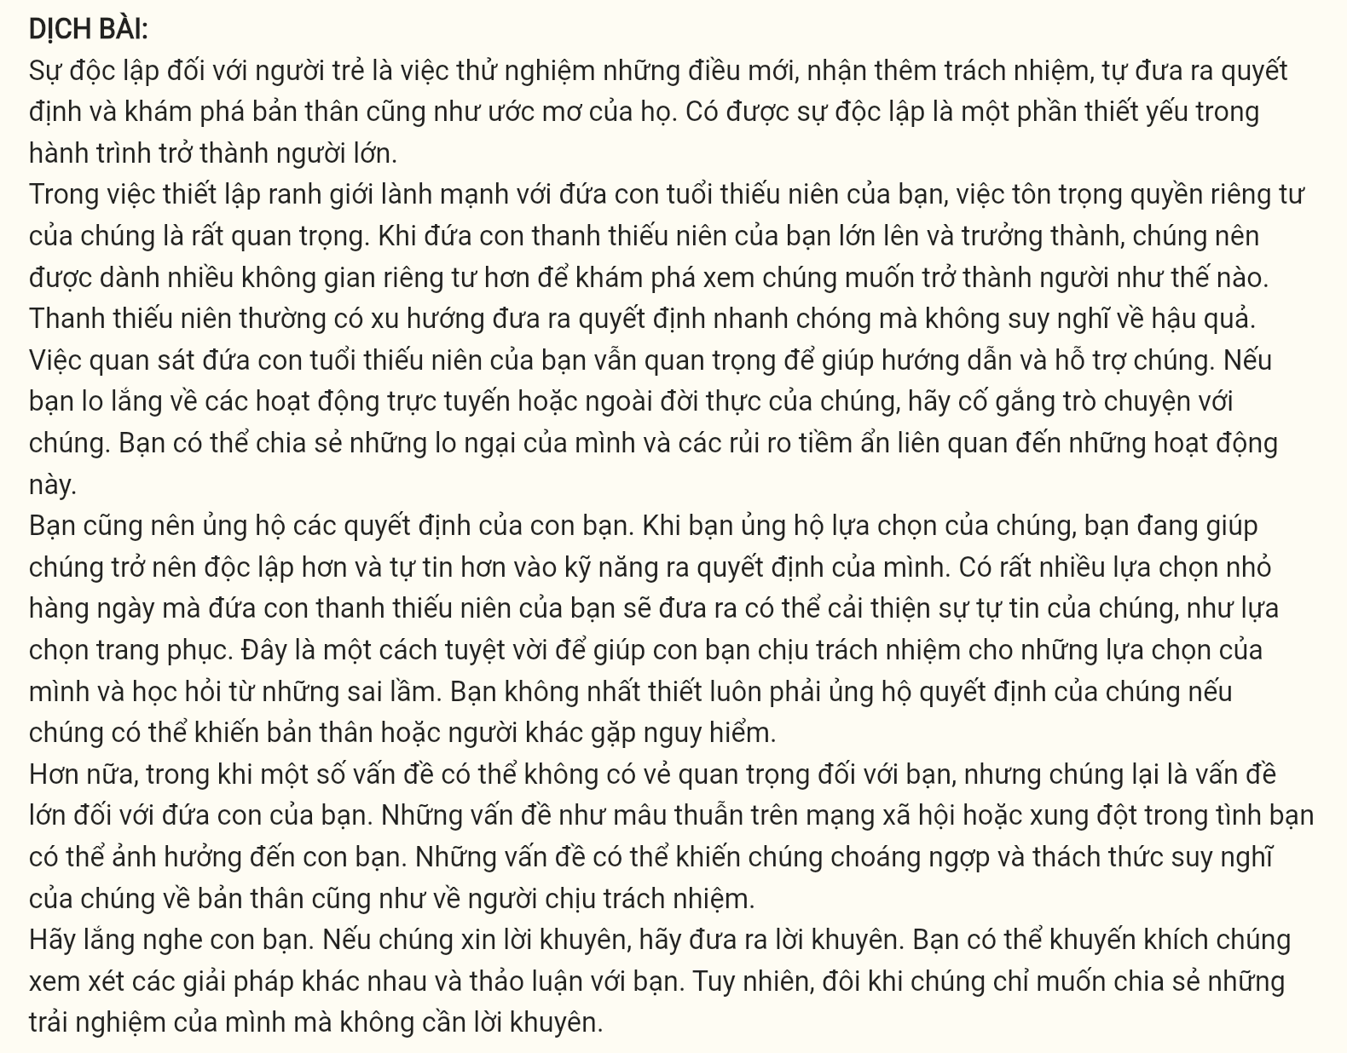
Independence for young people is about trying new things, taking on more responsibility, making decisions by themselves, and working out who they are and what they want to be. Achieving independence is an essential part of the journey to adulthood.
As part of setting up healthy boundaries with your teenager, it is important for you to respect their privacy. As your teenager grows older and maturer, they should be given more privacy as they figure out what kind of person they want to be. Teenagers are prone to make quick decisions without thinking about the consequences. It is still important to monitor your teenager to help guide them and support them. If you are concerned about their online or offline activities, try to have a conversation with them. You can discuss your concerns with them and the potential risks of these activities.
You should also support your teenager’s decisions. When you support your teenager’s choices you are helping them become more independent and confident in their decision-making skills. There are lots of small daily choices that your teenager will make that can improve their confidence such as their choices in clothes. It is a great way to help your child accept the responsibility for their choices and learn from their mistakes. You do not always have to support your teenager’s decision if they are putting themselves or others at risk.
Additionally, while some problems may not seem like a big deal to you, they are a big deal to your teenager. Issues like social media drama or conflicts in friendships can impact your teenager. They can be overwhelming for them and challenge their ideas of who they are and who is in charge. Listen to your teenager. If they ask for advice, give them advice. You can encourage them to look at different solutions and discuss them with you. However, sometimes they may just want to talk about their experiences with you, but do not want any advice.
(Adapted from https://cambrsborochildren’shealth.nhs.uk/)
Question 23 [698731]: Which of the following best paraphrases the underlined sentence in paragraph 2?
A. As teenagers mature, they should be told exactly what kind of person to be.
B. Teenagers need privacy to decide what type of person their parents want them to become.
C. The maturer your teen becomes, the more they need more freedom to decide who they want to become.
D. When teenagers grow up, they need constant supervision to figure out their future.
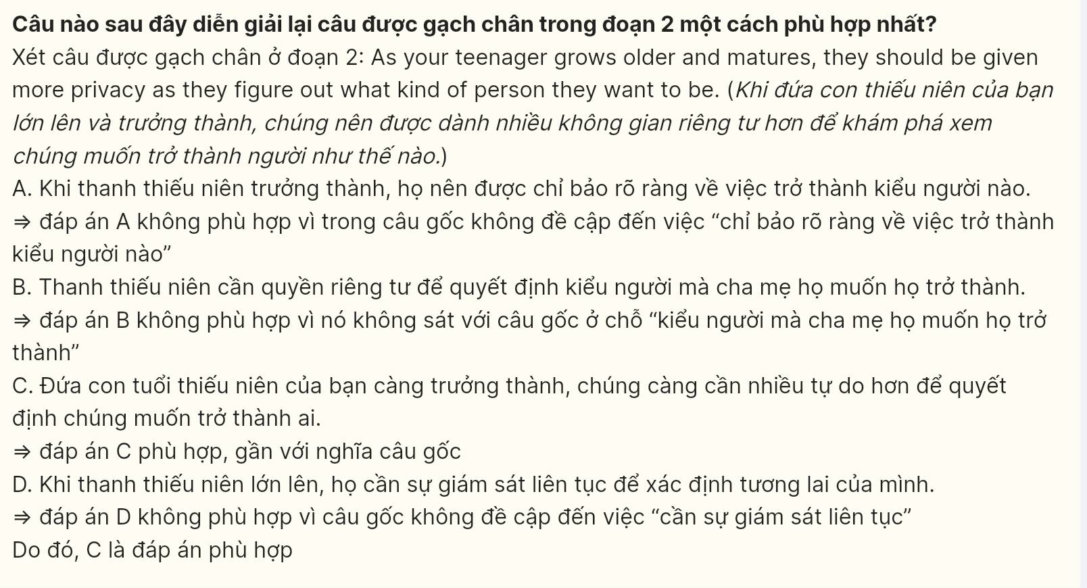
Question 24 [698732]: The word “monitor” in paragraph 2 could be best replaced by ______.
A. threaten B. impose C. observe D. assist
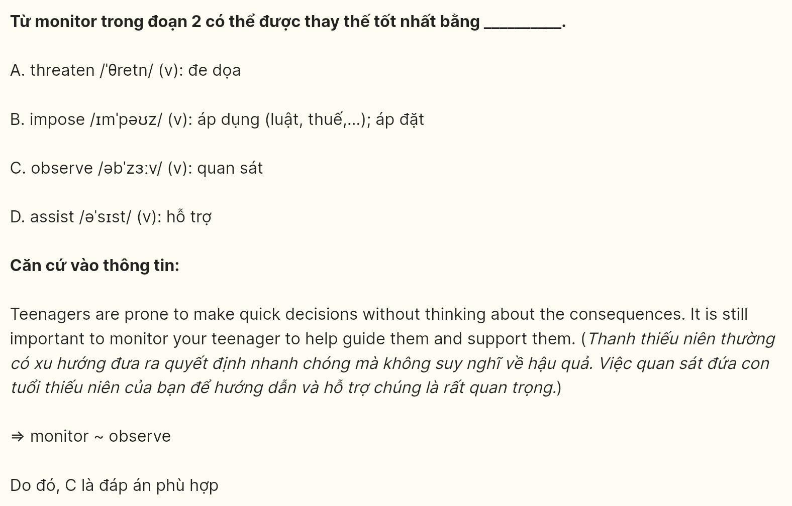
Question 25 [698733]: The word “overwhelming” in paragraph 4 is OPPOSITE in meaning to ______.
A. insignificant B. impossible C. manageable D. important
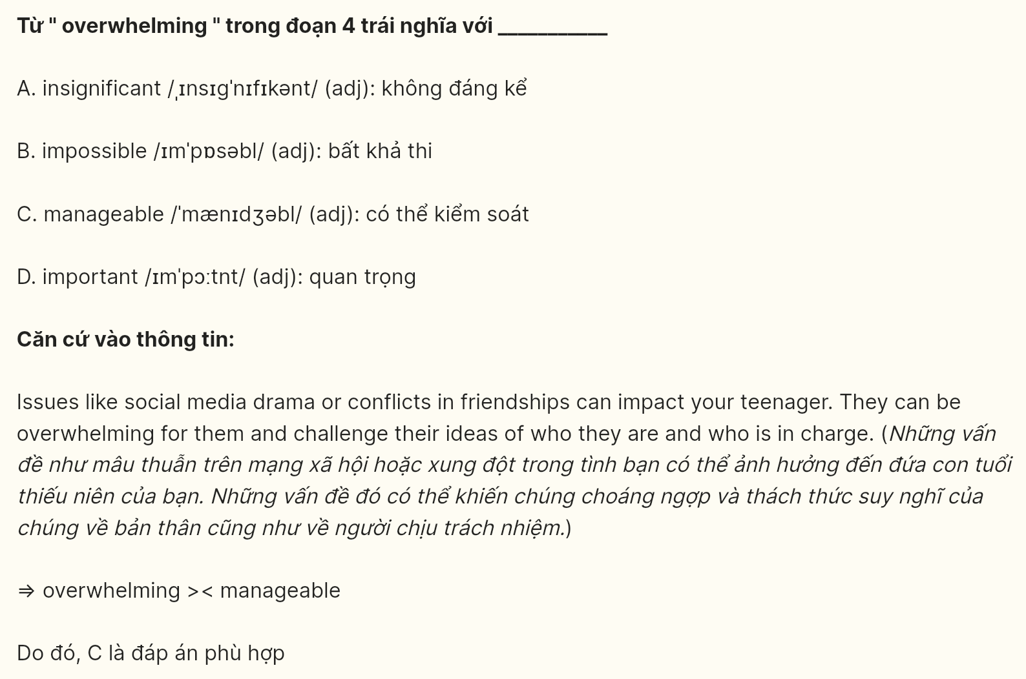
Question 26 [698734]: According to the passage, what is recommended if parents are worried about their teenager’s activities?
A. They should punish their teenager.
B. They should have a discussion about potential risks.
C. They should ignore their concerns.
D. They should completely invade their teenager’s privacy.
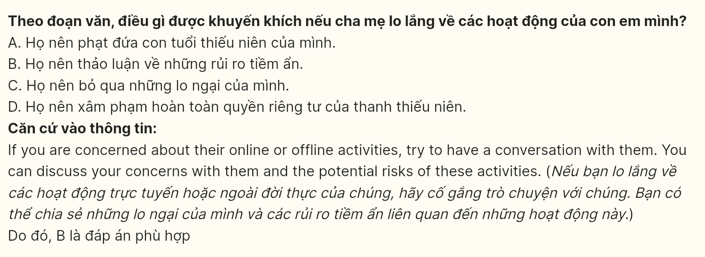
Question 27 [698735]: The word “you” in the whole passage most likely refers to ______.
A. teenagers B. siblings of teenagers C. friends of teenagers D. parents
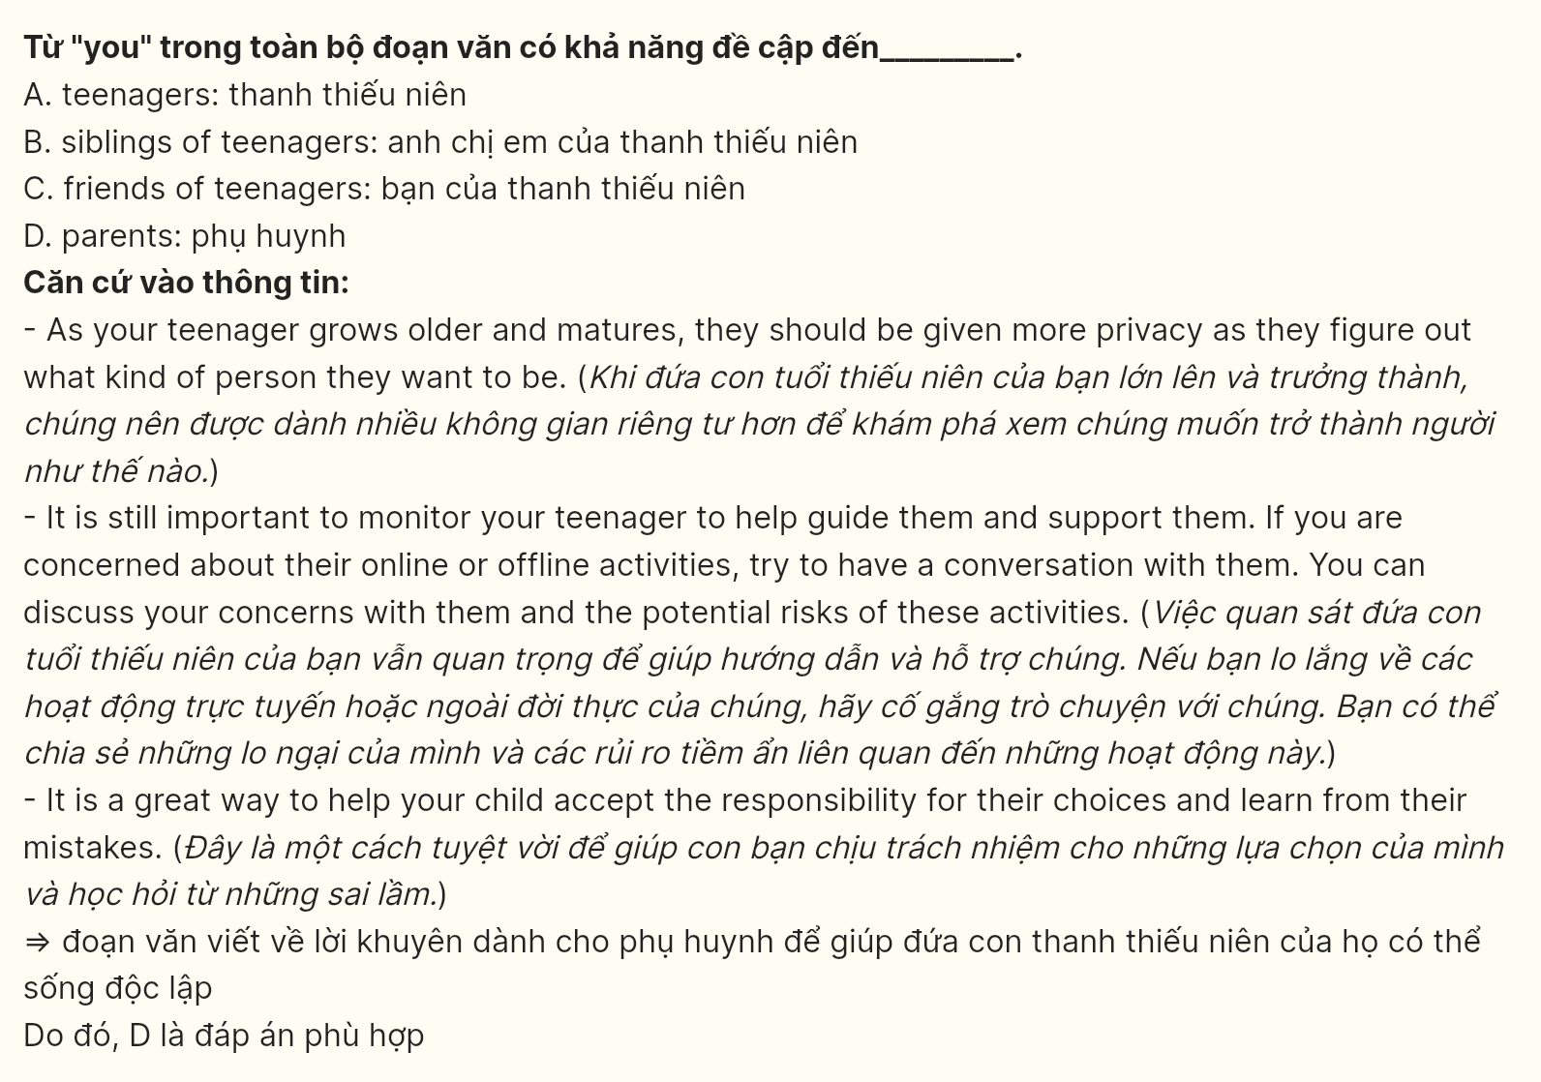
Question 28 [698736]: Which of the following is NOT TRUE, according to the passage?
A. Young people need to experience new things and handle more responsibilities to become independent.
B. Respecting a teenager’s need for privacy is crucial as they grow older.
C. Parents should always allow teenagers to make any decision without supervision.
D. Discussing concerns about activities can help guide teenagers and ensure their safety.
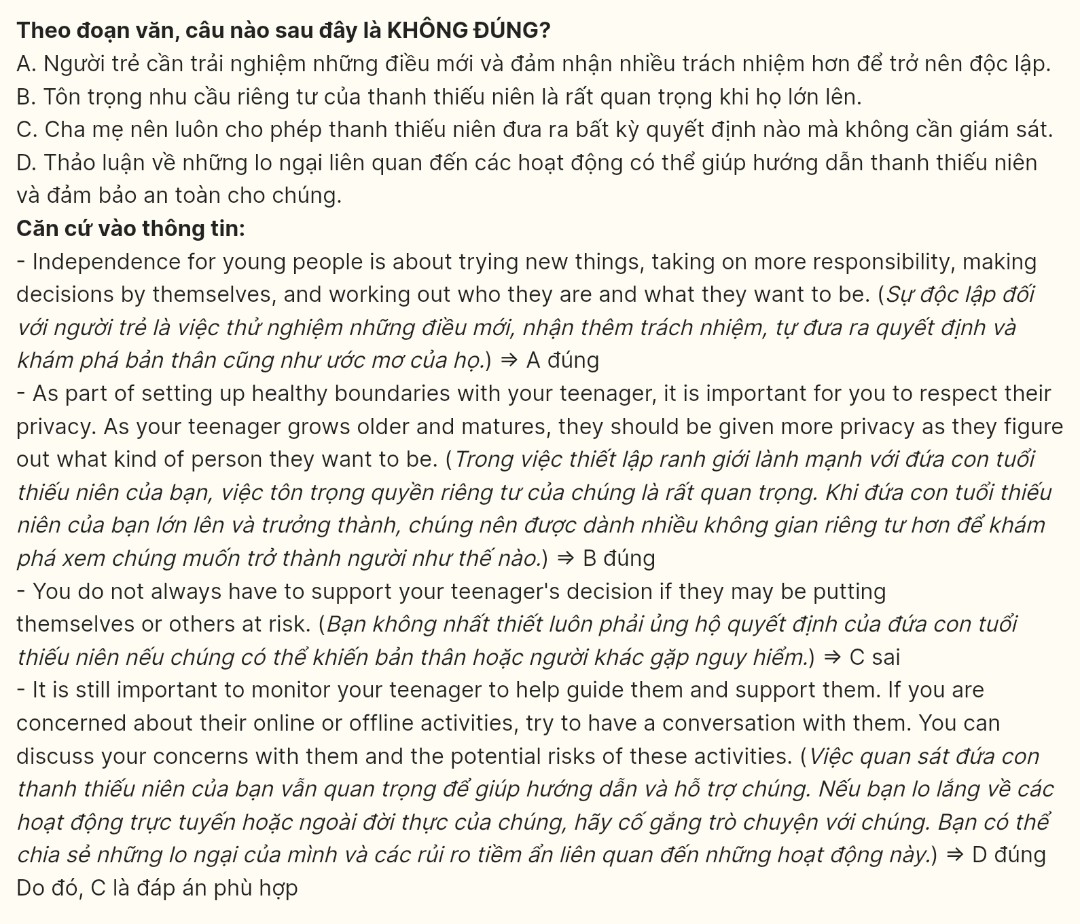
Question 29 [698737]: In which paragraph does the writer mention a present causal relationship?
A. Paragraph 1 B. Paragraph 2 C. Paragraph 3 D. Paragraph 4
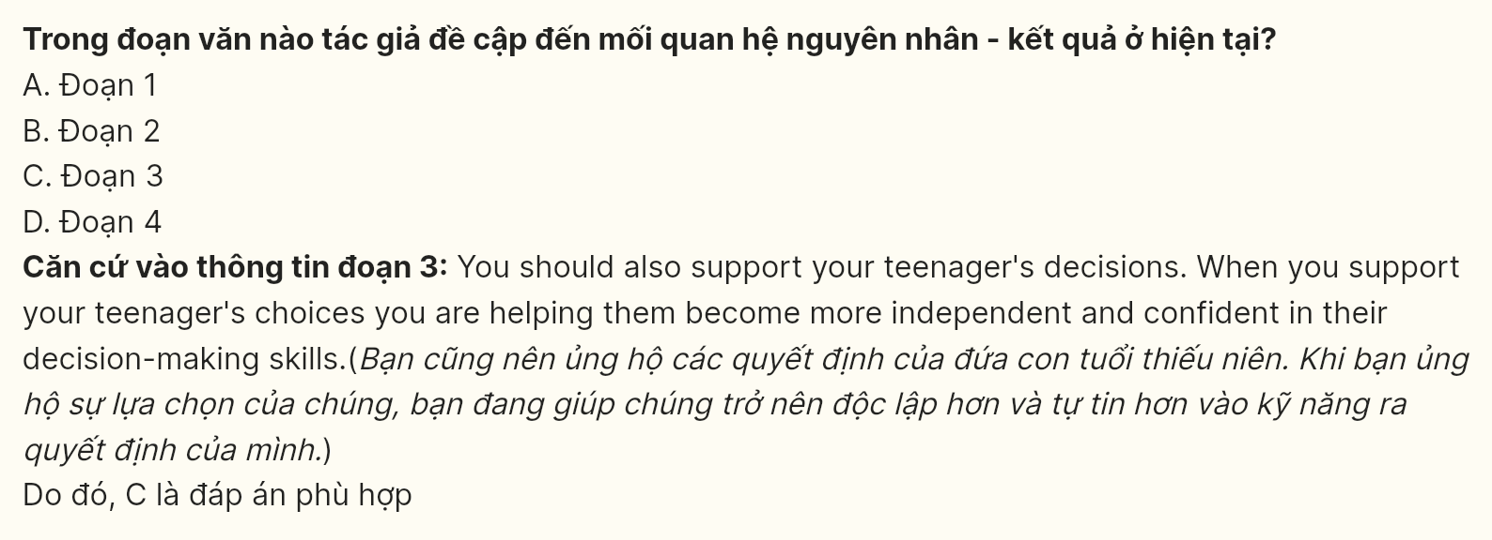
Question 30 [698738]: In which paragraph does the writer mention the importance of assisting teenagers in understanding and learning from their mistakes?
A. Paragraph 1 B. Paragraph 2 C. Paragraph 3 D. Paragraph 4
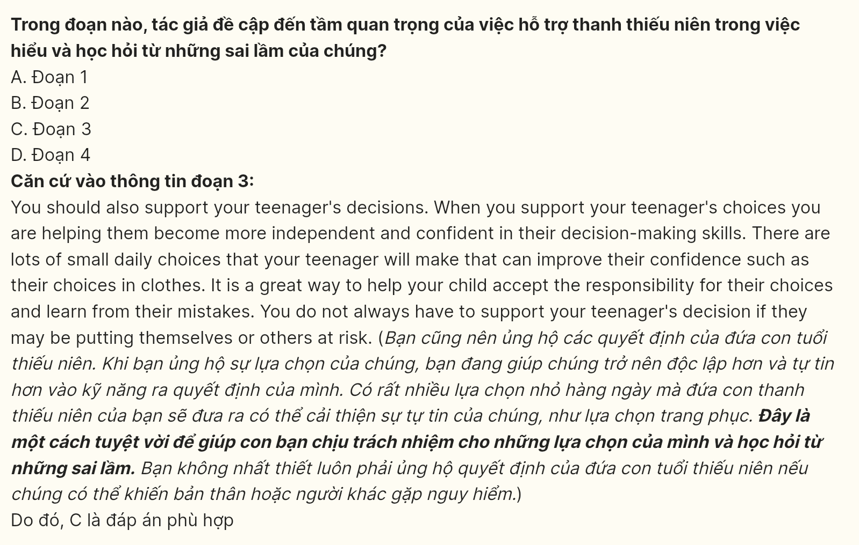
Read the following passage and mark the letter A, B, C, or D on your answer sheet to indicate the option that best fits each of the numbered blanks from 31 to 40.
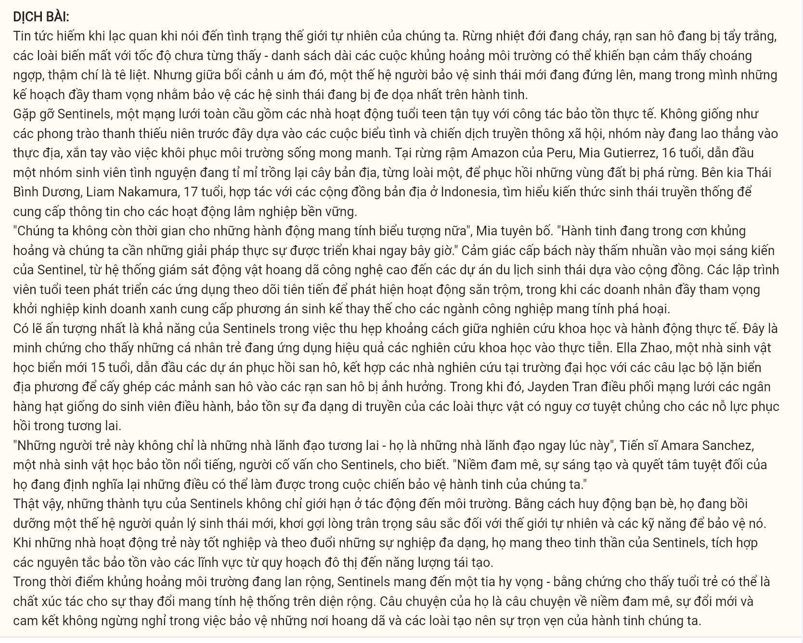
The news is rarely uplifting when it comes to the state of our natural world. Rainforests burning, coral reefs bleaching, species vanishing at an unprecedented rate – the litany of environmental crises can feel overwhelming, even paralyzing. But amid the gloom, a new generation of eco-guardians is stepping up, armed with ambitious plans to safeguard the planet's ecosystems and endangered species.
Meet the Sentinels, a global network of teenage activists dedicated to hands-on conservation work. Unlike previous youth movements that relied on protests and social media campaigns, this cohort is diving directly into the field, getting their hands dirty to restore fragile habitats. In the Peruvian Amazon, 16-year-old Mia Gutierrez leads a team of student volunteers painstakingly replanting native trees, species by species, to revive deforested lands. Across the Pacific, 17-year-old Liam Nakamura collaborates with indigenous communities in Indonesia, learning traditional ecological knowledge to inform sustainable forestry practices.
"We don't have time for symbolic gestures anymore," Mia declares. "The planet is in crisis, and we need real solutions implemented right now." This sense of urgency permeates every Sentinel initiative, from high-tech wildlife monitoring systems to community-based ecotourism ventures. Teenage coders develop advanced tracking apps to detect poaching activity while aspiring entrepreneurs launch green businesses that provide livelihood alternatives to destructive industries.
[I] Perhaps most impressive is the Sentinels' ability to bridge the gap between scientific research and on-the-ground action. [II] Elia Zhao, a 15-year-old budding marine biologist, spearheads coral restoration projects, pairing university researchers with local scuba diving clubs to transplant coral fragments onto damaged reefs. [III] Meanwhile, Jayden Tran coordinates a network of student-run seed banks, preserving the genetic diversity of endangered plant species for future restoration efforts. [IV]
"These young people aren't just future leaders – they're leaders right now," says Dr. Amara Sanchez, a renowned conservation biologist who mentors the Sentinels. "Their passion, creativity, and sheer determination are redefining what's possible in the fight to protect our planet."
Indeed, the Sentinels' achievements extend far beyond environmental impact. By mobilizing their peers, they are cultivating a new generation of eco-stewards, instilling a deep appreciation for the natural world and the skills to defend it. As these young activists graduate and pursue diverse careers, they carry the Sentinels' ethos with them, integrating conservation principles into fields ranging from urban planning to renewable energy.
In a time of overwhelming environmental crises, the Sentinels offer a glimmer of hope – proof that youth can be the catalysts for large-scale, systemic change. Their story is one of passion, innovation, and an unwavering commitment to safeguarding the wild places and species that make our planet whole.
(Adapted from Euronews.com)
Question 31 (698739): According to the passage, which of the following is NOT mentioned as a Sentinel activity?
A. Coral transplanting B. Tree replanting C. Wildlife tracking D. Climate protesting
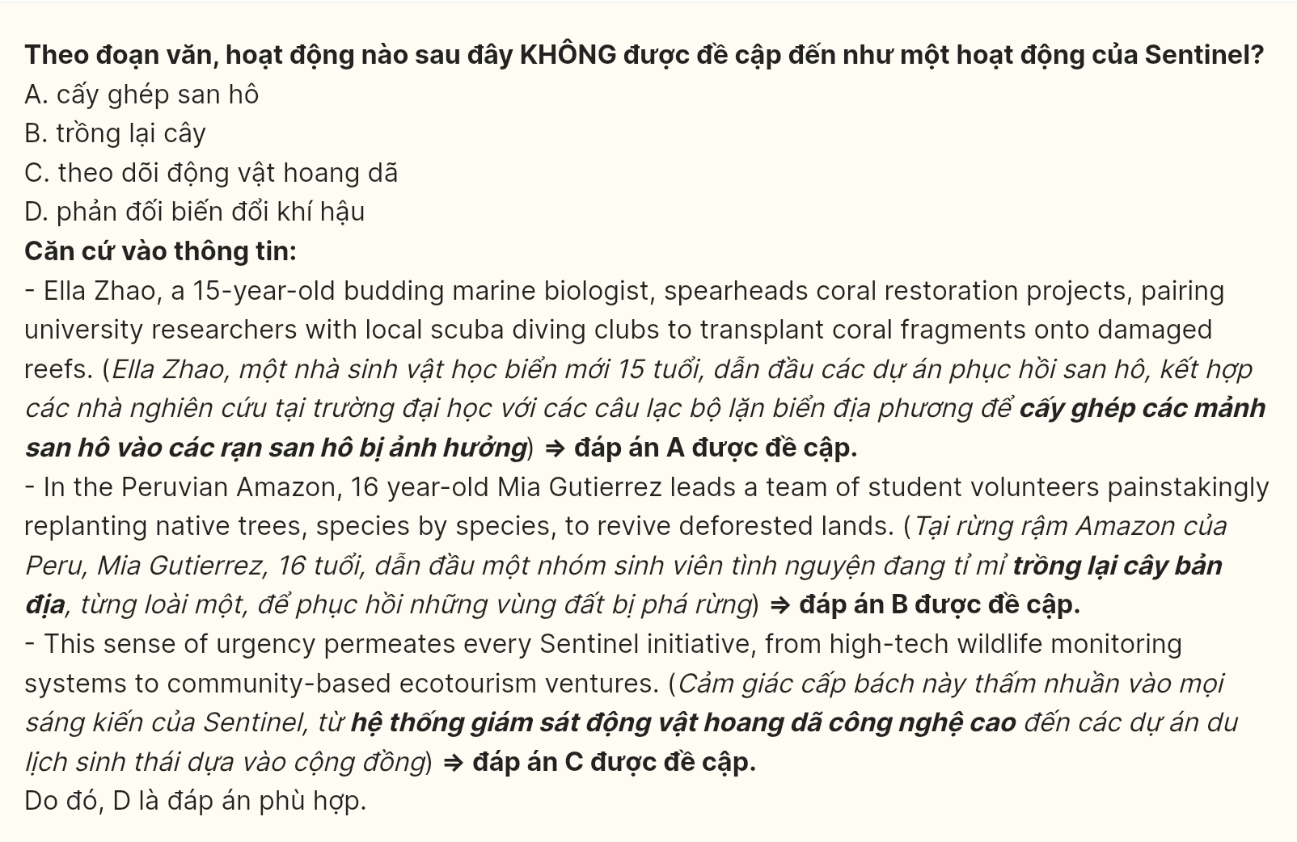
Question 32 (698740): Which of the following best paraphrases the underlined sentence in paragraph 1?
A. Media reports on the natural world’s state are typically disheartening rather than encouraging.
B. Uplifting reports about environmental conditions are rare due to the severity of current crises.
C. The news seldom presents an optimistic perspective given the current state of the natural world.
D. Rather than being uplifting, news about the environment is usually discouraging and gloomy.
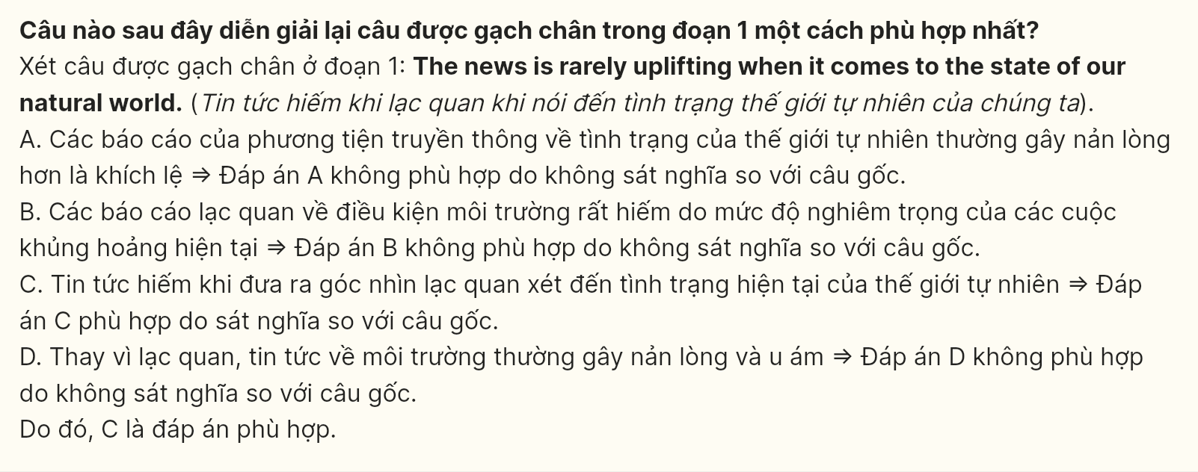
Question 33 (698741): The phrase "getting their hands dirty" in paragraph 2 could best be replaced by _____.
A. engaging directly B. working temporarily
C. starting actively D. participating early
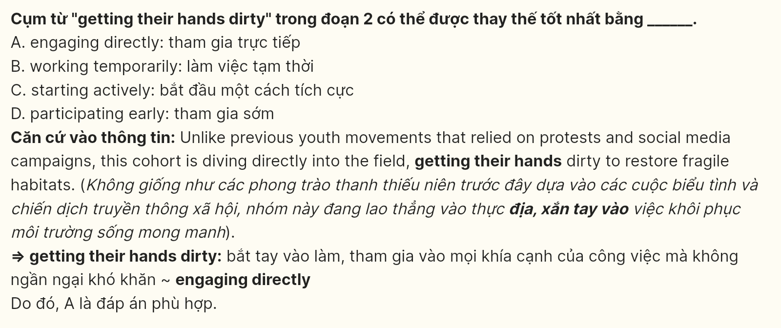
Question 34 (698742): Which of the following best summarizes paragraph 2?
A. Young volunteers are engaging in direct conservation through some local community projects.
B. The Sentinels implement hands-on fieldwork strategies instead of focusing on social media awareness campaigns.
C. The Sentinels are tackling environmental challenges through their practical conservation efforts.
D. A global network of teenage activists is taking direct action to balance the endangered ecosystem.
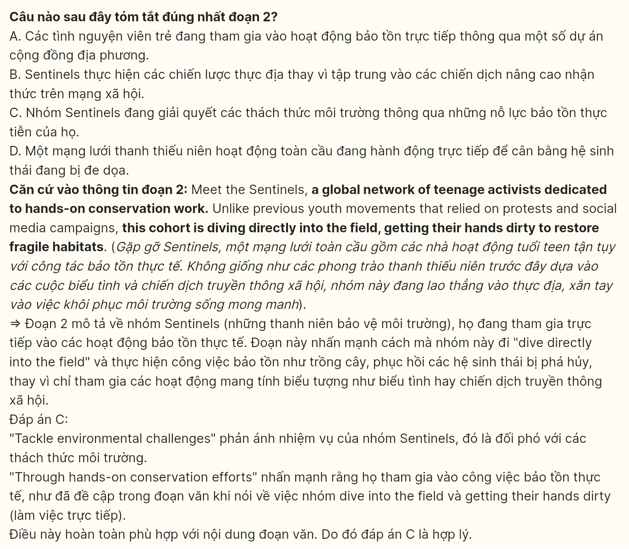
Question 35 (698743): The word "permeates" in paragraph 3 is closest in meaning to _____.
A. pervades B. concentrates C. divides D. restrains
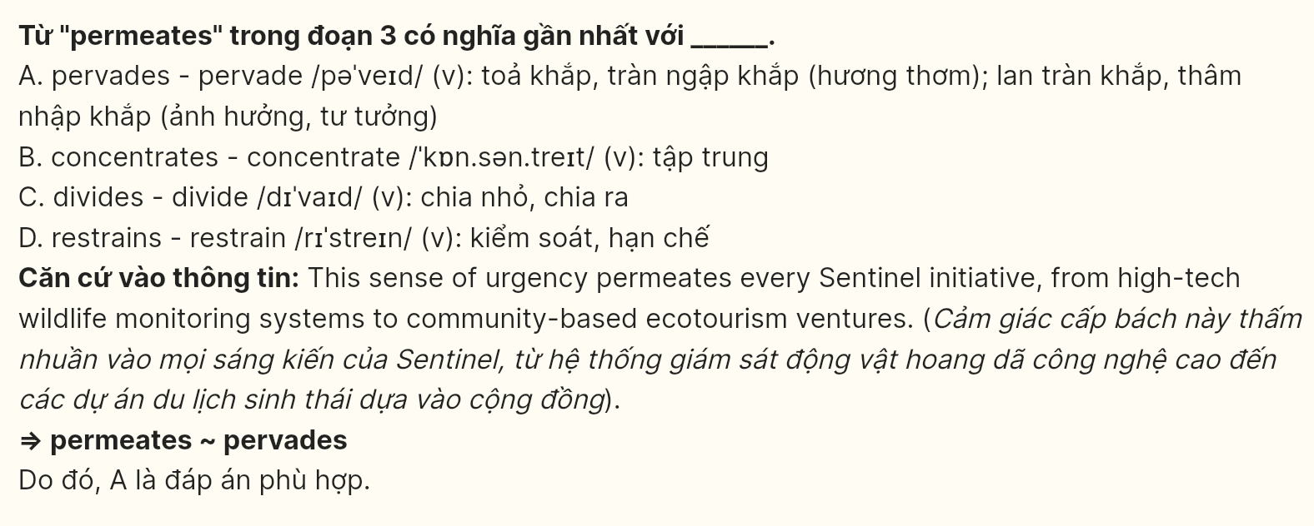
Question 36 (698744): Where in paragraph 4 does the following sentence best fit?
It is a testament to how young individuals are effectively translating scientific research into practical applications.
A. [I] B. [II] C. [III] D. [IV]
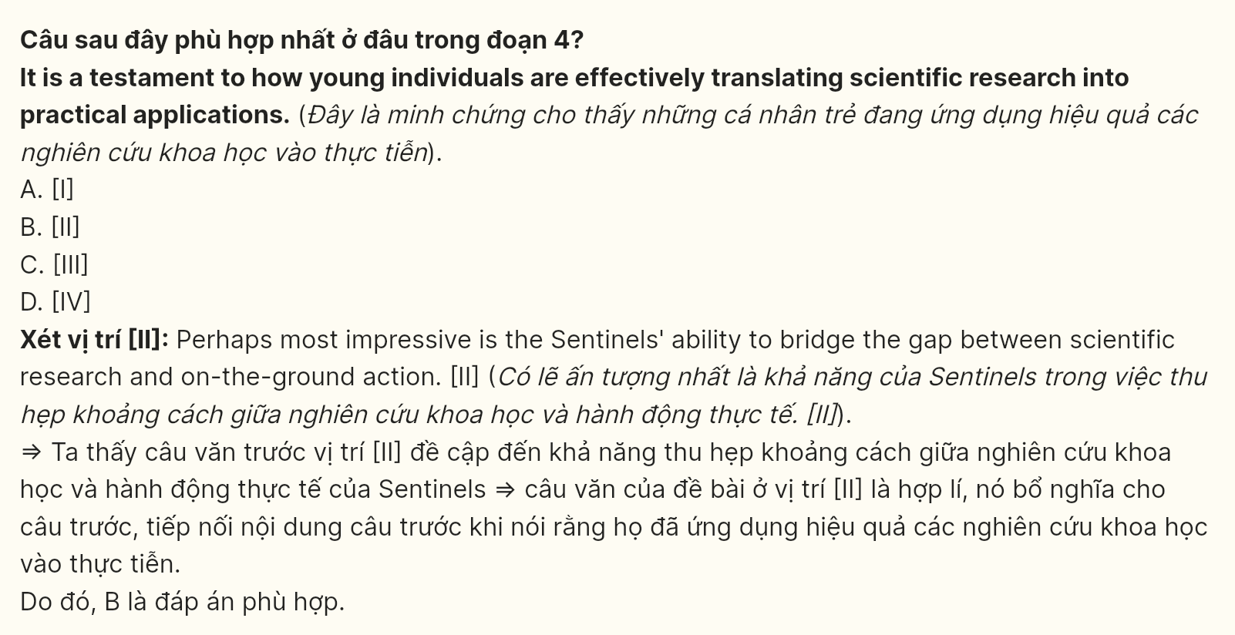
Question 37 (698745): The word "Their" in paragraph 5 refers to _____.
A. The students B. Biologists C. Our planet D. Young people
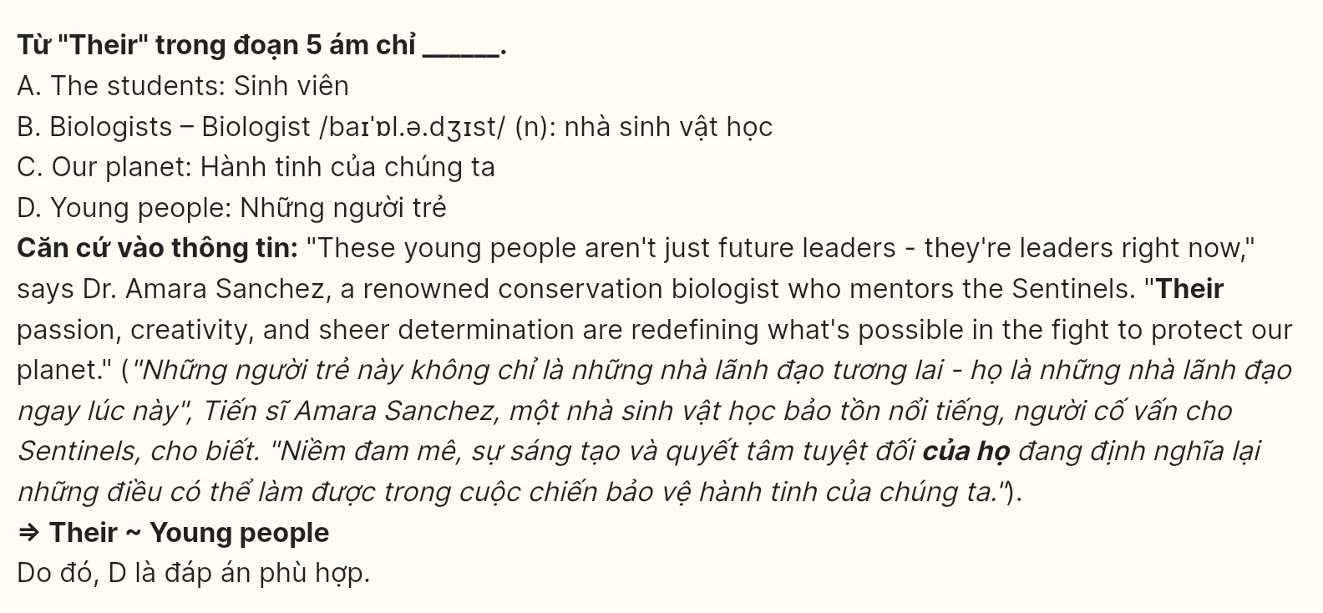
Question 38 [698746]: What can be inferred from the passage?
A. Youth conservation programs rely on digital campaigns to achieve environmental impact.
B. Traditional ecological knowledge will ensure current environmental preservation work.
C. Student research projects have shown better results in some conservation initiatives.
D. Some of the Sentinels’ initiatives translate scientific knowledge into concrete solutions.
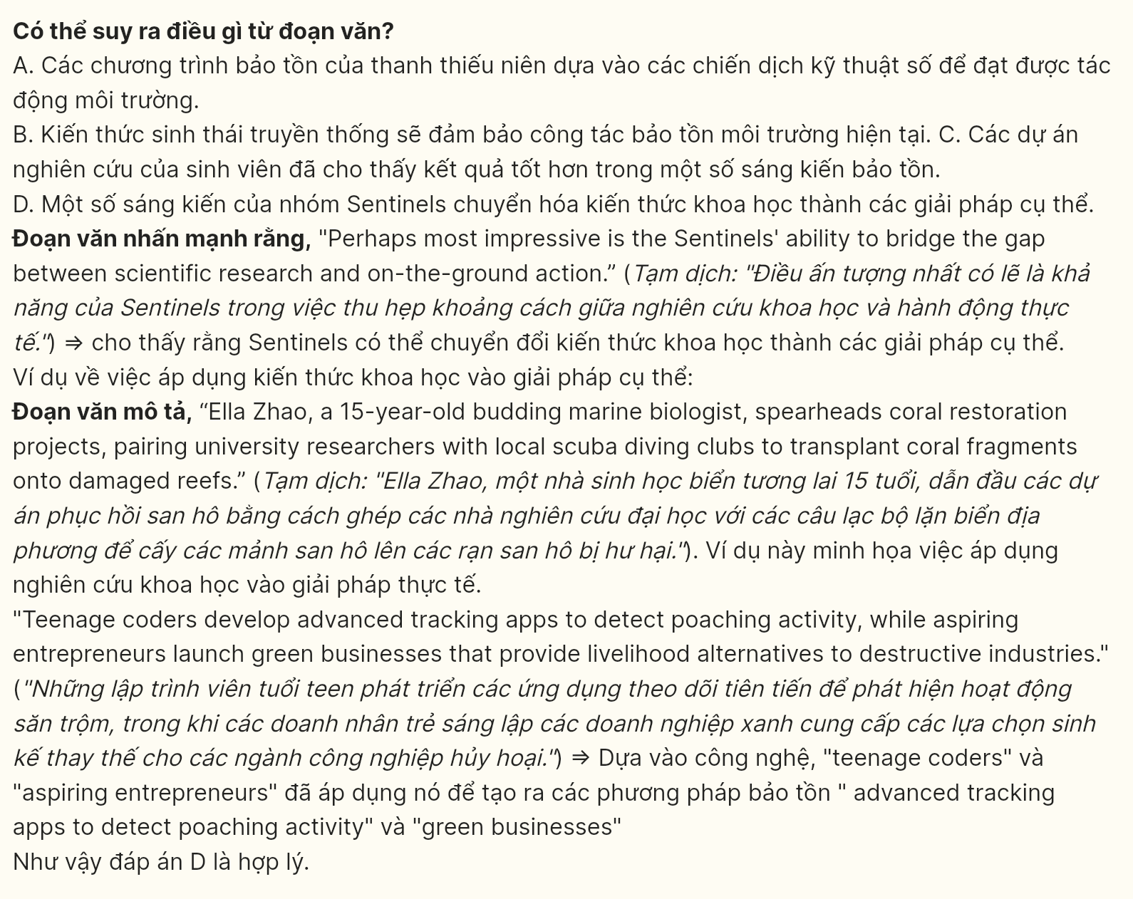
Question 39 [698747]: Which of the following is TRUE according to the passage?
A. Young coders develop digital technologies to identify illegal hunting practices.
B. Student volunteers focus their efforts on marine ecosystem restoration projects.
C. Indigenous communities lead sustainable forestry programs in tropical regions.
D. Environmental activists conduct their research through university partnerships.
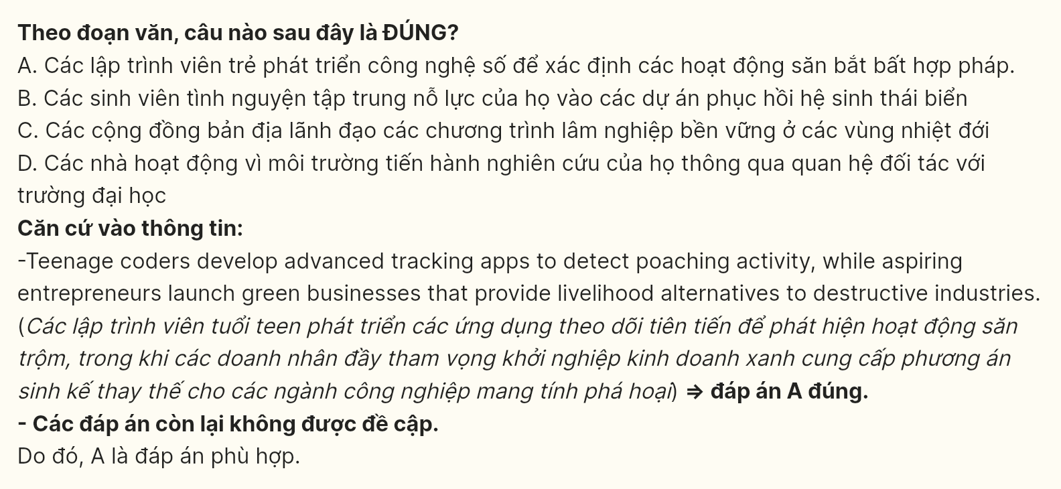
Question 40 [698748]: Which of the following best summarizes the passage?
A. The Sentinels network shows how teenage activists employ innovative solutions by blending fieldwork with digital tracking tools to combat environmental degradation.
B. Young environmentalists combine scientific knowledge with hands-on conservation, working alongside local communities to protect threatened ecosystems.
C. Modern youth conservation movements focus on direct habitat restoration rather than awareness campaigns to address environmental crises.
D. Student conservationists bridge research and implementation by partnering with scientific experts and indigenous knowledge holders.
