**ĐỀ SỐ 13**

**Mark the letter A, B, C, or D on your answer sheet to indicate the word whose underlined part differs from the other three in pronunciation in each of the following questions.**

Question 1. A. after B. advice C. agree D. afraid

**Question 2.** A. salmon B. almost C. behalf D. walk

Mark the letter A, B, C, or D on your answer sheet to indicate the word that differs from the other three in the position of primary stress in each of the following questions.

Question 3. A. attract B. destroy C. level D. occur

Question 4. A. mechanical B. evaporate C. academy D. mathematics

Mark the letter A, B, C, or D on your answer sheet to indicate the correct answer to each of the following questions.

Question 5. I can't go out with you now because I ______ my homework.

A. don't finish B. isn't finishing C. haven't finished D. won't finish

Question 6. They worked for three hours, and then they stopped ______ a rest.

A. have B. having C. to having D. to have

Question 7. You may take ______ you please.

A. whatever books what B. whatever books

C. any books whatever D. which bools whatever

Question 8. He was born blind. But despite his ______, he managed to become one of the top pop singers.

A. ability B. enabling C. inability D. disability

Question 9. Keep ______ me! I've got a terrible cold, and I don't want to give it to you.

A. up with B. away from C. out of D. on with

Question 10. Unselfishness, loyalty, trust and sympathy are some ______ for true friendship.

A. characters B. things C. qualities D. ideas

Question 11. ______ lay eggs, but some give birth to live young.

A. Most insects B. Although most insects

C. Despite most insects D. Most insects that

Question 12. Robert: "______ " - Mary: "I'd love to, but I have an extra class tonight."

A. Would you like to go to the prom with me tonight?

B. Should you go to the prom with me tonight?

C. Would you want to go to the prom with me?

D. Do you think we must go to the prom tonight?

Read the following conversation and mark the letter A, B, C, or D on your answer sheet to indicate the correct option that best fits each of the numbered blanks from 13 to 16.

Hello everyone!

We have some exciting news! This Saturday, we will have a fun school picnic at the park. Please join us at 10 a.m. (**13**) **______** your favourite snacks and drinks. We will play games and enjoy the (**14**) **______**. Don't forget your hats and sunscreen!

If you want to help, please talk to your teacher. We (**15**) **______** volunteers for games and setting up.

Remember, this is a great (**16**) **______** to have fun and make new friends. We hope to see you all there!

Thank you, and have a great day!

**Question 13.** A. FetchB. Hold C. Bring D. Carry

**Question 14.** A. sunshineB. sunbeam C. sunblock D. sunburn

**Question 15.** A. canB. must C. may D. need

**Question 16.** A. option B chance C. possibility D. prospect

**Mark the letter A, B, C, or D to indicate the correct answer to each of the following questions from 17 to 18.**

**Question 17.** ***Put the sentences (a-c) in the correct order, then fill in the blank to make a logical text.***

Teenage life is a special time filled with changes and new experiences. During these years, teenagers go to school, learn important subjects, and make friends. Many enjoy joining clubs or playing sports after school, which helps them stay active and meet new people. At home, they spend time with family but also value their independence.

a. However, this time can also be challenging, as they face pressure from school and peers.

b. Teenagers often like to listen to music, watch movies, and play video games.

c. Social media is popular, as it allows them to connect with friends and share their lives online.

A. a-b-c B. a-c-b C. c-a-b D. b-c-a

Question 18. *Choose the sentence that can end the text (in Question 17) most appropriately.*

A. Generally, teenage life is a mixture of fun, learning, and personal growth.

B. Playing sports and games is one of many teenagers' leisure time activities.

C. Otherwise, this is a hard time for most-of young people to cope with.

D. Many teenagers prefer to go out to join in social activities with their friends.

Read the following passage and mark the letter A, B, C, or D on your answer sheet to indicate the correct word or phrase that best fits each of the numbered blanks from 19 to 24.

Science and technology play a big role in our daily lives. Science helps us understand the world around us. It teaches us about plants, animals, and the universe. (19) ______, scientists study how the weather works and how diseases spread. This knowledge helps us stay healthy and safe.

Technology is how we use science to make tools and machines. Computers, smartphones, and the Internet are all (20) ______ of technology. They make (21) ______ and help us learn new things. With the Internet, we can find information quickly and connect with people from different countries.

In schools, students learn about science and technology to prepare (22) ______ the future. They do experiments, build robots, and explore new ideas. This learning is important because it helps them solve problems, like finding (23) ______ or improving healthcare. Overall, science and technology are essential for progress, helping us improve our lives and (24) ______ the world better. Embracing these fields can lead to exciting opportunities and discoveries.

Question 19. A. In addition B. For example C. In particular D. To illustrate

Question 20. A. products B. produce C. productive D. productions

Question 21. A. easy communication B. communicating easily

C. communication easier D. easier Communication

Question 22. A. in B. into C. for D. in

**Question 23.** A.energy sources clean B. energy clean sources

C. sources clean energy D. clean energy sources

**Question 24.** A. understand B. believe C. recognise D. consider

Mark the letter A, B, C or D on your answer sheet to indicate the sentence that is closest in meaning to the original sentence in each of the following questions.

**Question 25.** Be careful with the knife or you'll hurt yourself.

A. If you are not careful with the knife, you'll hurt yourself.

B. Hurt yourself or you are not careful with the knife.

C. If you were not careful with the knife, you would hurt yourself.

D. Be careful with the knife and hurt yourself at the same time.

**Question 26.** Although the weather was bad, we went to school on time.

A. We didn't go to school late because the weather was bad.

B. We were not late for school in spite of the bad weather.

C. The weather was bad, and so we went to school on time.

D. The weather was bad when it was time for us to go to school.

Mark the letter A, B, C, or D on your answer sheet to indicate the sentence that is made from the given cues in each of the following questions.

**Question 27.** it / get dark / they / decide / return home.

A. When it got dark, they were deciding to return home.

B. It was getting dark, and they decided to return home.

C. As it is getting dark, they decided to return home.

D. It has got dark when they decided to return home.

**Question 28.** use / play football / famous team / too old / play / now.

A. He used the football to play in a famous team and he is too old to play now.

B. He is used to playing for a famous team, but he is too old to play now.

C. He uses to play football for a famous team, but he is too old to play now.

D. He used to play football for a famous team, but he is too old to play now.

**Read the following sign or notice and mark the letter A, B, C, or D on your answer sheet to indicate the correct answer to each of the following questions.**

**Question 29.** What does this sign say?

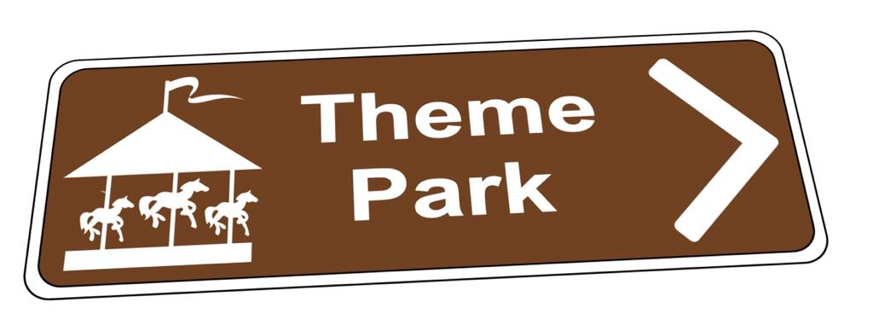

A. Get out of the theme park.

B. Go this way to the theme park.

C. The theme park is open now.

D. There is a free theme park ahead.

**Question 30.** What does the notice say?

**JOIN US FOR COMMUNITY DAY!**

Date: Saturday, April 15

Time: 10 A.M.-4 P.M.

Location: City Square

Food, games, and fun for all!

A. The Community Day is on a weekday.

B. The games and fun will go on until night.

C. There is free food for children.

D. All community members can join the games.

Read the following passage and mark the letter A, B, C, or D on your answer sheet to indicate the correct answer to each of the following questions from 31 to 36.

In today's rapidly advancing world of technology, one field that has captured the imagination of people everywhere is artificial intelligence (AI). AI refers to the ability of machines and computers to perform tasks that typically require human intelligence, such as learning, problem-solving, and decision-making.

One of the most exciting aspects of AI is the way it is **transforming** our lives. From personalised recommendations on our favourite streaming platforms to self-driving cars navigating the roads, AI is becoming increasingly integrated into our daily activities. This is thanks to the development of machine learning, a type of AI that allows systems to learn and improve from data without being explicitly programmed.

However, the integration of AI technology also raises important questions. There are concerns about privacy, the potential for bias, and the impact on jobs as AI systems become more advanced. It is crucial that we address these concerns and ensure that the benefits of AI are distributed fairly and its risks are **minimised.**

Despite these challenges, the potential of AI to improve our lives is undeniable. In fields like healthcare and scientific research, AI has the power to make groundbreaking discoveries and enhance our well-being. As we continue to explore the frontiers of AI, it is essential that we do so with a focus on ethics, transparency, and the betterment of humanity.

**Question 31.** How is AI defined in the paragraph?

A. The ability of machines to programme themselves to serve humans

B. The ability of machines to have human intelligence

C. The ability of machines to defeat humans

D. The ability of machines to perform tasks requiring human intelligence

**Question 32.** One of the most exciting aspects of AI is its ability to **______**.

A. transform our daily lives B. make groundbreaking discoveries

C. learn and improve from data D. increase integration

**Question 33. The** word **transforming** in paragraph 2 is CLOSEST in meaning to **______**.

A. developing B. increasing C. reducing D. changing

**Question 34.** What are some of the concerns raised about the integration of AI technology?

A. Privacy, bias and impact on jobs. B. Power to make groundbreaking discoveries.

C. Fairness and distribution of benefits. D. Integration into our daily activities.

**Question 35.** The word **minimised** in paragraph 3 is OPPOSITE in meaning to **______**.

A. reduced B. maximised C. challenged D. limited

**Question 36.** What is the main idea of paragraph 4?

A. AI poses significant risks that outweigh its potential benefits.

B. AI is a temporary trend that will eventually fade away.

C. AI has the potential to improve our lives in numerous ways.

D. AI is limited to certain industries and not applicable to everyday life.

Four phrases/ sentences have been removed from the text below. For each question, mark the letter A, B, C, or D on your answer sheet to indicate the correct option that best fits each of the numbered blanks from 37 to 40.

One famous art piece is the "Mona Lisa," painted by Leonardo da Vinci. This painting shows a woman with a gentle smile, sitting against a beautiful landscape. The "Mona Lisa" is known for her mysterious expression, (37) ______. The artist used soft colours and delicate brush strokes, giving the painting a lifelike quality. (38) ______. (39) ______, where it attracts millions of visitors each year. Many people visit the museum to see the "Mona Lisa" because it is a symbol of art and beauty. People admire the way da Vinci captured the woman's eyes and smile, making her seem alive. (40) ______. Overall, this artwork is not just a painting; it is a piece of history that connects us to the past and shows the talent of a great artist.

A. The background features mountains and a winding river, adding depth to the scene

B. The "Mona Lisa" has inspired many artists and continues to be a topic of discussion

C. which makes many people curious about her story

D. The painting is located in the Louvre Museum in Paris, France

**Question 37.** _____ **Question 38.** _____ **Question 39.** _____ **Question 40.** _____