School: ……………………………………….. | Date: …………………………………..
Class: ……………………………..................... | Period: ………………………….........

UNIT 9: ENGLISH IN THE WORLD
Lesson 1.3 – Pronunciation and Speaking (page 70)

I. OBJECTIVES
By the end of the lesson, Ss will be able to:
1.1. Language knowledge and skills
- distinguish and use /ð/ sound correctly.
- ask and answer about holiday plan (where to go, where to stay, what to eat, what to do, where to visit).
- make holiday plans.
1.2. Competences
- improve listening and speaking skills.
1.3. Attributes
- love studying English, love travelling.
- respect cultures of other countries in the world.

II. TEACHING AIDS AND LEARNING MATERIALS
1. Teacher’s aids: Student book and Teacher’s book, class CDs, Digital Book (DCR phần mềm tương tác SB, DHA (từ vựng/ cấu trúc) phần mềm trò chơi tương tác), projector/interactive whiteboard / TV (if any), PowerPoint slides, handouts.
2. Students’ aids: Student’s book, workbook, notebook, paper.

III. ASSESSMENT EVIDENCE
Performance Tasks | Performance Products | Assessment Tools
- Listen to the words and focus on the underlined letters. | - Ss’ performance and answers. | - T’s observation.
- Listen and cross out the word that doesn’t follow the note in “a”. | - Ss’ answers. | - T’s feedback/Peers’ feedback.
- Read the words with the sound noted in “a” with a partner. | - Ss’ performance. | - T’s feedback/Peers’ feedback.
- Ask and answer using the questions and the prompts. | - Ss’ performance. | - T’s feedback/Peers’ feedback.
- You're talking to your friend about your holiday plans. In pairs: Student B, turn to page 122, File 9. Student A, answer Student B's questions about Australia. Swap roles. Ask about Canada and complete the table. | - Ss’ performance /  Presentation. | - T’s observation, T’s feedback/Peers’ feedback.
- Which city would be more interesting to visit? Why? | - Ss’ performance /  Answers. | - T’s feedback/Peers’ feedback.

IV. PROCEDURES
A. Warm up: (5’)
a) Objective: Introduce the new lesson and set the scene for Ss to acquire new language; get students' attention at the beginning of the class by enjoyable and short activities as well as to engage them in the follow-up steps.
b) Content: Introduce /ð/ sound / Introduce London and Los Angeles.
c) Expected outcomes: Ss know some information that is useful for them in other speaking activities.
d) Organization of the activity:
TEACHER’S ACTIVITIES | STUDENTS’ ACTIVITIES
- Option 1: Introduce /ð/ sound: Chinese whisper  - Divide class into 4-5 groups.  - Have Ss in each group stand in a straight line.  - Give a sentence, have the last student in each line. whisper this sentence to the student standing before; continue until the first student in the line can hear the sentence and write it on the board.  - Check Ss’ answers.  - The group which has the closest sentence to the original one will be the winner. (T also checks spelling.)  - Announce the winner and give a small present.  - Lead to the new lesson: /ð/ sound.  *Suggested sentence: They want their fathers and mother take them to their fatherland.  Option 2: Introduce: London and Los Angeles  - T introduces London and Los Angeles, using pictures and questions.  - Have Ss answer the questions to find the hidden cities behind the questions. There are 4 questions in each picture.  - Have Ss answer the questions one by one to find out the name of the city.  - Check Ss’ answers.  - The student who has the correct answer from the very first clue will be the winner.  - Announce the winner and give a small present.  - Lead to the new lesson.  *Illustration:  City 1:  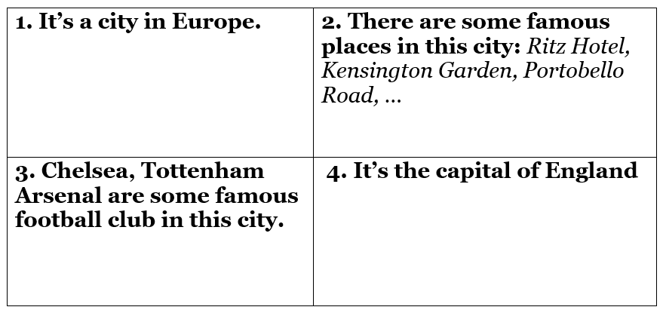  City 2:  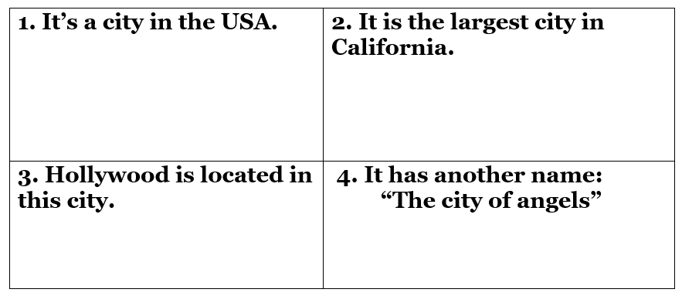 | - Form groups.  - Work in groups to take part in the game.  - The first student of each line writes answer on the board.  - Listen.  - Find the hidden cities behind the questions  - Listen.  Answer keys  City 1: London    City 2: Los Angeles  

B. New lesson (35’)
- Activity 1: Pre-Speaking: Pronunciation (8’)
a) Objective: Introduce: /ð/ sound.
b) Content:
- recognize: /ð/ sound.
- listen and check, cross out the word that doesn’t follow the note in “a”.
- practice.
c) Expected outcomes: Ss distinguish and use /ð/ sound in their speaking.
d) Organization of the activity:
TEACHER’S ACTIVITIES | STUDENTS’ ACTIVITIES
Task a + b. Listen to the words and focus on the underlined letters.  - Play the recording (CD2, track 14) using DCR.  - Ask Ss to listen and focus on the underlined letters.  - Play the recording again, have Ss listen and repeat with a focus on the sound feature.  Task c + d. Listen and cross out the word that doesn’t follow the note in “a”.  - Play the recording (CD 2 – Track 15), have Ss listen and cross out the option that doesn’t follow the note in “a”.  - Call Ss to give answers.  - Play the recording again and check answers as a whole class using DCR.  - Give feedback and evaluation. | - Listen.  - Listen again and repeat.  - Listen and give answers.  Answer keys  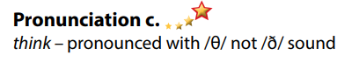
- Activity 2: While-speaking (22’)
a) Objective: Students can talk about plan for a trip (where to go, where to stay, what to eat, what to do, where to visit, …).
b) Content:
- Ask and answer using the questions and the prompts.
- You're talking to your friend about your holiday plans. In pairs: Student B, turn to page 122, File 9. Student A, answer Student B's questions about Australia. Swap roles. Ask about Canada and complete the table.
c) Expected outcomes: Ss produce the new language successfully.
d) Organization of the activity:
TEACHER’S ACTIVITIES | STUDENTS’ ACTIVITIES
PRACTICE  * Ask and answer using the questions and the prompts.  - Demonstrate the activity by practicing the role-play with a student.  - Divide the class into pairs.  - Have pairs practice the conversation.  - Swap roles and repeat using the ideas in the table.  - Observe, give help if necessary.  - Have some pairs demonstrate the activity in front of the class.  - Give feedback and evaluation.  SPEAKING: What an Amazing Trip!  Task a. You're talking to your friend about your holiday plans. In pairs: Student B, turn to page 122, File 9. Student A, answer Student B's questions about Australia. Swap roles. Ask about Canada and complete the table.  - Demonstrate the activity by practicing the activity with a student.  - Divide the class into pairs.  - Have Student B turn to page 122, File 9.  - Have Student B ask Student A questions and complete the table.  - Have students swap roles and repeat.  - Observe, give help if necessary.  - Have Ss pay attention to the tip:  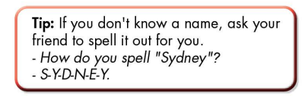 | - Observe, listen.  - Work in pairs.  - Present.  - Observe and listen.  - Work in pairs.  - Discuss and complete the table.

- Activity 3: Production (5’)
a) Objective: Students report the results.
b) Content: Which city would be more interesting to visit? Why?
c) Expected outcomes: Ss produce the new language successfully in everyday speaking and writing.
d) Organization of the activity:
TEACHER’S ACTIVITIES | STUDENTS’ ACTIVITIES
Task b. Which city would be more interesting to visit? Why?  - Have students discuss in pairs which city would be more interesting to visit.  - Have some students share their findings with the class.  - Give feedback and evaluation. | - Discuss in pairs.  - Present.

C. Consolidation and homework assignments (5’)
* Consolidation: Some sords with /ð/ sound: they, them, then, this, that, these, those, father, mother, weather, breathe, other, either, whether, then, although, brother, southern.
* Homework:
- Practice: reading /ð/ sound.
- Find more words with /ð/ sound.
- Prepare: Unit 9 - Lesson 2.1 – New words and Listening (page 71 – SB).
- Review the vocabulary and grammar notes in Tiếng Anh 7 i-Learn Smart World Notebook
(pages 54 & 55).
- Play consolation games in Tiếng Anh 7 i-Learn Smart World DHA App on www.eduhome.com.vn

D. Reflection
a. What I liked most about this lesson today:
…………………………………………………………………………………………
- What I learned from this lesson today:
…………………………………………………………………………………………
c. What I should improve for this lesson next time:
…………………………………………………………………………………………

