**TIẾNG ANH 8 – FRIENDS PLUS**

**UNIT 1 – TEST 1**

**KEY**

**I. PRONUNCIATION**

**Câu 1.** Which word has the underlined part pronounced differently from that of the others?

**A.** app **B.** fad **C.** craze **D.** gadget

**Đáp án đúng:** C

A. app /æp/

B. fad /fæd/

C. craze /kreɪz/

D. gadget /ˈɡædʒɪt/

**Câu 2.** Which word has the underlined part pronounced differently from that of the others?

**A.** music **B.** trouser **C.** toys **D.** social

**Đáp án đúng:** D

A. music /ˈmjuːzɪk/

B. trouser /ˈtraʊzə(r)/

C. toys /tɔɪz/

D. social /ˈsəʊʃl/

**Câu 3.** Which word has a different stress pattern from that of the others?

**A.** era **B.** follow **C.** bamboo **D.** fashion

**Đáp án đúng:** C

A. era /ˈɪərə/ - /ˈɪrə/ - /ˈerə/

B. follow /ˈfɒləʊ/

C. bamboo /ˌbæmˈbuː/

D. fashion /ˈfæʃn/

**Câu 4.** Which word has a different stress pattern from that of the others?

**A.** musician **B.** media **C.** interest **D.** indigo

**Đáp án đúng:** A

A. musician /mjuˈzɪʃn/

B. media /ˈmiːdiə/

C. interest /ˈɪntrəst/

D. indigo /ˈɪndɪɡəʊ/

**II. Choose the answer (A, B, C or D) that best fits the space in each question.**

**Câu 5.** Jennie (Blackpink) is a celebrity with millions of _______ on Instagram.

**A.** users **B.** followers **C.** believers **D.** gamers

**Đáp án đúng:** B

**Câu 6.** Do you spend any time _______ Angry Birds online?

**A.** play **B.** played **C.** to play **D.** playing

**Đáp án đúng:** D

**Câu 7.** The article below will show you eight _______ tips to make the hobby more fun.

**A.** collecting-card **B.** card-collect **C.** card-collecting **D.** collect-card

**Đáp án đúng:** C

**Câu 8.** I am wearing hats and _______ clothes to hide my real identity when I meet the clients.

**A.** baggy **B.** expensive **C.** patterned **D.** knee-length

**Đáp án đúng:** A

**Câu 9.** My sister is really _______ shopping and fashion, but I hate it.

**A.** about **B.** into **C.** at **D.** In

**Đáp án đúng:** B

**Câu 10.** She _______ like chocolate, but she does now.

**A.** use to **B.** used to **C.** didn't used to **D.** didn't use to

**Đáp án đúng:** D

**Câu 11.** I _______ work, walked to the beach and found a nice place to swim.

**A.** finish **B.** finished **C.** was finishing **D.** used to finish

**Đáp án đúng:** B

**Câu 12.** We suddenly _______ an old school friend when we _______ in a café.

**A.** saw / were sitting **B.** were seeing / sat **C.** saw / sat **D.** were seeing / were sitting

**Đáp án đúng:** A

**Câu 13.** Living in a flat is all right, but it has its limitations - _______, you don't have your own garden.

**A.** for good **B.** for sale **C.** for all **D.** for instance

**Đáp án đúng:** D

**Câu 14.** Anna: “What do you think of these boots?” - Megan: “_______”

**A.** That’s better. **B.** They look really good. **C.** You’re right. **D.** Really?

**Đáp án đúng:** B

**III. Look at each sign or notice. Choose the best answer (A, B, C or D) that matches its meaning.**

**Câu 15.** What does this sign mean?

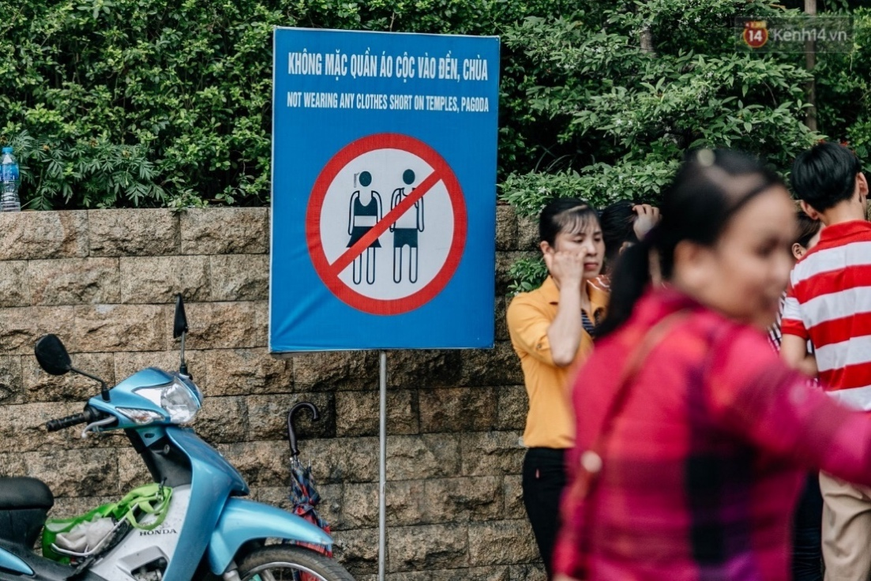

**A.** Visitors are allowed to wear short skirts to pagodas.

**B.** Visitors shouldn’t buy anything in temples or pagodas.

**C.** Visitors can make noises in pagodas and temples.

**D.** Visitors mustn’t wear shorts to temples and pagodas.

**Đáp án đúng:** D

**Câu 16.** What does the notice say?

|  |
| --- |
| *Subscribe to our mailing list and enjoy a* ***15% OFF*** *your first full price order.* |

**A.** You can take 15% off all items. **B.** You must sign up for the latest updates.

**C.** It is only applicable to your first order. **D.** You’ll get promotional codes if you phone the store.

**Đáp án đúng:** C

**IV. Read the following and do as directed.**

The outbreak of the Covid-19 has negatively affected fashion industries in developing countries. Like other Asian countries, Viet Nam is under a lot of pressure to thrive the fashion industry by carrying out reforms after the pandemic. Many people realize that fast fashion trends are not environmentally friendly, and they have turned to garments that cause no harm to the environment.

The concept of sustainable fashion in Viet Nam is almost too new as there are a few organizations working on recycling and restoration of old clothes. The country’s economic development has led to the trend that customers are inclined to choose cheap and mass-produced clothing items but quickly reject them. As a result, every year tons of clothes are thrown away in Viet Nam.

It is hoped that the situation will change soon. Some fashion designers begin to make clothes from durable materials such as natural cotton, bamboo and recycled polyester. These materials do not wear out easily and are strong enough for consumers to use over a long period of time. Moreover, local consumers, especially the youth, are willing to pay more for sustainable goods. Nearly 70% of surveyed consumers said that they chose to use eco-friendly clothing products which could save water and electricity.

**True/False Questions:**

**Câu 17.** The Covid-19 pandemic has had no influence on Viet Nam’s fashion industry.

**A.** True **B.** False

**Đáp án đúng:** B

**Câu 18.** The concept of sustainable fashion in Viet Nam is nothing new.

**A.** True **B.** False

**Đáp án đúng:** B

**Câu 19.** Fast fashion means that clothing items are mass-produced and thrown away quickly.

**A.** True **B.** False

**Đáp án đúng:** A

**Câu 20.** Young consumers don’t mind spending more money on clothes that are environmentally friendly.

**A.** True **B.** False

**Đáp án đúng:** A

**Choose the correct answer to each question:**

**Câu 21.** What does the passage mainly discuss?

**A.** Viet Nam’s fashion weeks after the pandemic. **B.** How to create a new fashion brand.

**C.** Sustainable fashion trends in Viet Nam. **D.** Durable materials used to make clothes.

**Đáp án đúng:** C

**Câu 22.** It can be inferred that Viet Nam’s fashion industry ______.

**A.** has developed faster than ever before

**B.** needs governmental policies to promote the use of eco-friendly garments

**C.** begin to save water and electricity as soon as possible

**D.** is highly likely to turn to green products in the future

**Đáp án đúng:** D

**V. Choose the word (A, B, C or D) that best fits each blank space in the following passage.**

I have always been a huge (23) ______ of video games, and no other game has developed my creativity like Minecraft. First released in 2011, the game is the (24) ______ game in history with over 140 million active players every month. In this game, I can not only explore many different worlds and builds from the simplest of homes to the grandest of castles, but also (25) ______ my own stories, write my own destiny and bring my fantasies to life.

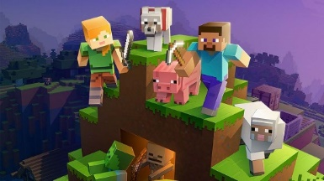What I really like about Minecraft is that the game allows me to interact with other players who have a common interest. We can communicate with each other, gather materials for construction and fend (26) ______ potential risks together. Other games may let you buy a home with the money you earn, but (27) ______ of them really challenge you to search for building elements and make it yourself. What a (28) ______ of ownership!

**Câu 23.** Choose the correct answer.

**A.** fin **B.** fan **C.** form **D.** film

**Đáp án đúng:** B

**Câu 24.** Choose the correct answer.

**A.** sold best **B.** selling-best **C.** best-selling **D.** best-to-sell

**Đáp án đúng:** C

**Câu 25.** Choose the correct answer.

**A.** tell **B.** say **C.** inform **D.** answer

**Đáp án đúng:** A

**Câu 26.** Choose the correct answer.

**A.** up **B.** in **C.** off **D.** with

**Đáp án đúng:** C

**Câu 27.** Choose the correct answer.

**A.** all **B.** both **C.** no **D.** none

**Đáp án đúng:** D

**Câu 28.** Choose the correct answer.

**A.** sense **B.** icon **C.** symbol **D.** emotion

**Đáp án đúng:** A

**VI. Supply the correct form of the word given in each sentence.**

**Câu 29.** In modern times, smartphone is one of the _______ gadgets every man should own. **(TECHNOLOGY)**

**Đáp án đúng:** TECHNOLOGICAL / HI-TECH / HIGH-TECH

**Câu 30.** You will be able to solve the Rubik’s Cube if you follow my step-by-step _______. **(INSTRUCT)**

**Đáp án đúng:** INSTRUCTIONS

**Câu 31.** Listen! Tom and Jerry are _______ having a quarrel. **(APPARENT)**

**Đáp án đúng:** APPARENTLY

**Câu 32.** They paid less for the house because it was in a/an ______ part of town. **(FASHION)**

**Đáp án đúng:** UNFASHIONABLE

**Câu 33.** I had been suffering from performance anxiety in the moments before ______ and had to learn how to manage these anxieties. **(COMPETITION)**

**Đáp án đúng:** COMPETING

**Câu 34.** It's interesting at parties to see how people interact ______. **(SOCIETY)**

**Đáp án đúng:** SOCIALLY

**VII. Rearrange the groups of words in a correct order to make complete sentences.**

**Câu 35.** How do / past crazes? / differ from / current crazes

**Đáp án đúng:** How do current crazes differ from past crazes?

**Câu 36.** and flared trousers. / for Vietnamese people / During the eighties, / the most common outfit / was a loose shirt

**Đáp án đúng:** During the eighties, the most common outfit for Vietnamese people was a loose shirt and flared trousers.

**VIII. Rewrite each of the following sentences in another way so that it means almost the same as the sentence printed before it.**

**Câu 37.** My uncle was a bus driver when he was young.

🡪 My uncle used ___________________________________________________________________________

**Đáp án đúng:** My uncle used to be a bus driver when he was young.

**Câu 38.** Sarah used to pay the bills.

🡪 The bills ________________________________________________________________________________

**Đáp án đúng:** The bills used to be paid by Sarah.

**Câu 39.** It is interesting to read the book. **(INTERESTED)**

🡪 I am ___________________________________________________________________________________

**Đáp án đúng:** I am interested in reading the book.

**Câu 40.** How about trying on the shirt?

🡪 Why not ________________________________________________________________________________

**Đáp án đúng:** Why don’t you try on the shirt? / Why don’t you try the shirt on?

**------ HẾT ------**