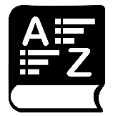

**PART 2: VOCABULARY**

|  |  |  |  |
| --- | --- | --- | --- |
| ENGLISH | TYPE | PRONUNCIATION | VIETNAMESE |
| **fashion** | (n) | */ˈfæʃn/* | Thời trang |
| **music** | (n) | */ˈmjuːzɪk/* | Âm nhạc |
| **performance** | (n) | */pərˈfɔːrməns/* | Buổi trình diễn |
| **puppet** | (n) | */ˈpʌpɪt/* | Con rối |
| **show** | (n) | */ʃəʊ/* | B.trình diễn, chương trình |
| **stand** | (n) | */stænd/* | Quầy bán hàng |
| **talent** | (n) | */ˈtælənt/* | Tài năng |
| **tug of war** | (n) | */ˌtʌɡ əv ˈwɔːr/* | Kéo co |
| **buy** | (v) | */baɪ/* | Mua |
| **candy** | (n) | */ˈkændi/* | Kẹo |
| **decorate** | (v) | */ˈdekəreɪt/* | Trang trí |
| **fireworks** | (n) | */ˈfaɪərwɜːrk/* | Pháo hoa |
| **flower** | (n) | */ˈflaʊər/* | Hoa |
| **fruit** | (n) | */fruːt/* | Hoa quả |
| **gift** | (n) | */ɡɪft/* | Quà tặng |
| **lucky money** | (n) | */ˈlʌki ˈmʌni/* | Tiền lì xì |
| **parade** | (n) | */pəˈreɪd/* | Buổi diễu hành |
| **traditional** | (adj) | */trəˈdɪʃənl/* | Truyền thống |
| **visit** | (v) | */ˈvɪzɪt/* | Thăm, tham quan |
| **hopscotch** | (n) | */ˈhɑːpskɑːtʃ/* | Trò chơi ô lò cò |
| **wrestling** | (n) | */ˈreslɪŋ/* | Môn đấu vật |
| **martial** | (adj) | */ˈmɑːrʃl/* | Hùng dũng |
| **basketball** | (n) | */ˈbæskɪtbɔːl/* | Bóng rổ |
| **overseas** | (adj) | */ˌəʊvərˈsiːz/* | Hải ngoại |
| **exchange new year’s wishes** | (v) | */ɪksˈtʃeɪndʒ njuː jɪə(r)s wɪʃɪz/* | chúc tết nhau |
| **dress up** | (v) | */dres ʌp/* | ăn diện |
| **sweep the floor** | (v) | */swiːp ðə flɔː(r)/* | quét nhà |
| **celebrate** | (v) | */ˈselɪbreɪt/* | kỷ niệm |
| **family gathering** | (n) | */ˈfæməli ˈɡæðərɪŋ/* | sự sum họp gia đình |
| **make a wish** | (v) | */meɪkə wɪʃ/* | ước một điều ước |
| **belief** | (n) | */bɪˈliːf/* | niềm tin |

**Task 1. Look at the pictures and complete the blanks with the words given.**

|  |  |  |  |
| --- | --- | --- | --- |
| **Tet** | **La Tomatina** | **Halloween** | **Easter** |
| **Christmas** | **Mid-Autumn Festival** | **Carnival** | **Thanksgiving** |

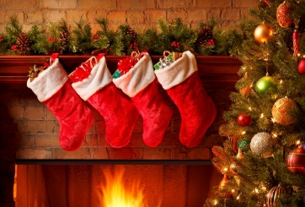 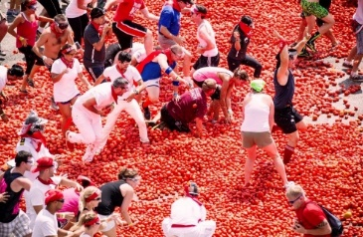 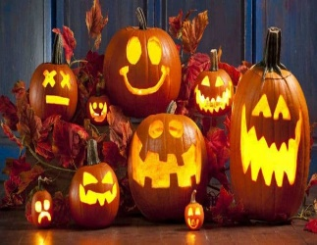 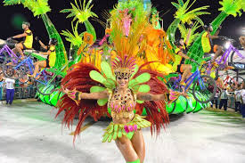

3…………………

1……………………………………………

2…………………

4……………………………………………

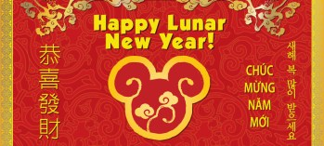 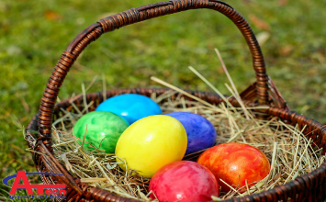 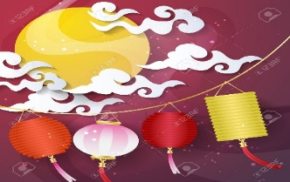 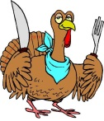

5…………………

8……………………………………………

7……………………………………………

6……………………

**Task 2. Put the following words about Tet into these columns.**

*fireworks egg rolls kumquat tree brother*

*candy flower market blossoms pagoda*

*grandparents Chung cake relatives lucky money fruits*

*balloon Red envelope envelope hometown cousin*

*friends*

|  |  |  |  |
| --- | --- | --- | --- |
| **Things** | **Places** | **Food** | **People** |
| ………………….  ………………….  ………………….  ………………….  …………………. | ………………….  ………………….  ………………….  ………………….  …………………. | ………………….  ………………….  ………………….  ………………….  …………………. | ………………….  ………………….  ………………….  ………………….  …………………. |

**Task 3. Use the given words to label the picture.**

|  |  |  |
| --- | --- | --- |
| watch fireworks | decorate a house or tree | watch parades |
| eat traditional foods | get lucky money, candy, or gifts | watch Korean wrestling |
| visit family and friends | play games or music | buy fruits or flowers |

|  |  |  |
| --- | --- | --- |
| **Watch fireworks** | **Decorate a house or tree** | **watch parades** |
| **1.** | **2.** | **3.** |
| **buy fruits or flowers** | **play games or music** | **visit family and friends** |
| **4.** | **5.** | **6.** |
| **eat traditional foods** | **get lucky money, candy, or gifts** | **watch wrestling** |
| **7.** | **8.** | **9.** |

10. I’m not very at Math. I often make mistakes in calculations.

**Task 4. Fill in the blanks with the words from the box.**

|  |  |  |  |
| --- | --- | --- | --- |
| get lucky money | rarely | fireworks | always |
| talent show | eat traditional foods | food stands | never |

**1.** I **rarely** eat fast food. I don't like the taste and it often makes me sick.

**2.** My favorite part about Tết is to____________________. I usually use it to buy new books.

**3.** I think you should participate in the____________________. You can dance really well.

**4.** Mary____________________ waters her flowers before going to school. She waters them every morning.

**5.** I want to check out the____________________. All the dishes look very tasty.

**6.** Let's watch____________________ together. My mom lets us stay up late and you can sleep at my apartment.

**7.** We____________________ go out after eight. My dad doesn't think it's safe.

**8.** We____________________ such as stollen, a special cake, on Christmas Day.

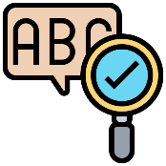

**PART 3: GRAMMAR**

**I. Adverbs of frequency**

***1. Định nghĩa trạng từ chỉ tần suất trong ngữ pháp tiếng Anh***

Trạng từ chỉ tần suất là trạng từ dùng để biểu đạt hay mô tả về mức độ thường xuyên xảy ra của một sự kiện, hiện tượng nào đó.

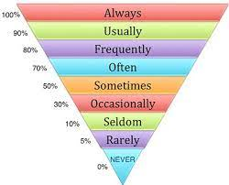

|  |  |  |
| --- | --- | --- |
| **%** | **Adverbs of frequency** | **Examples** |
| 100% | **always** (Luôn luôn) | I **always** brush my teeth at night. |
| 90% | **usually** (Thường xuyên) | I **usually** walk to school. |
| 70% | **often** (Thường thường) | I **often** play soccer. |
| 50% | **sometimes** (Thỉnh thoảng) | I **sometimes** sing a song. |
| 5% | **rarely** (Hiếm khi) | I **rarely** get bad marks. |
| 0% | **never** (Không bao giờ) | I **never** go to school late. |

**⮴ Only approximate numbers**

***2. Vị trí của trạng từ chỉ tần suất trong câu***

Cách dùng trạng từ này tương tự như các trạng từ khác trong ngữ pháp tiếng Anh, đứng sau động từ to be và trước động từ thường, và thường có các ý nghĩa như dưới đây:

***⚫ Trạng từ đứng sau động từ To be***

She is ***always*** patient when teaching her students.  
*(Cô ấy luôn kiên nhẫn khi giảng bài cho học sinh của mình.)*

***⚫ Trạng từ đứng trước động từ thường***

She ***usually*** comes back home at 7 p.m.  
*(Cô ấy thường xuyên về nhà vào 7 giờ tối.)*

***⚫ Trạng từ đứng trước trợ động từ và động từ chính***

Marry has ***never*** attended this kind of competition before.  
*(Marry chưa bao giờ tham dự cuộc thi như thế này trước đây.)*

***⚫ Trong ngữ pháp tiếng Anh, trạng từ chỉ tần suất đôi khi đứng ở đầu câu hoặc cuối câu (trừ hardly ever, never)***

***Sometimes***, I don’t understand what you are thinking.  
*(Thỉnh thoảng tôi chẳng hiểu bạn đang nghĩ gì.)*

**II. Present Simple for future use.**

Thì hiện tại đơn diễn tả công việc cụ thể (có kế hoạch xác định) trong tương lai như là thời khóa biểu hay chương trình, lịch trình cụ thể.

- The meeting **starts** at 8.00 tomorrow.

- The train **leaves** at 5.00.

- The shops **open** at 7.00 tomorrow.

**Task 1.Verbs form:**

***I. Use the right form of the verbs with each adverb of frequency.***

**1.** Our teacher, Mrs. Jones, (never/ [be](https://jes.edu.vn/qua-khu-cua-be-la-gi-mot-so-vi-du))____________________ late for lessons.

**2.** I (often/ clean)____________________ my bedroom at the weekend.

**3.** My brother (never/ help)____________________ me with my homework.

**4.** I (sometimes/ be)____________________ bored in the Maths lessons.

**5.** We (rarely/ watch)____________________ football on TV.

**6.** You and Tony (never/ play)____________________ computer games with me.

**7.** You (usually/ be)____________________ at the sports centre on Sunday.

**8.** The school bus (always/ arrive)____________________ at half past eight.

***II. Fill in the blanks using the Present Simple.***  
**1.** What time does the music performance____________________? (**start**)  
**2.** Does the café____________________ in the morning? (**open**)  
**3.** The train____________________ at 4:45 p.m. (**leave**)  
**4.** What time does the restaurant____________________? (**close**)  
**5.** The puppet show____________________ in ten minutes. (**end**)  
**6.** What time does the bus____________________?  (**leave**)

**Task 2. Give the correct form of the word given to complete the sentences.**

1. The Chinese New Year marks the ____________spring and the start of the Lunar New Year. **(begin)**

11. Streets are decorated with lights and red banners. **(colour)**

12. It is____________ in America to eat turkey on Thanksgiving Day. **(tradition)**

13. Vietnam’s New Year is ____________ according to the Lunar calendar. **(celebrate)**

14. What forms of ____________do you participate in during the festival? **(entertain)**

15. Her eyes were wide with ____________ when she heard the news. **(excite)**

16. A masquerade is a ______________ gathering of people wearing masks. **(festival)**

17. The Rio Carnival Samba ______________ are known as the greatest show on Earth! **(parade)**

18. A music festival includes live ______________ of singing and musical instrument playing. **(perform)**

19. Hue Festival is a ______________ event that is held every two years. **(culture)**

20. New Year’s Eve is one of the largest global ______________ because it marks the last day of the year. **(celebrate)**



**LISTENING**

**Task 1: Look at the table and fill in the blanks:**

|  |  |
| --- | --- |
| Moon Festival clipart - Mooncake, Orange, Illustration ... | 1. Mid-Autumn Festival is very -----------in many Asian countries, including Vietnam. 2. It is a ----------------------. Traditionally, it was held to celebrate the summer harvest’s end. 3. In Vietnam, most families buy Moon Cakes from shops, while some other families --------------for themselves. 4. People often eat Moon Cakes with fruits or -----------------. 5. During the festival, people can also watch the -----------------by the performers on the streets. |

**Task 2: Listen to the passage then decide if the statements are True (T) or False (F)**

1. Mid-autumn Festival is held in Vietnam only. ___________
2. Mid-autumn Festival is a seasonal festival. ___________
3. Some families make Moon Cakes by themselves. ___________
4. People never eat Moon Cakes with tea. ___________
5. People can watch the Lion Dances during Mid-autumn Festival.___________



**SPEAKING**

**Task 1. Match the questions and answers. Then practice.**

|  |  |  |
| --- | --- | --- |
| 1. What should we do on New Year’s Eve? |  | a. My family will travel to Thailand |
| 2. Will we buy peach blossoms this New Year, Mom? |  | b. Thanks a lot. May all your wishes come true! |
| 3. I wish you a healthy new year! |  | c. On the first day of Tet. |
| 4. Do you go home at Tet? |  | d. We should go out to watch fireworks. |
| 5. Shall we have a dinner party on New Year’s Eve? |  | e. For three days. |
| 6.What will you do during Tet holiday? |  | f. OK. Yes, let’s. I’ll make a cake. |
| 7. When will we visit grandparents, Dad? |  | g. No. We’ll buy apricot blossoms. |
| 8. How long will we stay at grandparents’ house? |  | h. Yes. Tet is a time for family reunion |

**Task 2. Answer the questions.**

1.

The Vietnamese celebrate Tetbetween late January and early February

2.

Tet lasts ten days.

3.

Before Tet, people should clean and decorate their houses.

4.

My family usually go to pagodas on the first day of Tet.

5.

We will visit our relatives on the second day of Tet.

6.

People shouldn’t eat duck meat at Tetbecause it brings unluckiness.

7.

My mother buys three apricot blossoms for Tet.

8.

They go home every New Year.

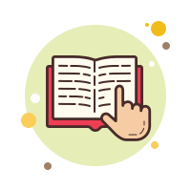

**READING**

**Task 1*.* Read and answer the questions.**

**MY WEEKEND**

**A Famous Festival in Vietnam**

In Vietnam, people celebrate many different festivals each year. The biggest festival in Vietnam is Tết. This celebrates the beginning of the Lunar New Year. Vietnamese people have to prepare a lot for this festival. Before Tết, people buy fruits and flowers from the market and decorate their houses. Most people buy a special tree with lots of flowers. In the north of Vietnam, people buy peach trees with pink flowers. In the south, people buy apricot trees with yellow flowers. Everyone cleans their house before Tết. This is very important because you shouldn't clean it during Tết. During Tết, people visit their family and friends. Few people go to school or work. Children wear new clothes and get lucky money. It's a great time to watch lion dances and fireworks. Everyone is happy and excited about the New Year. Vietnamese people love to celebrate this festival.

**Questions:**

**1.** Do people celebrate many different festivals each year?

**………………………………………………………………………………………………………………………………………**

**2.** Is Tết the biggest festival in Vietnam?

**………………………………………………………………………………………………………………………………………**

**3.** What do people often do before Tết?

**………………………………………………………………………………………………………………………………………**

**4.** What do people often do during Tết?

**………………………………………………………………………………………………………………………………………**

**5.** In the North of Vietnam, what type of tree do people buy?

**………………………………………………………………………………………………………………………………………**

**6.** In the South of Vietnam, what type of tree do people buy?

**………………………………………………………………………………………………………………………………………**

**Task 2: Complete the passage with the correct answer.**

Tet is a national and (1) ……… festival in Viet Nam. It is occasion forevery Vietnamese to be reunited to think (2) …………… their past activities and hope for good luck in the year to come. Before Tet all houses are white washed and (3) ………… with yellow apricot flowers and colorful lanterns. Everybody is looking forward to a more favorable life. On the New Year’s Eve, children are smartly dressed. They are hoping to (4) ………… money put in small red envelopes as they are wishing longevity (5) ……….. their grandparents and parents.

1. A. traditional B. modern C. music D. summer

2. A. to B. after C. about D. for

3. A. decorate B. decorates C. decorating D. decorated

4. A. buy B. receive C. sell D. make

5.A. for B. to C. with D. from



**WRITING**

**Task 1. Write sentences using the words given.**

**1.** dance performance/ start/6 p.m./end/ 7 p.m.  
**………………………………………………………………………………………………………………………………………  
2.** talent show/ start/ 11 a.m./end/ at 1 p.m.  
**………………………………………………………………………………………………………………………………………  
3.** music performance/ start/ 6 p.m./end/ 8 p.m.  
**………………………………………………………………………………………………………………………………………  
4.** tug of war/ start/ 2 p.m./end/3 p.m.

**………………………………………………………………………………………………………………………………………**

**Ta Task 3. Write about Chrismas**

- one of the biggest traditional holidays in the UK

- families get together

- give gifts and cards to family members and friends

- have a special meal

- play games after the meal

…Hi, Ben. Are you having a good holiday?

Let me tell you about Christmas.

……………………………………………………………………………………………… ……………………………………………………………………………………………… ……………………………………………………………………………………………… ……………………………………………………………………………………………… ………………………………………………………………………………………………

See you.

……………………………………………….

………………………………………………….

………………………………………………….

………………………………………………….

………………………………………………….

………………………………………………….

………………………………………………….

………………………………………………….

………………………………………………….



