Date of preparing: ………………………………….
Date of teaching: ………………………………….

Period……
UNIT 3: FRIENDS
Lesson 1 - Part 2 (Page 23) - Grammar

I. OBJECTIVES
By the end of the lesson, Ss will be able to…
1. Knowledge
- use the Present Simple and the Present Continuous.
- ask and answer about personal appearance.
2. Ability
- improve speaking skills, listening skill, writing skills.
- improve the use of English.
3. Quality
- have positive attitude in English language learning so that they actively participate in all classroom activities.
- love their school and friends.

II. TEACHING AIDS AND LEARNING MATERIALS
Lesson plan, PPT slides, student’s book, workbook, notebook, personal computer (if any), projector/TV, speakers, DCR & DHA on Eduhome, handouts…

III. PROCEDURES
A. Warm up: (5’)
a) Objective: Introduce the new lesson and set the scene for Ss to acquire new language; get students' attention at the beginning of the class by means of enjoyable and short activities as well as to engage them in the steps that follow.
b) Content: Rearranging letters to make a meaningful word/ Review the -ing form.
c) Product: Ss review the vocabularies of the previous lesson
d) Competence: Collaboration, analytical skill, communication.
e) Organization of the activity:
Teacher’s Activities | Students’ Activities
- Give greetings  - Check attendance  - Option 1: Game “JUMBLE WORD”  - Have Ss rearrange letters to make a meaningful word  - Call Ss to give answers  - Check Ss’ answers, give feedback and lead to the new lesson  1. obnw 2. olng  3. thors 4. misl 5. reaw  - Option 2: -ing form of verb  - Have Ss review the spelling of the -ing form of verb by giving some verbs and ask Ss to ad -ing. Examples:  1. wear  2. stay  3. study  4. put  5. make  6. have  7. go  8. miss  - Have Ss write answers on the board  - Tell Ss about another grammar point that contains -ing form they are going to study in the new lesson  →Lead to the new lesson | - Greet T  - Take part in the game  - Give answers (write on the board)  Answers keys  1. brown 2. long  3. short 4. slims 5. wear  - Work in pairs  Answers keys  1. wearing  2. staying  3. studying  4. putting  5. making  6. having  7. going  8. missing  - Write answers  - Listen

B. New lesson (35’)
- Activities 1: Grammar: Present and Present Continuous (18’)
a) Objective: Ss know how to use the Present and Present Continuous tense.
b) Content:
- The usage of Present (verb: be) and Present Continuous tense
- Circle the correct words
c) Products: Ss can use the Present and Present Continuous tense in everyday communication.
d) Competence: Communication, collaboration, presentation
e) Organization of the activity:
Teacher’s Activities | Students’ Activities
a. Listen and repeat  - Have Ss look at the picture  - Play audio (CD1 – Track 32) and have Ss listen and read the speech bubbles  - Play audio again and have Ss listen and repeat  Grammar box  - Option 1:  - Have Ss look at the grammar explanation  - Have Ss look at the box with the different forms  - Have some Ss read the sentences aloud  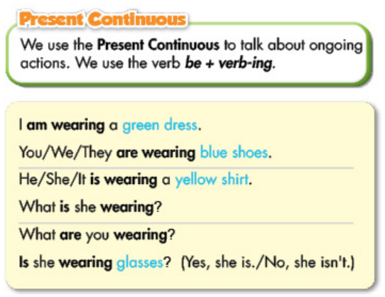  - Explain more about the form, usage of the Present Continuous  *Form: S + am / is / are + V-ing  Question: Am / Is / Are + S + V-ing?  *Usage: talk about ongoing actions  *Adverbs: at the moment, now, Look! ...  *Note: When we use present continuous to describe personal appearance, we do not use the adverbs  - Option 2:  - Have Ss close books  Show a picture on the screen and ask Ss to make comments on the clothes of the boy in the picture  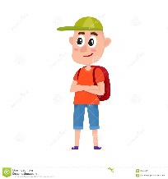  - Introduce: The boy is wearing a green hat.  The boy is wearing an orange T-shirt  The boy is wearing blue shorts  - Have Ss pay attention to the tense used in these sentences  →Lead to the grammar point: Present Continuous  - Explain more about the form, usage of the Present Continuous  *Form: S + am / is / are (not) + V-ing  Question: Am / Is / Are + S + V-ing?  *Usage: talk about ongoing actions  *Adverbs: at the moment, now, Look! ...  *Note: When we use present continuous to describe personal appearance, we do not use the adverbs  - Have Ss open books and read the grammar box  - Ask Ss to give some examples, using this tense  b. Circle the correct words.  - Demonstrate the activity, using the example  - Have Ss circle the correct words  - Have Ss work in pairs to check each other’s work  - Have some Ss share their answers with the whole class  - Give feedback, correct Ss’ answers if necessary | - Look  - Listen, then read  - Listen and repeat  - Look and read  - Read  - Listen and take notes  - Work in pairs  - Do what the teacher requests  Expected answers: blue shorts, green hat (green cap), orange T-shirt, red bag  - Look and listen  - Listen and take notes  - Open books, read  - Give examples  - Listen  - Work individually  - Work in pairs  - Give answers  Answer keys  2.is 3. are 4. am 5. are 6. Are
- Activity 2: Practice (17’)
a) Objective: Ss can make questions or answer the questions to develop a conversation.
b) Content: Writing answers, practicing the conversation
c) Products: Ss can use present continuous and “Yes” / “No” questions in everyday communication.
d) Competence: Collaboration, listening, communication, creativity.
e) Organization of the activity:
Teacher’s Activities | Students’ Activities
c. Look at the photo and write Simon’s answers  - Demonstrate the activity, using the photo.  - Have Ss write Simon’s answers  - Have Ss work in pairs to check each other’s work  - Have some Ss share their answers with the whole class (Write on the board)  - Check, correct Ss’ answers  d. Practice the conversation with partner  - Option 1:  - Have Ss do the task in pairs  - Call Ss to demonstrate the activity in front of the class  - Give feedback and correct Ss’ pronunciation if necessary  - Option 2:  - Have Ss do the task in pairs.  - Call Ss to demonstrate the activity in front of the class  - Give feedback and correct Ss’ pronunciation if necessary    - Give more pictures, have Ss practice, encourage them to be creative  Example:  - Call Ss give answers  - Give feedback and evaluation  - Option 3:  - Have Ss do the task in the book in pairs  - Have Ss demonstrate their conversation in front of the class  - Give an extra activity: Choose a secret student. Have Ss in class ask and answer questions to find who the secret student is.  Example:  Ss: Is he wearing glasses?  T: Yes, he is  Ss: Is he wearing sandals?  T: No, he isn’t  Ss: Is he wearing short-sleeved sweater?  T: Yes, he is  Ss: Is that Minh?  T: … | - Look and listen  - Work individually  - Work in pairs  - Write answers  Answer keys  2. No, he isn’t 3. Wearing a blue T-shirt 4. Black pants  - Work in pairs  - Present  - Work in pairs  - Read the answers aloud  Suggested dialogue  A: Do you know my friend?  B: Is she wearing a hat?  A: Yes, she is  A: Is she carrying a doll?  B: No, she isn’t  A: Is she wearing shorts?  B: No, she isn’t  A: What else is she wearing?  B: She is wearing a red skirt and a blue sweater  - Work in pairs  - Present  - Ask questions (as a whole class) and guess who the secret student is

C. Consolidation (3’)
* The Present Continuous tense:
Form: S + am / is / are (not) + V-ing
Question: Am / Is / Are + S + V-ing?
*Usage: talk about ongoing actions
Examples: What is he wearing? → He’s wearing a blue T-shirt

D. Homework (2’)
- Make 3 sentences to describe one of your classmates, using present continuous.
- Review vocabularies about clothes.
- Do exercises in Workbook: Lesson 1 - Grammar (page 15).
- Prepare: Lesson 1 – Pronunciation and Speaking (page 24 – SB).

