School: ……………………………………….. | Date:……………………………………..
Class: ……………………………..................... | Period: 15

UNIT 2: LIFE IN THE COUNTRY
Lesson 2.1: Vocab & Reading, pages 18 & 19
1. Objectives
By the end of this lesson, students will be able to…
1.1. Language knowledge/ skills
- learn and use vocab. related to life in the country and life in the city
- practice reading for gist and for detail
1.2. Competences
- improve Ss’ communication, collaboration, analytical, critical thinking skills.
1.3. Attributes
- love life in the country.
2. Teaching aids and materials
- Teacher’s aids: Student’s book and Teacher’s book, class CDs, DCR– Phần mềm tương tác trực quan, DHA – Ứng dụng trò chơi tương tác, projector / interactive whiteboard /TV (if any), PowerPoint slides.
- Students’ aids: Student’s book, Workbook, Notebook.
3. Assessment Evidence
Performance Tasks | Performance Products | Assessment Tools
- Read the words and definitions, then match the words with the pictures.  - Talk about what you like to do when you visit places in the country.  - Read a blog post and choose the best main idea.  - Talk about your favorite folk games. | - Ss’ answers.  - Ss’ answers.  - Ss’ answers.  - Ss’ answers. | - Observation.  - Observation.  - Observation.  - Observation.
4. Procedures
A. Warm up: 5’
a. Objective: to introduce the topic of the new lesson.
b. Content: Let’s talk!
c. Expected outcomes: Ss can talk leisure activities in the country.
d. Organization
Teacher’s activities | Students’ activities
In pairs: Look at the picture. What are the children doing? What else can children do for fun in the country?  - Ask Ss to work in pairs, to talk about what the children in the picture are doing and some more leisure activities in the country.  - Pick some Ss to share their ideas.  - Give feedback. | - Talk with their partner about the picture and list some more leisure activities in the country that they know.  - Share their ideas.  Sample answers:  Read books, play hide and seek, fly a kite
B. New lesson (35’)
1. Vocabulary: 15’
a. Objective: to help Ss know more vocabulary about leisure activities in the country.
b. Content: tasks a & b.
c. Expected outcome: Ss can talk about their favorite leisure activities.
d. Organization
Teacher’s activities | Students’ activities
Task a: a. Read the sentences, then match the words with the definitions. Listen and repeat.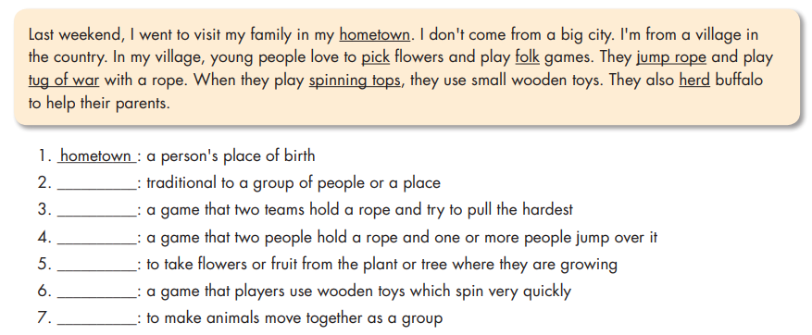  - Ask Ss to read the sentences and the definitions, then underline key words to help guess the meaning of new words.  - Pick some Ss to share their ideas.  - Give feedback.  - Ask Ss to match the words with their definitions.  - Let Ss check with their partners.  - Pick some Ss to give their answers.  - Check their answers.  - Ask Ss to listen and repeat chorally.  - Pick some Ss to say the words and correct their pronunciation if necessary.  - Check their memory by playing a game in pairs: Student A say the definition, Student B say the word (with books closed).  Task b. In pairs: Talk about what you like to do when you visit places in the country.  -Ask Ss to work in pairs to talk about what they like to do when they visit places in the country and say the reasons.  - Pick some Ss to share their ideas.  - Give feedback. | - Read the sentences and the definitions, then underline key words.  - share their ideas  Answer Keys:  1. __________: a person's place of birth  2. __________: traditional to a group of people or a place  3. __________: a game that two teams hold a rope and try to pull the hardest  4. __________: a game that two people hold a rope and one or more people jump over it  5. __________: to take flowers or fruit from the plant or tree where they are growing  6. __________: a game that players use wooden toys which spin very quickly  7. __________: to make animals move together as a group  -Match the words with their definitions.  - Check with their partners.  - Give their answers.  Answer Keys:  1. hometown 2. Folk  3. tug of war 4. jump rope  5. Pick 6. spinning tops 7. herd  - Listen and repeat chorally.  - Say the words individually.  - Talk with their partners about what they like to do when they visit places in the country.  - Share their ideas.  Sample answers:  A: When I go to my hometown, I like to play soccer with my friends.  B: I prefer to play folk games with my family.
2. Reading: 20 minutes
a. Objective: to help Ss practice reading for gist and for specific information.
b. Content: tasks a, b, and c.
c. Expected outcomes: Ss can figure the main idea and answers the questions about details.
d. Organization:
Teacher’s activities | Students’ activities
Task a: Read Vy's blog post. What does she mostly talk about?  1. popular activities in her hometown  2. her family's favorite folk games  - Introduce the task.  - Ask Ss to read through the blog post and choose the main idea.  - Give Ss some time to read.  - Pick some students to give their answers and justify their choice.  - Give feedback. | - Read through the blog post and choose the main idea.  - Give their answers.  Answer Keys:  - popular activities in her hometown  (They prefer to play outdoors. They play  sports and folk games. The girls love to jump rope and pick flowers. The boys love to play tug of war and soccer.)
Task b . Now, read and circle the correct answers.  - Ask Ss to read the questions and underline the key words.  - Pick some Ss to share their ideas.  - Give feedback.  1. Where was Vy last week?  A. in Ho Chi Minh City B. in her hometown C. in another country  2. What don't kids do in Vy's hometown?  A. play computer games B. pick flowers C. play soccer  3. What do girls like to do in Vy's hometown?  A. play spinning tops B. play tug of war C. pick flowers  4. What do boys like to do in Vy's hometown?  A. jump rope B. play tug of war C. herd buffalo  5. What does the word it in paragraph 4 refer to? A. a game B. a song C. a place  - Ask Ss to read the blog post and choose the best answer for each question.  - Let Ss check with their partner.  - Pick some students to give their answers and give evidence for their choices.  - Confirm the answers. | - Read the questions and underline the key words.  - Share their ideas.  Answer keys:  1. Where was Vy last week?  2. What don't kids do in Vy's hometown?  3. What do girls like to do in Vy's hometown?  4. What do boys like to do in Vy's hometown?  5. What does the word it in paragraph 4 refer to?  - Read the blog post and choose the best answer for each question.  - Check with their partner.  - Give their answers.  Answer keys:  1. B – hometown (Sorry I didn't post anything last week! I couldn't use my computer because I wasn't at home. I visited my family in my hometown.)  2. A - play computer games (Here, the kids never play computer games, and they rarely watch TV.)  3. C - pick flowers (The girls love to jump rope and pick flowers.)  4. B - play tug of war (The boys love to play tug of war and soccer.)  5. A- a game (I prefer to play chess because it's more relaxing than some folk games. My uncle and I sometimes sit down and play it under a tree.)
- Post-reading
a. Objective: to give Ss opportunities to talk about their favorite folk games.
b. Content: tasks d.
c. Expected outcomes: Ss can talk about the folk game they like and say why.
d. Organization:
Task d: In pairs: Which folk games do you like? Why?  - Ask Ss to work with their partner to talk about the folk game they like and state the reasons.  - Pick some Ss to share their ideas.  - Give feedback. | - Work with their partner to talk about the folk game they like and state the reasons.  - Share their ideas.  Sample answers:  I really like tug of war because it's exciting,  and many people can play it together.

C. Consolidation and homework assignments: 5’
- Vocabulary: hometown, Folk, tug of war, jump rope, Pick, spinning tops, herd
- Do vocabulary and reading exercises in workbook on pages 10 & 11.
- Prepare the next lesson: Lesson 2.2 - Grammar, pages 19 & 20
- Do the exercises in Tiếng Anh 8 i-Learn Smart World notebook (page 15).
5. Reflection

a. What I liked most about this lesson today:
…………………………………………………………………………………………
b. What I learned from this lesson today:
…………………………………………………………………………………………
c. What I should improve for this lesson next time:
…………………………………………………………………………………………

