Thời gian làm bài: 40 phút (Không kể thời gian giao đề)
-------------------------
Họ tên thí sinh: .................................................................
Số báo danh: ......................................................................
Mã Đề: 036.
Câu 1. Look at the signs. Choose the best answer for the question.
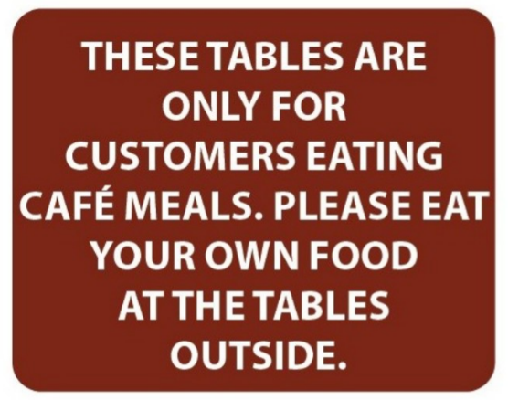
A. If you want to eat at the tables, you have to bring your own food.
B. You can eat at the café tables if you buy food there.
C. You cannot eat food at the tables outside.
D. The tables outside are for people who don’t eat food.
Câu 2. Look at the signs. Choose the best answer for the question.
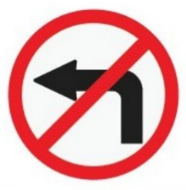
A. You mustn’t turn left. B. Only vehicles which turn left have to stop.
C. You don’t have to turn left at this point. D. You have to stop and turn left.
Câu 3. Which of the following items is NOT included in the half-price sale?
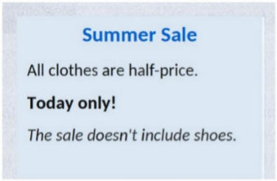
A. Dresses B. T-shirts C. Shoes D. Pants
Câu 4. What is the main request Anna is making to Pete?
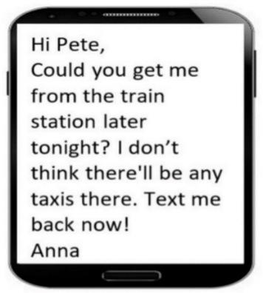
A. To get her from the train station later tonight B. To meet her at the station immediately
C. To pick her up from work D. To call for a taxi
Câu 5. "What does the person sending the message want to do?"
Hi there! I hope you're doing well. I wanted to see if you're interested in going to a show this weekend. There's a new play that just opened at the local theatre, and I've heard great things about it. Let me know if you're free and we can get tickets together.
A. Visit a museum B. Attend a concert C. Go to a show D. Watch a movie
Câu 6. What is Gemma asking Simon to do?

A. Return a book to the library B. Bring a borrowed book to school tomorrow
C. Buy a new book for school D. Read a book again
Câu 7. Look at the signs. Choose the best answer for the question.
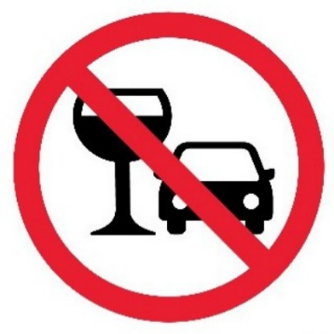
A. You are not allowed to drink alcohol before and while driving.
B. You should stop driving if you want to drink water.
C. You cannot use glasses in the car.
D. You mustn’t drink anything while you are driving.
Câu 8. Look at the signs. Choose the best answer for the question.
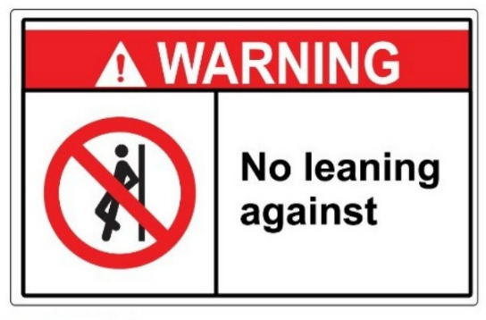
A. Don’t stand near the wall because it’s leaning. B. This is not a leaning wall.
C. Leaning against the wall is possible. D. Do not lean against the wall.
Câu 9. Look at the signs. Choose the best answer for the question.
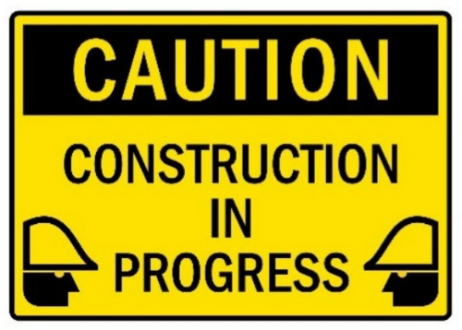
A. You have to construct buildings with caution. B. Be careful because building work is happening.
C. There is careful construction. D. Construction must be carefully done in progress.
Câu 10. What is the cost for children under 2 years old to join the 3-day trip to the countryside?
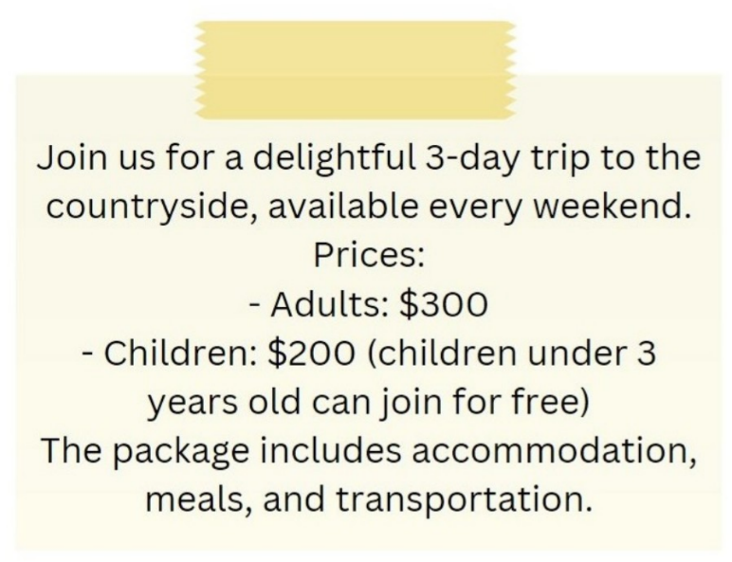
A. $100 B. $200 C. Free D. $150
----HẾT---

