School: ……………………………………….. | Date:……………………………………..
Class: ……………………………..................... | Period: 17

UNIT 2: LIFE IN THE COUNTRY
Lesson 2.3 – Pronunciation & Speaking, pages 20 & 21
1. Objectives
By the end of this lesson, students will be able to…
1.1. Language knowledge/ skills
- practice intonation for Yes / No questions
- practice talking about folk games and activities in the country, using Which activities do you prefer to do? Which activities don't you like? Why?!prepositions of time?
1.2. Competences
- improve Ss’ communication, collaboration, analytical, critical thinking skills.
1.3. Attributes
- love life in the country.
2. Teaching aids and materials
- Teacher’s aids: Student’s book and Teacher’s book, class CDs, DCR– Phần mềm tương tác trực quan, DHA – Ứng dụng trò chơi tương tác, projector / interactive whiteboard /TV (if any), PowerPoint slides.
- Students’ aids: Student’s book, Workbook, Notebook.
3. Assessment Evidence
Performance Tasks | Performance Products | Assessment Tools
- Listen and cross out the sentence that doesn't have rising intonation.  - Read the sentences with the rising intonation to a partner.  - Ask and answer about what young people like to do in specific places.  - Talk about the activities young people often like to do in the country.  - Ask and answers the questions: Which activities do you prefer to do? Which activities don't you like? Why? | - Ss’ answers.  - Ss’ answers.  - Ss’ answers.  - Ss’ answers.  - Ss’ answers. | - Observation.  - Observation.  - Observation.  - Observation.  - Observation.
4. Procedures
A. Warm up: 5 minutes
a. Objective: to review lesson 2.2 and lead in the new lesson.
b. Content: wordsearch game.
c. Expected outcomes: Ss can find the folk games have learnt in the wordsearch.
d. Organization
Teacher’s activities | Students’ activities
Wordsearch game.
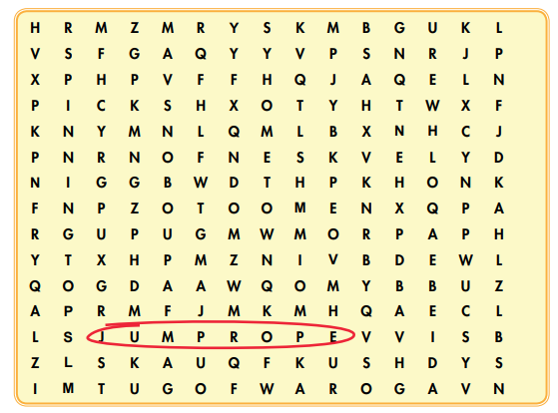
-Show the wordsearch on the board, using DCR.
- divide the class into 2 groups.
-Ask 2 Ss from 2 groups to circle the folk games said by the teacher in the wordsearch. The faster will get one points.
- Decide the winner with more points.
B. New lesson (35’)
1. Pronunciation: 10’
a. Objective: to help Ss pronounce Yes/No questions correctly.
b. Content: tasks a, b, c & d.
c. Expected outcomes: Ss can use rising intonation in Yes/No questions.
d. Organization
Teacher’s activities | Students’ activities
Task a:  - Write some Yes/No questions on the boards.  Does he like to play folk games?  Do you prefer to live in the city?  - Say the questions.  - Ask Ss to tell the intonation they hear: rising or falling intonation.  - Confirm the answer.  Task b:  - Ask Ss to listen to the questions and notice  how the intonation rises. (using the IWB).  Does she like to eat hamburgers?  Do they like to jump rope?  - Gets Ss to listen again and repeat chorally.  - Pick some Ss to say the questions individually and correct their intonation if necessary.  Task c: Listen and cross out the sentence that doesn't have rising intonation.  Does he love to pick flowers?  Do they prefer to play soccer?  Do you like to visit the country?  - Ask Ss to listen and cross out the the sentence that doesn't have rising intonation.  - Pick some Ss to give the answers.  - Check their answers.  - Get Ss to listen again and repeat.  Task d: Read the sentences with the rising  intonation to a partner.  -Ask Ss to work in pairs, reading the questions to their partners with the correct intonation.  - Pick some students to say the questions and correct their intonation if necessary. | - Listen and take notes.  - Give the answer.  Answer key:  Rising intonation.  -Listen to the words and focus on  the intonation.  -Listen again and repeat  - Listen and cross out the sentence that doesn't have rising intonation.  - Give their answer  Answer Keys:  Do you like to visit the country?  (Intonation falls.)  -Listen again and repeat.  -Work in pairs, reading the questions to their partners with the correct intonation.
2. Practice: 15’
a. Objective: to help Ss practice talking about what young people like to do in these places.
b. Content: task a & b
c. Expected outcomes: Ss can ask and answer about what young people like to do in different places, using given ideas.
d. Organization:
Teacher’s activities | Students’ activities
Task a: Ask and answer about what young people like to do in these places.  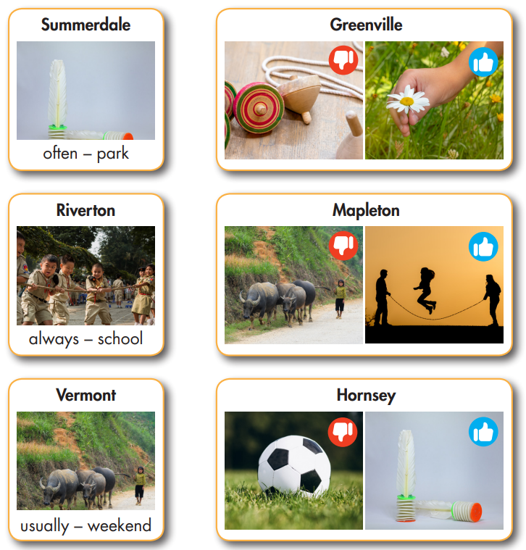  - Ask Ss to work in pairs to ask and answer about what young people like to do in these places.  - Go around and help if necessary.  - Pick one pair to read the conversations.  - Check their answers. | -Work in pairs to ask and answer about what young people like to do in these places.  Answer keys:  Conversation 1  A: What do young people like to do in Summerdale?  B: They like to play shuttlecock. They often play at the park.  Conversation 2  A: Do young people like to play spinning tops in Greenville?  B: No, they don't. They prefer to pick flowers.  Conversation 3  A: What do young people like to do in Riverton?  B: They like to play Tug of war. They always play at school.  Conversation 4  A: Do young people like to herd buffalo in Mapleton?  B: No, they don’t. They prefer to jump rope.  Conversation 5  A: What do young people like to do in Vermont?  B: They like to herd buffalo. They usually do it at the weekend.  Conversation 6  A: Do children like to play soccer in Hornsey?  B: No, they don’t. They prefer to play shuttlecock.
3. Speaking: 10’
a. Objective: to help Ss practice talking about activities in the country they prefer to do or don't like to do.
b. Content: task a, b and c.
c. Expected outcomes: Ss can talk about they activities they like or don’t like.
d. Organization:
Teacher’s activities | Students’ activities
Task a: In pairs: What activities do young people often like to do in the country? Where and when do they usually do the activities? Talk about the activities below and some of your own ideas.  - Ask Ss to work in pairs to talk about the activities given and some of their own ideas about what young people often like to do in the country.  tug of war  herd buffalo  pick flowers  shuttlecock  spinning tops  jump rope | - Work in pairs to talk about the activities given and some of their own ideas about what young people often like to do in the country.  Sample conversation:  A: What do young people like to do in the country?  B: They like to jump rope. They usually jump rope after school.  A: Do they like to play tug of war?  B: Yes, they do, but I think they prefer to...
Task b: Which activities do you prefer to do? Which activities don't you like? Why?  - Ask Ss to work in pairs to ask and answer about the activities in the country they like or don’t like to do.  - Go around to help if necessary.  - Pick some pairs to perform their conversations.  - Give feedback. | - Work in pairs to ask and answer about the activities in the country they like or don’t like to do.  Sample answer:  I prefer to play tug of war because it’s fun and I can play with my friends. I don’t like to herd buffalo because it’s boring.

C. Consolidation and homework assignments: 5’
- Pronunciation: the rising intonation of Yes/No questions.
- Prepare the next lesson: Lesson 3.1 – Reading & Writing, pages 22 & 23
- Do the exercises in Tiếng Anh 8 i-Learn Smart World notebook (page 17).

5. Reflection
a. What I liked most about this lesson today:
…………………………………………………………………………………………
b. What I learned from this lesson today:
…………………………………………………………………………………………
c. What I should improve for this lesson next time:
…………………………………………………………………………………………

