School: ……………………………………….. | Date: …………………………………..
Class: ……………………………..................... | Period: ………………………….........

UNIT 10: ENERGY SOURCES
Lesson 2.1 – New words and Reading (Page 79)

I. OBJECTIVES
By the end of the lesson, Ss will be able to:
1.1. Language knowledge and skills
- know some new words about things relating to energy (wind turbine, power play, solar panel, nuclear power) and adjectives about advantages and disadvantages of energy sources ( renewable, non-renewable, cheap, expensive, polluting, dangerous, clean, noisy).
- talk about advantages and disadvantages of energy sources.
- read a text about choosing the best option for energy to understand general and specific information.
1.2. Competences
- improve communication, collaboration, analytical and critical thinking skills.
1.3. Attributes
- save energy.
- choose suitable and economical types of energy for everyday use.

II. TEACHING AIDS AND LEARNING MATERIALS
1. Teacher’s aids: Student book and Teacher’s book, class CDs, Digital Book (DCR phần mềm tương tác SB, DHA (từ vựng/ cấu trúc) phần mềm trò chơi tương tác), projector/interactive whiteboard / TV (if any), PowerPoint slides, pictures.
2. Students’ aids: Student’s book, workbook, notebook.

III. ASSESSMENT EVIDENCE
Performance Tasks | Performance Products | Assessment Tools
- Match the words with the pictures. | - Ss’ answers. | - T’s feedback/Peers’ feedback.
- Add each word/phrase (5–9) to the correct column. Listen and repeat. | - Ss’ answers/ presentation. | - T’s observation / feedback.
- Discuss which energies you think are clean to run or cause pollution. | - Ss’ answers. | - T’s feedback/Peers’ feedback.
- Read the text and underline the correct title. | - Ss’ answers. | - T’s feedback/Peers’ feedback.
- Read and answer the questions. | - Ss’ answers. | - T’s feedback/Peers’ feedback.
- Speak: Which of the energy sources is the best choice for the future of your country? | - Ss’ answers/ presentation. | - T’s feedback/Peers’ feedback.
IV. PROCEDURES
A. Warm up: (5’)
a) Objective: Introduce the new lesson and set the scene for Ss to acquire new language; get students' attention at the beginning of the class by enjoyable and short activities as well as to engage them in the steps that followed.
b) Content: Introduce: adjectives to talk about advantages and disadvantages of energy sources. / Introduce devices to exploit energy.
c) Expected outcomes: Ss have general ideas about the topic of the new lesson: Advantages and disadvantages of energy sources.
d) Organization of the activity:
TEACHER’S ACTIVITIES | STUDENTS’ ACTIVITIES
- Option 1: Introduce: Adjectives used to talk about advantages and disadvantages of energy sources.  - Show list of adjectives, have Ss work in pairs divide them into 2 groups: positive and negative.  - Call Ss to give answers.  - Give feedback and show correct answers.  - Lead to the new lesson: Advantages and disadvantages of energy sources.  *Suggested adjective list: polluting, clean, safe, limited, abundant, expensive, dangerous, cheap, renewable, non-renewable, noisy, harmful, available.  - Option 2: Vocabulary (use New words part a for warm up activity)  - Have Ss close books and notebooks.  - Show pictures and words, have Ss do the matching activity.  - Call Ss to give answers.  - Give feedback.  - Introduce the new lesson.  *Illustration:  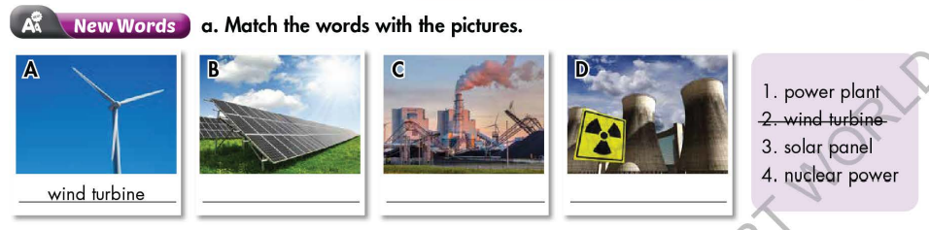 | - Work in pairs.  - Give answers.  Answer keys  - Positive: clean, safe, abundant, cheap, renewable, available  - Negative: polluting, limited, expensive, dangerous, non-renewable, noisy, harmful  - Close books and notebooks.  - Work in pairs, then give answers.  - Listen.  Answer keys  - A: wind turbine  - B: solar panel  - C: power plant  - D: nuclear power

B. New lesson (35’)
- Activity 1: Pre-Reading (Vocabulary) (12’)
a) Objective: Ss know some words about energy.
b) Content:
- Vocabulary study: wind turbine, power play, solar panel, nuclear power, renewable, non-renewable, cheap, expensive, polluting, dangerous, clean, noisy.
- Match the words with the pictures. Add each word/phrase (5–9) to the correct column. Listen and repeat.
- Speaking: Discuss which energies you think are clean to run or cause pollution.
c) Expected outcomes: Ss know how to pronounce the new words correctly and use them in appropriate situations.
d) Organization of the activity:
TEACHER’S ACTIVITIES | STUDENTS’ ACTIVITIES
Task a. Match the words with the pictures.  - Option 1  - Demonstrate the activity, using the example.  - Have Ss match the words with the pictures.  - Divide class into pairs and have them check their answers with their partners.  - Call Ss to give answers (read or write).  - Check answers as a whole class using DCR.  - Correct Ss’ pronunciation.  - Option 2:  - Demonstrate the activity, using the example.  - Have Ss match the words with the pictures. (T uses different pictures and different orders from those in the textbook.)  - Divide class into pairs and have them check their answers with their partners.  - Call Ss to give answers (read or write).  - Check answers as a whole class.  - Correct Ss’ pronunciation.  *Illustration:  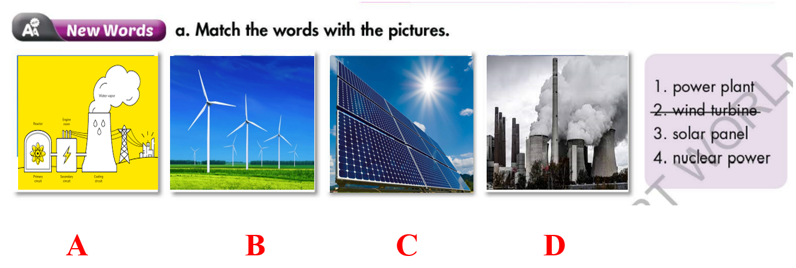  Task b. Add each word/phrase (5–9) to the correct column. Listen and repeat.  - Demonstrate the activity on DCR, using the example.  - Have Ss add each word/phrase (5–9) to the correct column.  - Divide class into pairs and have them check their answers with their partners.  - Call Ss to give answers (read or write).  - Check answers as a whole class using DCR.  - Play audio (CD2 – Track 29). Have Ss listen and repeat.  - Correct Ss’ pronunciation.  Task c. Discuss which energies you think are clean to run or cause pollution.  - Have pairs discuss which energies they think are clean to run or cause pollution.  - Have Ss share their answers in front of the class.  - Give feedback and evaluation. | - Look and listen.  - Work individually.  - Work in pairs.  - Give answers.  Answer keys  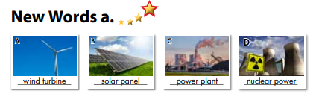  - Look and listen.  - Work individually.  - Work in pairs.  - Give answers.  Answer keys  - A: nuclear power  - B: wind turbine  - C: solar panel  - D: power plant  - Listen.  - Work in pairs.  - Exchange answers.  - Give answers.  - Listen and repeat.  Answer keys  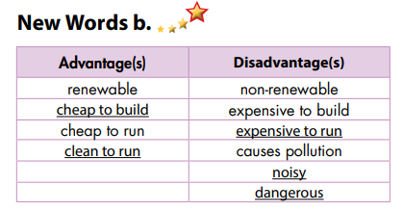  - Work in pairs.  - Present.  Sample answers  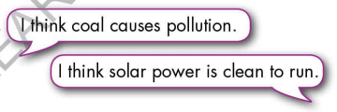
- Activity 2: While - Reading (18’)
a) Objective: Students can develop their reading skill.
b) Content:
- Read the text and underline the correct title.
- Read and answer the questions.
c) Expected outcomes: Students can read a text and understand more about advantages and disadvantages of energy sources.
d) Organization of the activity:
TEACHER’S ACTIVITIES | STUDENTS’ ACTIVITIES
Task a. Read the text and underline the correct title.  - Ask Ss to scan the text scan the text, then underline the correct title.  - Remind Ss to underline or highlight the keywords or supporting ideas for their answers.  - Have some Ss share their answers with the class (read), explain for their answers.  - Give feedback.  - Give feedback and correct Ss’ answers if necessary.  Task b. Read and answer the questions.  - Have Ss look at the content of task b.  - Have Ss underline key words.  - Have Ss scan the text again, and answer the questions.  - Elicit answers from different pairs.  - Give feedback and evaluation. | - Work individually: Scan the text underline the correct title.  - Read answers, explain.  - Check answers.  Answer keys  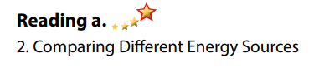  - Read.  - Work in pairs to answer the questions.  - Read answers.  Answer keys  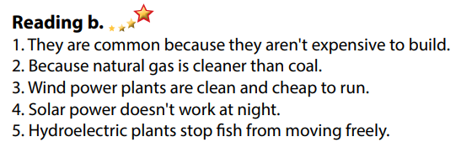
- Activity 3: Post - Reading (5’)
a) Objective: Students can use the vocabulary and ideas from the reading text to develop their speaking skill.
b) Content: Speaking: Which of the energy sources is the best choice for the future of your country?
c) Expected outcomes: Students can express their choice for the future of Vietnam.
d) Organization of the activity:
TEACHER’S ACTIVITIES | STUDENTS’ ACTIVITIES
Task c. In pairs: Which of the energy sources is the best choice for the future of your country?  - Have Ss work in pairs to answer the questions.  - Go round and give help if necessary.  - Call some Ss to share their ideas with the whole class.  - Give feedback and evaluation. | - Discuss in pairs.  - Present.  - Listen.

C. Consolidation and homework assignments (5’)
* Consolidation:
- Words about things relating to energy (wind turbine, power play, solar panel, nuclear power) and adjectives about advantages and disadvantages of energy sources (renewable, non-renewable, cheap, expensive, polluting, dangerous, clean, noisy).
* Homework:
- Learn the new words by heart.
- Do the exercises in WB: New words + Reading (pages 58, 59).
- Do the vocabulary exercise in Tiếng Anh 7 i-Learn Smart World Notebook (page 62).
- Play consolation games in Tiếng Anh 7 i-Learn Smart World DHA App on www.eduhome.com.vn
- Prepare: Unit 10 - Lesson 2.2 – Grammar (page 80 – SB).

D. Reflection
a. What I liked most about this lesson today:
…………………………………………………………………………………………
- What I learned from this lesson today:
…………………………………………………………………………………………
c. What I should improve for this lesson next time:
…………………………………………………………………………………………

