UNIT 11: SCIENCE AND TECHNOLOGY
Lesson 1: Getting started – Great news for students

I. OBJECTIVES
By the end of this lesson, Ss will be able to:
1. Knowledge
- Gain an overview about the topic Science and technology
- Gain vocabulary to talk about Science and technology
2. Competences
- Develop communication skills and creativity
- Be collaborative and supportive in pair work and teamwork
3. Personal qualities
- Be responsible in using technology for learning
- Have positive attitude in applying science and technology in learning and daily life
- Actively join in class activities

II. MATERIALS
- Grade 8 textbook, Unit 11, Getting started
- Computer connected to the Internet
- Projector / TV/ pictures and cards
- hoclieu.vn

Language analysis
Form | Pronunciation | Meaning | Vietnamese equivalent
1. technology(n) | /tekˈnɒlədʒi/ | scientific knowledge used in practical ways in industry, for example in designing new machines | công nghệ
2. face-to-face (adj) | /ˌfeɪs tə ˈfeɪs/ | in a way that involves people who are close together and looking at each other | trực tiếp, mặt đối mặt
3. epidemic (n) | /ˌepɪˈdemɪk/ | a large number of cases of a particular disease or medical condition happening at the same time in a particular community | đại dịch
4. contact lens (n) | /ˈkɒntækt lenz/ | a thin, curved lens placed on the film of tears that covers the surface of your eye | kính áp tròng
5. breakout room (n) | /ˈbreɪkaʊt ruːm / | a small meeting room or a separate part of an internet meeting where a small group can discuss a particular issue before returning to the main meeting | phòng học chia nhỏ, chia nhóm
6. invention (n) | /ɪnˈvenʃn/ | ​a thing or an idea that has been invented | sự phát minh,  sáng chế

Assumption
Anticipated difficulties | Solutions
Ss may not know enough vocabulary relating to the topic to understand the conversation. | Provide the necessary vocabulary for students to understand the conversation.

III. PROCEDURES
1. WARM-UP (5 mins)
a. Objectives:
- To create an active atmosphere in the class before the lesson.
- To lead into the new unit.
- To review the previous unit before Ss open their books.
b. Content:
- Game: Hidden words
c. Expected outcomes:
- Students have a chance to speak English and focus on the topic of the lesson.
d. Organisation

TEACHER’S AND STUDENTS’ ACTIVITIES | CONTENTS
GAME: HIDDEN WORDS  - T introduces the rule of the game:  + Read the questions or situations.  + Find a word to answer each question or fill in each situation.  + Discover the hidden words by unscrambling the red letters.  - T leads to the new unit. Write the unit title SCIENCE  & TECHNOLOGY on the board. Ask Ss to guess what they are going to learn about in this unit. | Suggested hidden words:  Science, Technology
e. Assessment
- T checks Ss’ vocabulary and gives feedback.

2. ACTIVITY 1: PRESENTATION (5 mins)
a. Objectives:
- To prepare vocabulary for students to understand the conversation.
b. Content:
- Vocabulary pre-teaching
c. Expected outcomes:
- Know more new words
- Understanding the conversation; topic of the lesson,…
d. Organisation

TEACHER’S AND STUDENTS’ ACTIVITIES | CONTENTS
Vocabulary pre-teaching  - Teacher introduces the vocabulary.  - Teacher explains the meaning of the new vocabulary by pictures/ explanations/ examples.  - Teacher reveals that these seven words will appear in the reading text and asks students to open their textbooks to discover further. | New words:  1. technology(n)  2. face-to-face (adj)  3. epidemic (n)  4. contact lens (n)  5. breakout room (n)  6. invention (n)
e. Assessment
- Teacher checks students’ pronunciation & understanding of the words and gives feedback.

3. ACTIVITY 2: PRACTICE (25 mins)
a. Objectives:
- To help Ss understand a conversation about some inventions and gain some knowledge about them.
- To help Ss learn words and phrases related to different modern technologies;
b. Content:
- Task 1: Listen and read.
- Task 2: Read the conversation again and tick T (True) or F (False).
- Task 3: Label each picture with a phrase from the box.
- Task 4: Complete the sentences, using the phrases in 3.
c. Expected outcomes:
- Know more new words about different modern technologies and inventions, understand the conversation; topic of the lesson.
d. Organisation

TEACHER’S AND STUDENTS’ ACTIVITIES | CONTENTS
Task 1: Listen and read. (6 mins)
- Teacher has Ss to look at the pictures in the book and answer the questions.  - T encourages ss to answer the questions, but doesn’t confirm their answers.  - Teacher plays the recording for ss to listen and read along. Then invite some pairs of Ss to read the conversation aloud.  - T refers to the questions previously asked and confirms the correct answer. | Questions:  - Who are the girl and the boy?  - Where do you think they are?  - What might they be talking about?  - What can you see in the bubble?  Suggested answer:  They are Minh and Ann. They are at school.  They are discussing their online class / robot teacher.
Task 2: Read the conversation again and tick T (True) or F (False) (6 mins)
- Ask Ss to work in pairs to read the conversation.  - Ask them to underline the key words and phrases in the statements. Then have pairs work for one or two minutes to check if the statements are true or false.  - Have Ss read out the statements and say if the statements are true or false.  - Make sure they pronounce the words correctly.  - Check the answers as a class. | Answer key:  1. F  2. T  3. F  4. T  5. T
Task 3: Label each picture with a phrase from the box. (6 mins)
- Ask Ss to say the phrases aloud. Make sure they pronounce the phrases correctly.  - Ask Ss to work in pairs to label the pictures with the appropriate words or phrases.  - Check the answers as a class. | Answer key:  1. computer screen  2. 3D contact lenses  3. online class  4. robot teacher  5. breakout rooms  6. Internet connection
Task 4: Complete the sentences, using the phrases in 3. (7 mins)
- Ask Ss to work independently to complete each sentence with a phrase from the box in 3.  - Allow Ss to refer to the pictures and phrases in Activity 3 or the conversation if needed.  - Check the answers as a class.  - Ask several Ss to read aloud the full sentences. Correct Ss’ pronunciation if needed. | Answer key:  1. computer screen  2. breakout rooms  3. robot teacher  4. online class  5. 3D contact lenses
e. Assessment
- Teacher checks students’ exercises individually and gives feedback.

4. ACTIVITY 3: PRODUCTION (5 mins)
a. Objectives:
- To introduce some inventions
- To create a fun atmosphere in the class.
b. Content:
- Task 5: Quiz: Do you know what things were invented in these years? Work in pairs and find out.
c. Expected outcomes:
- Ss can find out the things that were invented in the given years.
d. Organisation

TEACHER’S AND STUDENTS’ ACTIVITIES | CONTENTS
Task 5: Quiz: Do you know what things were invented in these years? Work in pairs and find out. (5 mins)
- Ask Ss to work in pairs to read the information and to make guesses.  - Encourage Ss to guess as many things as possible.  - Ask some Ss to report things they have thought of / worked out. | Answer key:  1. the first computer  2. the telephone  3. penicillin  4. the World Wide Web (WWW)  5. robot ASIMO (Advanced Step in Innovative Mobility)
e. Assessment
- T and other Ss listen and comment.
5. CONSOLIDATION (5 mins)
a. Wrap-up
- Ask Ss to recall the learnt lexical items related to science and technology
- If there is an overhead projector in the classroom, show the dialogue, highlight the key words related to the topic.
b. Homework
- Name technologies and inventions they have learnt about in the lesson.
- Learn new words and phrases by heart.
- Do Exercise in the Workbook
- Start preparing for the Project of the unit:
Teacher randomly puts Ss in groups of 4 or 5 and asks them to brainstorm about a problem and an invention to help them deal with the problem, then make a poster or prepare a model of the invention. Students will show and present in Lesson 7 – Looking back and Project. (Teacher should check the progress of students’ preparation after each lesson.)

BOARD PLAN

Date of teaching
Unit 11: Science and technology
Lesson 1: Getting started
* Vocabulary
1. technology(n)
2. face-to-face (adj)
3. epidemic (n)
4. contact lens (n)
5. breakout room (n)
6. invention (n)

* Practice:
Task 1: Listen and read.
Task 2: Tick T or F
Task 3: Label the pictures
Task 4: Complete the sentences.
Task 5: Quiz.
*Homework

UNIT 11: SCIENCE AND TECHNOLOGY
Lesson 2: A closer look 1

I. OBJECTIVES
By the end of this lesson, Ss will be able to:
1. Knowledge
- Identify some nouns related to the topic of science and technology and some new technologies.
- Identify some new verb phrases that used to talk about inventions, discoveries, creations and development
- Identify sentence stress.
2. Competences
- Develop competencies of communication, cooperation, and self-management.
- Be collaborative and supportive in pair work and teamwork
3. Personal qualities
- Be responsible in using technology for learning
- Have positive attitude in applying science and technology in learning and daily life
- Actively join in class activities

II. MATERIALS
- Grade 8 textbook, Unit 11, A closer look 1.
- Computer connected to the Internet
- Projector / TV
- hoclieu.vn

Language analysis
Form | Pronunciation | Meaning | Vietnamese equivalent
1. face recognition (n) | /feɪsˌrekəɡˈnɪʃn/ | technology that allows a computer to identify a person by their face | công nghệ nhận diện gương mặt
2. experiment (n) | /ɪkˈsperɪmənt/ | a scientific test that is done in order to study what happens and to gain new knowledge | thí nghiệm
3. eye-tracking (n) | /ˈai ˌtrækɪŋ/ | technology that follows the movements of eyes, especially by using special electronic equipment | theo dõi (cử động) mắt
4. fingerprint scanner(n) | /ˈfɪŋɡəprɪnt ˈskænə/ | a type of technology that identifies and authenticates the fingerprints of an individual in order to grant or deny access to a computer system or a physical facility | máy quét vân tay
5. digital communication (n) | /ˈdɪdʒɪtl kəˌmjuːnɪˈkeɪʃn/ | the use of online tools like email, social media messaging and texting to reach other individuals or a specific audience in order to share a message | giao tiếp kỹ thuật số

Assumption

Anticipated difficulties | Solutions
Ss may lack vocabulary related to the topic of science technology, new technologies, and verb phrases that used to talk about inventions, discoveries, creations and development, so they may have difficulty completing the tasks | T is willing to provide them with enough vocabulary related to the topic

III. PROCEDURES
1. WARM-UP (5 mins)
a. Objectives:
- To prepare students the vocabulary for the lesson.
b. Content:
- Pictures labelling
c. Expected outcomes:
- Students know some names of technology
d. Organisation

TEACHER’S AND STUDENTS’ ACTIVITIES | CONTENTS
Game: Labelling the pictures  - Give Ss a few minutes to play a game. Have Ss play in two groups.  - Give Ss pictures of things and strips of paper with phrases including computer screen, breakout rooms, robot teacher, online class, 3D contact lenses, connection.  - Ask teams to stick the phrases to the right pictures.  - The team with the most correct answers wins.  - Ask Ss to open their books to page 116. | Key:  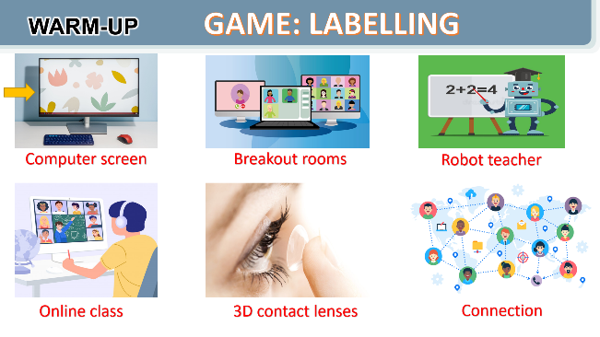
e. Assessment
- T checks ss’ answers and gives feedback

2. ACTIVITY 1: VOCABULARY (25 mins)
a. Objectives:
- To visually introduce some nouns related to the topic of science and technology
- To introduce some new verb phrases that are used to talk about inventions, discoveries, creation and development
- To allow Ss to use the learnt words / phrases in different contexts.
b. Content:
- Task 1: Write the words and phrases under each picture.
- Vocabulary teaching
- Task 2: Choose the option that best completes each phrase.
- Task 3: Complete the sentences with the words and phrases from the box.
c. Expected outcomes:
- Students are able to identify new words and phrases related to new technologies.
- Students are able to use the target vocabulary in different contexts.
d. Organisation

TEACHER’S AND STUDENTS’ ACTIVITIES | CONTENTS
Task 1: Write the words and phrases under each picture. (6 mins)
- Have Ss read aloud the words / phrases in the box.  - Ask Ss to work in pairs to look at the pictures and describe the pictures.  - Have pairs write the correct words / phrases under the pictures. Explain the meaning of the new words / phrases in Vietnamese, if needed.  - Invite Ss to take turns to read out their answers.  - Correct their pronunciation if needed.  - Check the answers as a class. | Answer key:  1. digital communication  2. face recognition  3. eye-tracking  4. experiment  5. fingerprint scanner  6. video conferencing
Vocabulary teaching (6 mins)
- Teacher asks students to try explaining the meaning of the words in Task 1.  - Teacher explains the vocabulary.  - Teacher checks students’ understanding by the follow-up tasks in the student's book. | New words:  1. face recognition (n)  2. eye-tracking (n)  3. experiment (n)  4. fingerprint scanner (n)  5. digital communication (n)
Task 2: Choose the option that best completes each phrase. (6 mins)
- Ask Ss to read aloud the given verbs and nouns.  - Explain the verbs and if possible, give some examples. Also explain the verbs in Vietnamese.  - Ask Ss to work in pairs to choose the correct options to complete the phrases.  - Check the answers as a class.  - Have some Ss read aloud the phrases.  - Correct Ss’ pronunciation if necessary.  - Also ask Ss to add more words / phrases to the verbs to make up other phrases. This way, T can broaden Ss’ vocabulary if they are ready. | - To create something = To bring into existence out of nothing.  E.g. She created a new robot.  - To invent = to design a new process or mechanism.  E.g. He invented a new electric cooker.  - To develop = grow gradually or become bigger, stronger, etc.  E.g. They developed a relationship / a method to work better / a computer programme.  - To discover = to find somebody/something that was hidden or that you did not expect to find.  E.g. Galileo discovered that Jupiter had moons.  Answer key:  1. A 2. A 3. B 4. B
Task 3: Complete the sentences with the words and phrases from the box. (7 mins)
- Ask Ss to work individually to choose the correct answer for each sentence.  - Have Ss swap their answers with partners. Then check the answers as a class.  - Also ask some Ss to read out their answers. Then have some Ss read the sentences aloud as a class.  - Correct Ss’ pronunciation if necessary. | Answer key:  1. discovered  2. invented  3. created  4. experiments  5. fingerprint scanner
e. Assessment
- Teacher checks students’ answers as a whole class and gives feedback.

3. ACTIVITY 2: PRONUNCIATION (12 mins)
a. Objectives:
- To help Ss be aware of the words to stress in a sentence;
- To help Ss practise saying sentences with the correct stress.
b. Contents:
- Task 4: Listen and repeat the sentences. Pay attention to the bold syllables.
- Task 5: Listen and repeat the sentences. How many stressed words are there in each sentence?
c. Expected outcomes:
- Say sentences with the correct stress.
d. Organisation

TEACHER’S AND STUDENTS’ ACTIVITIES | CONTENTS
Task 4: Listen and repeat the sentences. Pay attention to the bold syllables. (6 mins)
- Have Ss listen to the recording once first. Ask them to pay attention to the stressed syllables.  - Play the recording again for them to listen and repeat each word as a class, then as individuals. Play the recording as many times as possible.  - Then ask Ss to read out the sentences. Correct their pronunciation and stress if needed.  - Introduce the rules in the Remember! Box: stress sentences, which words in a sentence should be stressed, and which are not.  - Remind Ss of the words that receive stress in a sentence, which they leant in Unit 11 Tiếng Anh 7. | 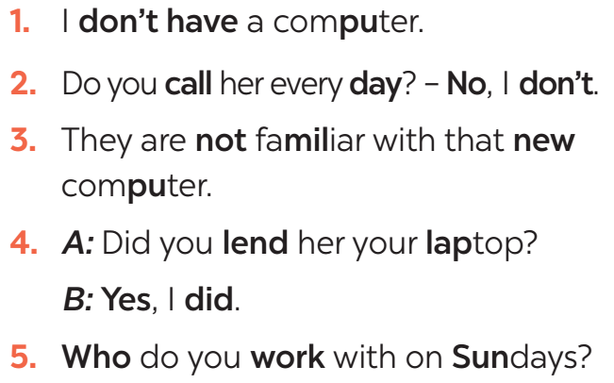
Task 5: Listen and repeat the sentences. How many stressed words are there in each sentence? (6 mins)
- Play the recording for Ss to listen and repeat each sentence after the recording. Correct Ss’ pronunciation if necessary.  - Ask Ss to count the number of stressed words in each sentence. Check if Ss have counted enough stressed words in each of the sentences.  - Call on some Ss to read the sentences. Play the recording multiple times if necessary. | Answer key:  1. He is an inventor.  → 1 stressed word  2. We won’t have a robot teacher next year.  → 6 stressed words  3. She likes learning online.  → 3 stressed words  4. Was she checking attendance when you came? – No, she wasn’t.  → 6 stressed words  5. What did he invent?  → 2 stressed words
e. Assessment
- Teacher checks students’ answers and their pronunciation and gives feedback.

4. ACTIVITY 3: PRODUCTION (5 mins)
a. Objectives:
- To test students' imitation and ability of memorisation.
b. Content:
- Game: Broken telephone
c. Expected outcomes:
- Remember the sentences and repeat them correctly (in both content and sentence stress).
d. Organisation
TEACHER’S AND STUDENTS’ ACTIVITIES | CONTENTS
GAME: BROKEN TELEPHONE
- Teacher explains the rule:  RULE:  + Gather 3 or more players.  + The person starting the game thinks of A SENTENCE and whispers it into the next player’s ear only once, with no repeats allowed.  - That listener tries to correctly repeat that SENTENCE into the next player’s ear (Paying attention to the sentence’s stress). The last person in the line or at the end of the circle repeats the SENTENCE  - Allow a moment for giggles if the message is “broken” or changed. The player who started announces the correct SENTENCE.  - Players take turns thinking of the next SENTENCE to pass through a whisper. | 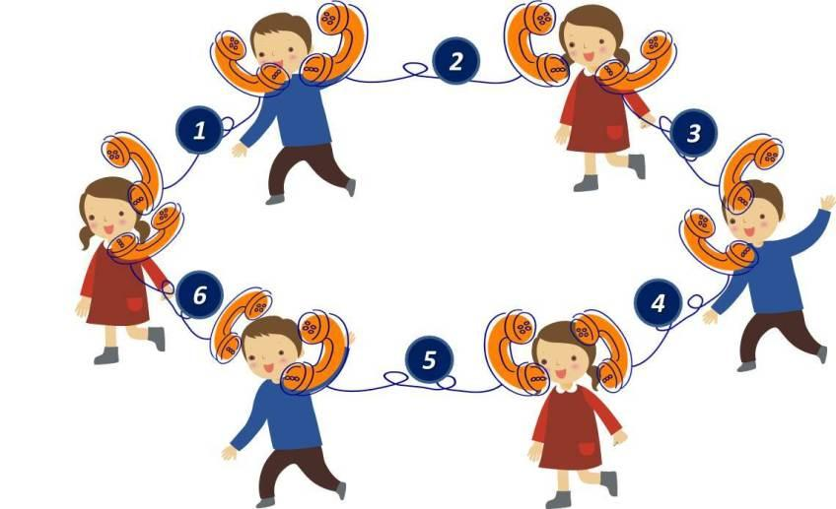
e. Assessment
- T and other Ss listen and give corrections to Ss’ pronunciation

4. CONSOLIDATION (4 mins)
a. Wrap-up
- Ask Ss to summarise what they have learned in the lesson.
- Ask them to list words and phrases related to new technologies.
- Ask them to list new verb phrases that are used to talk about inventions, discoveries, creation, and development.
- Ask them to retell the knowledge of sentences stress
b. Homework
- Learn by heart words and phrases related to new technologies and new verb phrases that are used to talk about inventions, discoveries, creation, and development.
- Do the exercises in the Workbook

BOARD PLAN
Date of teaching
Unit 11: Science and technology
Lesson 2: A closer look 1
I. Vocabulary
1. face recognition (n)
2. eye-tracking (n)
3. experiment (n)
4. fingerprint scanner (n)
5. digital communication (n)
Task 1: Write a word or phrase.
Task 2: Choose the option.
Task 3: Complete the sentences.
II. Pronunciation
Task 4: Listen and repeat the sentences.
Task 5: Listen and repeat the sentences. How many stressed words?
*Homework

UNIT 11: SCIENCE AND TECHNOLOGY
Lesson 3: A closer look 2
I. OBJECTIVES
By the end of this lesson, Ss will be able to:
1. Knowledge
- Identify what direct speech and reported speech are.
- Realise some differences between a direct speech and a reported speech (statements).
- Be aware of changes in tenses, pronouns, time, and place expressions.
2. Competences
- Develop competencies of communication, cooperation, and self-management.
- Be collaborative and supportive in pair work and teamwork
- Develop self-study skills
3. Personal qualities
- Be responsible in using technology for learning
- Have positive attitude in applying science and technology in learning and daily life
- Actively join in class activities

II. MATERIALS
- Grade 8 textbook, Unit 11, A closer look 2.
- Computer connected to the Internet
- Projector / TV
- hoclieu.vn

Language analysis
 | Direct speech | Reported speech
1. Definition | - a report of the exact words used by a speaker or writer  - usually placed inside quotation marks and accompanied by a reporting verb, signal phrase, or quotative frame. | - the form of speech used to convey what was said by someone at some point of time.
2. Changes in tenses | 1. Present simple  2. Present continuous  3. Present perfect  4. Past simple  5. Past continuous  6. Past perfect  7. will  8. can  9. may  10. must | 1. Past simple  2. Past continuous  3. Past perfect  4. Past perfect  5. Past perfect continuous  6. Past perfect  7. would  8. could  9. might  10. had to
3. Changes in pronouns  (according to situations) | 1. I/ me  2. We/ us  3. You  4. He/ she/ it/ they…  5. this  6. these | 1. He/ She/ him/ her  2. They/ them  3. I/ me  4. He/ she/ it/ they…  5. that  6. those
4. Changes in time and place expressions | 1. now  2. today  3. ago  4. tomorrow  5. this week  6. yesterday  7. last week  8. here | 1. then  2. that day  3. before  4. the following day/ the next day  5. that week  6. the day before/ the previous day  7. the week before/ the previous week  8. there
5. Structures | S1 said: “S2 + V2,”  “S2 + V2,” S1 said | S1 + said/ told sb + (that) + S2 + V2 (back-form tenses)

Assumption
Anticipated difficulties | Solutions
Ss may get confused about the changes from direct speech to reported speech. | T should be ready to find examples and give clear explanations to the students.

III. PROCEDURES
1. WARM-UP (5 mins)
a. Objectives:
- Introduce the grammar point through a game to lead into the lesson.
b. Content:
- Game: Memorising
c. Expected outcomes:
- Students can remember the content to answer the questions of the game
d. Organisation

TEACHER’S AND STUDENTS’ ACTIVITIES | CONTENTS
Game: MEMORISING  RULE:  - Work in 4 groups  - Look at the pictures in 30 seconds and try to remember what each person said.  - Write down on the posters what each of the people in the picture said.  - The group with the most correct answers is the winner. | 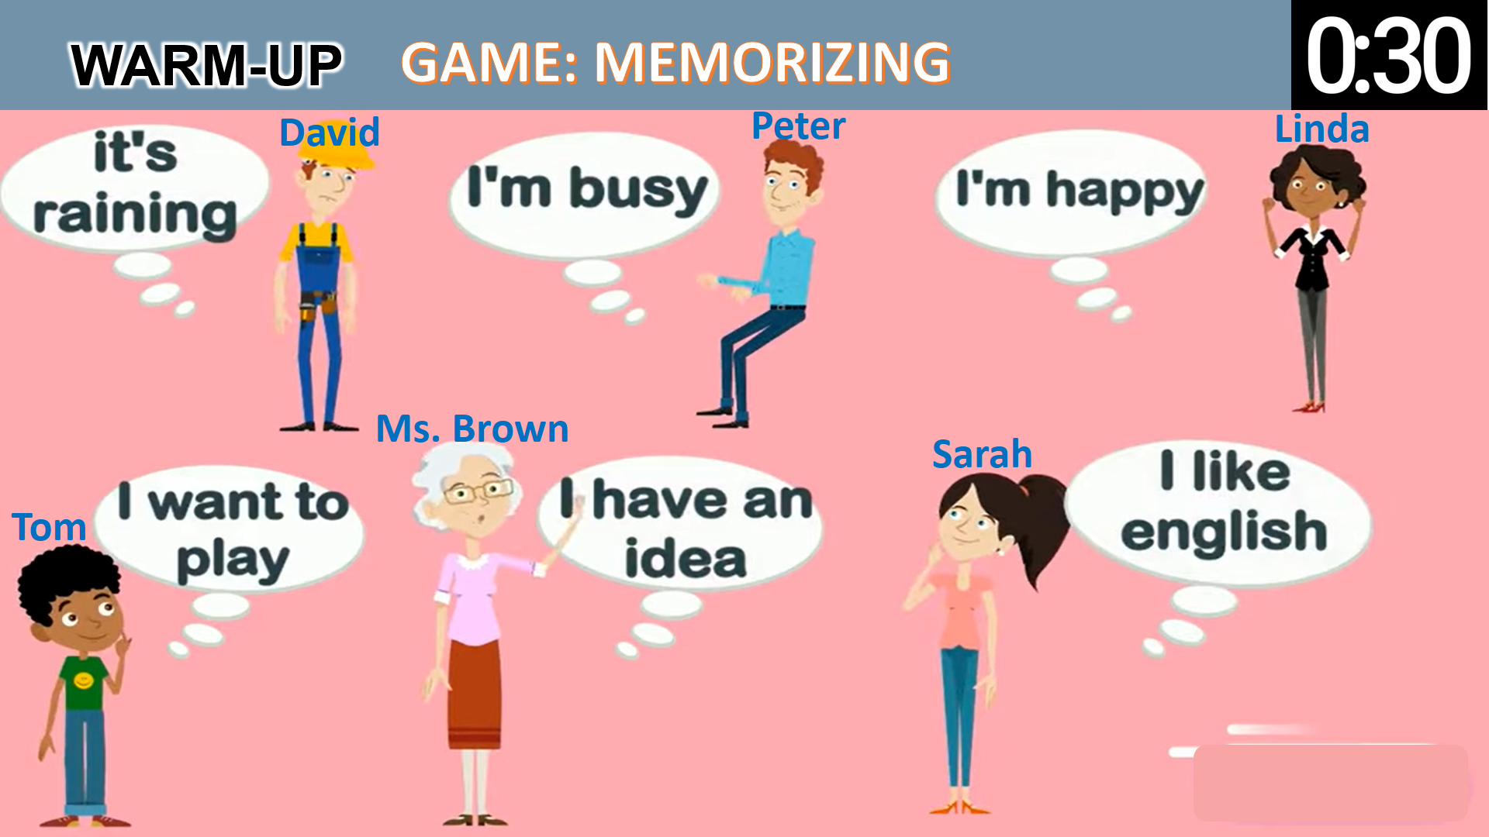
e. Assessment
- T checks ss’ answers and gives feedback.

2. ACTIVITY 1: PRESENTATION (12 mins)
a. Objectives:
- To realise some differences between direct speech and reported speech (Statements)
- To be aware of the changes in verb tenses, pronouns, time and place expressions.
b. Content:
- Task 1: Look at part of the conversation in GETTING STARTED again. Then match Minh’s uncle’s direct speech with his reported speech.
- Teaching point: Reported speech (statements)
c. Expected outcomes:
- Know what direct speech and reported speech are.
- Understand the changes in verb tenses, pronouns, time and place expressions.
d. Organisation
TEACHER’S AND STUDENTS’ ACTIVITIES | CONTENTS
Task 1: Look at part of the conversation in GETTING STARTED again. Then match Minh’s uncle’s direct speech with his reported speech.
- Ask Ss to work individually to look at the part of the conversation from GETTING STARTED  - Ask Ss to underline the sentences in GETTING STARTED  - Have Ss work in pairs to look at direct speech and reported speech boxes to match.  - Check the answers as a class.  - Ask some Ss to underline the differences in the pairs of sentences they have just matched.  - Emphasise will in direct speech is turned into would in the reported speech.  - Ask several Ss to read aloud full sentences. Correct their pronunciation if necessary. | Answer key:  1. B  2. A
Teaching point: Reported speech (statements)
- Have Ss work individually to read the Remember! box.  - Write examples of direct speech and reported speech on the board.  - Ask some Ss to point out the differences between pairs of sentences (direct and reported speech sentences)  - Remark on the differences in (1) verb form, (2) time expressions, (3) time and place expression, and (4) pronouns. | 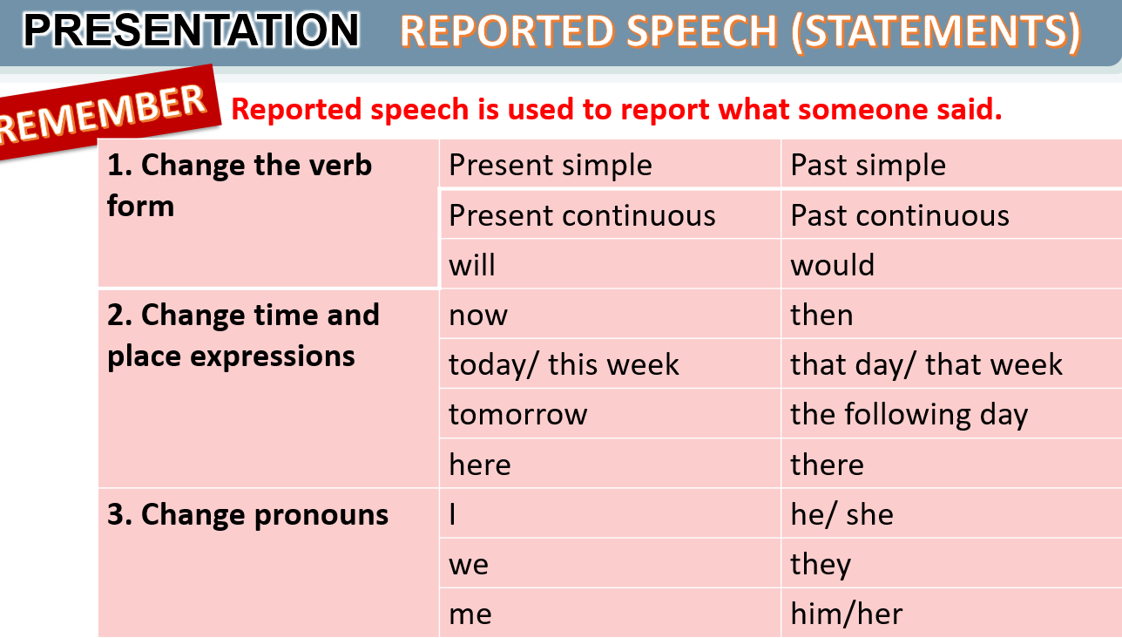
e. Assessment
- Teacher listens to students’ answers and gives feedback.

3. ACTIVITY 2: PRACTICE (28 mins)
a. Objectives:
- To be aware of how to change verb forms when they report information.
- To apply rules of changes in time and place expressions when they report information
- To practise changing direct sentences into reported sentences.
b. Content:
- Task 2: Complete the second sentences using the correct verb form.
- Task 3: Complete the second sentences with the words and phrases from the box.
- Task 4: Complete the second sentence in each pair so that it means the same as the first one.
c. Expected outcomes:
- Remember the rules of changes in verb tenses, time and place expressions, and pronouns when reporting information.
d. Organisation

TEACHER’S AND STUDENTS’ ACTIVITIES | CONTENTS
Task 2: Complete the second sentences using the correct verb form. (5 mins)
- Remind Ss that they should put the verb one tense back when they report something.  - Have Ss work in pairs to finish the sentences with the correct verb forms.  - Ask some Ss to write their answers on the board.  - Check Ss’ answers. Correct any mistakes and re-explain the rule if necessary.  - Have Ss read out loud sentences again and correct pronunciation if necessary. | Answer key:  1. was  2. would take  3. was talking  4. were going  5. didn’t have
Task 3: Complete the second sentences with the words and phrases from the box. (5 mins)
- Have Ss work individually to underline the expressions denoting time and place in the direct sentences.  - Ask Ss to choose the correct word / phrase from the box to fill each of the reported sentences. Remind them of the expressions they have just underlined in each of the direct speech sentences.  - Ask some Ss to read out the direct and reported speech sentences. Correct pronunciation if necessary.  - Check the answers as a class. | Answer key:  1. the next day  2. then  3. that day  4. that year  5. there
Task 4: Complete the second sentence in each pair so that it means the same as the first one.
(10 mins)
- Have Ss work individually for five minutes to complete the reported sentences. Then ask them to work in pairs to swap their answers.  - Ask some Ss to write their reported sentences on the board.  - Check the answers as a class.  - Have the class read out the sentences. Correct pronunciation when necessary. | Answer key:  1. The scientist said that we would live much longer in the future.  2. Our teacher said that our school was going to have a new laboratory there.  3. My dad said that they were developing technology to monitor students better.  4. Tom said that there were no classes the next day because their teacher was ill.  5. The teacher said that they wanted some students to join the science club the next semester.
e. Assessment
- Students do peer correction.
- Teacher checks students’ answers as a class and gives feedback.

4. ACTIVITY 3: PRODUCTION (4 mins)
a. Objectives:
- To enable Ss to practise reporting speech;
- To create an atmosphere of playing and learning.
b. Content:
- Game: He/She said that…
c. Expected outcomes:
- Reporting direct sentences correctly.
d. Organisation

TEACHER’S AND STUDENTS’ ACTIVITIES | CONTENTS
Task 5: Work in pairs. One student says a sentence and the other changes that sentence into reported speech. Then swap roles. (4 mins)
GAME: He/ She said that…  - Divide the class into groups of 4.  - Instruct Ss to play the game in groups.  - Give groups two minutes to prepare. Tell them that groups can write down their group’s sentences.  - Invite one group to read out or say aloud a direct speech sentence and the other to say out the sentence in reported speech, starting with She / He said...  - Remind them that the group that has the correct reported speech sentence has the right to read out their direct sentence for the other to turn into a reported one.  - Correct any grammar and pronunciation mistakes if necessary.  - The group with the most correct reported sentences wins. | 
e. Assessment
- T corrects any grammar and pronunciation mistakes if necessary.

4. CONSOLIDATION (4 mins)
a. Wrap-up
- Ask Ss to summarise what they have learnt in the lesson, retell what direct speech and reported speech are, retell the rules of changing direct speech to reported speech.
b. Homework
- Learn the rules of changing direct speech into reported speech by heart.
- Do the exercises in the workbook

BOARD PLAN
Date of teaching
Unit 11: Science and technology
Lesson 3: A closer look 2

* Grammar: Reported speech (statements)
Task 1: Match.
Remember box (p. 117)

* Practice:
Task 2: Complete the sentences using the correct verb forms.
Task 3: Complete the sentences with the given words/ phrases.
Task 4: Complete the sentences.
Task 5: GAME: He/She said that…

*Homework

UNIT 11: SCIENCE AND TECHNOLOGY
Lesson 4: Communication

I. OBJECTIVES
By the end of this lesson, Ss will be able to:
1. Knowledge
- Identify how to give and respond to good news.
- Know about the benefits and problems of online learning.
2. Skills:
- Give and respond to good news.
- Read and talk about the benefits and problems of online learning.
3. Competences
- Develop competencies of communication, cooperation, and self-management.
- Be collaborative and supportive in pair work and group work.
4. Personal qualities
- Be responsible in using technology for learning
- Have positive attitude in applying science and technology in learning and daily life

II. MATERIALS
- Grade 8 textbook, Unit 11, Communication.
- Computer connected to the Internet
- Projector / TV
- hoclieu.vn

Language analysis
Giving good news | Responding to good news
- Great news for us.  - (Tell the news) | - Great!: if good news is general and good for everyone  - Congratulations!: if the news is good for the speaker only

Assumption
Anticipated difficulties | Solutions
Some Ss may have difficulty getting enough information to talk about the benefits and problems of online learning. | T should give suggestions or let Ss read more times to get enough information.

III. PROCEDURES
1. WARM-UP (3 mins)
a. Objectives:
- To activate students’ knowledge on giving and responding to good/bad news;
b. Content:
- Video watching
c. Expected outcomes:
- Students can understand the video and answer the questions.
d. Organisation
TEACHER’S AND STUDENTS’ ACTIVITIES | CONTENTS
Video watching:  - T lets Ss watch a video and ask Ss what the video is about.  - T leads in the new lesson  - Ask Ss to look at COMMUNICATION on page 119. | Expected answers:  - Giving and responding to good news  Video link: Language Functions | Responding to Good and Bad News | Animated Lesson
e. Assessment
- T checks ss’ answers and give feedback

2. ACTIVITY 1: EVERYDAY ENGLISH (12 mins)
a. Objectives:
- To introduce how to give and respond to good news
- To help Ss practise giving and responding to good news
b. Content:
- Use everyday expressions to develop language skills (Giving and responding good news)
c. Expected outcomes:
- Learning how to give and respond to good news
d. Organisation
TEACHER’S AND STUDENTS’ ACTIVITIES | CONTENTS
Task 1: Listen and read the conversation. Pay attention to the highlighted sentences. (6 mins)
- Play the recording for Ss to listen and read the conversation between Nick and Mi. Ask Ss to pay attention to the highlighted parts. Emphasise the ways to give good news and respond to good news:  - Tell Ss that Great! and Congratulations! are different ways to respond to good news in different contexts. Tell them that if good news is general and good for everyone, we can say Great!; if the news is good for the speaker only, the responder may say Congratulations!  - Have Ss practise the conversation. | To give and respond to good news, you can use:  - Great news for us.  - Great!  - Congratulations!
Task 2: Work in pairs. Give news and respond to the news in the following situations.
- Ask Ss to work in pairs to make a similar conversation.  - Tell them to use the contexts given and the sample expressions.  - Give feedback on their conversation. | Situations:  1. You tell your classmate about the new vending machine at your school.  2. You tell your classmate about a new laptop that your dad gave you on your birthday.
e. Assessment
- Teacher listens to students’ dialogues and gives feedback.

3. ACTIVITY 2: ONLINE LEARNING (25 mins)
a. Objectives:
- To help Ss learn the language to describe the benefits and problems of online learning;
- To help Ss practise reading for specific information.
- To help Ss practise reported speech
b. Content:
- Task 3: Work in pairs. Read the posts from some students about online learning and complete the table.
- Task 4: Work in groups. Talk about a platform you use for your online classes or one you know about. What are the benefits and problems of using it?
- Task 5: Report the answers of one of your group members to the class.
c. Expected outcomes:
- Know the benefits and problems of online learning.
- Can apply reported speech to report to the class.
d. Organisation

TEACHER’S AND STUDENTS’ ACTIVITIES | CONTENTS
Task 3: Work in pairs. Read the posts from some students about online learning and complete the table. (7 mins)
- Ask some Ss to read the posts aloud.  - Have Ss work in pairs to read the posts to get information from the post and to fill in the table below.  - Ask some pairs to read out their answers. Make corrections if necessary.  - Check the answers as a class.  - If time allows, ask some students to retell information from the posts or to role play the four friends to tell class about the platform their teacher uses for their classes. | Answer key:  Benefits:  1. It’s convenient.  2. Students don’t have to get up early.  3. It helps students become more independent.  4. It helps students avoid traffic jams.  Problems:  1. Some students don’t have computers or smartphones.  2. The Internet connection is poor.  3. It makes some students feel more stressed when learning online.  4. Students can’t meet their classmates.  5. Some students get tired eyes and can’t concentrate well.
Task 4: Work in groups. Talk about a platform you use for your online classes or one you know about. What are the benefits and problems of using it? (8 mins)
– Have Ss work in groups to talk about the benefits and problems of their online learning platform.
- Ask them to think of the platform they use and use the table in Activity 3 to make notes. Tell them to use adjectives or phrases as in Activity 3.
- Invite some Ss to talk about their online learning platforms. Correct any grammar or pronunciation mistakes if necessary.
Task 5: Report the answers of one of your group members to the class. (10 mins)
- Have Ss work in groups to discuss their online learning platforms.  - Tell them that they can make notes about what their friends like and dislike about the platform their classes/ teachers use.  - Ask them to use ideas from the posts and the table in Activity 3.  - Invite group representatives to report one of their group member’s answers. Give feedback on Ss’ reports. | You can conclude:  - The name of the platform you use for your online classes or one you know about.  - Its benefits  - Its problems  Example:  Lan said that her extra class used Microsoft Teams. She said that she and her classmates found it difficult to use. However, it is convenient to have online classes on Microsoft Teams when the weather is bad.
e. Assessment
- T listens to Ss’ reports and gives feedback on their grammar, pronunciation and content.

4. CONSOLIDATION (4 mins)
a. Wrap-up
- Ask Ss what they have learnt in the lesson.
- Ss retell ways of giving and responding to good news
- Ss retell some benefits and problems of online learning.
b. Homework
- Review the ways of giving and responding to good news.
- Do the exercises in the workbook.

BOARD PLAN

Date of teaching
Unit 11: Science and technology
Lesson 4: Communication
* Everyday English:
Task 1: Listen and read the conversation.
Giving and responding to good news:
- Great news for us.
- Great!
- Congratulations!
Task 2: Give news and respond to the news.

* Online learning
Task 3: Read and complete the table.
Task 4: Talk about a platform: benefits and problems.
Task 5: Report to the class.

*Homework

UNIT 11: SCIENCE AND TECHNOLOGY
Lesson 5: Skills 1

I. OBJECTIVES
By the end of this lesson, Ss will be able to:
1. Knowledge
- Read the advertisements about new technologies
- Talk about a technology or an invention
2. Competences
- Develop communication skills and creativity
- Be collaborative and supportive in pair work and teamwork
- Develop presentation skill
4. Personal qualities
- Be responsible in using technology for learning
- Have positive attitude in applying science and technology in learning and daily life
- Actively join in class activities

II. MATERIALS
- Grade 8 textbook, Unit 11, Skills 1
- Computer connected to the Internet
- Projector / TV
- hoclieu.vn

Language analysis
Form | Pronunciation | Meaning | Vietnamese equivalent
1. biometrics (n) | /ˌbaɪəʊˈmetrɪks/ | a science that use measurements of human features (eyes, fingerprint…) to identify people | khoa học sinh trắc
2. truancy (n) | /ˈtruːənsi/ | the practice of staying away from school without permission | trốn học, nghỉ học không phép
3. nanolearning (n) | /’nænəʊlɜːnɪŋ/ | Nano + learning. Nano means very very small = one billionth. Nanolearning refers to a method of delivering educational content in tiny, bite-sized chunks | học thông qua những nội dung ngắn gọn, cô đọng
4. effortless (adj) | /ˈefətləs/ | needing little or no effort, so that it seems easy | không cần nhiều nỗ lực
5. platform (v) | /ˈplætfɔːm/ | the type of computer system or the software that is used | nền tảng
6. cheating (n) | /tʃiːtɪŋ/ | acting in a dishonest way in order to gain an advantage, especially in a game, a competition, an exam, etc. | gian lận

Assumption
Anticipated difficulties | Solutions
1. Ss may lack knowledge about some lexical items. | - Provide Ss with the meaning and pronunciation of words.
2. Ss may not have sufficient reading, speaking and cooperating skills. | - Let Ss read the text again (if needed).  - Create a comfortable and encouraging environment for Ss to speak.  - Encourage Ss to work in pairs, and in groups so that they can help each other.  - Provide feedback and help if necessary.

III. PROCEDURES
1. WARM-UP (3 mins)
a. Objectives:
- To create an active atmosphere in the class before the lesson;
- To elicit from Ss some technological applications
b. Content:
- Brainstorming
c. Expected outcomes:
- Students are able to list the technological applications used in their schools.
d. Organisation

TEACHER’S AND STUDENTS’ ACTIVITIES | CONTENTS
Brainstorming:  - Ask ss to name the technological applications your school uses  - Ask Ss to look at SKILLS 1 on page 120-121. | Expected answers:  - Fingerprint scanner  - Face recognition
e. Assessment
- T listens to ss’ answers and gives feedback

2. ACTIVITY 1: READING (25 mins)
a. Objectives:
- To help Ss learn new vocabulary in the reading text.
- To improve Ss’ skill of reading for general and specific information through a text about biometrics and nanolearning
b. Content:
- Task 1: Name the technological applications in the pictures.
- Vocabulary teaching
- Task 2: Read the passage and tick B (Biometrics) or N (Nanolearning)
- Task 3: Read the passage and choose the correct answer A, B, or C.
c. Expected outcomes:
- Know more new words and some technological applications
- Understand the text about the benefits of the two new technological applications.
d. Organisation
TEACHER’S AND STUDENTS’ ACTIVITIES | CONTENTS
Task 1: Work in pairs. Name the technological applications in the pictures. Can they be used in schools? (3 mins)
- Have the class work in pairs to describe the pictures and say what technology the pictures are about.  - Ask Ss to discuss if these technologies can be used at schools. | Answer key:  1. eye-tracking  2. fingerprint scanner  3. face recognition
Vocabulary teaching (6 mins)
- Teacher further explains the meaning of the new vocabulary with pictures.  - Teacher checks students’ understanding with follow-up questions. | New words:  1. biometrics (n)  2. truancy (n)  3. nanolearning (n)  4. effortless (adj)  5. platform (v)  6. cheating (n)
Task 2: Read the passage and tick B (Biometrics) or N (Nanolearning). (8 mins)
- Ask Ss to work individually to read the texts and to decide if the statements from the text are about biometrics or nanolearning. Ask them to write B (Biometrics) or N (Nanolearning).  - Ask Ss to underline the key words in each of the statements then search for the information in the two texts.  - Have Ss to work in pairs to swap answers or to check answers together.  - Ask some Ss to read out loud the statements and say B or N. Ask them to show the parts in the reading where they find the answers.  - Check the answers as a class. | Answer key:  1. N  2. B  3. B  4. N  5. N
Task 3: Read the passage and choose the correct answer A, B, or C. (7 mins)
- Have Ss work individually for five minutes and choose the correct answers. Remind them to underline the key words in the questions and the evidence for the answers.  - Ask Ss to take turns to give the answers. Ask them to show the parts in the reading texts where they find the answers.  - Check the answers as a class.  - T can also ask one or two Ss to say which technology they prefer and why or ask them to orally summarise each of the texts. | Answer key:  1. A  2. B  3. C  4. B
e. Assessment
- Teacher listens to students’ pronunciation and gives feedback.
- T checks the answers as a class and gives feedback.

3. ACTIVITY 2: SPEAKING (15 mins)
a. Objectives:
- To have Ss practise asking and answering questions for information about an invention or a technology;
- To give Ss an opportunity to practise explaining how the technology can help us;
- To improve Ss’ confidence in speaking in front of the class.
b. Content:
- Task 4: Work in pairs. Discuss and match the questions in A with the answers in B, and then make a conversation about an invention.
- Task 5: Work in groups. Ask and answer questions about a technology or an invention. Use the example in 4 as a cue. Then report your answers to the class.
c. Expected outcomes:
- Students can talk about an invention or a technology and its benefits.
d. Organisation

TEACHER’S AND STUDENTS’ ACTIVITIES | CONTENTS
Task 4: Work in pairs. Discuss and match the questions in A with the answers in B, and then make a conversation about an invention. (7 mins)
- Have Ss work in pairs to match the questions in A with the answers in B.  - Have them practise asking and answering questions about biometrics in the example.  - Assist Ss to make full questions when necessary.  - Ask them to ask and answer questions about an invention or a technology they like or know.  - Ask some pairs to role-play it.  - Ask the class to offer feedback on their questions, answers, and pronunciation.  - Prepare cue cards about different inventions / technologies and ask Ss to practise asking and answering questions about those inventions / technologies.  - This activity helps prepare Ss for 5. | Answer key:  1. c  2. a  3. d  4. b, e  Suggested conversation:  A: What invention do you like?  B: I like biometrics.  A: Who invented it?  B: Alphonse Bertillon.  A: When did he invent it?  B: In the 1880s.  A: What can we use it for?  B: It can help us check students’ attendance. We can also use it to check identities of people at airports or offices.
Task 5: Work in groups. Ask and answer questions about a technology or an invention. Use the example in 4 as a cue. Then report your answers to the class. (8 mins)
- Have Ss work in groups to ask and answer questions about a invention or a technology;  - Ask them to explain what they can use the technology or invention for.  - Invite one representative of each group to report their group’s answers to the class.  - Give feedback on their reports in terms of language, reported verb forms, and pronunciation. | Example:  Mi likes biometrics. Alphonse Bertillon invented it in 1800s. It is a very important technology. We use it to …
e. Assessment
- T asks the class to give feedback on their questions and answers, and pronunciation.
- T gives feedback on their reports in terms of language, reasoning skills, and pronunciation.

4. CONSOLIDATION (3 mins)
a. Wrap-up
- Ask Ss what they have learnt in the lesson.
- Ss retell some information about the two new technologies in the reading text.
b. Homework
- Learn the new words by heart.
- Do the exercises in the workbook

BOARD PLAN

Date of teaching
Unit 11: SCIENCE AND TECHNOLOGY
Lesson 5: Skills 1
* Reading
Task 1: Name the technological applications.
Vocabulary:
1. biometrics (n)
2. truancy (n)
3. nanolearning (n)
4. effortless(adj)
5. platform(v)
6. cheating (n)
Task 2: Read and tick.
Task 3: Read and choose the correct answer.

* Speaking
Task 4: Make a conversation.
Task 5: Ask and answer. Then report.
*Homework

UNIT 11: SCIENCE AND TECHNOLOGY
Lesson 6: Skills 2

I. OBJECTIVES
By the end of this lesson, Ss will be able to:
1. Knowledge
- Listen about what a robot teacher can do and can’t do.
- Write a paragraph expressing opinions about whether a robot teacher will replace human teachers at school.
2. Competences
- Develop communication skills and creativity
- Be collaborative and supportive in pair work and group work
3. Personal qualities
- Be responsible in using technology for learning
- Have positive attitude in applying science and technology in learning and daily life
- Actively join in class activities

II. MATERIALS
- Grade 8 textbook, Unit 11, Skills 2
- Computer connected to the Internet
- Projector / TV
- hoclieu.vn

Language analysis
Form | Pronunciation | Meaning | Vietnamese equivalent
1. interact with (v) | /ˌɪntərˈækt wɪð/ | to communicate with somebody, especially while you work, play or spend time with them | tương tác với, giao tiếp với
2. emotional (adj) | /ɪˌməʊʃənl/ | connected with people’s feelings  (= with the emotions) | thuộc tình cảm, dễ cảm động

Assumption
Anticipated difficulties | Solutions
1. Ss may lack knowledge about some lexical items. | - Provide Ss with the meaning and pronunciation of words.
2. Ss may not have sufficient listening, writing and co-operating skills. | - Let Ss listen to the text again (if needed).  - Encourage Ss to work in pairs, in groups so that they can help each other.  - Provide feedback and help if necessary.

III. PROCEDURES
1. WARM-UP (3 mins)
a. Objectives:
- To create an active atmosphere in the class before the lesson;
- To help Ss focus on the listening and writing topic
b. Content:
- Name the pictures
c. Expected outcomes:
- Students know some type of robots
d. Organisation

TEACHER’S AND STUDENTS’ ACTIVITIES | CONTENTS
Name the pictures  - Ask ss to look at the five pictures on the screen and name 5 types of robots.  - Lead in the lesson: There are many types of robots nowadays. Today we are going to learn about teacher robots and what a teacher robot can do and what it can’t do in Lesson 6. SKILLS 2 on page 89. | Suggested answers:  1. doctor robot  2. space robot  3. worker robot  4. home robot  5. teacher robot
e. Assessment
- T checks ss’ answers and gives feedback.

2. ACTIVITY 1: LISTENING (20 mins)
a. Objectives:
- To improve Ss’ skill of listening for specific information.
- To improve Ss’ listening comprehension and note-taking skills.
b. Content:
- Vocabulary pre-teaching
- Task 1: Tick the things that you think a robot teacher can do.
- Task 2: Listen to the conversation and fill in each blank with ONE word.
- Task 3: Listen again and tick T (True) or F (False).
c. Expected outcomes:
- Students know more new words and gain more knowledge through the listening tasks.
- Students can get general and specific information about a robot teacher through listening.
d. Organisation
TEACHER’S AND STUDENTS’ ACTIVITIES | CONTENTS
Vocabulary pre-teaching (3 mins)
- Teacher introduces the vocabulary.  - Teacher explains the meaning of the new vocabulary by pictures or explanation  - Teacher reveals that these two words will appear in the listening text and asks students to open their textbooks to discover further. | New words:  1. emotional (adj): thuộc tình cảm/cảm xúc  2. interact with (v): tương tác
Task 1: Tick the things that you think a robot teacher can do. (3 mins)
- Ask Ss to work in pairs to tick the things that a robot teacher can do. Ask Ss to add more things a robot teacher can do.  - Tell Ss that they are going to listen to a conversation about a robot teacher and fill in each of the blanks with ONE word.  - Also ask Ss to list things robots in general can do (for example: doing boring housework, hard work in factories, delivering letters at workplaces, etc.) | Suggested answers:  - 1, 2  - A robot teacher can dance, teach subjects, play with students...
Task 2: Listen to the conversation and fill in each blank with ONE word. (7 mins)
- Ask Ss to work individually to read the table and guess the possible words to fill in each of the blanks.  - Remind them to think of the part of speech of that word (noun, verb, adjective, adverb or number) and forms of nouns (singular, plural).  - Play the recording once for Ss to fill in the blanks. Remind Ss that they should write only ONE word for each blank.  - Check Ss’ answers and play the recording again for them to better understand the conversation between Tom and Lan. Stop or rewind the recording where necessary. | Answer key:  1. languages  2. maths  3. interact  4. behave  5. problems
Task 3: Listen again and tick T (True) or F (False). (7 mins)
- Ask Ss to work in pairs to read the statements and underline the key words in the statements.  - Play the recording once. Give them two minutes to decide if the sentences are T (True) or F (False).  - Play the recording again and check their answers as a class. | Answer key:  1. T  2. T  3. F  4. F  5. F
e. Assessment
- Teacher listens to students’ pronunciation and gives feedback.
- T checks the answers as a class and gives feedback

3. ACTIVITY 2: WRITING (20 mins)
a. Objectives:
- To improve ss’ skill of writing a paragraph expressing opinions about whether robots will replace teachers at schools.
b. Content:
- Task 4: Work in pairs. Discuss if you agree or disagree that robots will soon replace teachers at schools. Write the reasons in the table.
- Task 5: Now write a paragraph (80 - 100 words) to express your opinion. Use the notes in 4.
c. Expected outcomes:
- Students can use learned vocabulary and grammar to write a paragraph about the given topic.
d. Organisation

TEACHER’S AND STUDENTS’ ACTIVITIES | CONTENTS
Task 4: Work in pairs. Discuss if you agree or disagree that robots will soon replace teachers at schools. Write the reasons in the table. (5 mins)
- Ask Ss to work in pairs to brainstorm ideas and fill in the blanks.  - Ask Ss to get ideas from the listening and add any more ideas they have.  - Ask some Ss to read out loud ideas for each column.  - Correct their pronunciation where necessary. | Suggested answer:  Agree:  1. Robots can better remember things than teachers.  2. Robots can talk for a longer time and not feel tired.  3. Robots can store more data and information and tell it to students.  4. Robots can interact well with students.  5. Robots don’t make students embarrassed if they give wrong answers.  Disagree:  1. Robots can’t understand students’ emotions.  2. Robots can’t teach students how to behave well.  3. Robots can’t help solve problems between students.  4. Robots can’t motivate students.  5. Robots don’t have emotional connections with students.
Task 5: Now write a paragraph (80 - 100 words) to express your opinion. Use the notes in 4. (15 minutes)
- T records the ideas Ss have brainstormed in Activity 4 on the board.  - Ask Ss to work individually to write for 15 minutes. Tell them to use the information in Activity 4 and any other ideas they may think of. Remind Ss to choose only three ideas for their paragraph.  - T asks one student to read out his / her paragraph.  - If time allows, also ask Ss to work in groups to write on an A1 / A0 size piece of paper, then T organises a gallery walk. Ss walk round and offer feedback on peers’ writing in terms of ideas, grammar and connectors. | Suggested answer:  I disagree that robots will soon replace teachers at school. First, although robots can store much information to provide to students, they cannot teach students how to behave in the right ways in different situations. Second, a robot can only teach what is programmed, but cannot help students deal with problems, especially troubles among students’ relationships. Third, a robot can speak, walk, do simple actions, but they cannot interact with students in the way human teachers do. Robots do not have emotions and feelings, so I believe they cannot help students to deal with problems related to feelings and emotions.
e. Assessment
- T gives feedback on their writing in terms of spelling, grammatical mistakes, cohesion, and content.

4. CONSOLIDATION (3 mins)
a. Wrap-up
- Ask Ss what they have learned in the lesson.
- Ss tell the whole class:
- What a robot teacher can do and what it can’t do.
- The reasons robot teachers can or can’t replace teachers at school.
- How to write a paragraph expressing opinions.
b. Homework
- Learn the new words by heart.
- Rewrite the paragraph in the notebook.
- Do the exercises in the Workbook

BOARD PLAN

Date of teaching
Unit 11: Science and technology
Lesson 6: Skills 2
* Listening
Vocabulary:
1. interact with (v)
2. emotional (adj)
Task 1: Tick.
Task 2: Listen and fill.
Task 3: Listen and choose A, B, or C.

* Writing
Task 4: Discuss. Write the reasons.
Task 5: Write a paragraph.
*Homework

UNIT 11: SCIENCE AND TECHNOLOGY
Lesson 7: Looking back and Project

I. OBJECTIVES
By the end of this lesson, Ss will be able to:
1. Knowledge
- Use the vocabulary about new technologies and words and phrases that are used to talk about inventions, discoveries, inventions, and creations to do exercises.
- Apply the knowledge of reported speech (statements) to do exercises.
- Apply what they have learnt (vocabulary and grammar) into practice through a project.
2. Competences
- Develop communication skills and creativity
- Develop presentation skill
- Develop critical thinking skills
- Be collaborative and supportive in pair work and teamwork
3. Personal qualities
- Be responsible in using technology for learning
- Have positive attitude in applying science and technology in learning and daily life
- Actively join in class activities

II. MATERIALS
- Grade 8 textbook, Unit 11, Looking back and Project
- Computer connected to the Internet
- Projector / TV
- hoclieu.vn

Assumption
Anticipated difficulties | Solutions
1. Ss may not have sufficient speaking, writing and co-operating skills when doing the project. | - Encourage Ss to work in pairs, in groups so that they can help each other.  - Provide feedback and help if necessary.

III. PROCEDURES
1. WARM-UP (3 mins)
a. Objectives:
- To create an active atmosphere in the class before the lesson;
- To lead into the lesson.
b. Content:
- Kim’s game
c. Expected outcomes:
- Students can list the inventions mentioned in the video
d. Organisation

TEACHER’S AND STUDENTS’ ACTIVITIES | CONTENTS
Kim’s game:  - T asks students to work in groups of three or four.  - Get ss to watch a video clip and try to remember all the inventions mentioned in the clip without taking notes.  - After finishing watching the clip, ss write down as many inventions as possible.  - T gets ss to swap the posters and give corrections after T shows the answers.  -The group with the most correct answers will win.  - T leads in the lesson. | Answers:  10. The paper  9. The compass  8. The refrigeration  7. The printing press  6. Plumbing  5. Medicine  4. Engines  3. The wheel  2. Communication  1. Electricity  Video link: Top 10 Inventions of All Time
e. Assessment
- T check ss’ answers and gives feedback

2. ACTIVITY 1: LOOKING BACK (22 mins)
a. Objectives:
- To help Ss review the learnt vocabulary about science and technology
- To help Ss review reported statements
- To help Ss use the reported statements correctly
b. Content:
- Task 1: Circle the option that goes with each verb.
- Task 2: Fill in each gap with a word or phrase from the box. You may have to change the form of the word or phrase.
- Task 3: Which of the underlined parts in each question is incorrect? Find and correct it.
- Task 4: Rewrite the following sentences, using the words in BOLD.
c. Expected outcomes:
- Recall the vocabulary learnt
- Recall the changes in tenses, pronouns, time and place expressions to report information.
d. Organisation

TEACHER’S AND STUDENTS’ ACTIVITIES | CONTENTS
Task 1: Circle the option that goes with each verb. (4 mins)
- Have Ss work individually to circle the option that can combine with the given verbs.  - Have Ss read out their phrases.  - Check answers as a class.  - Correct Ss’ pronunciation if necessary. | Answer key:  1. A  2. B  3. B  4. A
Task 2: Fill in each gap with a word or phrase from the box. You may have to change the form of the word or phrase. (5 mins)
- Have Ss work individually to fill in each blank with the correct form of the words /phrases from the box.  - Check answers as a class.  - Ask some Ss to read the sentences aloud. Correct Ss’ pronunciation if necessary. | Answer key:  1. robot teachers  2. application  3. face recognition  4. eye-tracking  5. check attendance
Task 3: Which of the underlined parts in each question is incorrect? Find and correct it. (6 mins)
- Have Ss work individually to circle a mistake in each of the sentences. Remind them that only the underlined words will have mistakes.  - Then ask Ss to work in pairs to swap and check their answers.  - Check answers as a class.  - Ask one student to read out his/her sentences. Correct his / her pronunciation if necessary. | Answer key:  1. B (discovers → discovered)  2. A (is → was)  3. B (will make → would make)  4. B (can → could)  5. C (next year → the next / following year)
Task 4: Rewrite the following sentences, using the words in BOLD. (7 mins)
- Ask Ss to work individually to complete the sentences as requested in the book.  - Ask one or two Ss to go to the board and write their full sentences.  - Then ask the class to work in pairs. Tell them to swap their writings and check their partner’s answers.  - Check the sentences written on the board.  - Have all Ss correct their partner’s answers.  - Ask some Ss to read out their sentences. Correct Ss’ language and pronunciation if necessary. | Answer key:  1. Tom said (that) they couldn’t connect to the Internet to work online there.  2. Mr Thompson said (that) science was becoming a more important subject in schools then.  3. The headmaster said (that) the school would use a machine to check students’ attendance the following year.  4. The monitor said to the class (that) they were having a science competition that week.  5. The students said (that) they didn’t like robot teachers at all.
e. Assessment
- Teacher checks students’ answers and corrects Ss’ language and pronunciation if necessary.

3. ACTIVITY 2: PROJECT (18 mins)
a. Objectives:
- To raise Ss’ awareness of their ability to be creative to deal with the problems;
- To improve Ss’ teamwork and public speaking skills.
b. Content:
- Poster presentation
c. Expected outcomes:
- Students can present their posters with pictures or a paper model of the invention.
d. Organisation

TEACHER’S AND STUDENTS’ ACTIVITIES | CONTENTS
Your invention  - Ask Ss to read the instructions again (T has already been assigned the project since the first lesson of the Unit and checked their progress after each lesson). Let students have some time to check their posters for the final time and make any adjustments if necessary.  - T has groups show their posters and present them to the class. | Students’ posters & presentations
e. Assessment
- T checks ss’ grammatical and spelling mistakes on their poster, listens to their presentation, and gives feedback

4. CONSOLIDATION (2 mins)
a. Wrap-up
- Ask Ss to complete the self-assessment table.
- Identify any difficulties and provide further practice.
b. Homework
- Do the exercises in the workbook

BOARD PLAN

Date of teaching
Unit 11: Science and technology
Lesson 7: Looking back and Project
* Vocabulary:
Task 1: Circle.
Task 2: Fill in each gap.

* Grammar
Task 3: Find and correct.
Task 4: Rewrite the sentences.

* Project

*Homework

