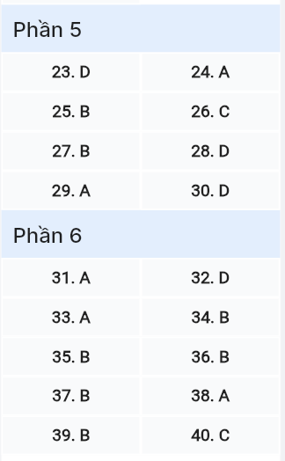
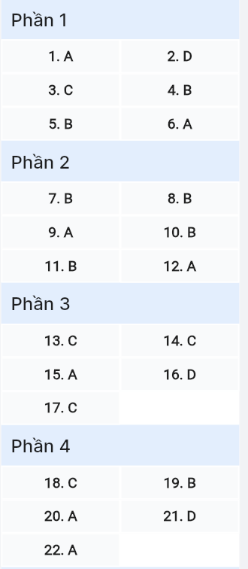
ĐỀ MINH HỌA SỐ 20
KỲ THI TỐT NGHIỆP TRUNG HỌC PHỔ THÔNG NĂM 2025
(Đề thi có 08 trang)
Môn thi: TIẾNG ANH
Thời gian làm bài: 50 phút, không kể thời gian phát đề

Read the following advertisement and mark the letter A, B, C or D on your answer sheet to indicate the option that best fits each of the numbered blanks from 1 to 6.

Planning Your Future
"Where will I go next? Will I find the career path that suits me best ever?" These are the questions you may ask yourself when attending a (1) ______. Fortunately, a new seminar program (2) ______ "Pathway to Success" aims to provide clarity. When you register, you receive a personalized guide (3) ______ the different career options available.
During the seminar, you can choose sessions that (4) ______ your interests and meet professionals from different industries. If you are hoping (5) ______ on business-related careers, there will be experts (6) ______ to share insights. For those interested in creative fields, there are sessions that help you explore artistic careers and build a portfolio.
Question 1 [697696]: A. career counseling seminar B. counseling career seminar
C. seminar counseling career D. seminar career counseling

Question 2 [697697]: A. calling B. was called C. calls D. called
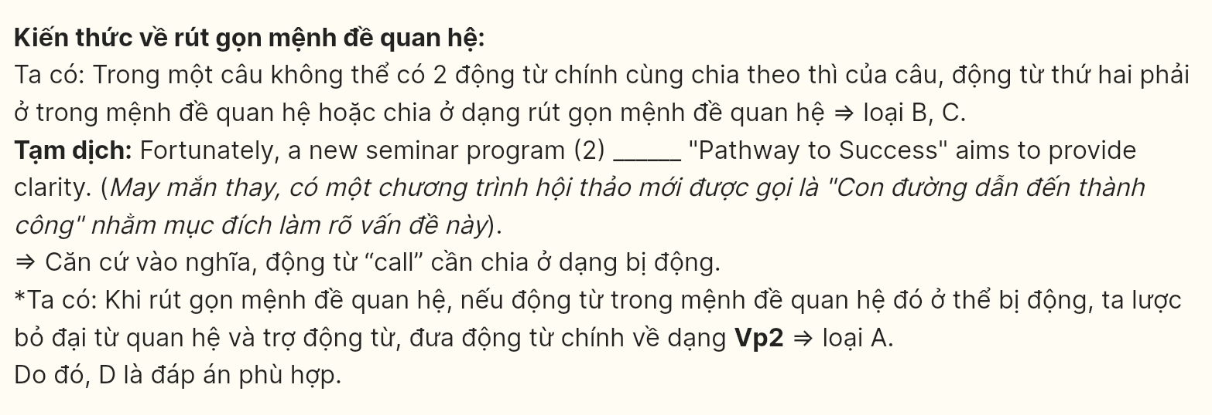
Question 3 [697698]: A. at B. in C. about D. on

Question 4 [697699]: A. fit B. match C. suit D. align
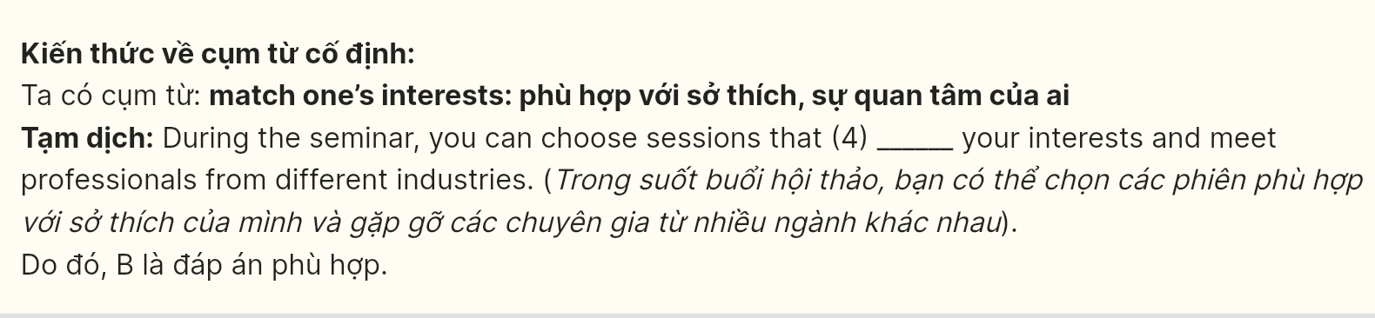
Question 5 [697700]: A. focusing B. to focus C. focus D. to focusing

Question 6 [697701]: A. available B. availability C. avail D. unavailable

Read the following leaflet and mark the letter A, B, C or D on your answer sheet to indicate the option that best fits each of the numbered blanks from 7 to 12.
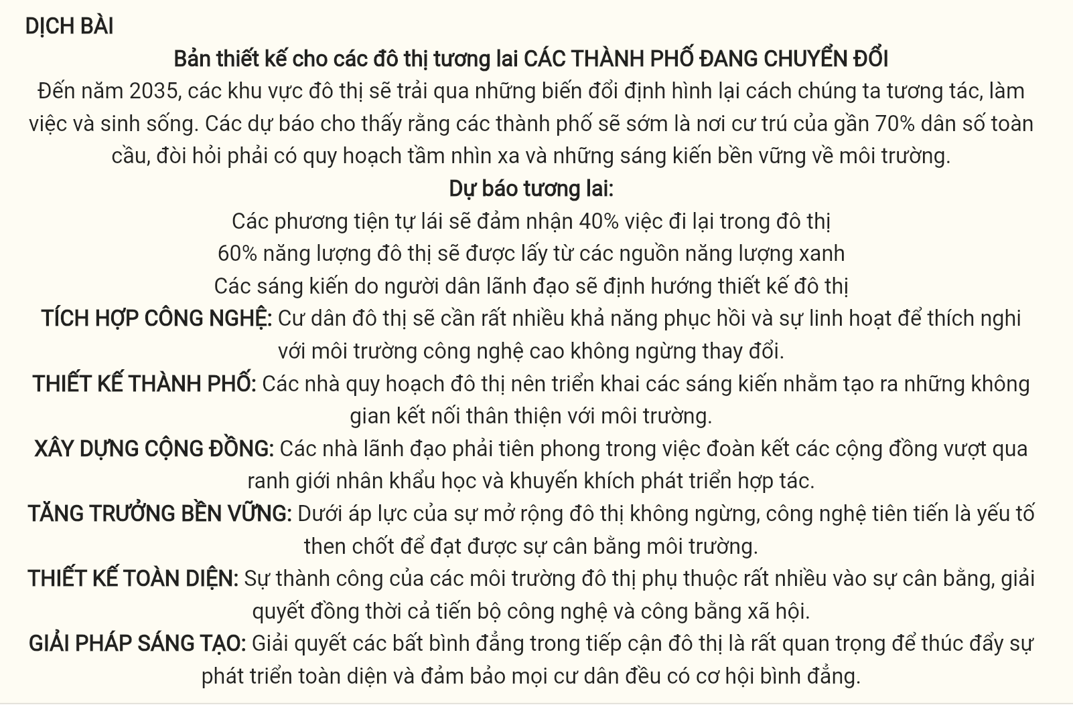
Blueprints for Tomorrow’s Metropolises
CITIES IN TRANSITION
By 2035, urban areas will undergo transformations that redefine how we interact, work, and live. Forecasts show that cities will soon house nearly 70% of the global population, requiring visionary planning and environmentally sustainable innovations.
FUTURE FORECASTS:
- Self-driving vehicles will handle 40% of urban commuting
- 60% of urban power will be derived from green energy sources
- Citizen-led initiatives will guide urban design
TECH INTEGRATION: Urban residents will need (7) ______ resilience and versatility to adapt to ever-evolving, high-tech surroundings.
CITY DESIGN: Urban planners should (8) ______ initiatives aimed at creating environmentally friendly, interconnected spaces.
BUILDING COMMUNITY: Leaders must (9) ______ efforts to unite communities across demographic lines and encourage cooperative development.
SUSTAINABLE GROWTH: (10) ______ relentless urban expansion, advanced technology is critical to achieving environmental balance.
HOLISTIC DESIGN: The success of urban environments relies heavily on (11) ______ that addresses both technological advancements and social equity.
RESOURCEFUL SOLUTIONS: Addressing (12) ______ in urban access is crucial for fostering inclusive growth and ensuring all residents have equal opportunities.
(Adapted from ResearchGate)
Question 7 [697702]: A. many B. much C. a little D. a few
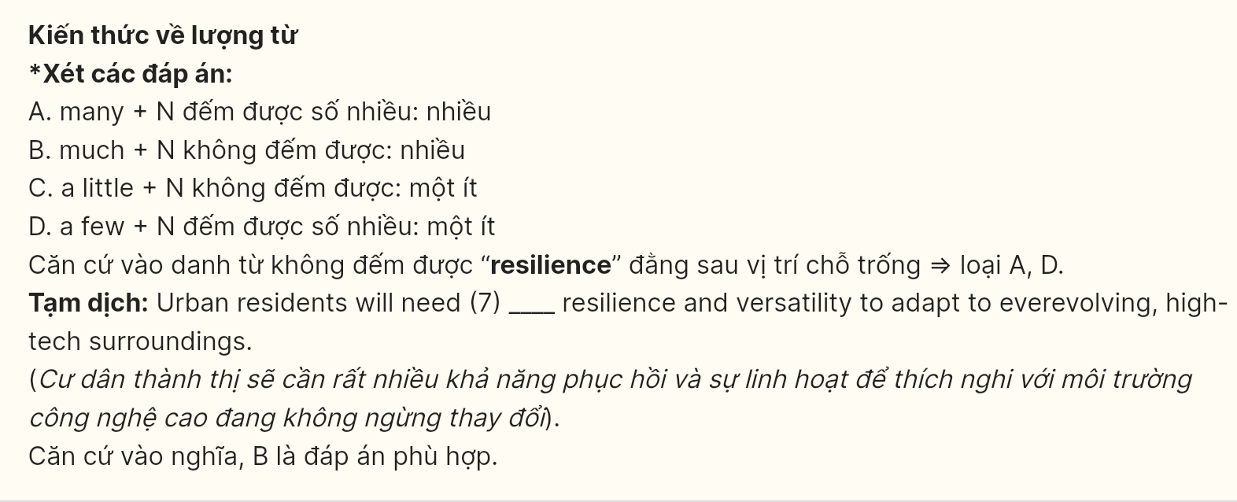
Question 8 [697703]: A. see off B. roll out C. run over D. get across
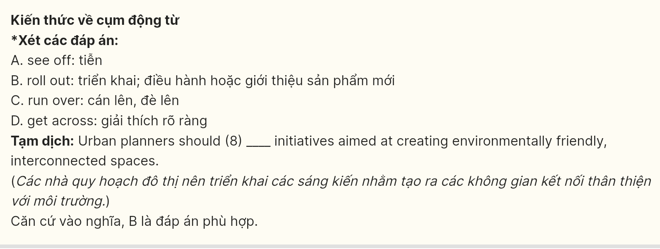
Question 9 [697704]: A. spearhead B. arbitrate C. incentivize D. anchor
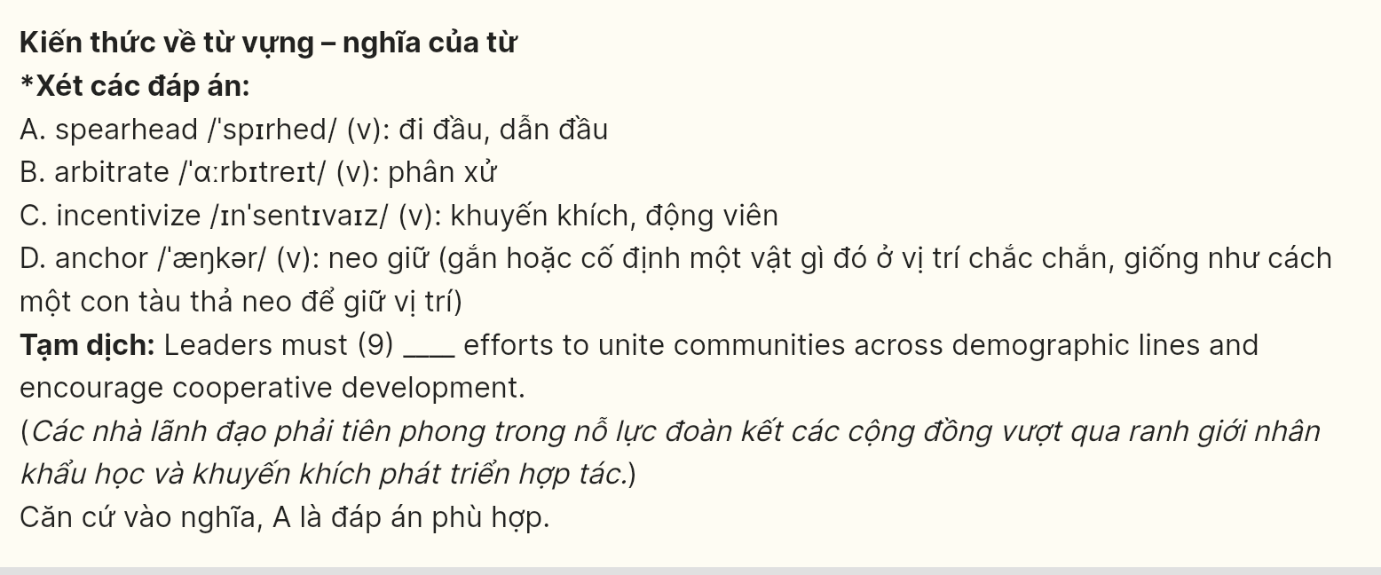
Question 10 [697705]: A. In response to B. Under the weight of
C. On the foundation of D. In view of
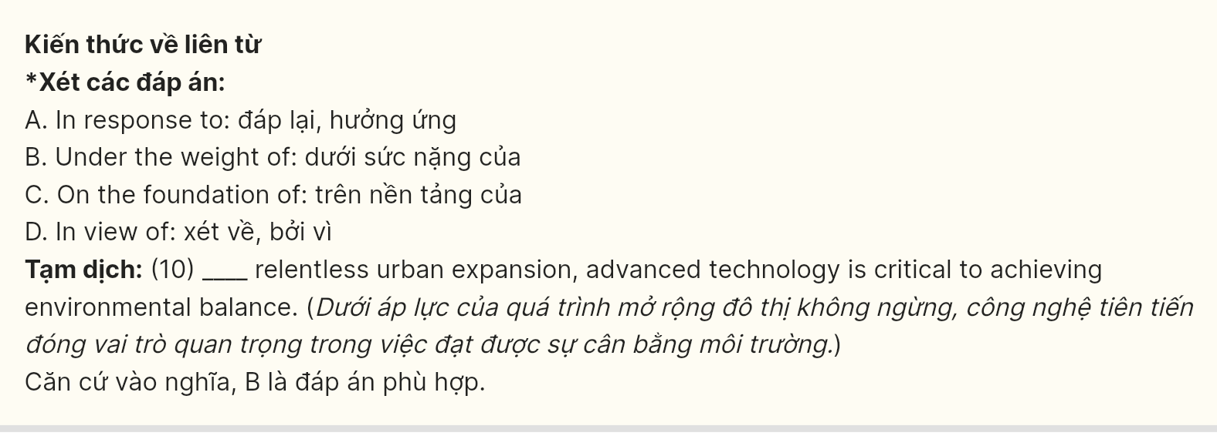
Question 11 [697706]: A. consonance B. equilibrium C. juxtaposition D. reconciliation

Question 12 [697707]: A. inequities B. inconsistencies C. shortcomings D. inadequacies
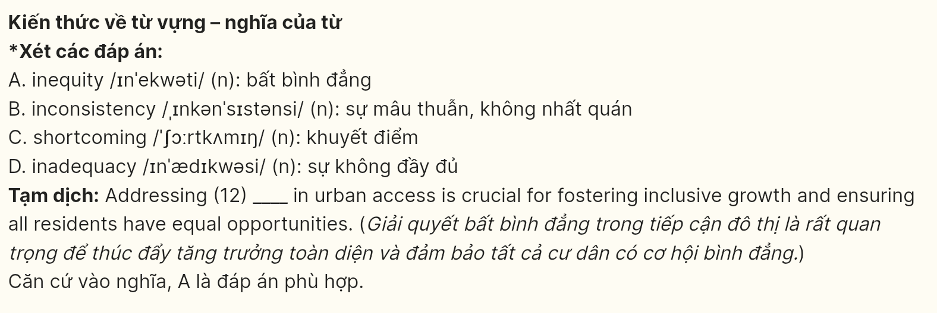
Mark the letter A, B, C or D on your answer sheet to indicate the best arrangement of utterances or sentences to make a meaningful exchange or text in each of the following questions from 13 to 17.
Question 13 [697708]:
a. Mark: I’ve been practicing a lot lately. I hope I can perform well in the competition.
b. Sarah: Hey, Mark! It’s been a while. How’s everything going?
c. Sarah: That sounds exciting! Good luck with the competition.
A. c - a – b B. b - c – a C. b - a – c D. a - c - b

Question 14 [697709]:
a. Steve: I usually get mine from food blogs or cooking websites.
b. Mary: Thanks! I’ll definitely look it up.
c. Mary: Do you know where I can find some good recipes?
d. Mary: Oh, I’ll check those out. Any specific ones you recommend?
e. Steve: Sure! You should try this blog called “Tasty Treats”. They have a lot of great ideas.
A. c - a - e - d – b B. a - c - d - e – b C. c - a - d - e – b D. b - a - c - d - e

Question 15 [697710]:
Hi James,
a. I'm excited to start my painting classes soon!
b. Thanks so much for the art supplies you sent me last week.
c. I've been practicing sketching daily, and I feel like I'm improving.
d. The brushes and paints are amazing - they are much better than the ones I've been using.
e. Hopefully, we can attend a class together in the future!
Write back soon.
Emma
A. b - d - a - c – e B. b - a - c - d – e C. a - c - b - d – e D. a - b - c - d - e

Question 16 [697711]:
a. There are also many music festivals around the globe that bring artists and music fans together.
b. People nowadays enjoy listening to music from different countries and cultures, and in different languages.
c. Thanks to globalization, people can quickly discover new music from all over the world.
d. To sum up, in today's connected world, it is very common for musicians across the world to work on music projects and share ideas together.
e. For example, American teens are captivated by K-pop music and dance.
(Adapted from Tiếng Anh 12 Global Success)
A. c - a - b - e – d B. d - a - b - e – c C. d - b - c - e – a D. c - b - e - a - d
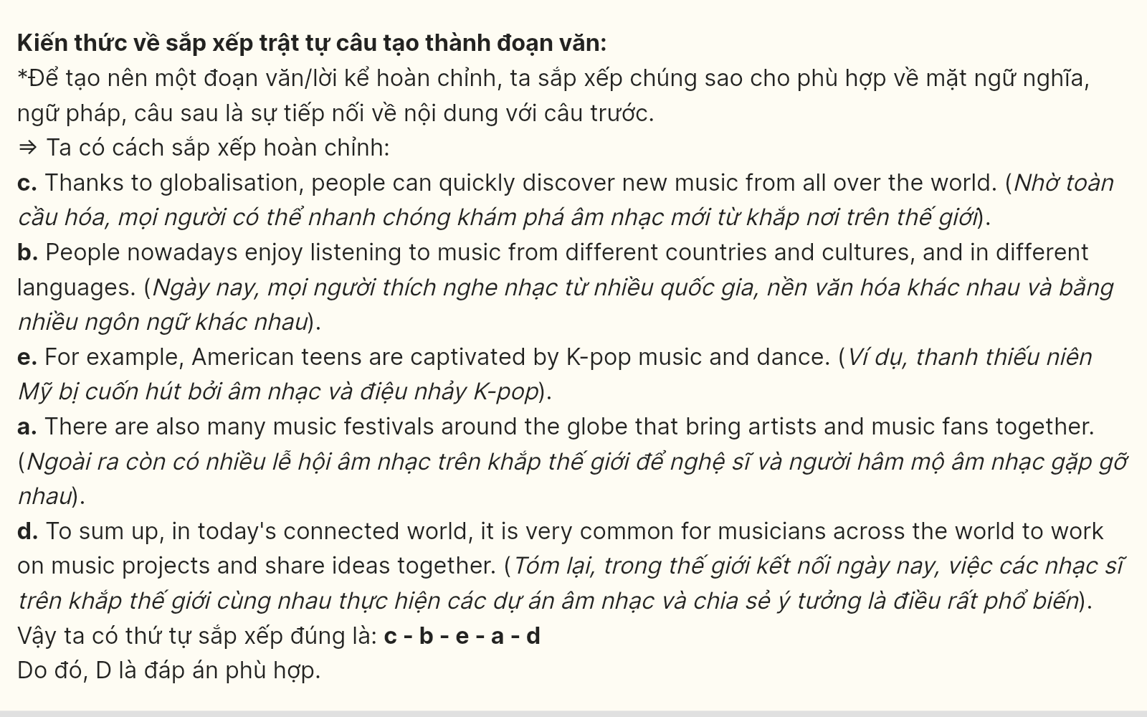
Question 17 [697712]:
a. Furthermore, tourism has significantly boosted the local economy, bringing in millions of visitors every year.
b. Recently, Lakewood has become a top travel destination, known for its breathtaking landscapes and outdoor activities.
c. However, the increase in tourists has also led to environmental concerns, such as littering and pollution in the parks and lakes.
d. The town has invested in eco-friendly projects to preserve the natural beauty while accommodating the growing number of tourists.
e. These projects include waste reduction programs, improved public transportation, and increased park maintenance.
A. b - a - d - e – c B. b - c - d - e – a C. b - a - c - d – e D. b - d - a - c - e
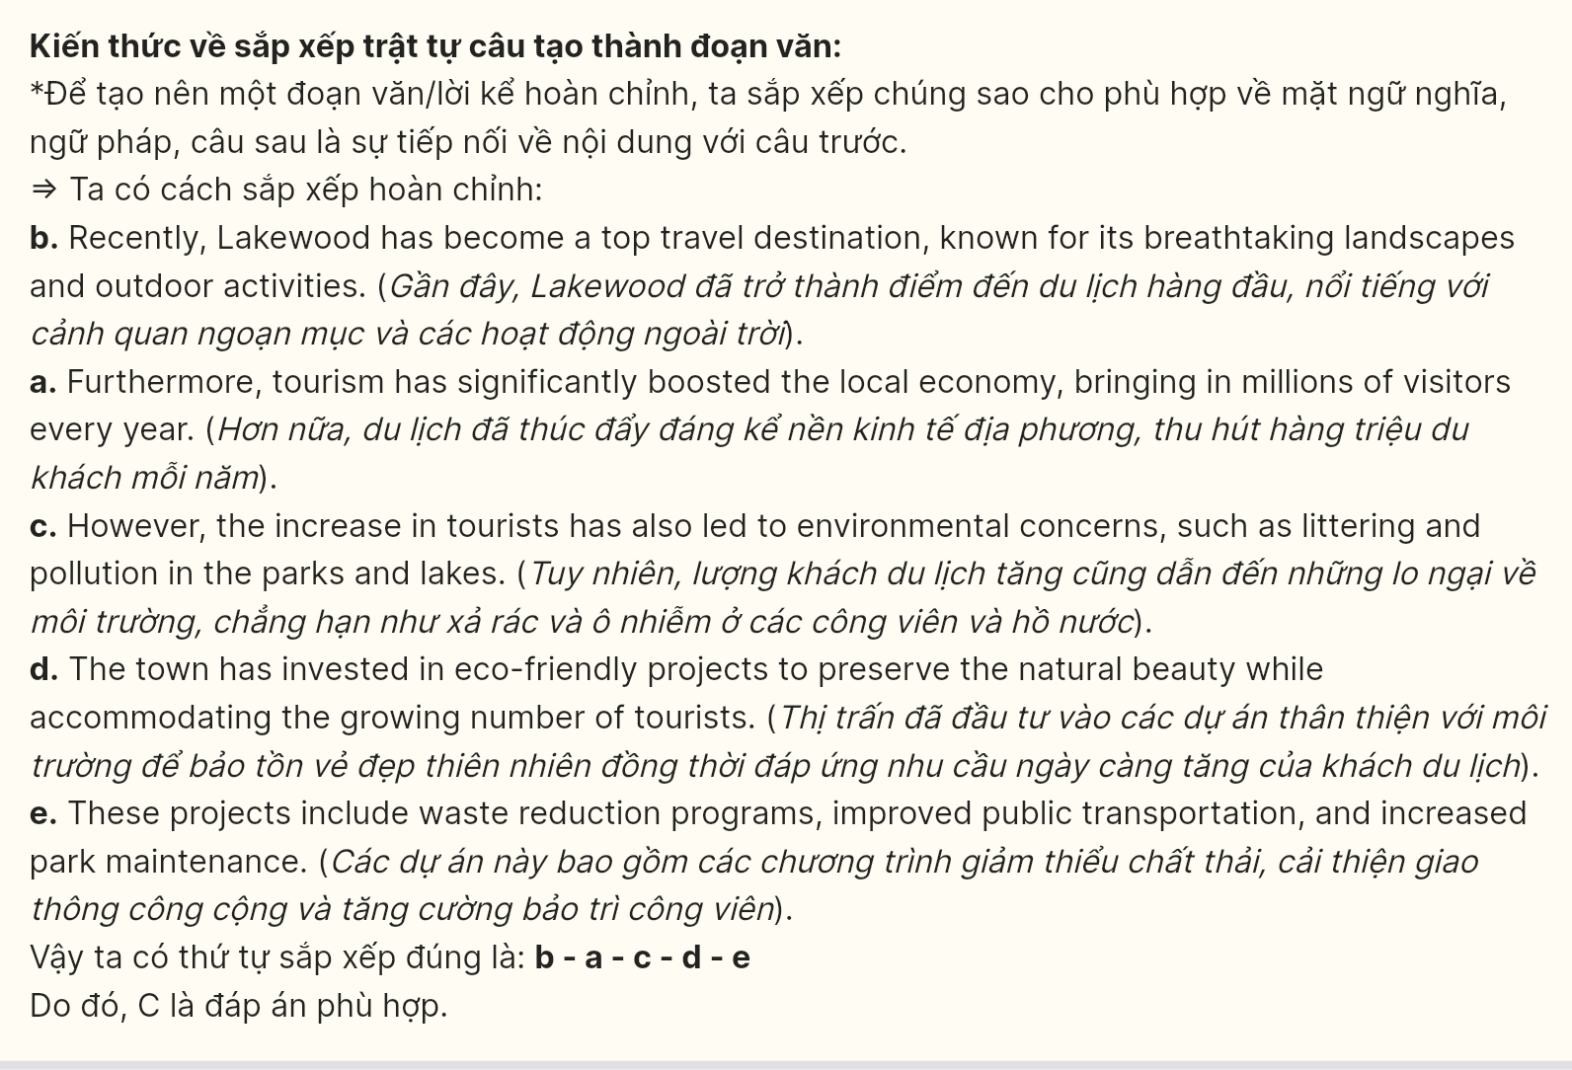
Read the following passage about Westlife's legacy and mark the letter A, B, C or D on your answer sheet to indicate the option that best fits each of the numbered blanks from 18 to 22.
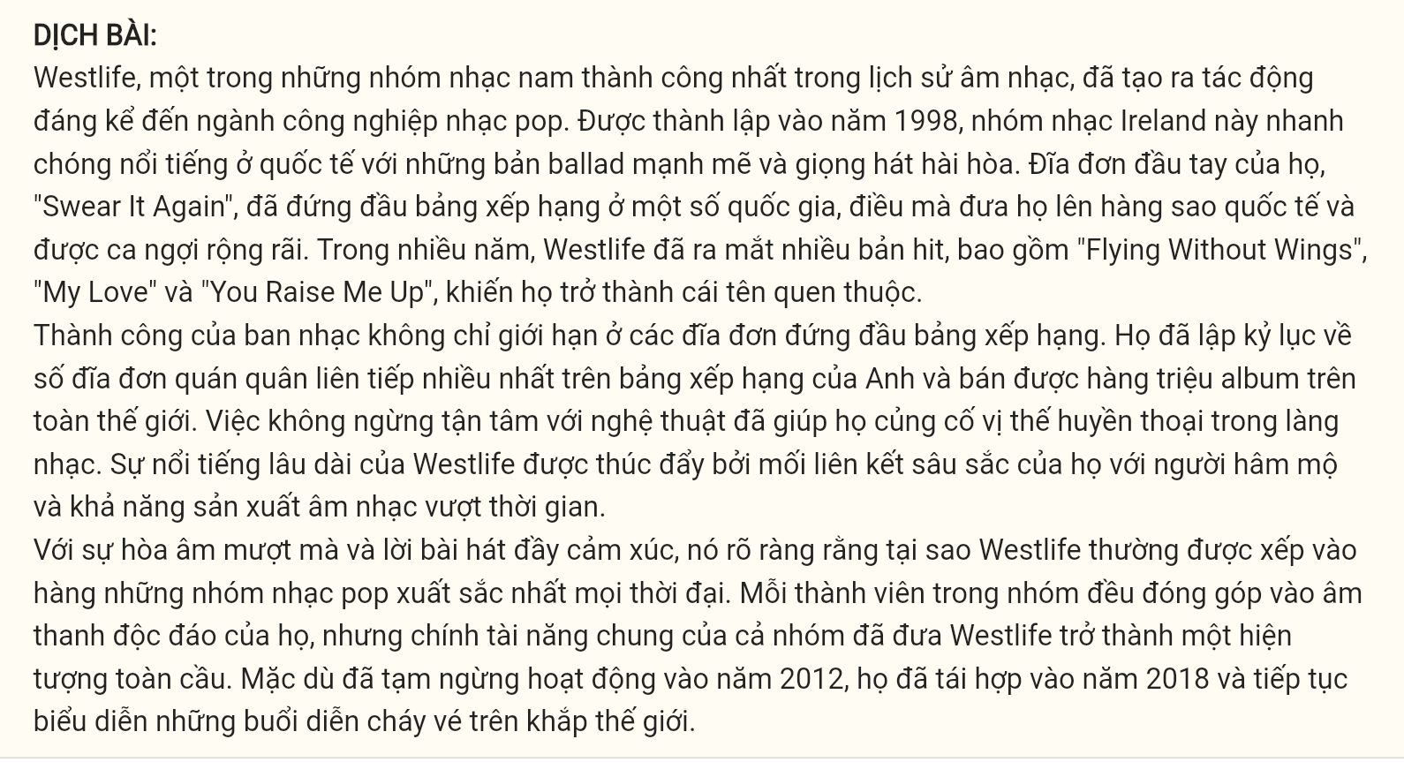
Westlife, one of the most successful boy bands in music history, (18) ______. Formed in 1998, (19) ______ with their powerful ballads and harmonious vocals. Their debut single, "Swear It Again", topped the charts in several countries, (20) ______. Over the years, Westlife produced numerous hits, including "Flying Without Wings", "My Love", and "You Raise Me Up", making them a household name.
The band’s success wasn’t limited to chart-topping singles. They set records for the most consecutive number-one singles on the UK charts and sold millions of albums worldwide. (21) ______. Westlife's enduring popularity was driven by their deep connection with fans and their ability to produce timeless music.
With their smooth harmonies and emotional lyrics, (22) ______. Each member of the group contributed to their distinct sound, but it was their collective talent that made Westlife a global sensation. Despite taking a hiatus in 2012, they reunited in 2018 and continue to perform sold-out shows around the world.
(Adapted from Huffpost)
Question 18 [697713]:
A. that has a significant impact on the pop music industry noted
B. impacting significantly on the pop music industry
C. has made a significant impact on the pop music industry
D. of whom significant impact on the pop music industry
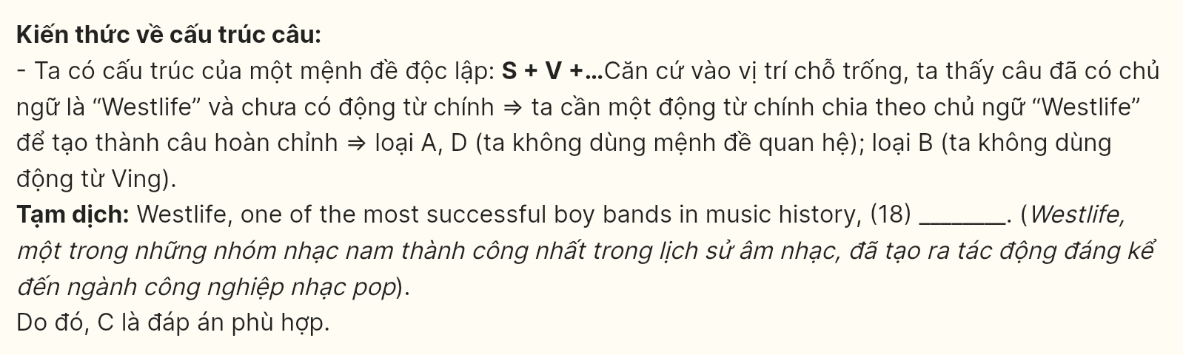
Question 19 [697714]:
A. international fame was gained quickly by this Irish group
B. this Irish group quickly gained international fame
C. people all over the world recognize this Irish group as the best band
D. the band had become popular

Question 20 [697715]:
A. which propelled them to international stardom and widespread acclaim
B. international stardom and widespread acclaim are propelled
C. international stardom and widespread acclaim are propelling
D. whose international stardom and widespread acclaim are propelled

Question 21 [697716]:
A. Aspiring musicians looked up to Westlife for their timeless hits and stunning performances
B. Many young artists have been motivated by Westlife’s consistent pursuit of excellence
C. Westlife’s indifference to their fans has been caused by many people
D. The group’s dedication to their craft helped solidify their status as legends in the music world
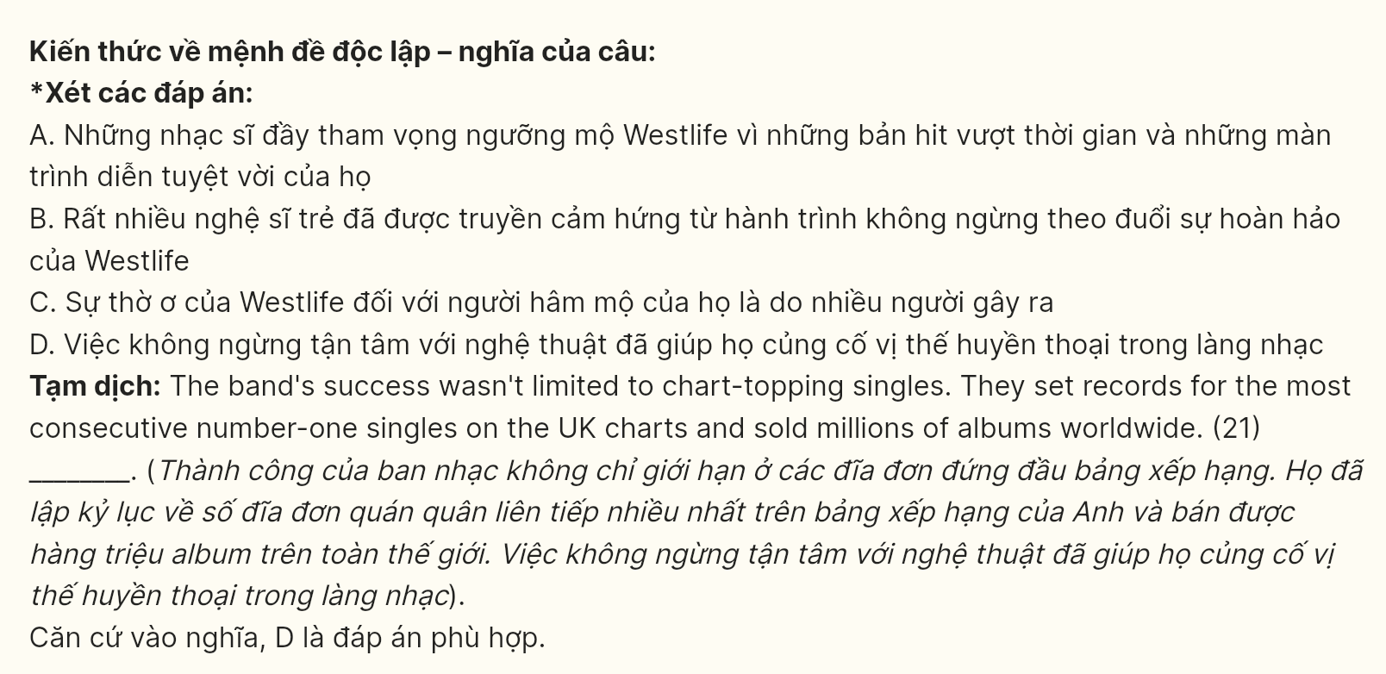
Question 22 [697717]:
A. It’s clear why Westlife is often ranked among the best pop groups of all time
B. Westlife always proves why they are one of the budding bands in pop history
C. the group hasn’t shown why they deserve their place among great pop acts
D. it’s evident that Westlife lacks the musical prowess needed to place them among the greats of the pop world
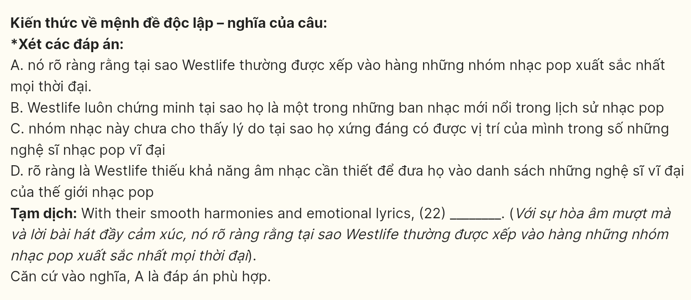
Read the following passage and mark the letter A, B, C or D on your answer sheet to indicate the best answer to each of the following questions from 23 to 30.
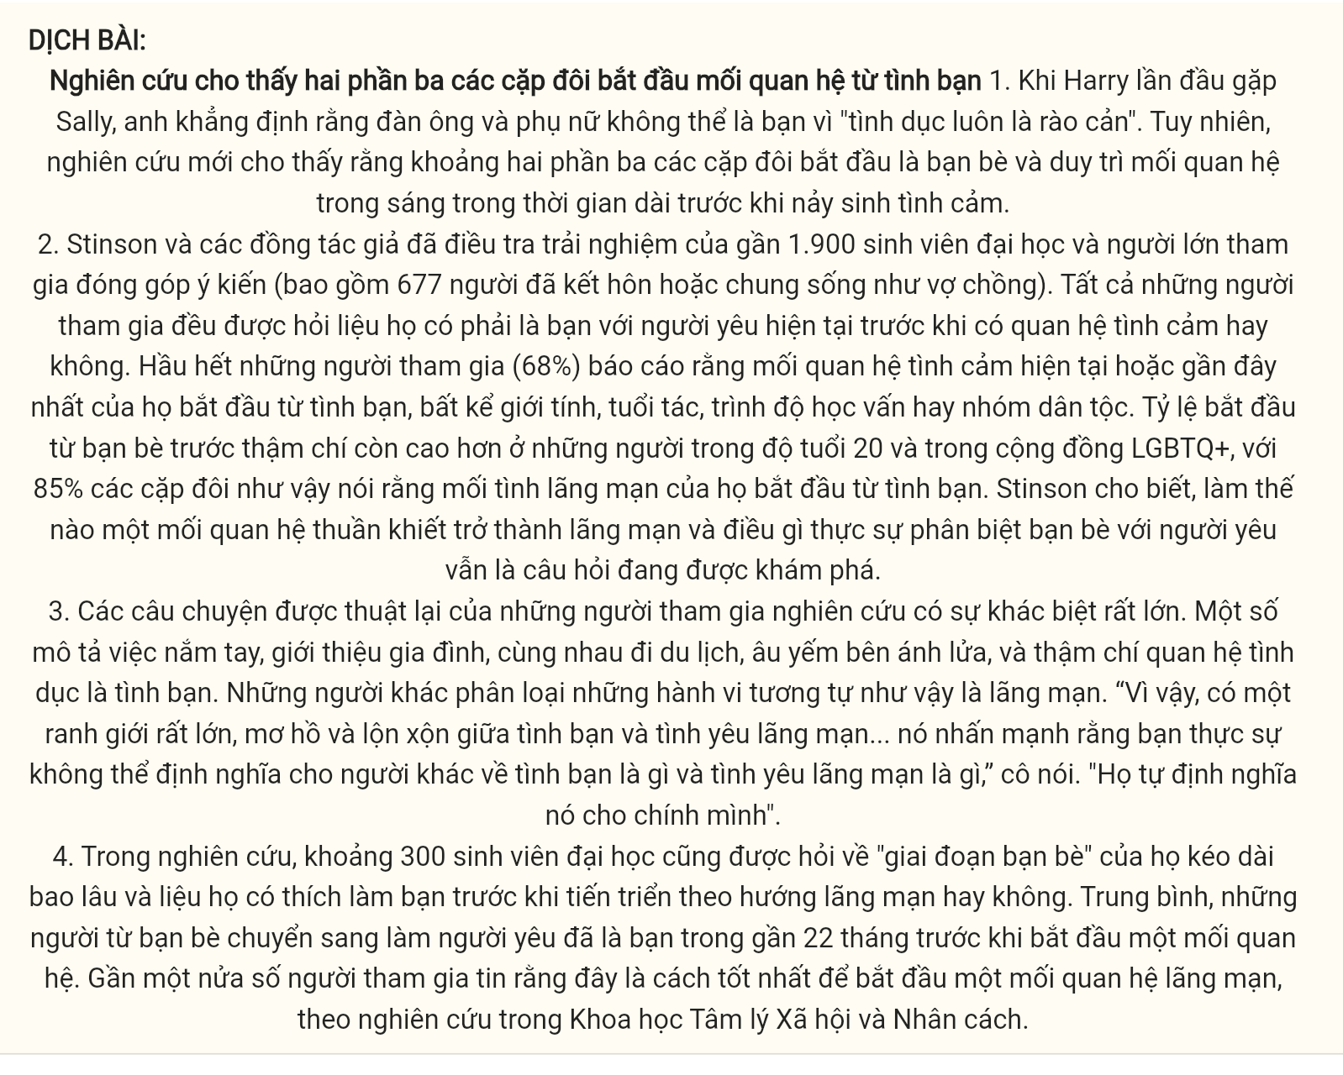
Two-thirds of couples start out as friends, research finds.
- When Harry first met Sally, he asserted that men and women could not be friends because the “sex part always gets in the way”. However, new research suggests that roughly two-thirds of couples begin as friends and maintain a platonic relationship for long periods before sparking a romance.
- Stinson and her co-authors investigated the experiences of nearly 1,900 university students and crowdsourced adults (including 677 who were married or in common-law partnerships). All participants were asked whether they were friends with their current romantic partner before becoming romantically involved. Most participants (68%) reported that their current or most recent romantic relationship began as a friendship, regardless of gender, age, education level, or ethnic group. The rate of friends-first initiation was even higher among those in their 20s and within LGBTQ+ communities, with 85% of such couples stating that their romance began as a friendship. How a platonic relationship turns romantic and what really distinguishes friends from lovers remains a question still being explored, Stinson said.
- The written accounts from study participants varied widely. Some described holding hands, family introductions, going on trips together, cuddling by the fire, and even having sex as friendship. Others categorized those same behaviors as romantic. “So there is a huge, messy, blurry line between friendship and romance … it emphasizes how you really cannot define for somebody else what a friendship is versus what a romance is”, she said. “They define it for themselves”.
- In the study, roughly 300 university students were also asked how long their “friends phase” lasted and whether they preferred to be friends before taking things in a romantic direction. On average, friends-turned-romantic partners were friends for nearly 22 months before starting a relationship. Nearly half of participants believed this was the best way to begin a romance, according to research in Social Psychological and Personality Science.
(Adapted from https://www.theguardian.com/)
Question 23 [697718]: Which of the following is NOT mentioned as a factor influencing friends-first romantic relationships?
A. Gender B. Age C. Education levels D. Occupation
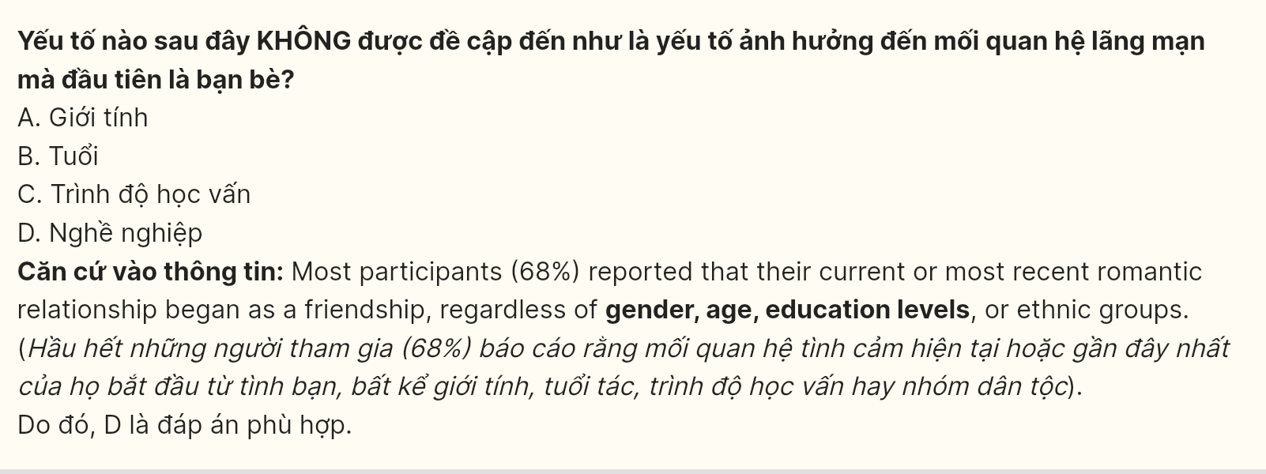
Question 24 [697719]: The word asserted in paragraph 1 is OPPOSITE in meaning to ______.
A. denied B. claimed C. stated D. declared
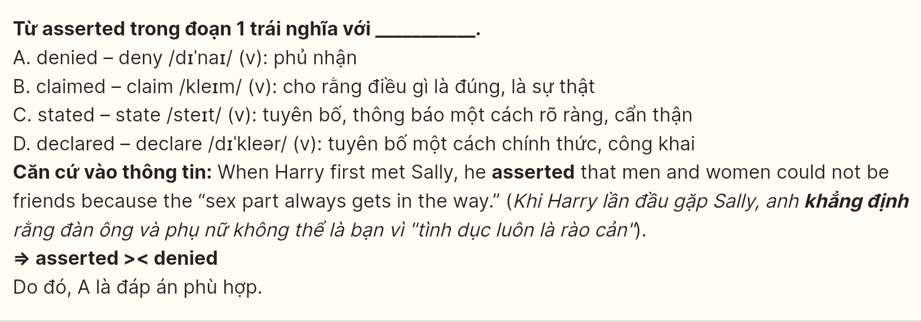
Question 25 [697720]: The word They in paragraph 3 refers to ______.
A. written accounts B. study participants C. family introductions D. behaviors
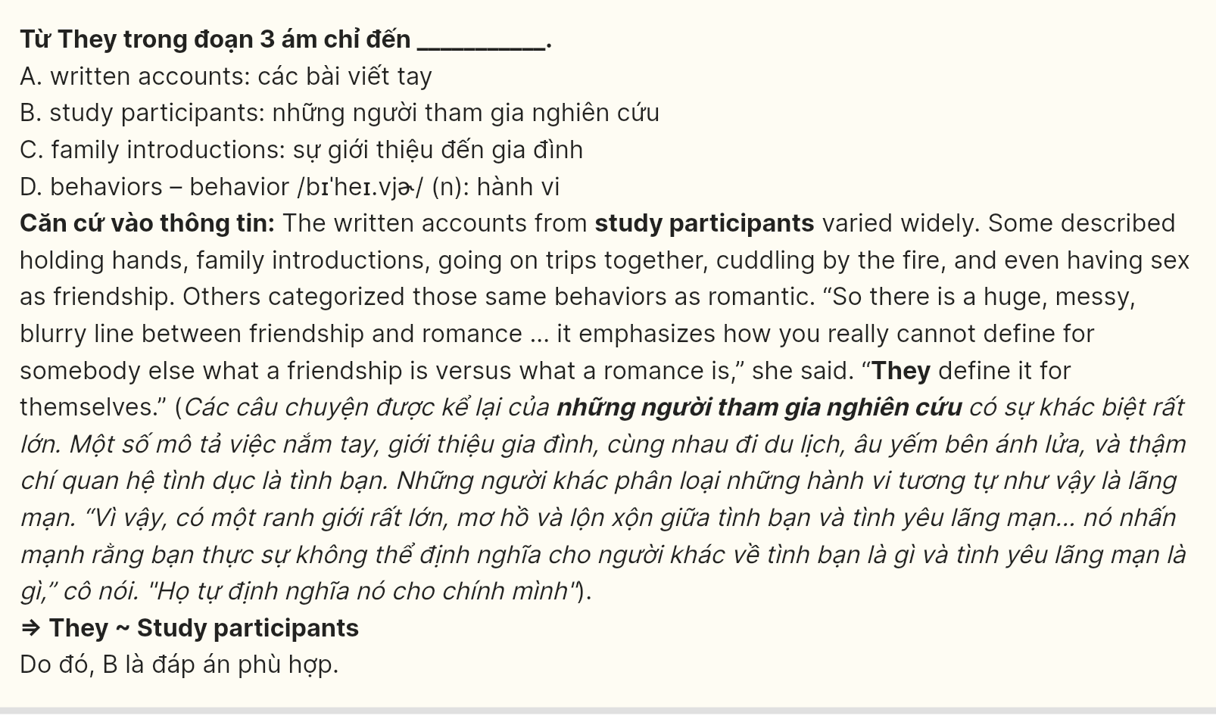
Question 26 [697721]: The word accounts in paragraph 3 could be best replaced by ______.
A. charges B. grounds C. stories D. explanations
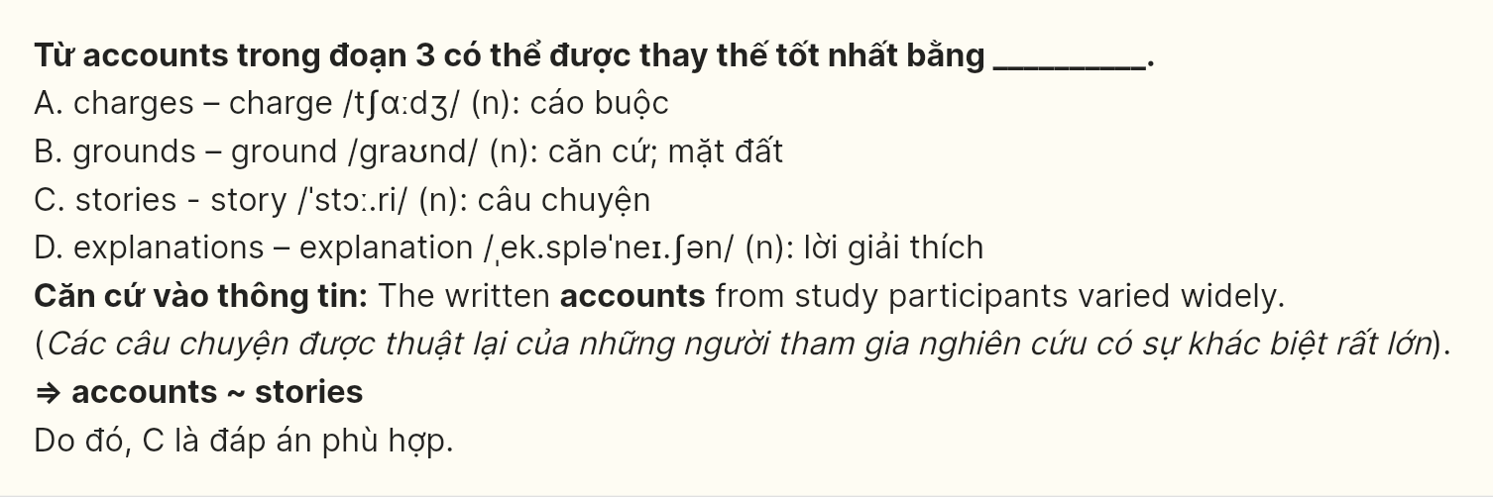
Question 27 [697722]: Which of the following best paraphrases the underlined sentence in paragraph 2?
A. Couples in their 20s and those in LGBTQ+ communities were less likely to start their relationships as friendships.
B. Among those in their 20s and LGBTQ+ communities, the friends-first approach was higher, with 85% starting as friends.
C. The tendency to start as friends before becoming romantic was notably weak among younger couples and LGBTQ+ partners.
D. Individuals in their 20s and LGBTQ+ couples have fewer romances starting as friendships, with 85% indicating this.
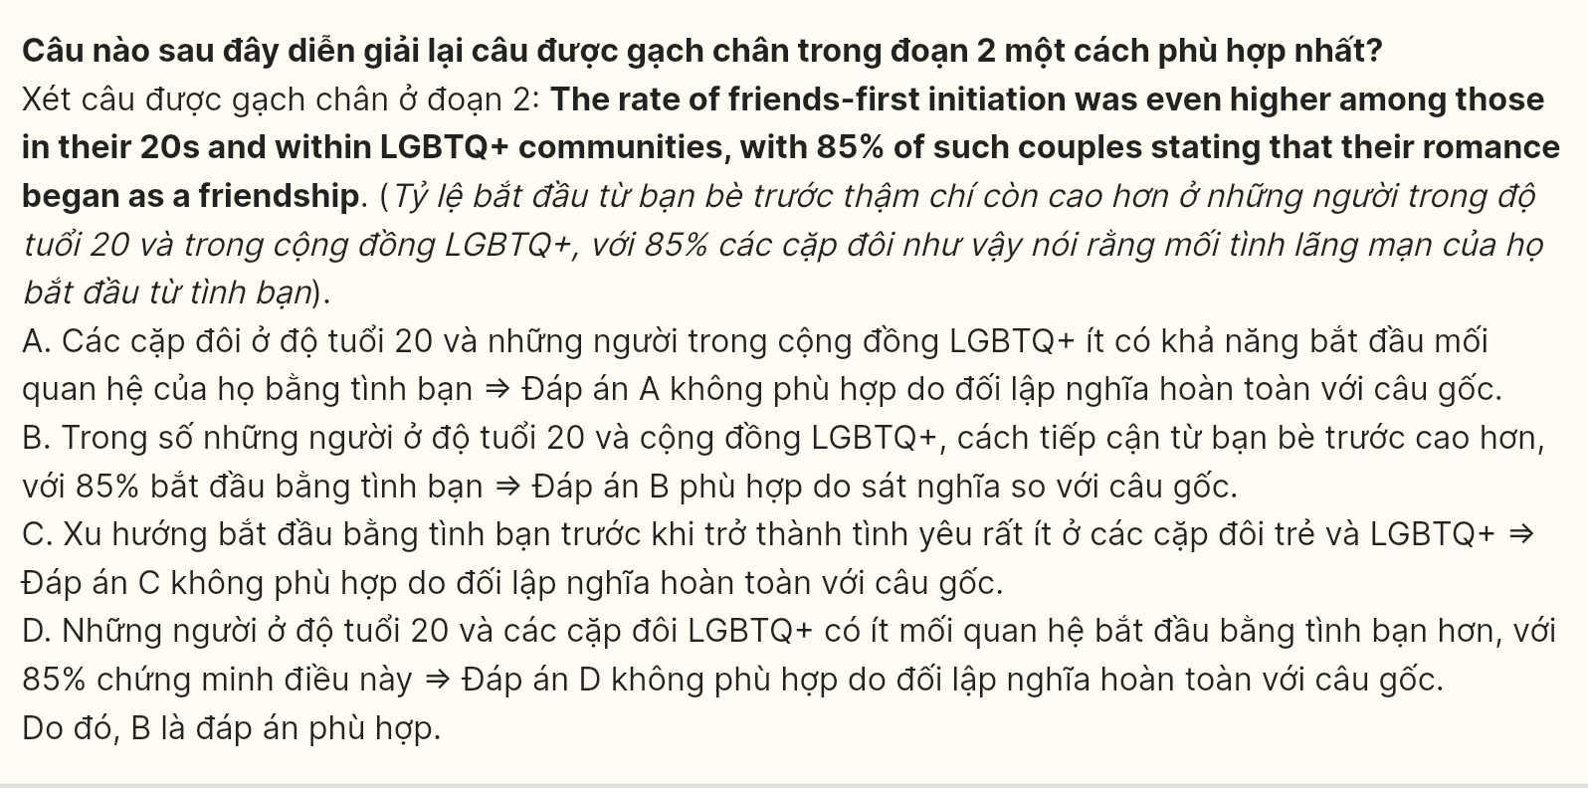
Question 28 [697723]: Which of the following is TRUE according to the passage?
A. Couples who transitioned from friends to romantic partners had an average friendship duration of twelve months.
B. The distinction between friendship and romance is clearly defined for everyone.
C. The rate of friend-first initiation is lower among LGBTQ+ communities.
D. A majority of romantic relationships originate from friendships, regardless of demographic characteristics.
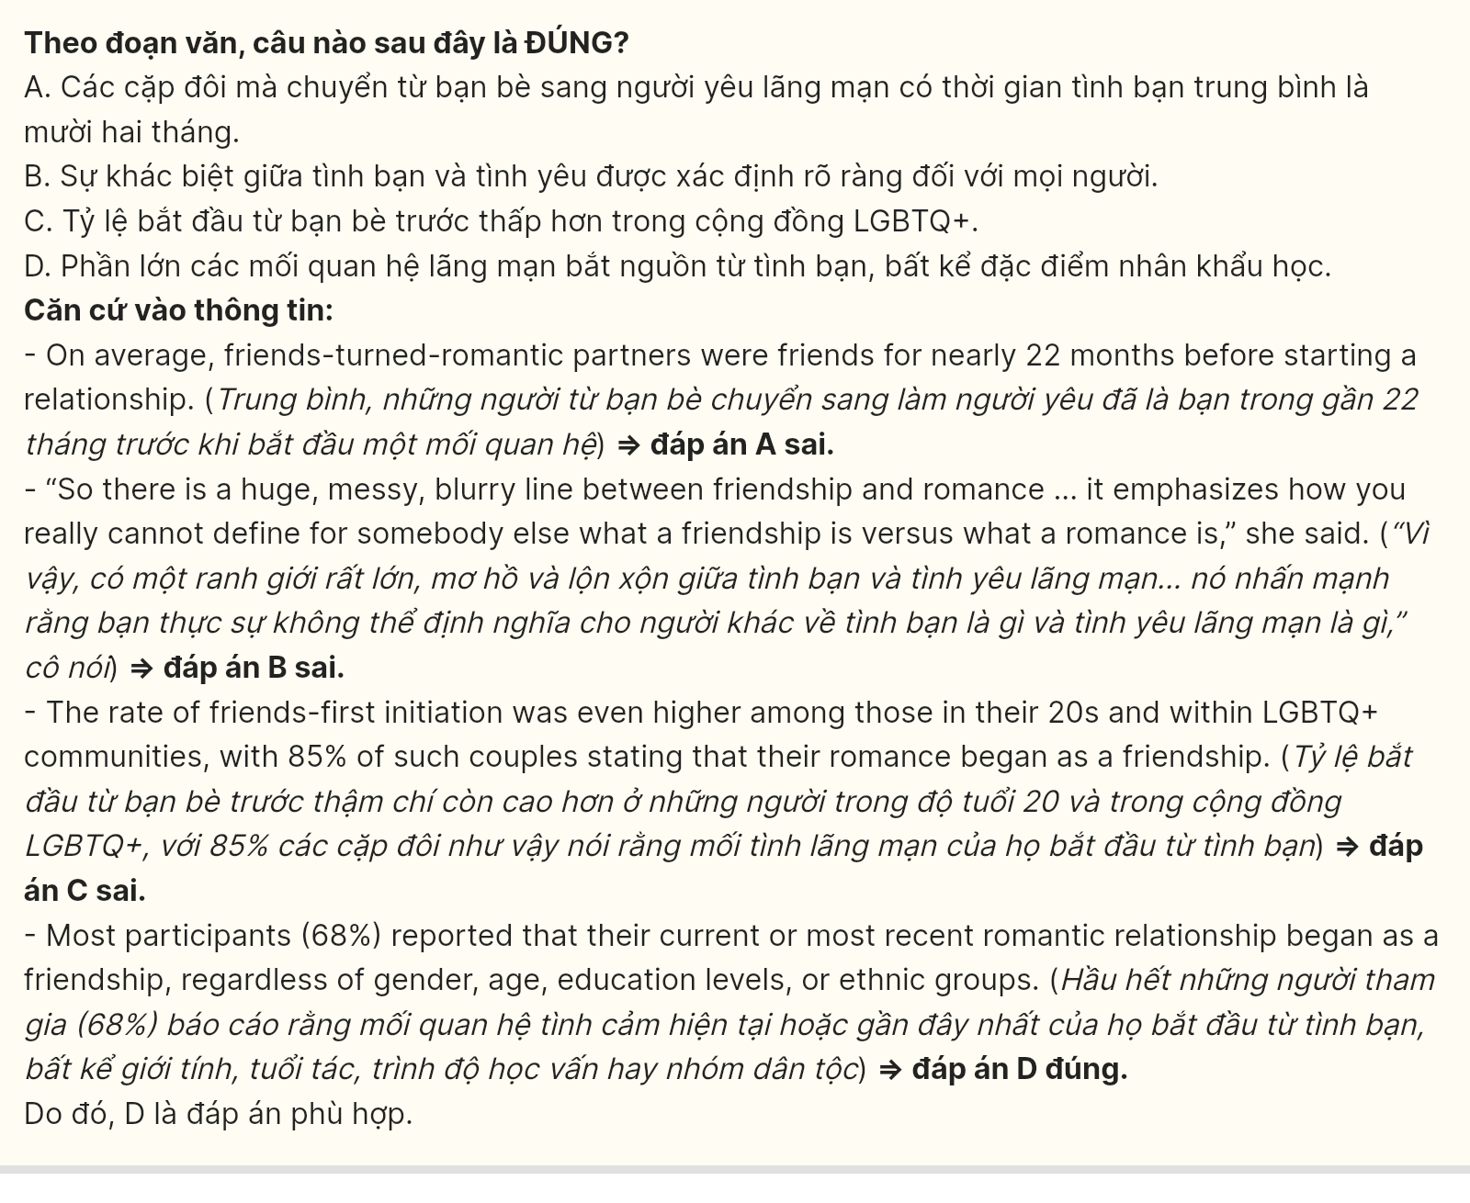
Question 29 [697724]: In which paragraph does the writer mention a contrasting relationship?
A. Paragraph 1 B. Paragraph 2 C. Paragraph 3 D. Paragraph 4
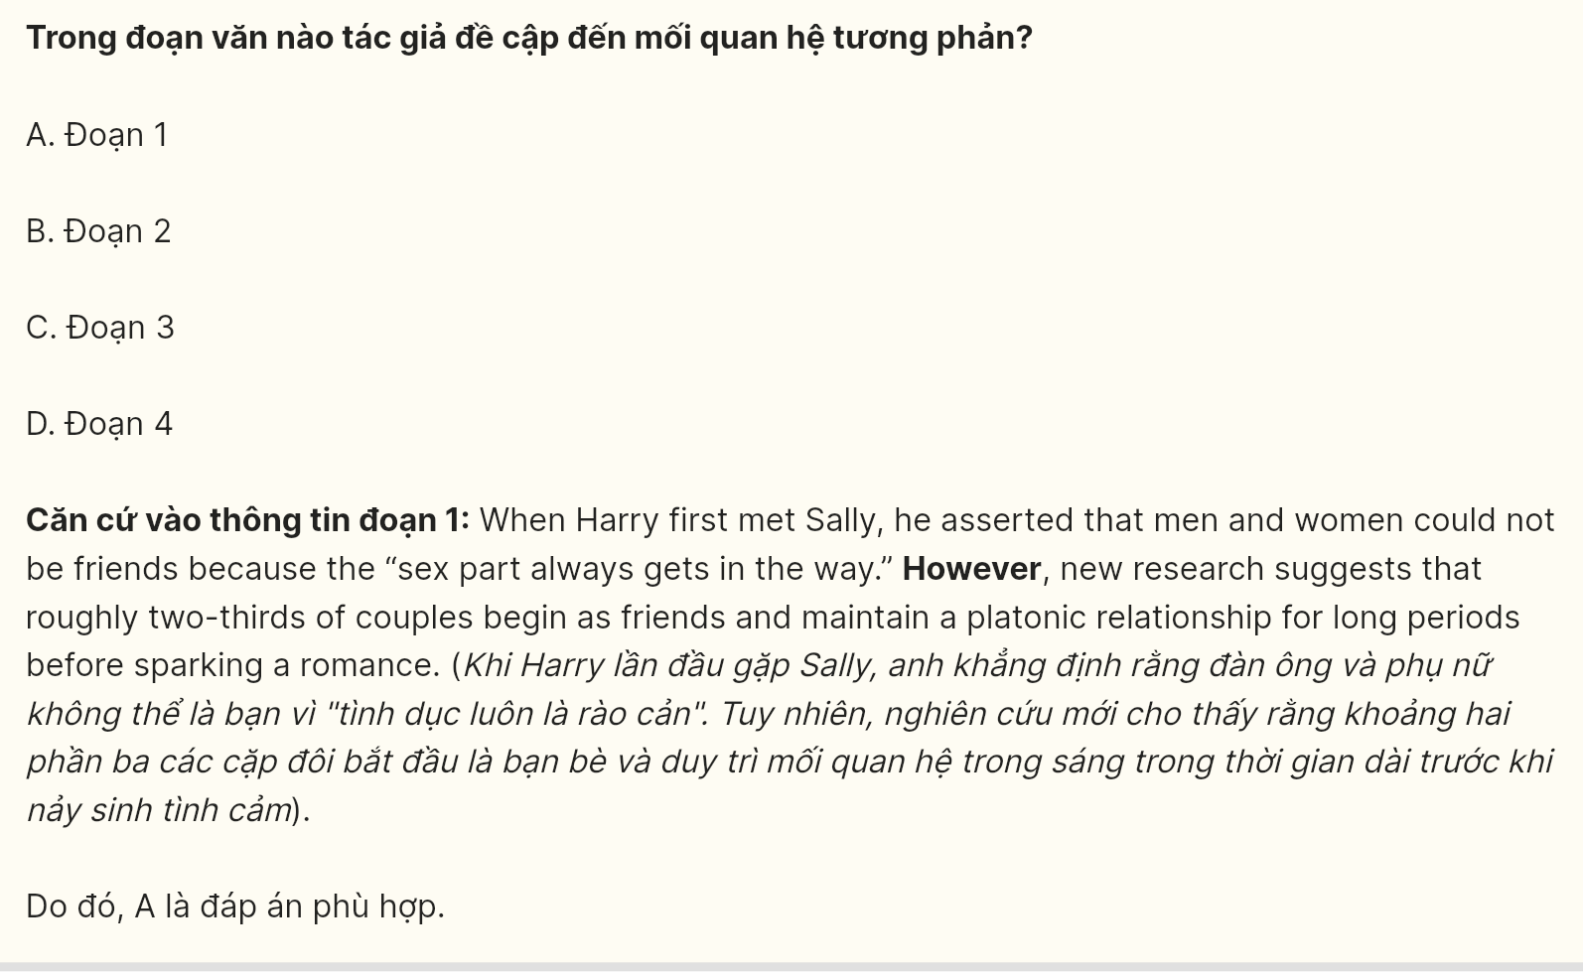
Question 30 [697725]: In which paragraph does the writer discuss the average duration of the friendship phase?
A. Paragraph 1 B. Paragraph 2 C. Paragraph 3 D. Paragraph 4

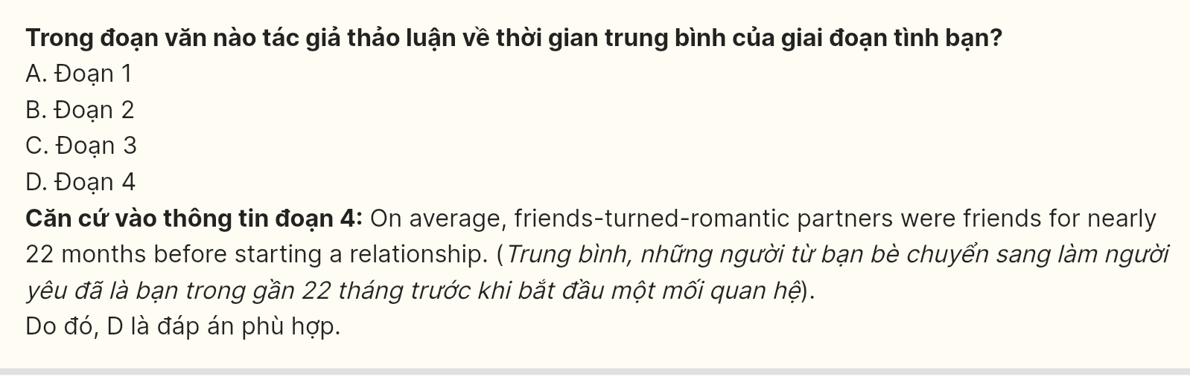Read the following passage and mark the letter A, B, C or D on your answer sheet to indicate the best answer to each of the following questions from 31 to 40.
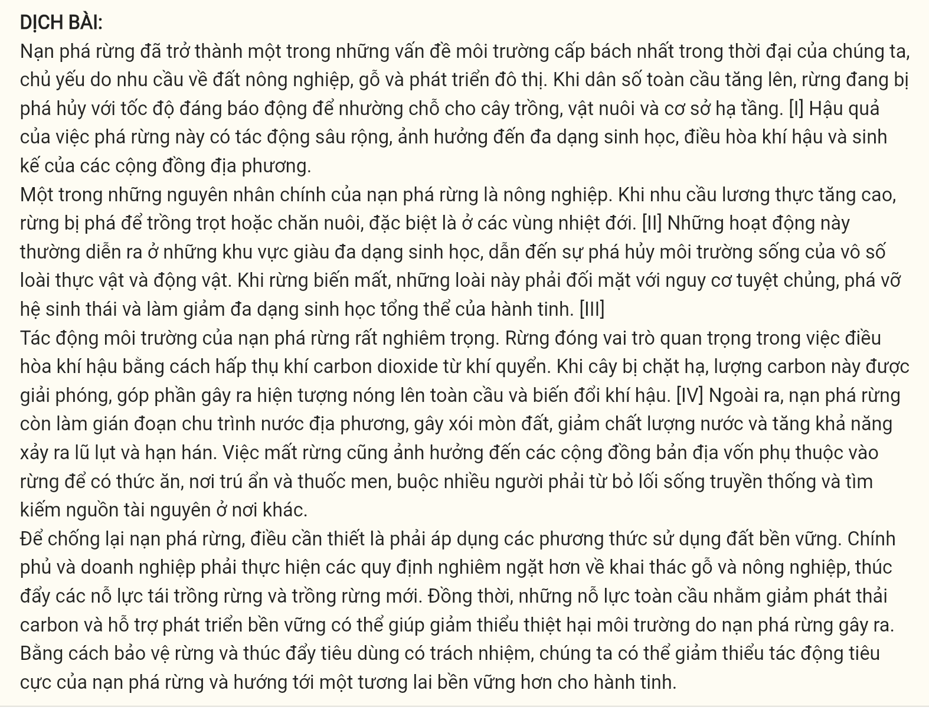
- Deforestation has become one of the most pressing environmental issues of our time, driven largely by the demand for agricultural land, timber, and urban development. As the global population grows, forests are being cleared at an alarming rate to make room for crops, livestock, and infrastructure. [I] The consequences of this deforestation are far-reaching, affecting biodiversity, climate regulation, and the livelihoods of local communities.
- One of the main drivers of deforestation is agriculture. As demand for food increases, forests are cleared to grow crops or raise livestock, particularly in tropical regions. [II] These activities often take place in areas rich in biodiversity, leading to the destruction of habitats for countless plant and animal species. As forests vanish, these species face extinction, disrupting ecosystems and reducing the planet’s overall biodiversity. [III]
- The environmental impacts of deforestation are severe. Forests play a crucial role in regulating the climate by absorbing carbon dioxide from the atmosphere. When trees are cut down, this carbon is released, contributing to global warming and climate change. [IV] Additionally, deforestation disrupts local water cycles, causing soil erosion, reducing water quality, and increasing the likelihood of floods and droughts. The loss of forests also affects indigenous communities that rely on them for food, shelter, and medicine, forcing many to abandon their traditional lifestyles and seek resources elsewhere.
- To combat deforestation, it is essential to adopt sustainable land-use practices. Governments and businesses must implement stricter regulations on logging and agriculture, promoting reforestation and afforestation efforts. At the same time, global efforts to reduce carbon emissions and support sustainable development can help mitigate the environmental damage caused by deforestation. By protecting forests and promoting responsible consumption, we can reduce the negative impacts of deforestation and work toward a more sustainable future for the planet. gia su tai hue 0793833272
Question 31 [697726]: Where in this passage does the following sentence best fit?
In addition, logging for timber, paper, and other wood products contributes significantly to forest loss.
A. [I] B. [II] C. [III] D. [IV]
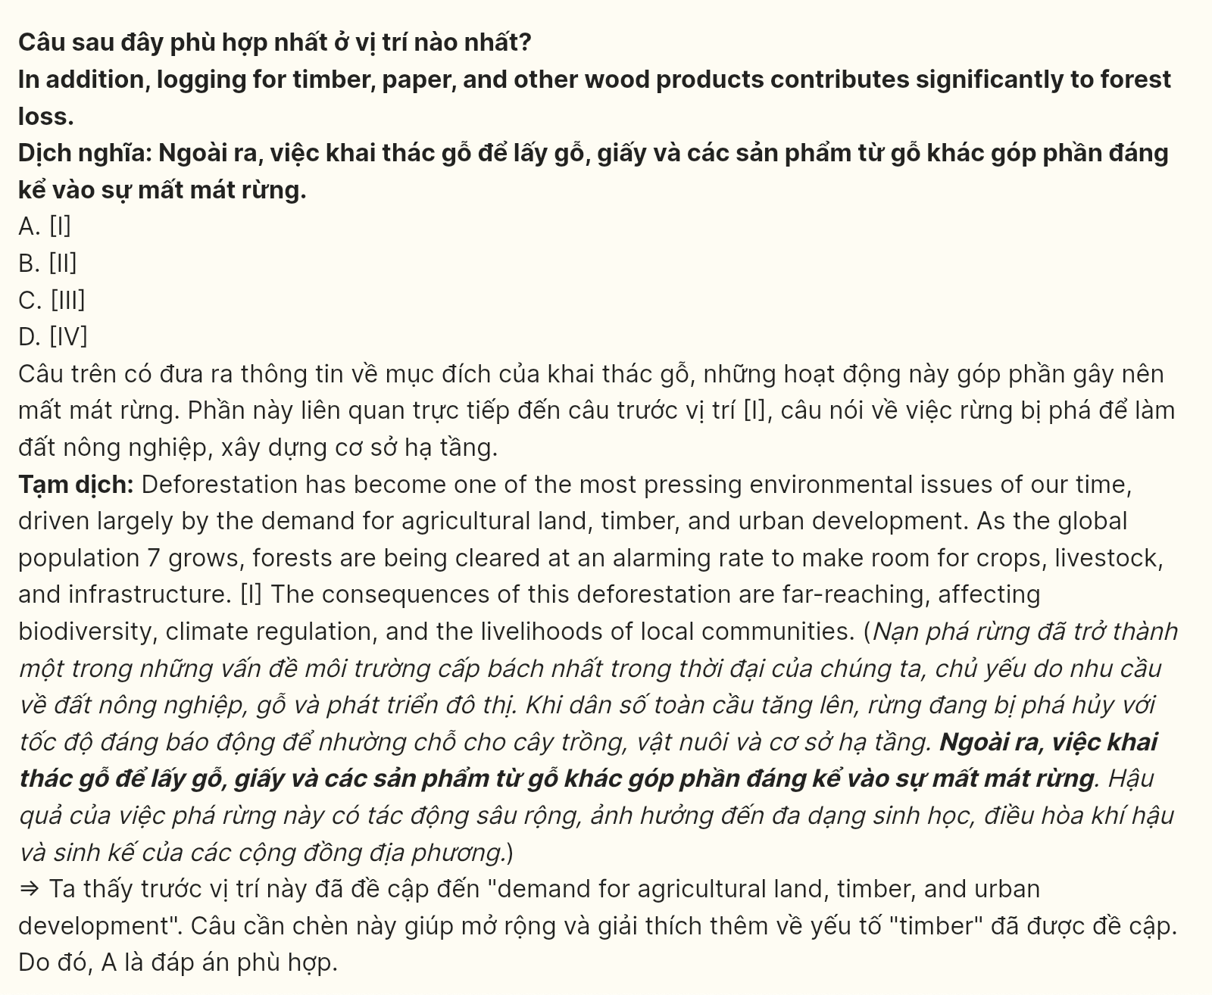
Question 32 [697727]: The phrase play a crucial role in in paragraph 3 could be best replaced by ______.
A. fail to impact B. are insignificant to
C. have a detrimental effect on D. are vital in
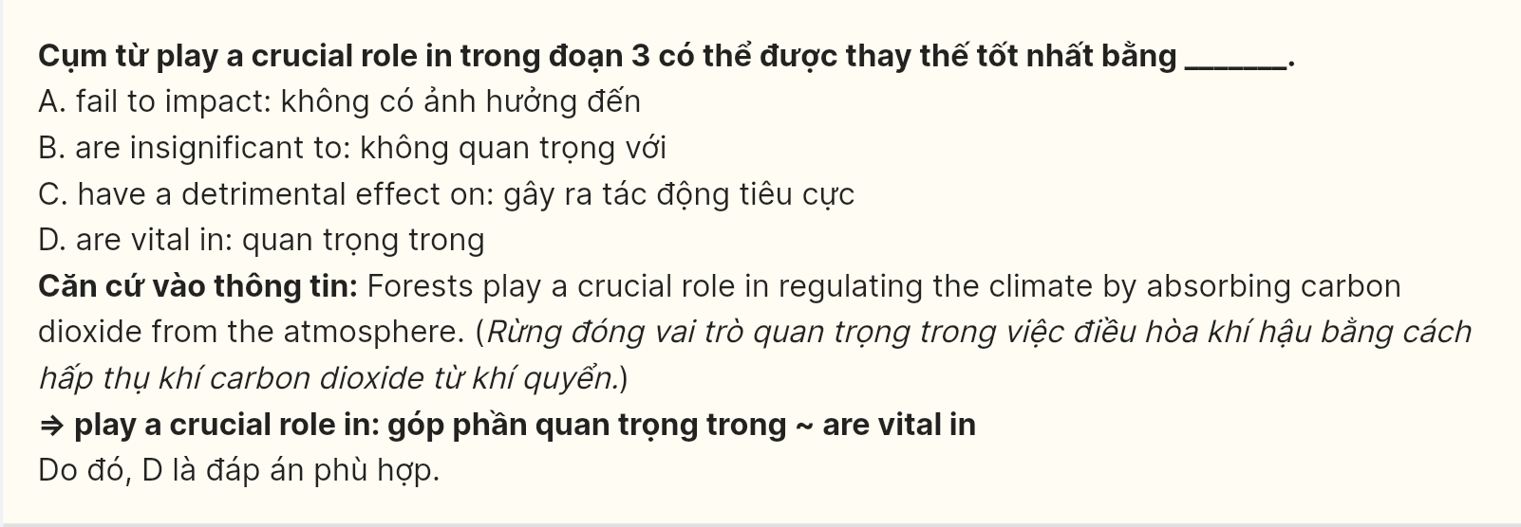
Question 33 [697728]: The word them in paragraph 3 refers to ______.
A. forests B. communities C. droughts D. floods
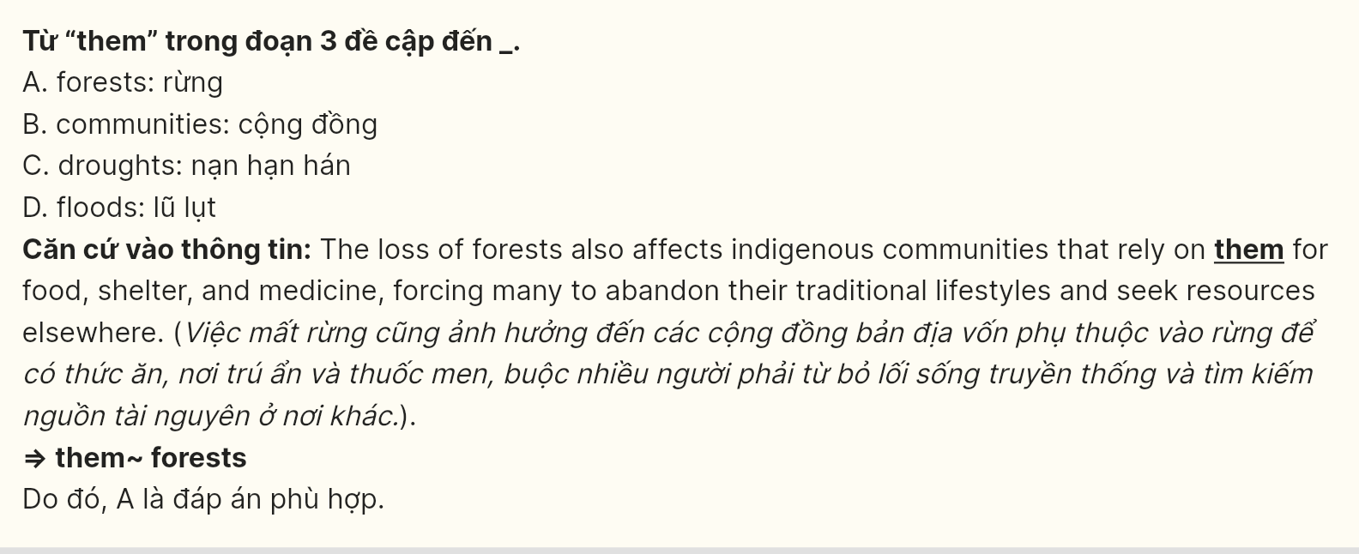
Question 34 [697729]: Which of the following is NOT mentioned in paragraph 2 as a consequence of deforestation?
A. Habitat destruction B. Increasing global warming
C. Loss of biodiversity D. Disruption of ecosystems
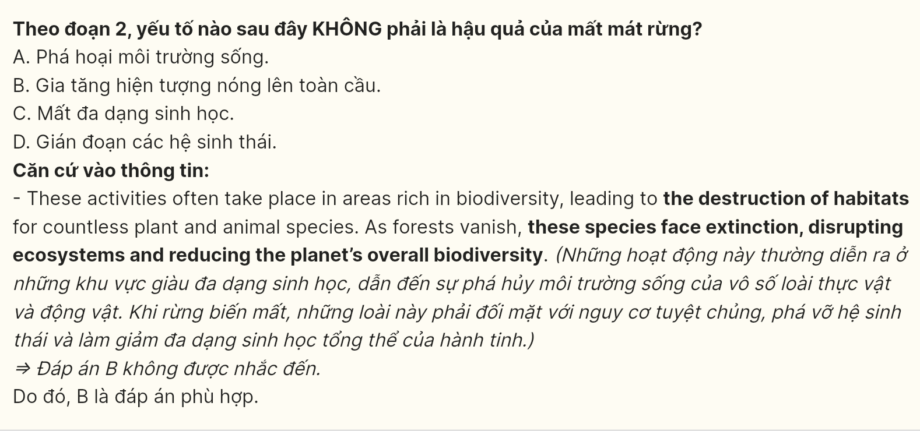
Question 35 [697730]: Which of the following best summarises paragraph 4?
A. Governments and businesses need to enforce stricter regulations on logging and agriculture to combat deforestation.
B. Sustainable land-use practices and global efforts are crucial in mitigating the environmental damage caused by deforestation.
C. Reforestation and afforestation are essential strategies to reduce the negative impacts of deforestation.
D. Protecting forests and promoting responsible consumption are key to achieving a sustainable future for the planet.
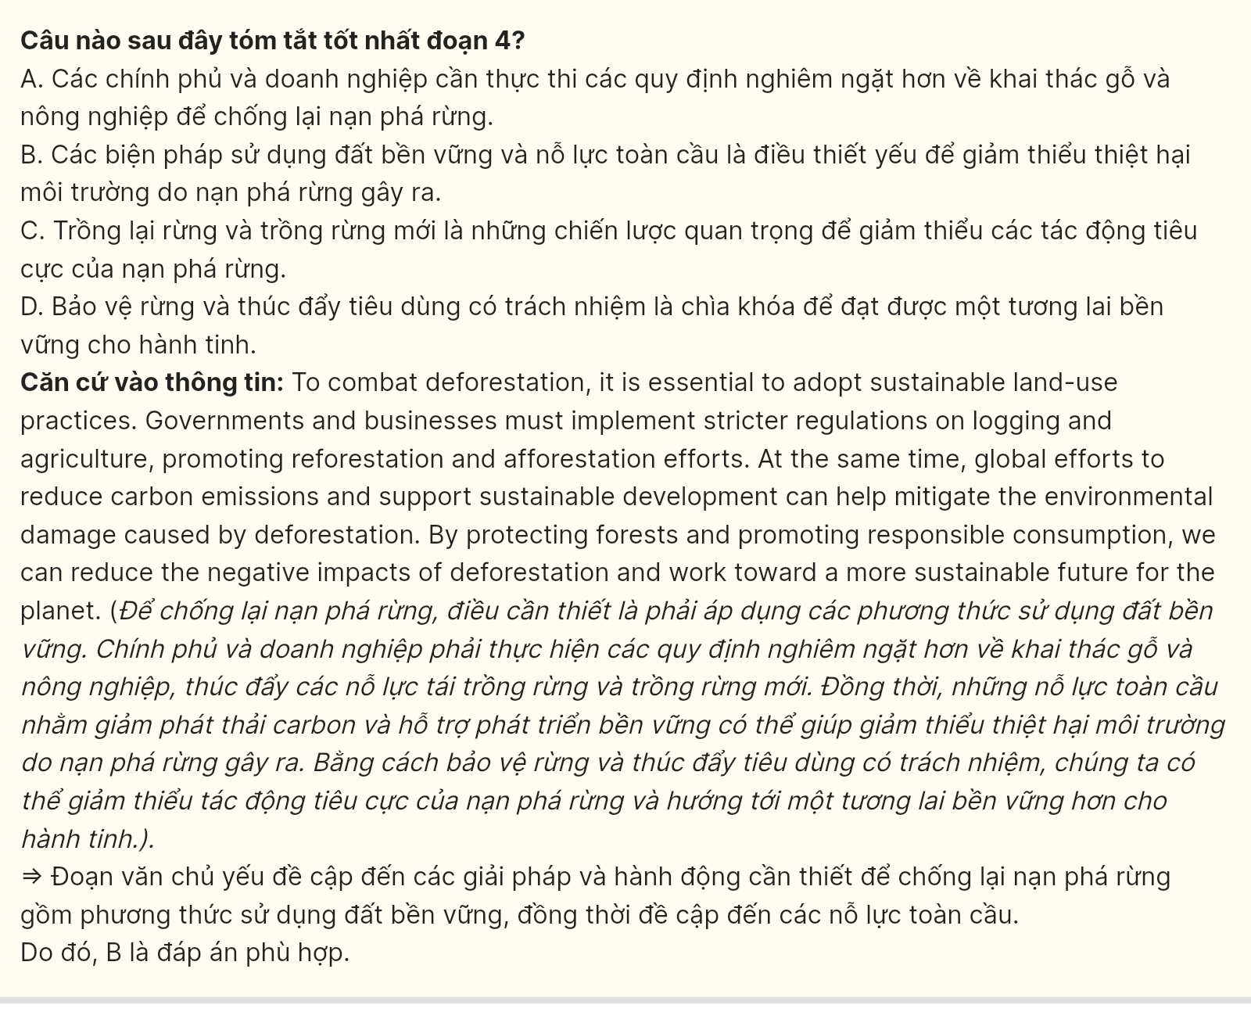
Question 36 [697731]: The word far-reaching in paragraph 1 is OPPOSITE in meaning to ______.
A. far-ranging B. limited C. widespread D. pervasive
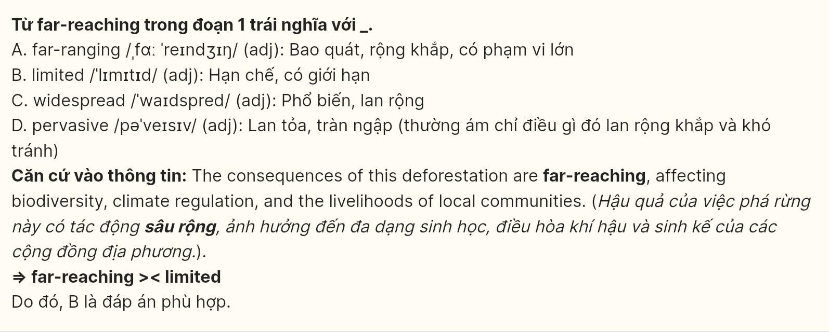
Question 37 [697732]: Which of the following is TRUE according to the passage?
A. Only natural environments are affected by climate change.
B. Local communities rely on forests for resources such as food and medicine.
C. Logging for timber does not contribute significantly to forest loss.
D. Deforestation only affects the environment and not local communities.
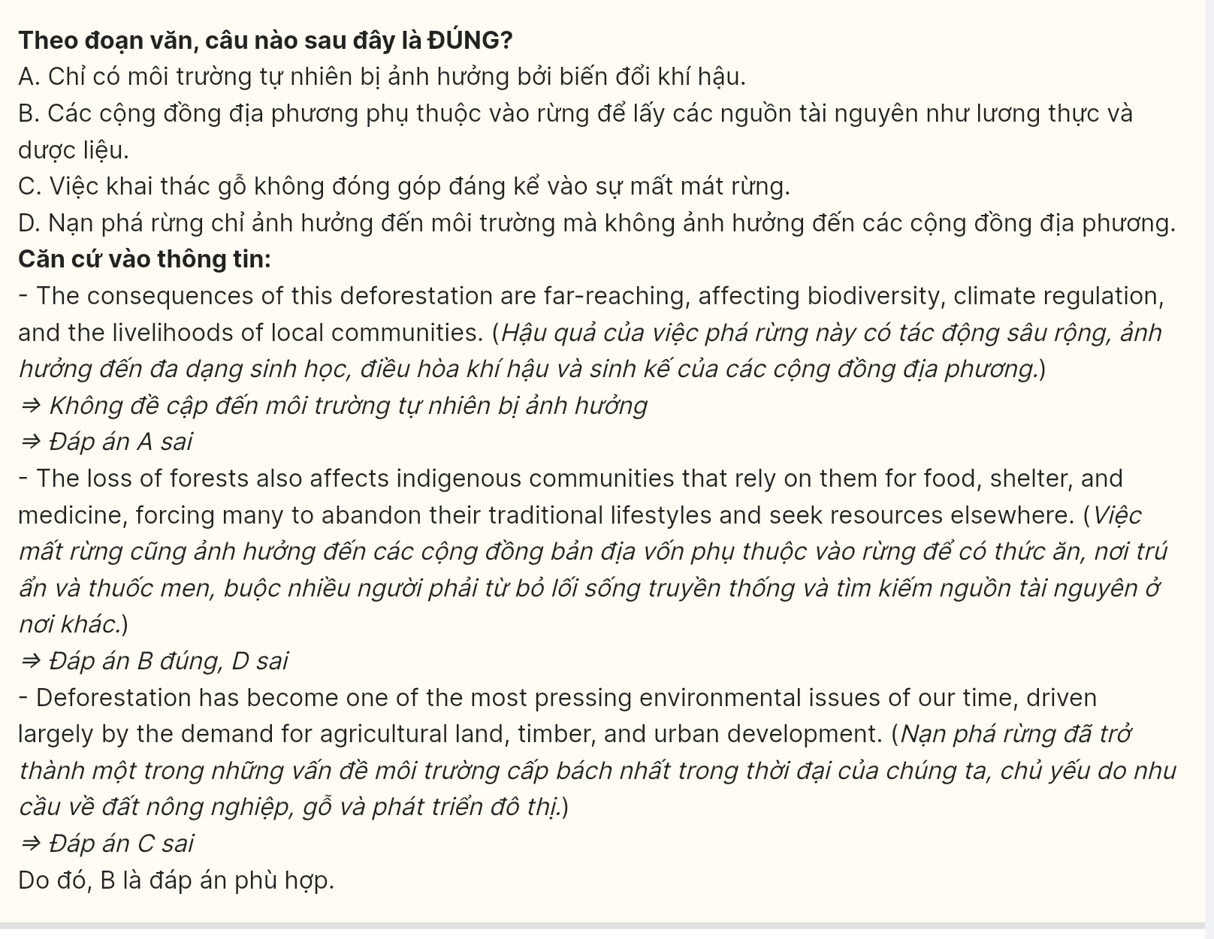
Question 38 [697733]: Which of the following best paraphrases the sentence in paragraph 4?
A. Sustainable land-use practices are vital in the battle against deforestation.
B. To worsen deforestation, adopting practices that use land unsustainably is vital.
C. Essential to promoting deforestation is the adoption of unsustainable land-use practices.
D. Sustainable land-use practices must be adopted to effectively combat deforestation.
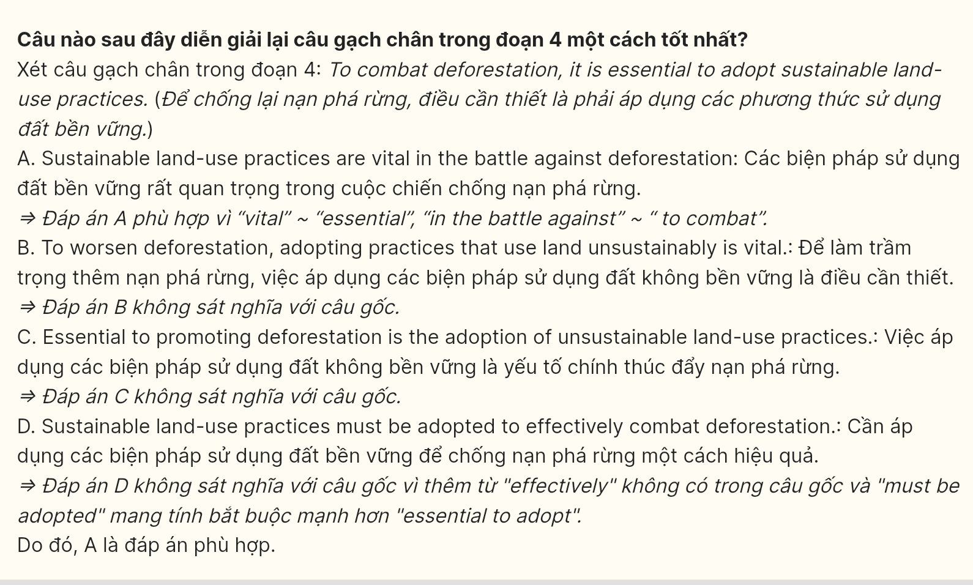
Question 39 (697734): Which of the following can be inferred from the passage?
A. The main cause of deforestation is urbanization, not agriculture.
B. Without proper regulations, deforestation will continue to worsen.
C. Indigenous communities benefit from deforestation due to economic opportunities.
D. The deforestation of tropical forests is directly linked to rising global temperatures.
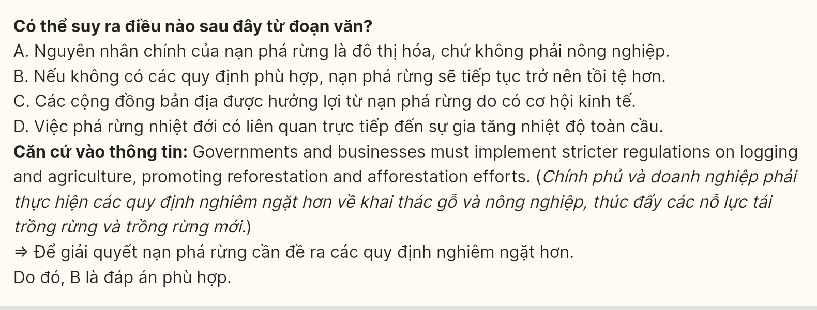
Question 40 (697735): Which of the following best summarises the passage?
A. Deforestation is an unavoidable consequence of urban growth, despite efforts to promote responsible consumption and development.
B. Migration-driven urban expansion contributes significantly to environmental degradation, particularly through deforestation and pollution.
C. Deforestation is an urgent environmental issue, driven by agricultural demands, logging, and urbanization, which must be addressed through sustainable practices and reforestation.
D. The deforestation problem can be solved through sustainable agriculture and responsible timber management, ensuring forest resources are used wisely while protecting ecosystems.

