Họ tên thí sinh: .................................................................
Số báo danh: ......................................................................
Mã Đề: 019.
Câu 1. When does the science club meet?
Science Club Notice:
Science club opening soon! Meets Tues/Thurs after school in room 205. First meeting on Sept. 14th at 3:30 pm.
A. Sunday afternoon B. Saturday morning
C. Monday and Wednesday after school D. Tuesday and Thursday after school
Câu 2. What does this sign mean?
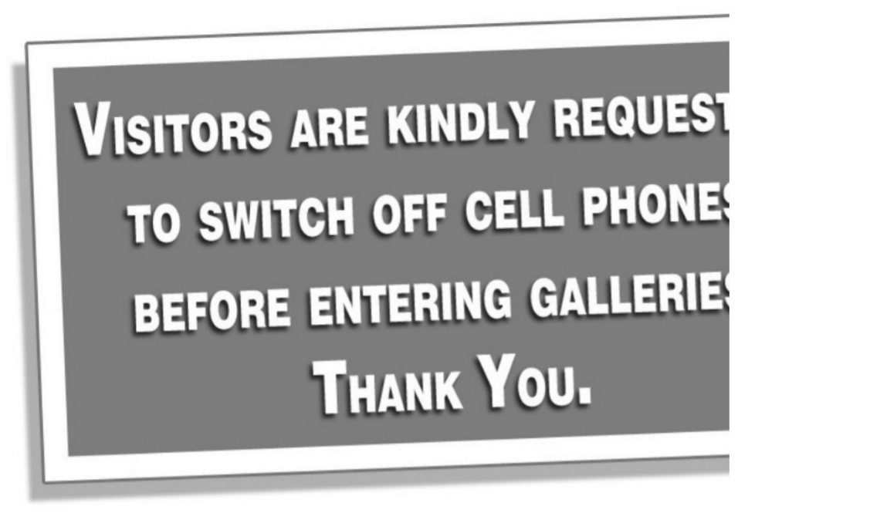
A. Visitors should turn off cell phones after visiting the galleries.
B. Visitors are allowed in the galleries with a cell phone.
C. Visitors should turn off their cell phones when they are in the galleries.
D. Visitors should use their cell phones in the galleries.
Câu 3. Which of the following statements is true?

A. The IT course is for advanced learners.
B. The IT course covers hardware, software, networking, and security.
C. The IT course does not provide a certificate.
D. The IT course starts on 1st October.
Câu 4. What is true about the Iceland advertisement?
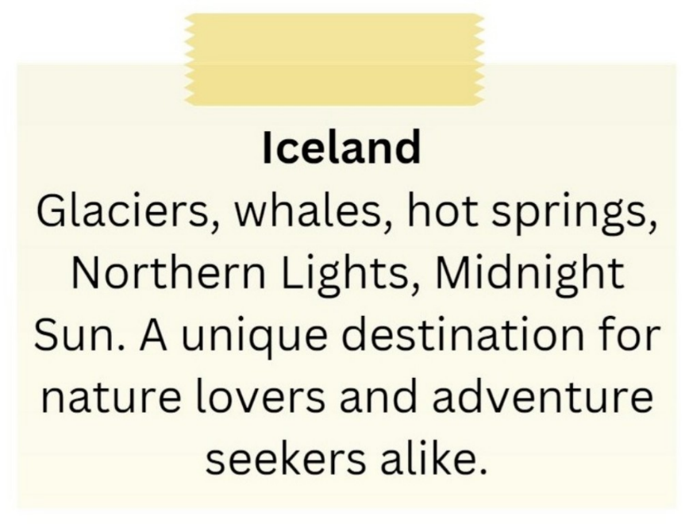
A. It emphasizes tropical beaches and sunbathing.
B. It showcases skyscrapers and bustling city life.
C. It is exclusively for adventure seekers.
D. It includes attractions such as glaciers, whales, hot springs, and the Northern Lights.
Câu 5. Look at the signs. Choose the best answer for the question.
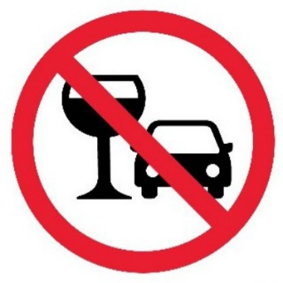
A. You should stop driving if you want to drink water.
B. You cannot use glasses in the car.
C. You mustn’t drink anything while you are driving.
D. You are not allowed to drink alcohol before and while driving.
Câu 6. Look at the signs. Choose the best answer for the question.
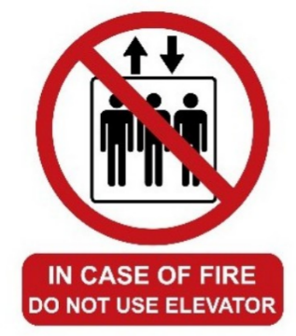
A. For your safety, do not use the elevator during a fire.
B. You mustn’t use the elevator when it is on fire.
C. Three people cannot ride the elevator at the same time during a fire.
D. If there is a fire, you don’t have to use the elevator.
Câu 7. Look at the signs. Choose the best answer for the question.
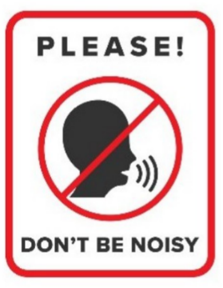
A. You mustn’t talk in this area. B. You must be quiet in this area.
C. You shouldn’t speak to anyone in this area. D. You don’t have to raise your voice in this area.
Câu 8. How much ice cream do you need to buy to get the discount?
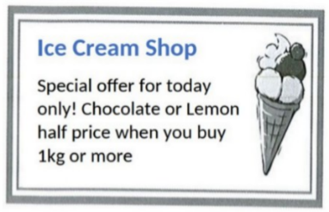
A. 1kg or more B. 500g or more C. 2kg or more D. Exactly 1kg
Câu 9. What is true about the New Zealand advertisement?
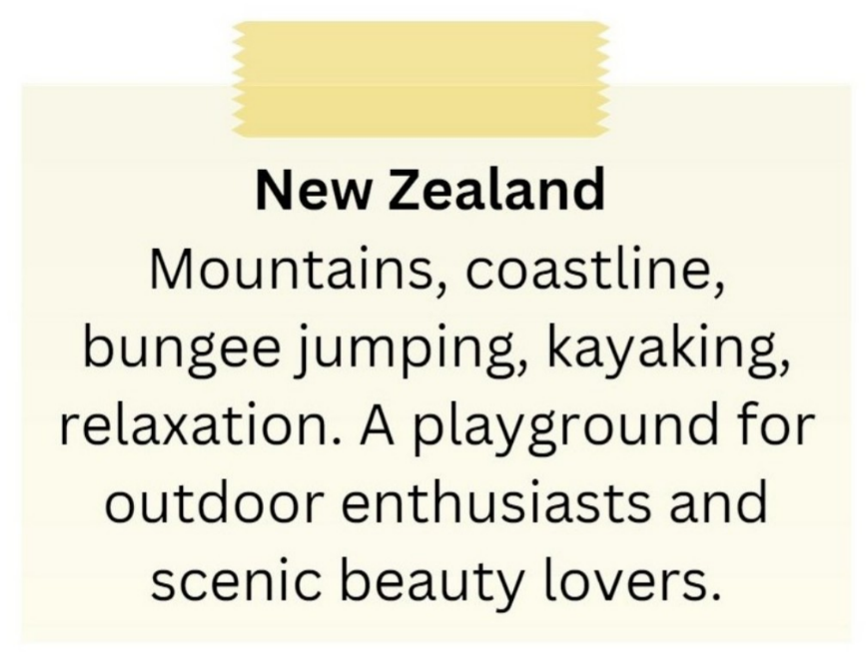
A. It is a destination for indoor activities and cultural experiences.
B. It highlights mountains, coastline, bungee jumping, and kayaking.
C. It is not suitable for outdoor enthusiasts.
D. It primarily appeals to relaxation enthusiasts.
Câu 10. What special offer is available at the new fast food restaurant?
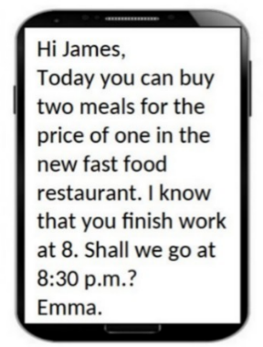
A. Two meals for the price of one B. 50% off all menu items
C. Free drinks with every meal D. Buy one get one free dessert
----HẾT---

