Career choices

Task 1. Listen to three recordings. Choose the correct photo, A, B or C.
1. What is the woman's job?
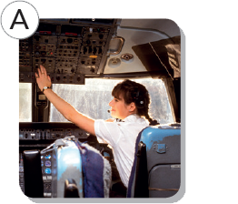 |  | 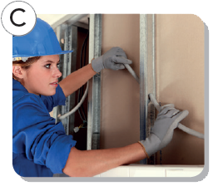
2. Why did the girl's dad get a new job?
 | 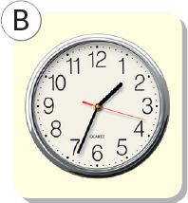 | 
3. What do you need to do the woman's job well?
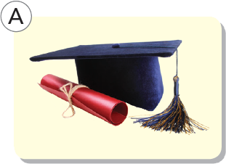 | 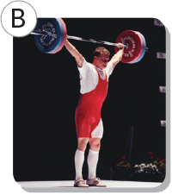 | 

Task 2: Listen to a dialogue between Sophie and her aunt Mary. Are statements 1–5 true or false?

1. Aunt Mary doesn't want Sophie to become an airline pilot. | True | False
2. Sophie hasn't been to university yet.
3. Aunt Mary doesn't enjoy her job and wants to change.
4. Aunt Mary is already a captain.
5. Aunt Mary doesn't think it's an easy career for women with children.

Task 3. Complete the collocations with the words below. Then listen, check and repeat.
degree eyesight home
off people training
Airline pilots must …
1 do long and expensive ____________.
2 have a university ____________.
3 get on well with ____________.
4 have excellent ____________.
5 spend a lot of time away from ____________.
Airline pilots can't …
6 choose when they take time ____________.

ANSWER KEY
Task 1.
1. A 2. B 3. C
Task 2.
1. False 2. True 3. False 4. False
5. True
Task 3.
1. training 2. degree 3. people
4. eyesight 5. home 6. off

AUDIO SCRIPT
Task 1. (Recording 3.5)
1
Mary: So do you know what you want to do when you leave school yet?
Sophie: Erm, yes, there is something I really really want to do, but I'm not sure if I can.
Mary: Oh? What's that?
Sophie: I want to do your job.
Mary: Ah! Right. Well, why not? It's a great job. And we need more women in the profession. There aren't many female pilots. Did you know that only 5% of airline pilots are women?
Sophie: That's terrible. Why is that?
Mary: I'm not sure. The training is long and very expensive, but it's the same for men and women. Maybe women think it's a man's job, so they don't apply for the training.
2
Boy: Is your dad enjoying his new job? He started last month, didn't he?
Girl: Yes. He decided to leave his last job because he spent ages travelling to work every day. He earned a lot more money then, but he thinks it's better to be at home longer.
Boy: I think he's right! My dad works from home now. He earns quite a lot and he can decide what time to start and finish work himself.
Girl: I think my mum would go mad if dad stayed home every day!
3
Woman: I'm the manager of a big supermarket and I really love my work. When I was at school, I really didn't know what I wanted to do. I wasn't very good at exams and studying has always been hard for me. So, I didn't want to go to university and get a degree. I get on well with people and I worked on the check-out at a supermarket. It was great fun and I enjoyed meeting all the different people. I got a promotion and they sent me on several courses. Now I'm the boss! To do this job you need to be sensible and organised but most importantly, you need good social skills. I sit at a desk a lot, so I go jogging and swimming to keep fit too.
Task 2 (Recording 3.6)
Mary: So do you know what you want to do when you leave school yet?
Sophie: Erm, yes, there is something I really really want to do, but I'm not sure if I can.
Mary: Oh? What's that?
Sophie: I want to do your job.
Mary: Ah! Right. Well, why not? It's a great job. And we need more women in the profession. There aren't many female pilots. Did you know that only 5% of airline pilots are women?
Sophie: That's terrible. Why is that?
Mary: I'm not sure. The training is long and very expensive, but it's the same for men and women. Maybe women think it's a man's job, so they don't apply for the training.
Sophie: If I wanted to be an airline pilot, would I find the training difficult?
Mary: No, I don't think so. In fact, I think you have the right qualities.
Sophie: Really?
Mary: Yes, you're healthy and you have excellent eyesight. You're intelligent, you're good at maths and science, and you get on well with people. If you got your university degree first, and then went to pilot school, you could be a great pilot.
Sophie: Do you enjoy your job?
Mary: I love it. I work long hours, but there are lots of good things about my job. For instance, I can travel anywhere in the world for free. There aren't many countries that I haven't visited!!
Sophie: I know – you're so lucky. But it's also a very responsible job.
Mary: Yes, it's true, but I like that. I need a challenge.
Sophie: What about your colleagues?
Mary: I work with some great people – we have a really good time together.
Sophie: Do you earn a lot?
Mary: I earn a good salary, but if I were captain, I would earn even more!
Sophie: Is it easy to become a captain and get a pay rise?
Mary: No, you need a lot of experience. I've only been doing this job for five years. I may become captain after another ten years.
Sophie: Ten years?
Mary: Yes. Think about it – if you went on a plane, you'd want the captain to have a lot of experience, wouldn't you?
Sophie: Yes, that's true! But it's such an exciting and glamorous job!
Mary: Well, sometimes, but the lifestyle is difficult – you spend a lot of time away from home.
Sophie: Yes, we don't see you very often. You couldn't come to my seventeenth birthday,
and you even missed last Christmas.
Mary: Yes, that's a problem. I can't always take time off when I want to. And if I had children, it would be almost impossible to do this job. I think that's the main reason why there aren't many female airline captains.
Sophie: You could have a house husband!
Mary: Okay, you find me a house husband, and I'll continue being an airline pilot!

Task 3 (Recording 3.7)
Airline pilots must …
1 do long and expensive training.
2 have a university degree.
3 get on well with people.
4 have excellent eyesight.
5 spend a lot of time away from home.
Airline pilots can't …
6 choose when they take time off.

