|  |  |
| --- | --- |
| **School: ………………………………………..** | **Date: …………………………………..** |
| **Class: …………………………….....................** | **Period: ………………………….........** |

**UNIT 6: LIFE ON OTHER PLANETS**

**Lesson 1.3 – Pronunciation & Speaking (pages 56 & 57)**

**I. OBJECTIVES**

By the end of the lesson, Ss will be able to:

**1.1. Language knowledge and skills**

- practice intonation for interest / opinion words.

- practice making predictions about where humans will live in the future, using Future Simple.

**1.2. Competences**

- improve Ss’ communication, collaboration and critical thinking skills.

**1.3. Attributes**

*-* be aware of what will happen in the future.

**II. TEACHING AIDS AND LEARNING MATERIALS**

**1. Teacher’s aids:** Student book and Teacher’s book, class CDs, Digital Book (DCR phần mềm tương tác SB, DHA (từ vựng/ cấu trúc) phần mềm trò chơi tương tác), projector/interactive whiteboard / TV (if any), PowerPoint slides, handouts.

**2. Students’ aids:** Student’s book, workbook, notebook, paper.

**III. ASSESSMENT EVIDENCE**

|  |  |  |
| --- | --- | --- |
| **Performance Tasks** | **Performance Products** | **Assessment Tools** |
| - Listen to the sentences and focus on how the intonation falls. | **-** Ss’ performance and answers. | - T’s observation. |
| **-** Listen and cross out the sentence that doesn't follow the note in "a." | - Ss’ answers. | - T’s feedback/Peers’ feedback. |
| - Listen to the sentences and focus on how the intonation falls. | **-** Ss’ performance. | - T’s feedback/Peers’ feedback. |
| - Take turns asking and answering using the prompts. | **-** Ss’ performance. | - T’s feedback/Peers’ feedback. |
| - Take turns asking and answering using the prompts. | - Ss’ performance /  Presentation. | - T’s observation, T’s feedback/Peers’ feedback. |
| - Make predictions about where people will and won't live in the future and why. Do you agree with the other pair's choices? Why (not)? | - Ss’ performance /  Answers. | - T’s feedback/Peers’ feedback. |

**IV. PROCEDURES**

**A. Warm up: (5’)**

**a) Objective:** Introduce the new lesson and set the scene for Ss to acquire new language; get students' attention at the beginning of the class by enjoyable and short activities as well as to engage them in the steps that followed.

**b) Content:** Reviewing the Future Simple.

**c) Expected outcomes:** Ss know some information that is useful for them in other speaking activities.

**d) Organization of the activity:**

|  |  |
| --- | --- |
| **TEACHER’S ACTIVITIES** | **STUDENTS’ ACTIVITIES** |
| **Review the Future Simple. (WB – page 33)**  - Divide the class into groups.  - Have Ss in each group match the sentence halves.  - Call Ss to write answers on the board.  - Check Ss’ answers give feedback.  - The group with the most correct answers is the winner.  - Lead to the new lesson. | - Form groups.  - Work in groups to match the halves.  *-* Write answers.  **Answer keys**  *2. D 3. A 4. E 5. B* |

**B. New lesson (35’)**

* **Activity 1: Pre-Speaking: Pronunciation (8’)**

**a) Objective:** Introduce Falling Intonation.

**b) Content: -** recognizing how to use intonation based on interest/opinion words.

**-** listening and checking, and crossing out the word that doesn’t follow the previous note.

- practicing.

**c) Expected outcomes:** Ss focus on how the intonation falls in their speaking.

**d) Organization of the activity:**

|  |  |
| --- | --- |
| **TEACHER’S ACTIVITIES** | **STUDENTS’ ACTIVITIES** |
| **Tasks a & b. Go over the pronunciation feature. Listen to the sentences and focus on how the intonation falls.**  **\*NOTE: *Falling intonation*** *describes how the voice falls on the final stressed syllable of a phrase or a group of words.**(https://dictionary.cambridge.org/*  *grammar/british-grammar/intonation)*  - Play the recording (CD2, track 5).  - Ask Ss to listen and focus on the interest/opinion words such as *dangerous* and *crazy.*  - Have students listen audio and notice the pronunciation feature.  - Focus on the examples and briefly explain the pronunciation feature.  - Play audio again and draw attention to how the intonation falls.  **Tasks c & d. Listen and cross out the word that doesn’t follow the note in “a”. Then, read the sentences to a partner.**  - Play the recording (CD 2 – Track 5), have Ss listen and cross out the option that doesn’t follow the note in “a”.  - Call Ss to give answers.  - Play the recording again and check answers as a whole class.  - Have students practice saying the sentences with a partner using the pronunciation feature.    - Give feedback. | - Listen.  - Listen again and repeat.  - Tell the feature.  - Listen and focus on the feature.  - Listen and give answers.  **Answer keys**    - Practice in pairs. |

* **Activity 2: While-speaking (22’)**

**a) Objective:** Students can talk about their own ideas regarding future predictions.

**b) Content:**  Asking and answering using the prompts, then practice with Ss’ own ideas.

**c) Expected outcomes:** Ss produce the new language successfully.

**d) Organization of the activity:**

|  |  |
| --- | --- |
| **TEACHER’S ACTIVITIES** | **STUDENTS’ ACTIVITIES** |
| **PRACTICE**  **\*OPTION 1:**  **Task a. Take turns asking and answering using the prompts.** - Demonstrate the activity by asking and answering with a student. - Emphasize the note as follows:  - Divide the class into pairs. - Have students take turns asking and answering using the prompts.  - Circulate during this time to give any help needed.  - Provide feedback.  **Task b. Practice with your own ideas.** - Have students practice the activity with their own ideas.  - Circulate during this time to give any help needed.  - Have some pairs demonstrate the activity in front of the class.  - Provide feedback.  **\*OPTION 2:**  **Read the following questions using the prompts. Ask your partner. Write Yes or No and the reason(s). Then write about your choices and practice with your own ideas.**  - Use the handout below and give each pair one copy.  - Have Ss work individually in order to answer their own answers first.  - Have students practice the activity, using the prompts and their own ideas.  - Circulate during this time to give any help needed.  - Provide feedback. | - Observe and listen.  - Work in pairs.  - Present.  - Work individually.  - Demonstrate the activity.  - Work individually.  - Ask and answer the questions in pairs. |

**\*HANDOUT:**

**Read the following questions using the prompts. Ask your partner. Write Yes or No and the reason(s). Then write about your choices and practice with your own ideas.**

|  |  |  |
| --- | --- | --- |
| **Questions**  ***Do you think …? Why?*** | **Your partner’s answer:**  **Yes or No? Why?** | **Your answer:**  **Yes or No? Why?** |
| 1. people/live/the moon/future?   **Do you think people will live on the moon in the future? Why?** | ………………………… |  |
| 1. Mars/good place to live/100 years?   Do you think … ? Why? | ………………………… |  |
| 1. families/live/space stations/20 years?   Do you think … ? Why? | ………………………… |  |

* **Activity 3: Production (5’)**

**a) Objective:** Students can make predictions of future life.

**b) Content:**  Making predictions about where people will and won't live in the future and why.

**c) Expected outcomes:** Ss produce the new language successfully in everyday speaking and writing.

**d) Organization of the activity:**

|  |  |
| --- | --- |
| **TEACHER’S ACTIVITIES** | **STUDENTS’ ACTIVITIES** |
| **Tasks a & b. You're talking to a friend about life in the future. In pairs: Make predictions about where people will and won't live in the future and why. Use the information from the lesson and your own ideas. Then answer the question “Do you agree with the other pair's choices? Why (not)?”**  - Demonstrate the activity by practicing with a student. - Divide the class into pairs, then combine pairs into groups of four. - Have students discuss where they think people will and won't live in 2100 and why. - Have students from each pair say where they think people will and won't live in the future and why. - Have groups share their findings with the class.  - Give feedback. | - Discuss in pairs.  - Work in groups of four.  - Discuss.  - Talk about their ideas.  - Share answers with the class. |

**C. Consolidation and homework assignments (5’)**

**\* Consolidation:** Using falling intonation for interest / opinion wordsand making predictions about where humans will live in the future, using Future Simple.

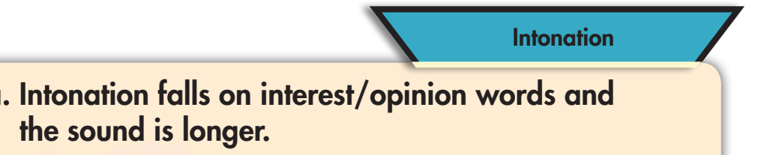 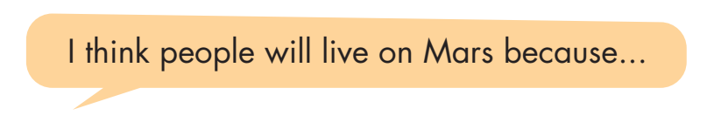

**\* Homework:**

- Practice: Write five sentences, using *will* regarding the reasons for where you think people will/ won’t live in the future.

- Do the exercises in WB: Writing (page 33).

- Play consolidation games in Tiếng Anh 8 i-Learn Smart World DHA App on [www.eduhome.com.vn](http://www.eduhome.com.vn)

- Prepare: Unit 6 - Lesson 2.1 – Vocabulary & Listening (pages 58 & 59 – SB).

**V. Reflection**

a. What I liked most about this lesson today:

…………………………………………………………………………………………

1. What I learned from this lesson today:

…………………………………………………………………………………………

c. What I should improve for this lesson next time:

…………………………………………………………………………………………