|  |  |
| --- | --- |
|  | *Thời gian làm bài: 40 phút (Không kể thời gian giao đề)*  *-------------------------* |

**Họ tên thí sinh: .................................................................**

**Số báo danh: ......................................................................**

**Mã Đề: 002.**

**Câu 1.** "What activity is the person inviting their friend to do?"

Hey friend! I hope you're having a good day. I wanted to see if you're up for watching a film this weekend. I heard that a new blockbuster just came out and it's supposed to be really good. Let me know if you're free and we can catch it together.

**A.** Read a book  **B.** Watch a film  **C.** Go to a museum  **D.** Attend a play

**Câu 2.** Which day is the City Zoo closed?

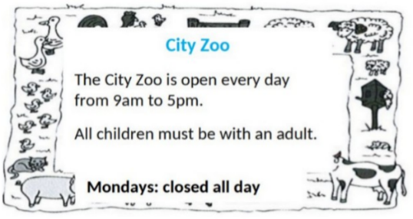

**A.** Saturday  **B.** Friday  **C.** Monday  **D.** Sunday

**Câu 3.** Which of the following items is NOT included in the half-price sale?

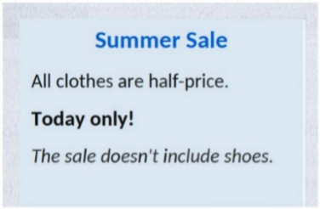

**A.** Shoes  **B.** Pants  **C.** Dresses  **D.** T-shirts

**Câu 4.** **Look at the signs. Choose the best answer for the question.**



**A.** You can buy cheaper apples after 6 p.m.

**B.** You can only buy apples today.

**C.** Today you can buy apples at a cheaper price before 6 p.m.

**D.** You can’t buy any apples before 6 p.m.

**Câu 5.** What should visitors do if the gate is closed?

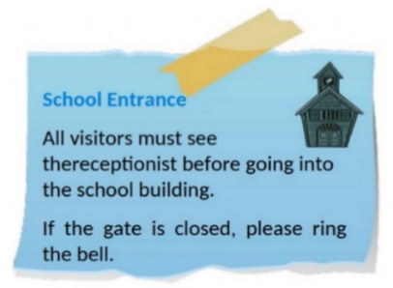

**A.** Call the school office  **B.** Wait for someone to open it

**C.** Come back later  **D.** Ring the bell

**Câu 6.** **Look at the signs. Choose the best answer for the question.**

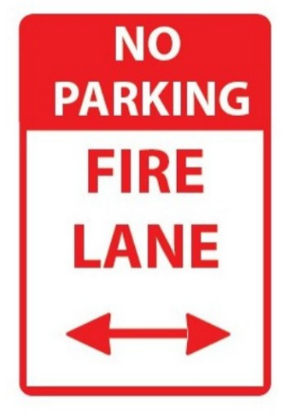

**A.** You can’t park your car here because this area is for fire trucks.

**B.** If there is a fire, park your vehicle in this area.

**C.** This area prevents your cars from fire.

**D.** You can’t park your car here when it is on fire.

**Câu 7.** **Look at the signs. Choose the best answer for the question.**

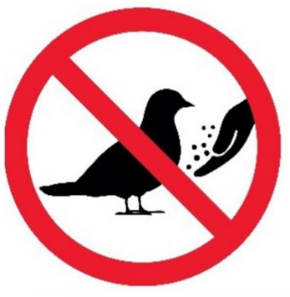

**A.** Birds don’t have to be given food.  **B.** You can’t bring any birds here.

**C.** No bird can be found here.  **D.** You mustn’t feed the birds.

**Câu 8.** Which of the following statements is true?



**A.** The IT course starts on 1st October.

**B.** The IT course covers hardware, software, networking, and security.

**C.** The IT course is for advanced learners.

**D.** The IT course does not provide a certificate.

**Câu 9.** What does it say?

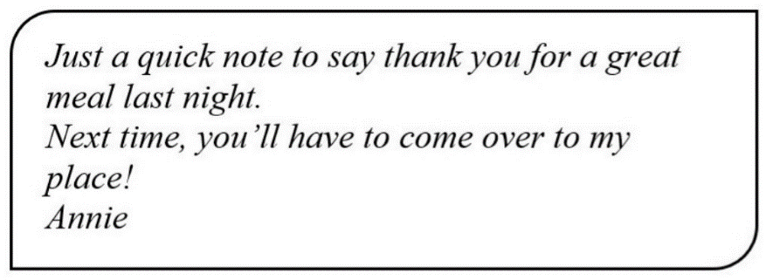

**A.** Annie went to a restaurant last night.  **B.** Annie cooked a great meal last night.

**C.** Annie invited her friend to her house last night.  **D.** Annie went to her friend’s house last night.

**Câu 10.** **Look at the signs. Choose the best answer for the question.**

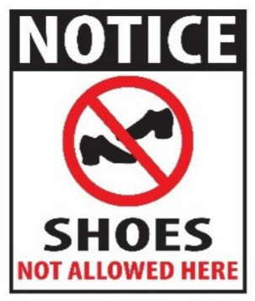

**A.** Please take off your shoes when entering this place.

**B.** You don’t have to wear shoes in this place.

**C.** Please put on your shoes when entering this place.

**D.** You can’t buy any shoes in this place.

**----HẾT---**