**Natural wonders of the world**

**Read the text and do the tasks that follow.**

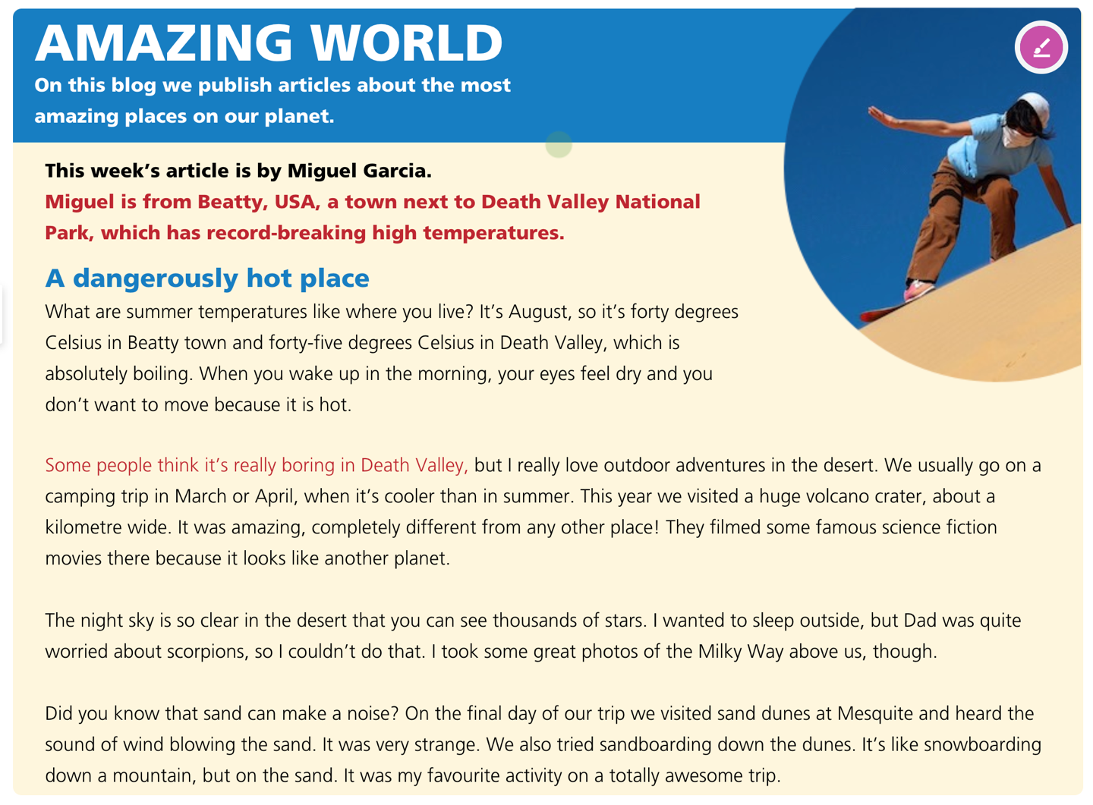

**Task 1. Look at the photo and read the article. What does Miguel like about the place where he lives?**

______________________________________________________________________

______________________________________________________________________

**Task 2. Read the whole article again and choose the correct answer.**

1. Miguel says that the temperature ___________________

a. is the same in Beatty and Death Valley.

b. makes you feel tired.

c. is normal for the time of year.

2. The volcano crater was ___________________

a. quite cold.

b. really unusual.

c. not very big.

3. One night in the desert Miguel ___________________

a. felt worried about something.

b. slept in the open air.

c. saw something special in the sky.

4. According to Miguel, sand dunes ___________________

a. look like mountains.

b. can make noises.

c. can be used for sport.

5. Which of the following is an opinion, not a fact?

a. The trip was totally awesome.

b. In March or April it’s cooler than in summer.

c. Sand can make a noise.

**ANSWER KEY**

**Task 1.**

**Possible answers:**  
He loves outdoor adventures in the desert. He likes going on camping trips. He enjoys watching stars in the night sky, which is very clear in the desert. He loves sandboarding on the sand.

**Task 2.**

1. c 2. b 3. c

4. c 5. a