LAX - ĐỀ THAM KHẢO KT TS 10 - MÔN TIẾNG ANH LỚP 9

I. Choose the word / phrase / sentence (A, B, C or D) that best fits the space or best answers the question given in each sentence. (3.5 pts).
1. Which word has the underlined part pronounced differently from that of the others?
A. meanwhile B. eventually C. furniture D. chemical
2. Which word has the underlined part pronounced differently from that of the others?
A. accomplished B. congested C. balanced D. embarrassed
3. Which word has a different stress pattern from that of the others?
A. discuss B. invent C. foreign D. afford
4. Which word has a different stress pattern from that of the others?
A. appliance B. instruction C. apartment D. monitor
5. Tom: “Why did Peter apologise to his brother?” – Maria: “Perhaps they ________ an argument.”
A. made B. had made C. had D. had had
6. Tai: “The trip is never complete______ a trip to the ancient monument.”
Tin: “I absolutely agree with you.”
A. without B. unless C. with D. if
7. Eric: “Why did you and your brother visit Beijing in this season?”
Lisa: “It was the low season, ______ my brother and I were able to afford a 5-day holiday.”
A. because B. but C. so D. however
8. Kate: Did you read that report about the pollution in the North Sea?
Ron: Yes. Toxic ____________continue to be dumped in the North Sea.
A. nutrient B. chemicals C. organ D. calories
FB: Thầy Đình (Dạy Tiếng Anh)
9. Cater: What are tour operators’ duties?
David: It's essential for tour operators to________ the needs of all their customers.
A. look over B. look through C. look on D. look after
10. Chau: My English grades are very poor! What should I do?
Dung: You should________ attention to the study methods of learning English right now.
A. take B. learn C. pay D. make
11. Tam: In the past, women were at home and took care of children.
Tu: So, they were content to let the man be the ______ and head of household.
A. housewife B. bread maker C. house husband D. breadwinner
12. Lucy: How can we save electricity for the lighting?
Emilia: Many lights now have _________ which turn on when there is a person moving in the room.
A. appliances B. sensors C. systems D. assistants
13. Jim: Congratulations Janet. You’ve passed the entrance exam into ABC High school for the gifted.
Janet: ___________! I did very badly in the exam.
A. Certainly B. You must be kidding C. You’re right D. No wonder
14. Hen: “Thanks a lot for telling me your life back then.” – Nga: “_________”
A. No problem B. That sounds fun! C. Oh, really? D. Lucky you

II. Look at the sign or the notice. Choose the best answer (A, B, C or D) for questions 15 and 16. (0.5 pt)

15. | What does the notice say?  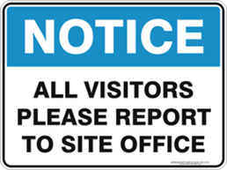 | A. If you want to visit, you have to inform the school.  B. Visitors must write a report to the school office.  C. Everyone can visit the school office.  D. All visitors are free to come to school office.
16. | What does the sign say?  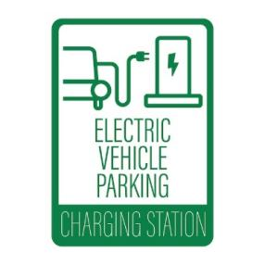 | A. This car is broken by electricity.  B. There is no electricity for your cars.  C. You can charge your electric cars here.  D. You can't charge your electric cars at home.
FB: Thầy Đình (Dạy Tiếng Anh)
III. Choose the word (A, B, C or D) that best fits each space in the following passage. (1.5 pts)
The Vietnamese are (17)________ proud of their historic capital city. The old quarter of Ha Noi dates back to the 11th century. Ha Noi’s peaceful ‘Van Mieu’, or Temple of Literature, is Viet Nam’s oldest educational institution. The Confucius inspired university was (18)___________ for the education of mandarins.
Around the central courtyard of Van Mieu stand 82 stone tortoises. These beautiful ancient sculptures were built to honour the men (19)________ received doctorates in triennial examinations.
While most tourists neglect Viet Nam’s fourth-largest city in favour of nearby Hue and Hoi An, it has (20)________ charm in its own right.
Another tourists’ favourite is Sai Gon which was renamed Ho Chi Minh City following its fall in 1975. However, the old name is still used by both Vietnamese and foreigners, especially when referring (21)_______ the most central part of the city.
The Vietnamese love a good cup of coffee. In the central market of Sai Gon, many small shops (22)________ samples of this favourite beverage, individually brewed with small metal French drip filter, and served with condensed milk.
17. A. rarely B. especially C. never D. shortly
18. A. established B. establish C. establishing D. establishes
19. A. who B. what C. when D. which
20. A. favorite B. many C. considerable D. considerate
21. A. to B. at C. in D. on
22. A. have B. get C. borrow D. offer

IV. Read the following paragraph. Decide whether the statements from 23 to 26 are True or False and choose the correct answer (A, B, C or D) to complete the statements in the questions 27 and 28. (1.5 pts)
No one can say exactly which jobs will be popular in the future. However, we do know which types of jobs people will have and what skills they will need.
Virtual reality (VR) is already common in video games and other entertainment. In the future, it will be used for work, too. People can expect to attend virtual business meetings or play virtual soccer. This means there will be lots of jobs in the virtual reality field.
People will want to experience personalized content. Companies and producers will use data about people's entertainment choices to know what their audience wants. We can expect to see lots of jobs in media for people working with digital content.
We can expect to see technology help people with training and communicating in all types of work. Training content will use podcasts, videos, and other digital media. VR will help businesses communicate with each other and give customers a better buying experience.
We do not know exactly which jobs people will have. However, it is clear which fields most people will work in and what skills they will need. If you want a job in the future, keep up to date with new technology!
23. Virtual reality (VR) is commonly used in entertainment, not business meetings and work-related activities yet. | ________
24. Businesses use data to find out what people like for entertainment. | ________
25. People will use virtual reality a lot in the future because everyone will use it in all work and entertainment. | ________
26. It is clear which fields people will work in, but we cannot predict specific jobs. | ________
27. What does the word "it" in paragraph 2 refer to?
A. entertainment B. virtual reality C. the future D. video gaming
28. Which of the following can you infer from the passage?
A. Most people will work in the field of virtual reality.
B. Most people will have the same jobs in the future.
C. Most people will need technology skills in their work.
D. Most people won't need jobs in the future.
FB: Thầy Đình (Dạy Tiếng Anh)
V. Use the correct form of the word given in each sentence. (1.5 pts)
29. The teacher emphasized the importance of _______________ new words regularly. (recognize)
30. After much ________________, they decided to move. (consider)
31. She is a well-known ________________ on social media. (influence)
32. The ________________ chair made it hard to sit for long. (comfort)
33. John ________________ agreed to try the new dish although he wasn’t sure he would like it. (hesitate)
34. The missing items have been ________________ after a thorough search by the team. (location)

VI. Look at the entry of the word ‘CONNECTED’ in a dictionary. Use what you can get from the entry to complete the sentences with two or three words. (0.5 pt)
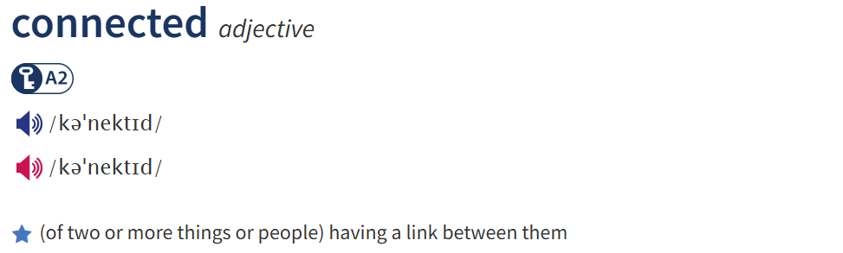
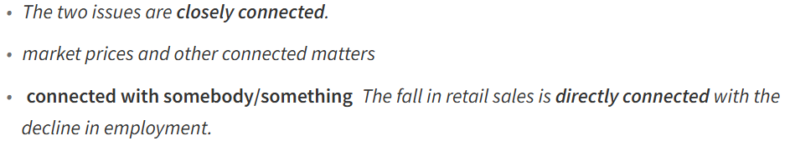
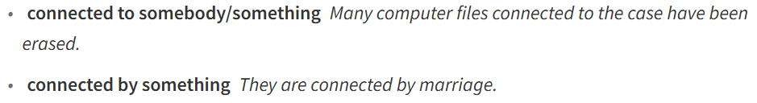

35. A device can be ________________ to a network via a cable or a wireless connection.
36. The two rooms are __________________ a door.

VII. Rewrite each of the following sentences in another way so that it means almost the same as the sentence printed before it. (1.0 pt)
37. Eating whole fruits and vegetables is healthier than drinking juice.
→ Drinking juice _________________________________________________________________.
38. He is interested in learning new languages.
→ He takes ______________________________________________________________________.
39. Why don’t you review your notes for the presentation tomorrow?
→ I think you should go ____________________________________________________________.
40. "I hope to have a flat-screen TV instead of a traditional bulky set", Kyle said.
→ Kyle wishes ____________________________________________________________________.

THE END OF THE TEST

