Họ tên thí sinh: .................................................................
Số báo danh: ......................................................................
Mã Đề: 026.
Câu 1. Look at the signs. Choose the best answer for the question.
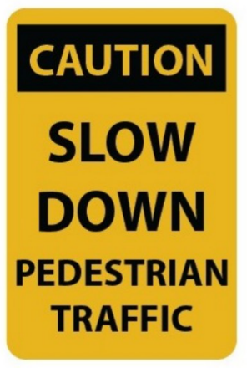
A. You should drive carefully because of slow pedestrians.
B. You should slow your speed and pay attention to pedestrians.
C. Pedestrians should walk slowly.
D. Pedestrians will slow down the traffic.
Câu 2. What is the main reason James cannot attend the concert?
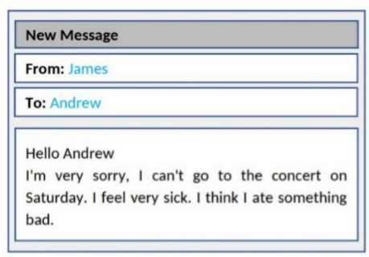
A. He doesn't like the music B. He has another commitment
C. He is feeling unwell D. He lost his ticket
Câu 3. Why has Jenna left a note for Marcus?
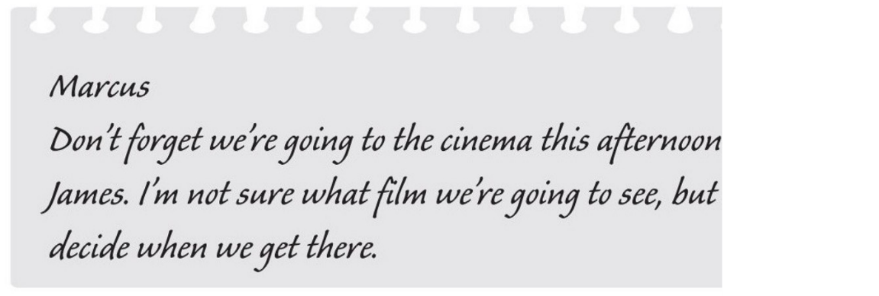
A. to suggest a film which they could see B. to invite him to the cinema
C. to choose the cinema D. to remind him about an arrangement
Câu 4. When is the grand opening of the new department store?

A. July 3rd B. June 4th C. July 4th D. July 5th
Câu 5. Look at the signs. Choose the best answer for the question.
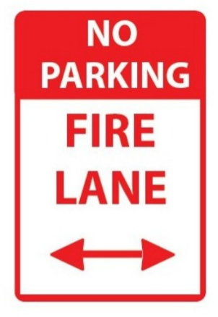
A. If there is a fire, park your vehicle in this area.
B. This area prevents your cars from fire.
C. You can’t park your car here because this area is for fire trucks.
D. You can’t park your car here when it is on fire.
Câu 6. Who can participate in this cycle ride?
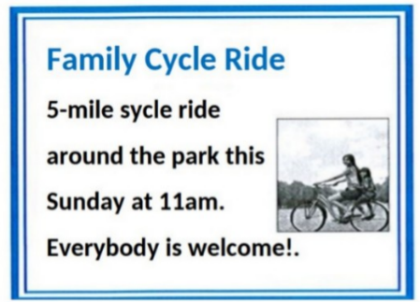
A. Anyone who wants to join B. Only families with children
C. Only experienced cyclists D. Only park members
Câu 7. Who can get free tickets to the football match?
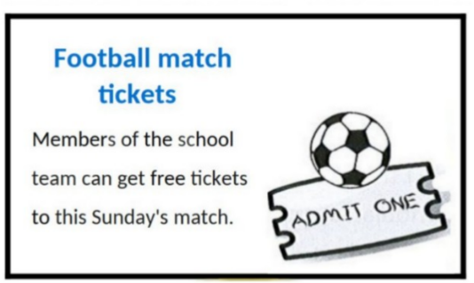
A. Members of the school team B. Parents
C. All students D. Teachers
Câu 8. Which of the following services is NOT offered by the Village Shop?
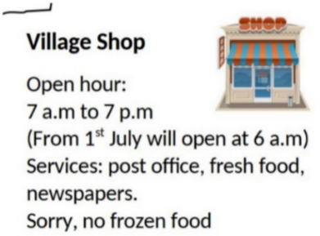
A. Fresh food B. Newspapers C. Post office D. Frozen food
Câu 9. Look at the signs. Choose the best answer for the question.
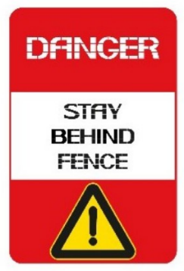
A. You shouldn’t stand close to the fence. B. The fence is dangerous.
C. You mustn’t cross the fence. D. It is dangerous to stay behind the fence.
Câu 10. What time was the theatre originally scheduled to open?
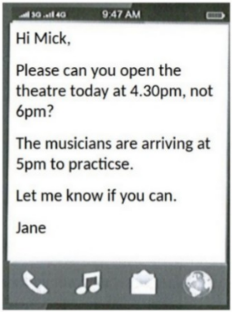
A. 5:00pm B. 5:30pm C. 4:30pm D. 6:00pm
----HẾT---

