Unit 1 Test
I. Listening
Listen to Mai talking about her new school day and fill in each blank with ONE word or a number.
Time | Activity / Place | Notes
7:30 | Meet teacher | Class (1) __________
8:00 | First lesson | (2) __________
9:30 | Break time | Talk with new (3) __________
10:15 | Favourite subject | (4) __________
11:30 | Lunch | In the school (5) __________
II. Pronunciation
A. Choose the word whose bolded part is pronounced differently.
6. A. class B. smart C. art D. subject
7. A. study B. lunch C. compass D. start
B. Choose the word that has a different stress pattern from the others.
8. A. teacher B. student C. homework D. around
9. A. calculator B. activity C. uniform D. library
III. Language use
Choose the best answer A, B, C or D.
10. Students usually wear a __________ at school.
A. uniform B. compass C. subject D. lunch
11. We __________ new subjects this school year.
A. has B. have C. having D. is having
12. My brother __________ to school by bicycle every day.
A. go B. going C. goes D. to go
13. __________ do you study English? - On Monday and Friday.
A. What B. When C. Who D. How many
14. There is a new __________ in my pencil case.
A. rubber B. playground C. science D. history
15. Duy is very friendly, __________ he helps new students.
A. but B. so C. because D. or
IV. Signs & Notices
Look at the signs and choose the best explanation.
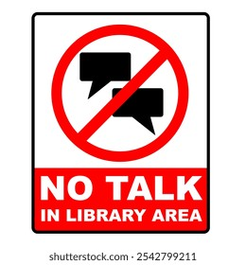 | 16. What does this notice mean?  A. Students can talk loudly in the library.  B. Students should be quiet.  C. Students must buy new books.  D. Students cannot read books here.

 | 17. What is the message of this sign?  A. Students can have lunch in the lab.  B. Students can bring water to the playground.  C. Students should clean the canteen.  D. Students must not eat or drink in the lab.

CLASS 6A:  English Club meets after school every Friday. | 18. Read the notice. What is TRUE?  A. The club meets before school.  B. The club is for Class 6A only.  C. The club meets after school each Friday.  D. Students meet every Monday.

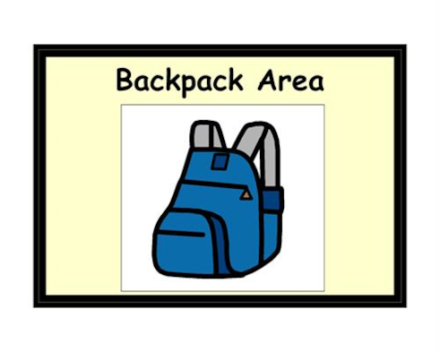 | 19. What does this notice tell you?  A. Students should put their bags in this area.  B. Students should bring bags to the football field.  C. Students can leave books at home.  D. Students must not have PE lessons.

V. Rearrange the sentences (a-d) to make a complete conversation.
20.
a. That's a great idea!
b. Hi Minh. Do you have any plans for this Saturday?
c. Shall we go to the school library to study together?
d. Not really. I'm just staying at home.
A. b - d - a - c B. b - a - d - c C. b - d - c - a D. a - b - d - c
21.
a. I like English and history.
b. What subjects do you like?
c. Yes, we do. We study Physics and Computer Science now.
d. That's cool! Do you have any new subjects this year?
A. d - c - b - a B. b - a - d - c C. d - b - a - c D. a - b - c - d
22.
a. At six o'clock. Then I have breakfast.
b. I usually go by bicycle.
c. Wow, that's early! How do you go to school?
d. What time do you get up?
A. c - b - d - a B. b - c - d - a C. d - c - a - b D. d - a - c - b
23.
a. It is large and has many trees.
b. What is your new school like?
c. That sounds great! Do you like it?
d. Yes, I do. My teachers are kind.
A. b - a - c - d B. a - b - d - c C. b - c - a - d D. d - b - a - c
VI. READING
A. Read and choose the correct word for each blank.
My new school is in the centre of the village. It is not very big, but it is clean and friendly. We have many (24) _________ such as English, maths and science. At break time, we often play in the (25) _________. Our teachers are kind, and they help us when we have problems. I (26) _________ my school because I have many good friends there. Students usually (27) _________ their uniforms on Mondays.
24. A. subjects B. rubbers C. compass D. bags
25. A. library B. playground C. calculator D. kitchen
26. A. likes B. liking C. like D. to like
27. A. wear B. wears C. wearing D. are wear
B. Read the text and choose the best answer A, B, C or D.
My name is Vy. This is my first week at Nguyen Du Secondary School. I am in Class 6A. My classroom is on the second floor. It is bright and clean. There are thirty-eight students in my class. Our teachers are friendly and helpful.
My favourite subjects are English and science. I have English on Monday, Wednesday and Friday. During break time, I often talk with my friends in the playground. My best friend is Mai. She is kind and hard-working. She usually helps me with homework. I like my new school because every day is interesting.
28. What is the text mainly about?
A. Vy's family B. Vy's new school C. Vy's house D. Vy's favourite food
29. Which class is Vy in?
A. Class 6A B. Class 6B C. Class 7A D. Class 5A
30. Where is her classroom?
A. On the first floor B. On the second floor
C. Next to the canteen D. Behind the library
31. How many students are there in her class?
A. Thirty-six B. Thirty-seven C. Thirty-eight D. Forty-eight
32. What are Vy's favourite subjects?
A. Maths and music B. English and science
C. History and PE D. Art and geography
33. When does Vy have English?
A. On Monday, Wednesday and Friday B. On Tuesday and Friday
C. Every day D. Only on Monday
34. What is Mai like?
A. She is kind and hard-working B. She is noisy and lazy
C. She is tall and sporty D. She is shy and quiet
35. Why does Vy like her new school?
A. Because the lessons are boring B. Because every day is interesting
C. Because she has no homework D. Because the school is very small
VII. WRITING
A. Rearrange the words to make complete sentences.
36. often / do / your / homework / you / after school /?
______________________________________________________________________.
37. has / My new school / a big playground / and / a library /.
______________________________________________________________________.
B. Rewrite the sentences without changing their meanings.
38. I usually go to school by bus.
I usually take ________________________________________________________.
39. My favourite subject is English.
I like ________________________________________________________________.
40. Duy is Phong's friend.
Phong’s _______________________________________________________________.

AUDIO SCRIPT (PHẦN I: LISTENING)
• Hello everyone.
• My name is Mai, and this is my new school day.
• I arrive at school at seven-thirty.
• First, I meet my teacher in Class 6A.
• She is very friendly.
• At eight o'clock, we have our first lesson.
• It is maths, and I like it very much.
• At nine-thirty, we have break time.
• I talk with my new classmates in the playground.
• At ten-fifteen, we have English.
• It is my favourite subject because I can learn many new words and speak with my friends.
• At eleven-thirty, we have lunch in the school canteen.
• The food is nice, and I always sit with my friends.
• I love my new school.
*************************************
Đáp án tham khảo
Listening: 1. 6A | 2. maths | 3. classmates | 4. English | 5. canteen
Pronunciation: 6. D | 7. D | 8. D | 9. B
Language: 10. A | 11. B | 12. C | 13. B | 14. A | 15. B
Signs & Notices: 16. B | 17. B | 18. C | 19. A
Logic: 20. C | 21. B | 22. D | 23. A
Cloze Test: 24. A | 25. B | 26. C | 27. A
Reading Comprehension: 28. B | 29. A | 30. B | 31. C | 32. B | 33. A | 34. A | 35. B
Writing:
36. Do you often do your homework after school?
37. My new school has a big playground and library.
38. I usually take the bus to school.
39. I like English best.
40. Phong's friend is Duy.

