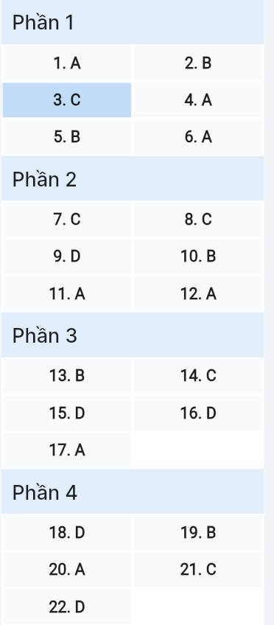
ĐỀ MINH HỌA SỐ 12
KỲ THI TỐT NGHIỆP TRUNG HỌC PHỔ THÔNG NĂM 2025
(Đề thi có 08 trang)
Môn thi: TIẾNG ANH
Thời gian làm bài: 50 phút, không kể thời gian phát đề
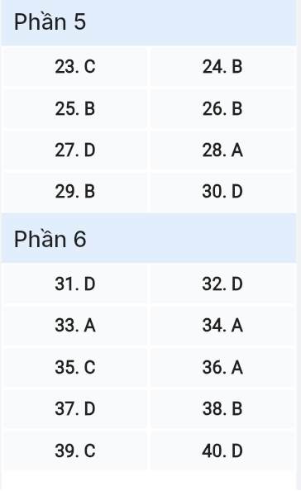
Read the following advertisement and mark the letter A, B, C or D on your answer sheet to indicate the option that best fits each of the numbered blanks from 1 to 6.
VITALTRACK PRO: YOUR PERSONAL WELLNESS COMPANION
Struggling to maintain (1) ______ in today’s fast-paced world? Meet VitalTrack Pro, the innovative (2) ______ that revolutionizes your approach to wellness!
Our comprehensive health monitoring system, (3) ______ recognition from medical professionals worldwide, tracks everything from heart rate patterns to sleep quality. The advanced sensors respond (4) ______ subtle changes in your body’s rhythms, providing real-time health insights.
Users can easily (5) ______ priority to their health goals through our intuitive dashboard. Our AI-powered analytics interpret your health data, offering personalized recommendations and early warning signals for potential health concerns.
Ready to take control of your well-being? Consider (6) ______ VitalTrack Pro today and experience the future of personalized wellness monitoring!
(Adapted from VitalTrack Pro Product Guide)

Question 1 [696737]: A. balance B. balanced C. balancing D. balanceable
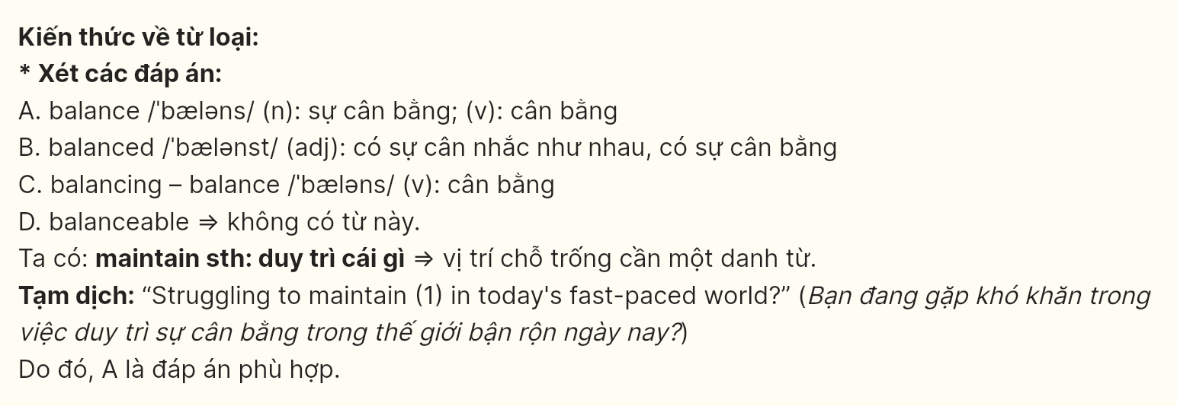
Question 2 [696738]: A. digital system wellness B. digital wellness system
C. wellness digital system D. system wellness digital
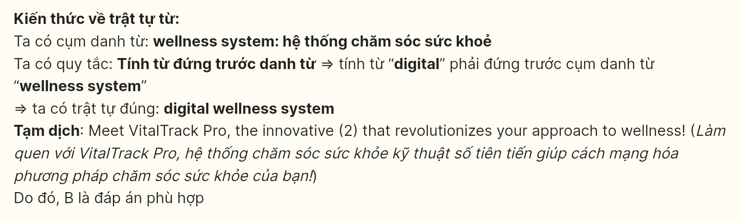
Question 3 [696739]: A. gained B. which is gained C. gaining D. gains
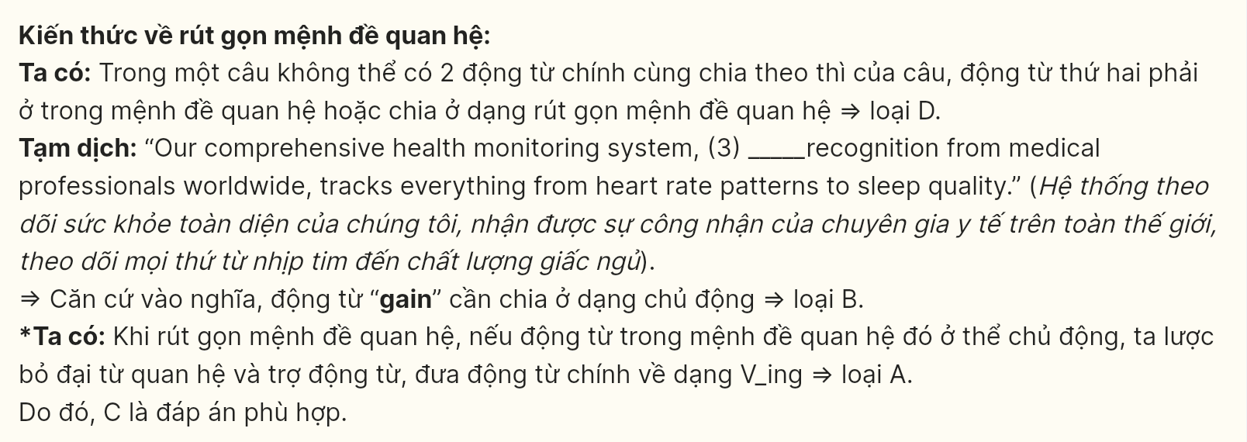
Question 4 [696740]: A. to B. for C. at D. by
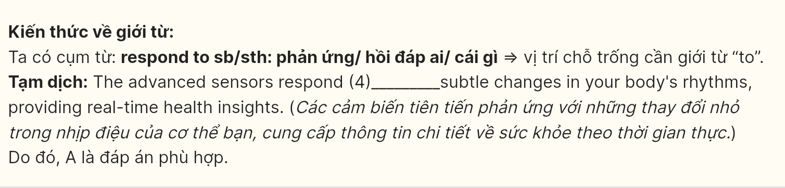
Question 5 [696741]: A. make B. give C. take D. put

Question 6 [696742]: A. purchasing B. to purchase C. purchase D. to purchasing
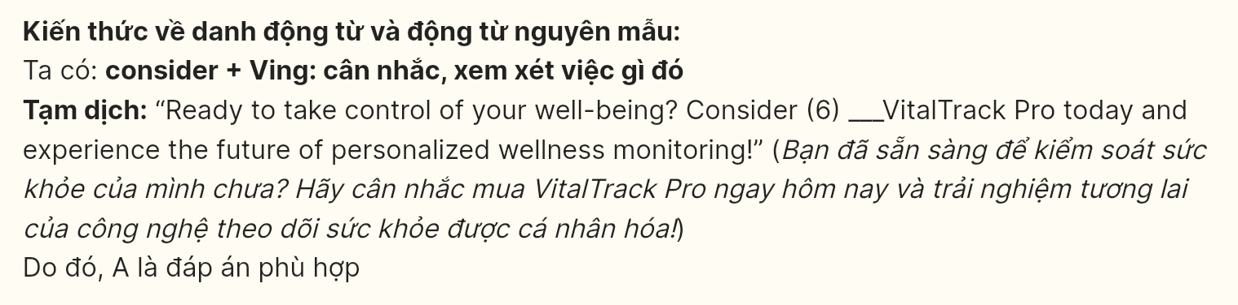
Read the following leaflet and mark the letter A, B, C or D on your answer sheet to indicate the option that best fits each of the numbered blanks from 7 to 12.
MIND THE GAP: A Guide to Understanding Today’s Generations
Did you know?
- 70% of grandparents struggle with smart devices
- 85% of teenagers rely extensively on texting to communicate
- 60% of families experience tension over technology use
What’s happening?
Today’s generation gap is wider than ever, largely due to rapid technological changes. Young people navigate the digital world with ease, while (7) ______ generations find it challenging to keep pace.
Key challenges:
1. Communication Preferences
- Messaging apps (8) ______ with the youth, leaving older relatives feeling disconnected
- Modern slang and internet terminology create barriers
2. Values & Perspectives
- Each generation must (9) ______ their deep-rooted assumptions about one another
- (10) ______ their differing approaches to life, meaningful connections are possible
Bridging the divide:
- Share Skills: (11) ______ between generations has never been more crucial as understanding others' perspectives without judgment helps to foster connectivity.
- Find Balance: Both generations must (12) ______ their differences to move forward
Tips:
- Schedule regular family tech-teaching sessions
- Practice patience and open-mindedness
- Celebrate both traditional and modern approaches
(Adapted from Generation Connect Institute, 2024)

Question 7 [696743]: A. others B. another C. other D. the others
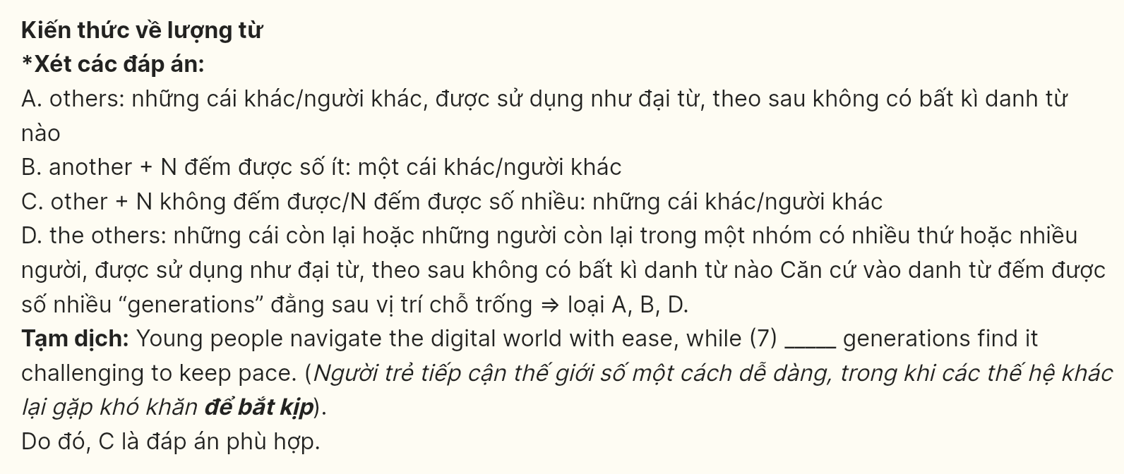
Question 8 [696744]: A. bring off B. keep up C. catch on D. give in
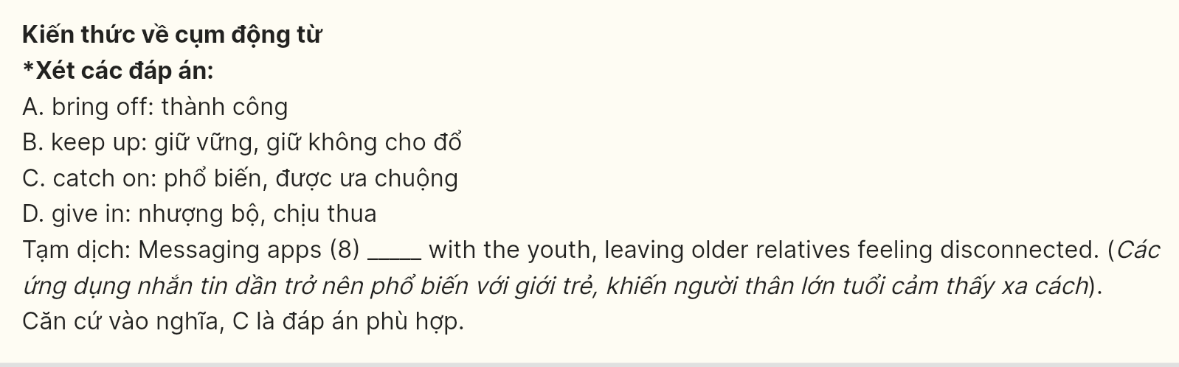
Question 9 [696745]: A. relinquish B. acquiesce C. rescind D. repudiate
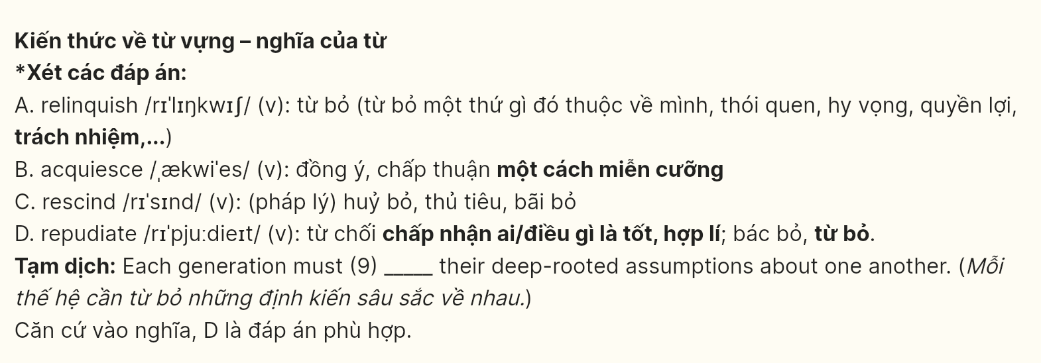
Question 10 [696746]: A. Contrary to B. Notwithstanding C. Apart from D. Aside from
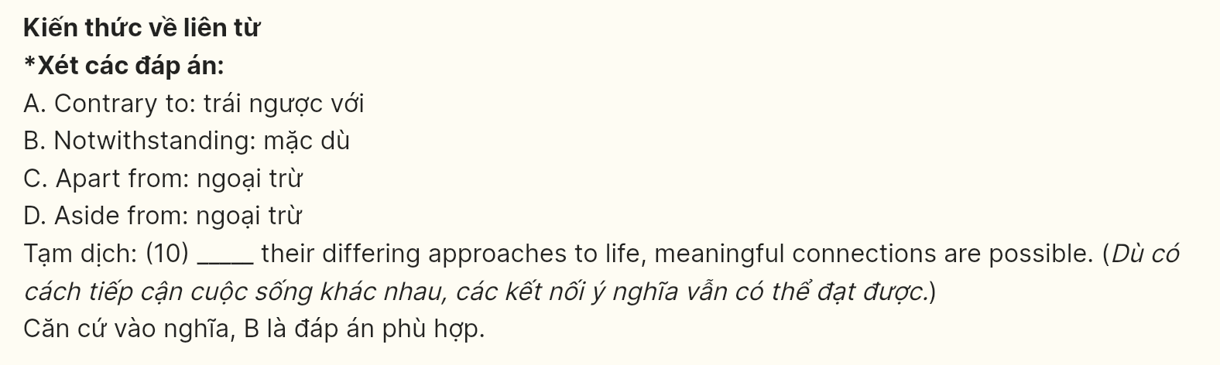
Question 11 [696747]: A. empathy B. sympathy C. compassion D. pity
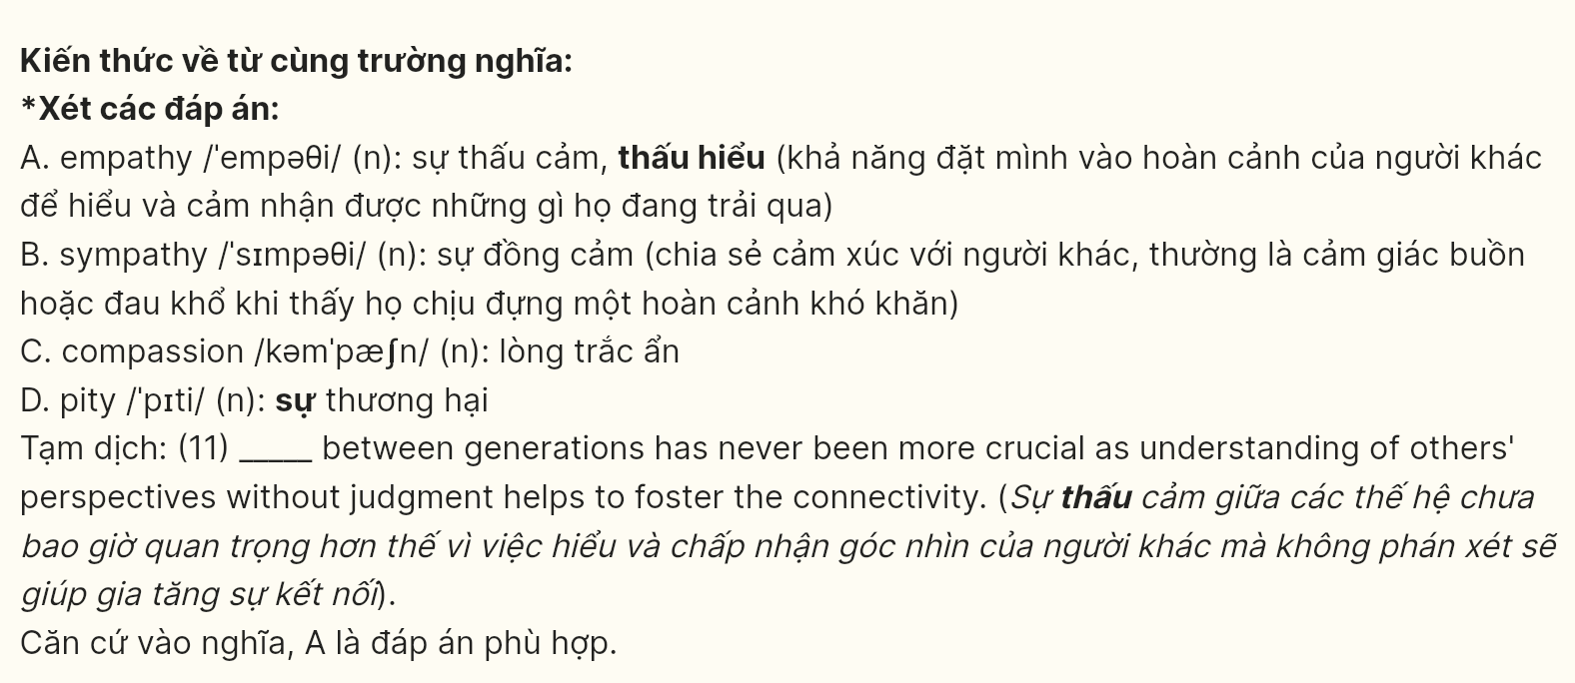
Question 12 [696748]: A. reconcile B. mediate C. negotiate D. arbitrate
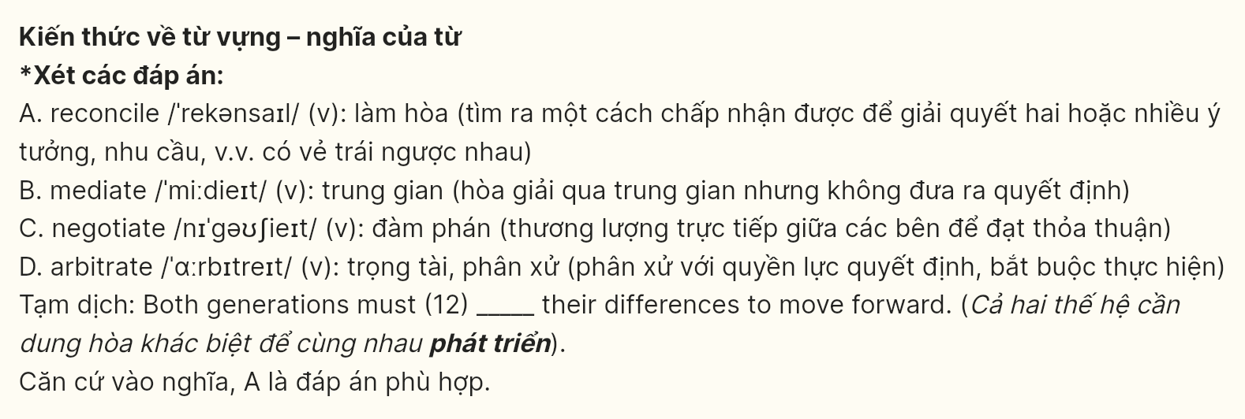
Mark the letter A, B, C or D on your answer sheet to indicate the best arrangement of utterances or sentences to make a meaningful exchange or text in each of the following questions from 13 to 17.
Question 13 [696749]:
Sarah: Thank you! I finally decided to take my health seriously after realizing how inactive I had become.
Tom: That’s inspiring. I think I also need to learn how to lead a more independent and healthy lifestyle.
Tom: I’ve noticed the positive changes in your lifestyle lately - your diet, exercise, everything! You look fantastic.
A. b - a – c B. c - a – b C. c-b-a D. a - c – b
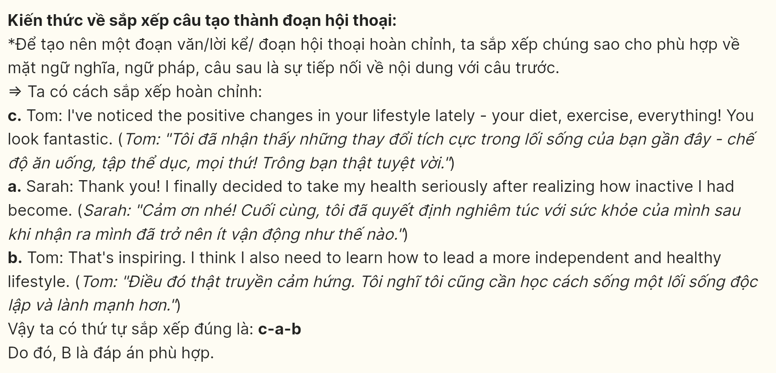
Question 14 [696750]:
a. Grandpa: In my time, we focused more on real face-to-face connections with people.
b. Grandpa: I don’t understand why young people spend so much time on their phones these days.
c. Lisa: Technology has actually created new ways for people to connect, especially across distances.
d. Lisa: We use them for everything - staying connected, working, learning, and entertainment.
e. Grandpa: Maybe you could show me how to use some of these apps to better understand your world.
A. b-d-c-a-e B. b-c-a-e-d C. b-d-a-c-e D. b-c-e-a-d
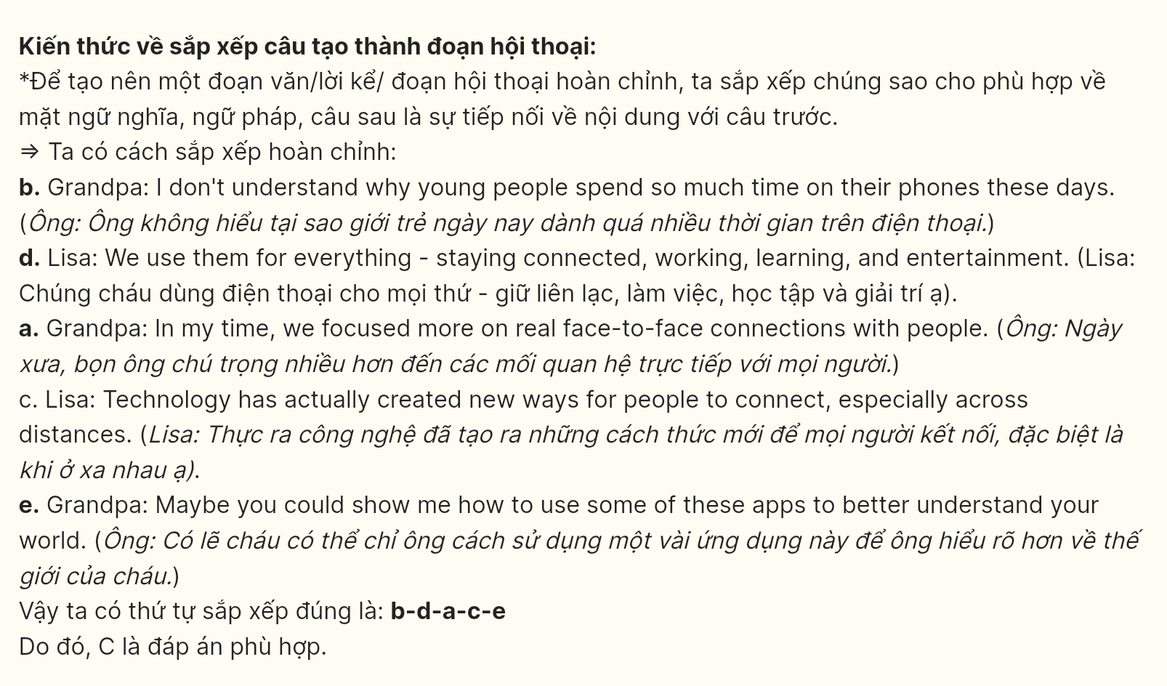
Question 15 [696751]:
Dear Film Festival Committee,
a. Through interviews, it reveals interesting insights about our changing media consumption habits.
b. The film explores how social media has transformed modern entertainment and audience engagement.
c. Given your festival’s focus on cultural trends, I believe this topic would resonate with your audience.
d. I am writing to submit my documentary for consideration at this year’s film festival.
e. I would be honored to have my work screened at your prestigious event.
Best regards,
David Chen
A. d - a - c - b – e B. d - b - c - a – e C. d - a - b - e – c D. d - b - a - c - e
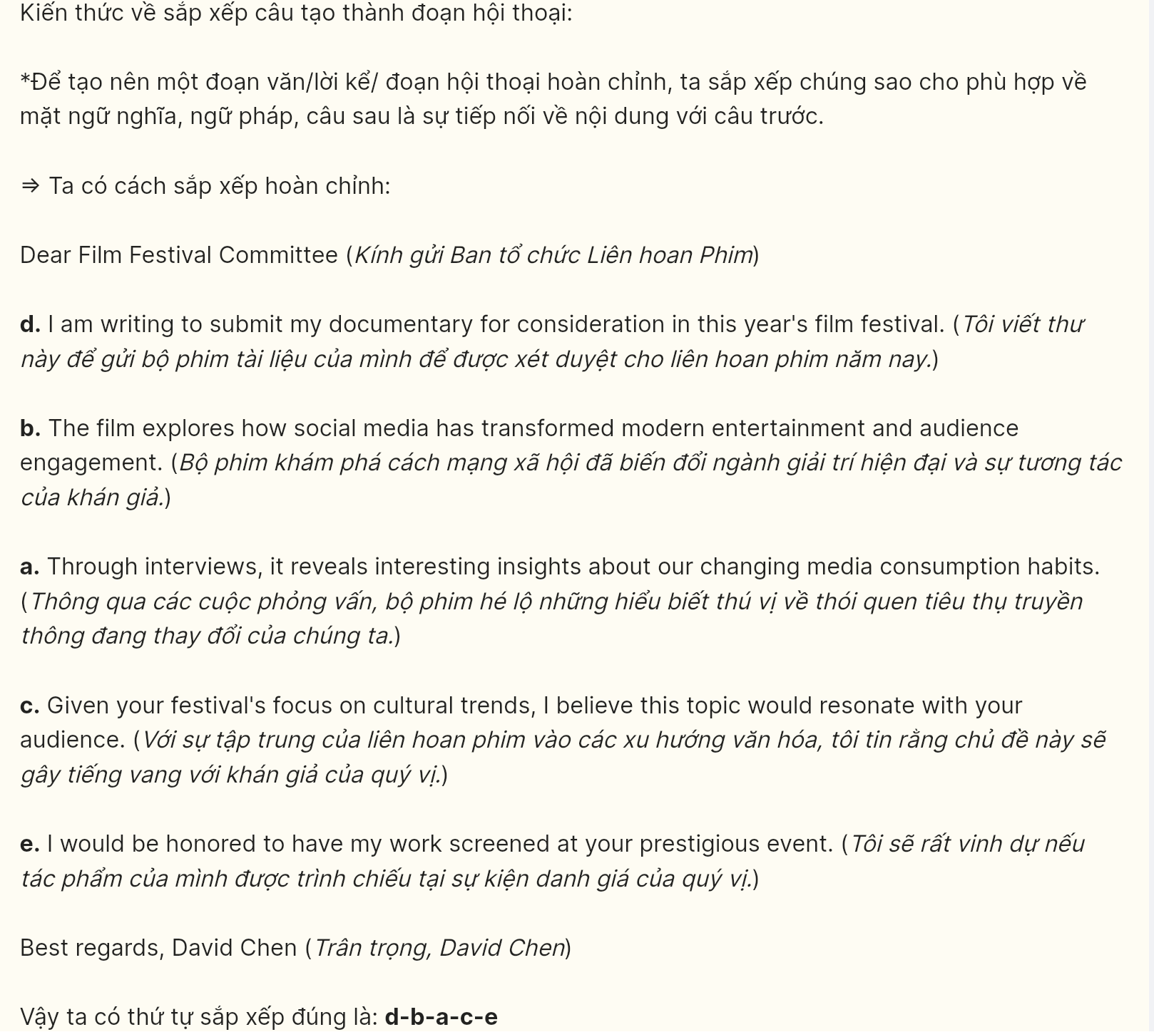
Question 16 [696752]:
a. However, we can still make a difference if we work together to reduce our environmental impact.
b. Communities everywhere are already experiencing the harmful effects of these changes.
c. Scientists warn that without immediate action, these changes could become permanent.
d. Extreme weather events have become more frequent and severe around the world.
e. Climate change has significantly altered our planet’s weather patterns over the past few decades.
A. d - b - c - a – e B. d - c - a - e – b C. e - d - b - a – c D. e - d - c - b - a
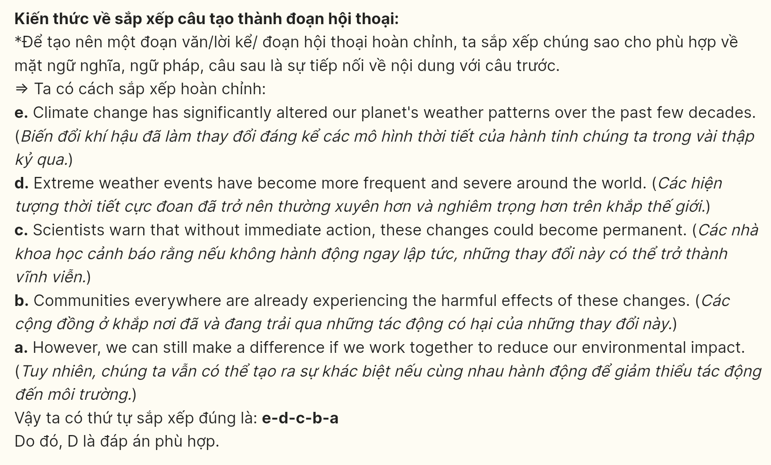
Question 17 [696753]:
a. Initially, many were skeptical about how this would affect the ecosystem.
b. The reintroduction of wolves to Yellowstone National Park has become a classic example of successful conservation.
c. Over time, the wolves' presence helped control the elk population.
d. This led to the regeneration of vegetation and the return of various species.
e. Today, the park serves as a model for ecosystem restoration worldwide.
A. b - a - c - d - e B. b - e - c - d – a C. b - c - a - e – d D. b - a - c - e - d
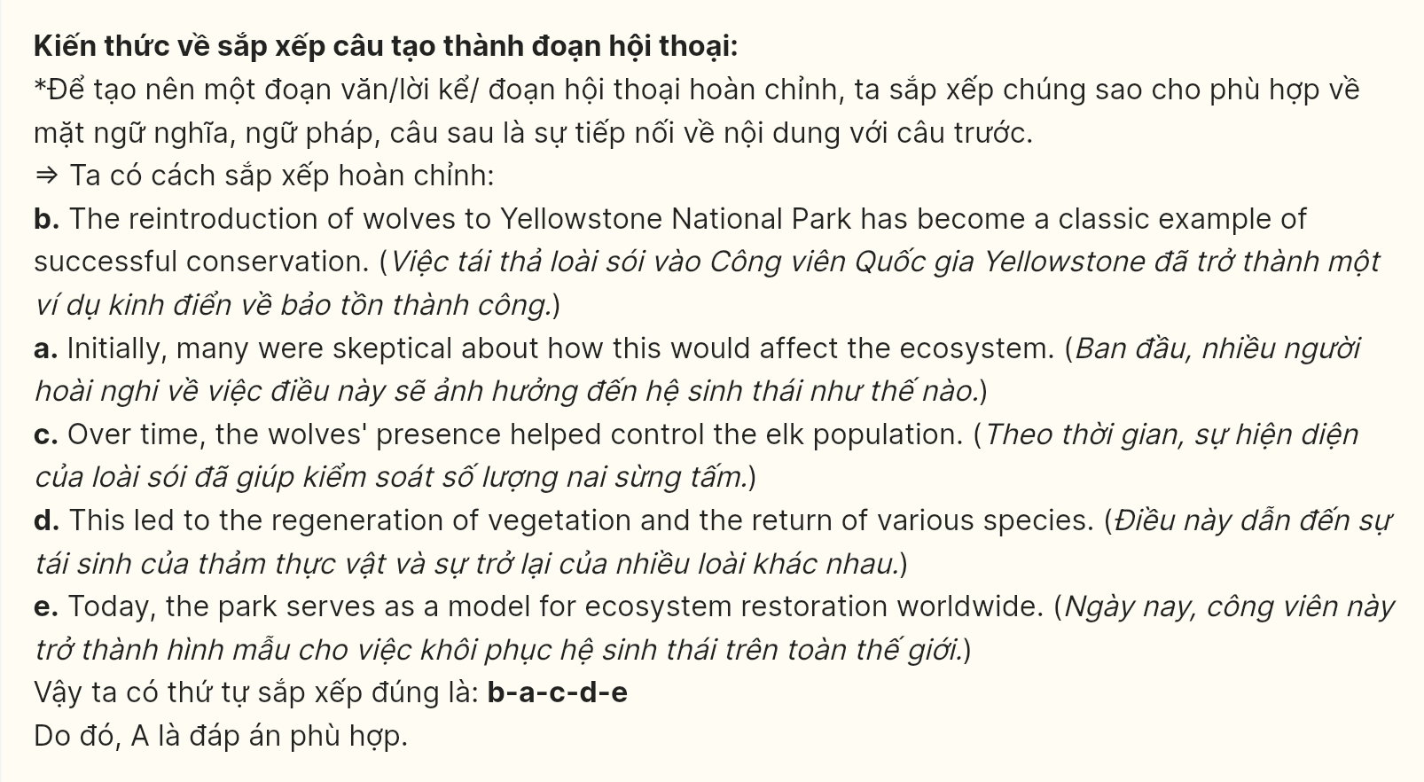
Read the following passage about digital entertainment and mark the letter A, B, C or D on your answer sheet to indicate the option that best fits each of the numbered blanks from 18 to 22.
Virtual reality gaming, beyond its initial experimental phase, (18) ______. Their increasingly sleek immersive experiences blur the lines between reality and digital worlds. Last quarter’s sales figures revealed that VR headset purchases doubled compared to previous years.
Young developer Sarah Chen, (19) ______, showcased her breakthrough at GameTech Expo 2024. Her innovations in haptic feedback technology allow players to feel virtual textures and temperatures. Through advanced motion sensors, players can now experience realistic physical sensations while gaming.
The Chen Gaming Lab leads innovation in virtual reality. (20) ______. The facility’s research combines neuroscience with gaming technology to create more engaging player experiences.
Additionally, (21) ______. Their latest "NeuroPulse" technology reads players’ emotional responses to adjust game difficulty in real-time.
The lab continues to push boundaries in gaming innovation. Powered by sophisticated AI algorithms, (22) ______.
(Adapted from LinkedIn)

Question 18 [696754]:
A. which sets new engagement records across global markets
B. setting new engagement records across global markets
C. that has new engagement records set across global markets
D. sets new engagement records across global markets

Question 19 [696755]:
A. from whom innovative gaming concepts revolutionized the virtual reality market
B. who revolutionized the virtual reality market with innovative gaming concepts
C. brought innovative gaming concepts to revolutionize the virtual reality market
D. led innovative gaming concepts to revolutionize the virtual reality market

Question 20 [696756]:
A. The lab developers create revolutionary gaming systems for virtual reality training
B. The systems create revolutionary developments for virtual reality lab training
C. To create revolutionary developments for virtual reality systems, the lab is trained
D. Developers create the revolutionary lab system for virtual reality training development
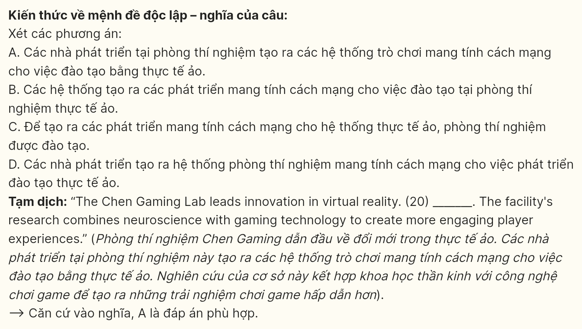
Question 21 [696757]:
A. before launching monthly updates to their sensory feedback systems, developers enhance player immersion
B. launched monthly updates to their sensory feedback systems, player immersion is enhanced
C. launching monthly updates to their sensory feedback systems, developers enhance player immersion
D. monthly updates are launched to their sensory feedback systems, developers enhance player immersion
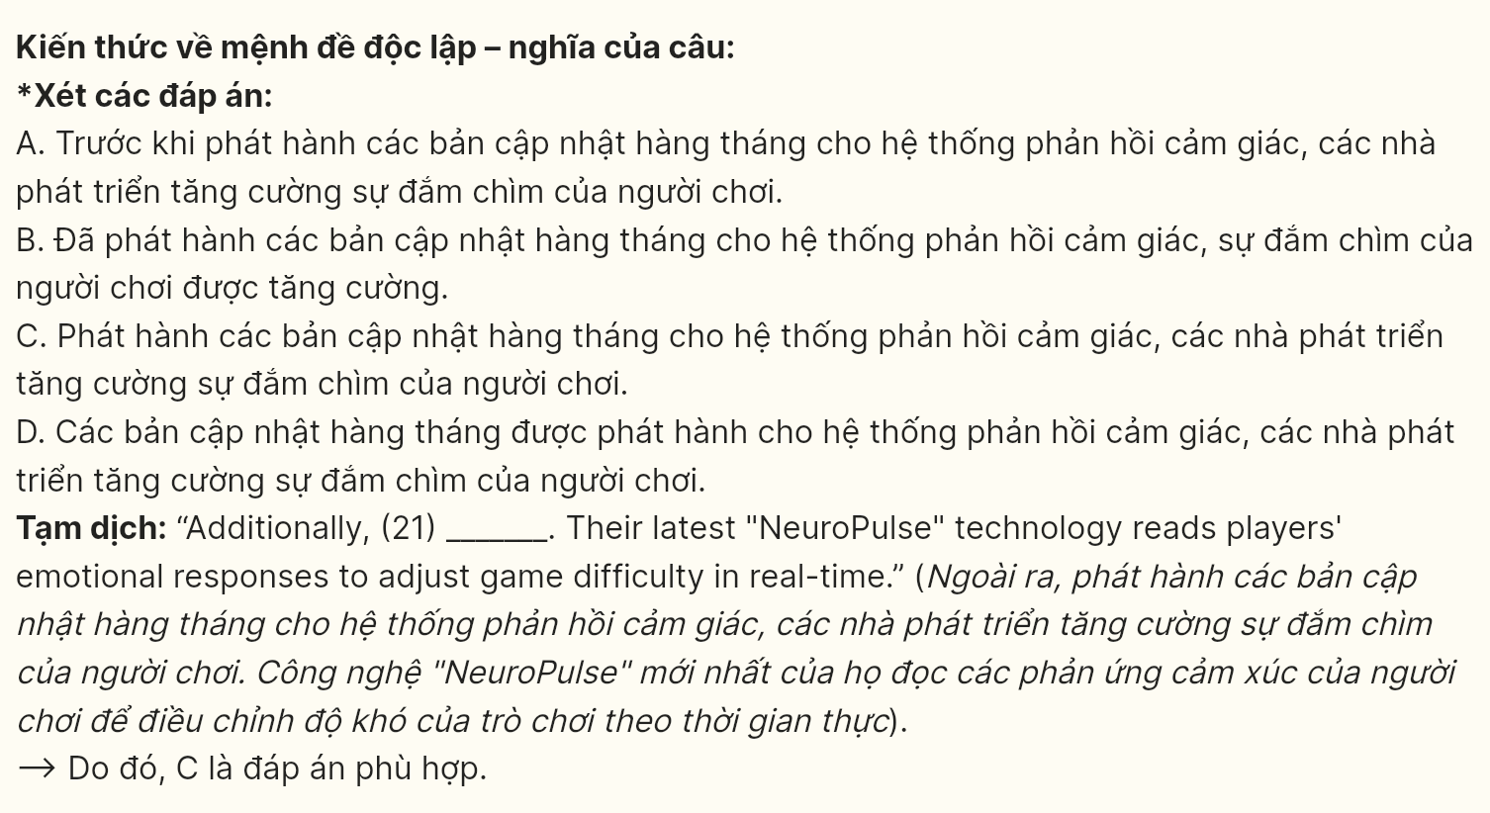
Question 22 [696758]:
A. gaming experiences will be improved through personalized player feedback
B. receiving gaming experiences through personalized system feedback is available
C. developers create gaming experiences through personalized system feedback
D. the system enhances gaming experiences through personalized player feedback
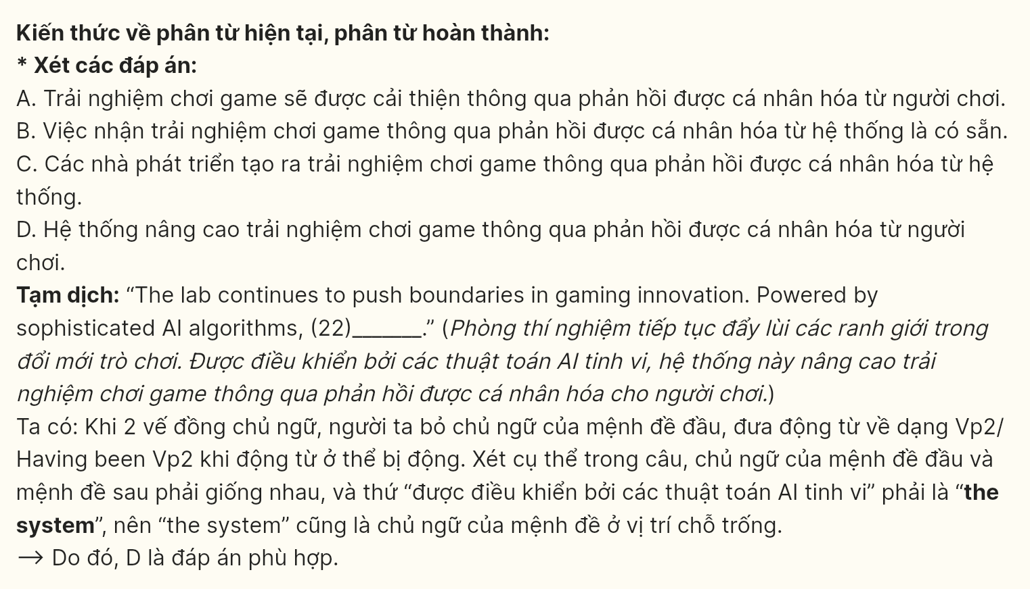
Read the following passage about the fast fashion environmental impact and mark the letter A, B, C or D on your answer sheet to indicate the option that best fits each of the numbered blanks from 23 to 30.
Your favorite $20 shirt harbors a startling secret. "When I learned that it takes 2,700 liters of water to produce a single cotton t-shirt, I couldn’t look at my wardrobe the same way," reveals Sarah Martinez, a former fast-fashion enthusiast turned sustainable style advocate. Her revelation mirrors a growing consciousness among consumers about the fashion industry’s environmental impact.
The numbers paint a sobering picture. The global fashion industry’s carbon footprint surpasses that of international flights and maritime shipping combined. Industry analysts observe a precipitous rise in what they term "throwaway culture". Their research indicates that while clothing production doubled between 2000 and 2015, the average number of times a garment gets worn decreased by 36%. These ephemeral fashion choices accumulate in landfills, where synthetic materials persevere for up to two centuries before decomposing.
A ray of hope emerges through innovative solutions. "Circular fashion" represents a paradigm shift in how we conceptualize clothing lifecycles. Under this model, garments are designed for longevity and biodegradability. The phenomenon of "clothing libraries" has proliferated across urban centers, where members can borrow high-quality garments instead of purchasing new ones. This system has proven to be so efficacious that participating consumers report a 70% reduction in new clothing purchases.
The secondhand market is undergoing its own revolution, driven by tech startups' "smart recycling" initiatives. Modern sorting facilities harness artificial intelligence to identify fabric types, dramatically streamlining the recycling process. This technological leap has slashed the cost of recycled textiles by 45% since 2020, prompting major fashion brands to integrate recycled materials into their production lines. Industry experts now envision a future where sustainable practices become the norm rather than the exception, reshaping the very foundation of fashion consumption.
(Adapted from BBC News)
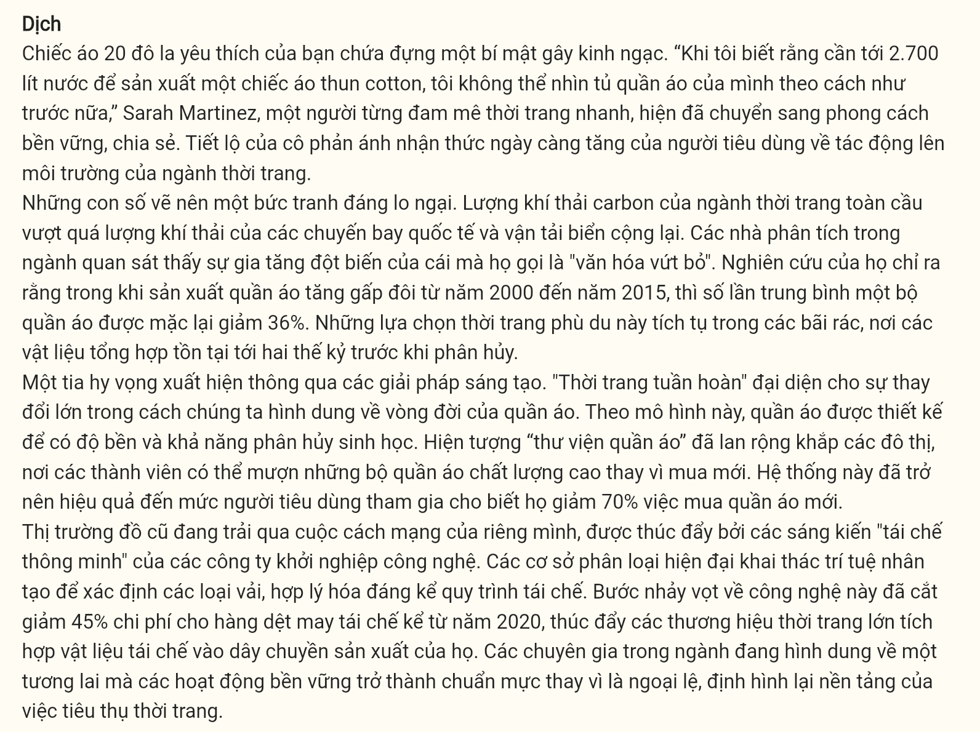
Question 23 [696759]: Which of the following is NOT mentioned as a solution to fashion waste?
A. clothing libraries B. biodegradable designs
C. digital fitting rooms D. smart recycling
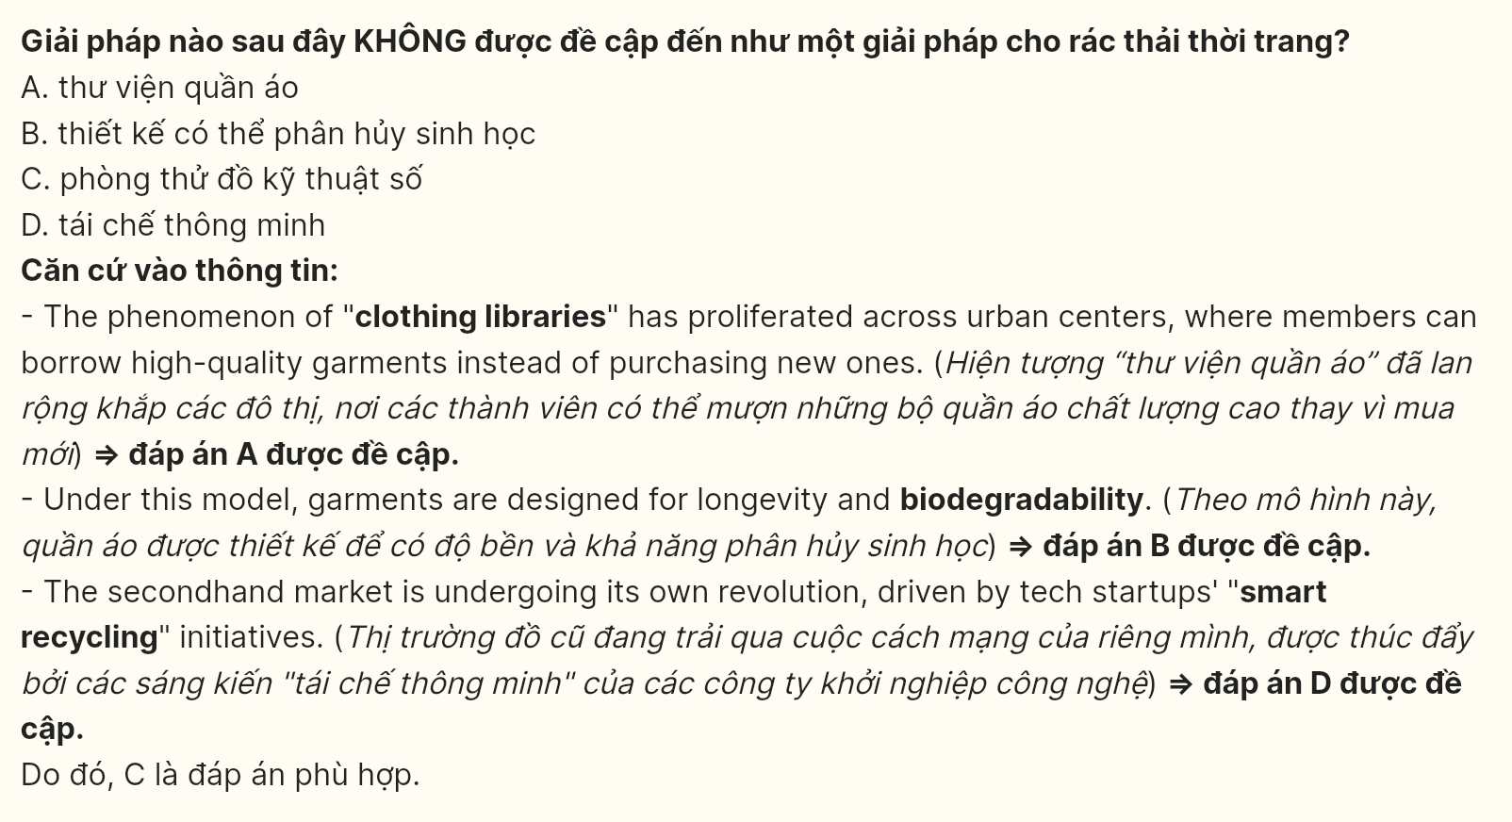
Question 24 [696760]: Which of the following best paraphrases the underlined sentence in paragraph 2?
A. The fashion sector creates more environmental damage than air and sea travel
B. Carbon emissions from clothing production exceed those of planes and ships together
C. Global transportation produces less pollution than the fashion industry alone
D. Fashion manufacturing generates higher emissions than worldwide shipping
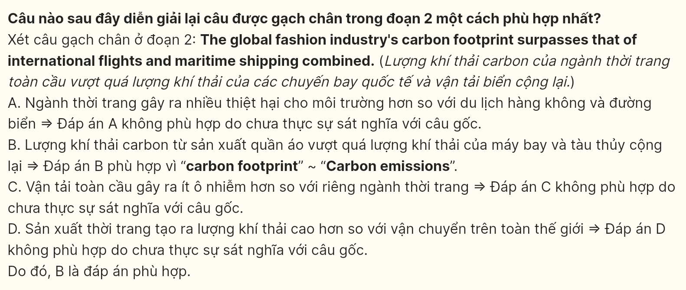
Question 25 [696761]: The word "ephemeral" in paragraph 2 is OPPOSITE in meaning to _______.
A. transient B. enduring C. endless D. interminable
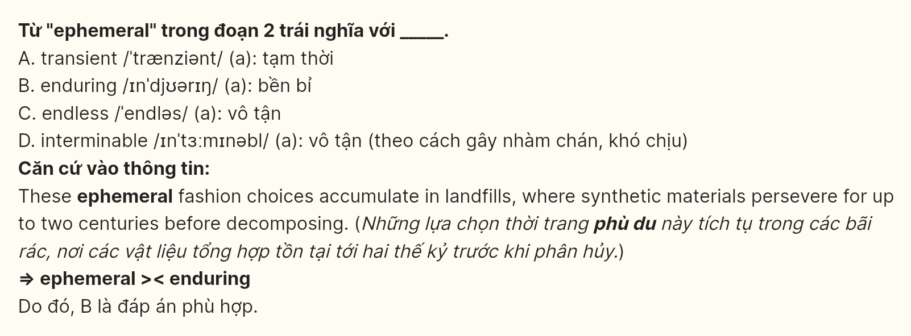
Question 26 [696762]: The word "Their" in paragraph 2 refers to _________.
A. Choices B. Analysts C. Materials D. Consumers
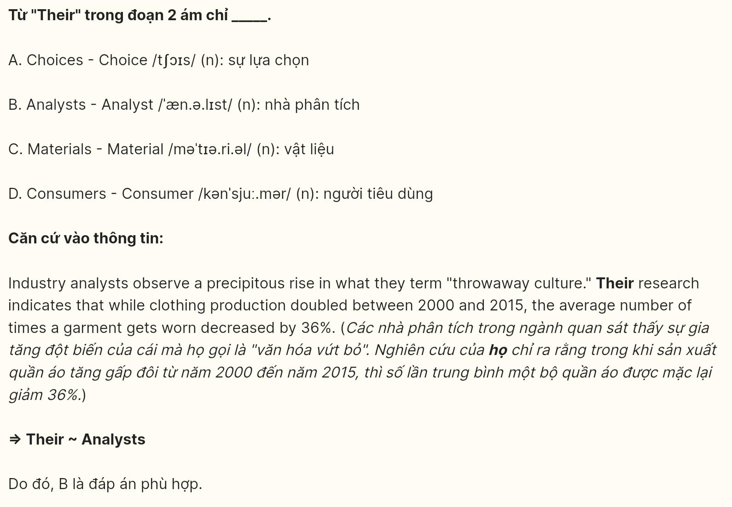
Question 27 [696763]: The word "efficacious" in paragraph 3 could be best replaced by _________.
A. beneficial B. productive C. advantageous D. effective
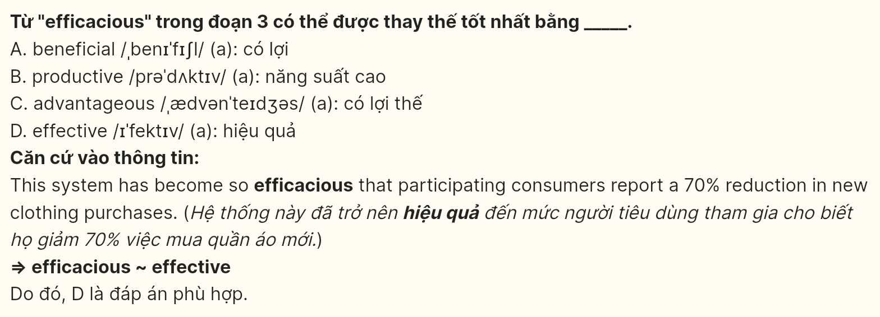
Question 28 [696764]: Which of the following is TRUE according to the passage?
A. Clothing production growth corresponded with a decrease in garment usage time.
B. Technology advances in recycling have reduced the costs of processed textiles.
C. Modern sorting facilities have improved the quality of recyclable materials.
D. Fashion brands are adopting new approaches to sustainable material sourcing.
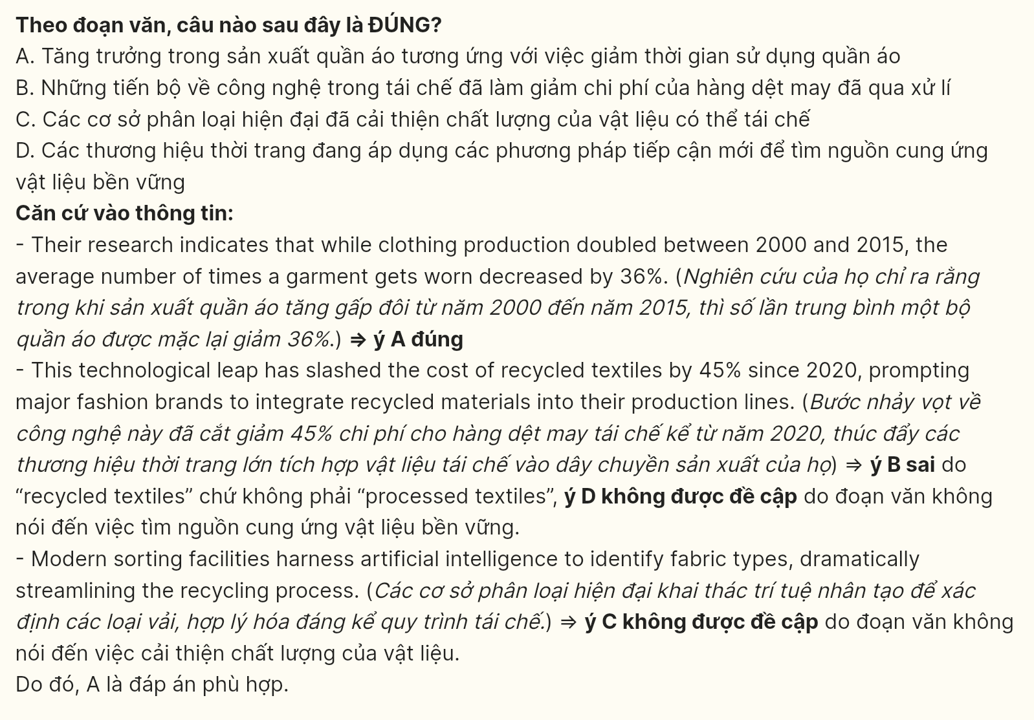
Question 29 [696765]: In which paragraph does the writer present comparative environmental impact data?
A. Paragraph 1 B. Paragraph 2 C. Paragraph 3 D. Paragraph 4
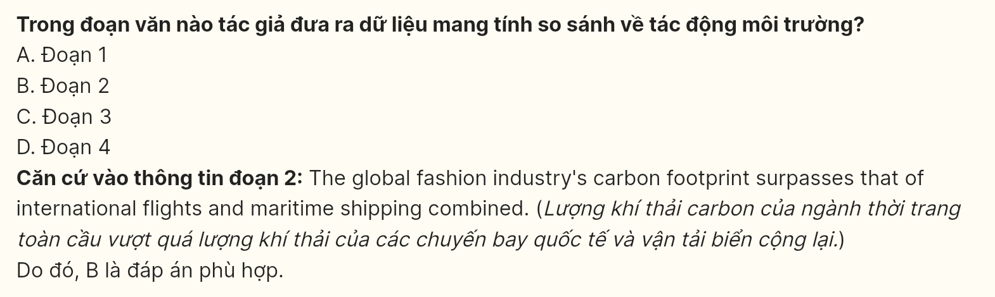
Question 30 [696766]: In which paragraph does the writer examine technological innovations in sustainability?
A. Paragraph 1 B. Paragraph 2 C. Paragraph 3 D. Paragraph 4
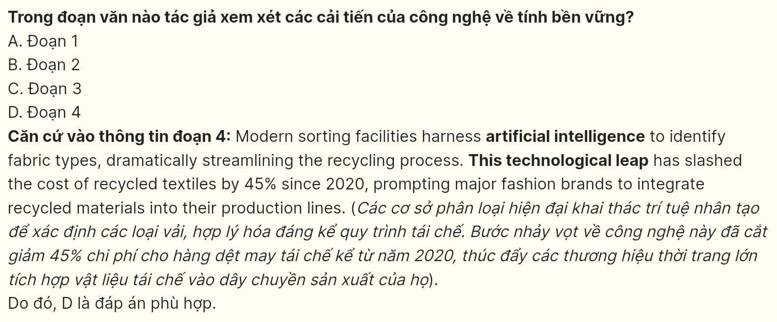
Read the following passage about conservation and mark the letter A, B, C, or D on your answer sheet to indicate the option that best fits each of the numbered blanks from 31 to 40.
[I] In what conservationists are calling a watershed moment, the ambitious Greater Mekong Wildlife Bridge Project has encountered an unexpected stumbling block. [II] Despite an unprecedented $50 million investment, the migrating elephant populations have plummeted by 35% since its inception. [III] These statistics have sent shockwaves through the conservation community, challenging long-held assumptions about wildlife corridor effectiveness. [IV]
The concept of wildlife corridors has long held conservationists in thrall. By creating protected pathways between fragmented habitats, these artificial lifelines were meant to ensure species survival. Yet beneath this seemingly foolproof approach lurks a more complex reality. As human settlements encroach on these corridors, animals find themselves playing Russian roulette with each crossing, facing lethal risks from poachers who have gained control of these predictable migration routes.
Recent findings from the Southeast Asian Conservation Institute paint a particularly sobering picture. When faced with human disturbance, elephants altered their migration patterns, venturing into unprotected areas. These behavioral adaptations proved catastrophic—poaching incidents soared by 180% in these zones. The findings have left conservationists wringing their hands over the unintended consequences of their well-intentioned interventions.
The economic implications of corridor conservation add another layer of complexity to an already thorny issue. Local communities, caught between a rock and a hard place, often view these projects with skepticism. Traditional farming practices fall by the wayside as authorities implement strict land-use regulations. While compensation schemes exist on paper, they rarely translate into adequate financial support for affected communities.
Conservation biologists have begun advocating for a paradigm shift in approach. Rather than imposing artificial corridors, they propose integrating wildlife passages into existing human infrastructure. This strategy has already borne fruit in countries like Malaysia, where elevated highways incorporate natural underpasses. These structures allow for wildlife movement while maintaining human activity above, creating a win-win situation for all stakeholders.
Yet the jury is still out on the long-term viability of such solutions. Critics argue that these modified corridors merely paper over the cracks of a deeper issue - humanity’s relentless expansion into natural habitats. As urban sprawl continues unabated, even these innovative approaches may prove to be nothing more than a band-aid on a gaping wound.
(Adapted from https://www.examenglish.com/CEFR/C1)

Question 31 [696767]: Where in paragraph 1 does the following sentence best fit?
Global conservation experts are, therefore, reconsidering the large-scale wildlife protection investments.
A. [I] B. [II] C. [III] D. [IV]
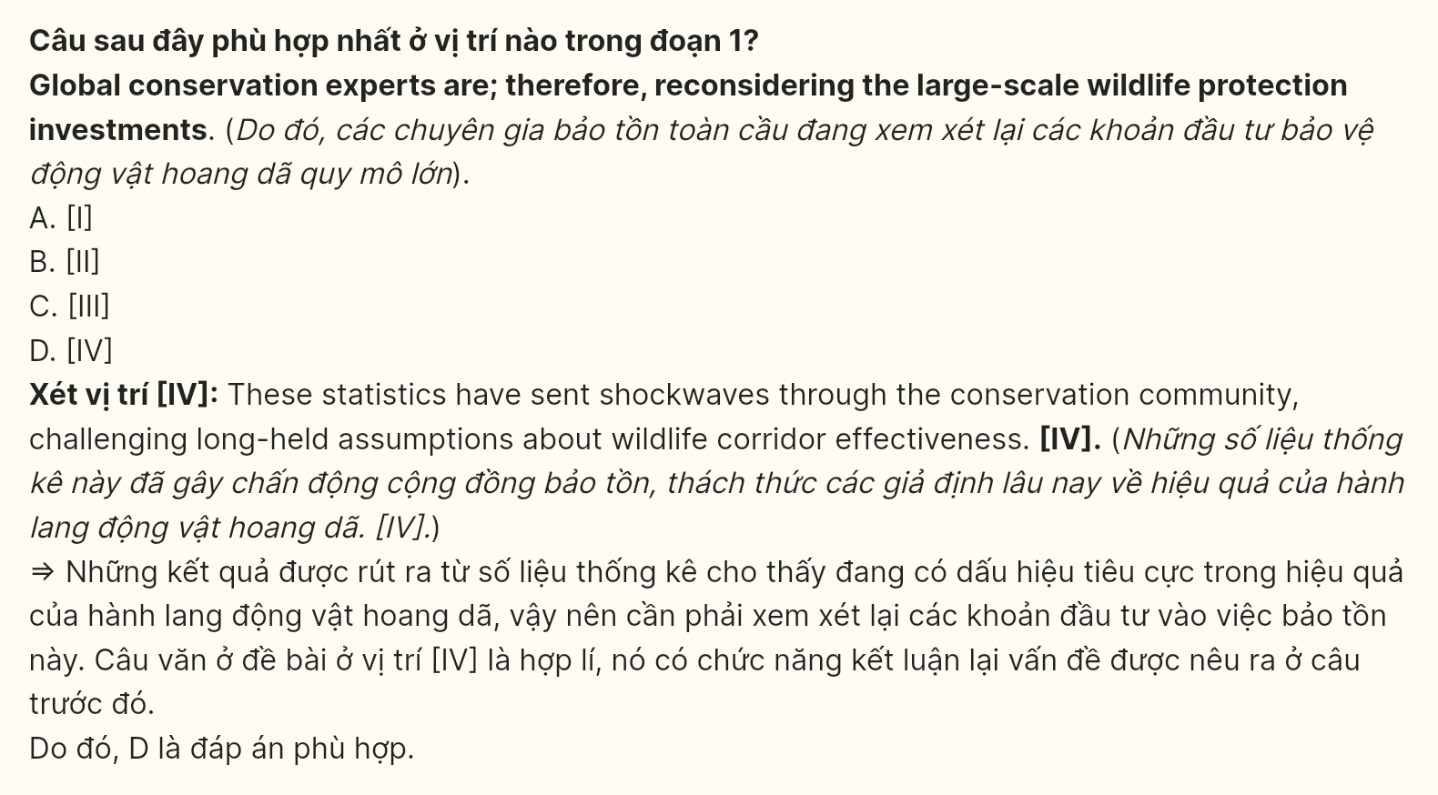
Question 32 [696768]: The phrase "playing Russian roulette" in paragraph 2 could be replaced by _____.
A. confronting dangers B. making choices
C. facing challenges D. taking severe risks
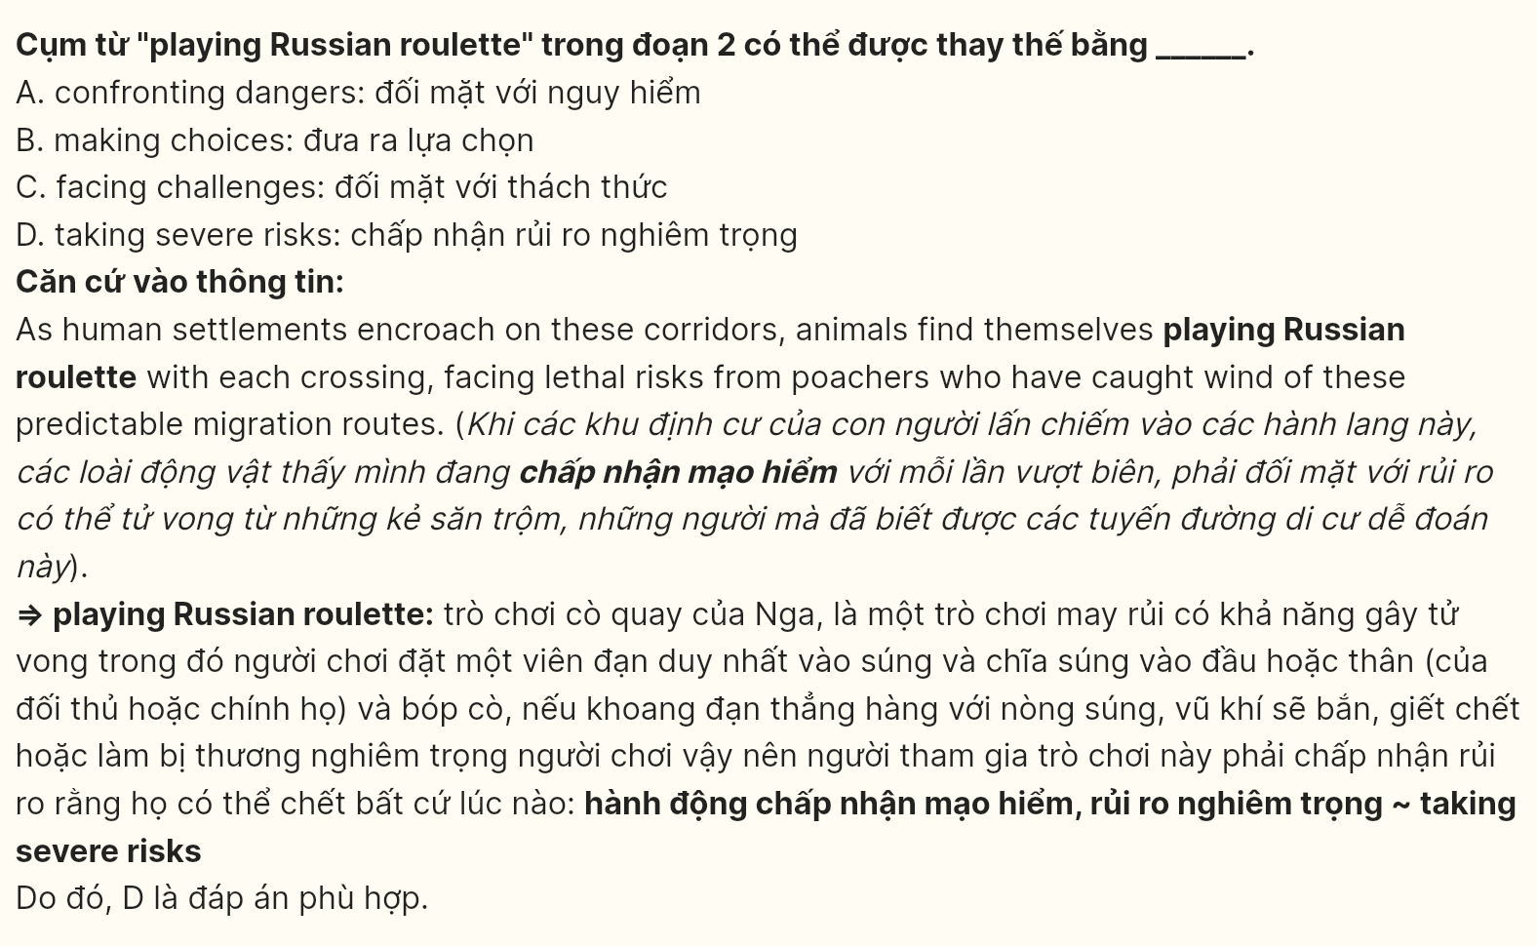
Question 33 [696769]: The word "their" in paragraph 3 refers to _____.
A. conservationists B. interventions C. consequences D. the findings
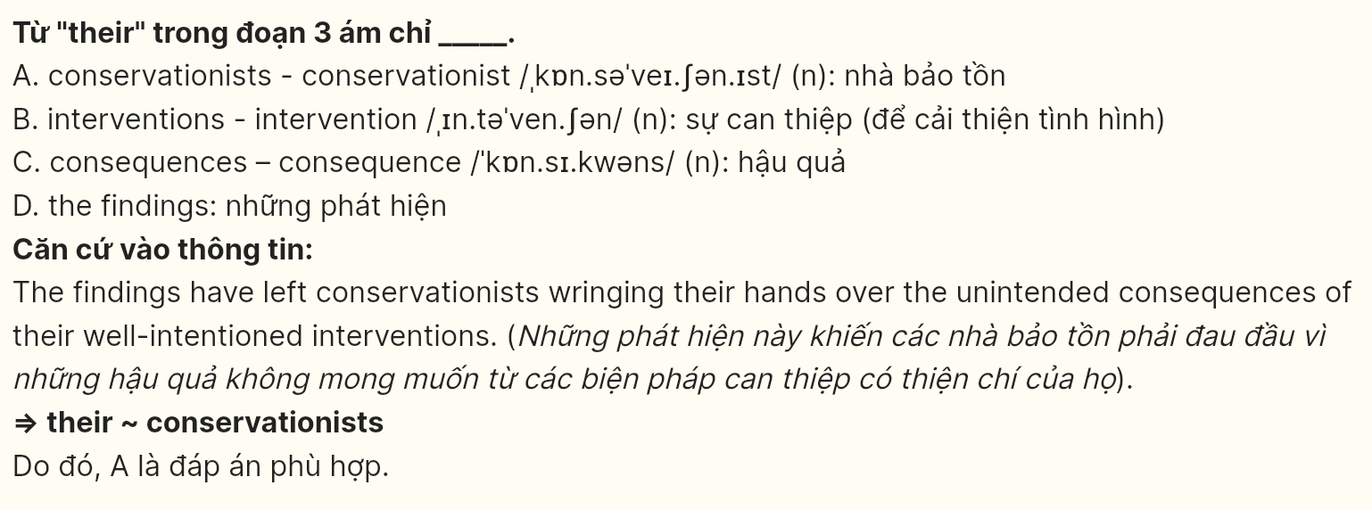
Question 34 [696770]: According to the passage, which of the following is NOT mentioned as a consequence of wildlife corridors?
A. Disruption of ecosystem balance B. Modification of animal behavior
C. Impact on local economies D. Increased poaching incidents
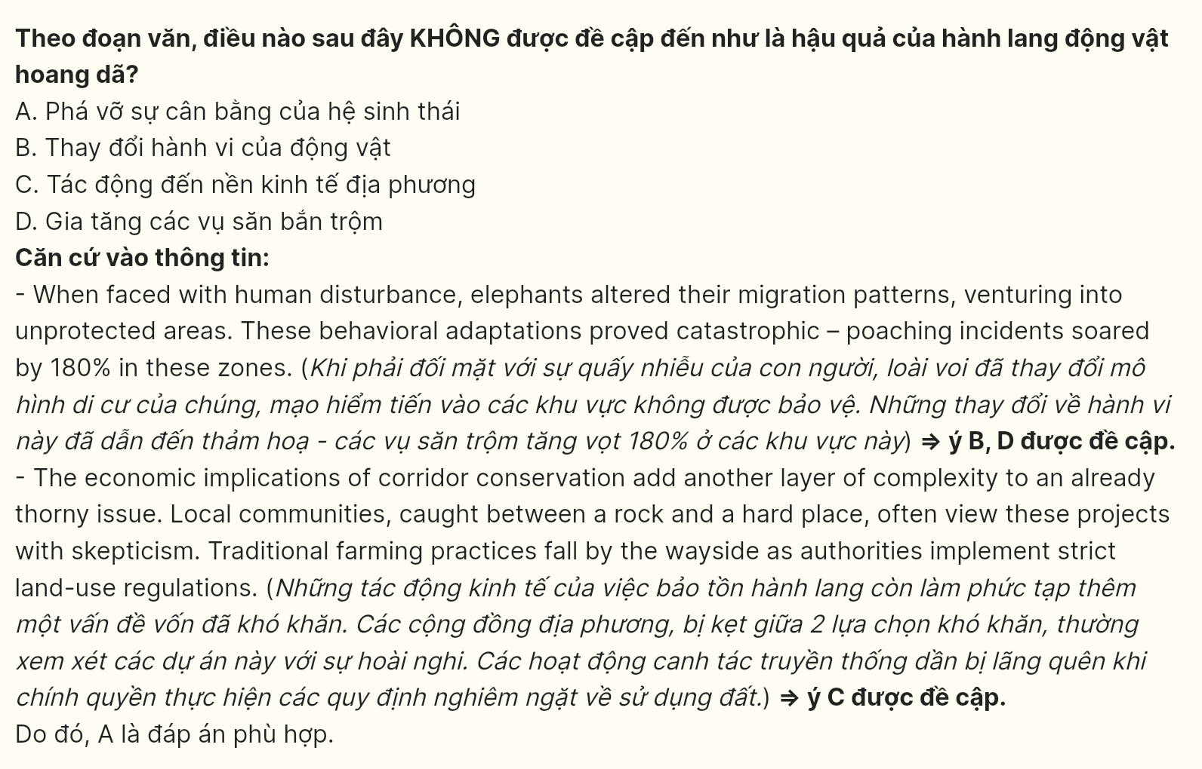
Question 35 [696771]: Which of the following best summarizes paragraph 4?
A. Economic compensation programs fail while traditional practices face a steady decline.
B. Communities experience financial hardships due to conservation management strategies.
C. Conservation projects burden local communities with economic challenges.
D. Financial support mechanisms prove inadequate for community sustainability.
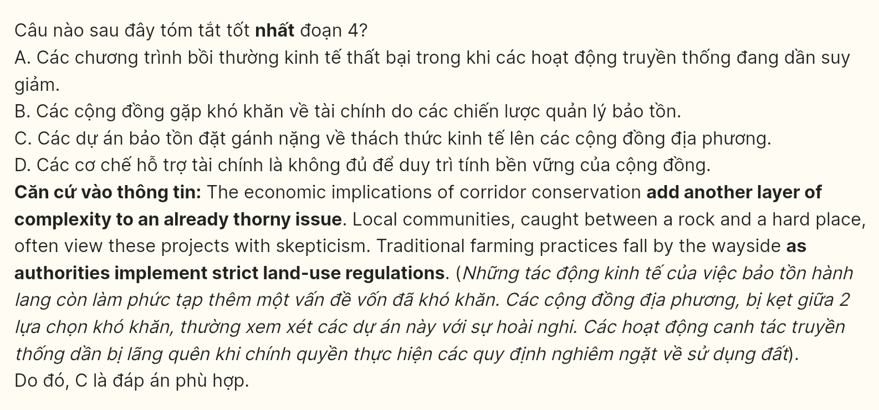
Question 36 [696772]: Which of the following best paraphrases the underlined sentence in paragraph 5?
A. Conservationists advocate for adapting current human structures to include wildlife crossings over creating separate corridors.
B. Scientists intend to substitute incorporated animal crossings into present infrastructure for building separate routes.
C. The integration of wildlife passages with existing human infrastructure must replace the creation of artificial corridors.
D. By incorporating wildlife crossings into current infrastructure, we eliminate the need for separate artificial corridors.
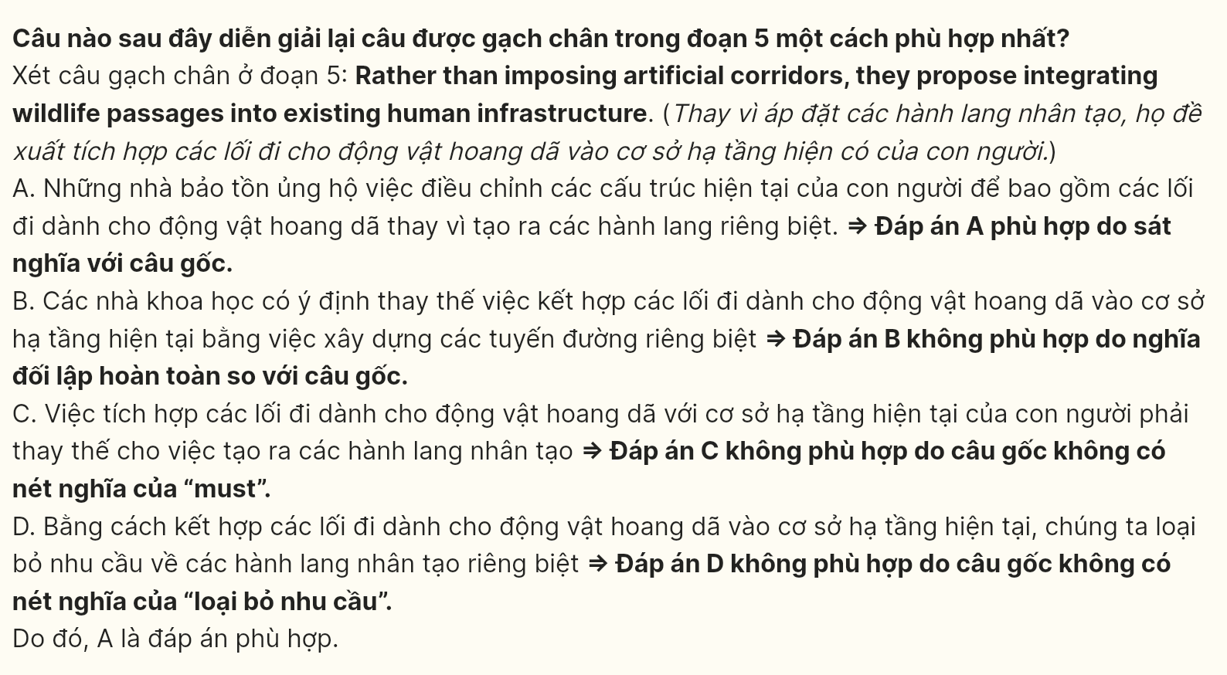
Question 37 [696773]: Which of the following is TRUE according to the passage?
A. Malaysian infrastructure projects have sparked controversy about wildlife integration.
B. Traditional farming practices deteriorate under increasing strict conservation measures.
C. Local authorities are implementing rigid controls on urban and industrial development.
D. Elevated highways with natural underpasses create beneficial outcomes for stakeholders.
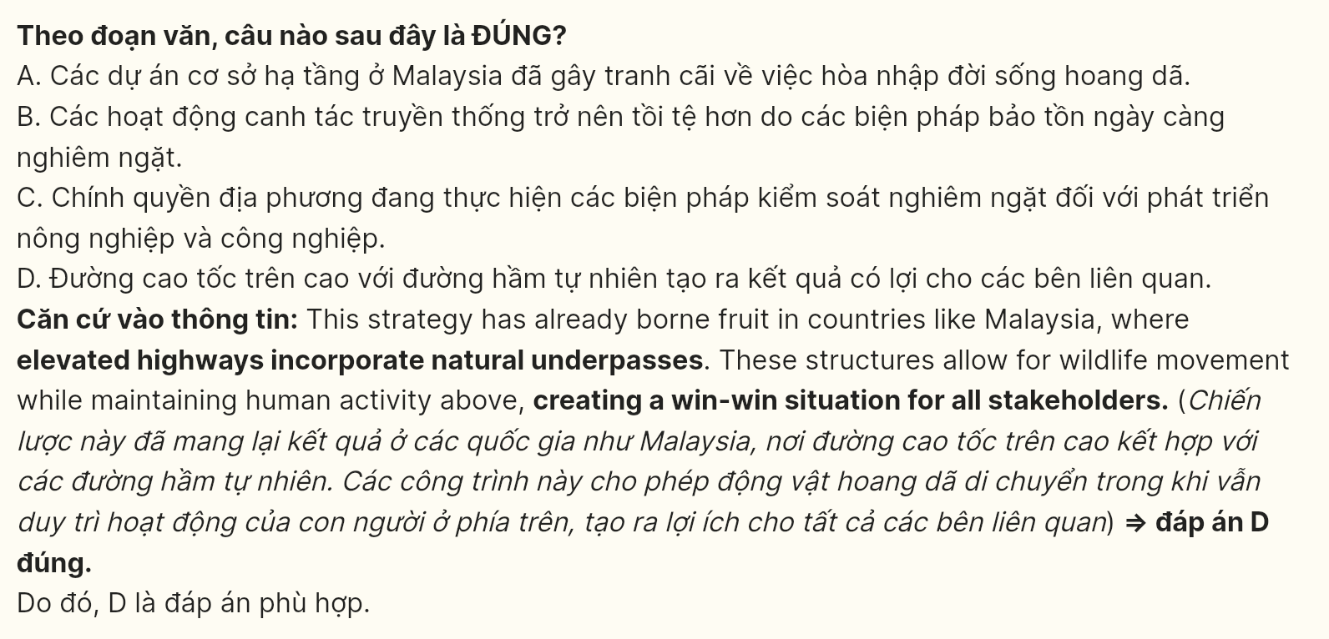
Question 38 [696774]: The word "unabated" in paragraph 6 is OPPOSITE in meaning to _____.
A. constrained B. attenuated C. curtailed D. arrested
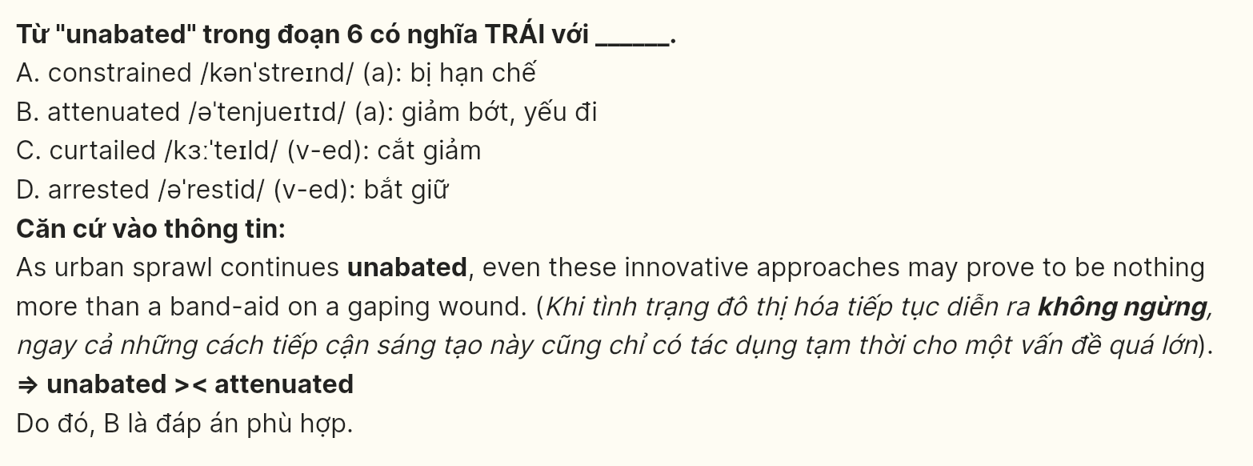
Question 39 [696775]: Which of the following can be inferred from the passage?
A. Conservation projects integrating natural passages with human structures are the most effective in wildlife movement.
B. Areas surrounding artificially created wildlife corridors experience increased rates of human-wildlife territorial conflict.
C. Protected pathways between fragmented habitats become more vulnerable to poaching activities over time.
D. Traditional conservation approaches lead to higher implementation costs when compared to integrated infrastructure.
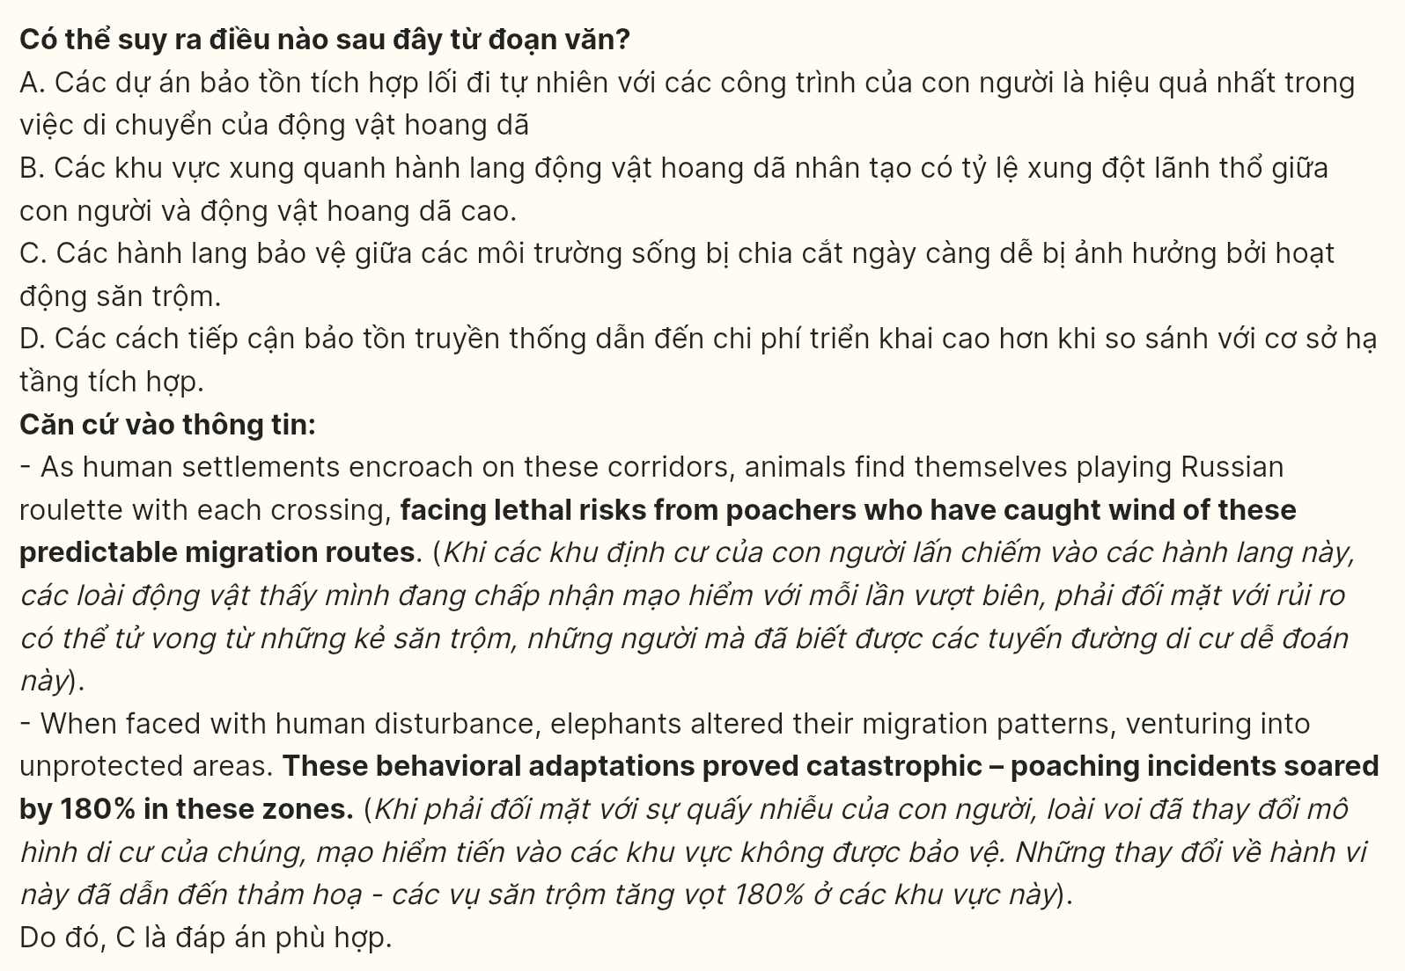
Question 40 [696776]: Which of the following best summarizes the passage?
A. Traditional wildlife corridors face mounting challenges from poaching activities, leading conservation experts to explore technologically integrated solutions for species protection.
B. Wildlife corridor projects demonstrate unintended consequences for local communities, requiring a fundamental shift toward integrated conservation methods.
C. The Greater Mekong Project reveals hidden limitations of conventional conservation approaches, pushing biologists to abandon traditional methods.
D. Modern conservation approaches must navigate the delicate balance between wildlife protection and human development while addressing the limitations of traditional corridor-based solutions.
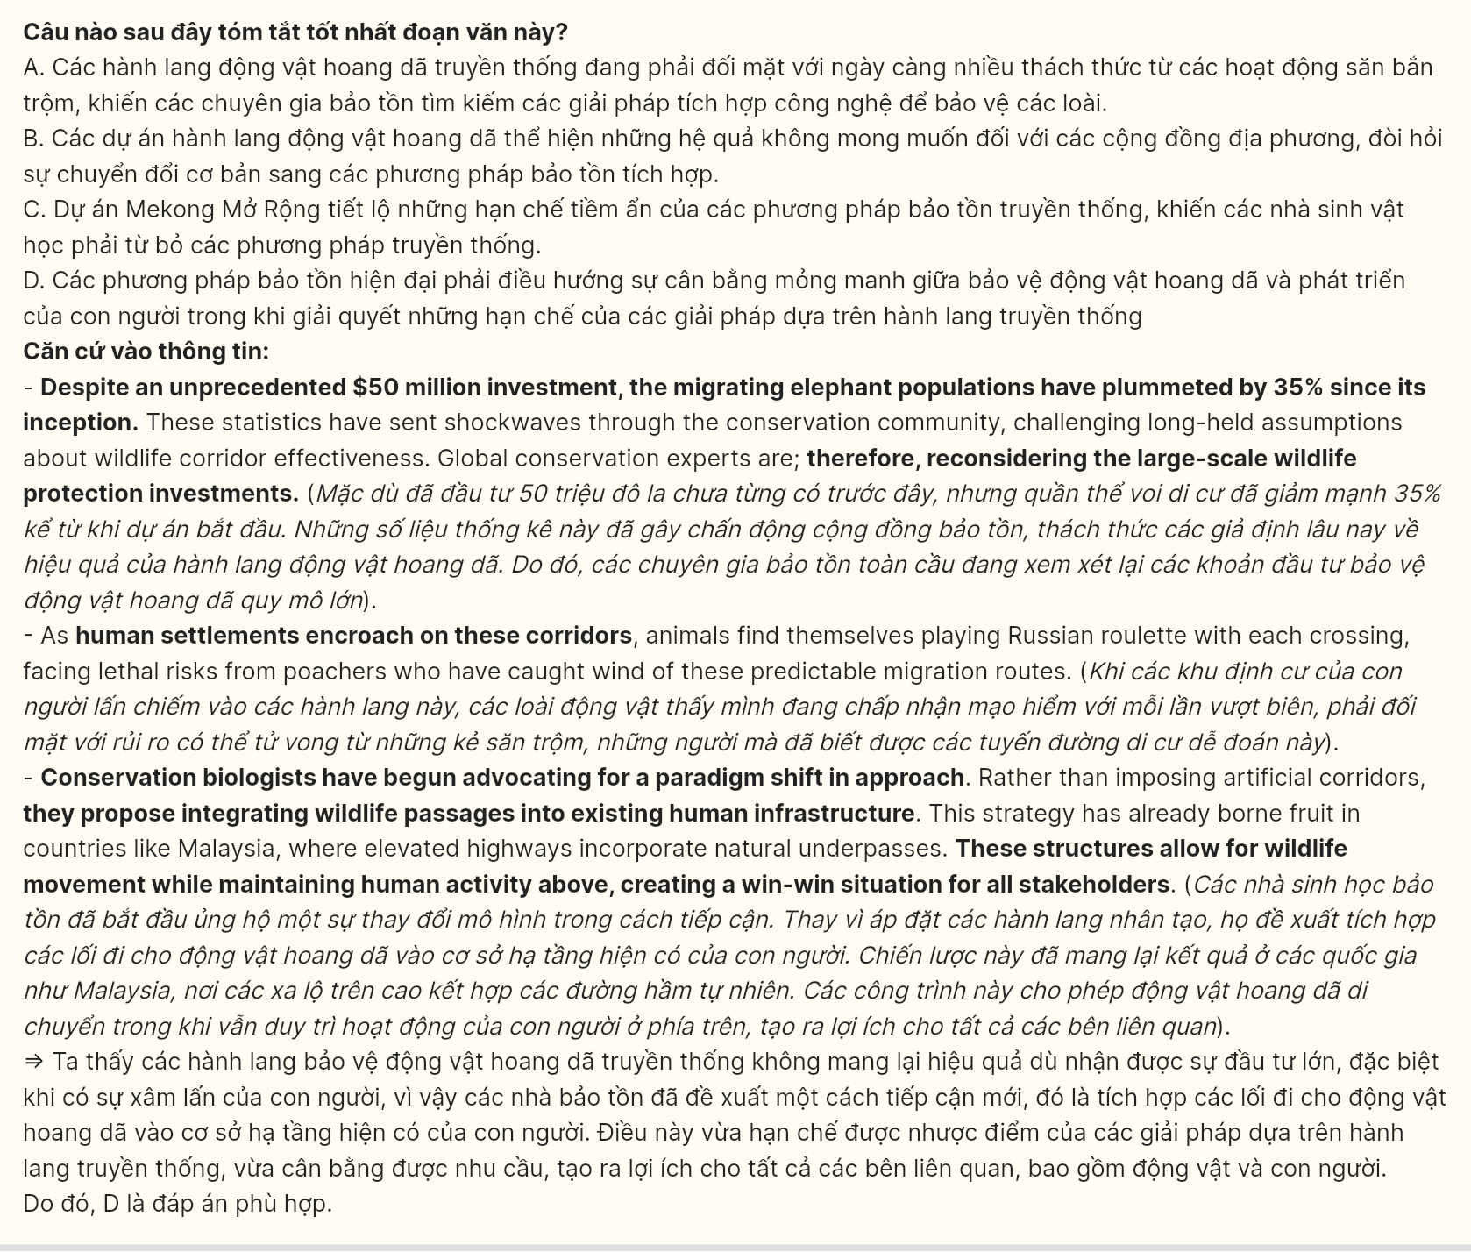
------ THE END ------

