TQK – THAM KHẢO TUYỂN SINH 10
I. PRONUNCIATION
1. Which word has the underlined part pronounced differently from that of the others?
A. decide B. social C. civic D. receipt
2. Which word has the underlined part pronounced differently from that of the others?
A. dweller B. work C. waste D. reward
3. Which word has a different stress pattern from that of the others?
A. astonish B. mummify C. chronicle D. magazine
4. Which word has a different stress pattern from that of the others?
A. bizarre B. deceive C. idea D. package
FB: Thầy Đình (Dạy Tiếng Anh)
II. Choose the answer (A, B, C or D) that best fits the space in each .
5. To address the problem of traffic congestion, the local authority is planning to invest __________ renovating infrastructure.
A. on B. with C. in D. for
6. Mr. Thompson has just been appointed as __________ of the whole project who makes sure that different groups work well with each other.
A. chronicler B. hoarder C. coordinator D. fashionista
7.
Sean: “How was your summer, Tim?”
Tim: “My parents took me to the Carnival of Brazil. I’ll never forget __________ many famous singers and artists there.”
A. see B. to see C. seen D. seeing
8. If you have enough money, you should buy a/an _________ phone instead of a secondhand one which may not be of high quality.
A. zero waste B. old-fashioned C. brand new D. out-of-money
9. Derek is meeting Kim at her house.
Derek: “Why on earth are you __________ dressed?”
Kim: “Well, I’m going to an important event tonight.”
A. commonly B. popularly C. usefully D. fashionably
10. Lan and Chris are talking in class at break time. Lan: “Who __________ to you before you came into the class?”
Chris: “Oh, you mean Ms. Middleton. She’s my Maths teacher.”
A. was talking B. has been talking C. used to be talking D. would be talking
11. Jack rarely reads comics in his free time, ___________?
A. is he B. does he C. isn’t he D. doesn’t he
12. Bob has been getting used to __________ the housework by himself since he decided to lead an independent life.
A. do B. did C. doing D. done
FB: Thầy Đình (Dạy Tiếng Anh)
13. Jane and David are talking about last night’s party. Jane: “How was the party last night?”
David: “How fantastic it is! We had a barbecue and stayed outside chatting _________ one in the morning.”
A. the moment that B. meanwhile C. finally D. until
14. Ben is inviting Mark to join the picnic.
Ben: “We are going to have a picnic next weekend. Would you like to join?” Mark: “Thanks for your invitation, but “ _________”
A. I’m pretty good at this. B. how are you doing?
C. I’ll need some time to consider it. D. I’m still trying to do something.
III. Look at each sign or notice. Choose the best answer (A, B, C or D) that matches its meaning.
 | 15. What does the sign mean?  A. On Highway. Speed up!  B. Be careful! One-way street.  C. Stay away! Excavation area.  D. Slow down! ahead.
 | 16. What does the notice say?  A. The workshop takes place in late January.  B. There are two sessions in the workshop.  C. The workshop is held on the rooftop.  D. The venue of the workshop is in the outskirts.
IV. Choose the word (A, B, C or D) that best fits each blank space in the following passage.
Personal development plays an important role in helping young students build a strong and positive foundation for their future life. It includes assisting students to get (17) _________ good study habits and improving interpersonal skills. One way to practice personal development is through self-reflection. Teenagers should take the (18) _________ to analyze their strengths and weaknesses and determine (19) ________to best use them in the future. Through self-reflection, they can understand their purpose and set (20) _________ up for success both academically and socially. Another important aspect of personal development is emotional intelligence. It means having some common sense, (21) __________ responding to situations and getting on well with colleagues. Students, therefore, (22) _________ a lot from this area of personal development in their journey to adulthood.

17. A. up B. out of C. on D. into
18. A. money B. touch C. contact D. time
19. A. what B. whether C. how D. that
20. A. yourselves B. themselves C. ourselves D. myself
21. A. effectively B. uselessly C. tastefully D. excitingly
22. A. deceive B. uncover C. benefit D. impact
FB: Thầy Đình (Dạy Tiếng Anh)
V. Read the following and do as directed.
The outbreak of COVID-19 has brought about the rapid transition from traditional to tech-based working methods with the application of the Internet and teleconferencing. During the COVID-19 pandemic, most companies encountered numerous difficulties in their administration and operation. They didn’t get the chance to have face-to-face meetings with each other to discuss important issues, as well as failed to work on various projects together, due to social distancing measures. Teleconferencing appeared as the optimal solution as they provided the necessary infrastructure to maintain continuity in work. Virtual platforms like Zoom, Microsoft Teams and Google Meet facilitated regular meetings, project management and even large-scale conferences and webinars.
In the post-pandemic era, the convenience of teleconferencing has led to a shift in the way we work and interact. Many organizations have decided to adopt a hybrid work model (the combination of working in an office and working from home) or fully remote work arrangements by means of virtual meeting apps. These apps provide employees with greater flexibility. In other words, all meetings and conferences can be conducted on virtual platforms so that it is unnecessary for employees to show up. Consequently, they can balance their professional and personal lives more effectively, resulting in increased job satisfaction and productivity. Participants across different time zones can join the meetings without their physical presence.
a. Decide whether the following sentences are True or False:
23. The transition to hybrid or fully remote work models has gradually occurred since the outbreak of COVID- 24. Online meetings allowed for ongoing workflow during the COVID-19 pandemic.
25. Many companies stop using teleconferencing in the new normal.
26. Teleconferencing makes employees to show up for meetings.
A. True B. False
b. Choose the correct answer to each :
27. What does the passage mainly discuss?
A. Teleconferencing in business communication B. The origin of online meeting apps
C. Why teleconferencing is widely used D. Businesses in the post-pandemic era
28. What can be inferred about teleconferencing from the passage?
A. It prevents the spread of diseases. B. It creates more jobs.
C. It reduces job satisfaction. D. It enhances global collaboration.
VI. Supply the correct form of the word given in each sentence.
29. Growing up in a small village, Mr. Harper was greatly influenced by traditional ___________ values like honesty, respect and community. (MORALITY)
30. The Board of Directors decided to ____________ from the money-losing business to focus on their core operations. (INVEST)
31. Despite his dedication to work, he is ___________ treated by his colleagues, who always underestimate his contributions. (FAIR)
32. Many people have had a deep ___________ of the media after reading a lot of misleading reports. (TRUST)
33. Through the efforts of the government, the number of ____________ in mountainous areas has significantly decreased by 21%. (DROP)
34. For me, environmental protection is the ___________ factor in choosing a means of transportation. (DECIDE)
FB: Thầy Đình (Dạy Tiếng Anh)
VII. Look at the entry of the word “mind” in a dictionary. Use what you can get from the entry to complete the sentences with THREE words.
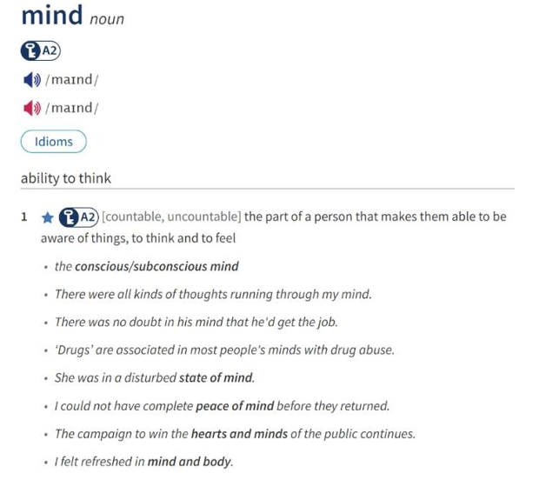 | 35. After a hard day of work, doing yoga helps me achieve a calm ____________.  36. Regular exercise is good for both the ____________.
VIII. Rewrite each of the following sentences in another way so that it means almost the same as the sentence printed before it.
37. My father no longer owns that car.
That car used
38. My advice to you would be to carefully consider buying an insurance policy.
I think you should before buying an insurance policy.
39. After making my own decision, I called my friend to share the news. (MIND)
By the time I called my friend to share the news,
40. Peter managed to save a lot of money despite his small salary.
Although his salary a lot of money.
FB: Thầy Đình (Dạy Tiếng Anh)

