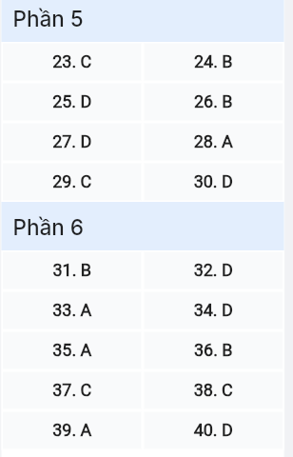
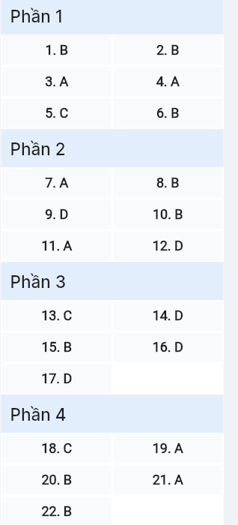
ĐỀ MINH HỌA SỐ 13
KỲ THI TỐT NGHIỆP TRUNG HỌC PHỔ THÔNG NĂM 2025
(Đề thi có 08 trang)
Môn thi: TIẾNG ANH
Thời gian làm bài: 50 phút, không kể thời gian phát đề

Read the following advertisement and mark the letter A, B, C or D on your answer sheet to indicate the option that best fits each of the numbered blanks from 1 to 6.

MINDSCAPE EDU: WHERE LEARNING MEETS INNOVATION
"Before MindScape Edu, I lacked (1) ______ in my studies," says Sarah Chen, a high school student. Now, she's thriving with our revolutionary (2) ______ that personalizes education.
What makes us unique? It starts with our core system, (3) ______ the latest neuroscience research, featuring AI technology that works differently for every student. Unlike traditional platforms that stick (4) ______ fixed learning paths, MindScape Edu evolves with you.
Real success stories prove our impact. "When I started (5) ______ the hang of the analytical tools, my grades improved dramatically," reports Michael Torres, a college freshman. His experience mirrors thousands of others worldwide.
The future of education is here! MindScape Edu promotes students (6) ______ innovative approaches. Ready to transform your learning experience? Start your free trial today!
(Adapted from MindScape Edu Success Stories)
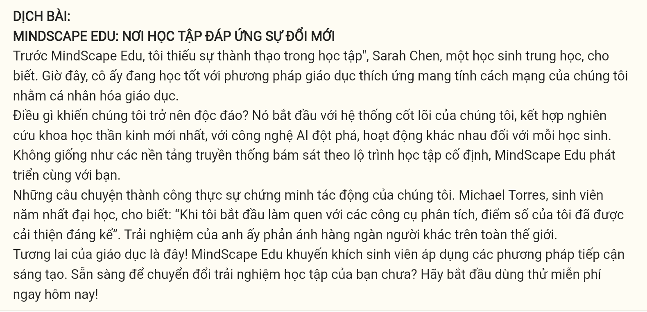
Question 1 [697138]: A. proficient B. proficiency C. proficiently D. proficience
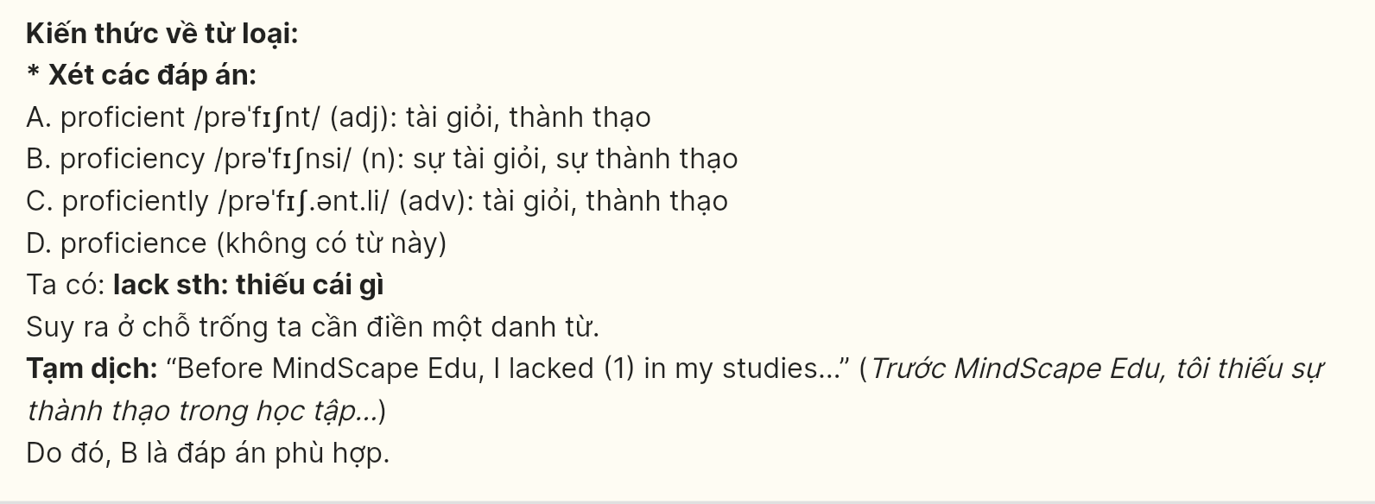
Question 2 [697139]: A. educational methodology adaptive B. adaptive educational methodology
C. educational adaptive methodology D. adaptive methodology educational
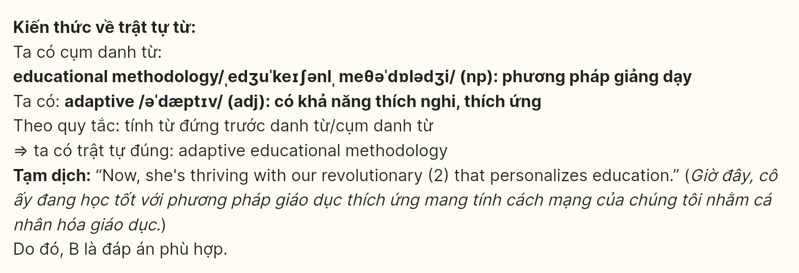
Question 3 [697140]: A. incorporating B. incorporated C. incorporate D. incorporates
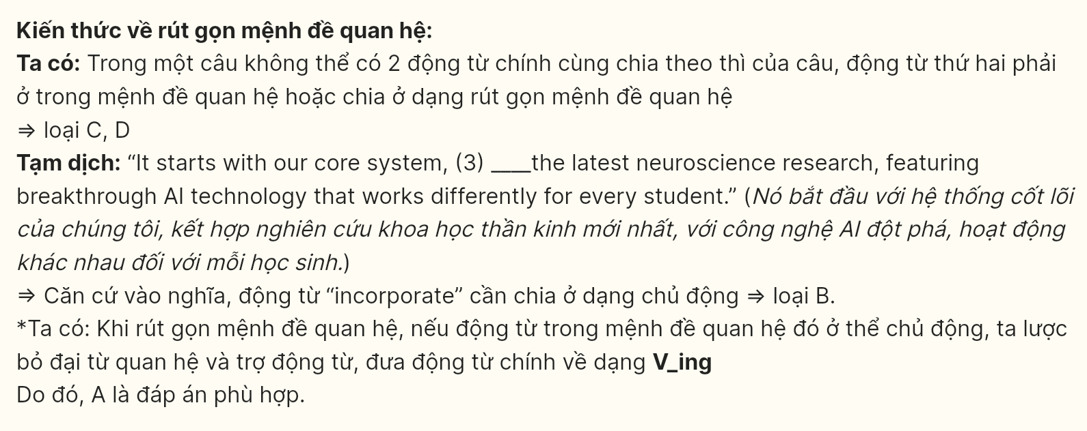
Question 4 [697141]: A. to B. on C. with D. in
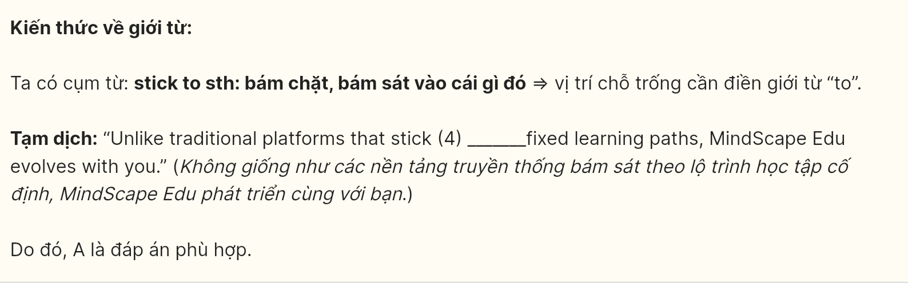
Question 5 [697142]: A. taking B. making C. getting D. putting
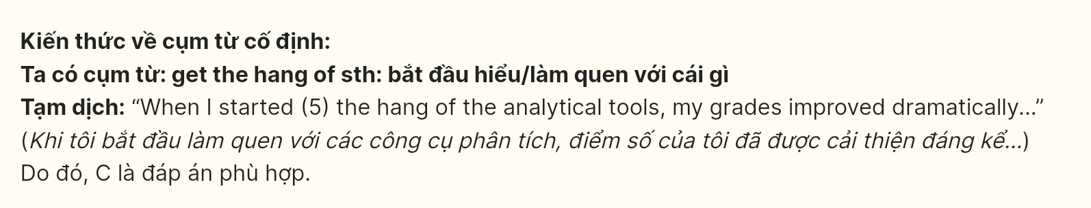
Question 6 [697143]: A. adopting B. to adopt C. adopt D. to adopting
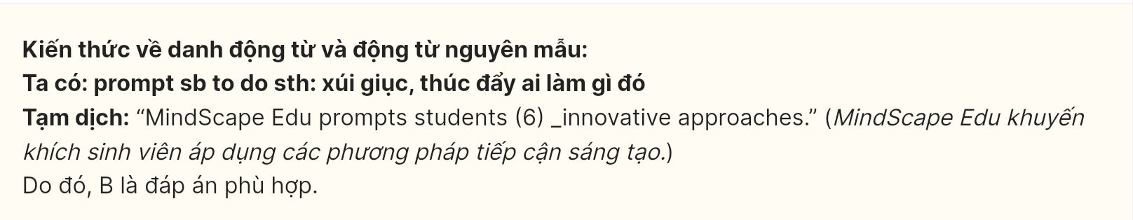
Read the following leaflet and mark the letter A, B, C, or D on your answer sheet to indicate the option that best fits each of the numbered blanks from 7 to 12.
Stay Informed: Understanding Mass Media and Its Influence
Facts and Figures: Every day, over 3 billion people worldwide consume media content through television, radio, newspapers, or the internet. Studies show that more than 60% of people shape their opinions based on what they see in the news. However, some platforms focus on delivering biased information, while (7) ______ provide more accurate and fact-based reporting. Social media allows both types to spread easily to millions of users swiftly.
Positive Action!
- Diversify your sources: Don’t (8) ______ a single news outlet. Follow (9) ______ different platforms so that you get a well-rounded view.
- Question what you read: Be skeptical about sensational headlines. (10) ______ sharing news articles online, take a moment to verify the facts.
- Engage responsibly: Use your voice online to (11) ______ positive discussions and avoid spreading false information.
- Support quality journalism: Pay attention to the (12) ______ of sources you trust and consider supporting independent media.
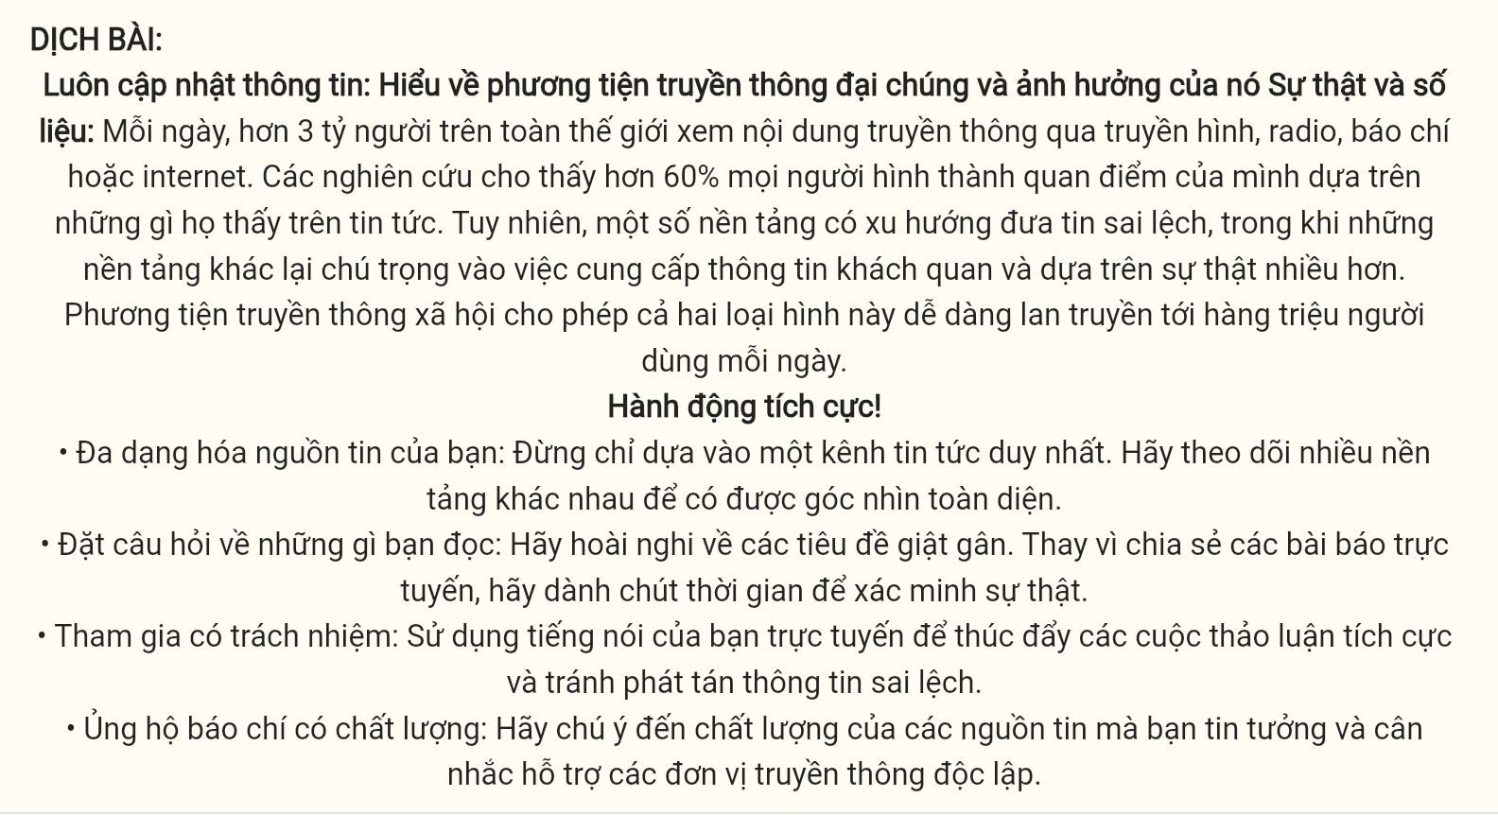
Question 7 [697144]: A. others B. the other C. another D. other
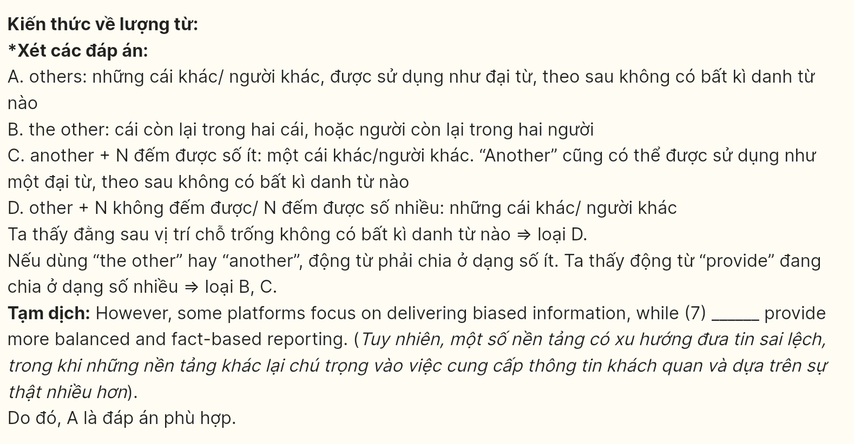
Question 8 [697145]: A. put off B. rely on C. miss out D. bring in
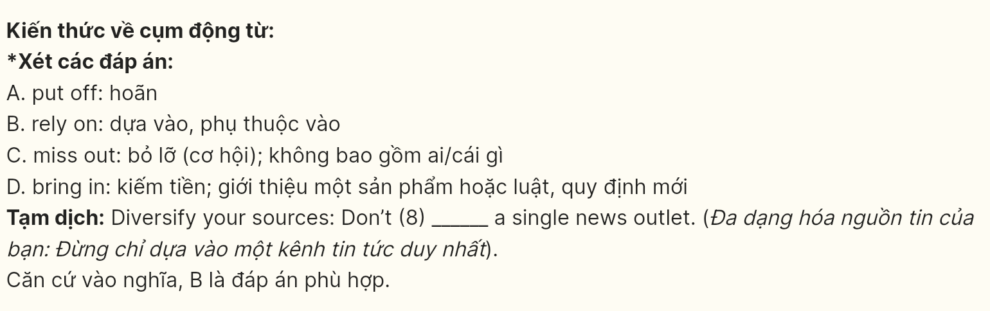
Question 9 [697146]: A. a large amount of B. the number of
C. a great deal of D. a number of
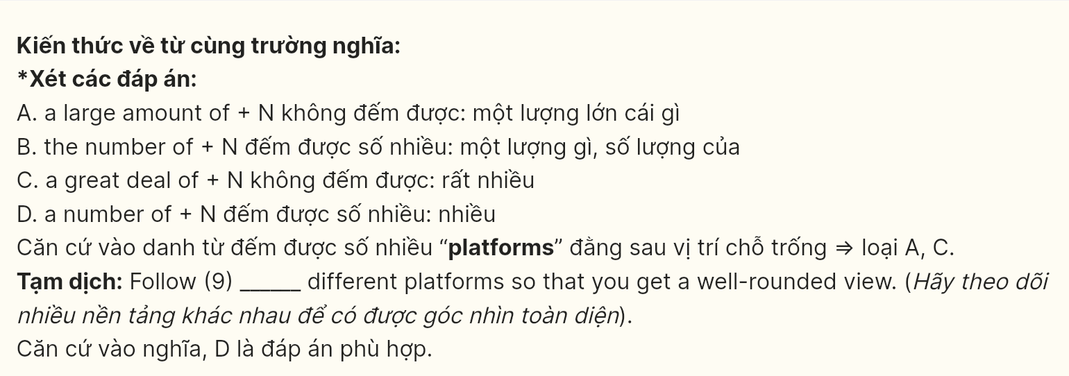
Question 10 [697147]: A. On account of B. Instead of C. Due to D. In spite of
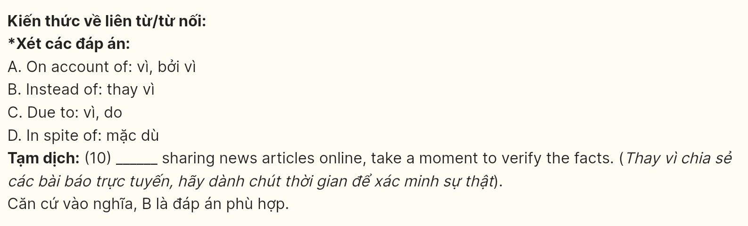
Question 11 [697148]: A. promote B. regulate C. determine D. administer
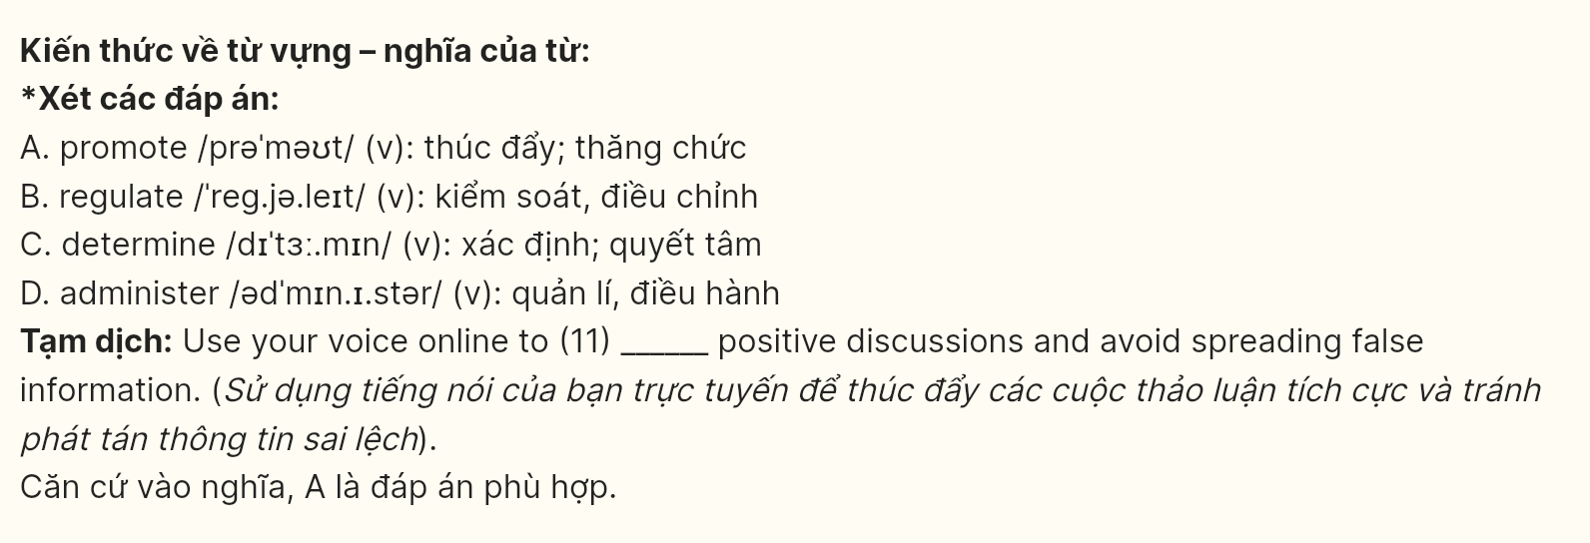
Question 12 [697149]: A. character B. trait C. condition D. quality
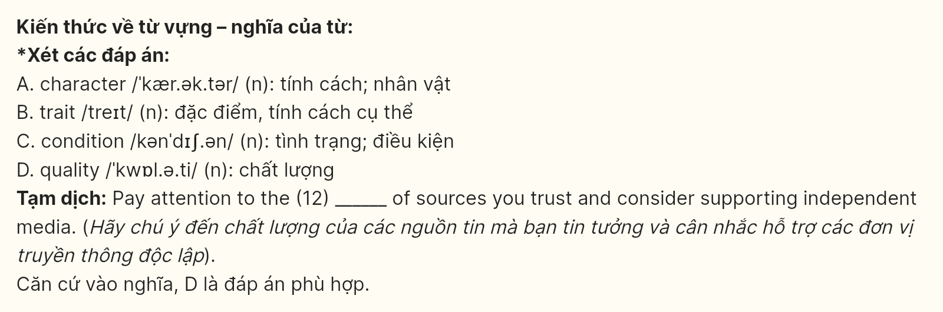
Mark the letter A, B, C, or D on your answer sheet to indicate the best arrangement of utterances or sentences to make a meaningful exchange or text in each of the following questions from 13 to 17.
Question 13 [697150]:
a. Lisa: It's hard, but I think prioritizing family time, even just one meal a week, really helps us reconnect.
b. Tom: That sounds wonderful! We rarely sit down for meals as a family anymore.
c. Lisa: My family always has Sunday dinners together, which helps us stay close despite our busy lives.
A. c-a-b B. b-c-a C. c-b-a D. a-c-b
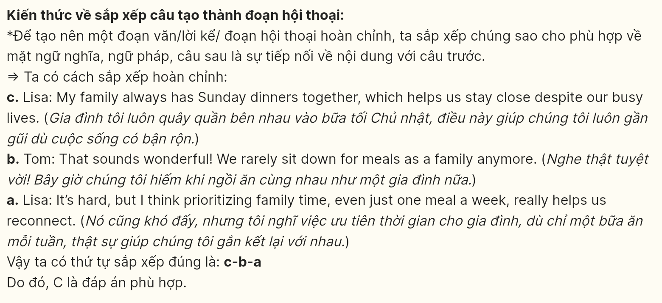
Question 14 [697151]:
a. Lily: Do you think it will win any awards this year?
b. Lily: I heard the storyline is quite unique. What did you think about it?
c. Jake: Yes, I watched it last weekend! The special effects were incredible.
d. Jake: I thought it was refreshing compared to other films in the genre.
e. Lily: Have you seen the latest superhero movie that just came out?
A. b-d-c-a-e B. b-c-d-a-e C. d-b-e-a-c D. e-c-b-d-a
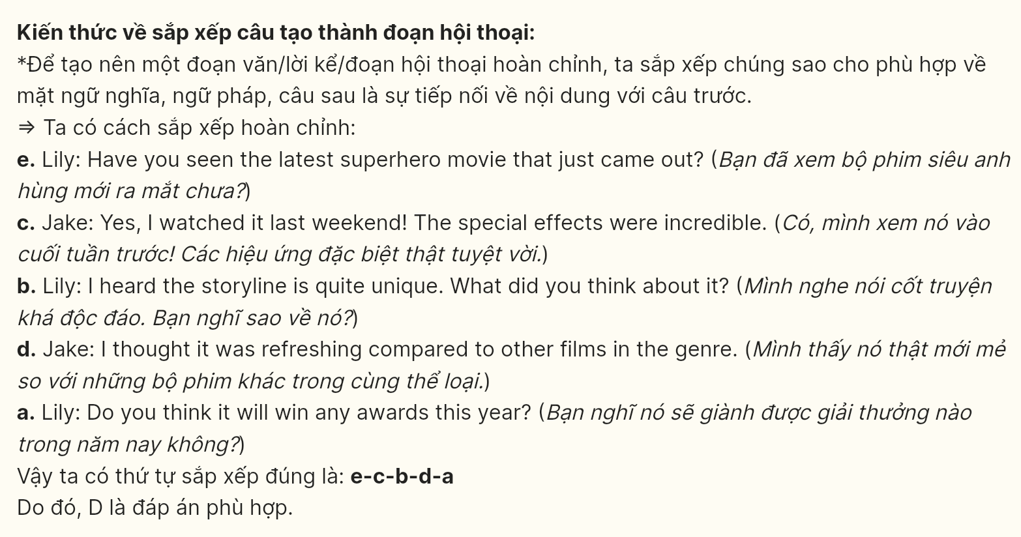
Question 15 [697152]:
Hi Emily,
a. It’s alarming how much damage we’re causing to our oceans and wildlife
b. I’ve been reading about the effects of plastic pollution on marine life recently.
c. I think it would be great to get involved in a beach clean-up campaign sometime.
d. Do you think there’s much we can do to help?
e. One thing I’ve heard that makes a big difference is reducing plastic usage in our daily lives.
Write back soon,
John
A. a-b-e-c-d B. b-a-d-e-c C. a-b-d-c-e D. e-b-a-c-d
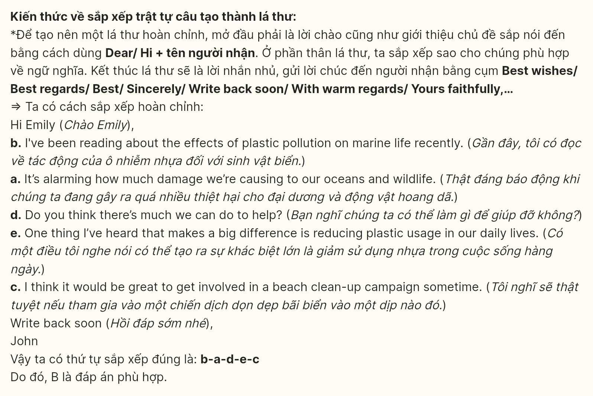
Question 16 [697153]:
a. This includes turning off screens at least an hour before bed, creating a calm sleeping environment, and sticking to a regular sleep schedule.
b. As a result, I’ve been feeling more rested, focused, and productive throughout the day.
c. Getting enough sleep is something I’ve been prioritizing more recently, and it has made a huge difference in my energy levels.
d. I’ve learned that quality sleep is just as important as quantity, so I’ve been focusing on improving my sleep hygiene.
e. I can’t believe how much better I feel just from making a few adjustments to my bedtime routine.
A. a-b-d-c-e B. b-a-e-c-d C. a-b-c-e-d D. c-d-a-b-e
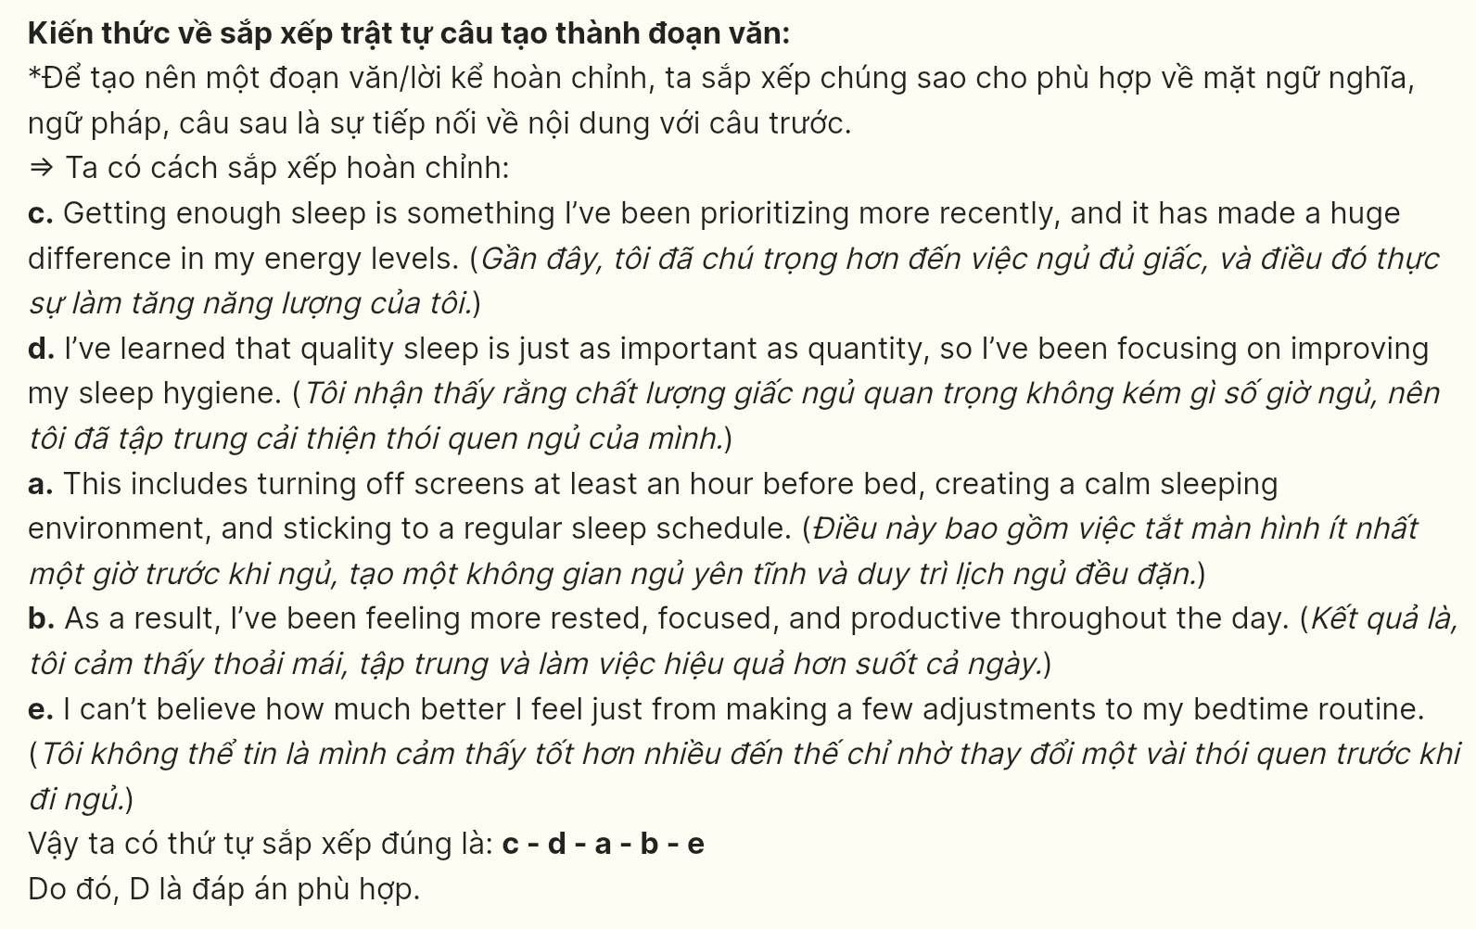
Question 17 [697154]:
a. Older generations tend to believe in hard work, often sacrificing personal time to advance professionally.
b. As society becomes more fast-paced, the generation gap in terms of work-life balance has become more evident.
c. In contrast, younger people place greater value on achieving a healthy work-life balance, often choosing jobs that offer flexibility.
d. This difference in work culture has led to some tension between the two groups, as they struggle to understand each other’s priorities.
e. While older people may view this as a lack of ambition, younger generations see it as a necessary step toward maintaining their mental health.
A. d-e-a-b-c B. e-d-a-b-c C. e-c-d-b-a D. b-a-c-e-d
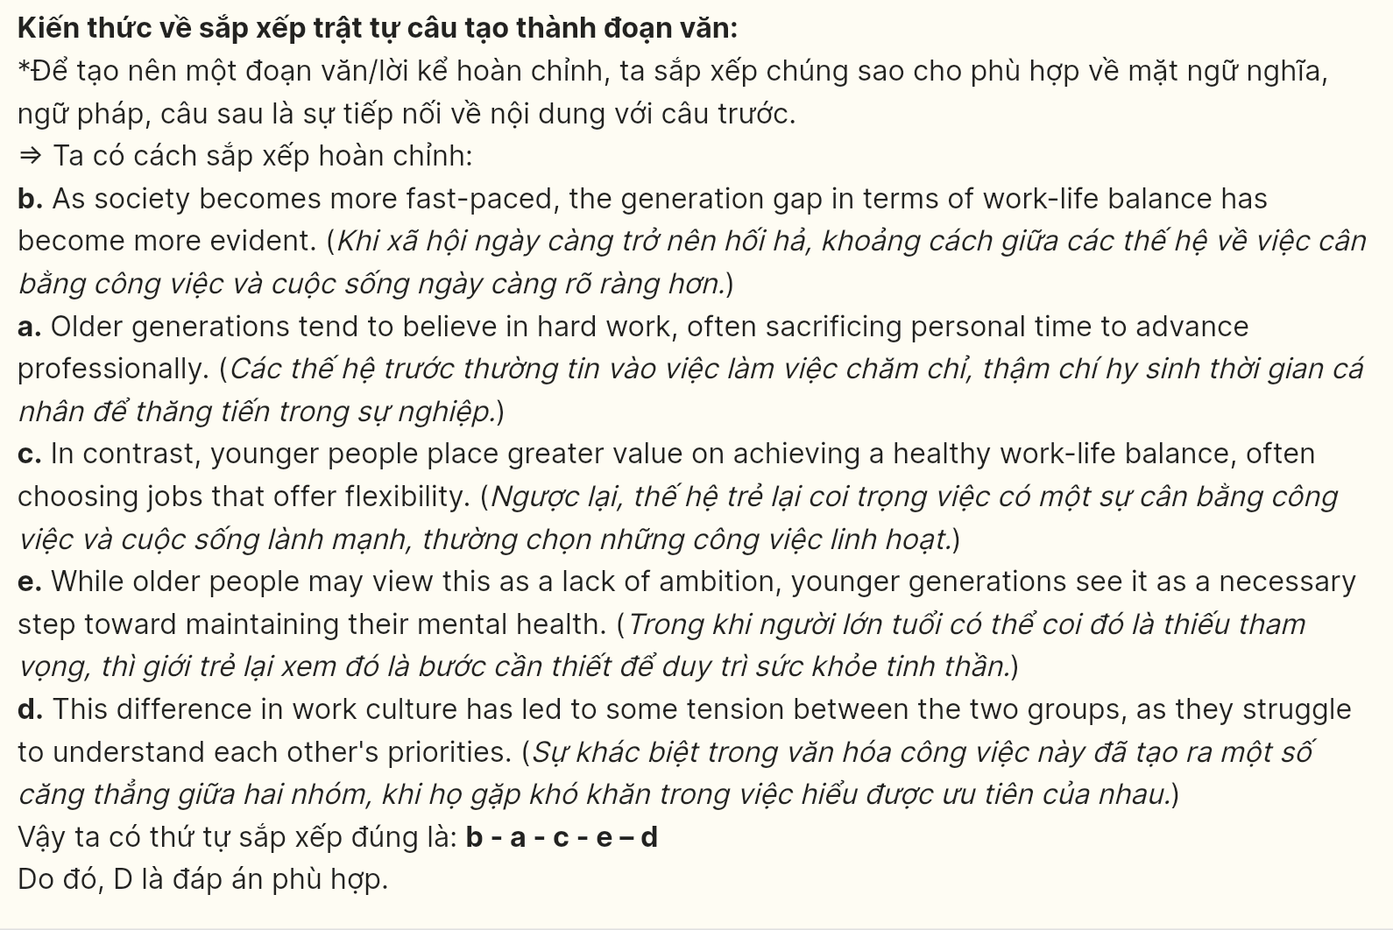
Read the following passage about humanoid robots and mark the letter A, B, C, or D on your answer sheet to indicate the option that best fits each of the numbered blanks from 18 to 22.
The Vietnamese tradition of ancestor worship, practiced by many families across the country, (18) ______. This custom reflects a deep respect and gratitude for one’s ancestors, honoring their spirits and inviting them to protect and bless their descendants. In Vietnamese homes, you often find an altar dedicated to past family members, decorated with offerings like fruits, flowers, and incense. (19) ______. To begin a ritual, they light incense sticks, the smoke representing a bridge between the living and the dead. (20) ______. These rituals are typically performed on special occasions, such as death anniversaries or during the Lunar New Year, which is called "Tết" in Vietnam. (21) ______. While some view this custom as a religious practice, others see it as a meaningful cultural tradition, preserving values of loyalty and respect for one’s origins. In modern society, (22) ______ adapting certain aspects but preserving the core spirit. In doing so, they keep the bond with their ancestors alive, maintaining a vital part of Vietnamese identity and heritage.
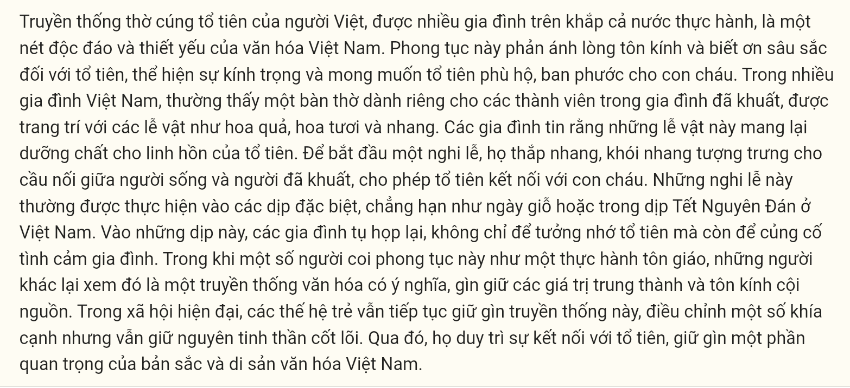
Question 18 [697155]:
A. which is a unique and essential aspect of Vietnamese culture
B. whose aspect of Vietnamese culture is unique and essential
C. is a unique and essential aspect of Vietnamese culture
D. being a unique and essential aspect of Vietnamese culture
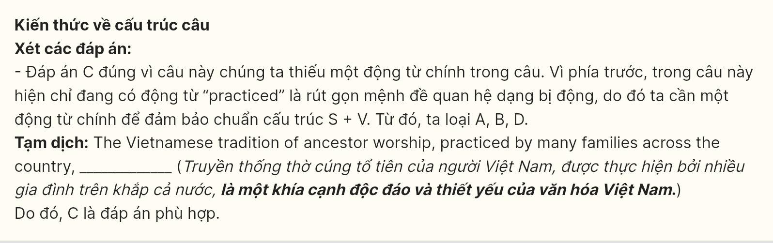
Question 19 [697156]:
A. Families believe that these offerings provide nourishment for the ancestors’ spirits
B. Believing that these offerings provide nourishment for the ancestors’ spirits, a lot of them are bought
C. These offerings that families believe provide nourishment for the ancestors’ spirits
D. Believing that these offerings provide nourishment for the ancestors’ spirits
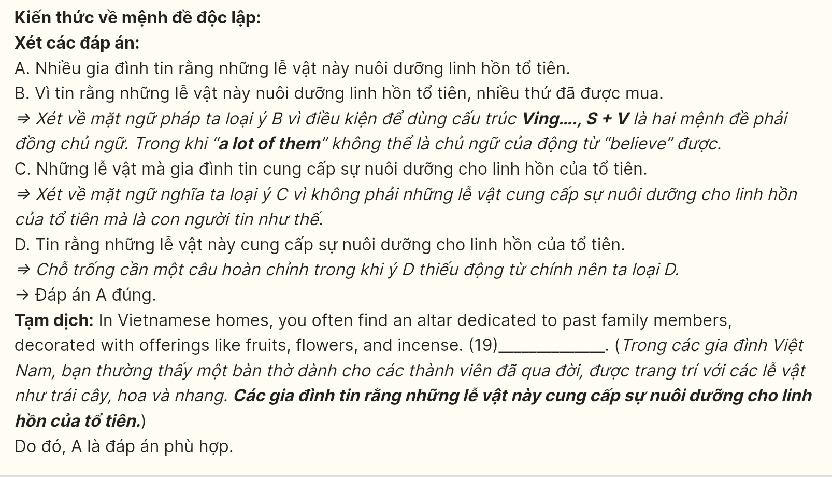
Question 20 [697157]:
A. allow ancestors to connect with their descendants
B. allowing ancestors to connect with their descendants
C. that allows ancestors to connect with their descendants
D. whose allow ancestors to connect with their descendants
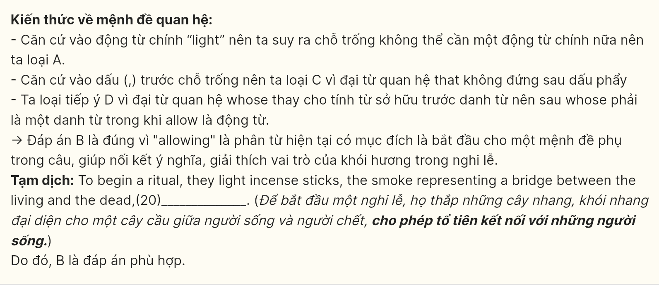
Question 21 [697158]:
A. Here, families gather, not only to remember their ancestors but also to strengthen family bonds
B. Here, families gather to remember their ancestors in case they strengthen family bonds
C. To remember their ancestors, families gather here to strengthen family bonds
D. Gathering here, families not only remember their ancestors but also strengthen family bonds
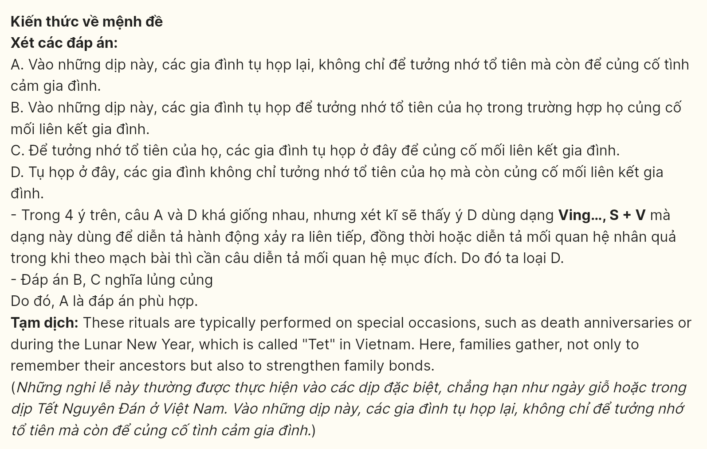
Question 22 [697159]:
A. traditional values are facing numerous challenges
B. younger generations continue to uphold this tradition
C. younger generations’ awareness of preserving traditional values is crucial
D. it is essential for younger generations to continue to uphold this tradition
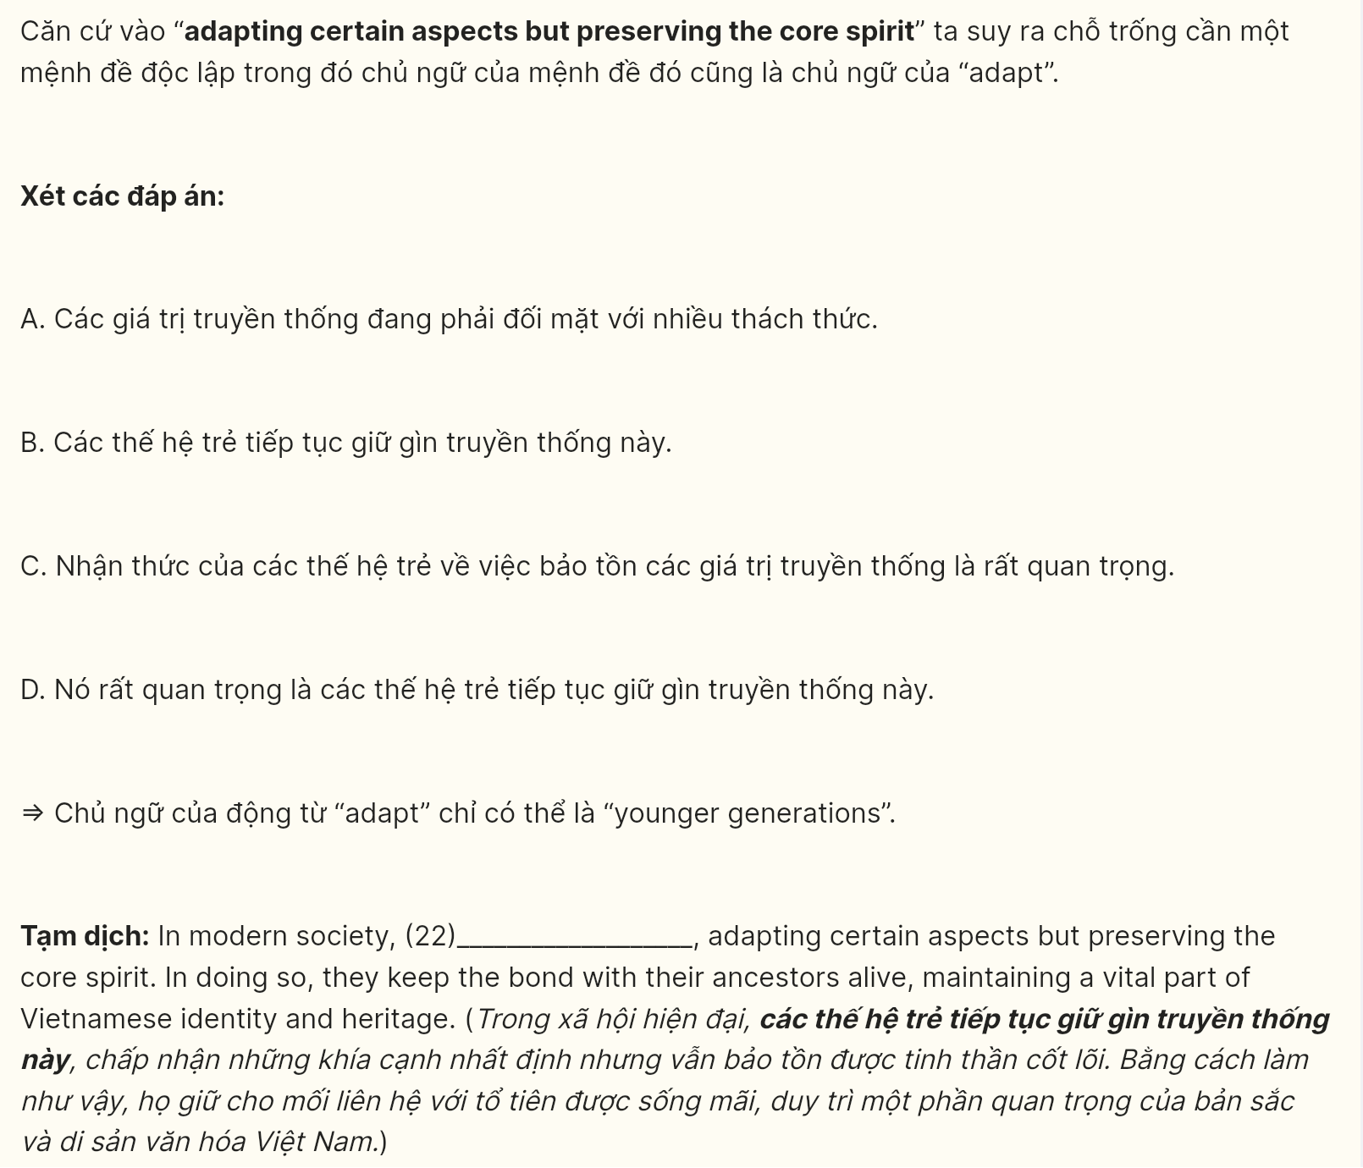
Read the following passage about endangered languages and mark the letter A, B, C, or D on your answer sheet to indicate the best answer to each of the following questions from 23 to 30.
In the nineteenth century, railways were built from the big industrial cities like Leeds and Manchester to seaside towns like Blackpool and Scarborough. For the first time, ordinary working people could visit the seaside. They used to take day trips on Sundays and special days like Bank holidays. Traditionally, people sat in deckchairs on the beach, swam in the sea, and ate fish and chips. Children could watch Punch and Judy shows, build sandcastles, and ride donkeys on the beach.
In the 1950s, the first package holiday was introduced. Throughout the 60s and 70s, the British increasingly began to abandon the traditional seaside holiday in favor of sunshine and warmer seas in countries like Spain and Greece. Caravan and camping holidays also became popular in the 60s and 70s as car ownership increased.
In the 1990s, budget airlines like EasyJet slashed the cost of air tickets to many European destinations. Long-haul flights also went down in price, so holidays to exotic destinations in Australia and Asia became affordable to ordinary families. A growing number of people began to book their own flights and accommodation, and as a result, the package holiday market declined.
The holiday habits of the British continued to change into the new millennium. The internet changed the way people booked holidays by allowing them to find the best deals online. City breaks grew in popularity and many families were able to afford a second foreign holiday – often a winter skiing holiday. However, the travel industry has suffered a serious setback in recent years because people are more aware that flying causes serious damage to the environment. More people are choosing not to fly nowadays, and many airlines are struggling to survive in the new economic climate.
(Adapted from Aim High by Tim Falla and Paul A Davies)
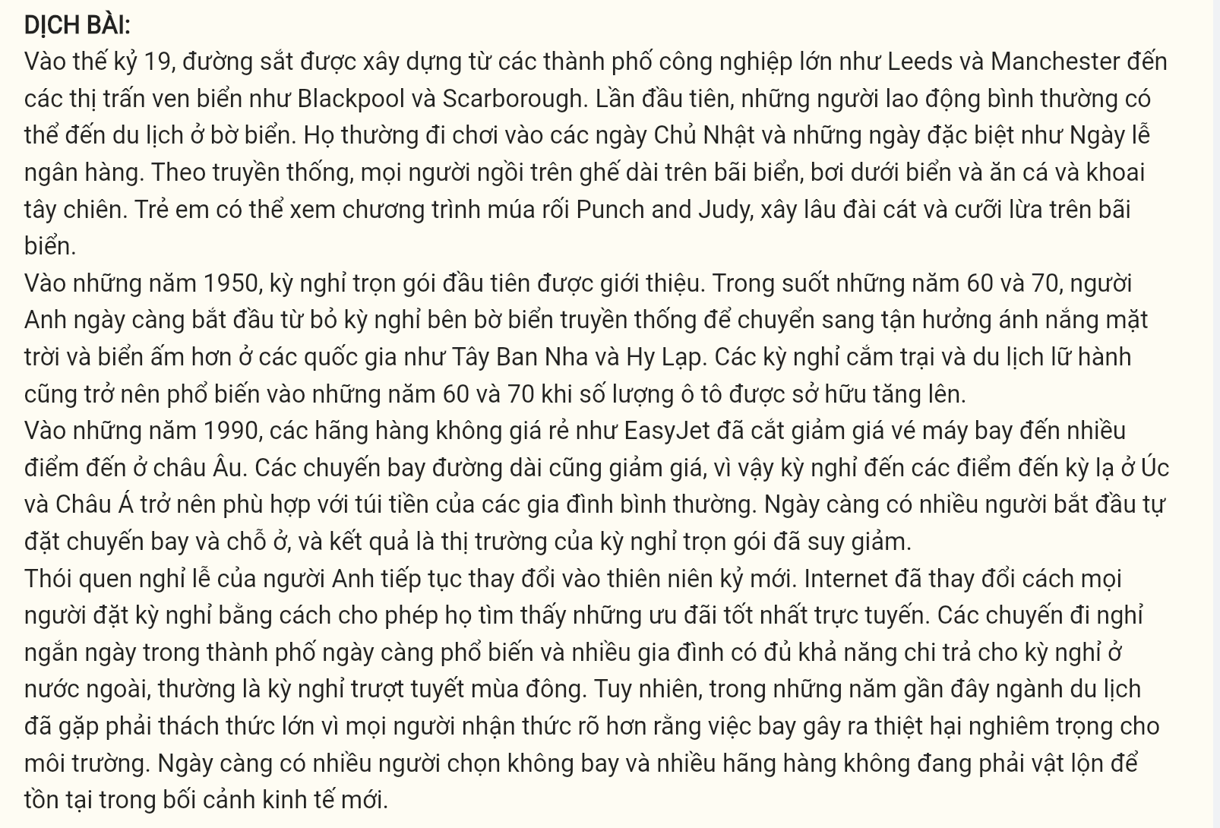
Question 23 [697160]: Which of the following best paraphrases the underlined sentence in paragraph 1?
A. Ordinary working people were allowed to visit the seaside for the first time.
B. Ordinary working people had never been to the seaside before.
C. The seaside was accessible to ordinary working people for the very first time.
D. Ordinary working people were restricted from visiting the seaside until now.
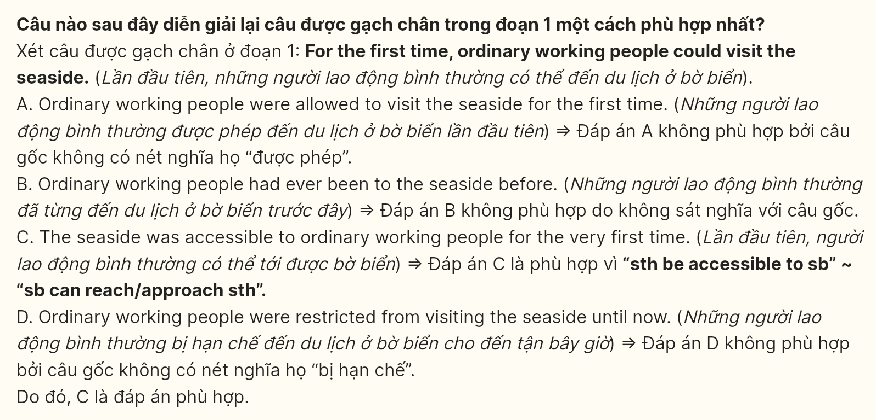
Question 24 [697161]: The word "they" in paragraph 1 refers to _______
A. seaside towns B. package holidays C. day trips D. ordinary people
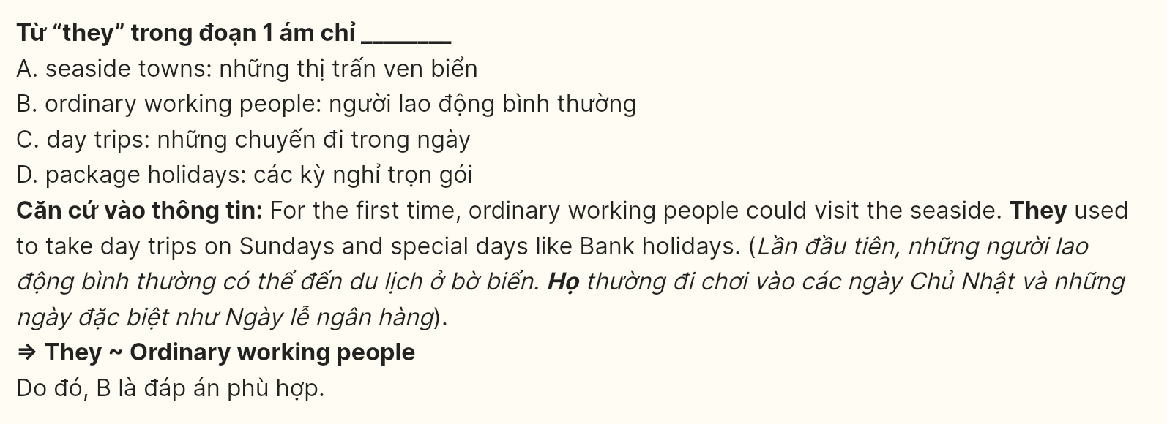
Question 25 [697162]: According to paragraph 2, what made camping holidays become popular among the British?
A. Traditional seaside holidays were expensive to take.
B. Hotels in Spain or Greece were built.
C. Children were more interested in Punch and Judy shows.
D. A lot of British people bought cars between 1960 and 1979.
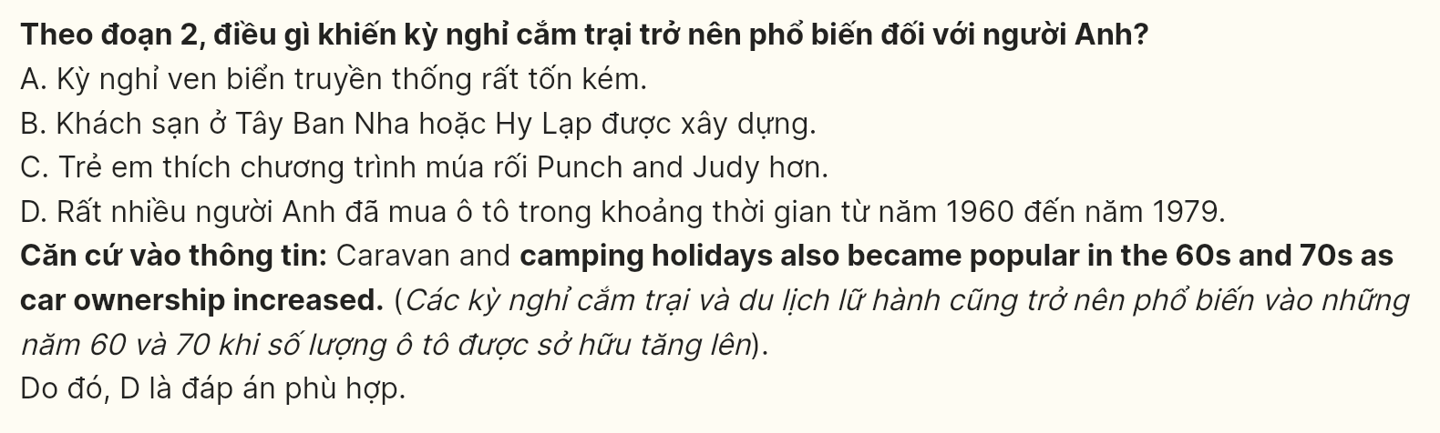
Question 26 [697163]: The word "slashed" in paragraph 3 is OPPOSITE in meaning to _______
A. destroyed B. increased C. betrayed D. decreased
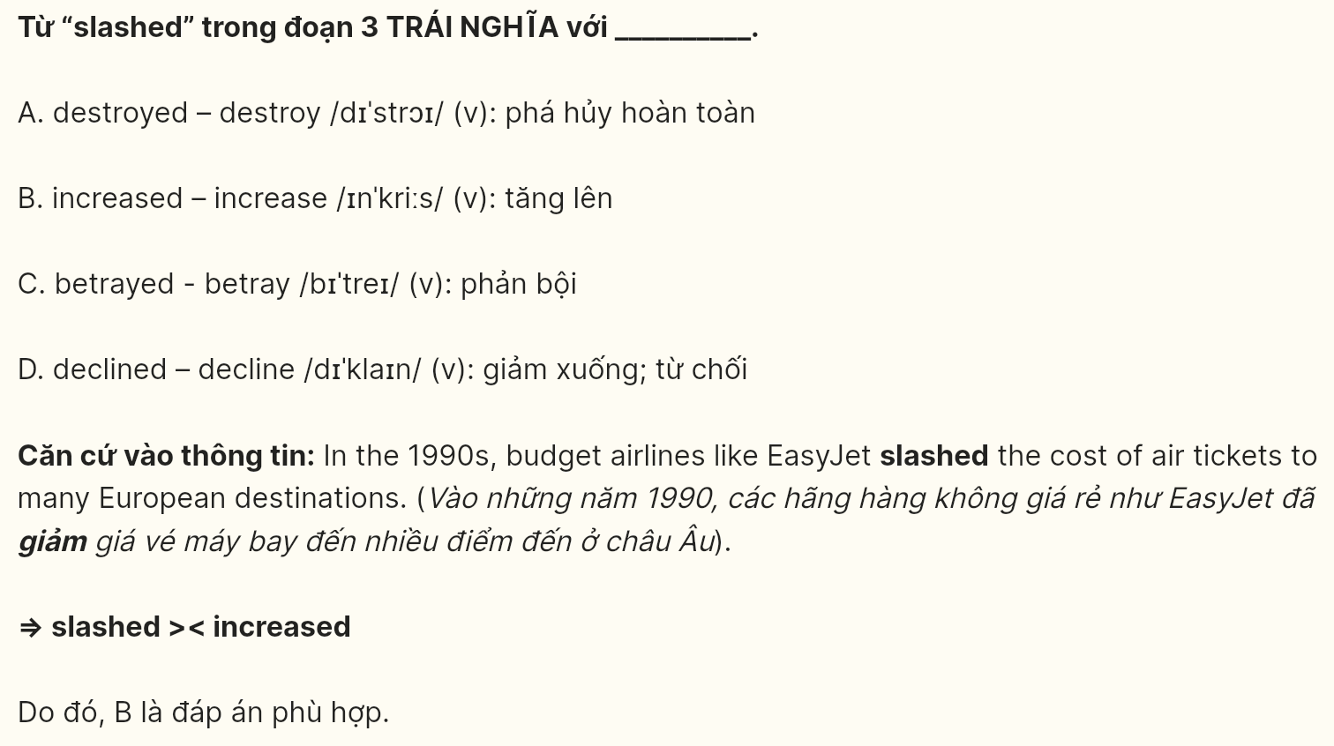
Question 27 [697164]: The word "damage" in paragraph 4 could best be replaced by _______
A. construction B. advantage C. improvement D. impairment
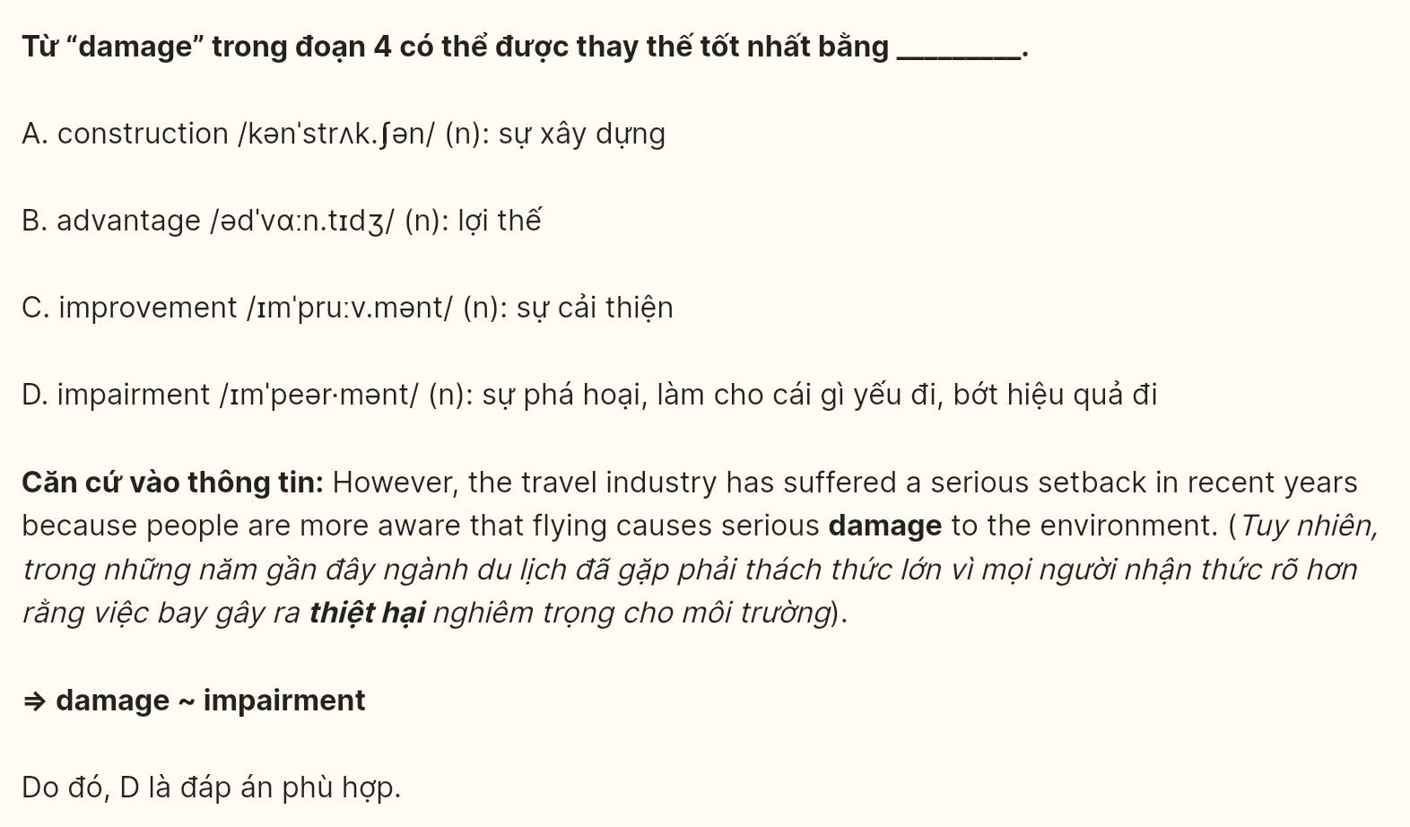
Question 28 [697165]: Which of the following is true, according to the passage?
A. Fewer people are flying because of the impact on the environment.
B. Traditionally, water sports were the most popular holiday activity.
C. The package holiday is still popular among a few British families.
D. Some people have lost a lot of money when booking flight tickets online.
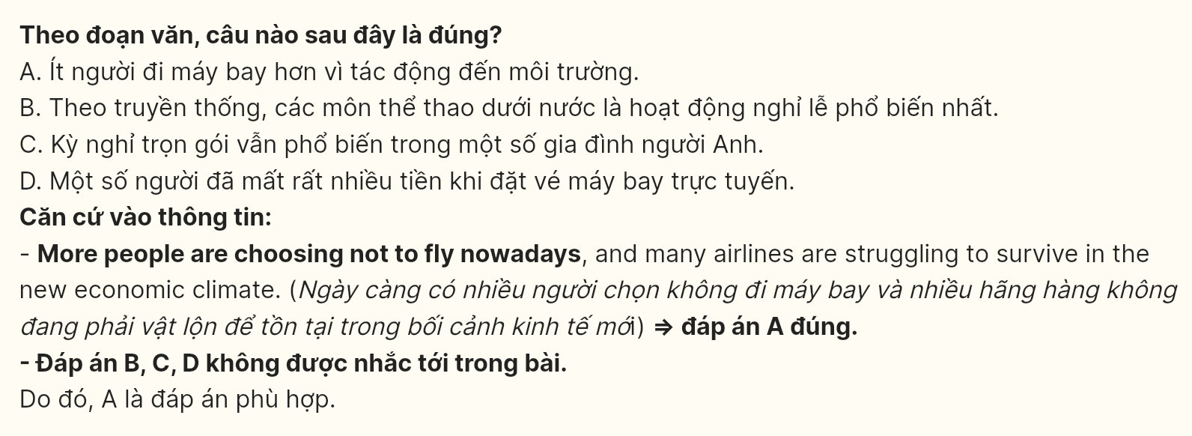
Question 29 [697166]: In which paragraph does the writer explain the impact of budget airlines on holiday choices?
A. Paragraph 1 B. Paragraph 2 C. Paragraph 3 D. Paragraph 4
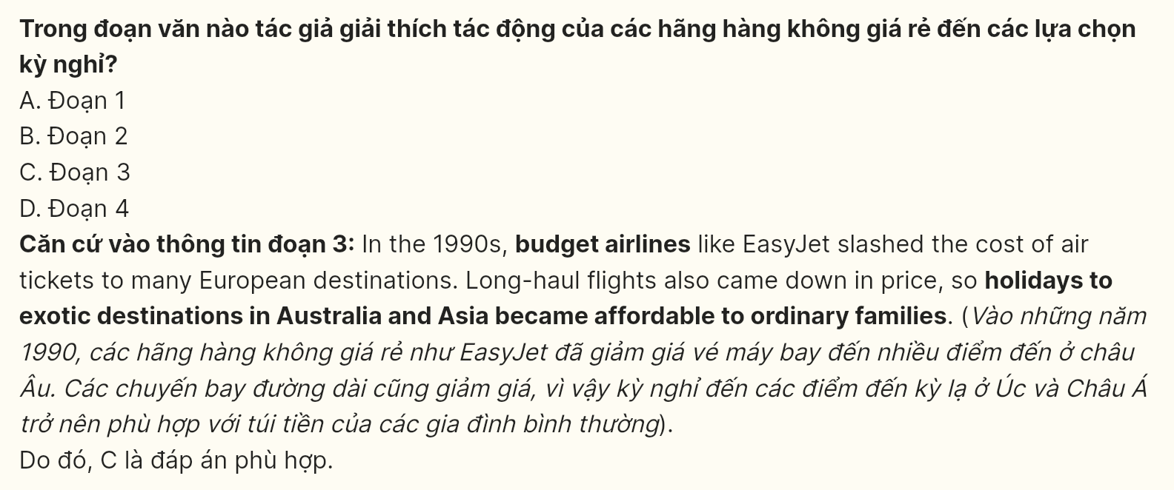
Question 30 [697167]: In which paragraph does the writer mention a present causal relationship?
A. Paragraph 1 B. Paragraph 2 C. Paragraph 3 D. Paragraph 4
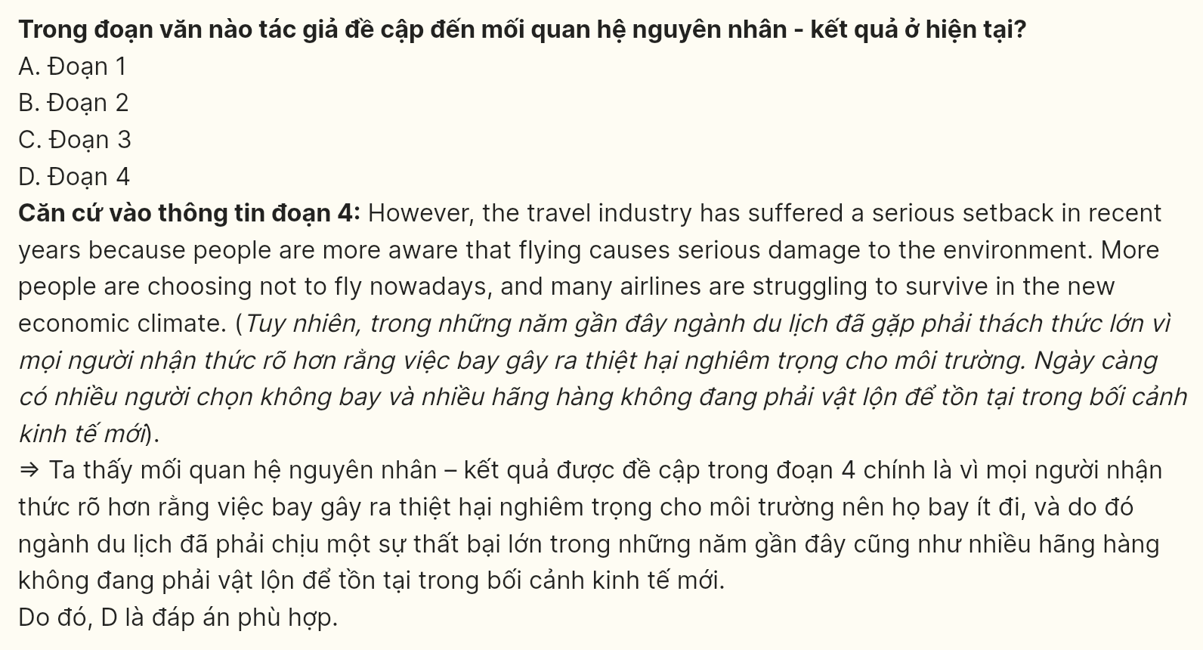
Read the following passage about the complexities of modern parenting and mark the letters A, B, C, and D on your answer sheet to indicate the best answer to each of the following questions from 31 to 38.
[I] In recent years, the relationship between parents and children has profoundly changed. The decision about whether or not to have children is voluntary. [II] Adults who choose to be "child-free" are no longer dismissed as shallow or self-absorbed. [III] As a result, for most adults, having a child is a deliberate and purposeful decision, representing a conscious choice to assume the responsibilities of parenting. [IV]
Parenting has become more complex compared to the past. Parents today are bombarded with conflicting advice about various aspects of child-rearing, such as breastfeeding, sleep arrangements, and toilet training. Without clear guidelines from experts like Dr. Benjamin, moms and dads must decide for themselves how to rear their children. Parenting labels like attachment parenting, natural parenting, and positive parenting further complicate the decision-making process, leaving parents uncertain about the best way to raise their children.
At the same time, parents have grown more sensitive to the risks their children face, both physical and psychological. Anxiety is a defining feature of modern parenting, starting with concerns about potential birth defects and continuing with worries about their children's safety. Media reports about the dangers of pedophiles, stranger abductions, bullying, and environmental hazards heighten these fears, leading to greater adult supervision and less freedom for children.
Finally, there has been a significant reversal in parental expectations. In the past, parents expected their children to love them, but today, parents seek to ensure that their children are happy and love them back. As work commitments increase, a sense of guilt often sours parent-child relationships, causing many parents to overcompensate by investing more time and resources in their children’s development.
(Adapted from Explorer 3)
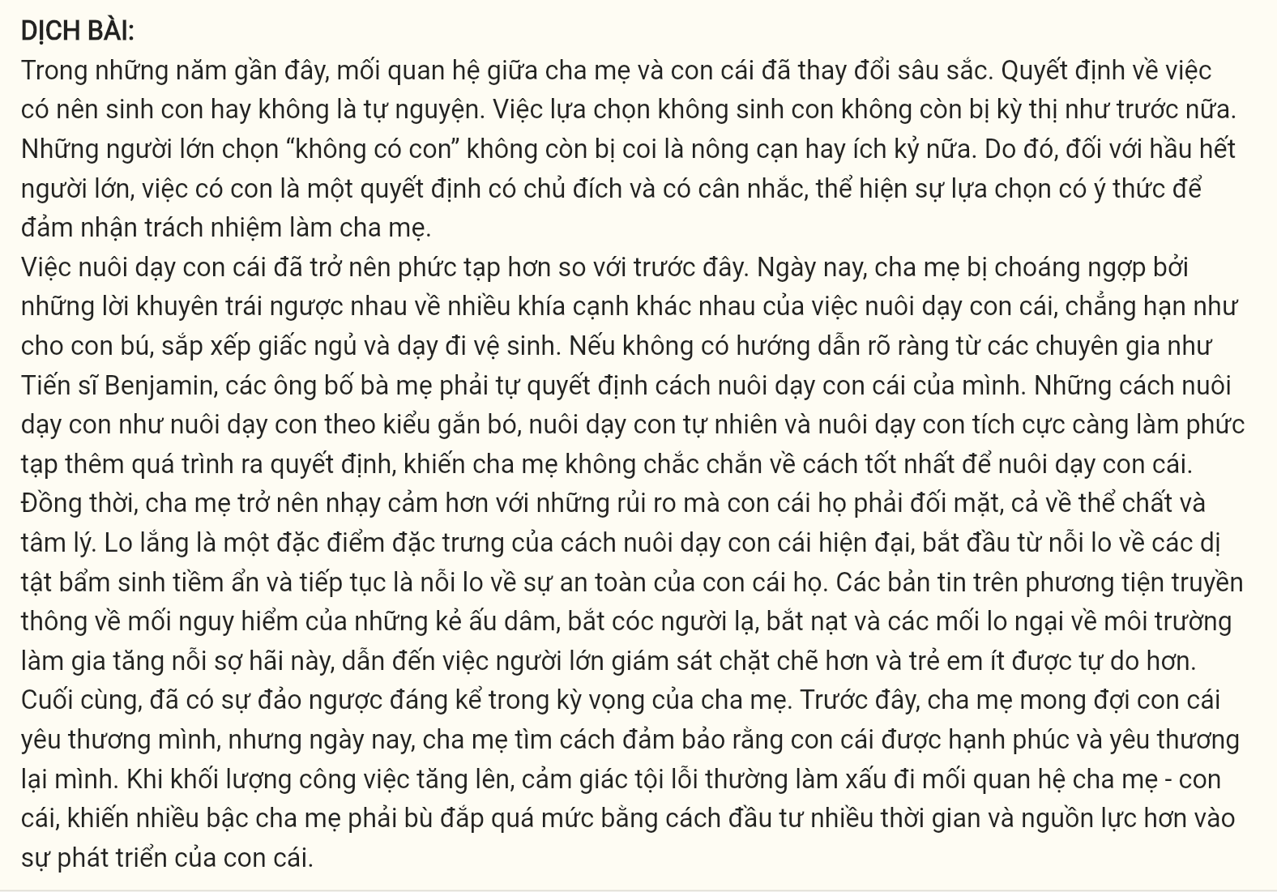
Question 31 [697168]: Where in this passage does the following sentence best fit?
"Electing not to have children is no longer stigmatized as it once was."
A. [I] B. [II] C. [III] D. [IV]
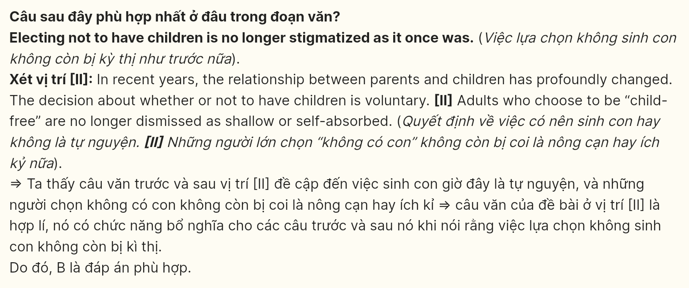
Question 32 [697169]: The word "bombarded with" in the second paragraph is OPPOSITE in meaning to ____
A. overwhelmed by B. inundated with C. compatible with D. shielded from
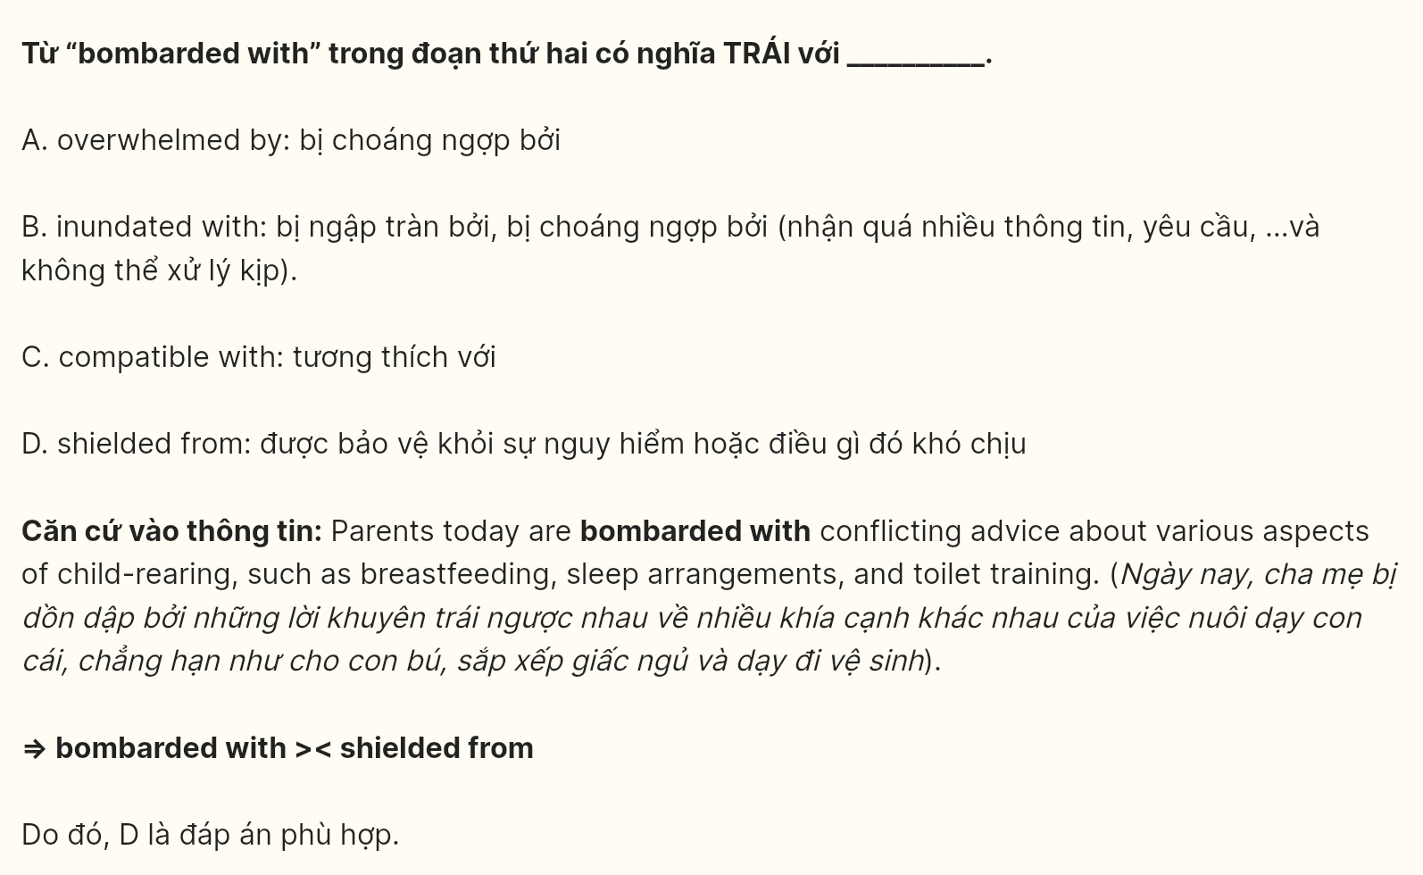
Question 33 [697170]: According to paragraph 2, which of the following is NOT one of the challenges modern parents face?
A. sensibility of child-rearing advice
B. a lack of clear expert guidance
C. choosing between numerous parenting labels
D. conflicting parenting methods
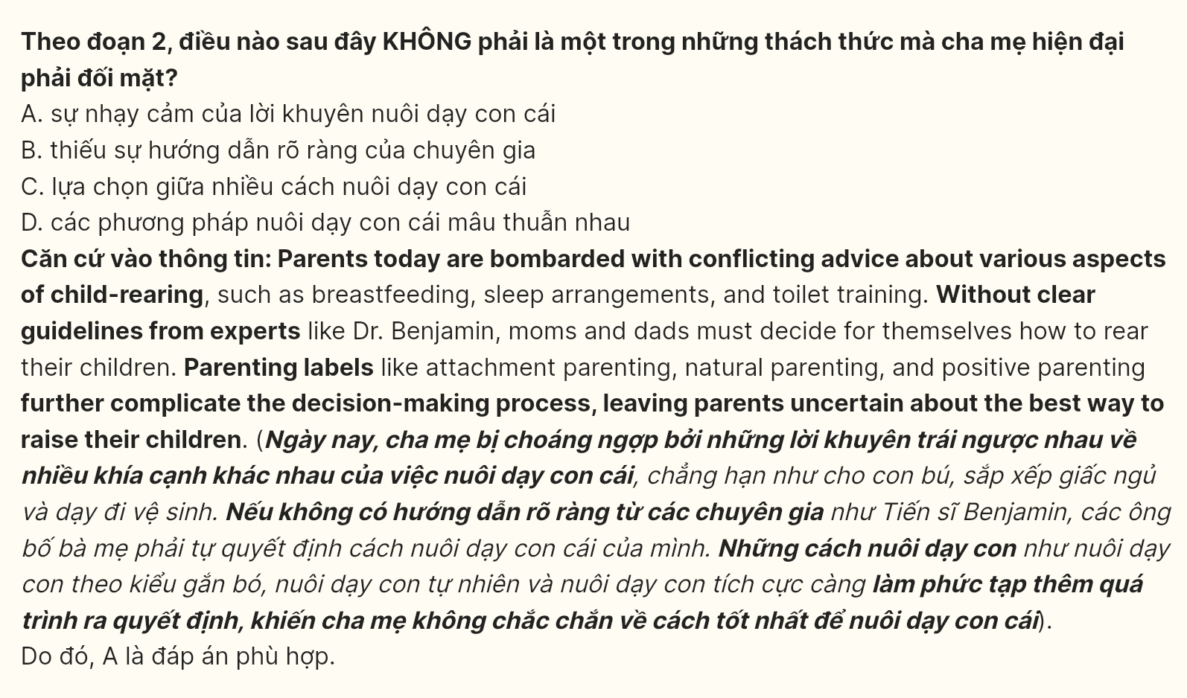
Question 34 [697171]: Which of the following best paraphrases the underlined part in paragraph 1?
A. Many adults feel pressured by society to avoid being child-free to avoid being seen as superficial or self-centered.
B. Society no longer automatically views adults who choose not to have children as superficial or selfish.
C. People who are committed to raising children are becoming more valued than those who are "child-free."
D. Adults opting for being childless are no longer deemed superficial or self-centered.
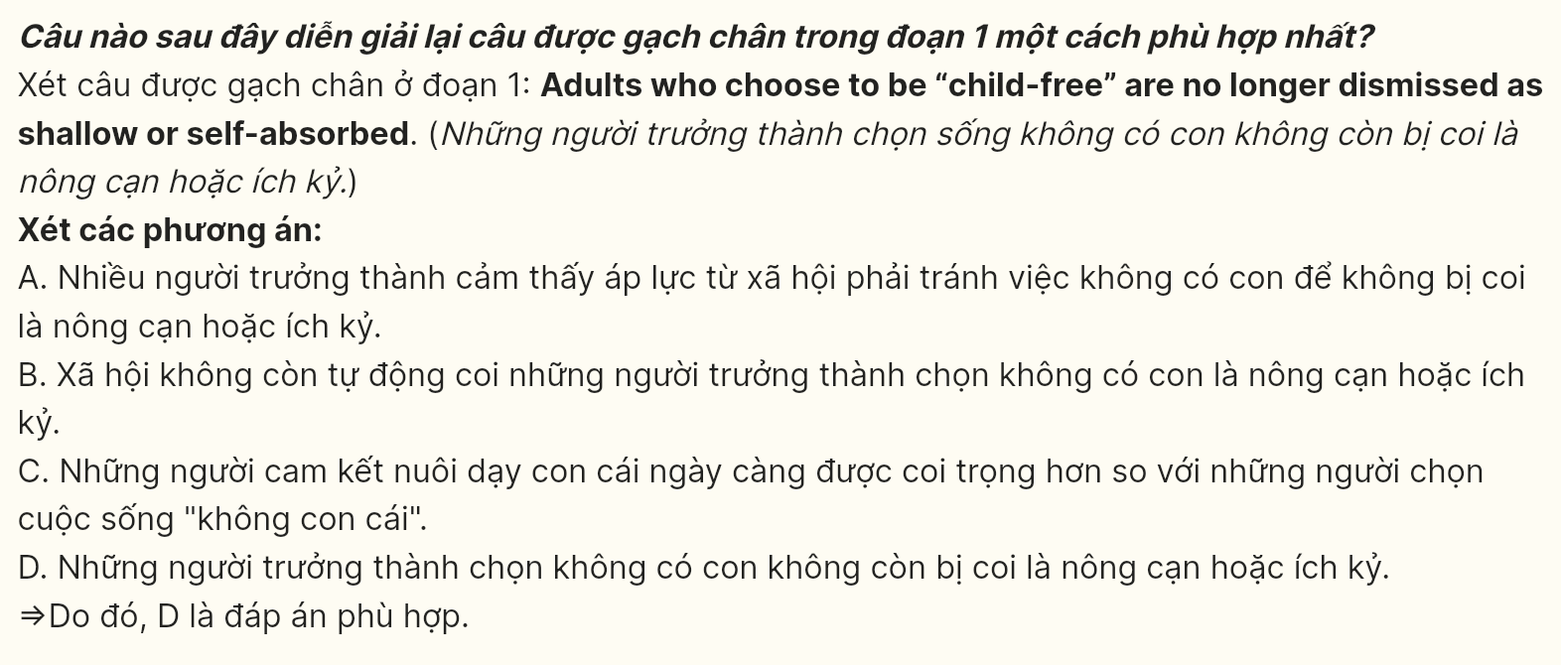
Question 35 [697172]: The word "sours" in the last paragraph could be best replaced by ____.
A. worsens B. happens C. strengthens D. afflicts
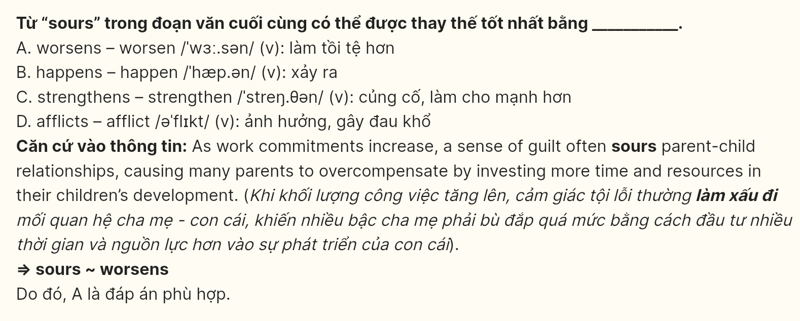
Question 36 [697173]: Which of the following is TRUE according to the passage?
A. As the relationship between parents and children evolves, modern parenting is characterized by less concern for emotional well-being and more focus on material support and career success.
B. The shift in societal attitudes toward having children has contributed to parents feeling more intentional and thoughtful about child-rearing, yet they face increasing uncertainty due to conflicting advice.
C. Modern parents are largely unaffected by media reports about potential risks to their children’s safety, as they rely more on their own experience and intuition.
D. Despite the deliberate decision to have children, parents today emphasize fostering independence in their children above emotional closeness, as was common in previous generations.
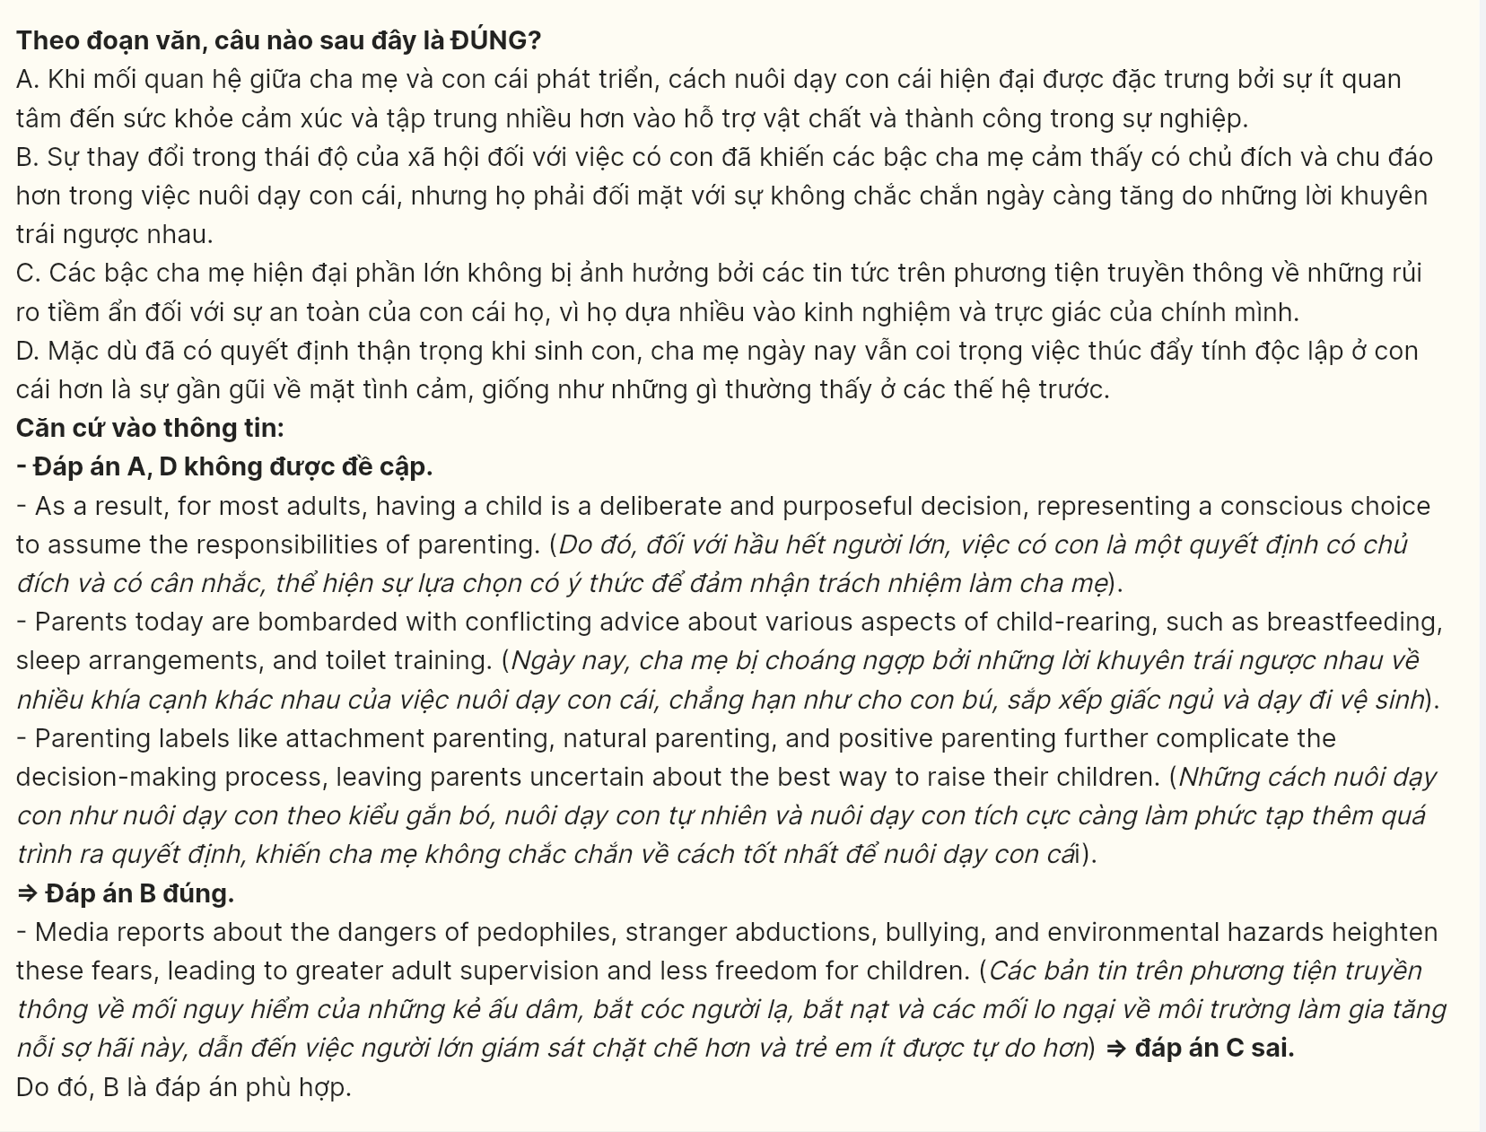
Question 37 [697174]: The word "them" in the last paragraph refers to ____
A. resources B. commitments C. parents D. children
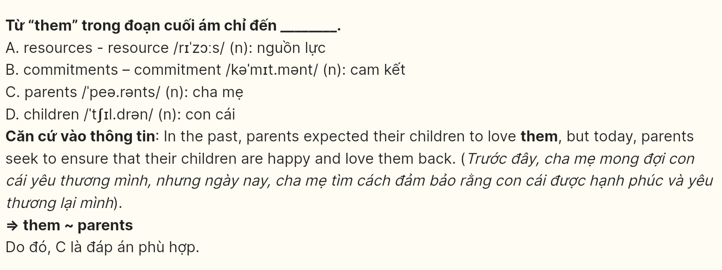
Question 38 [697175]: Which of the following best summarizes paragraph 3?
A. Media coverage of risks, such as pedophiles and bullying, leads parents to overestimate measures.
B. Parental concern over their children’s psychological health has resulted in more protective measures.
C. Modern parenting is defined by heightened anxieties about potential dangers, which limits children’s independence.
D. Fear of environmental and social risks has led to a rise in supervised activities for children.
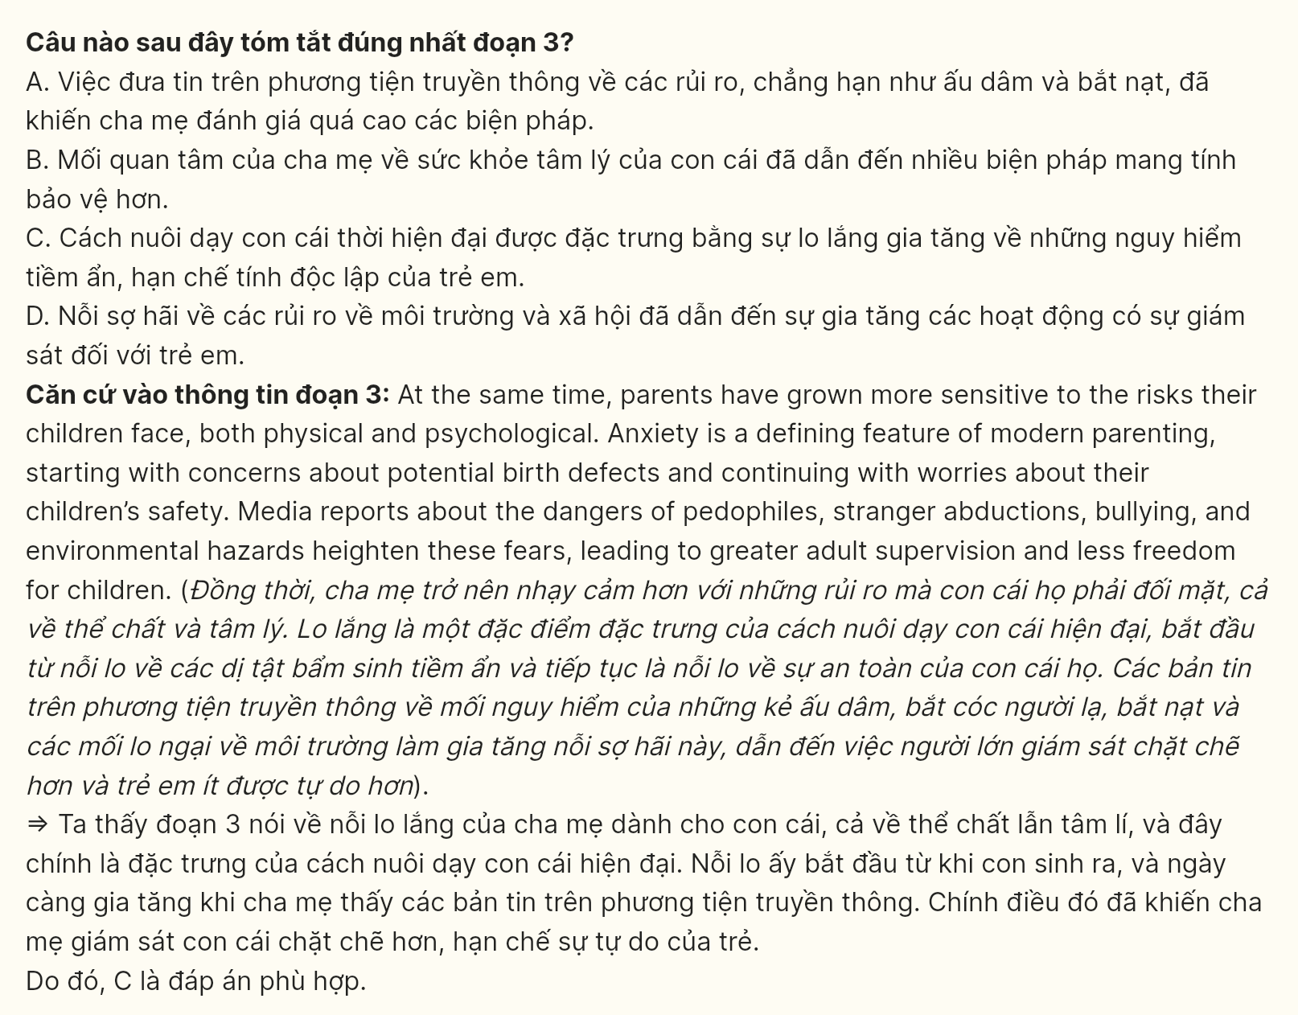
Question 39 [697176]: Which of the following can be inferred from the passage?
A. The media's influence has exacerbated parental fears and reduced children's independence.
B. Parental guilt has lessened as parents spend more time with their children.
C. Parenting in the past involved greater emotional distance between parents and children.
D. Modern parents no longer experience any social stigma for choosing not to have children.
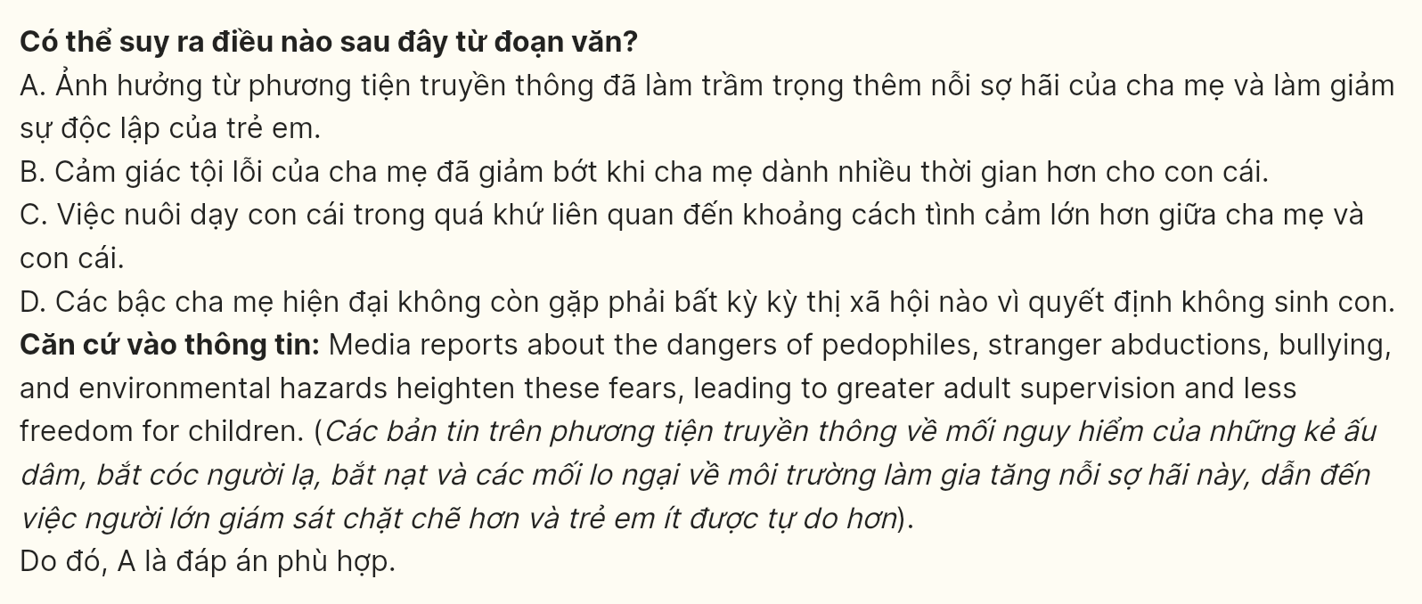
Question 40 [697177]: Which of the following best summarizes the passage?
A. Parenting today has become less about maintaining control, since parents respond to growing social pressures to foster their children’s happiness.
B. Despite the rise of media-driven anxieties, modern parents are more focused on ensuring their children’s emotional stability than addressing concerns about physical safety or social expectations.
C. The decision to become a parent has become more deliberate in modern society; however, the increasing availability of advice has simplified the challenges of child-rearing, despite ongoing concerns about children’s well-being.
D. Modern parenting is fraught with complexity, as parents must navigate conflicting advice, heightened anxieties about safety, and shifting societal expectations surrounding the parent-child relationship.
