Họ tên thí sinh: .................................................................
Số báo danh: ......................................................................
Mã Đề: 020.
Câu 1. Look at the signs. Choose the best answer for the question.
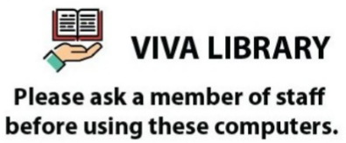
A. A member of staff will give you a computer.
B. You must ask for a computer when you go to Viva Library.
C. You need to ask for permission when you want to use the computer.
D. You have to be a member of staff in order to use the computers.
Câu 2. Look at the signs. Choose the best answer for the question.

A. This parking space is for people with disabilities. B. Disabled people are allowed to enter this place.
C. This place is used for parking vehicles. D. People can put their wheelchairs here.
Câu 3. Look at the signs. Choose the best answer for the question.

A. This door must remain closed to prevent the spread of fire.
B. You should only shut the door when it is on fire.
C. You mustn’t put the door on fire.
D. You should keep the door open unless there is a fire.
Câu 4. Who is Andrew planning to go to the cinema with?
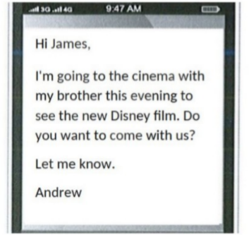
A. Alone B. His parents C. James D. His brother
Câu 5. What activities will be allowed when the pool reopens?
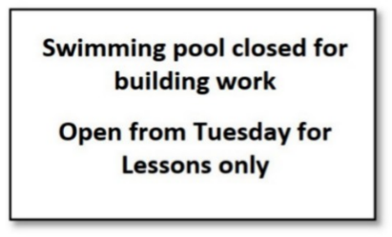
A. The notice doesn't specify allowed activities B. All regular activities
C. Only swimming lessons D. Building work and swimming lessons
Câu 6. Which of the following statements is true?

A. The English course is taught by experienced teachers.
B. The English course starts on 1st September.
C. The English course is for advanced learners.
D. The English course does not provide a certificate.
Câu 7. Look at the signs. Choose the best answer for the question.

A. Be careful because building work is happening. B. There is careful construction.
C. You have to construct buildings with caution. D. Construction must be carefully done in progress.
Câu 8. What does this sign mean?
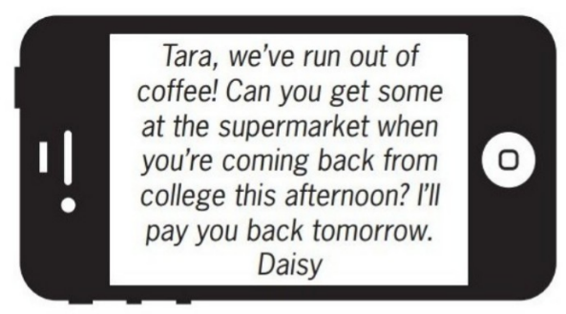
A. Daisy will buy coffee tomorrow when she returns home.
B. Daisy wants Tara to buy some coffee this afternoon.
C. Tara will go to the supermarket tomorrow.
D. Tara should give Daisy some money to buy coffee.
Câu 9. How much discount do students get on the smartphone?
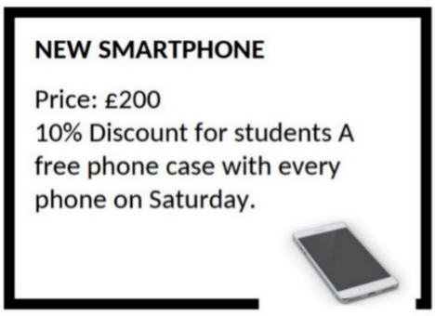
A. 20% B. 5% C. 15% D. 10%
Câu 10. Look at the signs. Choose the best answer for question.

A. Anyone who visits must go to the site office and check in.
B. All visitors can enter the place through the site office.
C. Guests are reported to visit the site office.
D. The site office is for everyone to make a report.
----HẾT---

