UNITS | VOCABULARY | GRAMMAR
Unit  WELCOME BACK | - Countries & Nationalities  - Numbers  - Family members  - Clothes  - Days of the week – months – seasons  - School subjects | - To be  - Subject/ Object personal pronouns – Possessive adjectives – Possessive pronouns  - Can  - Have got  - Possession  - Plurals  - This / These – That/ Those  - Prepositions of place – There is/ There are  - Question words
Unit 1  MY WORLD | - Appearance  - Free-time activities & Hobbies  - Character  - Cultural etiquette in the UK | - Present simple  - Adverbs of frequency  - Prepositions of time  - Present continuous
Unit 2  FIT FOR LIFE | - Sports/ Activities & Equipment  - Food & Food categories  - Health problems  - Parts of the body | - Past Simple  - Used to  - Quantifiers
Unit 3  ARTS & MUSIC | - Festivals & Activities  - Types of entertainment  - Areas in the theatre  - Types of music  - Things to do at festivals/ celebrations  - Musical instruments  - Pronunciation: /iː/ - /ɪ/; /əʊ/ - /aʊ/ | - Will – Be going to – Present Continuous – Present simple (future meaning)  - Conditional (type 1)  - Definite/ Indefinite articles – Zero article
Tiếng Anh 7 – RIGHT ON

SEMESTER 1 - FINAL TEST
Note: Each correct answer earns 0.2 points.

I. PRONUNCIATION (0.8 points)
A. Choose the word whose underlined part is pronounced differently.
1. A. yoga B. show C. clothes D. flower
2. A. benefit B. generous C. percussion D. selfish
B. Choose the word that has a different stressed syllable from the rest.
3. A. display B. argue C. science D. famous
4. A. badminton B. impatient C. popular D. balcony

II. VOCABULARY AND GRAMMAR (2.4 points)
Choose the best option (A, B, C or D) to complete each of the following questions.
5. Can I have ______ butter on my toast, please?
A. a lot B. any C. a few D. a little
6. Becky is really __________. She made us laugh a lot at the party last night.
A. serious B. funny C. generous D. talkative
7. I didn’t have a good seat at the theatre. I wasn’t very close to the __________.
A. row B. aisle C. stage D. theatre
8. Student A: I’ve got a bad __________.
Student B: You should make an appointment with the dentist.
A. headache B. sore throat C. cold D. toothache
9. There’s __________ sugar in my milk; it’s really sweet!
A. too much B. some C. a little D. little
10. My friend, Ara, is a big fan of Blackpink – a famous Kpop group. She goes to all their __________.
A. premieres B. exhibitions C. concerts D. matches
11. I think I ______ vanilla ice cream for dessert. It looks delicious.
A. am having B. will have C. have D. am going to have
12. My brother plays in __________ basketball team. The name of ______ team is the Giants.
A. a/ a B. the/ the C. the/ a D. a/ the
13. I saw a __________ yesterday. I loved it because all the actors are great. However, I sat very close to the screen, so my neck hurts now.
A. film B. play C. ballet show D. fashion show
14. Student A: Jim and I are going to the robot exhibition this Friday. Would you like to join us?
Student B: _________
A. Yes, I would. B. Yes, that’s right.
C. Yes, you can count me in. D. I’d love not.

15. What does the sign mean?
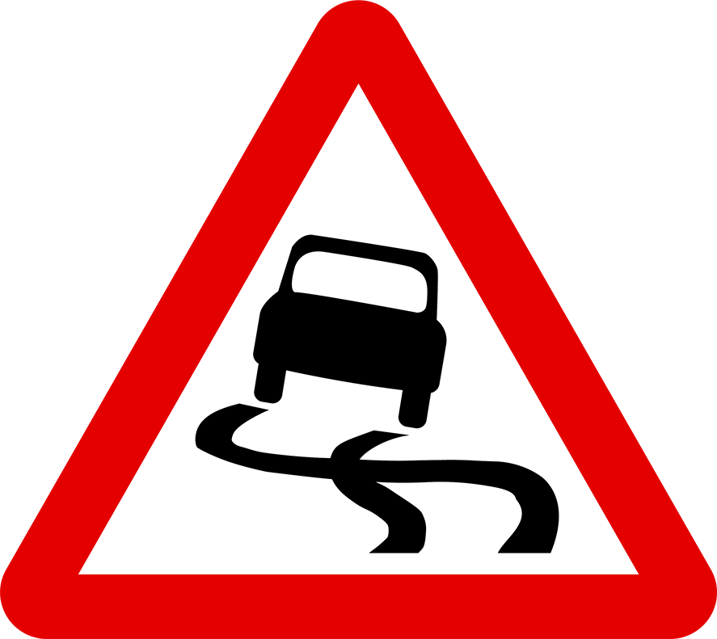 | A. Be careful; there are many cars on this road.  B. There is only one car on this road.  C. If you don’t slow down, you will crash into a car.  D. You should slow down because the road is slippery.

16. What does the sign mean?
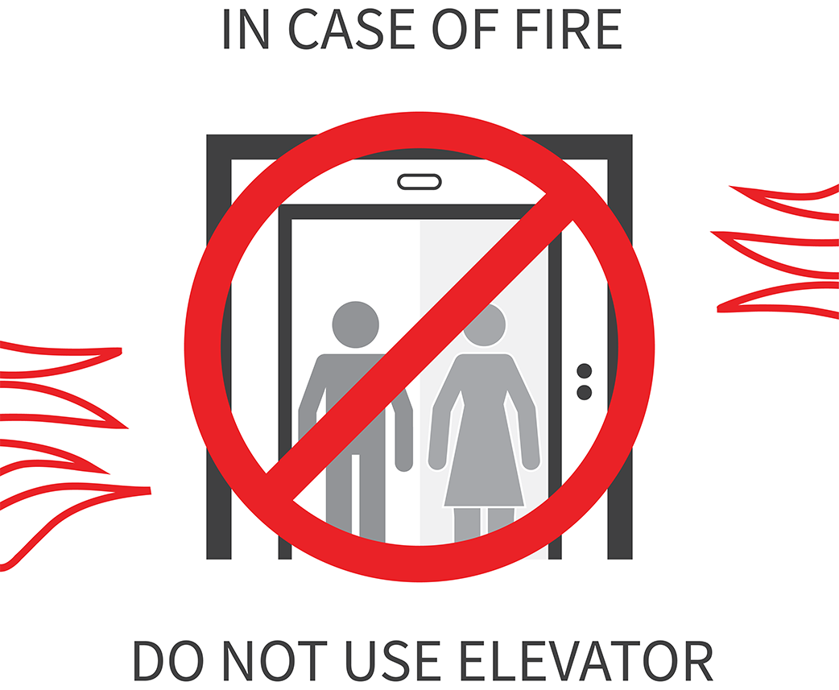 | A. Don’t use the lift when there is a fire.  B. You shouldn’t use the lift unless there is a fire.  C. If there is a fire, people will use the lift.  D. Don’t use the lift, or there will be a fire.

III. WORD FORMATION (1.2 points)
Write the correct form of the words in brackets.
17. Luis is a very __________ person. He always tries new sports and activities. (ENERGY)
18. You’ll never get bored at night in Berlin because the nightlife is so __________. (AMAZE)
19. The show ended with all the ___________ singing on stage together. (PERFORM)
20. Folk is __________ music from a particular country or region. (TRADITION)
21. I first became __________ in skateboarding at the age of seven. (INTEREST)
22. Watching TV is one of the most common types of __________. (ENTERTAIN)

IV. LISTENING (2 points)
A. You will listen to Eliza talking to her friend about a sports camp. For questions 23-27, match the people (23-27) to the sports that they tried (A-G). There are THREE extra sports.

23. Eliza • • A. swimming
24. Noah • • B. snorkelling
25. Isabel • • C. kickboxing
26. Stefan • • D. tennis
27. Marcus • • E. windsurfing
• F. climbing
• G. basketball
• H. football

B. You will hear two people discussing a plan. For each question from 28 to 32, listen and decide whether the statements are True (T) or False (F).

28. Clara is going to come to Ryan’s party.
29. Clara has a maths exam on Monday.
30. Matt is going to meet Lucas at 10.15 a.m.
31. Clara won’t go with Matt and Lucas because she doesn’t like art.
32. Matt borrowed Clara a tennis racket because he didn’t buy one.

V. READING (2 points)
A. Read the following passage. For each question from 33 to 37, write a short answer for each question.

Sumo wrestling is a national sport of Japan. It is a very old sport. It probably dates back to 2,000 years ago. Traditionally, only men can be professional sumo wrestlers. Training to become a sumo wrestler can begin at the age of fifteen after the applicants pass a health check. Sumo wrestlers are very big men. They usually weigh between 120 and 150 kilos. Sumo wrestlers don’t eat breakfast, so they are very hungry and eat a lot at lunchtime. They usually eat chankonable, a traditional dish with chicken, fish, beef, tofu and a lot of vegetables. They also eat lots of rice, four or five bowls. While sumo wrestling doesn’t look very complicated, it is incredibly exciting and skillful. It’s important for sumo wrestlers to be quick, active and flexible. When the match begins, wrestlers lock hands and arms and try to tip each other over or push their opponent out of the thick rope border. One match rarely lasts more than a minute. Nowadays, there are about 700 sumo wrestlers. Not all of the wrestlers are from Japan. There are wrestlers from Hawaii, Bulgaria, Russia and other countries.

33. When did sumo wrestling begin?
→
34. How old can people start applying for sumo training?
→
35. How heavy are sumo wrestlers?
→
36. What are the ingredients for chankonable?
→
37. How long does a sumo wrestling match usually last?
→
B. Read the following passage on Tien’s blog. For each question from 38 to 42, choose the correct option A, B, C or D.

My family went to Singapore last month. Although Singapore is a small country with a (38) _________ of around 5.8 million, it is famous (39) _________ having some of the cleanest streets in the world. We spent the first day visiting Universal Studios. The roller coasters were really fast and exciting. I loved them so much, but my sister was too (40) _________ to try. Then, we watched a 4D movie. It was fantastic. I could actually feel the action from my seat – every jump, bump, bounce, air blast and water spray. In the evening, we went shopping on Orchard Road, the main shopping street. I bought some souvenirs from a department store, and my dad got a new camera. On the second day, we explored the S.E.A. Aquarium. (41) _________ aquarium is home to over 100,000 different marine animals. For dinner, we ate Chilli Crabs – a traditional dish in Singapore. They cooked crabs in tomato-chilli sauce and served the dish with bread. The crabs were so fresh and delicious. After that, we (42) _________ the Light and Water show in the Marina Bay Sands. It was such a brilliant holiday.

38. A. pollution B. population C. popularity D. populate
39. A. to B. with C. for D. in
40. A. excited B. interested C. cheerful D. scared
41. A. An B. A C. The D. Its
42. A. watched B. observed C. listened D. attended

VI. WRITING (1.6 points)
A. Rewrite the following sentences without changing their meaning. Use the given word(s) if any.
43. Jack really enjoys playing the guitar. (FOND)
→ Jack .
44. There wasn’t much rain in December.
→ It .
45. How about going to the museum this weekend? (FANCY)
→ .
46. My plan is to invite Susan to the party.
→ I am .
47. Hurry or we will be late for the show.
→ Unless .

B. Use the given words or phrases to make complete sentences.
48. you/ going/ take part/ school sports day?
→
49. If/ you/ eat/ too /cheese/ you/ have/ stomachache.
→
50. I/ used/ go/ swimming/ twice/ week/ when/ I/ young.
→

***End – Of – Test***

