School: ……………………………………….. | Date:……………………………………..
Class: ……………………………..................... | Period: …………………………….........

UNIT 1: FREE TIME
Lesson 2.2 - Grammar (Page 8)

I. OBJECTIVES
By the end of the lesson, Ss will be able to:
1.1. Language knowledge and skills
- listen to 2 people asking and answering about a plan.
- talk about future plans.
- use the Present Continuous and prepositions of place correctly.
- write questions about next week’s plan, then answer them.
1.2. Competences
- improve speaking, listening and writing skills
- improve the use of English.
1.3. Attributes
- make plans for themselves.
- be well-organized and disciplined.

II. TEACHING AIDS AND LEARNING MATERIALS
1. Teacher’s aids: Student book and Teacher’s book, class CDs, Digital Book (DCR phần mềm tương tác SB, DHA (từ vựng/ cấu trúc) phần mềm trò chơi tương tác), projector/interactive whiteboard / TV (if any), PowerPoint slides, handouts.
2. Students’ aids: Student’s book, Workbook, Notebook.

III. ASSESSMENT EVIDENCE
Performance Tasks | Performance Products | Assessment Tools
- Listen and repeat.  - Circle the correct word.  - Write questions using the prompts in the next week’s plan, then answer them.  - Work with your partner to make a plan to go out with your friend. | - Ss’ performance.  - Ss’ answers.  - Ss’ answers.  - Ss’ answers/ presentation. | - T’s feedback.  - T’s feedback/Peers’ feedback.  - T’s feedback/Peers’ feedback.  - T’s feedback/Peers’ feedback.

IV. PROCEDURES
A. Warm up: (5’)
a) Objective: Introduce the new lesson and set the scene for Ss to acquire new language; get students' attention at the beginning of the class by enjoyable and short activities as well as to engage them in the follow-up steps.
b) Content: Jumbled word or rearranging words to make a meaningful sentence.
c) Expected outcomes: Ss review words about hobbies or Ss have general ideas about the grammar point they are going to study in the new lesson.
d) Organization of the activity:
TEACHER’S ACTIVITIES | STUDENTS’ ACTIVITIES
- Give greetings.  - Check attendance.  - Option 1: Review: Prepositions of place.  - Have Ss review some prepositions of place by doing the matching activity:  - Call Ss to give answers.  - Check Ss’ answers, give feedback and lead to the new lesson.  Near / under / next to / on / in front of / behind  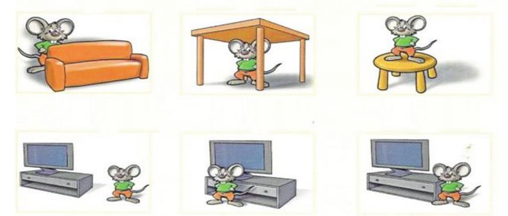  - Have Ss make sentences, using the prepositions of places.  à Lead to the new lesson.  - Option 2: Fill in the blank  - Have Ss close all books and notebooks.  - Show some sentences with pictures, have Ss use the pictures to think of a word/phrase to fill in each blanks.  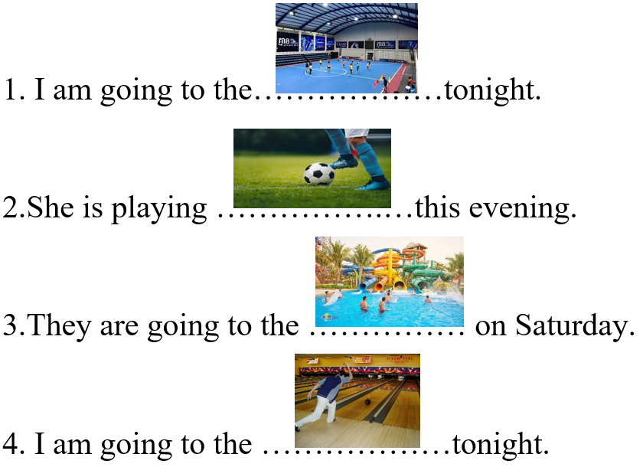  - Have Ss read their answers.  - Tell Ss about the grammar point they are going to study in the new lesson.  àLead to the new lesson. | - Greet T.  - Work in pairs.  - Give answers.  Answers keys  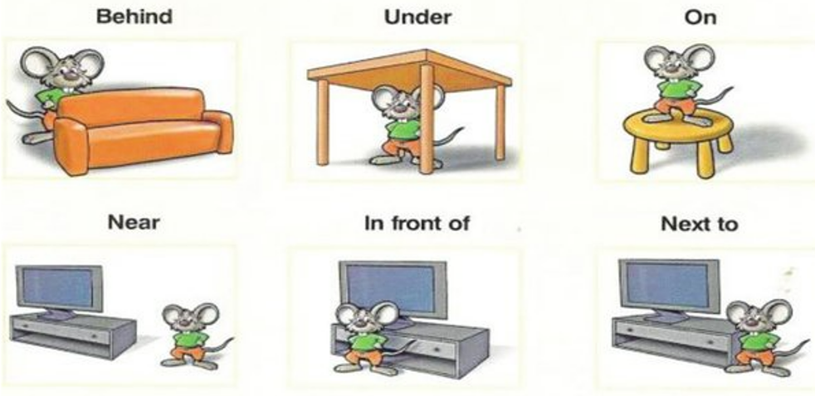  - Read sentences.  - Close books and notebooks, then work in pairs.  - Give answers.  Answers keys  1. sport center 2. soccer  3. water park 4. bowling alley  - Listen

B. New lesson (35’)
- Activity 1: Presentation (10’)
a) Objective: Help Ss review Present Continuous tense (form, usage).
b) Content:
- Listen and repeat
- Review the form and usage of the Present Continuous.
- Review: Prepositions of place.
c) Expected outcomes: Ss remember the Present Continuous, prepositions of place and use them in some exercises that follow.
d) Organization of the activity:
TEACHER’S ACTIVITIES | STUDENTS’ ACTIVITIES
Task a. Listen and repeat  - Have Ss look at the picture (using DCR).  - Play audio (CD1 – Track 09) and have Ss listen and read the speech bubbles.  - Play the audio again and have Ss listen and repeat.  Grammar box  - Option 1:  - Have Ss look at the grammar explanation (using DCR).  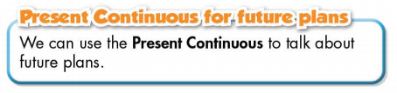  - Have Ss look at the box and read examples of different forms.    - Explain more about the form and the usage of the Present Simple, have Ss pay attention to the negative and the question form.  Form:  (+) S + am / is / are + V-ing …  (-) S + am / is / are + not + …  (?) Am / Is / Are + S + V-ing …  Usage: to talk about future plans.  - Have some Ss read aloud the sentences in the Grammar Box aloud.  - Ask Ss to give more examples using the Present Continuous.  - Have Ss look at the Prepositions of Place box, remind them that Prepositions of Place are used to talk about where something or someone is located.  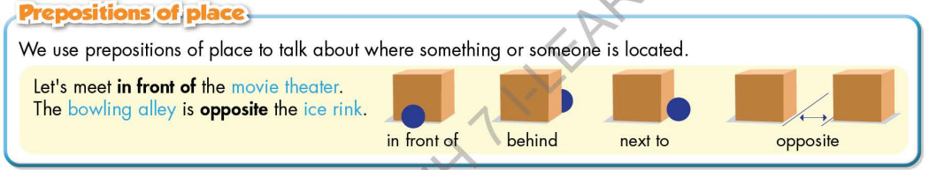  - Option 2:  - Have Ss close books.  - Give some model sentences (T can use the sentences form the warm-up activity), ask Ss to indicate which tense is being used, then have Ss retell form of the Present Continuous.  *Suggested model sentences:  1. I am going to the sports center tonight.  2.She is playing soccer this evening.  3.They are going to the water park on Saturday.  4. I am going to the bowling alley tonight.  - Call Ss to give answers, comment on Ss’ answers.  - Ask Ss: What are these sentences about?  - Then have Ss open the books and read the grammar box.  - Have Ss give more examples of the Present Continuous, encourage them to make sentences with their own ideas.  - Give feedback and evaluation.  * Prepositions of Place: If T has used it in the warm-up activity, there’s no need to carry out this grammar part again. | - Look.  - Listen, then read.  - Listen and repeat.  - Look and read.  - Read.  - Listen and take notes.  - Read.  - Give examples.  - Close all books.  - Look and answer.  Expected answer: The sentences are about future plans.  - Read.  - Give examples.  - Listen.
- Activity 2: Practice (19’)
a) Objective: Students can use the “Present Continuous for future plans” and “Prepositions of Place” to do the given exercises.
b) Content:
- Circling the correct words.
- Writing questions using the prompts in the next week’s plan, then answer them.
c) Expected outcomes: Students can get used to the use of the “Present Continuous for future plans”. and Prepositions of Place and use it correctly.
d) Organization of the activity:

TEACHER’S ACTIVITIES | STUDENTS’ ACTIVITIES
Task b. Circle the correct words.  - Use DCR to show the task.  - Demonstrate the activity, using the example.  - Have Ss read the sentences and circle the correct words.  - Have Ss work in pairs to check each other’s work.  - Have some Ss share their answers with the whole class.  - Give feedback, correct Ss’ answers if necessary  Task c. Look at the next week’s plan. Write questions using the prompts, then answer the questions.  - Use DCR to show the task.  - Demonstrate the activity, using the example.  - Have Ss write questions using the prompts, then answer the questions.  - Have Ss check answers with their partners.  - Call Ss to write answers.  - Check Ss’ answers, give feedback. | - Look and listen.  - Work individually.  - Work in pairs.  - Read answers.  Answer keys  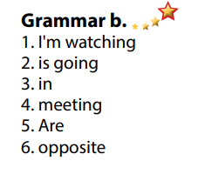  - Look and listen.  - Work individually.  - Work in pairs.  - Write answers.  Answer keys  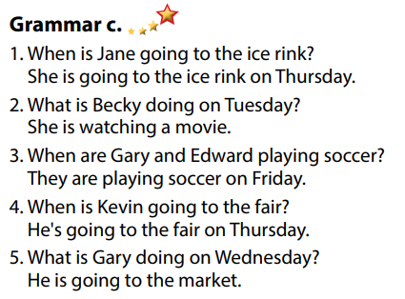

- Activity 3: Production (6’)
a) Objective: Students master the grammar point they study in the lesson.
b) Content: Speaking: Making a plan to go out with your friend.
c) Expected outcomes: Ss produce the new language successfully, and they can apply the Present Continuous in speaking and writing.
d) Organization of the activity:
TEACHER’S ACTIVITIES | STUDENTS’ ACTIVITIES
Task d. In pairs: Make a plan to go out with your friend.  *Remind Ss some useful structures to make plan:  - How about / What about + V-ing  - Let’s + V _{B.I}  - Why don’t we / Shall we + V _{B.I}  - Divide class into pairs.  - Have Ss discuss their plan to go out.  - Have some pairs demonstrate the activity in front of the class.  - Give feedback and evaluation.  - For more practice, have Ss play grammar games with DHA. | -Listen and take notes.  - Have conversation in pairs.  - Present.  - Listen.

C. Consolidation and homework assignments (5’)
*Consolidation
- Present Continuous
Form:
(+) S + am / is / are + V-ing …
(-) S + am / is / are + not + …
(?) Am / Is / Are + S + V-ing …
Usage: to talk about future plans.
- Prepositions of place: in front of, behind, next to, opposite, on, under, …
.
* Homework:

- Make 2 sentences, use the Present Continuous to talk about your future plans.
- Make 2 sentences with prepositions of place.
- Do the exercises in WB: Grammar & Writing (page 5).
- Complete the grammar notes in Tiếng Anh 7 i-Learn Smart World Notebook (page 7).
- Play consolation games in Tiếng Anh 7 i-Learn Smart World DHA App on www.eduhome.com.vn
- Prepare: Lesson 2 – Pronunciation and Speaking (page 9 – SB).

D. Reflection
a. What I liked most about this lesson today:
…………………………………………………………………………………………
- What I learned from this lesson today:
…………………………………………………………………………………………
c. What I should improve for this lesson next time:
…………………………………………………………………………………………

