Unit 4 Test
I. Listening
Listen to Khang talking about his neighbourhood. Decide whether the statements are TRUE (T) or FALSE (F).
Statements | TRUE | FALSE
1. Khang lives in the suburbs of Da Nang City.
2. There is a big beach next to his house.
3. His neighbourhood has many shops and cafes.
4. The streets are not busy in the morning.
5. Khang thinks the people in his neighbourhood are friendly.

II. Pronunciation
A. Choose the word whose bold part is pronounced differently.
6. A. cinema B. building C. village D. street
7. A. beach B. clean C. street D. city
B. Choose the word that has a different stress pattern from the others.
8. A. cathedral B. gallery C. village D. market
9. A. convenient B. expensive C. beautiful D. exciting

III. Language use
Choose the best answer A, B, C or D.
10. There is a big __________ in the centre of the town.
A. square B. river C. traffic D. food
11. The streets are very __________ at rush hour. There are many cars and motorbikes.
A. quiet B. crowded C. peaceful D. cheap
12. This road is __________ than that road.
A. wide B. wider C. more wide D. widest
13. Could you tell me the way __________ the railway station?
A. to B. on C. at D. in
14. Go straight and turn left __________ the traffic lights.
A. in B. on C. at D. under
15. My neighbourhood is __________ than the city centre. There are fewer cars.
A. noisy B. quieter C. more crowded D. busier

IV. Signs & Notices
Look at the signs/notices and choose the best explanation.
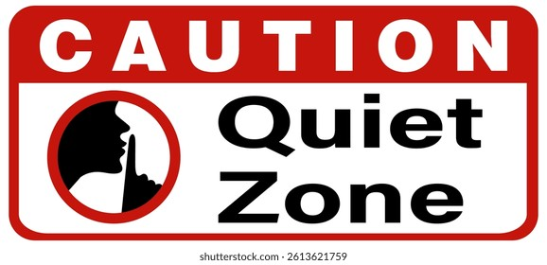
16. Read the notice.
A. Students should make noise here.
B. Students should be quiet here.
C. Students can eat in this room.
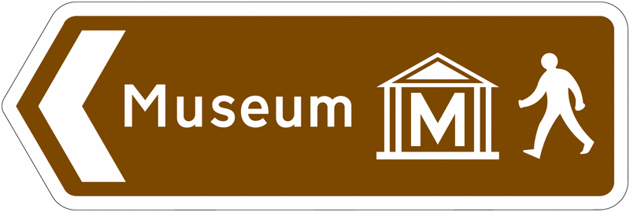
D. Students must run in the library.
17. What does this sign mean?
A. The museum is on the right.
B. Turn left to get to the museum.
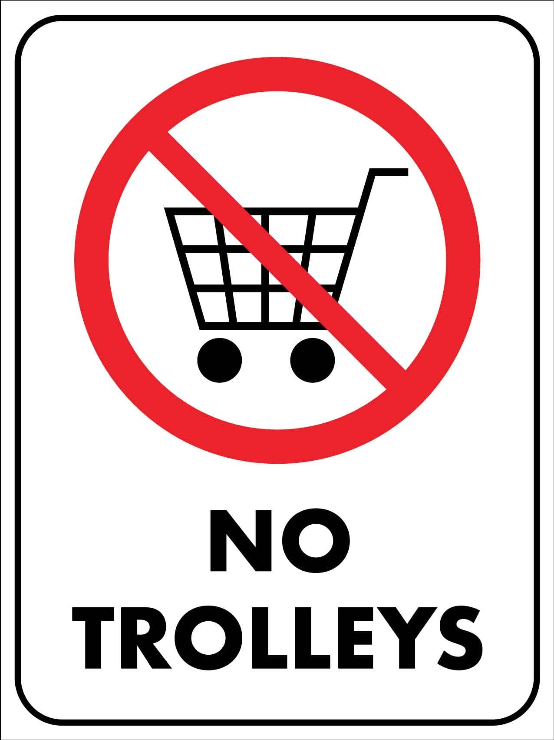
C. Go straight to the bus stop.
D. The bank is closed today.
18. What is TRUE?
A. You can park your cars here for free.
B. You need to put all your trash inside the basket.
C. You should pay for using a trolley here.
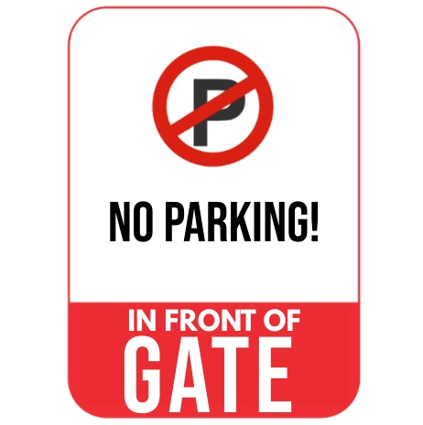
D. You must not bring shopping carts into this area.
19. What does this notice tell you?
A. You should open the gate and drive your car inside.
B. You must not leave your car right in front of the gate.
C. You can park your vehicle here if the gate is closed.
D. You need to wash your car before you go through the gate.

V. LOGIC
Rearrange the sentences (a-d) to make a complete conversation.
20.
a. Tourist: Thank you. Is it far from here?
b. Girl: Go straight and turn right at the bank. It's opposite the cinema.
c. Tourist: Excuse me. Where is the post office?
d. Girl: No, it takes only five minutes to walk there.
A. c - b - d - a B. b - c - d – a C. c - d - b - a D. a - c - b - d
21.
a. Nick: It is very peaceful and clean.
b. Vy: What is your new neighbourhood like, Nick?
c. Vy: That's great! But are there any modern shopping malls?
d. Nick: No, there aren't. We only have a small supermarket.
A. a - b - d – c B. b - a - c - d C. b - c - a - d D. d - c - b - a
22.
a. Mai: That's a wonderful idea! The weather is perfect for outdoor activities.
b. Tom: Shall we cycle to the town square this afternoon?
c. Mai: I'm bored. What shall we do after school, Tom?
d. Tom: Great. Let's meet at the school gate at 4.30 p.m. then.
A. c - b - a - d B. b - a - c – d C. c - a - b - d D. a - c - d - b
23.
a. Ben: No, it isn't. The city square is much more crowded and noisier.
b. Anna: Is the local park crowded at weekends?
c. Ben: Agreed. Let's go there to draw some pictures this Saturday.
d. Anna: Oh, good. I prefer quiet places for our project.
A. b - a - c - d B. a - b - c – d C. b - a - d - c D. c - d - b - a
VI. READING
A. Read and choose the correct word for each blank.
My neighbourhood is in the suburbs. It is not very (24) _________ because there are not many cars. There is a park (25) _________ my house, so I can walk there after school. The park is (26) _________ than the market. The people are friendly, and the streets are clean. However, the bus stop is far from my house, so I (27) _________ walk for ten minutes to get there.
24. A. noisy B. noise C. noisier D. noisiest
25. A. under B. near C. between D. on
26. A. quiet B. quieter C. quietest D. more quiet
27. A. rarely B. never C. often D. not
B. Read the text and choose the best answer A, B, C or D.
My name is An. I live in an old neighbourhood near Hoi An. There are many old houses, a small temple, an art gallery and a busy market. The streets are narrow, but they are beautiful. In the morning, many tourists walk around the old town. My favourite place is the square because I can meet my friends there. The cinema is opposite the cafe, and the post office is next to the bank. I like my neighbourhood because it is interesting and friendly, but I dislike the traffic at weekends.
28. What is the text mainly about?
A. An's neighbourhood B. An's school C. A new supermarket D. A railway station
29. Where does An live?
A. Near Hoi An B. In Ha Noi C. At the beach D. In a forest
30. What is NOT mentioned in An's neighbourhood?
A. A temple B. An art gallery C. A factory D. A market
31. What are the streets like?
A. Narrow but beautiful B. Wide and noisy
C. Dirty and dangerous D. Modern and empty
32. Why does An like the square?
A. Because he can meet his friends there B. Because it is opposite the bank
C. Because it is far away D. Because there is a railway station
33. Where is the cinema?
A. Next to the bank B. Opposite the cafe
C. Behind the temple D. In front of the post office
34. What does An like about his neighbourhood?
A. It is interesting and friendly B. It has no tourists
C. It is very expensive D. It has wide streets
35. What does An dislike?
A. The traffic at weekends B. The square
C. The old houses D. The cafe
VII. WRITING
A. Rearrange the words to make complete sentences.
36. my neighbourhood / is / than / yours / quieter /.
______________________________________________________________________.
37. straight / and / turn left / Go / at the cinema /.
______________________________________________________________________.
B. Rewrite the sentences without changing their meanings.
38. The park is quieter than the market.
The market ___________________________________________________________.
39. The bank is opposite the cinema.
The cinema ___________________________________________________________.
40. Let's go to the museum this afternoon.
Shall ________________________________________________________________?

AUDIO SCRIPT (PHẦN I: LISTENING)
My name is Khang. I live in the suburbs of Da Nang City. My neighbourhood is quiet and clean. There is a small park near my house, but there isn't a big beach next to it. The beach is about fifteen minutes away by bicycle. There are many shops, cafes and a small market in my neighbourhood, so it is very convenient. In the morning, the streets are quite busy because many people go to work and school. I like my neighbourhood because the people are friendly and helpful.
*************************************
Đáp án tham khảo
Listening: 1. T | 2. F | 3. T | 4. F | 5. T
Pronunciation: 6. D | 7. D | 8. A | 9. C
Language Use: 10. A | 11. B | 12. B | 13. A | 14. C | 15. B
Signs & Notices: 16. B | 17. B | 18. D | 19. B
Logic: 20. A | 21. B | 22. A | 23. D
Cloze Test: 24. A | 25. B | 26. B | 27. C
Reading Comprehension: 28. A | 29. A | 30. C | 31. A | 32. A | 33. B | 34. A | 35. A
36. My neighbourhood is quieter than yours.
37. Go straight and turn left at the cinema.
38. The market is noisier than the park. / The market is not as quiet as the park.
39. The cinema is opposite the bank.
40. Shall we go to the museum this afternoon?

