|  |  |
| --- | --- |
| **School: ………………………………………..** | **Date:…………………………………..** |
| **Class: …………………………….....................** | **Period: ………………………….........** |

**UNIT 6: EDUCATION**

**Lesson 1.2 - Grammar (page 45)**

**I. OBJECTIVES**

By the end of the lesson, Ss will be able to:

**1.1. Language knowledge and skills**

- listen to 2 people asking and answering about making a plan.

- use “have to”, “has to” for obligation expression.

- talk about things they have to / don’t have to do at home or at school.

**1.2. Competences**

- improve speaking, listening skills.

- improve the use of English.

**1.3. Attributes**

- be responsible for school work and housework.

- have a balance between studying and relaxing.

**II. TEACHING AIDS AND LEARNING MATERIALS**

**1. Teacher’s aids:** Student book and Teacher’s book, class CDs, Digital Book (DCR phần mềm tương tác SB, DHA (từ vựng/ cấu trúc) phần mềm trò chơi tương tác), projector/interactive whiteboard / TV (if any), PowerPoint slides, handouts.

**2. Students’ aids:** Student’s book, workbook, notebook, handouts.

**III. ASSESSMENT EVIDENCE**

|  |  |  |
| --- | --- | --- |
| **Performance Tasks** | **Performance Products** | **Assessment Tools** |
| - Listen and repeat. | **-** Ss’ performance. | - T’s feedback. |
| **-** Write sentences with have to using the prompts. | - Ss’ answers. | - T’s feedback/Peers’ feedback. |
| **-** Fill in the blanks with *have to, has to, don't have to, or doesn't have to.* | - Ss’ answers. | - T’s feedback/Peers’ feedback. |
| - Speak: What things do/don't you have to do at home or at school? | - Ss’ answers/ presentation. | - T’s observation, T’s feedback/Peers’ feedback. |

**IV. PROCEDURES**

**A. Warm up: (5’)**

**a) Objective:** Introduce the new lesson and set the scene for Ss to acquire new language; get students' attention at the beginning of the class by enjoyable and short activities as well as to engage them in the follow-up steps.

**b) Content:** Review words about school tasks.

**c) Expected outcomes:** Ss review old vocabularies which are very useful for them in the new lesson.

**d) Organization of the activity:**

|  |  |
| --- | --- |
| **TEACHER’S ACTIVITIES** | **STUDENTS’ ACTIVITIES** |
| * **Option 1: Phone code**   - Have Ss close books and notebooks.  - Have Ss look at the phone code and write the correct words.  - Call Ss to give answers.  - Check Ss’ answers, give feedback.  **\*Codes:**  *1. 33 7777 7777 2 999*  *2. 8 33 7777 8*  *3. 44 666 6 33 9 666 777 55*  *4. 7 777 666 5 33 222 8*  *5. 44 2 888 33 8 666*    - Have Ss make sentences, using the words they have just made.  - Lead to the new lesson.   * **Option 2: Matching**   - Have Ss close all books and notebooks.  - Have Ss do the matching activity.  - Call Ss to give answers, tell the meaning of the phrases again.  - Check Ss’ answers, give feedback.  - Lead to the new lesson.  **\*Illustration** | **-** Close books and notebooks.  - Work in pairs.  - Give answers.  **Answers keys**  *1. essay*  *2. test*  *3. homework*  *4. project*  *5. have to*  - Make sentences.    - Close books and notebooks.  - Work in pairs to match.  - give answers, tell the meaning of the phrases.  - Listen and write the new lesson.  **Answers keys**  *1. write: an essay, a book report*  *2. do: a project, a test, homework*  *3. take: a test*  *4. make: a presentation*  *5. have: a project, an essay, a book report, a test, homework, a presentation* |

**B. New lesson (35’)**

* **Activity 1: Presentation (10’)**

**a) Objective:** Introduce: “have to” and “has to”.

**b) Content:**

**-** Listen and repeat.

**-** Introduce the grammar points.

**c) Expected outcomes:** Ss know the new grammar points (“have to” and “has to”) and use them in some exercises that follow.

**d) Organization of the activity:**

|  |  |
| --- | --- |
| **TEACHER’S ACTIVITIES** | **STUDENTS’ ACTIVITIES** |
| **Task a. Listen and repeat**  - Have Ss look at the picture using DCR.  - Play audio (CD1 – Track 61) and have Ss listen and read the speech bubbles.  - Play the audio again and have Ss listen and repeat.  **Grammar box**   * **Option 1:**   - Have Ss look at the grammar explanation and read.    - Have Ss look at the box and read examples of different forms.    - Explain more about “have to”, “has to” to express obligation.  - Ask Ss to make more sentences using “have to”, “has to” to express obligation.  - Give feedback and evaluation.   * **Option 2:**   - Have Ss look at the sentences in the speech bubbles in Task a and read them again.    - Have Ss make comments on the verb in bold.  - Give feedback.  - Have Ss look at the examples, read and answer the question: *Does teacher often ask you to do these activities at school?*    - Then, lead to the grammar box, briefly explain the way to use *“have to” and “has to”.*  - Have Ss read the grammar box again.    - Ask Ss to make more sentences using “have to”, “has to” to express obligation.  - Give feedback and evaluation. | - Look.  - Listen, then read.  - Listen and repeat.  - Look and read.  - Read examples of different forms.  - Listen.  - Give more examples.  - Look and read.  - Comment.  - Read.  - Give more examples.  - Listen. |

* **Activity 2: Practice (19’)**

**a) Objective:** Students can use “have to”, “has to” to do the given exercises.

**b) Content:**

- Write sentences with have to using the prompts.

- Fill in the blanks with *have to, has to, don't have to, or doesn't have to.*

**c) Expected outcomes:** Students can get used to the form and usage of use “have to”, “has to” and use them correctly.

**d) Organization of the activity:**

|  |  |
| --- | --- |
| **TEACHER’S ACTIVITIES** | **STUDENTS’ ACTIVITIES** |
| **Task b. Write sentences with “have to” using the prompts.**  - Demonstrate the activity on DCR, using the example.  - Have Ss write sentences with “have to” using the prompts.  - Have Ss work in pairs to check each other’s work.  - Have some Ss share their answers with the whole class.  - Give feedback, correct Ss’ answers if necessary.  **Task c.** **Fill in the blanks with *have to, has to, don't have to, or doesn't have to.***  - Demonstrate the activity on DCR using the example.  - Have students fill in the blanks with *have to, has to, don't have to, or doesn't have to.*  - Have pairs check each other's work.  - Have some students share their answers with the class. | - Look and listen.  - Work individually.  - Work in pairs.  - Write answers.  **Answer keys**    - Look and listen.  - Work individually.  - Work in pairs.  - Read answers, explain.  **Answer keys** |

* **Activity 3: Production (6’)**

**a) Objective:** Students master the grammar points they study in the lesson.

**b) Content:**  Speaking: What things do/don't you have to do at home or at school?

**c) Expected outcomes:** Ss produce the new language successfully, and they can use the grammar point in the lesson in everyday speaking and writing.

**d) Organization of the activity:**

|  |  |
| --- | --- |
| **TEACHER’S ACTIVITIES** | **STUDENTS’ ACTIVITIES** |
| **Task d. In pairs: What things do/don't you have to do at home or at school?**  - Divide class into pairs.  - Have Ss take turns asking their partner about what things do/don't they have to do at home or at school?  - Have some pairs demonstrate the activity in front of the class.  - Give feedback and evaluation. | - Have conversation in pairs.  - Present.  - Listen.  **Suggested answers** |

**C. Consolidation and homework assignments (5’)**

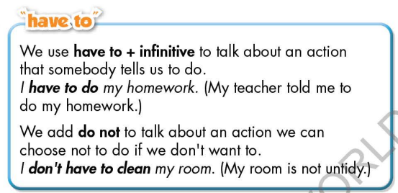**\* Consolidation:**

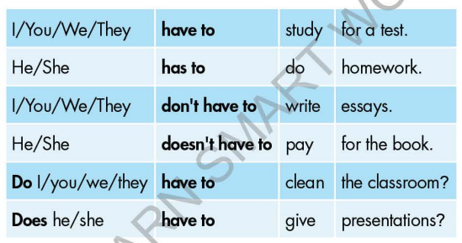

**\* Homework:**

- Make 4 sentences using *have to / has to / don’t have to / doesn’t have to.*

- Do the exercises in WB: Grammar (page 33).

- Complete the grammar notes in Tiếng Anh 7 i-Learn Smart World Notebook (page 37).

- Play consolation games in Tiếng Anh 7 i-Learn Smart World DHA App on [www.eduhome.com.vn](http://www.eduhome.com.vn)

- Prepare: Lesson 1.3 – Pronunciation and Speaking (page 46 – SB).

**D. Reflection**

a. What I liked most about this lesson today:

…………………………………………………………………………………………

1. What I learned from this lesson today:

…………………………………………………………………………………………

c. What I should improve for this lesson next time:

…………………………………………………………………………………………