(Đề thi gồm 21 trang) | KỲ THI CHỌN HỌC SINH GIỎI  LẦN THỨ XVII, NĂM 2026  ĐỀ THI MÔN: TIẾNG ANH - LỚP 10  Thời gian làm bài: 180 phút  (không kể thời gian giao đề)

SECTION A: LISTENING (50 points)
HƯỚNG DẪN PHẦN THI NGHE HIỂU
● The listening section is in FOUR parts. You will hear each part TWICE. At the beginning of each part, you will hear a sound.
● There will be a piece of music at the beginning and at the end of the listening section. You will have TWO minutes to check your answers at the end of the listening section.
● All the other instructions are included in the recording.

Part 1. For questions 1-5, listen to part of a talk about the Tower of London and decide whether the following statements are True (T), False (F) according to what you hear. Write your answers in the corresponding numbered boxes provided. (10 points)
1. The Tower of London used to be the site for money printing.
2. The Tower of London was built by the English king Harold to reinforce his rule over the English people.
3. Death sentences to religious and political prisoners were once carried out in the Tower.
4. The Crown Jewels were once melted down to get gold and jewels for the royal family.
5. The lions kept in the menagerie – a kind of zoo – of the Tower are known as its guardians.
(Adapted from Mindset for IELTS level 3 – Unit 5)
Your answers:
1. | 2. | 3. | 4. | 5.
Part 2. For questions 6-10, listen to a talk about the common uses of helium and answer the questions. Write NO MORE THAN FOUR WORDS for each question. Write your answers in the corresponding numbered boxes provided. (10 points)
6. What can helium do to the superconducting magnets in MRI (magnetic resonance imaging) and NMR (nuclear magnetic resonance) machines?
- ……………………………………………………………………………………..
7. What type of environment does helium create in semiconductor chip production?
- ……………………………………………………………………………………..
8. How can helium enhance the quality of fiber optic cables?
- ……………………………………………………………………………………..
9. What function does helium perform in the field of welding?
- ……………………………………………………………………………………..
10. In food packaging, how can helium help keep food fresh and prevent the development of bacteria?
- ……………………………………………………………………………………..
(Adapted from https://www.youtube.com/watch?v=RxeQaoUf-18)
Your answers:
6.
7.
8.
9
10.
Part 3. For questions 11-15, listen to an interview in which two social scientists called Jane Chase and Bersten are talking about statistics in the media and choose answer (A, B, C, or D) which fits best according to what you hear. Write your answers in the corresponding numbered boxes provided. (10 points)
11. What does Jane suggest about how different countries understand facts?
A. All countries are equally biased.
B. Each country tends to have particularly biases.
C. The same biases tend to affect different countries.
D. No two countries shared the same biases.
12. What does Paul say about the media?
A. The media are irresponsible everywhere.
B. The media aren’t particularly influential.
C. The media exploit prejudice for profit.
D. The media like to focus on unemployment.
13. Jane thinks that politicians could end up
A. only basing policies on media stories.
B. wasting public funds for their own ends.
C. having to work hard to earn citizens’ trust.
D. understanding facts that or figures badly.
14. Paul and jane agree that politicians nowadays are more likely to
A. be threatening during times of crisis.
B. emphasize the differences between people.
C. make speeches that lead to violence.
D. use methods associated with extremism.
15. Paul feels that general public don’t really
A. want the media restricted. B. know how figured are produced.
C. trust the opinion of academics. D. get a good education.
(Taken from CAE practice tests for students – revised version 2012)
Your answers:
11. | 12. | 13. | 14. | 15.
Part 4: For questions 16-25, listen to a TV report about bullying and complete the following summary. Write NO MORE THAN TWO WORDS AND/OR A NUMBER for each space. Write your answers in the corresponding numbered boxes provided. (20 points)
In the US, there is a day called (16) ________________ Day, when people, especially students, wear orange to show protest against bullying,
Presenter Stephanie Stahl says that (17) ________________ adults and teenagers in the USA, including famous people, are suffering health problems associated with bullying.
Her mother says that Lady Gaga was bullied when she attended (18) ________________ school.
Lady Gaga Lady Gaga’s mother says, as a result of being bullied, she experienced hard times being taunted, isolated and (19) ________________.
It is reported that half of the teenager victims of bullying suffer from (20) ________________ bullying.
According to Lady Gaga’s mother, no family is (21) ________________ to bullying.
Studies have pointed out a connection between bullying and problems such as depression and (22) ________________, without parents’ acknowledgement.
Lady Gaga’s mother says, from her own experience of the issue, that parents should listen and (23) ________________ their kids’ feelings.
Sadly, reports indicate that out of 10 adult sufferers of bullying, only (24) ________________ get treatment.
Lady Gaga and her family set up a (25) ________________ called Born This Way as part of their effort to resolve the issue.
(Adapted from https://www.youtube.com/watch?v=son8f2nJel4)
Your answers:
16. | 21.
17. | 22.
18. | 23.
19. | 24.
20. | 25.
SECTION B: LEXICO- GRAMMAR (40 points)
Part 1. For questions 26-45, choose the best option A, B, C, or D to complete the following sentences and write your answers in the corresponding numbered boxes provided. (20 points)
26. I was pretty _______ then, I had a lot to learn.
A. white B. green C. blue D. black
27. It appears that the hostages were not _______ to any unnecessary suffering.
A. subjugated B. subjected C. subsumed D. subverted
28. Entire houses in that village were _______ in yesterday’s large fire.
A. consumed B. depleted C. digested D. exhausted
29. Nine times out of ten, Zack’s red face is _______ of his extreme anger.
A. signifying B. personified C. equivalent D. indicative
30. Tiny tots with their eyes all _______ will find it hard to sleep tonight.
A. luminous B. prismatic C. aglow D. starlit
31. Heartbreaker, you got the best of me. But I just keep on coming back _______.
A. incessantly B. customarily C. firmly D. rigidly
32. “Have you tried to read the guarantee?”. There’s so much legal _______ that it’s impossible to understand.
A. mumbo jumbo B. bongo bongo C. abracadabra D. okey-dokey
33. Brain cancer requires _______ treatment such as surgery.
A. aggressive B. confrontational C. malignant D. rigorous
34. With her excellent qualifications it’s not surprising that she _______ being treated as an inferior at work.
A. molests B. exasperates C. resents D. embitters
35. What stands out from The Voice Kids is that many young children are _______ with natural talent for music.
A. bestowed B. conferred C. endowed D. vouchsafed
36. The government’s plans to reduce crime came _______ for a lot of criticism from freedom groups.
A. across B. around C. in D. with
37. You really dropped _______ the other day when you told Brian you’d seen his wife at the cinema. He thought she was at her mother’s.
A. a brick B. a stone C. a log D. a plank
38. After years of working together, the partners found themselves _______ linked.
A. permanently B. indelibly C. perpetually D. inextricably
39. In some countries, confrontation between police and strikers on _______ has become a feature of life in the eighties.
A. dole queues B. picket lines C. back benches D. assembly lines
40. It is up to the court to decide in the exercise of their _______ whether to grant the favour or not.
A. circumspection B. discretion C. judiciousness D. prudence
41. _______ so incredible is that these insects successfully migrate to places they have never seen.
A. That makes the monarch butterflies’ migration
B. The migration of the monarch butterflies is
C. What makes the monarch butterflies’ migration
D. The migration of the monarch butterflies, which is
42. Following years of intense training, the accomplished athlete _______ the medal triumphantly.
A. took off B. went off C. ran off D. carried off
43. He _______ safety goggles, but he wasn’t and, as a result, the hot steel badly damaged his eyes.
A. could have been wearing B. must have been wearing
C. should be wearing D. ought to have been wearing
44. _______, our original thesis that we are in fact a lot more uptight about sexuality than we’d like to believe is going to be adapted for psychological consultation.
A. As it was opulently vindicated B. As was amply vindicated
C. Bountifully vindicated as it was D. Much as it was copiously vindicated
45. About six million years ago, the Mediterranean sea is said _______, _______ thick layers of salt in southern France.
A. to have evaporated - depositing B. to evaporate - depositing
C. to be evaporating - deposit D. having evaporated - to deposit
Your answers:
26. | 27. | 28. | 29. | 30.
31. | 32. | 33. | 34. | 35.
36. | 37. | 38. | 39. | 40.
41. | 42. | 43. | 44. | 45.
Part 2. For questions 46-55, fill each gap with the correct form of the words in brackets. Write your answer in the boxes provided. (10 points)
46. Even a(n) _______________ person like James can suffer from stress or sadness from time to time. (VIVID)
47. The judge asked whether she was in or out of _______________ at the time of the offense. (LOCK)
48. Some superpowers tried to prolong the _______________ in 2016. The longer a country is without a leader, the more benefits they can gain. (REIGN)
49. John helped a lost child yesterday. The police praised him for his _______________ act. (PUBLIC)
50. "Hojotoho" is meant for Wagnerian sopranos. Every performance featuring this aria has the proscenium arch decorated in a way that captures the _______________ of Scandinavian culture. (ESSENCE)
51. She _______________ the things we need to buy – sugar, tea, and sandwiches. (NUMBER)
52. She wants everything to be in _______________ order before her mother-in-law arrives. (PIE)
53. Wittgenstein is acting in “his usual grotesquely arrogant, _______________ rude and boorish manner. (OPINE)
54. The recent _______________ of the famous singers really made me sad. (BAND)
55. Bats use their _______________ to direct in the dark while going hunt. (LOCATE)
Your answers:
46. | 47.
48. | 49.
50. | 51.
52. | 53.
54. | 55.
Part 3. The passage below contains 5 mistakes. UNDERLINE the mistakes and WRITE YOUR CORRECTIONS in the corresponding numbered boxes provided. (10 points)
Line
1  2  3  4  5  6  7  8  9  10  11  12  13  14  15  16  17 | The relatively soundless space - beyond significant road, rail, air and mining noise - where the British picnic and play and do all things green and pleasantly has shrunk from 91,000 sq km in the 1960s to 73,000 sq km today. What's more, National Noise Action Day organized by a coalition of pressure groups, recently highlighted such varied stealers of silence as in car stereos, mobile telephones and talking household appliances as things which are driving up the decibels. In town, we're even stealing it from us. One recent report recorded sound levels in London restaurants which came close to the legal limits set for noisy levels in the workplace. As life gets louder, so silence becomes a commodity. Clever designers and marketers have already begun to package what was once naturally freely available. To the traditional double glazing and thick curtaining that keep external noise at bay, are now added silent washing machines and other appliances designed to keep the peace within. Other products, ostensibly designed to prevent us polluting the oral comfort zone of our neighbors, to me smack more of affected indulgence. One company, for example, has just added the eerily silent cello to its range of silent musical instruments; silent, that is, to everyone except the headphone-clad player.
Your answers:
Mistake | Line | Correction
56.
57.
58.
59.
60.
SECTION C: READING (60 points)
Part 1. For questions 56-65, read the following passage and decide which option (A, B, C, or D) best fits each gap. Write your answers in corresponding numbered boxes. (10 points)
Unlocking the secrets to happiness might sound like the stuff of self-help books. Still, it's often the simplest truths - inner strength, genuine connections, a (56) ______ of humility, and the ability to enjoy life's little moments - that really matter. Jane Austen's classic Pride and Prejudice offers all this and more, (57) ______ up in a story that's stood the test of time. Over 200 years since its publication, this beloved novel resonates with anyone searching for a meaningful and (58) ______ life.
When it comes to timeless wisdom, Austen is (59) ______. Her sharp observations about human nature, relationships, and personal fulfilment feel just as relevant in today's hectic, modern world as they did in the Regency era. Pride and Prejudice is a love story on the (60) ______, but beneath the romance lies a treasure trove of insights into what it means to live with purpose and joy.
Elizabeth Bennet, a character who virtually oozes confidence and self-worth, (61) ______ the plot. She's not about to let societal expectations (62) ______ her choices. When others might have jumped at a chance to marry rich, Elizabeth (63)______ valuing her independence and authenticity above all else. She reminds us that true happiness doesn't come from chasing wealth, status, or other people's approval - it's (64) ______. Austen's message is as straightforward as inspiring: start by being (65) ______ to yourself if you want a fulfilled life.
56. A. touch B. matter C. flavour D. stroke
57. A. covered B. nested C. boxed D. wrapped
58. A. purpose-driven B. well-lived C. stress-free D. self-aware
59. A. one without enemy B. full of surprises
C. far from nothing D. hard to beat
60. A. outside B. façade C. surface D. sheath
61. A. drives B. leads C. controls D. steers
62. A. limit B. make C. dictate D. guard
63. A. sticks her neck out B. sticks to her guns
C. sticks in her craw D. sticks out like a sore thumb
64. A. an inside job B. in the fine print
C. beside the point D. above all that
65. A. good B. true C. content D. kind
(Adapted from Perspectives on Proficiency)
Your answers:
56. | 57. | 58. | 59. | 60. | 61. | 62. | 63. | 64. | 65.
Part 2. For questions 66 – 75, read the passage and fill each of the following numbered blanks with ONE suitable word. Write your answers in the boxes provided. (10 points)
GALLAUDET UNIVERSITY
Gallaudet University is the (66) ______ university in the world dedicated to educating students who are deaf or hard of hearing. Located in the nation’s capital, Washington, DC, Gallaudet’s campus is home to over one thousand undergraduates, only five percent of (67) ______ can be without any hearing impairment. There are over five hundred students enrolled in (68) ______ graduate and professional programs, which are geared toward careers involving service to the deaf and hearing-impaired community. Gallaudet students are encouraged to use American Sign Language in addition to English, and entering students who are not (69) ______ fluent in ASL are able to become (70) ______ through training programs offered by the university. Technology is also a key component of the curriculum at Gallaudet, (71) ______ ninety percent of classes (72) ______ online work. In fact, the use of educational technology at Gallaudet is twice the national average for universities.
Through its education center, which includes two schools that serve deaf and hearing-impaired infants, children and teens in the DC area, as well as through its conferences, regional centers and other programs, Gallaudet University helps ten (73) ______ thousands of individuals who are deaf or hard of hearing (74) ______ their full potential every year. Gallaudet alumni work in diverse fields (75) ______ graduation, including education, the sciences, public service and the arts.
(Adapted from The New On The Move)
Your answers:
66. | 67. | 68. | 69. | 70.
71. | 72. | 73. | 74. | 75.
Part 3. For questions 76-85, read the following passage and circle the best answer to each of the following questions. Write your answers in corresponding numbered boxes provided. (15 points)
FACING UP TO CHANGE
Where was the Gran she'd known all her life? Could this meek, withdrawn shadow of a woman really be the decisive, caring, all-knowing family matriarch that Claudia had grown up with? Huddled in her upright armchair, trying to attract some heat from the small fire in the hearth, Gran was paying little attention to Claudia, for the most part appearing to be isolated in a world of her own, one where Claudia, though sitting beside her, might to all intents and purposes have been a ghostly presence haunting the visitor's chair.
Claudia herself was actually, to some extent, drifting between awareness of her immediate surroundings and memories of her childhood: some distant ones from when she was a toddler, fleeting shadows of the parents who had died in an accident when she was four, and some from the busy days of life and love when she was one of the privileged members of Gran's large household. Now, it was just the two of them. Some of Claudia's aunts and uncles had emigrated with their families fifteen or more years ago. Others had moved to the city, having been fortunate enough to get good jobs there. Three of her cousins had still been living with Gran when Claudia enlisted in the army, and when she'd been posted overseas as part of a UN peacekeeping force, but now they were all busily getting on with their own lives elsewhere.
What all this meant was there was plenty of room in the big old house, which was just as well now that Claudia was back, if not for good, at least for the foreseeable future. Claudia knew that getting used to the routine in Gran's house and quiet village life would take some doing, but she would manage it. If she was honest with herself, she had to face the fact that there wasn't any alternative.
A career in the military had seemed to promise Claudia a life of adventure that would be the polar opposite of her existence in her quiet hometown. In some ways, of course, the army had delivered on that promise, but Claudia had often noticed that her new life had retained many elements of her upbringing with Gran.
In both, she had a strong sense of belonging and had appreciated the support that had undoubtedly been there for her to rely on in time of need. This support enabled her to mature into a self-sufficient and responsible young woman.
During this relaxed daydreaming session, Claudia began to wonder if maybe Gran was changing because there was nobody else there now, nobody that Gran could take care of and fuss over. "What's more," she thought to herself, "what right have I got to expect the dynamic grandmother of my youth, especially after she's done so much for all of us?" Perhaps, though, it was the very lack of anyone's need for constant care and attention that had led to Gran's withdrawal into her own world, one where she found little to occupy herself with. "Well, it doesn't have to be that way," Claudia thought to herself. After all, she was back home now. She could help Gran in many different ways, but she would also be counting on Gran for a great deal too.
Half dozing as she was, Claudia jolted alert the moment the walking stick between them fell and hit the stone floor. She leant over to grasp hold of it so that Gran didn't have to attempt a similar manoeuvre, "No need to worry, Gran!" said Claudia. "Remember, I'm here now, so you don't have to do everything yourself."
"I know that, Claudia, and I really do appreciate it. Just because I get a little sleepy at times doesn't mean that I'm not fit to do a little light housework. Anyway, now that you're here with me again, my dear, what have I got to worry about? You'll see. We'll make quite a team."
"Who's kidding whom?" Gran mentally scolded herself. "Given time, Claudia's wounds might heal to some extent, but will she be capable of much? She's trying desperately to paint a rosy picture for me about her support team, her old comrades; and the wonders of modern medicine, but how much of it does she truly believe herself?"
76. What is suggested about Gran and Claudia in the first paragraph?
A. Claudia appears to be ignoring her grandmother.
B. Claudia often thinks her grandmother is too bossy.
C. Gran has never taken much interest in Claudia.
D. Gran is different now from the person Claudia remembers.
77. What do we learn from the second paragraph?
A. Claudia dwells too much on the tragedy of her early life.
B. Claudia feels fortunate to have been brought up where she was.
C. Claudia's grandmother treated some relatives very differently from others.
D. Claudia barely remembers any of her childhood.
78. The writer implies that ________.
A. Claudia is disappointed that her other relatives moved out of Gran's house.
B. something forced Claudia to move back in with her grandmother.
C. Claudia is unlikely.to stay in Gran's house for long.
D. Claudia found it very easy to adapt to living in her grandmother's home again.
79. Claudia believes that her upbringing and her career ________.
A. were quite similar in some ways. B. made her too dependent on others.
C. were both very exciting. D. required her to give a lot of support to others.
80. In the fifth paragraph, what does Claudia's thought “it doesn't have to be that way” refer to?
A. the fact that she is living at home again
B. Gran's seeming lack of purpose
C. the amount of work that Gran has to do
D. the fact that things might change now that Claudia is home
81. What impression is given by the text as a whole?
A. Gran is unhappy that Claudia has moved back home again.
B. Gran never wanted Claudia to leave their hometown.
C. The women haven't honestly discussed their feelings about the new situation they are in.
D. Claudia isn't sure if she will still be able to get on well with Gran.
82. In the first paragraph, the word “withdrawn” most nearly means:
A. introspective B. detached C. inhibited D. unresponsive
83. In the context of the passage, the opposite of “self-sufficient” would be:
A. vulnerable B. reliant C. inadequate D. subordinate
84. What does "This support" refer to in the sentence “This support enabled her to mature into a self-sufficient and responsible young woman.”?
A. Claudia’s military training and career experience
B. The emotional and practical help Gran had provided over the years
C. The encouragement from Claudia’s extended family
D. The structured routine of village life
85. Which of the following sentences best expresses the same idea as: "She had to face the fact that there wasn’t an alternative."
A. She reluctantly accepted that her options were extremely limited
B. She realised she had chosen the only reasonable course
C. She admitted that she had made the wrong decision
D. She understood that others had decided things for her
(Adapted from Complete CPE Practice Tests)
Your answers:
76. | 77. | 78. | 79. | 80.
81. | 82. | 83. | 84. | 85.
Part 4. For questions 86-95, read the passage and do the following tasks. Write your answers in the corresponding numbered boxes. (15 points)
BUILDING A CASTLE
Guédelon is no ordinary building site. There is no rumble of diggers or shriek of circular saws. All is peaceful and quiet, save for the continual tapping of the small army of stonemasons, the quacking of the ducks or the occasional crow of the cockerel. Slowly but surely, a brand new medieval castle is rising from the woods of Guédelon, Yonne, home to the Burgundy vineyards in the heart of France. The year is 1229 that is, for the purposes of this project: to build a prince’s “château fort” using only the techniques and tools of the 13th century.
“The project has four main aims,” explains Macyline Martin, managing director for Guédelon. “The first experimental archaeology - to try and verify all the theories, based on documents of the time. There’s also a social aim, because this region is very poor, with high unemployment: so it provides jobs. Then there’s tourism: the project couldn't work without visitors because a lot of money is needed to pay people working here and to run the site. And finally, we want to open experimental archaeology to everybody - because in France, history and architecture are still very much oriented to academics.”
The idea for the project emerged about five years ago. It was the brainchild of Michel Guyot, who bought and renovated the nearby castle of Saint-Fargeau, which was built and rebuild between the 10th and 18th centuries. Beneath hist castle were the original foundations of the 13th-century building. Guyot thought it would be fun to construct a château to the same plans, but this proved too big to attempt. So Jacques Moulin, managing director for the local historical monuments, drew up plans for a smaller castle that would still be ambitious, but realistic. Five months later, having managed to get together 600,000 Euros in funding, they began looking for a site that would provide all the materials they needed: stone, water, sand, wood, iron and clay. They found it at Guédelon.
The only major cheat so far was early on when a mechanical earthmover was brought in to raise the castle floor. Archaeologists know how it was done in the 13th century: by backbreaking, tedious work. 'To do it by hand would have added ten years to the project,' says Franck, one of the site's guides. It's still a long, painstaking task. Next to the beginnings of the east wall is the quarry, where masons extract the ferruginous limestone to build the thick castle walls. They bore lines of holes into the rocks and then they hammer metal wedges into them until the rock splits along the line. It is then hewn into bricks, and cemented together with a mortar of chalk, sand and quicklime.
Quicklime is made by heating limestone to 800°C - done off-site because of the poisonous gases that come from the process. Little wonder that 13th-century lime-burners had a life expectancy of only 25-30 years. 'The bricks are the laid horizontally for the first metre of the wall, and vertically thereafter, says Franck, 'because if there was a shock from, say, a catapult, and the stones were all laid in the same way, the shockwave would shatter the wall.'
The scientists and craftspeople alike are learning on the job, as they don't know exactly why or how things were done as the historical evidence suggests. One such discovery significance of the marks that masons carved into each finished stone. It was thought that these probably had superstitious meaning, but experience and archaeological research reveals three very practical uses: to establish how much each mason should be paid; to keep track of who made what, in case of any problems; and to specify where the stone should be placed in the castle reconstruction.
Guédelon has scientific committee of archaeologists that discusses ideas and problems as they emerge, and will approve works and practices only when its members are sure that they are true to the 13 century. Reaching unanimity is not always easy. 'All the big plans for the castle itself all done but the details aren't settled,' says Martin. 'So, during the winter, the site manager and I visit other castles in the region. When we see something we want to do here, we draw a sketch, make plans and show this to the committee.'
The castle will take at least a decade longer to build then it would have in the 13th century. "With the same number of workers it would have taken 15 years then,' says Franck. 'But we could do this too if we had only professional workers, if the site wasn't open to the public and if we worked harder - today it's illegal to work more than 8 hours a day, as they did at the time.'
Workers come and go but at any one time about 40 people are working on the site. Some are students, others have 'downshifted' from other careers, others are local unemployed people learning skills they might use elsewhere - say, in château restorations around France. They are trained on the site as the need arises, and in the winter they may be trained in modern techniques as part of Guédelon's social remit.
So, indeed, what will happen when Guédelon's magical-looking castle is complete? They might build houses around it; perhaps villages may develop, testing out 13th-century agricultural techniques. If they can build this castle, anything seems possible.
(Adapted from Cambridge IELTS Practice Tests)
Questions 86 - 89
Do the following statements agree with the information given in Reading Passage?
TRUE if the statement agrees with the information
FALSE if the statement contradicts the information
NOT GIVEN if there is no information on this
86. One of the reasons for building the castle is to make history more accessible to the general public.
87. Guyot was reluctant to abandon his original idea in favour of a more realistic project.
88. The lime-burners did not live long because their bodies were damaged by the extreme heat.
89. The bricks used to be laid in different ways to lessen the impact of an attack.
Questions 90 - 92
Choose THREE letters, A-H
The list below gives reasons why the castle may be taking a long time to build.
Which THREE reasons are mentioned by the writer of the text?
A the reluctance of workers to commit themselves to the project
B the lengthy training programmes the workers have to do
C having to abide by modern employment regulations
D the inability of committee members to reach any decisions
E tourists who come and visit the site
F the number of unskilled workers employed
G having to do everything by hand
H the difficulty of finding authentic raw materials
Questions 93 - 95
Complete the flow-chart below.
Choose NO MORE THAN TWO WORDS from the passage for each answer.

How the limestone is extracted and used
The masons drill rows of holes

93 ______________ are used

The result is that the rock eventually splits

Once extracted, the limestone

or, through a 95 ______________ process, can be used to make quicklime.
is made into 94 ______________

Your answers:
86. | 87. | 88. | 89. | 90.
91. | 92. | 93. | 94. | 95.
Part 5: You are going to read an extract from a newspaper article in which five people describe their food-budgeting methods. For questions 96-105, choose from the sections (A-E). The sections may be selected more than once. Write your answers in the corresponding numbered boxes. (10 points)
In which section are the following mentioned?
96. using technology, amongst other things, to compare food items
97. structured and conscious food preparation
98. the need to know how to avoid food-related illnesses
99. a lack of loyalty to one particular food retailer
100. a method that brings the greatest financial benefits when it is used long-term
101. not needing to devote as much time to food shopping as one otherwise would
102. the psychological effects of using a specific method
103. using information from a combination of print materials and the internet
104. the distribution of food amongst a connected group of people
105. how to combat the additional expense of spontaneous purchases
Food budgeting
Five people tell us about different approaches to getting their weekly food shopping.
A. Freeganism
As a devoted advocate of "freeganism', I wholeheartedly embrace a unique approach to food budgeting that focuses on minimising waste and maximising resourcefulness. For me, it is a lifestyle choice aimed at reducing my ecological footprint while keeping my expenses in check. Instead of succumbing to the lure of consumerism, I actively seek out discarded food items that are still perfectly edible but have been put in waste bins nevertheless. Through activities such as collecting edible food from waste bins and participating in food-sharing networks, I am able to obtain a fantastic range of nourishment that would otherwise go to waste. My commitment to freeganism requires a keen eye for understanding the difference between spoiled food and food that can be eaten, thus ensuring that I consume only safe and healthy provisions. By reframing my perception of waste and adopting a resourceful mindset, I am able to enjoy fewer limitations on the food I can eat. This approach also fosters a profound sense of belonging to a community of freegans who stay in touch with and support each other.
B. Coupons
As a clever practitioner of the art of using coupons to save money on food - also known as couponing - I have honed my skills in the pursuit of effective food budgeting. Armed with a range of meticulously collected and organised coupons, I embark on my shopping ventures with a steady determination to extract maximum value from every penny spent. My tireless efforts in looking through newspapers, magazines and online platforms enable me to benefit from numerous discounts, special offers and promotional deals. With a discerning eye for strategic savings, I meticulously plan my grocery shopping list to align with the available coupons. By skilfully combining these tangible vouchers with ongoing store discounts, I am able to obtain as many price reductions as possible at the checkout counter. Such careful planning translates into tangible monetary savings that accumulate over time, enabling me to stretch my food budget far beyond the limits that would otherwise be on it.
C. Bulk buying
The art of bulk buying has become my hallmark when it comes to smart food budgeting. By purchasing wholesale quantities of food, I am able to achieve substantial savings while maintaining well-stocked food cupboards. I recognise that economies of scale can allow me to secure essential food items, things that don't go off for a long time, and household necessities at significantly reduced prices. In my quest for the best savings, I meticulously compare prices and seek out wholesale suppliers, whether online or at brick-and-mortar establishments. By purchasing larger quantities of goods, I am not only able to negotiate better deals but also reduce the frequency of my shopping trips, which saves me both time and money. However, the rewards of my bulk-buying endeavours are, above all, enhanced cost efficiency and peace of mind. I know that my provisions are readily available at a fraction of the regular cost.
D. Shopping around
I diligently practise the art of shopping around to master the realm of food budgeting. Rather than succumbing to the convenience of shopping at a single store, I enjoy the adventure of exploring multiple establishments in pursuit of the best deals and the most favourable prices. Armed with a discerning eye and a carefully compiled shopping list, I make my way around the bustling aisles and vibrant marketplaces, adeptly comparing prices, scrutinising quality and weighing up the overall value offered. Through this relentless pursuit of amazing savings, I am able to capitalise on the dynamic nature of the food market. By keeping my finger on the pulse of prevailing prices and staying informed about discounts and promotions, I can artfully coordinate my purchases to secure the most advantageous deals. I am not only limited to physical stores but also love the convenience and accessibility of online platforms. By making use of the internet, I can effortlessly compare prices across various retailers, read customer reviews and make informed decisions that align with my budgetary goals.
E. Meal planning
One effective approach to food budgeting is meal planning. This involves carefully designing and organising your meals for a specific period of time, such as a week or a month. This method allows you to make the most of your budget by efficiently utilising ingredients and minimising waste. When practising meal planning, start by creating a menu for the desired time frame. Consider the number of meals you need to prepare and the dietary requirements of your household members. Next, make a detailed grocery list based on the planned meals, taking stock of the ingredients you already have at home to avoid unnecessary purchases. Meal planning provides several benefits beyond budgeting. By having a clear plan in advance, you can shop for ingredients in bulk, taking advantage of cost-effective options and discounts. Additionally, it helps to eliminate the costs associated with impulsive purchases and minimises food waste, as you only buy what you truly need. To further improve your meal planning, consider incorporating versatile ingredients that can be used in multiple dishes. This allows you to stretch your budget even further and create diverse meals from a limited number of items.
(Taken from Cambridge C2 Proficiency Reading)
Your answers:
96. | 97. | 98. | 99. | 100.
101. | 102. | 103. | 104. | 105.
SECTION D: WRITING (50 points)
Part 1. The chart and graph below give information about three categories of workers in Australia and unemployment levels within those categories.
Summarize the information by selecting and reporting the main features, and make comparisons where relevant. (20 points)
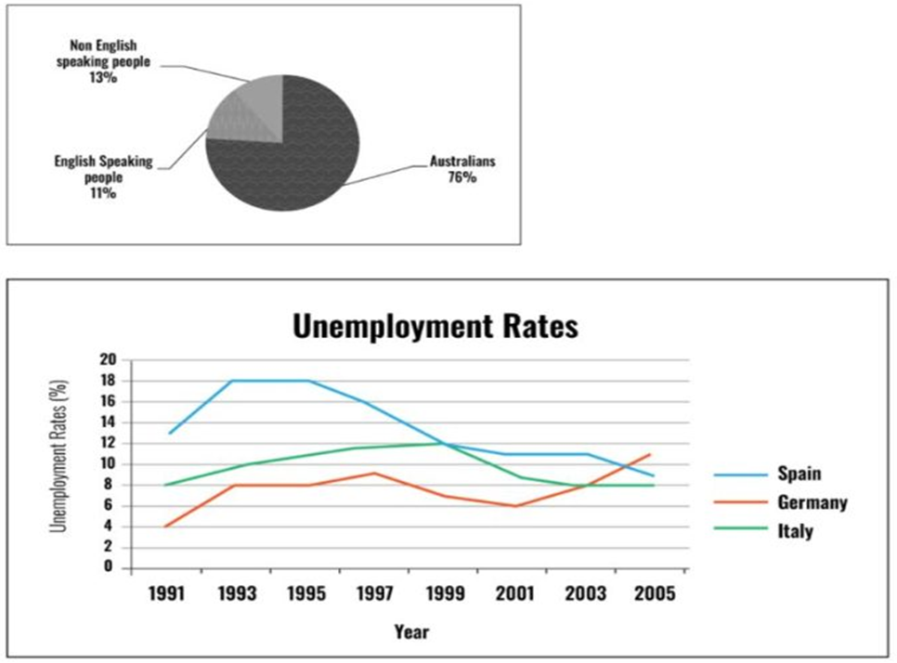
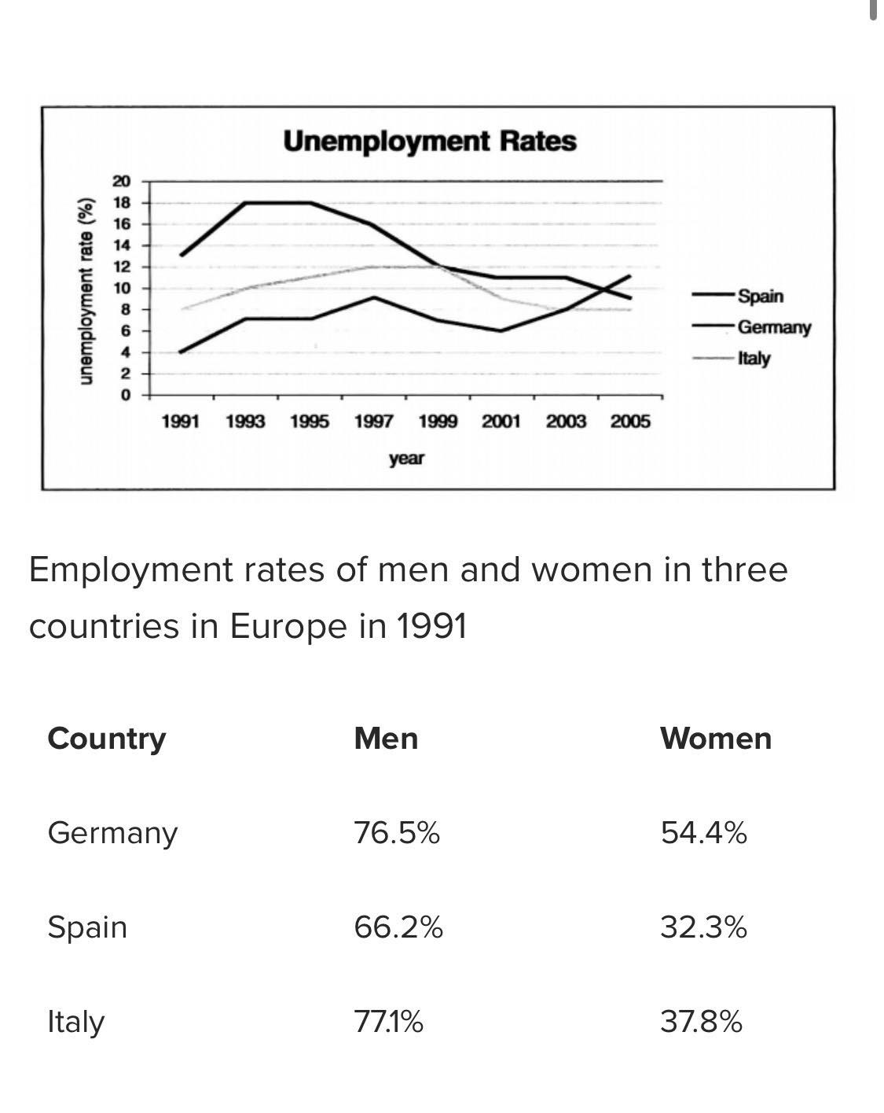

Part 2: Some people think history has little or nothing to offer, while others say the study of the past helps us understand the present.
Discuss both these views and give your own opinion.
Give reasons and include any relevant examples to support your answer.
(30 points)

-------------- THE END --------------

