Date of preparing: ………………………………….
Date of teaching: ………………………………….

Period …
UNIT 4: FESTIVALS and FREE TIME
Lesson 1 - Part 2 (Page 31) - Grammar

I. OBJECTIVES
By the end of the lesson, Ss will be able to…
1. Knowledge
- use adverbs of frequency to talk about how often we do things and how often things happen.
2. Ability
- improve speaking skills, listening skill, writing skills.
- improve the use of English.
3. Quality
- have positive attitude in English language learning so that they actively participate in all classroom activities.
- spend a suitable amount of time on studying and relaxing

II. TEACHING AIDS AND LEARNING MATERIALS
Lesson plan, PPT slides, student’s book, workbook, notebook, personal computer (if any), projector/TV, speakers, DCR & DHA on Eduhome, handouts…

III. PROCEDURES
A. Warm up: (5’)
a) Objective: to introduce the new lesson and set the scene for Ss to acquire new language; to get students' attention at the beginning of the class by means of enjoyable and short activities as well as to engage them in the steps that follow.
b) Content: rearranging words to make a meaningful sentence / Jumbled words
c) Product: Ss review some adverbs of frequency.
d) Competence: collaboration, critical thinking.
e) Organization of the activity:
Teacher’s Activities | Students’ Activities
- Give greetings  - Check attendance  - Option 1: Game “JUMBLED WORD”  - Have Ss rearrange letters to make a meaningful word  - Call Ss to give answers  - Check Ss’ answers, give feedback and lead to the new lesson  1. walays 2. onftn 3. lyaerr  4. vener 5. mosmtites 6. lulusay  - Option 2: REARRANGING  - Have Ss rearrange the words to make a meaningful English sentence  1. usually / she / on / plays / guitar / weekends / the / the  2. sister / goes / my / shopping / never  3. always / swimming / we / Sundays / go / on  4. father / newspaper / my / morning / the / reads / a / in / usually  5. breakfast / I / for / milk / have / often  - Have Ss read their answers  - Tell Ss about another grammar point they are going to study in the new lesson  →Lead to the new lesson | - Greet T  - Take part in the game  - Give answers (write on the board)  Answers keys  1. always 2. often 3. rarely  3. never 4. sometimes 5. usually  - Work in pairs  Answers keys  1. She usually plays the guitar on the weekends.  2. My sister never goes shopping.  3. We always go swimming on Sundays.  4. My father usually reads a newspaper in the morning.  5. I often have milk for breakfast.  - Give answers  - Listen

B. New lesson (36’)
- Activities 1: Grammar: Adverbs of frequency (18’)
a) Objective: Ss know how to use the adverbs of frequency.
b) Content:
- The usage of the adverbs of frequency.
- Filling in the blanks
c) Products: Ss can use the adverbs of frequency.in everyday communication.
d) Competence: Communication, collaboration, presentation, creativity.
e) Organization of the activity:
Teacher’s Activities | Students’ Activities
a. Listen and repeat  - Have Ss look at the picture  - Play audio (CD1 – Track 43) and have Ss listen and read the speech bubbles  - Play audio again and have Ss listen and repeat  Grammar box  - Option 1:  - Have Ss look at the grammar explanation  - Have Ss look at the box with the different forms  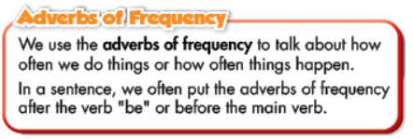  - Explain more about the usage of the adverbs of frequency, have Ss pay attention to the positions of these kinds of adverbs  *Usage: talk about how often we do things or how often things happen.  - Remind Ss to use always and usually with a time phrase  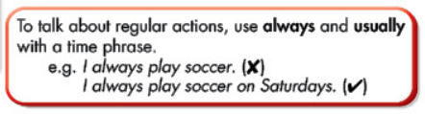  - Have some Ss read the sentences aloud  - Ask Ss to give more examples using adverbs of frequency  - Option 2:  - Have Ss close books  - Give some model sentences, have Ss tell the positions of adverbs of frequency and time phrase  - Call Ss to give answers  - Then have Ss open the books and read the grammar box  - Have Ss give more examples of adverbs of frequency, encourage them to make sentences with their own ideas  - Give feedback and evaluation  b. Fill in the blanks with the adverbs of frequency  - Option 1:  - Demonstrate the activity, using the example  - Have Ss fill in the blanks with the adverbs of frequency  - Have Ss work in pairs to check each other’s work  - Have some Ss share their answers with the whole class  - Give feedback, correct Ss’ answers if necessary  - Option 2:  - Follow the same steps as option 1  - Give Ss an extra exercise, using another way to express the frequency of the activities.  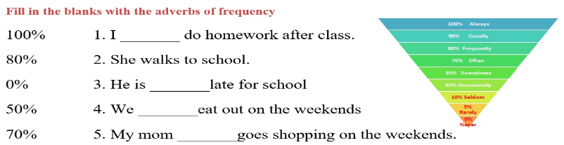  - Have Ss work in pairs to do the exercise  - Call Ss to give answers  - Give feedback, correct Ss’ answers if necessary | - Look  - Listen, then read  - Listen and repeat  - Look and read  - Read  - Listen and take notes  - Read  - Give examples  - Close all books  - Look and answer  - Read  - Give examples  - Look and listen  - Work individually  - Work in pairs  - Read answers  Answer keys  2. usually 3. never 4. always  5. often 6. rarely  - Work in pairs  - Give answers  Answer keys  1. always 2. frequently 3. never  4. sometimes 5. often
- Activity 2: Practice - Writing and Speaking (18’)
a) Objective: Ss can write sentences, using adverbs of frequency.
b) Content: Looking at the table and writing answers
c) Products: Ss can apply the use of adverbs of frequency in everyday communication esp. in speaking and writing.
d) Competence: Collaboration, communication, creativity.
e) Organization of the activity:
Teacher’s Activities | Students’ Activities
c. Look at the photo and write answers  - Option 1:  - Demonstrate the activity, using the table  - Have Ss write the answers  - Have Ss work in pairs to check each other’s work  - Have some Ss share their answers with the whole class (Write on the board)  - Check, correct Ss’ answers  - Option 2:  - Follow the same steps as option 1  - Have Ss close all books and notebooks  - Give Ss extra exercise: Choose the best answer  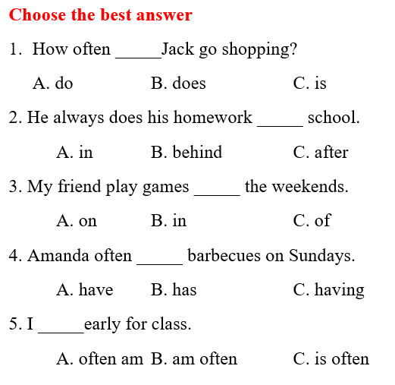  d. Ask your partner how often they do these activities  - Have Ss do the task in pairs, then swap the roles  - Call Ss to demonstrate the activity in front of the class  - Give feedback and correct Ss’ pronunciation if necessary | - Look and listen  - Work individually  - Work in pairs  - Write answers  Answer keys  1. Jack rarely goes shopping (on the weekends) (The time phrase may vary)  2. Bobby always does his homework (after school).  3. Sarah sometimes plays soccer.  4. Amanda often has barbecues.  - Close books and notebooks  - Work in pairs  - Read the answers aloud  Answer keys  1. B 2. C 3. A 4. B 5. B  - Work in pairs  - Present

C. Consolidation (2’)
* The adverbs of frequency
Position: after “be” or before the main verb
To talk about regular actions “always” and “usually” are used with a time phrase

D. Homework (2’)
- Make 3 sentences, using adverbs of frequency.
- Do exercise in Workbook: Lesson 1 - Grammar (page 23).
- Prepare: Lesson 1 – Pronunciation and Speaking (page 32 – SB).

