**ĐỀ VIP 9+ - ĐỀ SỐ 8**

***Read the following leaflet and mark the letter A, B, C, or D to indicate the correct option that best fits each of the numbered blanks from 1 to 6.***

# DISCOVER THE WILD AT PEAK ADVENTURE CENTRE!

Looking for a (1) outdoor experience? At Peak Adventure Centre, you’ll find thrilling activities (2) to challenge and excite. From mountain climbing and river rafting to an exhilarating ropes course, there’s something for everyone here!

Our dedicated instructors provide expert guidance, allowing enjoying (3) adventure safely and at your own pace. For those new (4) adventure sports, we offer beginner-friendly programmes covering the basics while ensuring safety. All equipment is included, ensuring a stress-free experience. Peak Adventure Centre is located near a (5) , creating a perfect base for a weekend escape, surrounded by nature’s beauty.

Have questions or want to book? (6) us a ring at (555) 123-4567 – we’re ready to make your adventure unforgettable!

|  |  |  |  |  |
| --- | --- | --- | --- | --- |
| **Question 1.** | **A.** refreshed | **B.** refreshing | **C.** refresh | **D.** refreshment |
| **Question 2.** | **A.** designed | **B.** designing | **C.** are designed | **D.** which design |
| **Question 3.** | **A.** other | **B.** each | **C.** several | **D.** the others |
| **Question 4.** | **A.** with | **B.** for | **C.** by | **D.** to |
| **Question 5.** | **A.** stunning lake forest |  | **B.** lake stunning forest | |
|  | **C.** forest stunning lake |  | **D.** stunning forest lake | |
| **Question 6.** | **A.** Book | **B.** Take | **C.** Give | **D.** Put |

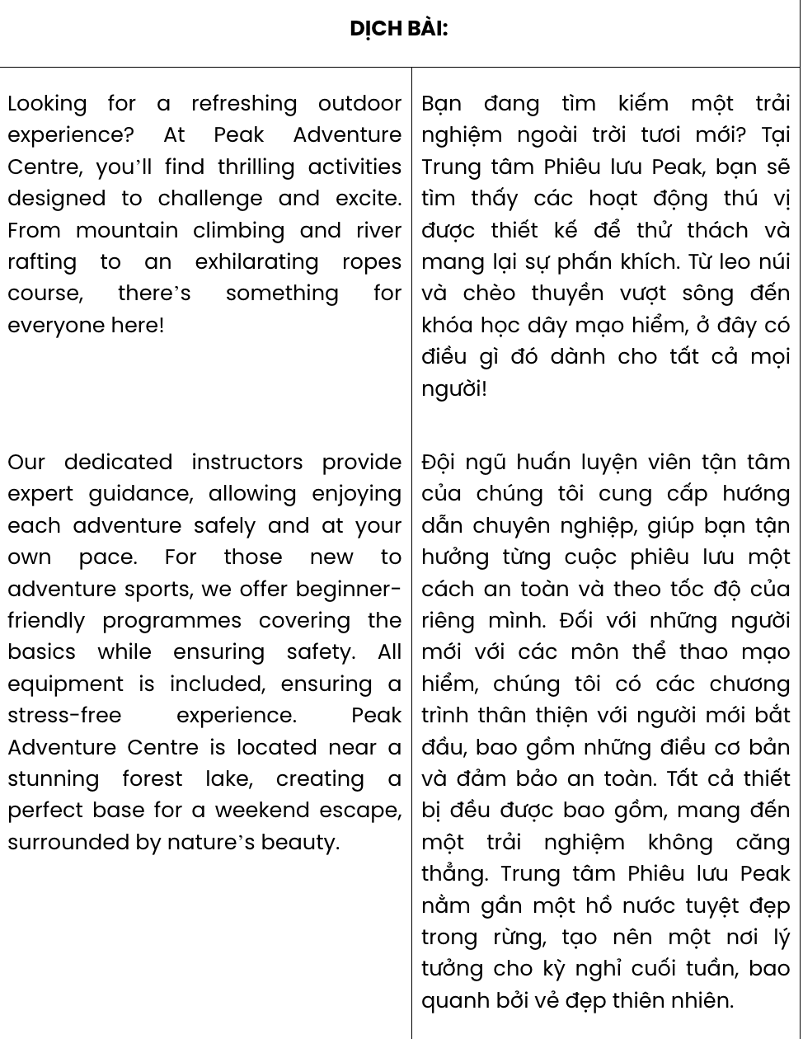

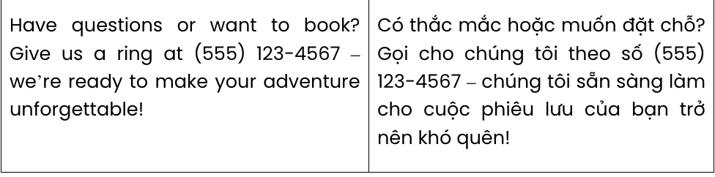

**GIẢI CÂU 1:**

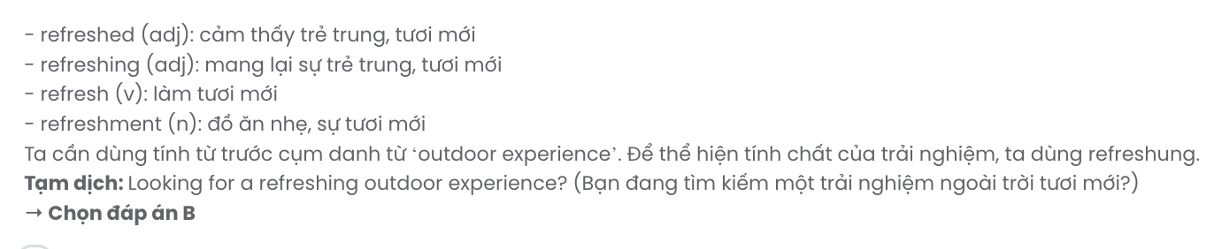

**GIẢI CÂU 2:**

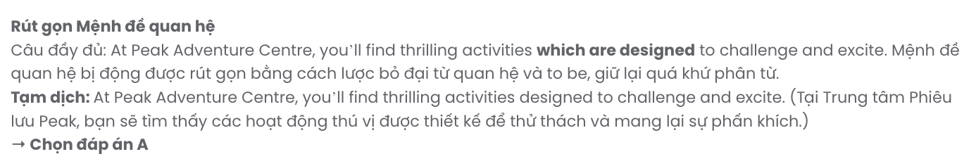

**GIẢI CÂU 3:**

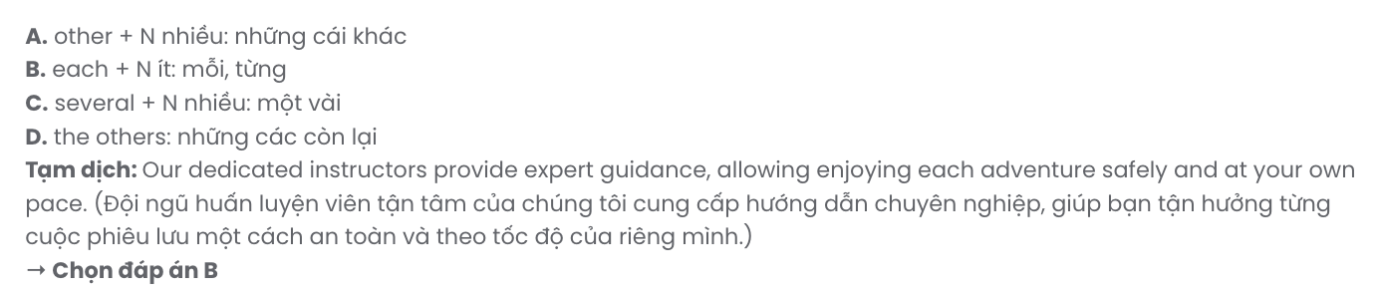

**GIẢI CÂU 4:**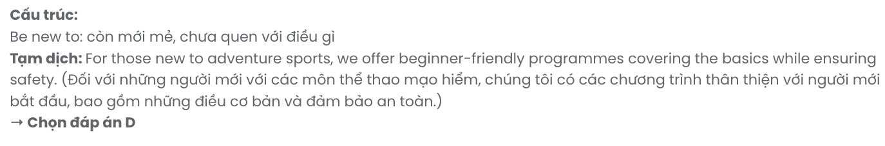

**GIẢI CÂU 5:**

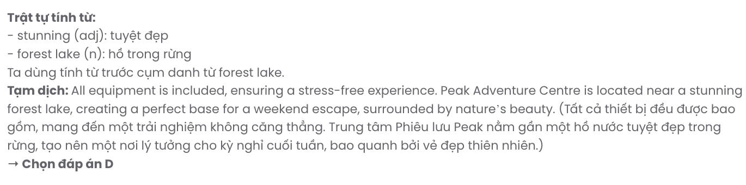

**GIẢI CÂU 6:**



***Read the following notice and mark the letter A, B, C, or D to indicate the correct option that best fits each of the numbered blanks from 7 to 12.***

# NOTICE: ASEAN STUDENT EXCHANGE PROGRAMME

We are pleased to announce an upcoming exchange programme for high school students from ASEAN countries. This programme aims to (7) stronger cultural ties and mutual understanding. Students will participate in a (8) of activities, including cultural workshops, team-building events, and local excursions. Participants will have the opportunity to (9) with peers from different countries, building friendships and shared experiences. The programme will involve (10) about sustainable development and community (11) . (12) the application process, please contact the Student Affairs Office. We look forward to your contribution to this exciting regional experience!

|  |  |  |  |  |
| --- | --- | --- | --- | --- |
| **Question 7.** | **A.** make out | **B.** turn into | **C.** bring about | **D.** put up |
| **Question 8.** | **A.** variety | **B.** degree | **C.** volume | **D.** quality |
| **Question 9.** | **A.** promote | **B.** contribute | **C.** evaluate | **D.** interact |
| **Question 10.** | **A.** learning | **B.** to learning | **C.** to learn | **D.** learn |
| **Question 11.** | **A.** purposes | **B.** influences | **C.** initiatives | **D.** resources |
| **Question 12.** | **A.** In the light of | **B.** With regards to | **C.** Apart from | **D.** In place of |

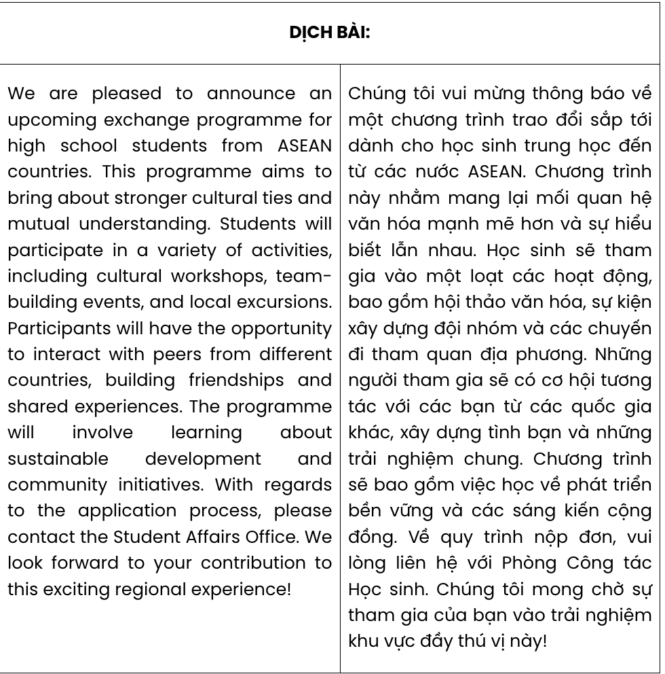

**GIẢI CÂU 7:** GIA SƯ TẠI HUẾ (0793833272)

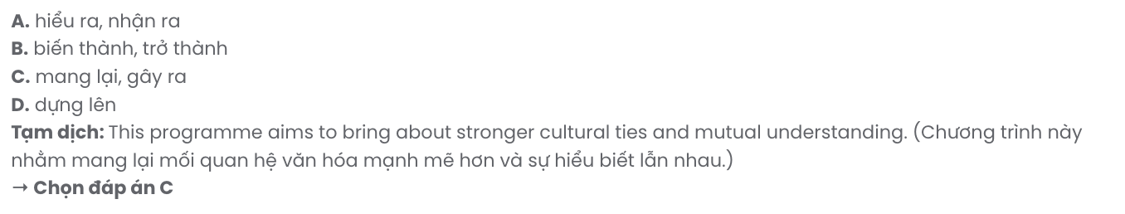

**GIẢI CÂU 8:**

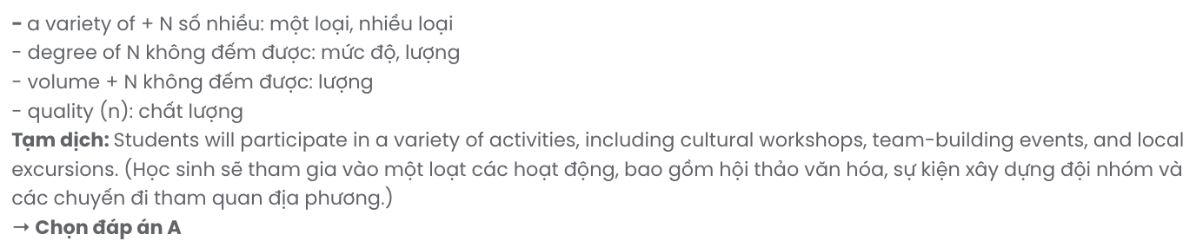

**GIẢI CÂU 9:**

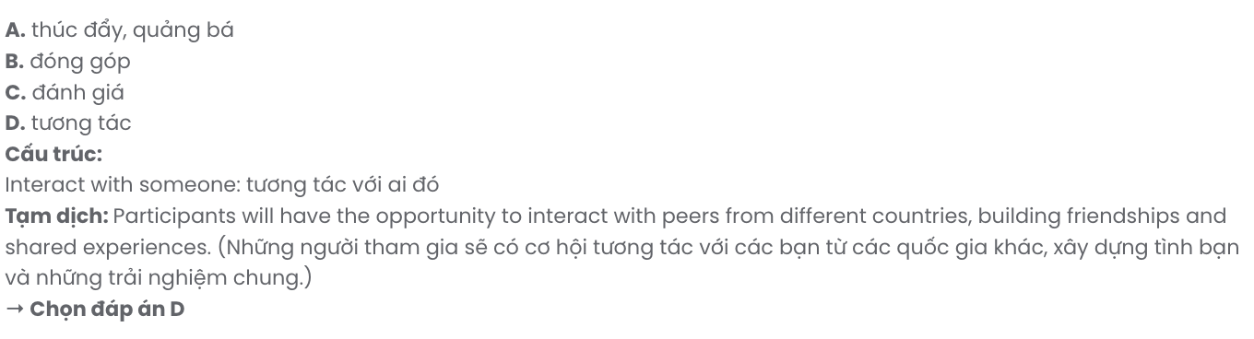

**GIẢI CÂU 10:**

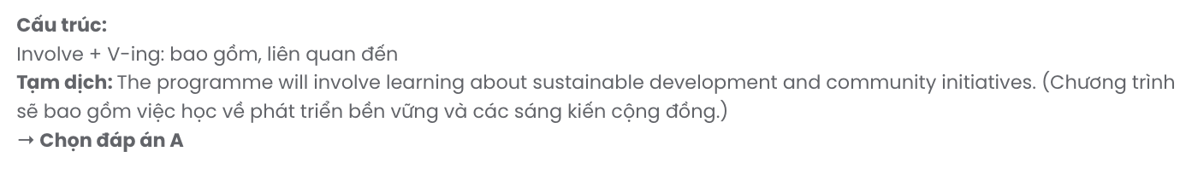

**GIẢI CÂU 11:**

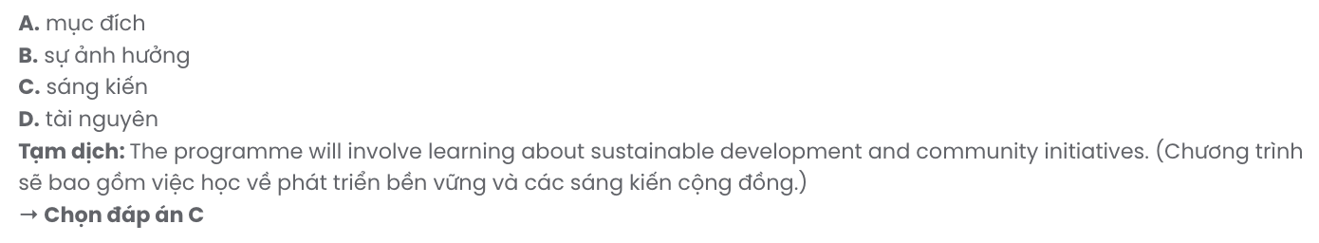

**GIẢI CÂU 12:**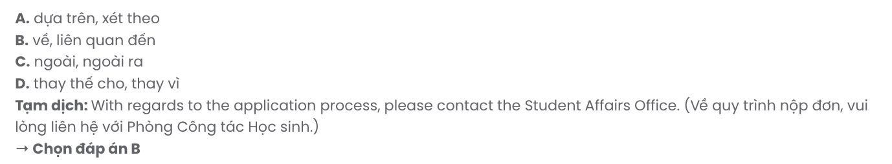

***Mark the letter A, B, C or D to indicate the best arrangement of utterances or sentences to make a meaningful exchange or text in each of the following questions from 13 to 17.***

# Question 13.

1. Max: Isn’t it hard to keep up with yoga practice regularly?
2. Max: How do you usually unwind after work?
3. Max: That sounds perfect, but I’m not sure I’d be able to commit to it consistently.
4. Sarah: I’ve taken up yoga recently. It really helps me relax and clear my mind.
5. Sarah: The classes are flexible, so I can join whenever I have time.

**A.** b – e – c – d – a **B.** a – e – c – d – b **C.** b – d – a – e – c **D.** a – d – b – e – c

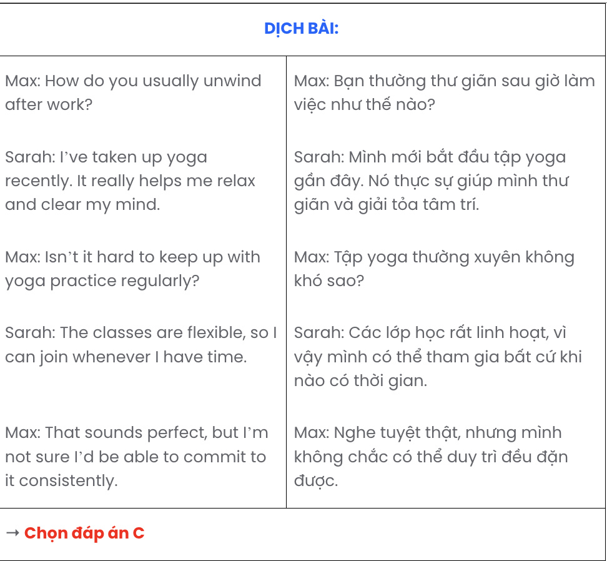

# Question 14.

Dear Max,

1. This interest began when I bought a few plants for the balcony, but it has quickly turned into a passion.
2. If you have any tips for a beginner, I’d love to hear them!
3. I’ve been learning how to care for each one, and the process of nurturing these plants has been surprisingly relaxing.
4. The basil and mint are thriving, and they bring a fresh scent to the space.
5. I’ve recently taken up a new interest that has quickly become a favourite - gardening. Write back soon,

Kate

**A.** e – a – c – d – b **B.** a – c – b – e – d **C.** c – a – e – b – d **D.** d – b – e – a – c

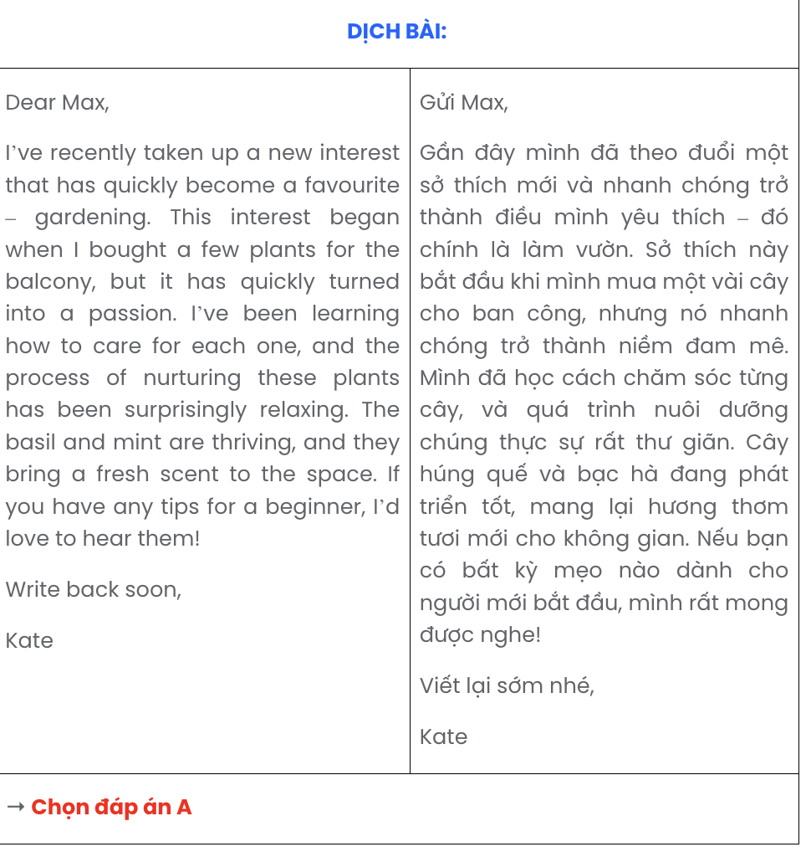

# Question 15.

1. Maya: Have you been using a virtual assistant lately?
2. Leo: Yes, mostly for reminders and looking up quick facts - it’s really convenient.
3. Maya: I hadn’t thought of that! I’ll have to give it a try.

**A.** a – c – b **B.** c – b – a **C.** c – a – b **D.** a – b – c

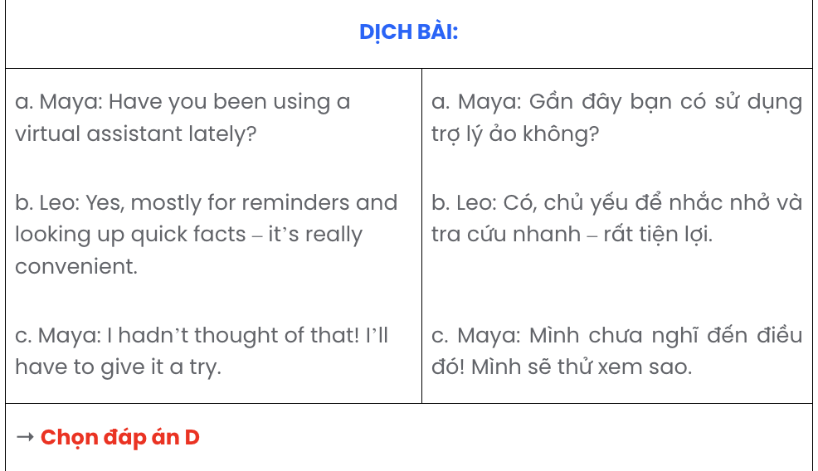

# Question 16.

1. This undertaking has demanded not only patience but also consistent practice, as I strive to build a strong foundation day by day.
2. The journey was daunting at first, with the complex grammar rules and an entirely unfamiliar vocabulary.
3. Learning a foreign language I’d always found fascinating has turned into a new challenge I’m fully committed to.

**e.** While there are inevitable setbacks and moments of frustration during the journey, each small achievement provides a sense of progress and keeps me motivated.

1. Ultimately, this immersive experience has broadened my perspective, deepened my appreciation for different cultures, and reinforced the importance of persistence.

**A.** b – e – c – a – d **B.** c – b – a – e – d **C.** e – b – c – a – d **D.** a – e – c – b – d

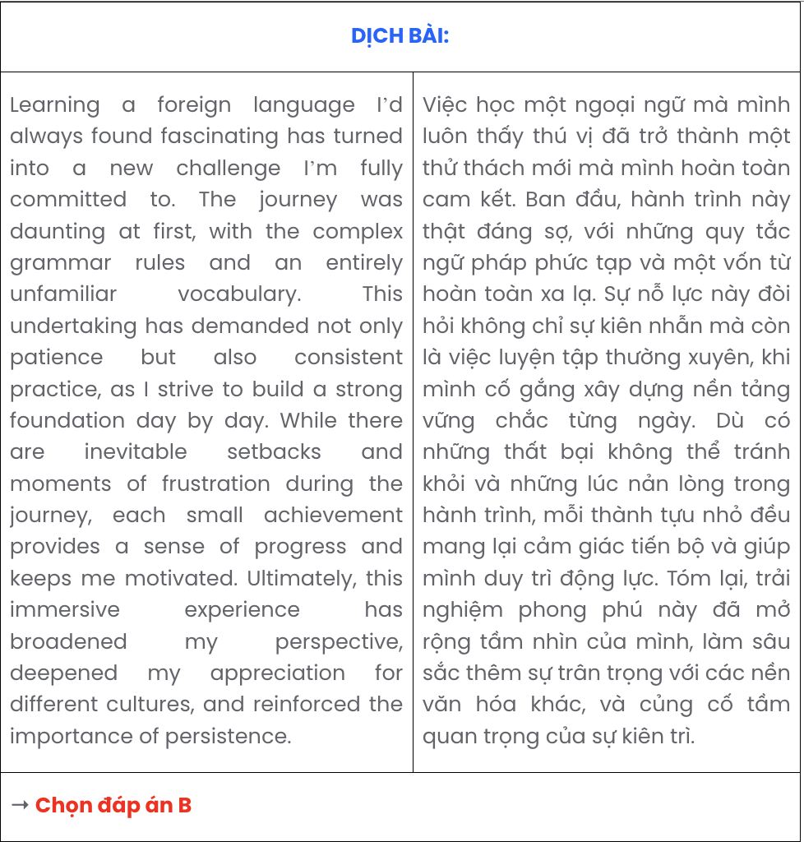

# Question 17.

1. These individuals often build large followings by sharing content that resonates with specific audiences.
2. The influence they wield can shape trends, drive consumer behaviour, and even impact public opinion.
3. However, the pressure to maintain an online persona can be intense, as these influencers constantly seek to stay relevant and engaging.
4. Social media influencers have become a powerful force in today’s digital landscape.
5. Through platforms like Instagram and TikTok, influencers showcase products, lifestyles, and ideas to their followers.

**A.** d – b – c – a – e **B.** d – e – b – c – a **C.** d – a – b – e – c **D.** d – c – e – a – b

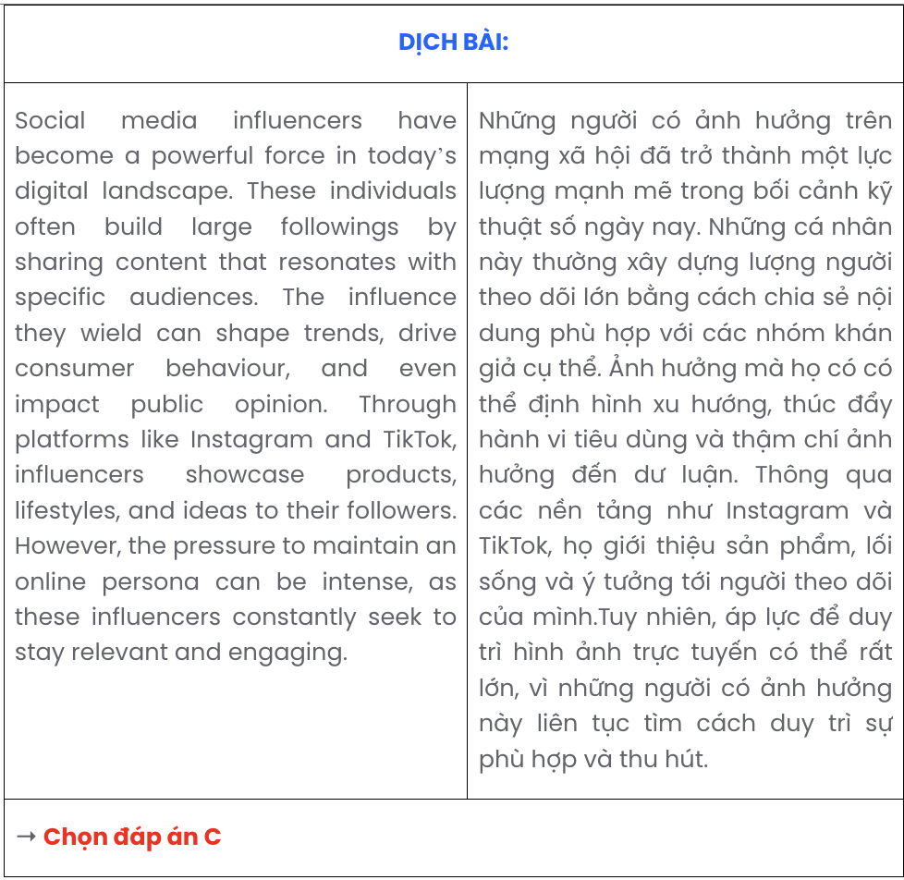

***Read the following passage about bike-sharing systems and mark the letter A, B, C, or D to indicate the correct option that best fits each of the numbered blanks from 18 to 22.***

Bike-sharing systems, popular forms of sustainable urban transportation, are revolutionising how people commute in cities. For instance, Citi Bike, one of the largest bike-sharing programs in the United States, was launched in New York City in 2013. Shortly after, it expanded to other cities and has since become a reliable transport option for millions of users. (18) .

The bike-sharing system was developed by a US-based company (19) . This network, along with others worldwide, (20) .

The bikes used in this system are sturdy, weather-resistant, and equipped with tracking technology. They have built-in lights for night use and GPS devices to locate available bikes easily. (21) .

Bike-sharing systems are lauded for their ability to make urban transportation more sustainable. The integration of mobile apps and real-time tracking software allows users to locate, reserve, and unlock bikes from their phones, enhancing the ease of use. Equipped with efficient data management systems,

(22) .

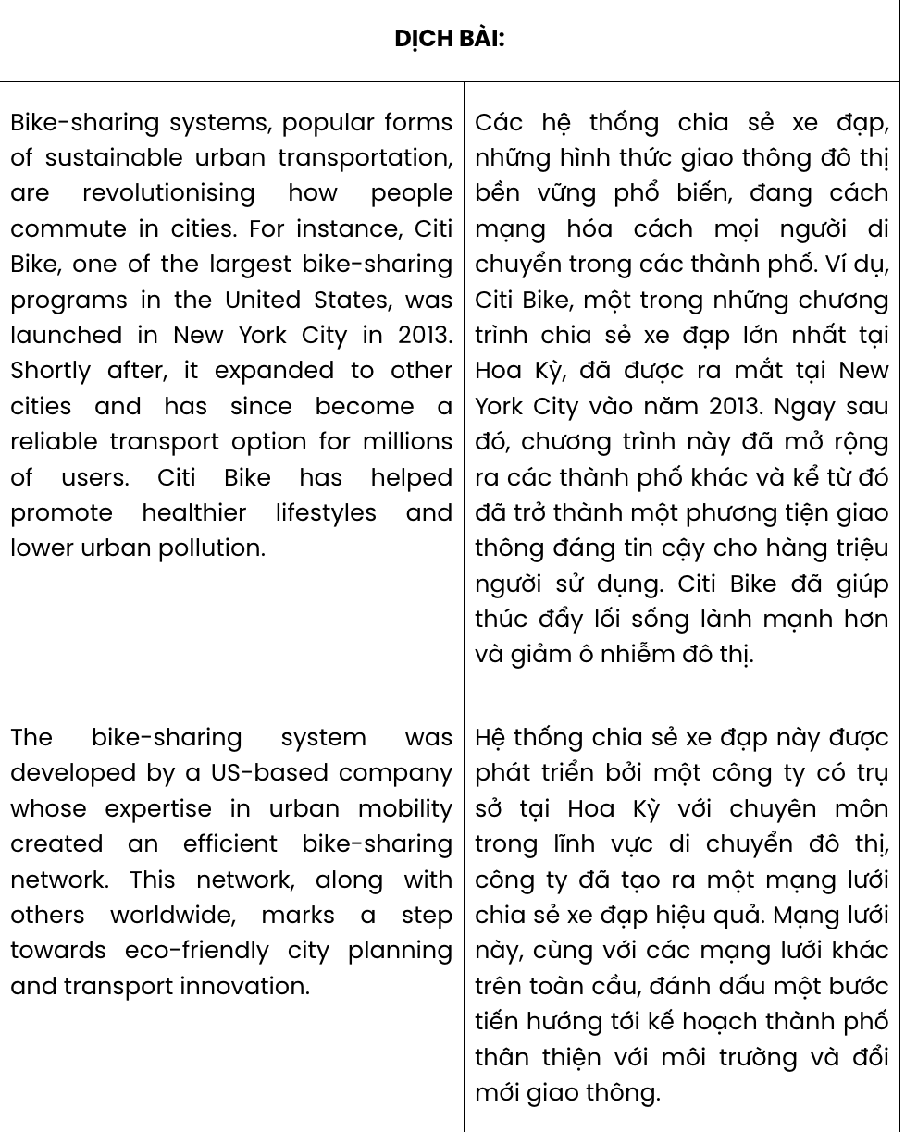

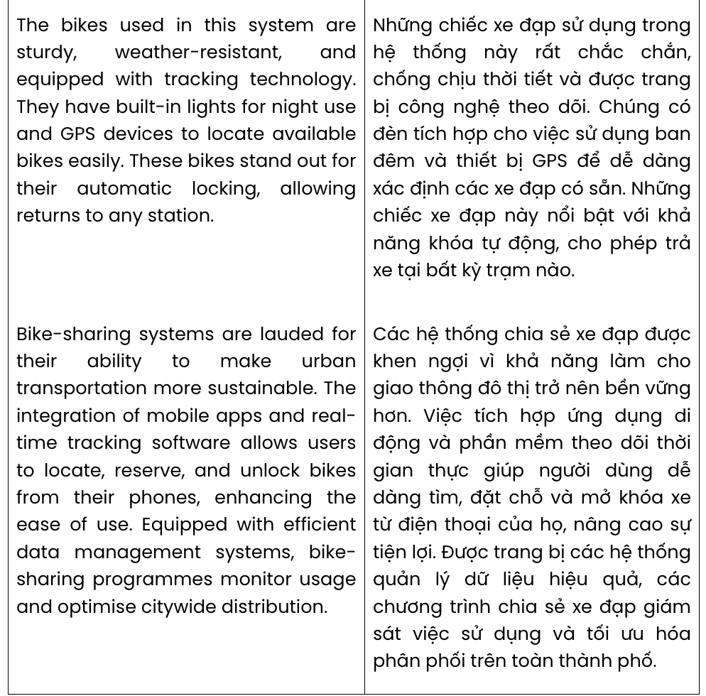

# Question 18.

**A.** Wishing to promote healthier lifestyles and lower urban pollution, Citi Bike is helpful

**B.** Citi Bike has helped promote healthier lifestyles and lower urban pollution

**C.** Promoting healthier lifestyles and lowering urban pollution is useful to Citi Bike

**D.** The assistance in healthier lifestyles and low urban pollution promotes Citi Bike

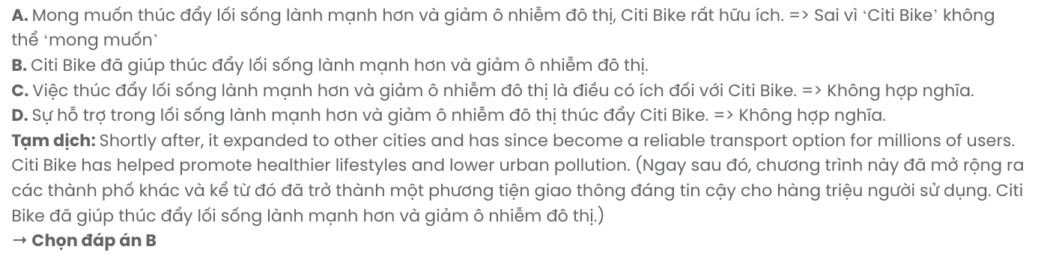

# Question 19.

**A.** specialised in urban mobility to create an efficient bike-sharing network

**B.** prioritised creating an efficient bike-sharing network through urban mobility

**C.** of which speciality in creating an efficient bike-sharing network by urban mobility

**D.** whose expertise in urban mobility created an efficient bike-sharing network

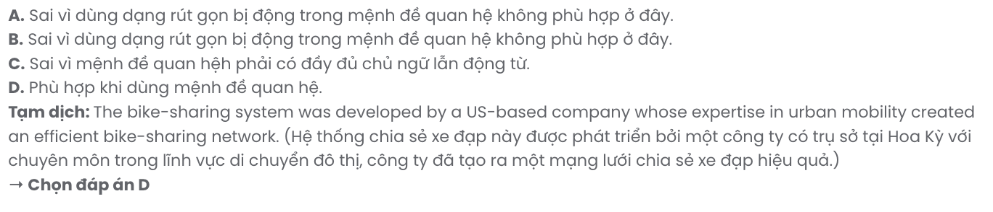

# Question 20.

**A.** marks a step towards eco-friendly city planning and transport innovation

**B.** signifying progress towards eco-friendly city planning and transport innovation

**C.** of which a move towards eco-friendly city planning and transport innovation is marked

**D.** that represents progress towards eco-friendly city planning and transport innovation

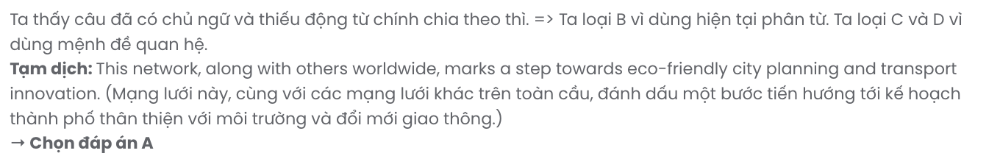

# Question 21.

**A.** These bikes stand out for their automatic locking, allowing returns to any station

**B.** These bikes allow returns to any station so that their automatic locking is outstanding

**C.** Allowing returns to any station, their automatic locking sets these bikes apart

**D.** Without their outstanding automatic locking, these bikes could allow returns to any station

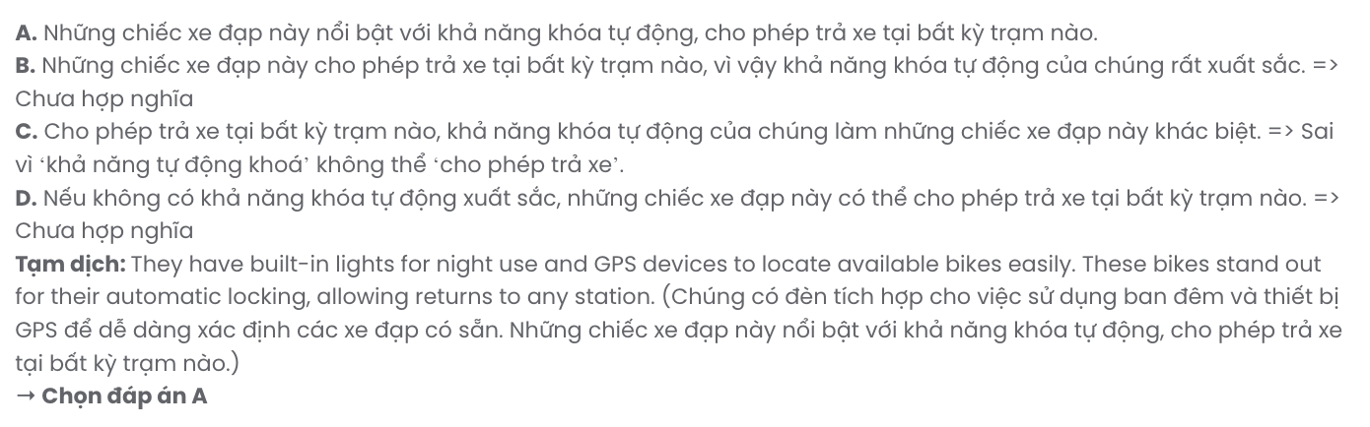

# Question 22.

**A.** programmes monitoring usage and optimising citywide distribution facilitate bike-sharing

**B.** monitored usage and optimised citywide distribution are part of bike-sharing programmes

**C.** they help bike-sharing programmes monitor usage and optimise citywide distribution

**D.** bike-sharing programmes monitor usage and optimise citywide distribution

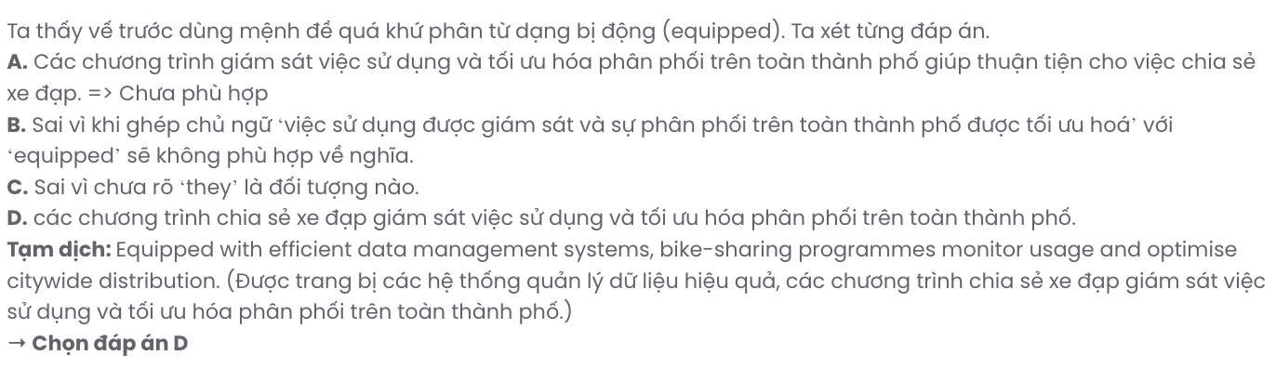

***Read the following passage about Lisbon and mark the letter A, B, C, or D to indicate the correct answer to each of the questions from 23 to 30.***

Lisbon, which has been the capital of Portugal since 1252, is both beautiful and historic. Today, visitors can spend their time walking across Lisbon's beautiful squares, exploring the city's narrow streets and wide range of shopping opportunities - from high-end designer shops to market stalls. Or, **they** can simply sit in the wonderful cafés and restaurants which serve great local food.

Lisbon is rich in ancient cultural **delights**. Under the busy shopping area in the city centre, there is a hidden network of 2,000-year-old Roman rooms. If history is your passion, Lisbon certainly won't disappoint. There are many other places to visit: the Gulbenkian Museum, the 16th century Jeronimos Monastery, the Castle of St George, and the wonderful Alfama district, with its lively eateries and traditional Fado music.

If you are hoping to travel around and see more of the city, there are **various** options. You might like to jump on the old tram system, which has been in use from 1873, or go on a bike tour of the city or a river cruise. You could also visit the zoo, the modern Pavilion of Knowledge, which is Lisbon's own interactive science museum, or one of the largest indoor aquariums in Europe, the Oceanarium.

Lisbon is one of the few European cities lucky enough to be so close to sandy beaches, which are rarely over-crowded, except perhaps in August. However, it's not just a summer destination either. **Lisbon has one of the mildest climates of any European cities, making it good to visit all year around.**

(Adapted from *Gateway*)

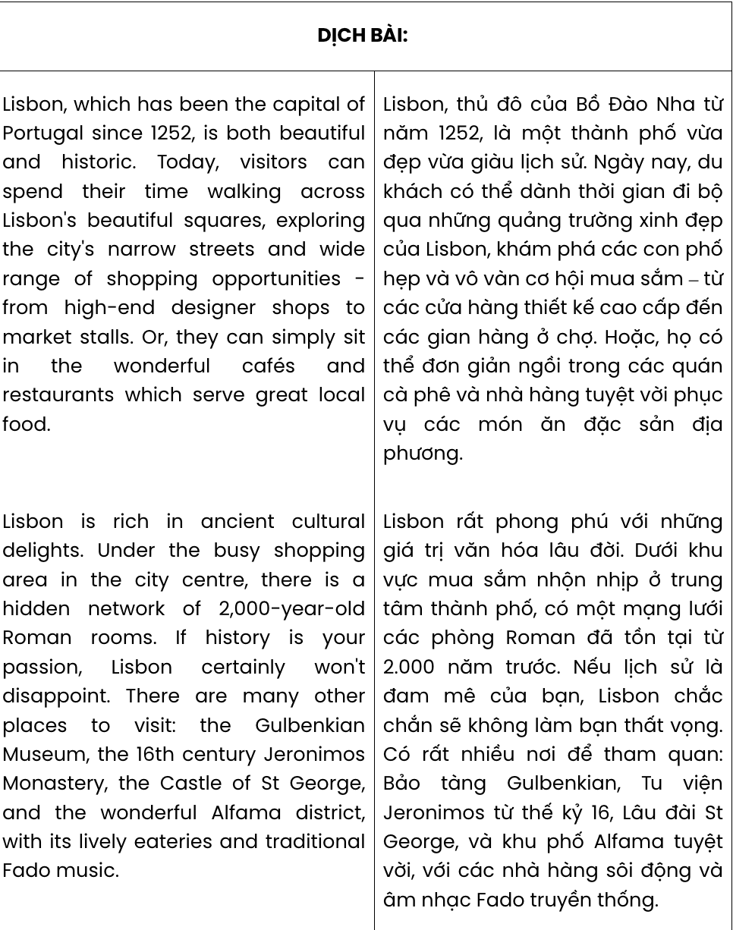

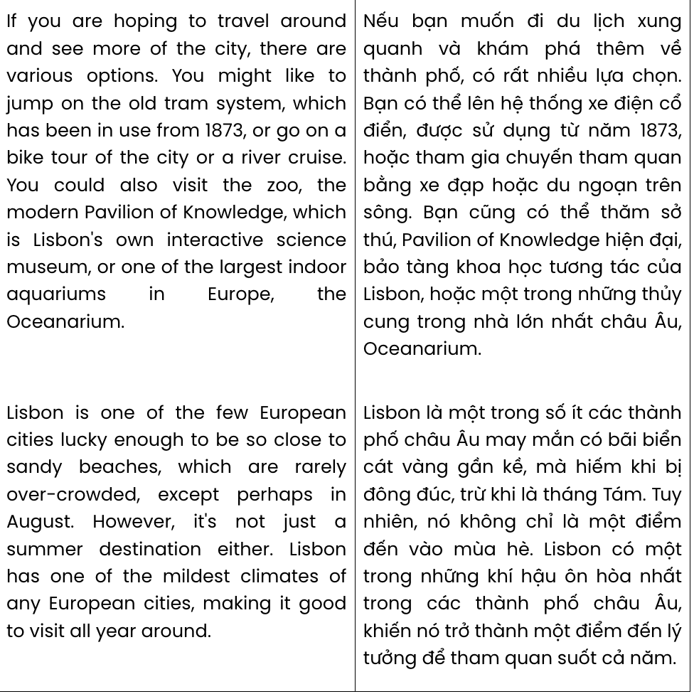

**Question 23.** The word **they** in paragraph 1 refers to . GIA SƯ TAI HUẾ (079.3833.272)

**A.** squares **B.** shops **C.** tourists **D.** market stalls

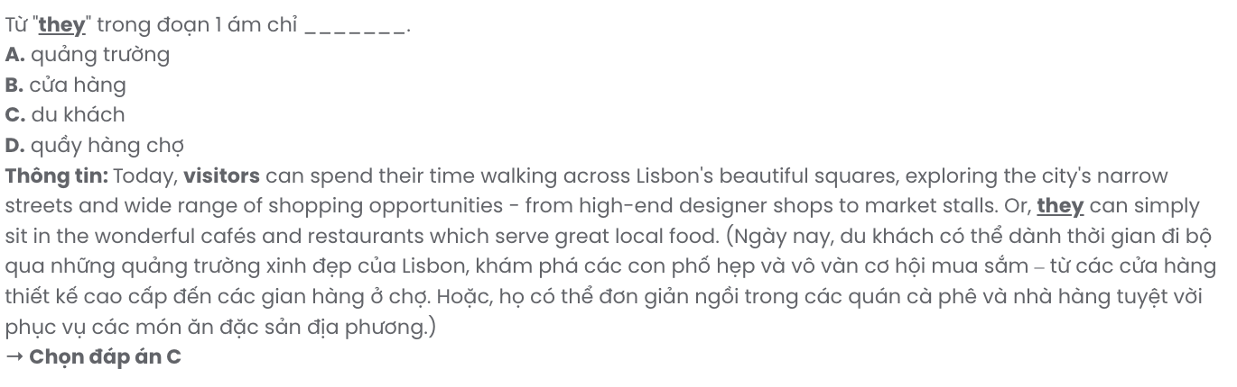

**Question 24.** According to paragraph 1, tourists can do all the following when visiting Lisbon EXCEPT

.

**A.** browsing clothes stores **B.** walking through beautiful squares

**C.** trying local dishes **D.** watching parades in narrow streets

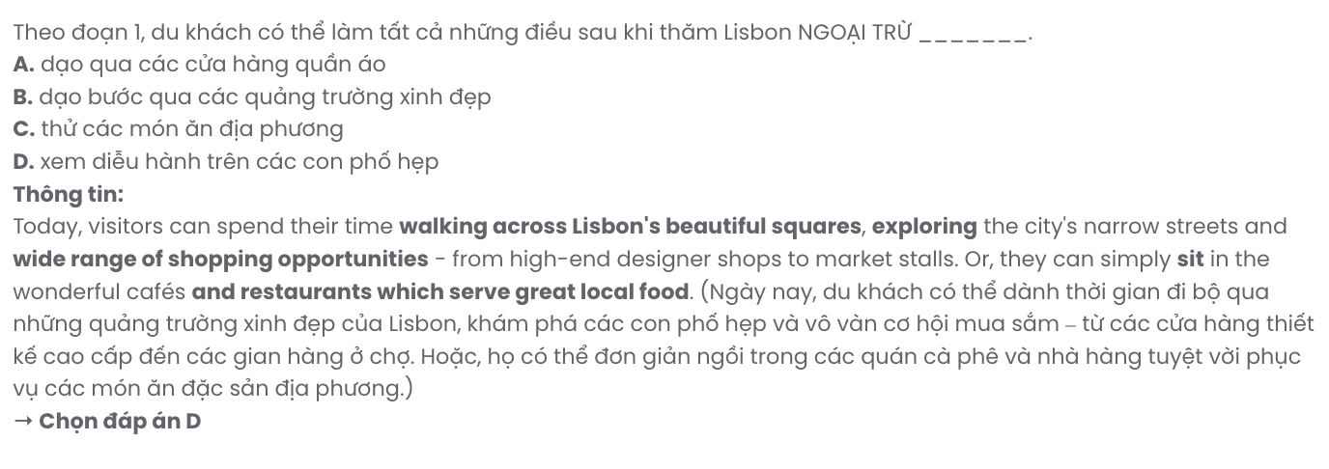

**Question 25.** The word **delights** in paragraph 2 mostly means .

**A.** features **B.** habits **C.** feelings **D.** joys

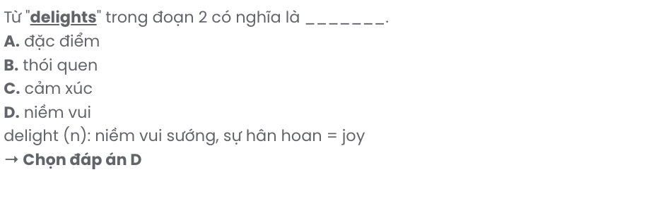

**Question 26.** The word **various** in paragraph 3 is OPPOSITE in meaning to .

**A.** top-rated **B.** numerous **C.** restricted **D.** customary

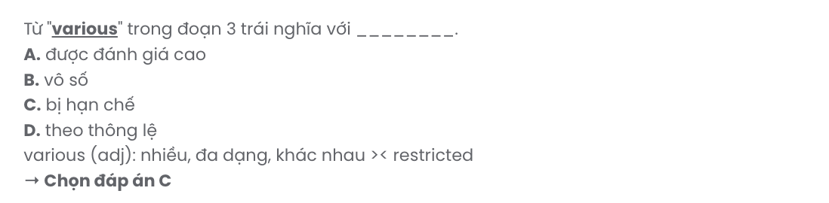

**Question 27.** Which of the following best paraphrases the underlined sentence in paragraph 4?

# Lisbon has one of the mildest climates of any European cities, making it good to visit all year around.

**A.** Lisbon’s mild climate, one of the most comfortable in Europe, makes it a great year-round destination.

**B.** Lisbon has one of Europe’s mildest climates, making it an ideal place to visit throughout the year.

**C.** Lisbon’s weather is known for its warmth, making it an attractive destination in every season.

**D.** Lisbon is pleasant all year due to its warm, mild weather that draws visitors from across Europe.

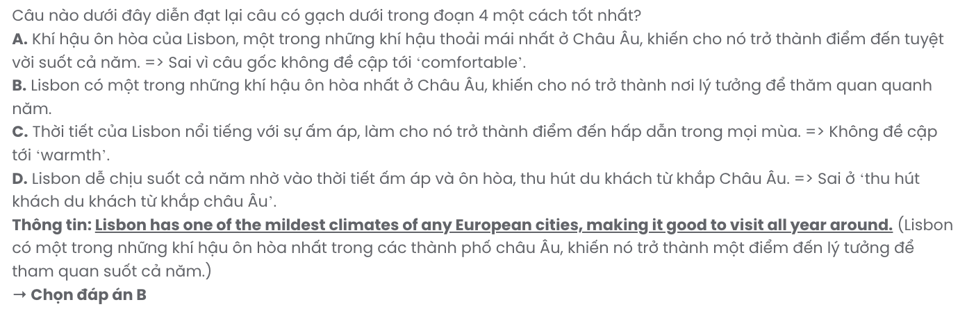

**Question 28.** Which of the following is true according to the passage?

**A.** The Pavilion of Knowledge is the only interactive science museum in Lisbon.

**B.** Famous beaches in Lisbon hardly get overcrowded, especially in August.

**C.** 2,000-year-old Roman rooms are located in busy shopping streets in Lisbon.

**D.** Lisbon offers a variety of transportation options for exploring the city.

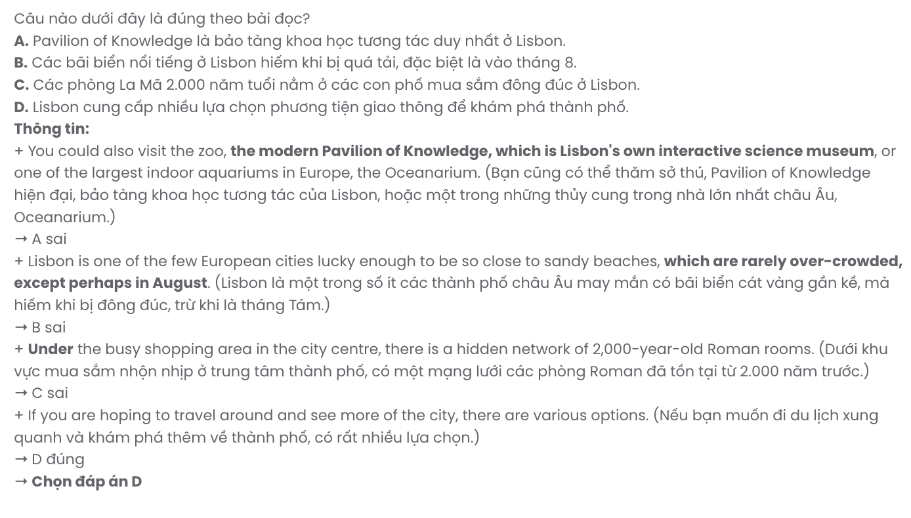

**Question 29.** In which paragraph does the writer suggest some places for travellers who are keen on going back in time?

**A.** Paragraph 1 **B.** Paragraph 2 **C.** Paragraph 3 **D.** Paragraph 4

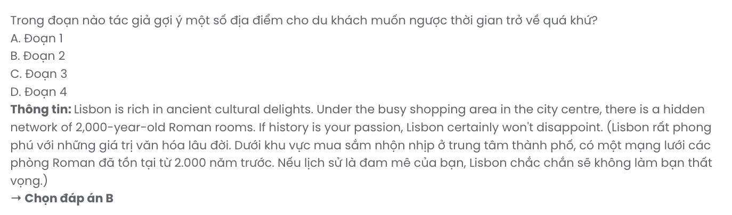

**Question 30.** In which paragraph does the writer mention a contrast relationship?

**A.** Paragraph 1 **B.** Paragraph 2 **C.** Paragraph 3 **D.** Paragraph 4

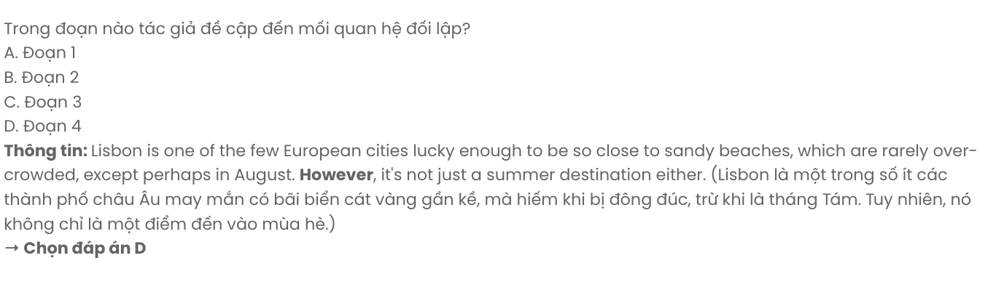

***Read the following passage about the largest school in the world and mark the letter A, B, C, or D to indicate the correct answer to each of the questions from 31 to 40.***

The first day at school can be quite scary for any pupil but imagine being one among 50,000 or more! That is the total number of students at the City Montessori School in Lucknow, India. The school, better known as CMS, employs 4,500 staff including teachers, support staff, and others such as cleaners and gardeners. The school was set up by husband and wife team Dr Jagdish Gandhi and Bharti Gandhi in 1959. The first pupils were the children of family members - and there were only five of them. As time went by, more people started to hear about the school and **they** wanted their children to attend. Slowly, the numbers rose.

The school educates students between the ages of 3 and 17. **[I]** But due to the size of the school, it is never possible for everyone to meet as there is no place that is big enough for everyone to fit in. **[II]** One of the school's heads, Dr Gandhi's daughter Geeta Kingdon, said in an interview that, 'The whole of Lucknow would be **jammed** if we tried because one bus holds 50 children, so we'd need 1,000 buses to bring everyone together. **[III]** The school doesn't receive any money from the government and the children's parents are only charged a small amount for their children to attend. **[IV]**

For each pupil, there is also one teacher responsible for his or her health and life outside the classroom. In this way, the staff believe that no one is forgotten. Besides the traditional subjects such as maths, English and geography, the students also learn about world peace. CMS is the only school in the world to be awarded a UNESCO Peace Prize for Education for its **endeavours** in this field.

**Today, the school is famous for its exam results and its international exchange programmes**. The school has some well-respected past students, who have gone on to work in international organisations. However, within the school, and especially with everyone wearing the same uniform, it can be difficult to get noticed, so the students have to work especially hard. Dr Gandhi believes that the children receive not only an education, but also a love of the world.

(Adapted from *Prepare*)

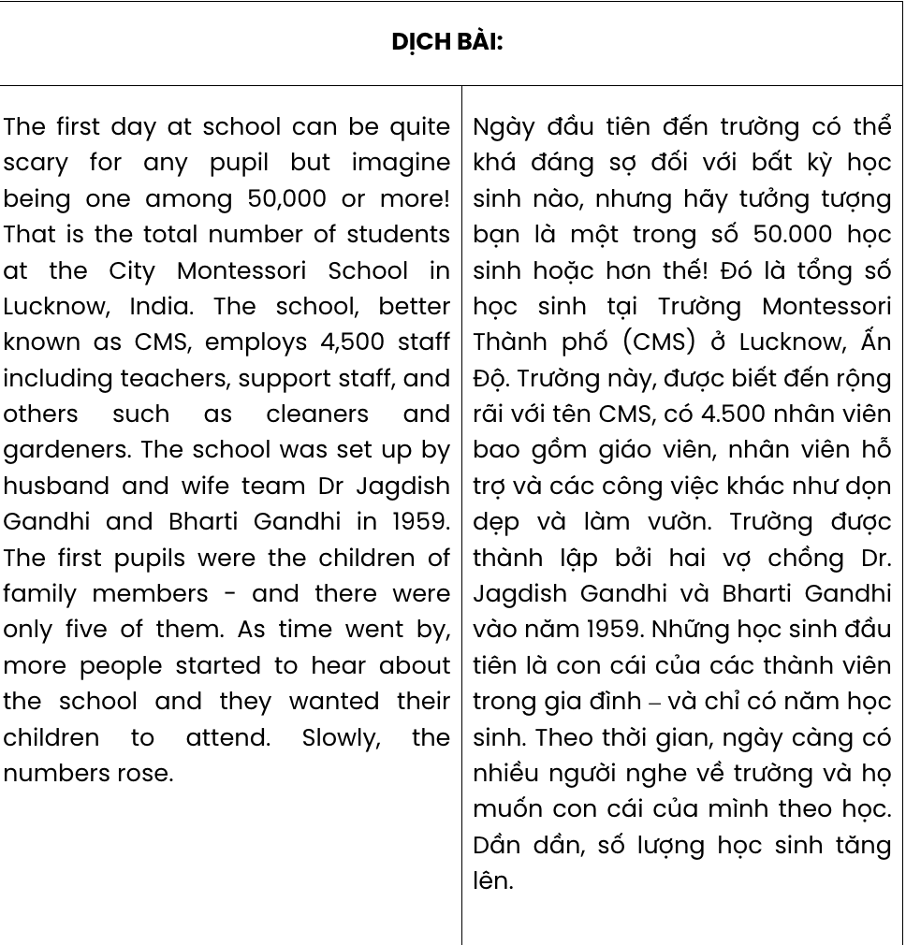

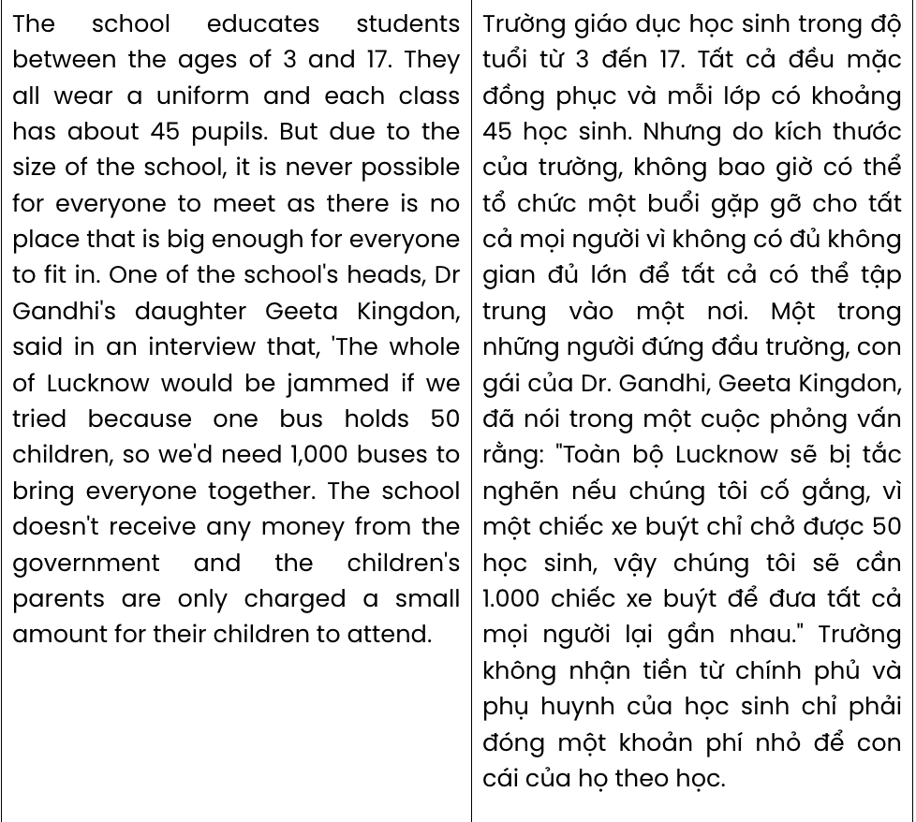

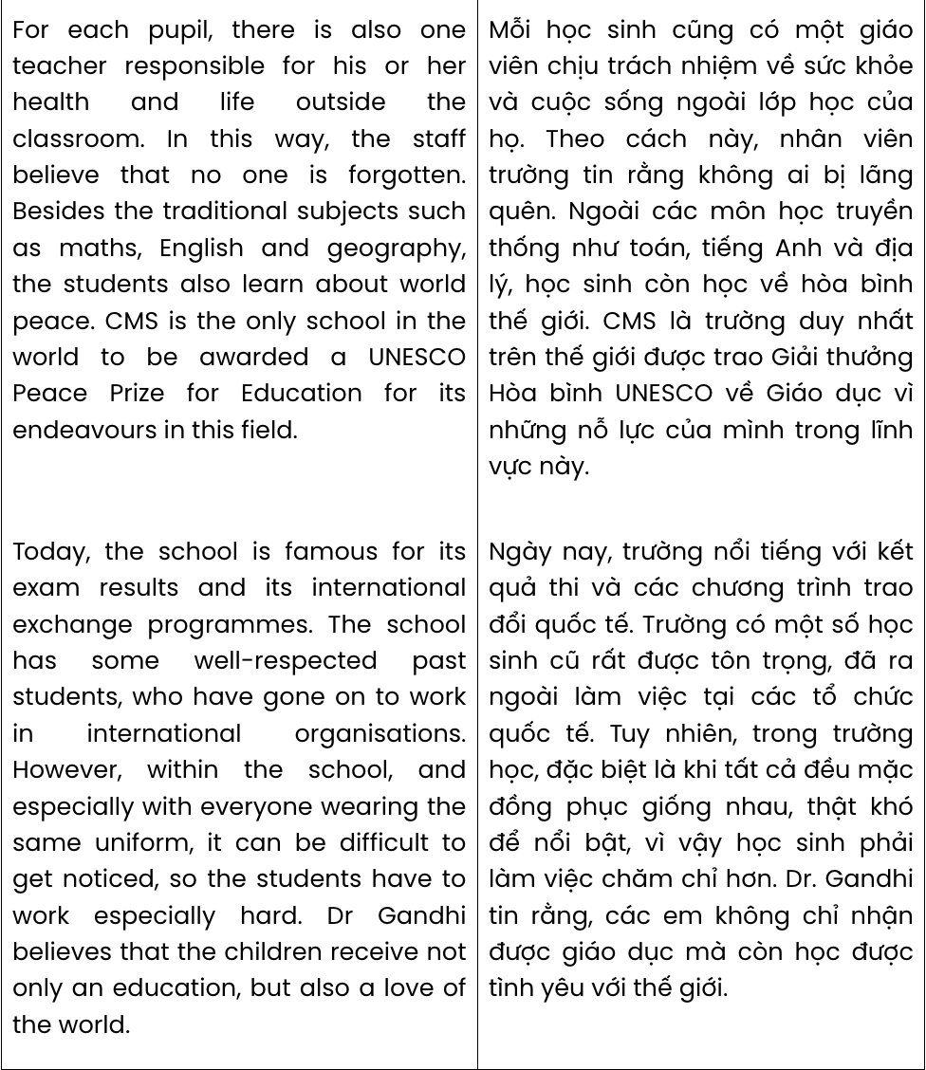

**Question 31.** The word **they** in paragraph 1 refers to .

**A.** pupils **B.** family members **C.** staff **D.** people

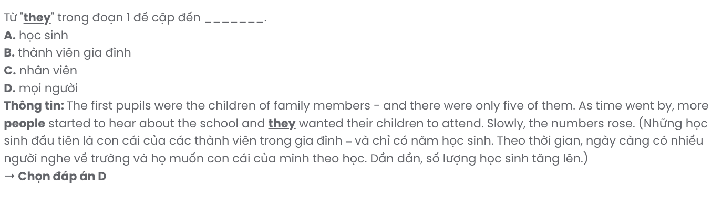

**Question 32.** According to paragraph 1, what is indicated about the City Montessori School?

**A.** It employs more than 4,000 staff from other countries.

**B.** It provides both scary and exciting learning experiences.

**C.** Its first five students were relatives of Dr Gandhi.

**D.** The number of its students has recently reached a peak.

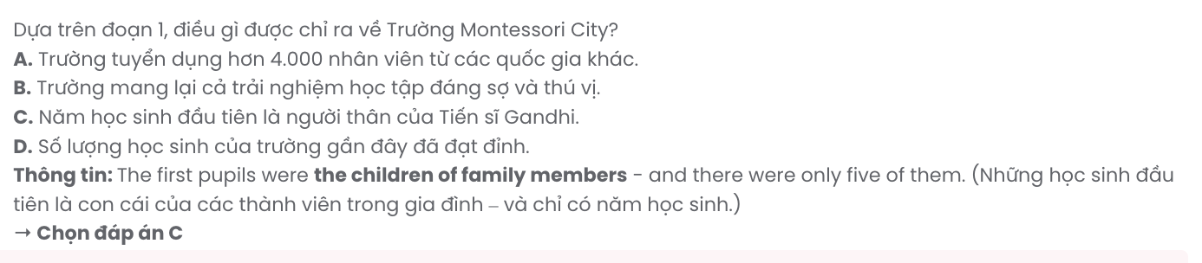

**Question 33.** Where in paragraph 2 does the following sentence best fit?

# They all wear a uniform and each class has about 45 pupils.

**A. [I] B. [II] C. [III] D. [IV]**

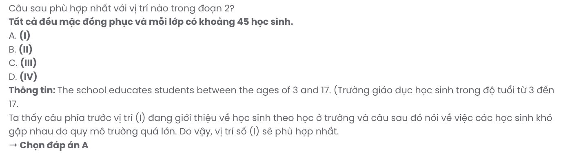

**Question 34.** The word **jammed** in paragraph 2 is OPPOSITE in meaning to .

**A.** panicked **B.** comfortable **C.** sparse **D.** congested

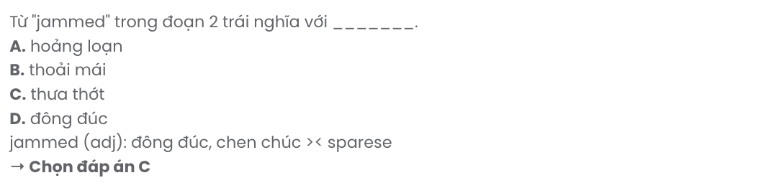

**Question 35.** The word **endeavours** in paragraph 3 is closest in meaning to .

**A.** opportunities **B.** purposes **C.** attempts **D.** achievements

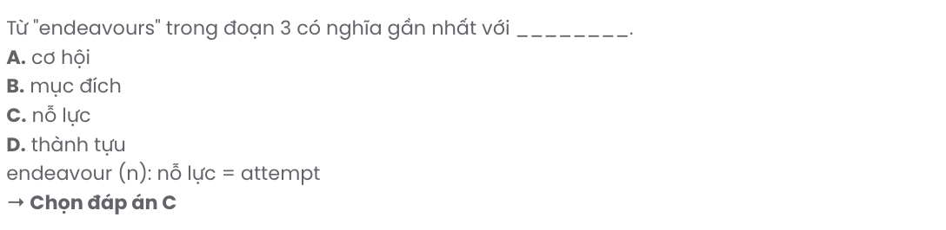

**Question 36.** Which of the following best summarises paragraph 3?

**A.** Each pupil has a teacher for their well-being, and CMS focuses on teaching world peace subjects.

**B.** At CMS, each pupil is assigned a teacher, and world peace is given priority to other academic subjects.

**C.** CMS has teachers responsible for each pupil’s well-being and offers world peace lessons rather than core subjects.

**D.** Every pupil has a teacher for support, and CMS uniquely promotes world peace in education.

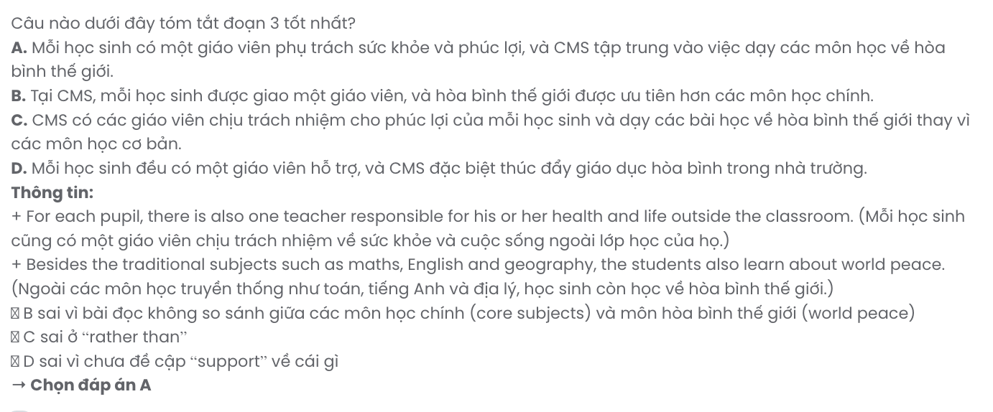

**Question 37.** Which of the following best paraphrases the underlined sentence in paragraph 4? **Today, the school is famous for its exam results and its international exchange programmes**.

**A.** The school is renowned for high exam scores and one-of-a-kind exchange programmes around the world.

**B.** Today, the school’s international exchange programmes and exam results bring it significant recognition.

**C.** The school is recognised globally for its impressive exam results and efforts to promote exchange programmes.

**D.** Today, the school’s exam results and activities abroad make it a prime example for other schools to follow.

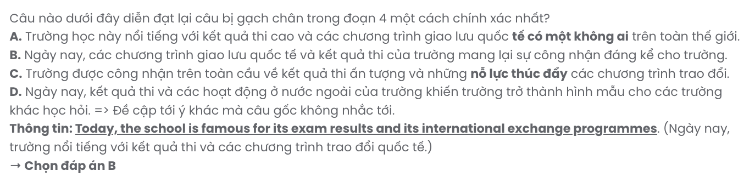

**Question 38.** Which of the following is NOT true about CMS according to the passage?

**A.** Due to the large size of the school, it is quite challenging to organise a meeting that includes all the students.

**B.** The school’s tuition fees are prohibitive, making it impossible for low-income families to afford.

**C.** CMS is unique worldwide in receiving a UNESCO Peace Prize for Education for its focus on peace education.

**D.** The students must put in extra effort to be outstanding given that everyone at school gets dressed in the same uniform.

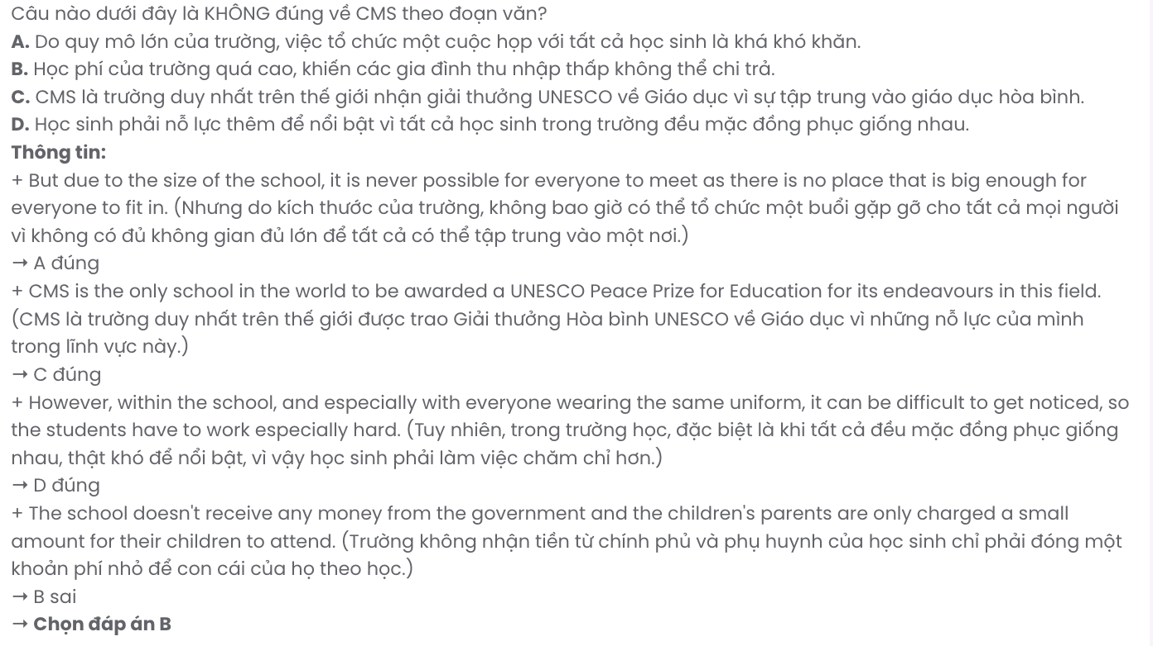

**Question 39.** Which of the following can be inferred from the passage?

**A.** CMS is the only school in the world that fosters a love of peace through education.

**B.** The students at CMS find it hard to gain recognition despite their academic excellence.

**C.** Teachers at CMS have been trying to instil a sense of confidence in the students.

**D.** CMS places a strong emphasis on supporting the overall well-being of its students.

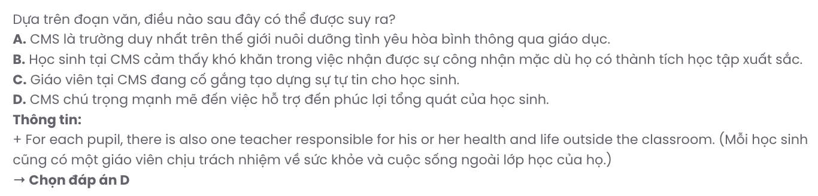

**Question 40.** Which of the following best summarises the passage?

**A.** CMS is an enormous school with 50,000 students, known for its focus on world peace, exam results, and international exchange programmes, with teachers supported by government funding for student well- being.

**B.** The City Montessori School in Lucknow, India, educates 50,000 students with a focus on academic excellence, world peace, and personal care, earning global recognition, including a UNESCO Peace Prize.

**C.** CMS, one of the largest schools in the world, serves 50,000 students and is renowned for its international exchange programmes, UNESCO Peace Prize, and government-funded resources for its pupils.

**D.** CMS educates over 50,000 students in Lucknow and is celebrated for its innovative exchange programmes, world-class exam results, and a focus on world peace supported by a UNESCO Peace Prize.

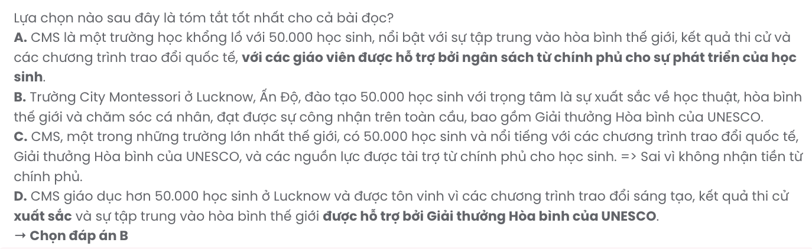

|  |  |  |  |  |
| --- | --- | --- | --- | --- |
| **BẢNG TỪ VỰNG** | | | | |
| **STT** | **Từ vựng** | **Từ loại** | **Phiên âm** | **Nghĩa** |
| **1** | outdoor | adj | /ˈaʊt.dɔːr/ | ngoài trời |
| **2** | thrilling | adj | /ˈθrɪl.ɪŋ/ | hồi hộp, ly kỳ |
| **3** | excite | v | /ɪkˈsaɪt/ | làm phấn khích |
| **4** | challenge | n | /ˈtʃæl.ɪndʒ/ | thử thách |
| **5** | rafting | n | /ˈræf.tɪŋ/ | chèo thuyền |
| **6** | exhilarating | adj | /ɪɡˈzɪl.ə.reɪtɪŋ/ | phấn khích, kích thích |
| **7** | rope | n | /rəʊp/ | dây thừng |
| **8** | dedicated | adj | /ˈded.ɪ.keɪ.tɪd/ | tận tâm, cống hiến |
| **9** | instructor | n | /ɪnˈstrʌk.tər/ | người hướng dẫn |
| **10** | expert | n | /ˈek.spɜːrt/ | chuyên gia |
| **11** | guidance | n | /ˈɡaɪ.dəns/ | sự hướng dẫn |
| **12** | adventure | n | /ədˈven.tʃər/ | cuộc phiêu lưu |
| **13** | programme | n | /ˈprəʊ.ɡræm/ | chương trình |
| **14** | ensure | v | /ɪnˈʃʊər/ | đảm bảo, chắc chắn |
| **15** | equipment | n | /ɪˈkwɪp.mənt/ | thiết bị |
| **16** | stress-free | adj | /ˈstres ˌfriː/ | không căng thẳng |
| **17** | located | adj | /ləʊˈkeɪ.tɪd/ | nằm ở, tọa lạc |
| **18** | surround | v | /səˈraʊnd/ | được bao quanh |
| **19** | unforgettable | adj | /ˌʌn.fərˈɡɛt.ə.bəl/ | không thể quên |
| **20** | stunning | adj | /ˈstʌn.ɪŋ/ | tuyệt vời, ấn tượng |
| **21** | announce | v | /əˈnaʊns/ | thông báo |
| **22** | upcoming | adj | /ˈʌpˌkʌm.ɪŋ/ | sắp tới |
| **23** | participant | n | /pɑːˈtɪsɪpənt/ | người tham gia |
| **24** | workshop | n | /ˈwɜːk.ʃɒp/ | hội thảo, lớp học |
| **25** | excursion | n | /ɪkˈskɜːʃən/ | chuyến tham quan |
| **26** | local | adj | /ˈloʊ.kəl/ | địa phương |
| **27** | opportunity | n | /ˌɒp.əˈtjun.ɪ.ti/ | cơ hội |
| **28** | application | n | /ˌæplɪˈkeɪʃən/ | đơn xin |
| **29** | process | n | /ˈprəʊ.ses/ | quá trình |
| **30** | contact | n/v | /ˈkɒn.tækt/ | liên hệ, liên lạc |
| **31** | contribution | n | /ˌkɒn.trɪˈbjuː.ʃən/ | sự đóng góp |
| **32** | regional | adj | /ˈriː.dʒə.nəl/ | khu vực |
| **33** | promote | v | /prəˈməʊt/ | thúc đẩy |
| **34** | evaluate | v | /ɪˈvæl.juː.eɪt/ | đánh giá |
| **35** | interact | v | /ˌɪn.təˈrækt/ | tương tác |
| **36** | initiative | n | /ɪˈnɪʃ.ə.tɪv/ | sáng kiến |
| **37** | resource | n | /rɪˈzɔːs/ | tài nguyên |
| **38** | regularly | adv | /ˈreɡ.jə.lər.li/ | đều đặn |
| **39** | unwind | v | /ʌnˈwaɪnd/ | thư giãn, nghỉ ngơi |
| **40** | consistently | ad | /kənˈsɪs.tənt.li/ | một cách nhất quán |
| **41** | relax | v | /rɪˈlæks/ | thư giãn |
| **42** | flexible | adj | /ˈflek.sə.bəl/ | linh hoạt |

|  |  |  |  |  |
| --- | --- | --- | --- | --- |
| **43** | passion | n | /ˈpæʃ.ən/ | đam mê |
| **44** | balcony | n | /ˈbæl.kə.ni/ | ban công |
| **45** | nurture | v | /ˈnɜː.tʃər/ | nuôi dưỡng, chăm sóc |
| **46** | thrive | v | /θraɪv/ | phát triển mạnh mẽ |
| **47** | basil | n | /ˈbæz.əl/ | cây húng quế |
| **48** | mint | n | /mɪnt/ | cây bạc hà |
| **49** | virtual | adj | /ˈvɜː.tʃuəl/ | ảo |
| **50** | assistant | n | /əˈsɪs.tənt/ | trợ lý |
| **51** | fascinating | adj | /ˈfæs.ɪ.neɪ.tɪŋ/ | hấp dẫn, lôi cuốn |
| **52** | daunting | adj | /ˈdɔːn.tɪŋ/ | đáng sợ, gây nản lòng |
| **53** | complex | adj | /ˈkɒm.pleks/ | phức tạp |
| **54** | unfamiliar | adj | /ˌʌn.fəˈmɪl.iər/ | không quen thuộc |
| **55** | entirely | adv | /ɪnˈtaɪə.li/ | hoàn toàn |
| **56** | frustration | n | /frʌsˈtreɪ.ʃən/ | sự thất vọng |
| **57** | achievement | n | /əˈtʃiːv.mənt/ | thành tựu, sự đạt được |
| **58** | immersive | adj | /ɪˈmɜː.sɪv/ | sống động |
| **59** | broaden | v | /ˈbrɔː.dən/ | mở rộng |
| **60** | perspective | n | /pəˈspek.tɪv/ | góc nhìn, quan điểm |
| **61** | deepen | v | /ˈdiː.pən/ | làm sâu sắc |
| **62** | appreciation | n | /əˌpriː.ʃiˈeɪ.ʃən/ | sự cảm kích, sự đánh giá cao |
| **63** | reinforce | v | /ˌriː.ɪnˈfɔːs/ | củng cố, tăng cường |
| **64** | undertake | v | /ˌʌn.dəˈteɪk/ | đảm nhận, thực hiện |
| **65** | patience | n | /ˈpeɪ.ʃəns/ | sự kiên nhẫn |
| **66** | persistence | n | /pəˈsɪs.təns/ | sự kiên trì |
| **67** | digital | adj | /ˈdɪdʒ.ɪ.təl/ | kỹ thuật số |
| **68** | resonate | v | /ˈrez.ə.neɪt/ | liên quan, có sự kết nối |
| **69** | wield | v | /wiːld/ | có, nắm giữ |
| **70** | impact | n | /ˈɪm.pækt/ | tác động |
| **71** | showcase | v | /ˈʃəʊ.keɪs/ | trưng bày, phô diễn |
| **72** | intense | adj | /ɪnˈtens/ | mãnh liệt, dữ dội |
| **73** | relevant | adj | /ˈrel.ə.vənt/ | liên quan, phù hợp |
| **74** | engaging | adj | /ɪnˈɡeɪ.dʒɪŋ/ | hấp dẫn, lôi cuốn |
| **75** | popular | adj | /ˈpɒp.jʊ.lər/ | phổ biến |
| **76** | transportation | n | /ˌtræn.spɔːrˈteɪ.ʃən/ | phương tiện giao thông, vận tải |
| **77** | sustainable | adj | /səˈsteɪ.nə.bəl/ | bền vững |
| **78** | urban | adj | /ˈɜː.bən/ | thuộc về đô thị |
| **79** | revolutionise/  revolutionize | v | /ˌrevəˈluːʃənaɪz/ | cách mạng hóa |
| **80** | commute | n/v | /kəˈmjuːt/ | đi lại (giữa hai nơi) |
| **81** | launch | v | /lɔːntʃ/ | khởi động, ra mắt |
| **82** | expand | v | /ɪkˈspænd/ | mở rộng |
| **83** | reliable | adj | /rɪˈlaɪ.ə.bəl/ | đáng tin cậy |
| **84** | worldwide | adv | /ˌwɜːldˈwaɪd/ | toàn cầu |
| **85** | sturdy | adj | /ˈstɜː.di/ | cứng cáp, chắc chắn |

|  |  |  |  |  |
| --- | --- | --- | --- | --- |
| **86** | innovation | n | /ˌɪn.əˈveɪ.ʃən/ | sự đổi mới, sáng tạo |
| **87** | mark | n | /mɑːrk/ | dấu hiệu, đánh dấu |
| **88** | eco-friendly | adj | /ˌiː.kəʊˈfrend.li/ | thân thiện với môi trường |
| **89** | represent | v | /ˌrep.rɪˈzent/ | đại diện, tượng trưng cho |
| **90** | signify | v | /ˈsɪɡ.nɪ.faɪ/ | biểu thị, có nghĩa là |
| **91** | delight | n | /dɪˈlaɪt/ | niềm vui |
| **92** | square | n | /skweər/ | quảng trường |
| **93** | ancient | adj | /ˈeɪn.ʃənt/ | cổ đại |
| **94** | disappoint | v | /ˌdɪs.əˈpɔɪnt/ | làm thất vọng |
| **95** | over-crowded | adj | /ˌəʊ.vəˈkraʊ.dɪd/ | quá đông đúc |
| **96** | destination | n | /ˌdes.tɪˈneɪ.ʃən/ | điểm đến |
| **97** | narrow | adj | /ˈnær.əʊ/ | hẹp |
| **98** | customary | adj | /ˈkʌs.tə.mər.i/ | thông thường, theo phong tục |
| **99** | numerous | adj | /ˈnjuː.mə.rəs/ | nhiều |
| **100** | jammed | adj | /dʒæmd/ | tắc nghẽn, đông đúc |
| **101** | educate | v | /ˈedʒ.u.keɪt/ | giáo dục |
| **102** | award | n | /əˈwɔːd/ | giải thưởng, trao thưởng |
| **103** | exchange | n | /ɪksˈtʃeɪndʒ/ | sự trao đổi |
| **104** | uniform | n | /ˈjuː.nɪ.fɔːrm/ | đồng phục |
| **105** | prohibitive | adj | /prəˈhɪb.ɪ.tɪv/ | đắt đỏ, cao ngất ngưởng |
| **106** | low-income | adj | /ləʊ ˈɪn.kʌm/ | thu nhập thấp |
| **107** | afford | v | /əˈfɔːd/ | có đủ khả năng chi trả |
| **108** | outstanding | adj | /aʊtˈstænd.ɪŋ/ | nổi bật, xuất sắc |
| **109** | well-being | n | /ˈwelˌbiː.ɪŋ/ | sức khỏe, phúc lợi |

|  |  |  |
| --- | --- | --- |
| **BẢNG CẤU TRÚC** | | |
| **STT** | **Cấu trúc** | **Nghĩa** |
| **1** | at one's own pace | theo nhịp độ của riêng ai đó |
| **2** | give someone a ring | gọi điện cho ai đó |
| **3** | be new to | mới làm quen với, mới đối với |
| **4** | aim to | nhắm đến, có mục đích làm gì |
| **5** | involve doing something | bao gồm, liên quan đến việc gì |
| **6** | make out | nhận ra, hiểu ra |
| **7** | turn into | biến thành |
| **8** | bring about | mang lại, gây ra |
| **9** | put up with | chịu đựng |
| **10** | a variety of | nhiều loại |
| **11** | contribute to | đóng góp vào |
| **12** | in the light of | xét đến, dựa trên |
| **13** | with regards to | liên quan đến |
| **14** | keep up with | theo kịp |
| **15** | commit to | cam kết làm gì |
| **16** | clear my mind | làm tâm trí minh mẫn, thoải mái |
| **17** | take up something | bắt đầu một sở thích, hoạt động gì đó |
| **18** | strive to | phấn đấu để làm gì |
| **19** | build a foundation | xây dựng nền tảng |
| **20** | be equipped with | được trang bị với |
| **21** | bring someone together | gắn kết mọi người |
| **22** | get noticed | được chú ý, nhận ra |
| **23** | focus on | tập trung vào |
| **24** | get dressed | mặc quần áo |
| **25** | place a strong emphasis on | chú trọng đến |