School: ……………………………………….. | Date:……………………………………..
Class: ……………………………..................... | Period: …………………………….........

UNIT 8: ECOLOGY AND THE ENVIRONMENT
Lesson 1.2 – Grammar, (page 65)

1. Objectives
By the end of this lesson, students will be able to…
1.1. Language knowledge & skills
- practice and use First Conditional correctly.
- improve writing skill.
1.2. Competences
- improve Ss’ communication, collaboration, analytical and critical thinking skills.
1.3. Attributes
- develop environmentally-friendly awareness.
2. Teaching aids and materials
- Teacher’s aids: Student’s book and Teacher’s book, class CDs, Digital Book, (DCR phần mềm tương tác SB, DHA (từ vựng/ cấu trúc) phần mềm trò chơi tương tác) projector / interactive whiteboard /TV (if any), PowerPoint slides.
- Students’ aids: Student’s book, Workbook, Notebook.
3. Assessment Evidence
Performance Tasks | Performance Products | Assessment Tools
- Describe pictures.  - Fill in the blanks.  - Write first conditional sentences.  - Make first conditional sentences. | - Ss’ answers.  - Ss’ answers.  - Ss’ performance.  - Ss’ answers/ presentation. | - T’s feedback.  - T’s observation/ DCR.  - T’s observation/ DCR.  - T’s feedback/Peers’ feedback.

4. Procedures
A. Warm up: 5 minutes
a. Objectives: to raise the Ss’ awareness of the topic and get them ready for the lesson.
b. Content: A picture
c. Expected outcomes: Ss can have some first ideas about first conditional.
d. Organization

Teacher’s activities | Students’ activities
A picture  - Show/ write a picture.  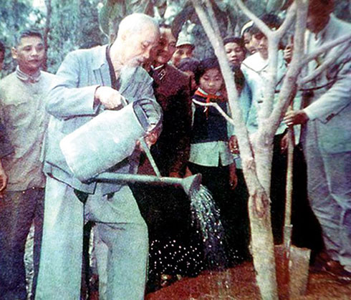  => Planting trees.  - Elicit some information from Ss.  - Get Ss to write their answers on the board.  - Change Ss’ answers into first conditional, and lead to new lesson. | - Give answers.  - Write them on the board.  Ss’ own answers

B. Presentation: 10 minutes
a. Objectives: to prepare Ss for the writing activity by providing the form, meaning and use of First Conditional.
b. Content: Task a. Listen and repeat.
c. Expected outcomes: Ss can generalize the use of First Conditional.
d. Organization
Teacher’s activities | Students’ activities
Task a.  - Get Ss to look at the picture and elicit some information.  - Play the audio file (using DCR) and ask Ss to listen and repeat chorally and individually.  - Have Ss practice the sentence with a friend.  - Get Ss to give the form, the meaning, and the use of First Conditional or T does (if needed). | - Look at the picture and give the answers.  - Listen to the audio file.  - Practice the sentence with a friend.  - Give the form, the meaning, and the use  of First Conditional.  - Listen to the teacher and take notes.

C. Practice: 15 minutes
a. Objectives: to help Ss get used to using the grammar point and improve Ss’ writing skill.
b. Content: Task b, and c
Task b: Fill in the blanks.
Task c: Write two conditional sentences for each situation.
c. Expected outcomes: Ss can complete the tasks correctly.
d. Organization:
Teacher’s activities | Students’ activities
Task b:  - Ask Ss to read the sentences before fill in the blanks individually.  - Set time for the activity.  - Get Ss to share their answers with a friend.  - Get the answers from Ss.  - Check Ss’ answers and give feedback if needed.  - Have them practice the sentences with a partner. | - Read the sentences.  - Fill in the blanks.  - Share the answers  - Give their answers.  - Practice the sentences with a partner.  Answer Keys (Use the DCR)
Task c:  - Ask Ss to look at the situations.  - Get Ss to write two conditional sentences individually, and then share the answers with a partner.  - Get answers and explanation from Ss.  - Use the DCR to check Ss’ work. | - Look at the situations.  - Write two conditional sentences individually.  - Share the answers with a partner.  - Give answers and explanation.  Answer Keys (Use the DCR)

D. Production: 10 minutes
a. Objectives: to help Ss to use the language and information in the real situation.
b. Content: Task d
Task d: In pairs: Make conditional sentences from the prompts in the table.
c. Expected outcomes: Ss can make first conditional sentences correctly.
d. Organization

Teacher’s activities | Students’ activities
Task d:  - Ask Ss to work in pairs to make conditional sentences.  - Set the time for Ss to do.  - Get around to give help and take notes of some mistakes.  - Call some pairs to talk to the whole class.  - Check and give comment. | - Work in pairs.  - Make conditional sentences.  - Give their answers.  Ss’ own answers

E. Consolidation and homework assignments: 5 minutes
- Write five first conditional sentences about the benefits of cleaning the classroom every day.
- Do exercises in workbook on page 45.
- Prepare the next lesson: Lesson 1.3 – Pronunciation & Speaking (page 66).
- Practice grammar in the Notebook page 45.
5. Reflection

a. What I liked most about this lesson today:
…………………………………………………………………………………………
- What I learned from this lesson today:
…………………………………………………………………………………………
c. What I should improve for this lesson next time:
…………………………………………………………………………………………

