**TRANSCRIPT**

**Part 1**

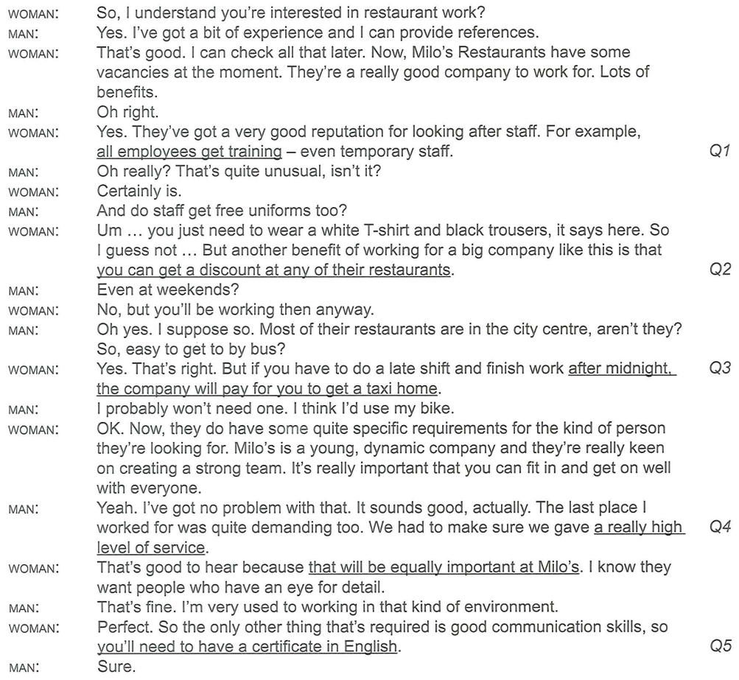

**Part 2**

Thanks for that lovely introduction, Helen. You are doubtless aware that obesity – being grossly overweight – is one of the greatest challenges of the 21st century. The instances of this have tripled since the 80s and continue to rise at an alarming rate, affecting around one in four citizens in Europe and the USA. As well as causing physical and psychological problems, excess weight drastically increases a person’s chances of developing serious illnesses. Which is why ministers from the European Union convened a meeting this week, specifically to address the issue of healthcare and how long governments will be able to afford to fund this, given the mounting cost of obesity-related diseases.

It’s actually not so much overweight adults that’s the issue for me; it’s the young people who are growing up eating so much junk food. In my view, it’s the advertisements for all this stuff that are partly to blame because they target kids. They should be banned!

Obese 12-year-olds are eighty-two percent more likely to be obese adults. Which is why the quality of school dinners must also be addressed. Most of you will be shocked when I tell you that this government spends four times more per head on prisoners’ meals than on those for kids in school – that’s how much of a priority they’ve been! Thank goodness something is finally being done to improve this situation. Although this does involve spending more, it will save us money in the long run.

In order for obesity to be reduced, it is clear that supermarkets also need to take more responsibility for the contents of the products they sell. True, there is much more availability of low-fat food on the shelves these days. Now the World Health Organization has issued new guidelines suggesting that we cut the amount of sugar we consume daily by as much as a half to bring it to a recommended limit of 25 grams per day. Which is less than the amount you will get in just one can of some fizzy drinks or ready-prepared meals.

People often ask me how come the French manage to remain relatively slim despite their love of high-fat cheeses and meat. I’m inclined to think that the key is their approach to food. Because they still tend to have proper sit-down meals, they seem to be less tempted by the high-calorie snacks that are the downfall of many other cultures.

Also, in my view, the fact that lunchtime tends to be the main meal in France, rather than dinner, is also a contributory fact. The earlier in the day calories are consumed, the more opportunity there is to convert them into energy, so we should follow their example and try not to have a heavy meal in the evenings.

Moving on to other parts of the world, why is it that in Japan, for example, life expectancy is much higher than anywhere else in the world? One of the reasons could be that their diet is built around rice and fish and plentiful fruit and vegetables. There is little meat, animal fat or sweets and two thirds of their calorie intake comes from carbohydrates, as opposed to the UK or the USA, where fat accounts for much more than the recommended quarter of our daily calories.

You would think the Inuit in Greenland had very little in common with the Japanese, wouldn’t you? And unlike the Japanese, 60 percent of the calories eaten in Greenland do come from fat – even more than we consume – and they eat surprisingly little fruit and vegetables. However, as in Japan, heart disease there is not that common. The difference is that the fat they eat is from oily fish such as salmon and mackerel. This type of unsaturated fat, called omega three, we already know has huge benefits for the bones. What has only recently been discovered and is therefore less well known is that it is also said to improve mental health.

And for those of us who are worried about forgetting things, scientists are also suggesting that turmeric, a key ingredient of curries, may be a major factor as to why elderly Indian people are less likely to lose their memory than someone in the western world. So perhaps we can learn ……...

**Part 3**



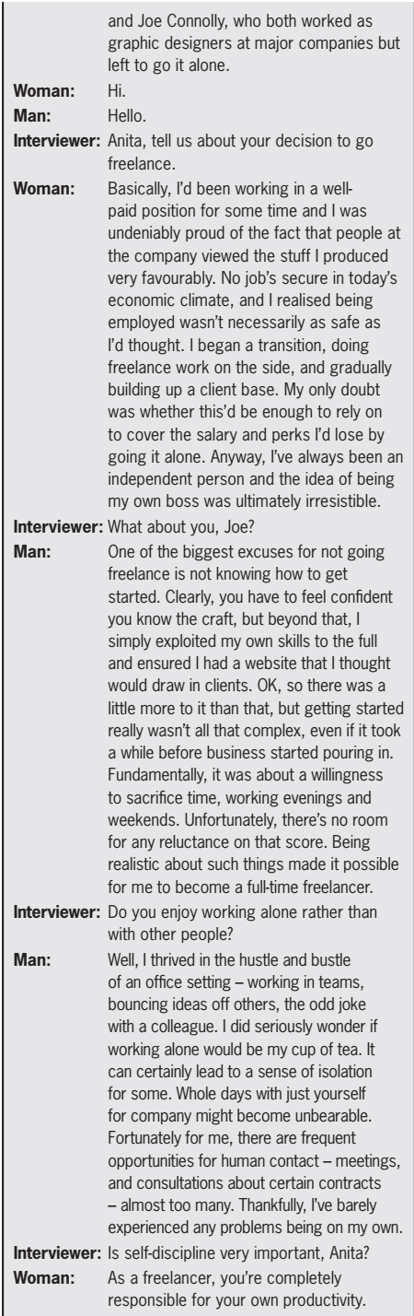 

**Part 4**

In the middle of the 19th century, the California gold rush brought thousands of settlers to America's west coast. But finding gold may have been easier than transporting it back East. The only hope for avoiding a grueling six month wagon journey was to travel the narrowest portion of the continent-the 48-kilometer Isthmus of Panama.

By 1855, a railroad spanning the region significantly shortened to the trip, but unloading and reloading ships at each port cost time and money. To truly connect these two bodies of water shipping interests needed a canal-a continuous maritime passage through the isthmus. The first attempt at this colossal construction project was taken up in 1881 by French diplomat Ferdinand de Lesse ps. De Lesseps had supervised construction of Egypt's Suez Canal, but his success made him overconfident. He insisted on digging the canal at sea level, even though it required boring directly through the Continental Divide mountain range. Futile excavation efforts were buried under constant landslides. And since the diplomat had only visited the site briefly during Panama's dry season, his workers were unprepared for torrential storms, venomous jungle fauna, and tropical diseases. After spending $287 million and losing a staggering 22,000 lives, the French abandoned the project. The United States had been considering building a canal through Nicaragua, but at this point, the chance to succeed where France failed was tempting. Panamanian leaders were also eager to complete a canal which would bring their country business and prestige. However, Panama was still a part of Colombia at the time, and the country was stalling negotiations with the U.S. Sensing an opportunity, President Teddy Roosevelt went straight to the Panamanians.

With encouragement and military support from the U.S., Panama launched a coup in 1903.Within days, they became an independent nation and signed a treaty to begin construction of the canal. Just over a decade after the French left, the Americans were ready to dig in-and they were determined to avoid their predecessor's mistakes.

Instead of cutting the mountain down to sea level, they would raise the sea up the mountain. The plan was to build massive steel gates separating the canal into multiple chambers with different water levels. As a ship passed through each successive gate would open, lowering the water level in the next chamber, while raising the ship and allowing it to move on.

The design called for five of these so-called canal locks-three on the Atlantic side and two on the Pacific, raising traversing ships 26 meters above sea level. Operating this lock system would require a massive reservoir of water. And fortunately, the low-lying Chagres river valley provided a natural solution. By building a dam across the gap where the river flowed out to sea, the entire valley could be flooded. At 32 meters high and over 800 meters wide, the Gatun Dam would be larger than any built before.

With this innovative plan, the Americans didn't need to excavate the entire mountain, but rather, just the pathway for the canal itself. Still, the work was staggering. Even after progress made by the French, it took over nine years for 24,000 workers to blow up, shovel, and drill out the Culebra Cut-a roughly 14 kilometer passageway through the Continental Divide. The railway, now upgraded and rerouted to follow the canal, carted away over 76 million cubic meters of excavated rock to be used at the Gatun Dam site. Construction was only half the battle.

Leading army officials struggled to maintain infrastructure and sanitation, but accidents and diseases took the lives of 5,000 workers-mostly Black Caribbean migrants. Then, in the fall of 1913, the moment finally came. A telegraph signal from President Woodrow Wilson triggered a dike explosion, flooding the Culebra Cut and joining the Atlantic and Pacific Oceans. Today, nearly 14,000 vessels travel through the Isthmus annually-each in under 12 hours. The canal remains Panama's chief source of revenue; and since the country gained ownership of the passage in 1999, it has also become a source of national pride.