Period
LESSON PLAN
TIẾNG ANH 10 FRIENDS GLOBAL
UNIT 1: FEELINGS
LESSON 1D: PAST SIMPLE (NEGATIVE AND INTERROGATIVE), QUESTION WORDS
By the end of the lesson, Ss will be able to:
1. Knowledge:
- use simple past to describe some events in the past
- Grammar: simple past tense (negative and interrogative), questions words.
- main skills: listening and speaking skills
- sub skills: reading and writing skills
- Use the past affirmative properly in exercises as well as everyday conversations.
2. Quality:
- have positive attitude in English language learning so that they can participate enthusiastically in all classroom activities, especially with the topic conducted by the teacher
- know how to use the past simple tense to describe events
II. TEACHER AIDS AND LEARNING MATERIALS:
Lesson plan, PPT slides, student’s book, workbook, notebook, personal computer (if any), projector/TV, speakers, IWB software.
III. PROCEDURES:
A. Warm-up (5’)
a) Objective: Introduce the new lesson and set the scene for Ss to acquire new language; get students' attention at the beginning of the class by means of enjoyable and short activities as well as to engage them in the steps that followed.
b) Content: Game ‘Choosing Right Rocket’
c) Outcomes: Students can gain more confidence and interest in the lesson.
d) Competence: communication, collaboration, critical thinking
e) Organisation of the activity:

TEACHER’S ACTIVITIES | STUDENT’S ACTIVITIES | CONTENTS
WARM-UP. T- Ss/ S – S/ Indiv  Game ‘Choosing Right Rocket’  - Divide class into groups and ask student to answer the questions due to the picture. Students choose the correct answer among 3 rockets to get bonus. If students get it wrong, the incorrect ones will disappear.  - Give bonus to the team that get the most correct answers.  - Lead to the lesson ‘Past simple with negative and interrogative forms and question words’. | - Play the game in groups.  - Each group will answer the question.  - With one correct answer, students will get one bonus point.  - Open the coursebook page 14. | Question: “What did you do last night?”  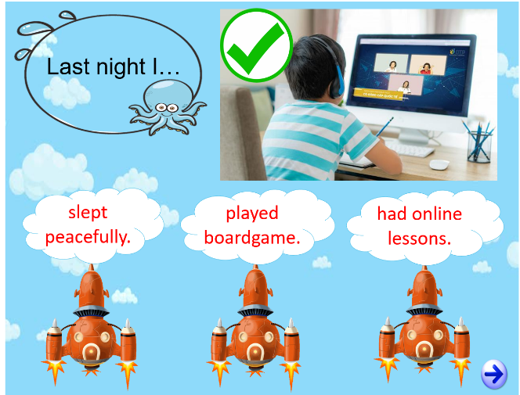  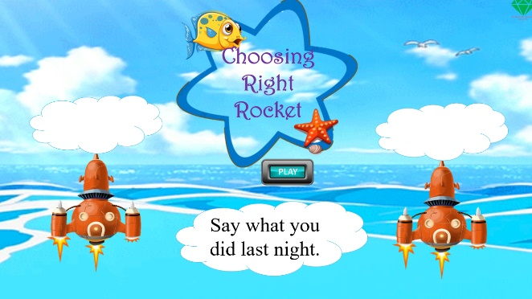

B. New lesson (35’)
- Activity 1: Presentation (10’)
a) Objective: Review student simple past tense in negative and interrogative form.
b) Content:
Speaking, Listening
Grammar
c) Outcomes: Students can apply the useful language in everyday conversations.
d) Competence: communication, presentation, presentation
e) Organisation of the activity:

TEACHER’S ACTIVITIES | STUDENT’S ACTIVITIES | CONTENTS
Activity 1 (2’): Read the text and underline all the past simple negative and question in the text.  - Ask students to read the text and underline.  - Check the answers.  Activity 2 (3’): Listen to the video chat and answer the question ‘Why did Emma not enjoy her evening at the cinema?’  - Play the audio for the students.  - Let the students listen and answer the question of task 2.  - Check the answer.  Activity 3 (5’): Tense reminder. Review past simple in negative and interrogative form.  - Revise how to use simple past with action verbs and ‘be’ verbs.  - Point out how to answer ‘Yes/No’ questions in past simple.  - Review how to use simple past with ‘could’ in negative and questions. | - Listen to the instructions, read, and underline.  - Check the answers with the teacher.  - Listen to the audio carefully and answer the question.  - Check the answer with the teacher.  - Listen carefully.  - Take note.  - Raise hands if students get any questions. | 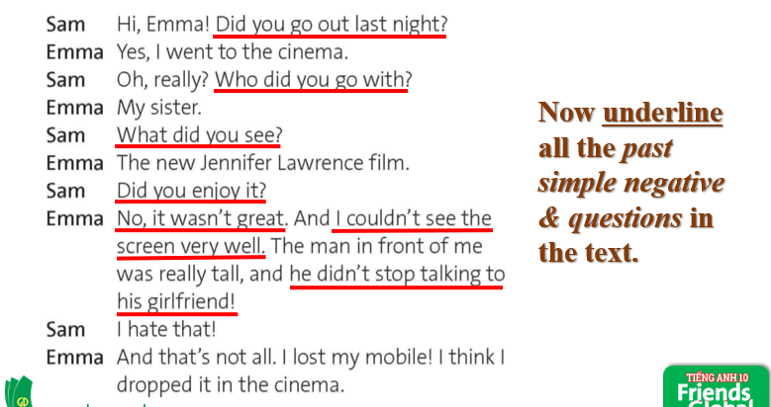  Answer:  Answer:  The film wasn’t great. She couldn’t see the screen well. She also lost her mobile.
- Activity 2: Practice (18’)
a) Objective: Students know more about past simple tense and some irregular verbs.
b) Content: Student read the box and complete it with correct answers. Then complete and listen the dialogue in task 4. Finally, fill in the blank with the right words.
c) Outcomes: Ss how to use past simple in negative and interrogative form in everyday conversations.
d) Competence: communication, collaboration, presentation
e) Organisation of the activity:
TEACHER’S ACTIVITIES | STUDENT’S ACTIVITIES | CONTENTS
PRACTICE. T-Ss/ S-S/ Indiv.  Activity 1 (3’): Read the Learn this! Box and complete the rules.  - Have students read the box and complete the blank spaces.  - Check the answers.  Activity 2 (7’): Complete the second part of the dialogue. Use the correct form of verbs in the brackets. Then listen and check.  - Ask students to do task 4.  - Play the audio.  - Check the answers.  Activity 3 (3’): Read ‘Learn this! Question words’ box.  - Ask students to read the box on page 14.  - Present some examples to make it clear.  Activity 4 (5’). Complete the yes/ no questions. Then complete the follow-up questions.  - Ask students to do task 5.  - Check the answers. | - Read the box and complete it with correct answers.  - Check the answers with the teacher.  - Complete the next part of the dialogue.  - Listen and check the answers.  - Check the answers with the teacher.  - Read the box.  - Take note.  - Complete exercise 5 with correct answers.  - Check the answers with the teacher. | Answer:  a. (1) didn’t  b. (2) did  c. (3) was/were  (4) could/ couldn’t  Answer:  1. didn’t leave  2. lent  3. didn’t give  4. left  5. did you do  6. Did you bring  7. couldn’t  8. wasn’t  9. phoned  10. Did anyone answer  11. did she have  12. Was she  13. picked  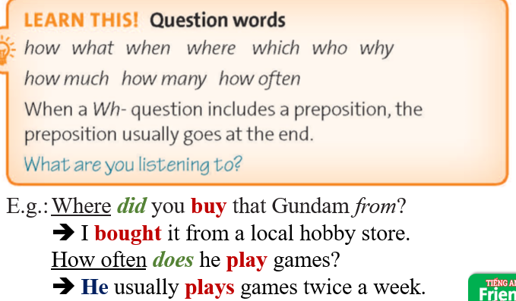  Answer  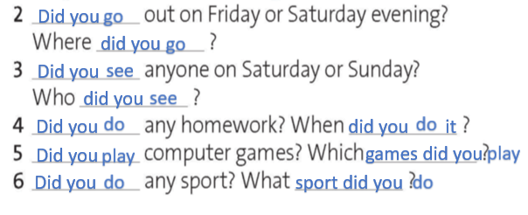

- Activity 3: Outcomes (7’)
a) Objective: Ss can answer questions to describe events in the past. Communication is also be practiced.
b) Content: Work in pairs. Take turns to ask and answer the questions in exercise 5.
c) Outcomes: Ss speak and listen mutually, they can apply the structure of past simple or some adjectives to their conversations.
d) Competence: Collaboration, communication, guessing
e) Organisation of the activity:
TEACHER’S ACTIVITIES | STUDENT’S ACTIVITIES | CONTENTS
PRODUCT. T- Ss/ S-S  Activity 1 (7’): Pair-work. Ask and answer some questions in exercise 5.  - Ask students to work in pair. Students take turn to ask and answer some situations and add some follow-up questions. Students can answer yes or no, and there will be other questions and hints for students to practice.  - Invite some pairs to ask and answer.  - Give bonus if the students talk well. | - Volunteer to share their ideas.  - Get bonus if the students do well. | 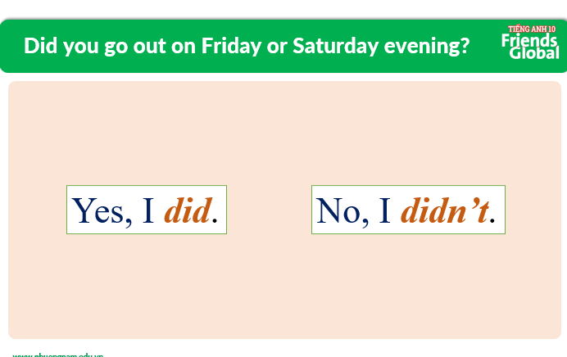    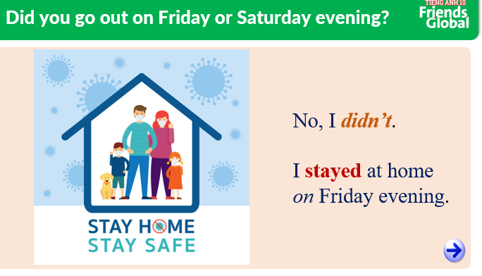
C. Consolidation (3’)
a) Vocabulary: some regular and irregular verbs
b) Grammar: Past Simple (negative and interrogative), question words
D. Homework (2’)
- Learn by heart simple past form of the irregular verbs
- Review simple past structures
- Do exercise
- Prepare: Unit 1 – E-Work skills (page 15 – SB)

