Date of preparing: ………………………………….
Date of teaching: ………………………………….

Period……
UNIT 10: CITIES AROUND THE WORLD
Lesson 1 - Part 1 (Page 78) – Vocabulary and Listening

I. OBJECTIVES
By the end of the lesson, Ss will be able to...
1. Knowledge
- identify landmarks in cities around the world;
- discuss and show their interest;
- get someone’s attention into a conversation and choose suitable answers;
2. Ability
- improve the four English skills (main skills: Listening and Speaking; sub-skills: Reading and Writing);
- develop communication, collaboration, self-study, and problem-solving skills;
- discuss and show interest in landmarks in cities around the world;
3. Quality
- have a positive attitude in learning and actively participate in all classroom activities related to the topic “Cities around the World”;
- show interest in landmarks in cities around the world.
II. TEACHING AIDS AND LEARNING MATERIALS.
Lesson plan, PPT slides, Student’s book, workbook, notebook, personal computer (if any), projector/ TV, speakers, DCR & DHA on Eduhome, CD player, handouts…
III. PROCEDURES
A. Warm-up: (5’)
a) Objective: To introduce what Ss need to learn and develop Ss’ collaboration and communication skills.
b) Content: Learning new words about the topic “landmarks in cities around the world”
c) Product: Students can identify general ideas and show interest in the topic.
d) Competence: Collaboration and communication
e) Organization of the activity:
Teacher’s activities | Students’ activities
- Show some pictures about Ha Long Bay, Da Lat, Opera Theater, Liberty Statue, …  - Ask Ss to name those cities and tell the countries of the places in the provided pictures.  - Have them tell something about the cities they like most.  - Lead to a new topic - Unit 10: Cities around the World. | - Observe the pictures.  - Name those cities and tell where each of the pictures is.  - Tell something about the cities they like most. (Ss can give any reasons they think are reasonable.)

B. New lesson (35’)
- Activity 1: Introduce new language (10’)
a) Objectives: To help Ss identify and understand the language knowledge (new vocabulary items).
To help Ss develop their critical thinking skills (guessing/ reasoning).
b) Content:
- Learning and using the language knowledge (Section: New words on page 78)
- Listening and naming the landmarks related to the topic “Cities around the World”
c) Products: Correctly pronounce the new words and appropriately use them in real-life situations
d) Competence: Communication, collaboration, presentation, and imagination
e) Organization of the activity:
Teacher’s activities | Students’ activities
Write the letters in the boxes. Listen and repeat.  + Option 1:  - Show the Power-point slides/DCR with the following pictures and ask Ss to guess the new words.  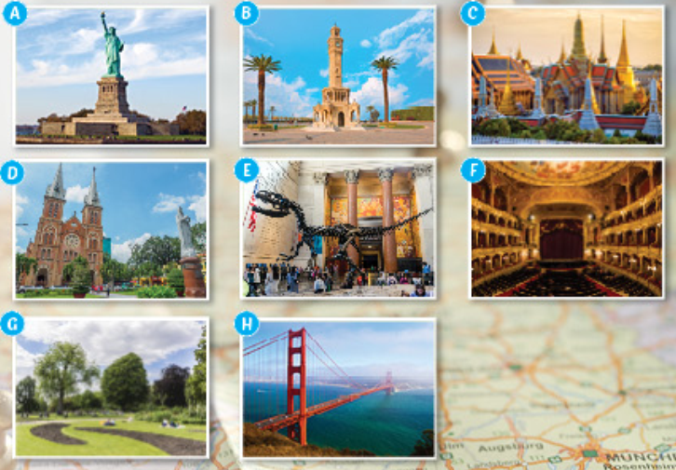  - Demonstrate the activity using an example.  - Have them write the letters in the boxes (exercise a on page 78).  - Get some Ss to read aloud the new words.  - Have Ss give the meaning to the words in Vietnamese.  + Option 2:  - Divide the class into groups of 4, and ask them to discuss something about one of the landmarks they know.  - Provide Ss with some information about those landmarks (where/ in which country/ when/ be famous for/ …  - Ask some pairs to demonstrate the activity in front of the class.  - Give comments on the Ss’ demonstration. | - Observe the pictures.  - Do the exercise as the example individually and share their answers with their partners.  - Read aloud the new words.  - Give the meanings to the new words in Vietnamese.  Expected answers: 1A 2E 3C 4B 5F 6D 7H 8G  - Work in groups of 4 and discuss what they know.  - Read information about the landmarks.  - Work in pairs and demonstrate the activity in front of the class.

- Activity 2: Speaking Skill (10’)
a) Objective: To help Ss appropriately use the new vocabulary items in real-life situations illustrated in the lesson.
b) Content: listening, thinking, reading and practicing the new language in the situations
c) Products: Students can use the language knowledge to talk about landmarks in Vietnam.
d) Competence: Collaboration, communication, and imagination
e) Organization of the activity:
Teacher's activities | Students' activities
Think of three famous landmarks in your country. Tell your partner about them.  + Option 1:  - Have Ss think of several famous landmarks in Vietnam they know. (Individual working, working in pairs, or small groups)  - Ask them to tell something about those landmarks (name, where, be famous for, who, when, why you like, …)  Example:  + Well, the city I like most is in the highland of the center of Vietnam. It is famous for its cool climate. You can see many kinds of flowers there and can visit many famous sites such as …. Do you know it? It is Da Lat.  - Encourage them to give more information in their speaking.  - Ask Ss to practice in their pairs/groups.  - Give comments and corrects them.  - Have some pairs share their ideas with the class.  - Give comments and correct. | - Think of several famous landmarks in Vietnam they know.  - Prepare some information about the landmarks they like/know.  - Work in pairs/groups (discuss and give advice).  - Demonstrate the activity in front of the class.

- Activity 3: Listening Skill (10’)
a) Objectives: To improve listening skills, and develop critical thinking and communication skills
b) Content: discussing the questions, making sentences/ dialogues and completing the listening tasks
c) Products: Students can produce the new language successfully and improve their listening skills through doing the listening exercise.
d) Competence: listening skills, collaboration, and communication
e) Organization of the activity:
Teacher's activities | Students' activities
Listening skill:  a. Listen to Kathryn and Tom talking about a vacation.  Are they both going on vacation? - YES / NO  - Provide Ss with some vocabulary  + Vacation (n)  + Be popular = Be famous for  + Free (a)  + Square (n)  - Have Ss look at the questions.  - Play the audio once.  - Give feedback and ask Ss to give the reasons for their answers.  b. Now, listen and answer the questions.  - Have Ss look at the questions.  - Demonstrate the activity.  - Play the audio twice.  - Check answers as a whole class.  - Give them feedback.  - Have Ss listen to the dialogue again to check the answers.  - Encourage Ss to give explanations for their answers as much as possible. | a. Listen to Kathryn and Tom talking about a vacation. Are they both going on vacation? - YES / NO  - Write vocabulary on notebooks and read after T  + Vacation (n) + Be popular = Be famous  + Free (a) + Square (n)  - Look at the questions.  - Listen and answer the questions by circling "Yes" or "No".  - Check answers as a whole class.  Expected answer: No  b. Now, listen and fill in the blanks.  - Look at the questions carefully.  - Listen to the audio twice and answer the questions.  - Do the task/ check answers as a whole class.  Expected answer:  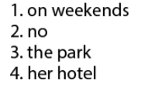

- Activity 4: Conversation Skill (5’)
a) Objective: To improve their speaking skill by showing interest.
b) Content: practicing their speaking skill by showing interest
c) Products: Students can improve their conversation skills by showing interest.
d) Competence: Collaboration, communication, and imagination
e) Organization of the activity:
Teacher's activities | Students' activities
Conversation skill:  + Option 1.  - Focus on the Conversation Skill box.  - Explain to Ss how to use these fillers + intonation.  + “Uh-huh, I see: understanding  + really? + rising intonation: surprise  - Demonstrate the activity.  - Play the audio and ask them to listen and repeat  + Option 2.  - Ask Ss to make a short conversation, using this conversation skill.  - Check answers as a whole class.  - Give them feedback.  - Check and give comments. | - Focus on the Conversation Skill box and read after T.  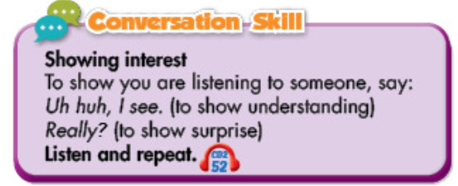  - Listen to the audio and repeat.  - Work in pairs or groups to make conversations.

C. Homework (5’)
- Learn new words about Cities around the World
- Write some sentences about your favorite landmarks in Vietnam.
- Do exercises in the New Words part on page 56 (WB).
- Prepare for the new lesson – Grammar on page 79 (SB).

