Date of preparing: ………………………………….
Date of teaching: ………………………………….

Period……
UNIT 2: SCHOOL
Lesson 2 - Part 2 (Page 18) - Grammar

I. OBJECTIVES
By the end of the lesson, Ss will be able to…
1. Knowledge
- use “like + V-ing” to talk about hobbies and interests.
- write V-ing with correct spelling.
- ask and answer about the school activities they like or don’t like.
2. Ability
- improve speaking skill, listening skill.
- improve the use of English.
3. Quality
- have positive attitude in English language learning so that they actively participate in all classroom activities, especially with the topic “School” conducted by the teacher.
- love their school, have their favorite school activities to join in.

II. TEACHING AIDS AND LEARNING MATERIALS
Lesson plan, PPT slides, student’s book, workbook, notebook, personal computer (if any), projector/TV, speakers, DCR & DHA on EDUHOME, handouts…

III. PROCEDURES
A. Warm up: (5’)
a) Objective: to introduce the new lesson and set the scene for Ss to acquire new language; to get students' attention at the beginning of the class by means of enjoyable and short activities as well as to engage them in the steps that follow.
b) Content: Introduction of “like + V-ing”
c) Product: Ss get to have general ideas about like +gerund
d) Competence: Collaboration, communication, responding, creativity.
e) Organization of the activity:
Teacher’s Activities | Students’ Activities
- Give greetings  - Check attendance  - Option 1:  - Let Ss listen to a recording about hobbies and interests, then repeat  - Link from YouTube (T doesn’t need to play full clip, just a minute with some sentences):  https://www.youtube.com/watch?v=N1o4oOXLOZc  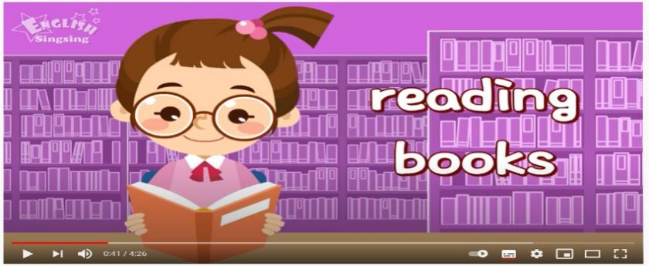  - Ask Ss to pay attention to the kind of verb they use after “like”  → Lead to the new lesson  - Option 2: CHATTING  - Ask Ss: - Do you like reading books?  - Do you like playing soccer?  - Do you like listening to music?  - Do you like watching TV?  →Lead to the new lesson: “like + V-ing” | - Greet T  - Listen and repeat  - Listen  - Answer

B. New lesson (35’)
- Activities 1: Grammar: Like + V-ing (17’)
a) Objective: Ss know how to use “like + V-ing” to talk about hobbies and interests and they can use the correct spelling of the V-ing form in writing.
b) Content:
- Listening and repeating.
- Writing the verbs with -ing form.
c) Products: Ss can use “like + V-ing” in everyday communication.
d) Competence: Communication, collaboration, creativity.
e) Organization of the activity:
Teacher’s Activities | Students’ Activities
a. Listen and repeat  - Have Ss look at the picture  - Play the audio (CD1 – Track 23), ask Ss to listen and read the speech bubbles  - Play the audio and have Ss listen and repeat  *Grammar box:  - Ask Ss to make comments on the verb form after “like” in the recording  - Lead to the grammar table and explain the usage of “like + V-ing”  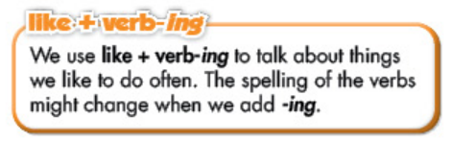  - Ask Ss to pay attention to different forms of the -ing form spelling  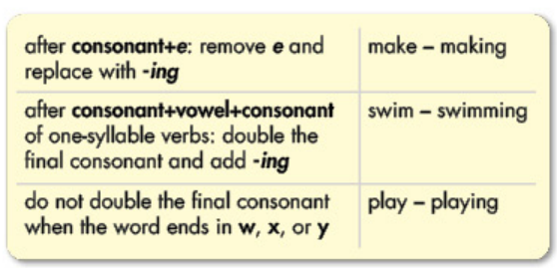  - Have Ss give more examples of:  - -ing after consonant + e  - -ng after consonant +vowel + consonant  b. Rewrite the verbs, using -ing  - Option 1:  - Use the example to demonstrate this activity  - Have Ss add -ing to the verbs to make the -ing form (individually)  - Have pairs check each other’s work  - Have Ss share their answers with the class by writing down on the board  - Check Ss’ answers, correct if necessary  - Option 2:  - Use the example to demonstrate this activity.  - Have Ss and -ing to the verbs to make the -ing form (individually)  - Have pairs check each other’s work  - Have Ss share their answers with the class by taking part in the game: Lucky number    - Give feedback, correct Ss’ answers if necessary  c. Fill in the blanks  - Let Ss work individually to fill in the blanks  - Have Ss work in pairs to check each other’s answers  - Have Ss give answers | - Look  - Listen and read  - Listen and repeat  - Comment  - Listen and take notes  - Look, read  - Give examples  Suggested answers  - -ing after consonant + e: take→taking; give→giving; come→coming  - -ng after consonant +vowel + consonant: put→putting, sit→sitting; begin→beginning  - Look, listen  - Work individually  - Work in pairs  - Write on the board  Answer keys  1. singing 2. drawing 3. cutting  4. reading 5. dancing  6. getting 7. acting  - Work individually  - Work in pairs  - Give answers by choosing number, read the answer, then write on the board  Suggested answer keys  (Upon the questions designed by each teacher)  - Work individually  - Work in pairs  - Give answers (read, then write on notebooks)  Answer keys  2. doing outdoor activity  3. playing tennis 4. swimming
- Activity 2: Practice (18’)
a) Objective: Ss can make questions or answer the questions to develop a conversation.
b) Content: practicing the conservation in the textbook, then making up a similar dialogue.
c) Products: Ss can apply the use of “like + V-ing” to daily communication.
d) Competence: Collaboration, creativity, communication, presentation
e) Organization of the activity:
Teacher’s Activities | Students’ Activities
d. Practice the conversation with your partner  - Let Ss work in pairs to practice the conversation with a partner  - Remind Ss to use correct response to each of the question:  Like: Yes, I do / Yes, I like it  Don’t like: No, I don’t / I don’t like it / No, not really  - Call some pairs to demonstrate the activity in front of the class  *Extra speaking activity  - Option 1: (for class with better students)  - Have Ss use the sample dialogue in task c. and make up a similar dialogue; then make a conversation with their own ideas, encourage Ss to be creative  - Go round and give help if necessary  - Call some pairs to share their conversation in front of the class  - Give feedback and evaluation  - Option 2  - Deliver handouts, have Ss use the phrases and pictures in the handout to make a complete conversation, then practice reading it in pairs  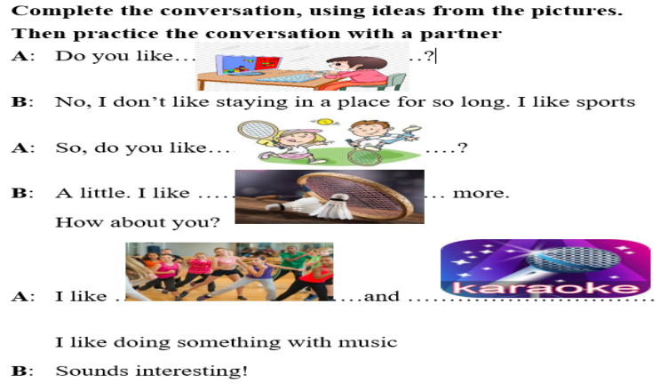  - Go round and give help if necessary  - Have some pairs present in front of the class  - Give feedback and evaluation | - Practice in pairs  - Listen  - Act out the dialogue  - Practice in pairs  - Listen  - Act out the dialogue  Suggested conversation  A: There’s a music club. Do you like playing musical instruments?  B: No, I don’t  A: Do you like doing outdoor activities?  B: Yes, I do. I like doing sports.  A: Do you like playing soccer?  B: No, not really.  A: Do you like playing badminton?  B: Yes, I like it very much.  A: OK. So, we can sign up for the badminton club.  Expected answers  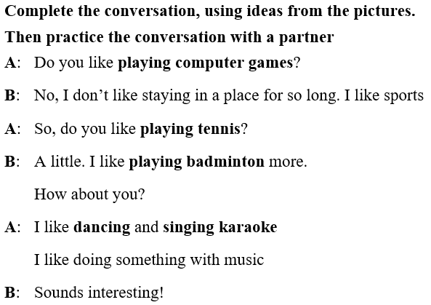

C. Consolidation (3’)
* “Like + V-ing”: talk about things we like to do often
* V-ing spelling:
After consonant + e →remove “e” and replace with “ing”
After consonant + vowel +consonant (for 1 syllable verb)→double the final consonant and add “ing”
Words ending with w, x, y →do NOT double the final consonant

D. Homework (2’)
- Make 2 sentences, using “like + V-ing”
- Practice asking and answering about hobbies and interests, using “like + V-ing”
- Do exercises in WB: Lesson 2 - Grammar (page 11)
- Prepare: Lesson 2 – Pronunciation and Speaking (page 19 – SB)

