Thời gian làm bài: 40 phút (Không kể thời gian giao đề)
-------------------------
Họ tên thí sinh: .................................................................
Số báo danh: ......................................................................
Mã Đề: 012.
Câu 1. Look at the signs. Choose the best answer for the question.
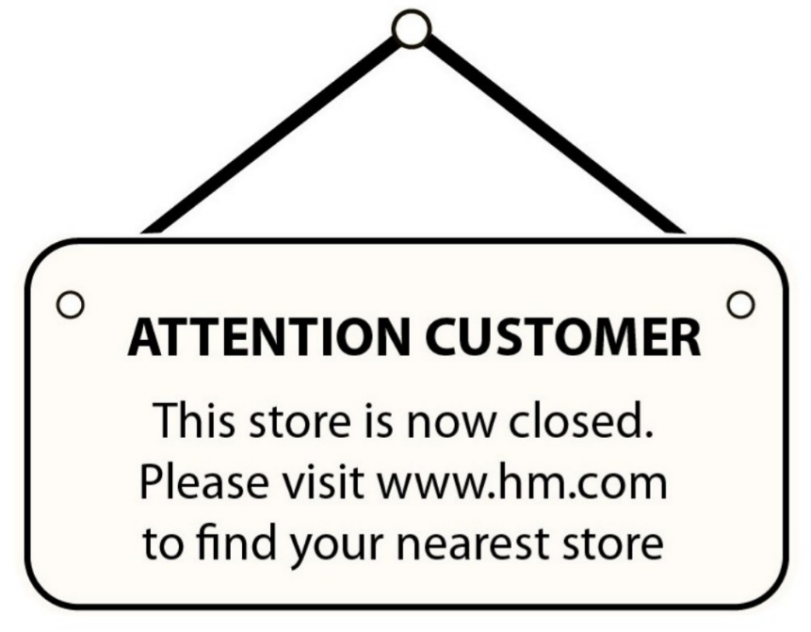
A. You can visit the website to find the nearest location that is open.
B. This store will be moved to the nearest location.
C. You should pay attention when you find the nearest store.
D. Please visit the website and shop online.
Câu 2. What is the condition of the bicycle's tyres according to the advertisement?
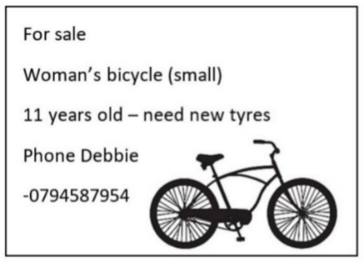
A. They are brand new B. The advertisement doesn't mention the tyres
C. They need to be replaced D. They are in good condition
Câu 3. What subject does John need help with?
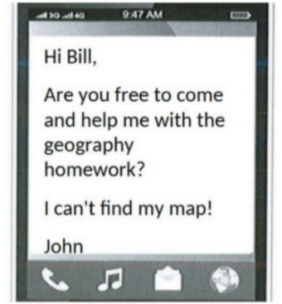
A. Geography B. Math C. English D. History
Câu 4. What should visitors do if the gate is closed?
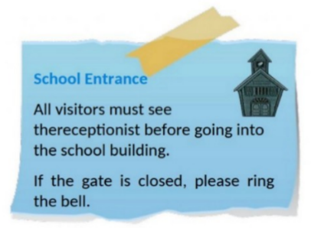
A. Call the school office B. Ring the bell
C. Come back later D. Wait for someone to open it
Câu 5. "What activity is the person inviting their friend to do?"
Hey friend! I hope you're having a good day. I wanted to see if you're up for watching a film this weekend. I heard that a new blockbuster just came out and it's supposed to be really good. Let me know if you're free and we can catch it together.
A. Attend a play B. Read a book C. Watch a film D. Go to a museum
Câu 6. Look at the signs. Choose the best answer for the question.
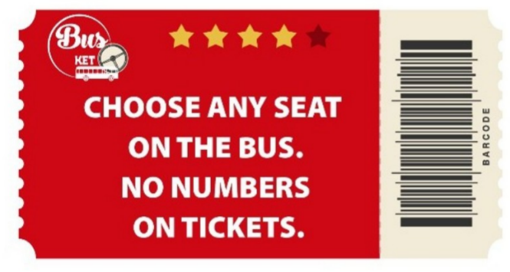
A. There aren’t any numbers on the seats.
B. You have to choose your seat when you buy tickets.
C. The tickets don’t show bus numbers.
D. You may sit where you like.
Câu 7. What is Peter asking Helen to bring to the barbecue?
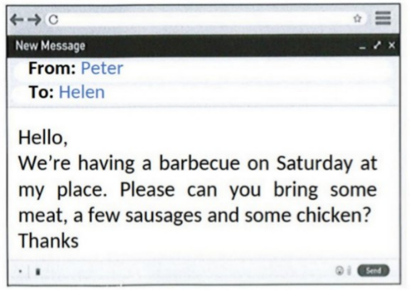
A. Meat, sausages, and chicken B. Bread and condiments
C. Dessert and side dishes D. Drinks and salad
Câu 8. What does this sign mean?
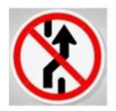
A. No parking here. B. Roundabout ahead
C. Prohibit Changing Lane D. Slippery road.
Câu 9. How long does the reading competition last?
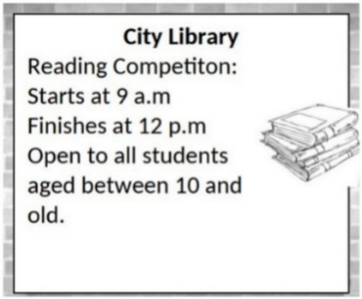
A. 4 hours B. 2 hours C. 3 hours D. 5 hours
Câu 10. Look at the signs. Choose the best answer for the question.
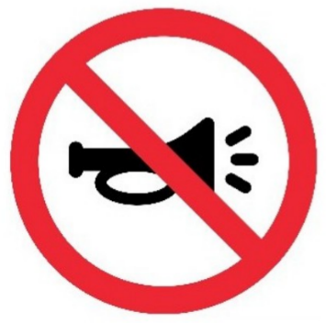
A. You don’t have to use the horn in this area. B. There aren’t any horns in this area.
C. You mustn’t use the horn in this area. D. You should use the horn only in an emergency.
----HẾT---

