|  |  |
| --- | --- |
| **Tiếng Anh 8 Friends Plus** | **FP 8 – REVIEW 3 - TEST 1**  **Test for Unit**  *Thời gian làm bài: 40 phút (Không kể thời gian giao đề)*  *-------------------------* |

**I. Pronunciation (1-4)**

**Câu 1.** Which word has the underlined part pronounced differently from that of the others?

**A.** handicraft  **B.** adopt

**C.** apart  **D.** adapt

**Đáp án đúng**: A

**Câu 2.** Which word has the underlined part pronounced differently from that of the others?

**A.** money  **B.** oneself  **C.** somebody  **D.** social

**Đáp án đúng**: D

**Câu 3.** Which word has a different stress pattern from that of the others?

**A.** accountant  **B.** media

**C.** amazement  **D.** manipulate

**Đáp án đúng**: B

**Câu 4.** Which word has a different stress pattern from that of the others?

**A.** advice  **B.** career  **C.** computing  **D.** payment

**Đáp án đúng**: D

**II. Choose the answer (A, B, C or D) that best fits the space in each question. (5-14)**

**Câu 5.** The artist used spray paint to create a masterpiece of ___________.

**A.** historic  **B.** concerned

**C.** journalism  **D.** graffiti art

**Đáp án đúng**: D

**Câu 6.** At 9 PM tonight, she _____ her favourite TV show.

**A.** will be watching  **B.** watches

**C.** watched  **D.** will watch

**Đáp án đúng**: A

**Câu 7.** The politician tried to ___________ the results of the election by manipulating the votes.

**A.** conclude  **B.** cheat

**C.** alternative  **D.** attend

**Đáp án đúng**: B

**Câu 8.** The company had to ___________ many of its products due to a manufacturing error.

**A.** process  **B.** manipulate

**C.** destroy  **D.** adapt

**Đáp án đúng**: C

**Câu 9.** Unless she studies hard, she _____ the exam.

**A.** passes  **B.** passed

**C.** will not pass  **D.** will pass

**Đáp án đúng**: C

**Câu 10.** The ____________ method of learning allows individuals to gain practical experience while working.

**A.** alternative  **B.** attend

**C.** graduate  **D.** apprenticeship

**Đáp án đúng**: D

**Câu 11.** This time tomorrow, I _____ on the beach.

**A.** will be lying  **B.** will lie

**C.** lie  **D.** am lying

**Đáp án đúng**: A

**Câu 12.** The government is ___________ about the increasing number of traffic accidents.

**A.** hoping  **B.** concerned

**C.** concluding  **D.** challenging

**Đáp án đúng**: B

**Câu 13.** If it rains tomorrow, I _____ my umbrella.

**A.** have taken  **B.** take

**C.** will take  **D.** took

**Đáp án đúng**: C

**Câu 14.** John: "I'm going to the gym after work." - Sarah: "______"

**A.** I can't find my keys.  **B.** I went to the gym yesterday.

**C.** I don't like vegetables.  **D.** That's a good idea, I might join you.

**Đáp án đúng**: D

**III. Look at the signs. Choose the best answer (A, B, C or D). (15-16)**

**Câu 15.**

Which of the following statements is true?

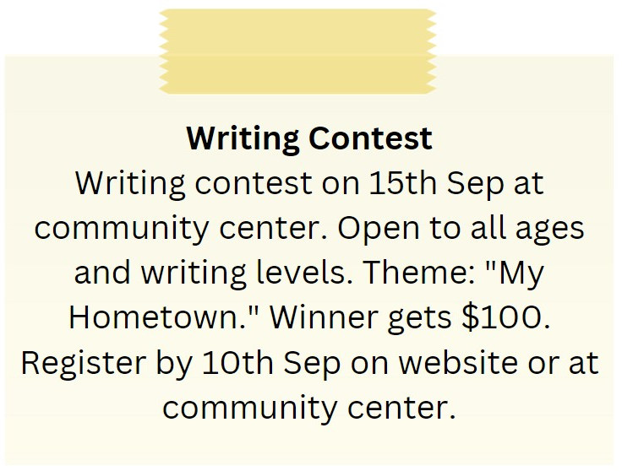

**A.** The writing contest is only open to experienced writers.

**B.** The English course starts on 1st September.

**C.** The English course is for advanced learners.

**D.** The theme of the writing contest is “My Hometown.”

**Đáp án đúng**: D

**Câu 16.**

Which of the following statements is true?

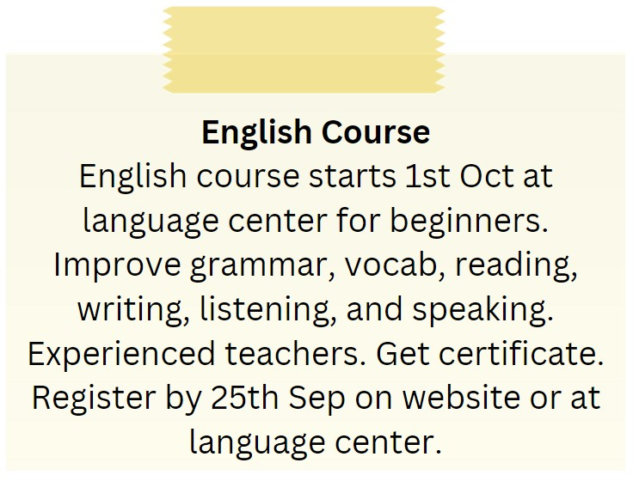

**A.** The English course is taught by experienced teachers.

**B.** The English course is for advanced learners.

**C.** The English course starts on 1st September.

**D.** The English course does not provide a certificate.

**Đáp án đúng**: A

**IV. Read the following passage and do as direct. (17-22)**

My friend, Sarah, has recently shared her plans to study abroad with me. She wants to pursue her Masters in Business Administration from a prestigious university in the USA. She is very excited about this opportunity as it will not only help her gain valuable knowledge and skills but also enhance her career prospects. Sarah has already started preparing for the admission process by taking the necessary exams and getting her documents in order. She is also exploring various scholarships and funding options to support her studies. Although she is a bit nervous about living in a new country, she is determined to make the most of this experience and immerse herself in the culture. I am thrilled for her and cannot wait to hear all about her adventures abroad. I know she will do great and make us all proud.

**Câu 17.** Sarah wants to pursue her Masters in Business Administration from a prestigious university in the USA.

**A.** False  **B.** True

**Đáp án đúng**: B

**Câu 18.** Sarah is not excited about studying abroad.

**A.** True  **B.** False

**Đáp án đúng**: B

**Câu 19.** Sarah has not started preparing for the admission process.

**A.** False  **B.** True

**Đáp án đúng**: A

**Câu 20.** Sarah is exploring various scholarships and funding options to support her studies.

**A.** False  **B.** True

**Đáp án đúng**: B

**Câu 21.** What is Sarah's main goal for studying abroad?

**A.** To gain valuable knowledge and skills  **B.** To enhance her career prospects

**C.** Both A and B  **D.** None of the above

**Đáp án đúng**: C

**Câu 22.** How does Sarah feel about living in a new country?

**A.** Excited  **B.** Nervous

**C.** Determined  **D.** All of the above

**Đáp án đúng**: D

**V. Choose the word (A, B, C or D) that best fits the blank space in the following passage. (23-28)**

School holidays **____23____** an essential break for students to take a breath and recharge. However, some argue that the holidays are too long, and students lose the momentum they built up in the **___24_____** term. In my opinion, I believe that school holidays should not be shorter.

**____25____**, students need time to relax and de-stress from the demands of school life; this is especially important for students who have a lot of extracurricular activities or who struggle with mental health. Shorter holidays would deprive them of this essential time to **____26____** and recuperate.

Secondly, students need time to pursue their **____27____** and passions outside of the classroom. Lengthy holidays provide ample time for students to explore their hobbies, develop new skills, and volunteer in their communities.

In summary, while shorter school holidays may seem like a good idea on the surface, they could have negative consequences on students' well-being and **____28____** growth. Therefore, I believe that school holidays should remain at their current length.

**Câu 23.** School holidays ____ an essential break for students to take a breath and recharge.

**A.** providing  **B.** provide  **C.** provides  **D.** provided

**Đáp án đúng**: C

**Câu 24.** However, some argue that the holidays are too long, and students lose the momentum they built up in the ___ term.

**A.** current  **B.** future  **C.** next  **D.** previous

**Đáp án đúng**: D

**Câu 25.** ____, students need time to relax and de-stress from the demands of school life.

**A.** Firstly  **B.** Secondly  **C.** Lastly  **D.** Thirdly

**Đáp án đúng**: A

**Câu 26.** Shorter holidays would deprive them of this essential time to ____ and recuperate.

**A.** study  **B.** rest  **C.** play  **D.** work

**Đáp án đúng**: B

**Câu 27.** Secondly, students need time to pursue their ____ and passions outside of the classroom.

**A.** interests  **B.** dislikes

**C.** fears  **D.** weaknesses

**Đáp án đúng**: A

**Câu 28.** In summary, while shorter school holidays may seem like a good idea on the surface, they could have negative consequences on students' well-being and ____ growth.

**A.** professional  **B.** academic

**C.** emotional  **D.** personal

**Đáp án đúng**: D

**VI. Supply the correct form of the word given in each sentence. (29-34)**

**Câu 29.** Even though they are twins, they have ____________ personalities and interests. (differ)

**Đáp án đúng**: different

**Câu 30.** After ____________, she plans to travel around the world and experience different cultures. (graduate)

**Đáp án đúng**: graduation

**Câu 31.** The audience was amazed by the ____________ of the acrobats in the circus. (perform)

**Đáp án đúng**: performance

**Câu 32.** I ____________ cannot believe how beautiful the view is from here. (simple)

**Đáp án đúng**: simply

**Câu 33.** With regular exercise and a healthy diet, he is becoming ____________ and healthier. (strength)

**Đáp án đúng**: stronger

**Câu 34.** The ____________ are working hard in the laboratory to find a cure for the disease. (science)

**Đáp án đúng**: scientists

**VII. Rearrange the groups of words in a correct order to make complete sentences. (35-36)**

**Câu 35.** languages by / able to speak / three / was five? / Was he / the time he

…

**Đáp án đúng**: Was he able to speak three languages by the time he was five?

**Câu 36.** be / Australia. / Tomorrow at / flying to / this time I’ll

…

**Đáp án đúng**: Tomorrow at this time I’ll be flying to Australia.

**VIII. Rewrite each of the following sentences in another way so that it means almost the same as the sentence printed before it. (37-40)**

**Câu 37.** Learning a foreign language is important for students nowadays.

It’s …

**Đáp án đúng**: It’s important for students nowadays to learn a foreign language.

**Câu 38.** Mrs. Kim was tired, but she tried to finish all the housework.

Despite …

**Đáp án đúng**: Despite being tired, Mrs. Kim tried to finish all the housework.

**Câu 39.** Children are not allowed to drink any type of alcohol.

Children mustn’t …

**Đáp án đúng**: Children mustn’t drink any type of alcohol.

**Câu 40.** Unless Tom pays attention to the teacher, he won’t understand the lesson.

If Tom …

**Đáp án đúng**: If Tom doesn't pay attention to the teacher, he won’t understand the lesson.

**IX. Listening: listen and do as direct. (41-50)**

*Listen to a dialogue between two friends:*

**Câu 41.** John is worried about school.

**A.** True  **B.** False

**Đáp án đúng**: A

**Câu 42.** Mary is not stressed about school.

**A.** False  **B.** True

**Đáp án đúng**: A

**Câu 43.** John is having trouble with Math and English.

**A.** False  **B.** True

**Đáp án đúng**: B

**Câu 44.** Mary is good at history and science.

**A.** False  **B.** True

**Đáp án đúng**: A

**Câu 45.** Mary suggests they can help each other.

**A.** True  **B.** False

**Đáp án đúng**: A

**Câu 46.** John and Mary plan to meet at the library after school.

**A.** False  **B.** True

**Đáp án đúng**: B

**Câu 47.** John is free on Mondays and Wednesdays.

**A.** False  **B.** True

**Đáp án đúng**: A

**Câu 48.** Mary is free on Tuesdays and Thursdays.

**A.** True  **B.** False

**Đáp án đúng**: A

**Câu 49.** They plan to start studying together next week.

**A.** True  **B.** False

**Đáp án đúng**: A

**Câu 50.** John and Mary believe they will do better in their exams if they study together.

**A.** True  **B.** False

**Đáp án đúng**: A

**----HẾT---**